AegisRAG Project Guide
  - Understand the project through a payment incident
Guide 1 of 2 | Read this first
Guide 1 of 2. Start here. You do not need to know Python or AI. This guide explains the problem, the flow, the choices, and the limits without showing source code. The code guide connects these ideas to the implementation.
Source snapshot: AegisRAG 0.2.0, revision eb3fbc5, read in this workspace on 12 October 2026. The payments story below follows the actual supplied scenario. It describes a demonstration, not a claim of a real production deployment.
New practice part: Jump to the study exercises and interview preparation. Use these alongside the chapters below.

Reading route
1 You are the engineer on call
2 Where AegisRAG helps
3 Two journeys meet in the middle
4 Prepare the knowledge the library analogy
5 Search two imperfect clues can help together
6 The investigation follows a controlled route
7 Watch the supplied payments scenario unfold
8 Read the report without being fooled by its labels
9 The two other scenarios explain why controls matter
10 Why the design has interchangeable parts
11 What has been tested and what should improve next
12 Tell the story in an interview
13 Five checks before moving to the code guide

1 You are the engineer on call
Picture a customer pressing Pay. Usually the website passes the payment to a service, the service records it, and the customer sees a confirmation. Today the customer sees an error. More customers try; more errors appear. Your job is to understand what failed and choose a safe response.
The payment service needs a connection to PostgreSQL, its database. A connection is a communication channel. Instead of opening a new channel for every request, the service reuses a pool of connections. Think of a shop with a fixed number of checkout counters.
A new release allows more payment requests to run at once. That sounds like a speed improvement, but the number of database connections has not increased. Fifty requests can compete for a much smaller pool. Requests wait, some time out, and the service starts returning HTTP 503. That status means the service cannot handle the request right now.
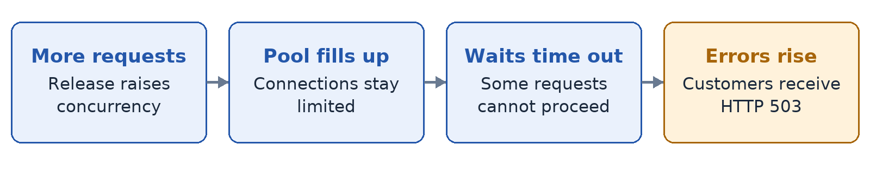
Figure 1. How more concurrency can create payment failures
An error is a symptom: what you can observe. Pool exhaustion is a possible cause: why the symptom occurs. The recent release is a possible trigger: what changed. Keeping those three ideas separate is the beginning of good incident investigation.
Pause and explain: why can increasing concurrency make a service worse? Because more work can compete for a resource whose capacity stayed the same.

2 Where AegisRAG helps
You may have dozens of runbooks, service documents, and old incident reports. A runbook tells an operator how to investigate and recover. A postmortem explains what happened in an earlier incident. During a failure, finding the useful paragraph quickly matters.
AegisRAG takes the symptoms and searches this operational knowledge. It produces an answer with source excerpts, possible failure explanations, and recommended checks. It helps you prepare an investigation; you still decide whether the evidence fits the real incident.
The name includes RAG: retrieval-augmented generation. In ordinary words, find useful information first, then construct an answer using it. Think of an open-book examination: before answering, locate the relevant page.
The default implementation does not need a large language model. It can answer by selecting sentences from the retrieved documents. An optional model can produce a more composed answer. Both use the same general search-before-answer idea.
A good one-sentence description is: “AegisRAG helps investigate service incidents by finding relevant operational documents and returning evidence-linked explanations and advisory next steps.”

3 Two journeys meet in the middle
There are two separate journeys. Knowledge must be prepared before it can be searched. An incident must be described before the system can decide what to search for. They meet at retrieval.
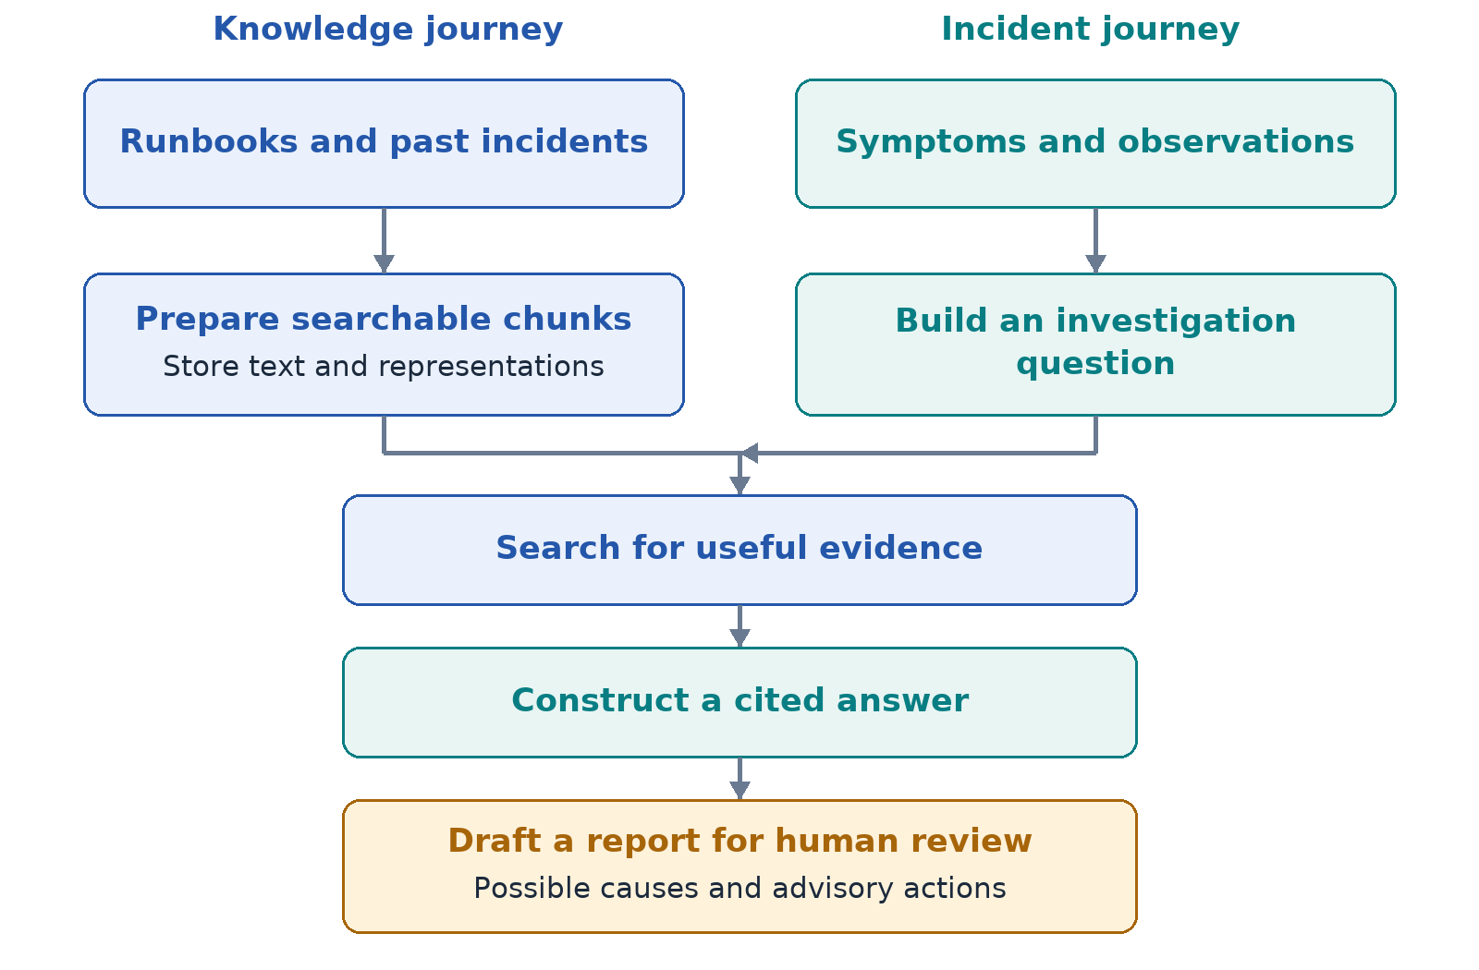
Figure 2. Knowledge preparation and incident description meet at retrieval
Documents are the background knowledge. Telemetry is the description of the current situation. Telemetry means observations such as error rates, log messages, request traces, and deployment records. A request trace follows work across operations; a log records a message; a metric records a measurement.
In this repository, telemetry is either supplied as incident input or generated by scenario recipes. There is no built-in collector subscribing to all your live production systems.

4 Prepare the knowledge the library analogy
Imagine a library that files whole books under one label. Finding a single useful paragraph would be difficult. AegisRAG makes smaller searchable pieces called chunks. It uses Markdown headings to identify sections, then groups paragraphs within each section.
In the payments runbook, “Connection pool exhaustion” explains the failure, “Safe remediation” explains recovery, and “Verification” explains what recovery should look like. Keeping those labels helps a person understand the purpose of an excerpt.
Each document receives a fingerprint of its content. Sending the same content again for the same customer and source is recognized as a repeat. It does not create another copy of every chunk. Changed content creates another version rather than silently replacing the older one.
Every document belongs to a tenant. Here a tenant means a logical customer or organization. Search only reads the chosen tenant's knowledge. This is data separation. The current request header selects the tenant, so authenticating who may use that tenant is still a separate requirement.
Chunks also receive numerical representations so a second kind of search can compare them. The local representation is based on words and spelling fragments. It is reproducible and runs offline, but it has limited understanding of meaning.
Pause and explain: why save both the original chunk text and a numerical representation? The numbers help compare candidates; the text is what people inspect and what the answer uses.

5 Search two imperfect clues can help together
The first clue is a word match. If the application logs db_pool_timeout, a document containing that exact identifier is valuable. This is keyword or lexical search. It gives unusual matching words more importance than very common words.
The second clue is vector similarity. A vector is simply a list of numbers representing text. The system compares the question's numbers with each chunk's numbers. In the default mode these numbers come from hashing words and short spelling fragments, rather than a trained language model.
Each clue produces a ranked list. AegisRAG combines the positions in those lists. A paragraph that is useful according to both clues can rank well. This combination is called hybrid retrieval.
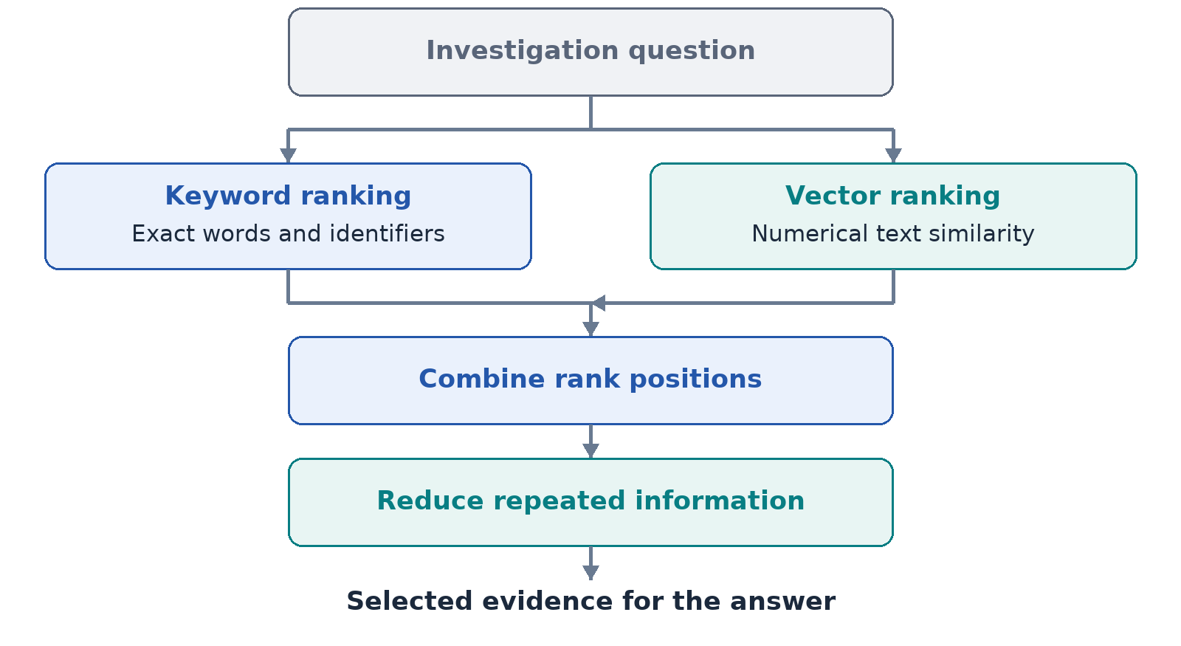
Figure 3. The local search combines two rankings and reduces repetition
The local path then reduces repetition. If three paragraphs all say the same thing, another paragraph about recovery may be more useful than the third duplicate. The goal is useful coverage: cause, context, and next steps.
This does not guarantee relevant results. A ranking tells you what is best among the available candidates. If every available paragraph is unrelated, the top-ranked one is still unrelated. This distinction becomes important when the system grades its evidence.

6 The investigation follows a controlled route
The workflow is a sequence with one decision. Search, grade the evidence, optionally try one expanded search, construct an answer, and check its citation numbers. A graph library called LangGraph connects these steps. The steps are ordinary program functions; they are not a team of independent AI personalities.
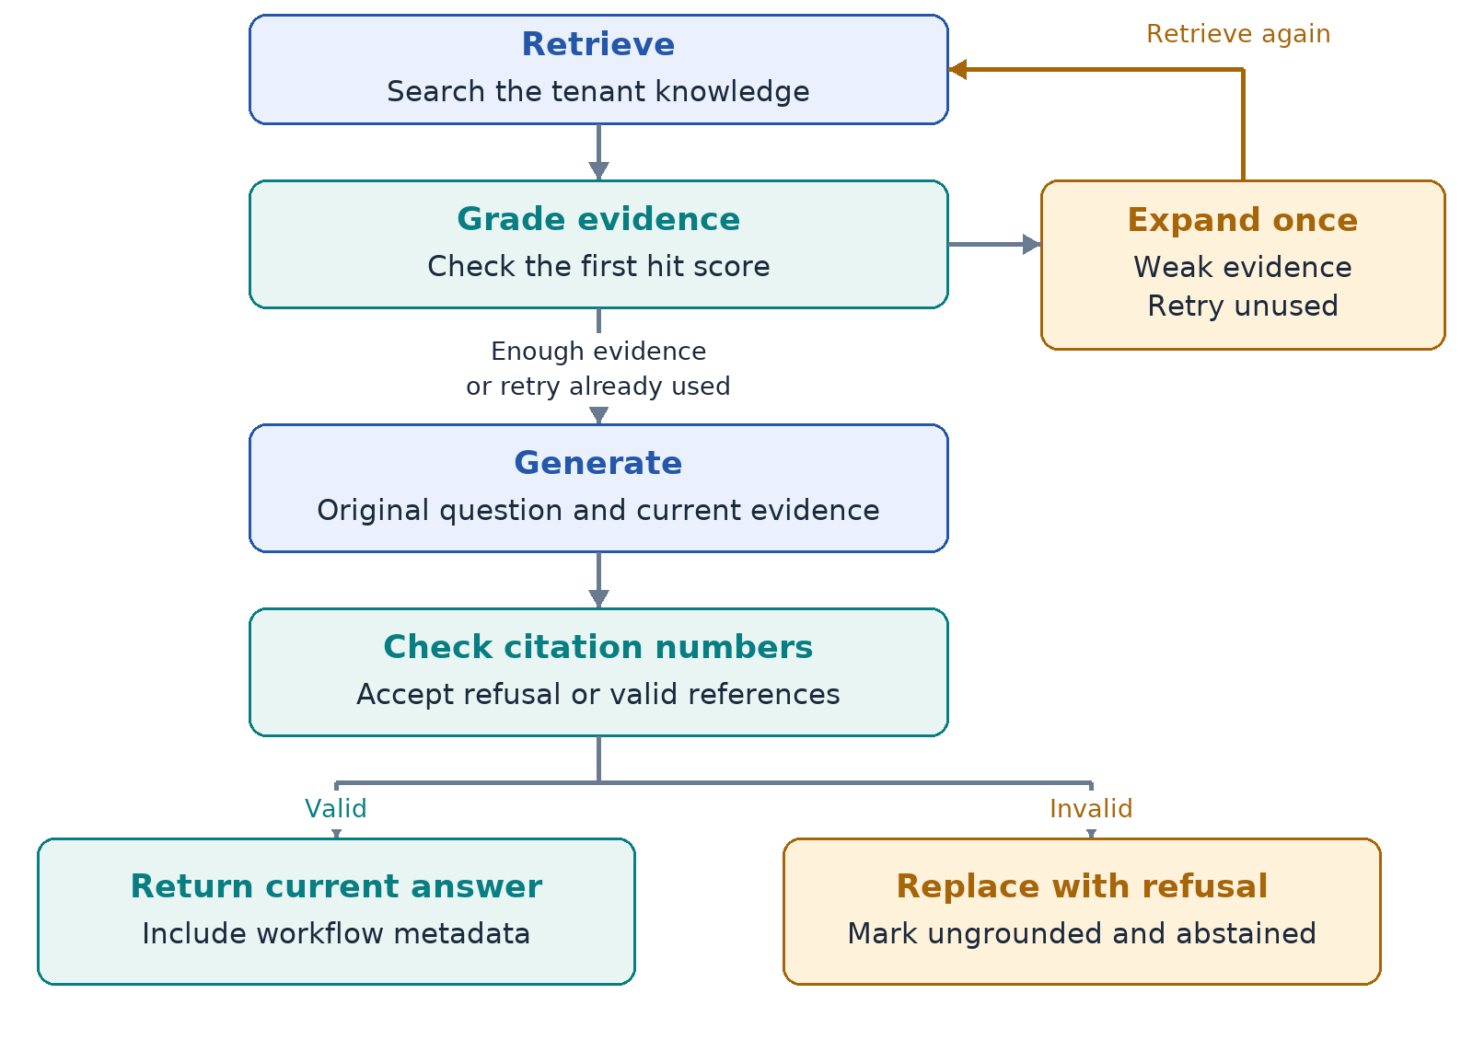
Figure 4. The bounded investigation route and citation validation
The retry adds fixed operational search words such as root cause and remediation. It is not a model inventing a better question. Only one retry is allowed, so a poor search cannot create an endless loop.
The workflow records which steps ran. That trace helps you distinguish a normal answer, a retried search, and a cached result. Optional checkpoints store state, but this repository does not provide a complete user-facing interruption-and-resume feature.

7 Watch the supplied payments scenario unfold
The demonstration reads a recipe containing six observations. Their timestamps describe simulated time. The program creates them in a loop; it does not make you wait ninety real seconds.
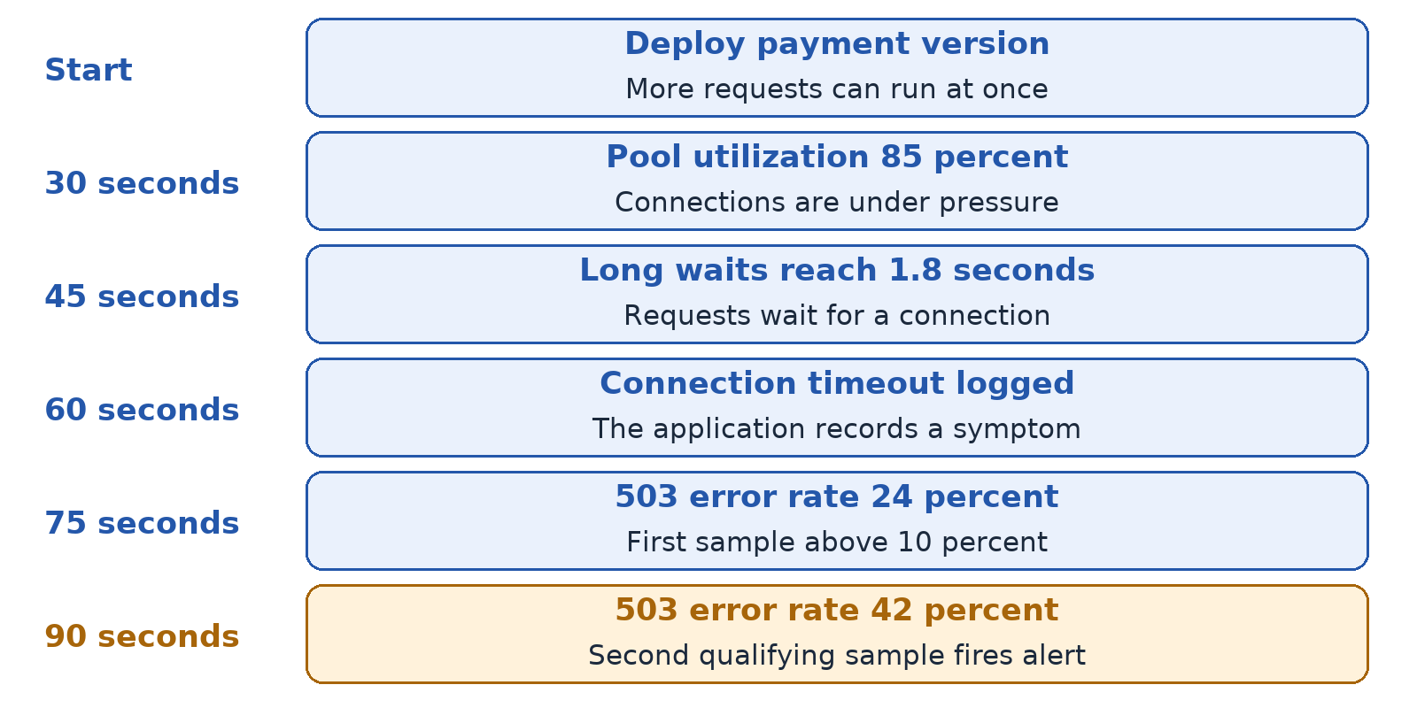
Figure 5. The six synthetic inputs in the payments recipe
The rule requires two measurements above a 10% HTTP 503 rate. The 24% value is the first qualifying measurement. The 42% value is the second, so an alert is recorded. An alert means the configured rule fired; it is not yet proof of a particular cause.
The simulator gathers its observations into an incident description. The investigation searches the payments runbook and service catalog. The leading possible cause refers to the “Connection pool exhaustion” section.
The supplied runbook says that a concurrency increase can exhaust connections. It advises first stopping the rollout and reducing concurrency, then considering rollback with approval if saturation continues. Those details are source knowledge. The report's action list is more generic: validate the hypothesis, compare deployment timing, and require approval for risky changes.
The scenario saves the generated telemetry, incident report, and timeline. The browser can fetch the saved report again to show that persistence worked. Direct incident analysis through the API returns a report without saving it; persistence is explicitly part of the scenario path.
One subtle limit: the backend counts qualifying measurements in total. It does not require them to be consecutive. High-low-high can still satisfy a two-occurrence rule. The interface currently uses the stronger word “consecutive”.

8 Read the report without being fooled by its labels
Start with the answer and its source excerpts. A citation points to a retrieved chunk. The title and section tell you where the excerpt came from. The content fingerprint identifies which document version was used.
Then read the hypotheses. A hypothesis is a plausible explanation to test. The incident layer favors sections whose labels sound like causes or failures. This is rule-based ranking, not an independent proof of causation.
The displayed confidence is calculated from a search score. For example, the checked local payments run displayed 80%. It does not mean the program has demonstrated an 80% probability that the diagnosis is correct. Call it a heuristic confidence value.
Severity is also a rule. Words such as unavailable lead to the highest severity group. This is not a full assessment of business impact, customer count, or incident duration.
Citation verification checks that reference numbers point to supplied evidence. It does not check that every claim is supported or that the source is up to date. In a checked example, a question about France received an unrelated answer about audit retention with a valid citation. This makes the difference concrete: cited is not automatically correct.
Human approval is marked as required. The system does not execute rollback, failover, or database repair. There is also no authenticated approval-execution process implemented. The report is advisory.

9 The two other scenarios explain why controls matter
The healthy payments recipe includes error rates of 1% and 2%. Both stay below the 10% boundary. No alert fires, no investigation runs, and no incident is created. This is a negative control: demonstrate that a normal case does not trigger the same response.
The checkout recipe describes a different failure. A release removes Redis pipelining, so a large cart creates many separate network calls. This repeated-access pattern slows requests and saturates a client connection pool. Two high latency measurements trigger its alert, and search retrieves a matching previous incident.
Together the recipes show a failure, a healthy case, and another failure pattern for another tenant. They are useful demonstrations, but three carefully prepared scenarios do not establish broad production accuracy.
All three checked runs matched their configured outcome expectations. The expectation check looks for specified terms in evidence excerpts. It does not independently establish that the final diagnosis is logically correct.

10 Why the design has interchangeable parts
The default mode stays small: SQLite stores data, hash features represent text, and the answerer selects source sentences. This makes the project runnable without model credentials or a service cluster. It also makes tests repeatable.
Optional Qdrant stores and searches vectors. Redis reuses previous query responses for a short time. An OpenAI provider can compose structured answers from the evidence. OpenTelemetry records traces of API requests. These solve different problems; switching one on does not automatically enable the others.
The Qdrant path uses its own dense-plus-sparse search and fusion. It does not run every rule of the local search, including the local diversity selection and injection regex. The comparison between local and optional paths therefore needs testing rather than an assumption that they behave identically.
Caching can make repeated questions faster, but answers can be stale after documents change because ingestion does not clear the cache. Checkpoints can retain workflow state, but are different from saved incident reports. Keeping these responsibilities separate helps explain the architecture.

11 What has been tested and what should improve next
The checked local suite reported sixteen passing tests and one skipped optional Qdrant test. Tests cover ingestion, local retrieval, tenant separation, graph routes, scenario controls, API contracts, and basic evaluation. No live OpenAI call, Redis server, Qdrant server, or Docker stack was verified for these guides.
The supplied six-question retrieval evaluation passed its gate. It measures whether relevant evidence appears and how early it appears. Its field called recall is actually a hit rate, and the relevance labels use simple document-ID or text-term matches. Treat it as a small regression check, not a complete quality benchmark.
The most useful next improvements are stronger relevance checks, claim-to-evidence verification, authenticated tenant selection, consistent alert semantics, and recovery from partially completed indexing. These address the observed behavior, rather than adding more impressive-sounding service names.
A strong interview answer about a limitation sounds like this: “The current verifier checks citation indices. To check factual support, I would compare each claim with its cited excerpt and evaluate on deliberately incorrect but cited answers.”

12 Tell the story in an interview
Thirty-second version: “AegisRAG helps investigate service failures using operational knowledge. It prepares runbooks for search, combines keyword and vector rankings, follows a bounded search-and-answer workflow, and returns citations with possible causes. I demonstrate it with synthetic incidents. Humans validate the diagnosis and approve operational changes.”
Longer version: begin with the payment failure. Explain that an increase in concurrent requests competes for a fixed connection pool. Then describe the two journeys: documents become searchable knowledge; observations become an investigation question. Explain the search, the one-retry workflow, the cited report, and the saved scenario timeline. Finish with the precise guarantees and the next improvement.
If asked why the project matters, say that it makes operational knowledge easier to find and inspect during an incident. If asked whether it proves the cause, say that it supplies evidence-linked hypotheses. If asked whether it fixes production, say that the current implementation returns recommendations.
Try explaining the story without saying RAG, LangGraph, BM25, Redis, or Qdrant. If the listener still understands the problem and solution, your explanation is clear. Then add technical names only where they explain a design decision.

13 Five checks before moving to the code guide
1. Explain symptom, cause, and trigger using the payments example. 2. Draw the knowledge and incident journeys. 3. Explain why the top search result may still be irrelevant. 4. Explain what a valid citation number does and does not prove. 5. Explain why the healthy recipe creates no incident.
Answers: a symptom is a visible failure, a cause is the mechanism, and a trigger is a preceding change. Knowledge preparation and incident description meet at search. Ranking compares available candidates, not absolute correctness. Citation checks validate evidence indices rather than truth. The healthy input never satisfies its alert rule, so analysis is not invoked.
Next read 02_AegisRAG_Code_Guide.docx. You now know the job each part must accomplish; that makes the code much easier to read.

Practice 1 Build the foundations and choose a study route
The first part explained the project. This practice part helps you explain it without reading from the page. Read a section, close the document, answer its checkpoint aloud, and then compare your answer. If a word is unclear, return to the example before memorizing a technical definition.

Words you need before discussing architecture
Client means the program asking for work. Server means the program receiving that request. An API is the agreed way they exchange messages. HTTP carries those messages; JSON represents named values in their bodies. Backend means the server code. Frontend means the page the user interacts with.
A database stores records that can be read later. Persistence means data survives after a request or process ends. A schema describes the fields in those records. An index helps find records without checking every record. The local AegisRAG search still checks tenant chunks in Python; a database index on the tenant does not make that a vector index.
A model is a system that maps input to output. An LLM generates language using learned patterns. An embedding maps text to numbers. This project has a numerical embedding without requiring an LLM: its default uses hashing. Retrieval finds evidence; generation constructs an answer; verification checks a defined condition.
A heuristic is a practical rule that can be useful without being a proof. A hypothesis is a possible explanation to test. A regression test checks that a behavior still works after a change. A benchmark measures behavior on selected examples. None of these automatically proves real-world accuracy.

Read in four manageable passes
Pass 1: read the project story and draw the two journeys. Pass 2: read the code guide request journey and the worked example. Pass 3: run the learning lab, inspect the results, and use the file reference when a function is unfamiliar. Pass 4: answer the interview questions and complete the final assessment without looking.
You can split these passes across study sessions. Progress is being able to explain and demonstrate a behavior, not finishing a page count. Keep a short list of questions you cannot yet answer; use it to choose your next session.

Practice 2 Defend the central design choices
The repository shows what was implemented. The reasons below explain why those choices can fit this project; they are engineering interpretations, not a claim about the original author's private intentions.

Why search documents before answering
Operational answers depend on specific service knowledge. Searching runbooks and past incidents gives the answer a source that the engineer can inspect. A model answering from its general memory might miss the exact error code or the current operating procedure. Retrieval can also fail when the right document is missing, old, or ranked poorly.
If they go deeper: Compare three alternatives: manual document search requires more operator effort; a rules-only lookup is predictable but narrow; an LLM-only answer is flexible but lacks repository-specific evidence unless supplied.

Why combine two search clues
Exact identifiers such as db_pool_timeout help word search. A numerical comparison adds another way to rank text. Combining positions avoids directly adding values with unrelated scales. Local hash vectors mainly capture spelling patterns; they do not provide the meaning understanding of trained semantic embeddings.
If they go deeper: Hybrid retrieval must earn its extra complexity. Compare word-only, vector-only, and combined retrieval on the same labeled questions, including off-topic cases.

Why use a graph for a small workflow
The workflow has a branch and a return path: weak evidence permits one expanded search. A graph makes that route and its state explicit. It also offers checkpoint support. Ordinary Python could implement the same behavior with fewer dependencies; the benefit here is an inspectable route and a clear place to add future branches.
If they go deeper: A graph does not itself make the diagnosis smarter. The usefulness comes from the operations and conditions inside it.

Why keep the default local
SQLite, hash embeddings, and sentence extraction let someone run the main path without external service credentials. This is helpful for learning, repeatable tests, and a small demonstration. The trade-offs are limited language understanding, Python scans over chunks, and a local-file database.
If they go deeper: An optional service should be chosen for a measured need. More services introduce deployment, availability, configuration, and consistency work.

Practice 3 Separate capability from evidence and aspiration
Question | Current behavior | Next capability to build
Who selects the tenant | Caller supplies a validated header | Authenticate identity and derive allowed tenants
Does the answer cite evidence | Checks available citation numbers | Check each claim against its cited text
Does it know the root cause | Ranks evidence and builds hypothesis templates | Evaluate diagnoses with independent expert labels
Does it fix an outage | Returns advice and approval_required | Build an authenticated approval and execution workflow
Does it watch live production | Accepts input or simulates events | Integrate collectors and event handling
Does the graph resume a failed run | Stores optional checkpoints | Implement and test interruption and resume semantics

Use three kinds of statement in an interview. “It does” must match implemented behavior. “I checked” must name a reproducible test or run. “I would add” describes future work. Keeping these separate is stronger than presenting every planned capability as complete.

What the supplied demonstration establishes
The payments recipe generates six events and triggers the configured rule on the second high 503 sample. Search retrieves relevant supplied knowledge. The scenario stores the report and a tenant-scoped reload succeeds. The healthy recipe shows a case with no incident. These are controlled examples of the intended flow.

What it does not establish
A matching demonstration does not prove that the system identifies unfamiliar outages, saves a measured amount of operator time, or safely remediates production. The expected outcome checks evidence terms. The confidence value comes from a score heuristic. A valid citation can still accompany an unrelated answer.
If asked about impact, explain the intended benefit: making useful operational evidence easier to find and inspect. To establish actual impact, measure investigation time, useful evidence rate, incorrect diagnosis rate, and user feedback against a baseline. Report a measured result only after conducting that comparison.

Practice 4 Answer the opening interview questions

What problem does your project solve
During a service failure, engineers need to connect symptoms with scattered operational knowledge. AegisRAG searches prepared runbooks and service documents, then returns a source-linked answer and possible causes with advisory next steps. Its demonstration uses synthetic incidents. The engineer still validates the cause and decides what action to take.

Explain it to someone who does not know AI
Imagine an assistant that finds the useful paragraphs in your operations handbook. You describe an error; it searches the handbook, shows relevant excerpts, and offers a possible explanation. It can remember the demonstration report so you can open it again. It does not independently repair the service.

What makes the payments story plausible
A release allows more requests to run at once. Each may need a database connection, but the pool has limited capacity. Work waits, some requests time out, and 503 errors rise. The runbook describes this mechanism. The timing and matching error support investigation, but a recent release alone does not prove causation.

What does agentic mean in this repository
The workflow follows programmed steps, carries state, and can choose a bounded retry based on a score condition. It does not freely plan arbitrary tools or run autonomous production changes. LangGraph coordinates ordinary retrieval, grading, rewriting, generation, and citation-check functions.

What did you personally contribute
Describe only work you actually performed. Identify a function, design decision, test, or diagnosis you can explain and demonstrate. If you studied an existing implementation, say that clearly. Understanding a repository is valuable, but it is different from having authored or deployed every part of it.
If they go deeper: Before the interview, write three specific contributions you can defend. Avoid saying you ran a production rollout or used a live service if your experience was limited to the local demo.

Practice 5 Handle skeptical follow up questions

Why should I trust its output
I would inspect the source excerpts and validate the hypothesis against current observations. The implementation checks citation numbers, not full factual support. The learning lab includes an off-topic question that still receives a cited answer. That makes stronger relevance checks and claim verification clear next steps.

What happens when evidence is missing
An empty search goes through one fixed query expansion, then the local answerer refuses. That is useful behavior, but missing evidence and unrelated available evidence are different cases. Unrelated chunks can still rank highly relative to one another and pass the score threshold.

Is tenant isolation the same as security
The store and selected search path restrict records by the supplied tenant label. That is a useful data boundary. The API does not authenticate the caller's right to choose that label. A production design would derive tenant access from a verified identity and test unauthorized access at every boundary.

How would you know the project is improving
Use a stable evaluation set with realistic questions, known relevant documents, missing evidence, off-topic questions, stale knowledge, and adversarial text. Compare retrieval and answer quality before and after changes. Measure latency separately. The existing small term-based gate is a regression check, not a broad accuracy claim.

What would you improve first
For a production-facing API, authenticated tenant selection is a prerequisite. For answer usefulness, I would strengthen evidence relevance and claim support, using the observed off-topic case as a regression test. I would also repair indexing consistency and cache invalidation. The order depends on the intended deployment and measured failures.
Practice answering each question in your own words. Then ask yourself “Where in the code can I show this?” The second guide supplies that connection. A convincing answer pairs a claim with a concrete function or observed result.

Practice 6 Check your understanding of chapters 1 to 7
Try answering: Chapter 1: classify 503, pool exhaustion, and the concurrency change.
Check your answer: 503 is an observable symptom. Pool exhaustion is a possible failure mechanism. The concurrency increase is a possible trigger. Validate the chain rather than treating these labels as interchangeable.
Try answering: Chapter 2: what does RAG add here, and is an LLM required?
Check your answer: It finds service knowledge before creating an answer. The default constructs an answer from source sentences, so no LLM call is required.
Try answering: Chapter 3: why are knowledge and telemetry separate inputs?
Check your answer: Knowledge explains known mechanisms and procedures. Telemetry describes the current situation. The incident description becomes a search question that connects them.
Try answering: Chapter 4: why use chunks, fingerprints, and tenant labels?
Check your answer: Chunks make useful sections searchable. Fingerprints recognize repeat content for a source and tenant. Tenant labels restrict the chosen data set, but the label itself is not proof of caller authorization.
Try answering: Chapter 5: can the highest ranked chunk still be unrelated?
Check your answer: Yes. Ranking compares available choices. If all choices are poor, one still comes first. The local numeric threshold is not a calibrated test of meaning.
Try answering: Chapter 6: what changes during the retry?
Check your answer: The search question gains fixed operational words and attempts becomes one. The original question remains available for answer generation. The graph permits no second rewrite.
Try answering: Chapter 7: at which simulated time does the payments alert fire?
Check your answer: At 90 seconds. The 0.24 sample at 75 seconds is the first qualifying value and 0.42 at 90 seconds is the second. The process does not wait 90 real seconds.
If you used a technical term in your answer, explain it with the payments example. If you cannot, revisit that chapter before continuing.

Practice 7 Check your understanding of chapters 8 to 13
Try answering: Chapter 8: does confidence 0.80 mean 80 percent diagnosis accuracy?
Check your answer: No. It is derived from a retrieval score, multiplied by 25 and capped. It has not been calibrated against independently verified diagnoses.
Try answering: Chapter 9: why is a healthy scenario valuable?
Check your answer: It checks that a case below the threshold does not open an incident. A failure-only demonstration would not test that distinction.
Try answering: Chapter 10: distinguish Redis, Qdrant, and checkpoints.
Check your answer: Redis reuses finished query responses. Qdrant optionally searches indexed dense and sparse vectors. Checkpoints record graph state. Scenario report persistence is a separate SQLite responsibility.
Try answering: Chapter 11: what does a passing evaluation gate mean?
Check your answer: The selected metric values meet configured thresholds for the supplied labeled cases. Relevance labels use document IDs or text terms. This says less than broad correctness on unfamiliar incidents.
Try answering: Chapter 12: give the project explanation without tool names.
Check your answer: Prepare operational documents, describe a failure, search for useful excerpts, construct a cited answer, add hypotheses, and save the demonstration report. Humans inspect evidence and decide actions.
Try answering: Chapter 13: why might changing document content create two versions?
Check your answer: Content identity includes its fingerprint. Changed content has a different identity, and this implementation does not retire the older version automatically.

Connect the project guide to the code guide
Now locate the owner of each job: chunk_document prepares knowledge; HybridRetriever searches locally; AgenticRAGWorkflow controls the route; IncidentCommander adds report fields; ScenarioRunner creates events and persists the report; SQLiteKnowledgeStore reads and writes records. Explain one input and one output for each before looking at its full implementation.

Practice 8 Rehearse a complete project interview
Use this as an open-book rehearsal first. Repeat it without notes when the explanation feels natural. Do not memorize a script word for word; aim to explain the same behavior clearly in different words.

A twenty minute rehearsal
Minutes 0 to 2: explain the problem and intended user. Minutes 2 to 5: draw knowledge preparation and incident investigation. Minutes 5 to 9: walk through the payments story and distinguish symptom, cause, and trigger. Minutes 9 to 13: explain search and the retry in plain words. Minutes 13 to 17: answer skeptical questions about citations, confidence, tenant access, and production readiness. Minutes 17 to 20: propose one improvement and how you would measure it.

Score the explanation against observable skills
Skill | Evidence that you understand it
Purpose | You explain the operational problem before naming libraries
Flow | You draw both journeys and identify where they meet
Precision | You distinguish a hypothesis from a verified cause
Choices | You explain a benefit, a cost, and an alternative
Limits | You explain cited but unrelated answers and heuristic confidence
Ownership | You describe your real contribution without inventing experience

For each skill, score 0 if you cannot explain it, 1 if you need notes, or 2 if you can explain it unaided and answer a follow-up. Twelve is a useful practice target, not a prediction of an interview result. Any zero identifies something to revisit.

You are ready to move beyond reading when
You can give a thirty-second explanation, draw the flow without looking, explain the healthy case, identify three limitations, and justify one next change. Technical readiness also requires the worked example and practical assessment in the code guide. Reading provides the material; explaining and demonstrating it checks whether you have learned it.

