SeatSync Project Guide
  - Understand the system and explain its design
Read in this order: Project Guide, Code Journey Guide, then Code Reference when you need a file lookup or extra practice. Use the linked reading route below and Word’s navigation pane to move between chapters.
Source baseline 4a964d6 Java 21 Prepared 12 October 2026
Learn the purpose, architecture, data ownership, failure recovery, trade-offs and honest interview answers before looking at implementation.

Reading route
The problem a ticket system must solve
What happens when a customer reserves
Changes reach the seat map later
Scaling and operational signals
Check your understanding and plan your study

Study actively
After each chapter, predict a changed input or failure, name the responsible class, and say the answer aloud. Reading alone is not a test of understanding.

The problem a ticket system must solve
Imagine a concert opens for sale. Asha and Ravi both see seat A-1 as available. They press Reserve at almost the same time. If both requests read AVAILABLE and then write HELD, both might believe they own the same seat. A normal read followed by a write is not enough.
SeatSync is a Java backend that studies this problem. Its most important rule is that a seat must not be sold twice. It also handles people pressing a button again, losing a network response, paying too slowly, or leaving checkout halfway through.

Start with three different ideas
A seat is a physical place at an event. A hold is a temporary claim on that seat while a customer checks out. A booking is the recorded checkout workflow, including whether payment and confirmation succeeded. A hold is not a completed booking.
The seeded demo has one concert and three seats, A-1 to A-3. Each costs 499900 minor currency units. For INR, 100 paise make one rupee, so this is INR 4999.00. Using integer minor units avoids floating-point rounding in amounts.
The repository contains five services, databases and command-line verification. It has no customer-facing browser application, real card processor, email ticket delivery, or full account system. The payment service simulates outcomes using tokens such as pm_success.
Check yourself: Why is this more than storing a booking row?
Answer: Requests can compete and networks can fail after a remote service has already committed. Correctness requires ownership, atomic changes, safe retries, and recovery from partial completion.

How requests and databases work
A backend is a program that receives requests and decides what to return. An API is the agreed set of operations it exposes. An HTTP request has a method, path, headers and sometimes a body. GET reads; POST asks for an operation; DELETE asks to remove or release something. JSON is the structured text used for bodies here.
The response includes an HTTP status and usually data. 200 means a successful ordinary response; 201 means creation; 204 has no body; 400 means invalid input; 404 means missing resource; 409 means a conflict. A booking response can be HTTP-successful while its body says FAILED, because the workflow was created and its outcome was recorded.
A database table is a collection of rows with named columns. A primary key identifies one row. A unique constraint prevents repeated values. A foreign key requires a reference to an existing row. An index helps find rows and can also enforce uniqueness.
A transaction groups database changes so they commit together or roll back together. A row lock makes a conflicting operation wait. A conditional update changes a row only if its current value matches a rule. These tools prevent two independent requests from acting on the same old observation.
A network call can time out even when the receiving program finished its work. Idempotency means a repeated logical command avoids another business effect. Eventual consistency means a separate view catches up later; it does not mean the authoritative decision is allowed to be wrong.
Check yourself: Why does this project need more than one transaction?
Answer: Payment, reservation and booking own separate databases. Each local commit is durable independently, so remote coordination needs recovery and compensation.

How the pieces communicate
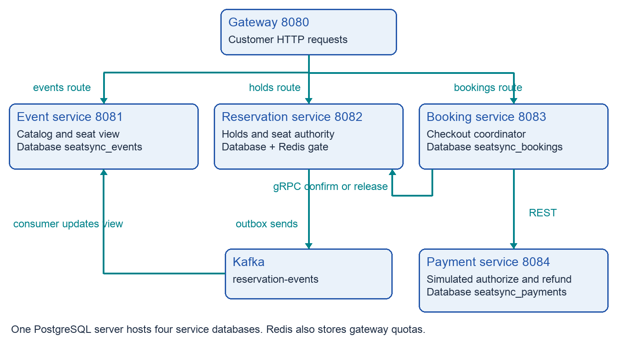
Read the diagram as a map of responsibilities. Booking calls payment by REST and reservation by gRPC. Reservation sends asynchronous changes through Kafka to event-service.
A service is a separately running program with one responsibility. All five run from the same repository, but each starts its own Spring Boot application. The gateway is the public entry point; it forwards HTTP requests to the right service.
The event service provides event information and the seat map. Reservation owns the durable decision about seat state. Booking coordinates checkout. Payment records simulated authorization and refund outcomes.
REST uses HTTP paths and JSON bodies. gRPC uses generated request classes and a Protocol Buffers contract. Kafka carries events later, so the customer request does not wait for the seat-map consumer to finish.

Who owns which facts
Owner | Stored facts | Authority
Event service | Events, seat labels, displayed availability, prices, inbox | Catalog and projected seat view
Reservation service | Inventory, holds, replay records, outbox | Whether a seat can be held or confirmed
Booking service | Checkout status, hold ID, customer ID, payment ID | Progress of its checkout workflow
Payment service | Simulated payment status and amount | Simulated payment result
Gateway | No business database | Routing and admission policy

PostgreSQL is the database technology. Compose uses one PostgreSQL server with four logical databases. Service code does not join across these databases; IDs are passed over network boundaries. One physical server does not remove the separation of ownership.
There are two seat representations. Event-service seats is a convenient view for reading. Reservation seat_inventory is the write authority. The view can lag behind real ownership while Kafka is delayed. Seeing AVAILABLE is a reason to attempt a hold, not a promise that the hold will succeed.
Redis contains temporary seat tokens and gateway quota state. It is fast, but its contents do not decide who paid for a seat. If its key disappears, PostgreSQL can still reject a hold on a HELD or BOOKED seat.
Check yourself: Why keep a separate seat view?
Answer: It lets event reads evolve independently of reservation commands. The cost is eventual consistency and an event-processing pipeline that must be monitored.

What happens when a customer reserves
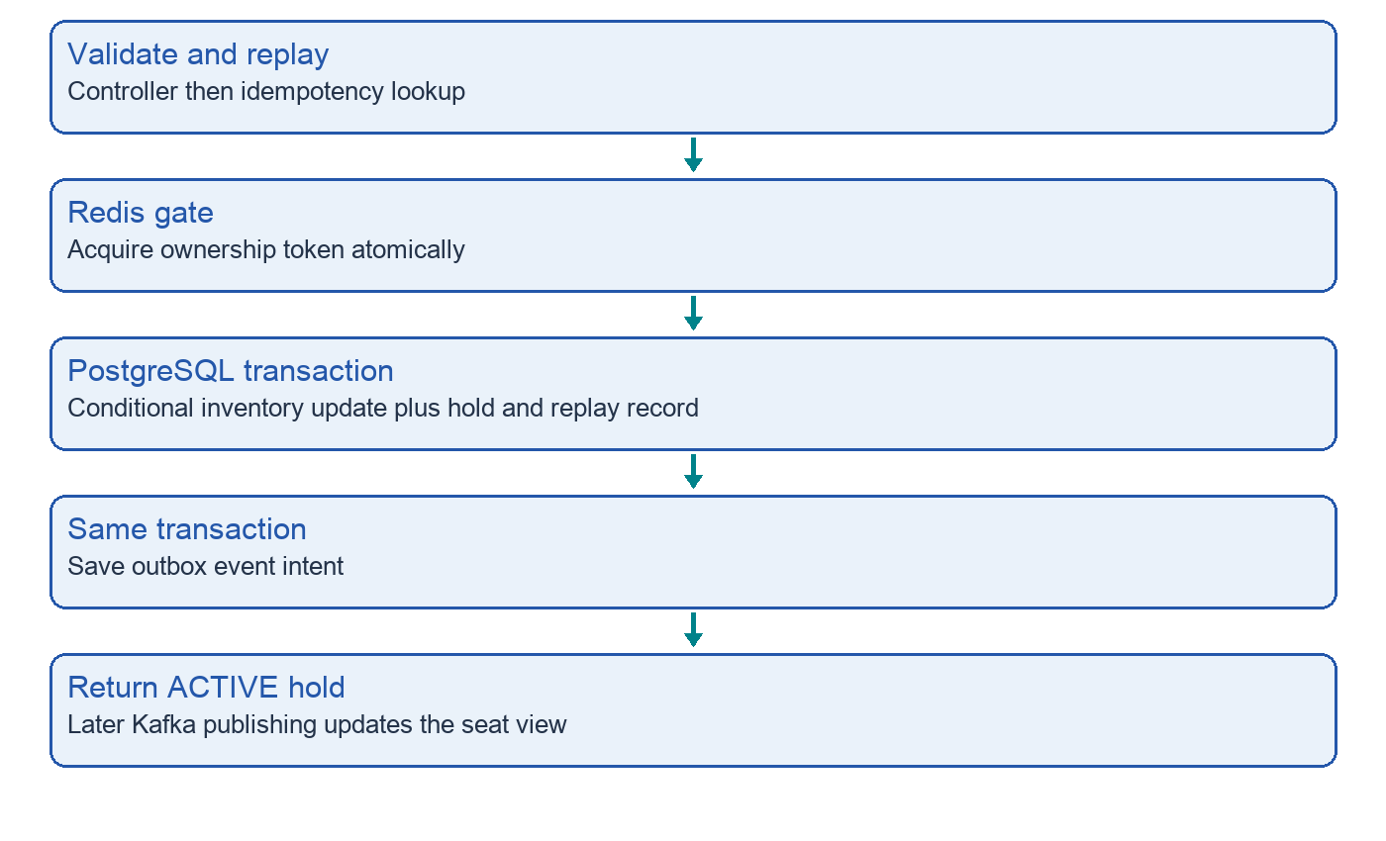
The Redis check is preliminary. The database update is the durable winner decision.
The customer sends the event ID, seat ID, customer ID and an Idempotency-Key. This key names one logical request so a retry can find the same hold. Reservation rejects a missing key and checks whether this key was already used.
For a new request, Redis atomically stores a token if the seat key is absent. PostgreSQL then changes AVAILABLE to HELD only if that condition still holds. Reservation stores an ACTIVE hold, a replay record and an outbox event together in one database transaction.
The default hold lasts five minutes. Redis keeps its token for five minutes plus thirty seconds. Database expiresAt, not the Redis lifetime, determines whether confirmation is allowed. Expired holds are released by a scheduled worker.

Why two customers cannot both win the normal hold race
Atomic means one indivisible decision. The Redis Lua script combines checking the key and writing the token so another request cannot slip between those operations. Usually one request is admitted and the others receive SEAT_UNAVAILABLE.
Even if Redis loses a key, reservation still uses one conditional SQL UPDATE. Suppose Asha changes the inventory row to HELD. Ravi cannot later change that same row from AVAILABLE because it no longer satisfies the condition. The number of updated rows tells the service whether it won.
A partial unique index also permits at most one ACTIVE hold row for a seat. Historical RELEASED, EXPIRED and CONFIRMED rows can remain. This protects the hold table as well as the inventory decision.

Ownership matters during cleanup
Redis stores the hold ID as an ownership token. Cleanup deletes a token only if it still equals the caller’s token. Without this check, an old request could delete a newer customer’s token after the old key expires and is reused.
If the hold transaction rolls back, a transaction-completion callback tries to remove the Redis token. A process crash can prevent the callback, so the token TTL is also needed. During that interval a valid request may be rejected unnecessarily; this affects availability rather than allowing a database-only double booking.
Check yourself: Does this prove the entire system is perfect?
Answer: No. It explains the intended single-winner hold boundary. Other failure windows, worker races, and projection ordering still need separate tests and design work.

Checkout is a sequence of local commitments
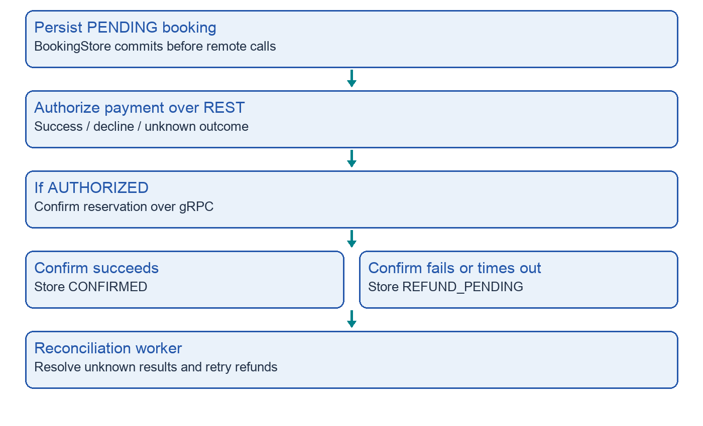
There is no database transaction covering payment, reservation and booking together. Recovery is part of the workflow.
Booking first commits a PENDING row. It then asks payment to authorize an amount. A successful authorization is followed by a gRPC request to confirm the hold. Confirmation checks ownership, status and expiry in the reservation database.
If confirmation succeeds, booking stores CONFIRMED. If payment is declined, it tries to release the hold and stores FAILED. If payment succeeds but confirmation fails, it records REFUND_PENDING and tries to refund the payment.
This style of coordination is often called an orchestrated saga: a coordinator runs several local steps and uses compensating actions when a later step fails. A refund is another operation; it is not a magical rollback of the earlier payment database commit.

The state machines
Thing | States | Meaning
Inventory | AVAILABLE → HELD → BOOKED | HELD can return to AVAILABLE on release or expiry
Hold | ACTIVE → CONFIRMED / RELEASED / EXPIRED | Terminal hold records remain for history
Booking | PENDING → CONFIRMED / FAILED / PAYMENT_UNKNOWN / REFUND_PENDING | Recovery can resolve UNKNOWN and refund pending
Payment | AUTHORIZED / DECLINED / REFUNDED | A simulated authorization can be refunded

ACTIVE is a hold state; HELD is a seat state. CONFIRMED is a booking or hold state; BOOKED is a seat state. These names describe different records, so they are not interchangeable.
PAYMENT_UNKNOWN means booking does not know the result. A timeout does not prove that payment failed. The provider may have committed an authorization while the response was lost. REFUND_PENDING means the system knows the payment ID but still needs a successful compensating refund.
The worker finds old PENDING rows, all PAYMENT_UNKNOWN rows and REFUND_PENDING rows. It queries payment by booking ID, tries confirmation for an authorized result, or retries refund. After a grace period, a provider 404 causes a failed booking and a best-effort hold release.
Check yourself: Why store PENDING before payment?
Answer: It leaves a durable record that the worker can discover if booking crashes between starting checkout and saving the payment outcome.

Changes reach the seat map later
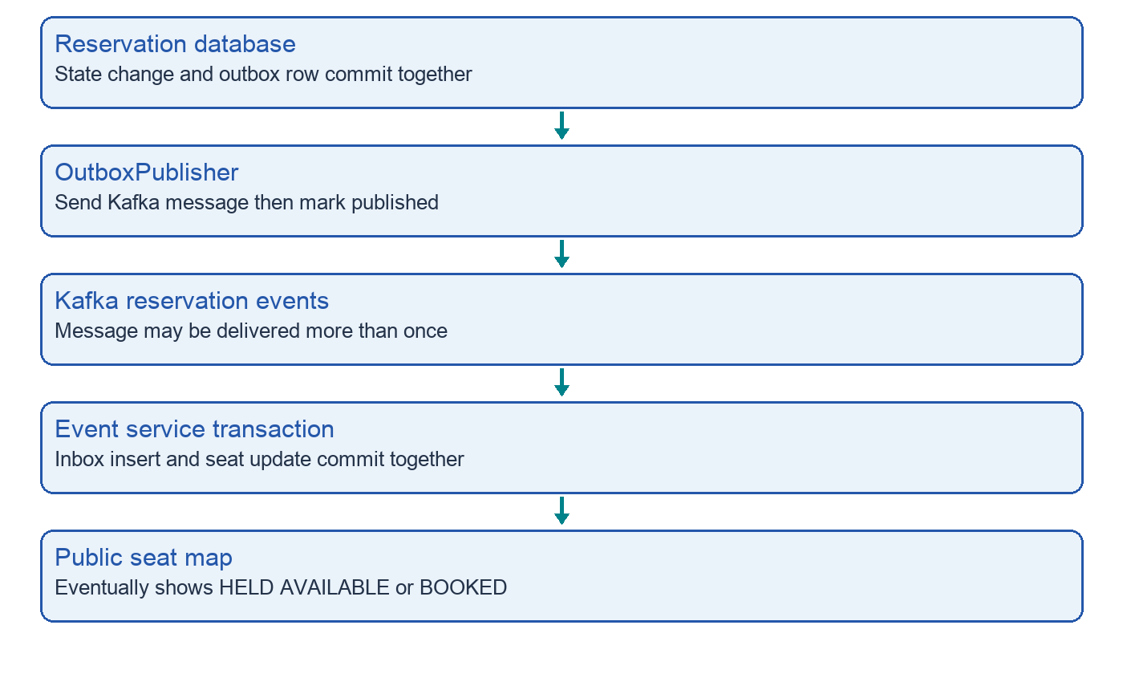
The outer eventId is a message ID. The eventId inside data is the concert ID. They have different jobs.
An outbox is a database table of messages that still need sending. Reservation commits the state change and the message intent together. This prevents a committed hold from having no durable event intent merely because Kafka was unavailable.
A publisher later sends each row to Kafka and marks it published. A crash between sending and marking can send the same message twice. Event-service inserts the message ID into event_inbox before changing the seat view, in the same database transaction. A duplicate insert returns zero and the consumer stops.
This is at-least-once delivery with deduplicated effects for the same message ID. It is not end-to-end exactly-once delivery. Deduplication also does not solve messages arriving in an incorrect order.

Failure stories you should be able to explain
Failure | Current response or recovery
Redis unavailable | New holds fail; no cache-only booking path
PostgreSQL unavailable | Writes fail; Redis cleanup or TTL removes temporary gate
Kafka unavailable | Reservation outbox retains messages; seat view can be stale
Poison Kafka record | Consumer retries, then sends to reservation-events.DLT
Payment takes four seconds | Booking HTTP read timeout is three seconds; outcome may become UNKNOWN
Booking crashes with PENDING | Worker checks payment after the configured grace
Refund endpoint unavailable | REFUND_PENDING remains and worker retries
Customer abandons checkout | Expiry worker releases ACTIVE expired holds

A worker is a background function that runs repeatedly. It does not rely on the customer keeping a browser open. In this code expiry scans every second, outbox publishing every half second, and booking recovery every two seconds by default.
There is an important uncertainty: a gRPC confirmation timeout can happen after reservation committed BOOKED. Booking currently treats any confirmation exception as a refund case. It does not first query the authoritative hold to distinguish a rejected confirmation from a lost success response. This is an improvement to discuss honestly.
Check yourself: How would you improve that window?
Answer: Use a recoverable confirmation state and query/retry an idempotent reservation command before deciding to refund. Test a lost response after reservation commit.

Why these technologies were chosen
Technology | Job here | Trade off
Java 21 and Spring Boot | Typed services, DI, validation, HTTP and scheduling | Framework lifecycle and configuration must be understood
PostgreSQL and JPA | Durable state and transactions; entities and repositories | Hot rows and one primary limit scaling
Redis Lua | Atomic contention gate | Dependency can reduce availability
Kafka and outbox | Decouple reservation changes from seat reads | Duplicates, ordering and lag need handling
gRPC and protobuf | Typed internal confirm/release commands | Generated build inputs and another network boundary
Flyway | Versioned database migrations | Migration history must remain consistent
Docker Compose | Repeatable local topology | Local settings are not deployment hardening
Prometheus and Actuator | Health and runtime metrics | Custom business alerts still require work

The five-service split is useful for learning data ownership and distributed failure handling. It adds operational cost: five programs, multiple ports, schema migrations, Kafka and Redis. A modular monolith would be simpler for an early commercial product. Explain the learning purpose instead of claiming that microservices are always better.

Security and product limits
The default gateway profile permits all requests. The prod profile validates JWTs for /api/** and requires JWT_ISSUER_URI. A JWT is a signed token carrying identity claims; resource-server validation checks a trusted issuer. The project does not implement login or issue tokens itself.
A customerId in a request is still supplied by the caller. Reservation compares that value with the hold owner, but does not bind it to the authenticated JWT subject. A caller who knows an owner ID may be able to impersonate that owner. The gateway also exposes the REST confirm endpoint, which checks no payment result.
Booking accepts the amount and currency from the client. It does not fetch the authoritative catalog price. The smoke script sends the catalog price, but a well-behaved script does not replace server-side price validation.
Internal application ports and payment REST are exposed in local Compose. gRPC uses plaintext. For public deployment, restrict internal network access, use TLS and secrets, bind identity to commands, restrict confirmation, and validate price before authorization. These are proposed changes, not current features.
There is no sales-window enforcement, multi-seat atomic checkout, durable release retry queue, seat-version-aware projection, or full recovery lock for competing booking workers. The program is a portfolio backend, not a complete commercial ticketing product.
Check yourself: What is the first hardening work?
Answer: Close identity, price and direct-confirmation gaps before adding more product features. Then test uncertain remote results and worker concurrency.

Scaling and operational signals
Start by measuring where time and work accumulate. A hot seat concentrates writes on one inventory row. Redis rejects many losing attempts before they reach that row, but PostgreSQL remains a shared correctness and capacity boundary. More application replicas alone do not remove a hot row.
Gateway replicas and catalog reads can scale independently. Reservation replicas share Redis and the authoritative database. Outbox publishers use SKIP LOCKED to divide rows, while booking recovery still needs a claim or conditional transition before competing workers can be described as safe under all races.
At larger scale, a proposed design is to assign event ownership to separate reservation shards using eventId. Keep a seat on one authority so the single-winner decision remains local. Sharding requires routing, rebalancing and migration work; none is implemented in this repository.
Signal | What it can reveal
Hold conflicts vs server errors | Demand contention versus broken infrastructure
Expired ACTIVE backlog | Expiry worker falling behind
Oldest unpublished outbox | Kafka or publisher interruption
Consumer lag and DLT records | Stale or broken seat view
Age of UNKNOWN and pending refunds | Unresolved payment and compensation
Database pool usage and latency | Saturation or long-held transactions

Actuator exposes health and Prometheus-format runtime metrics. The optional Prometheus container scrapes them. Business counters, backlog alerts and operating objectives described in docs are further work; do not claim the suggested alerts are already active.

What the verification actually proves
At repository commit 4a964d6, the Java 21 Maven test run on 12 October 2026 passed 12 tests: gateway context 1, reservation 3, booking store 3, booking worker 1, and payment 4. These tests are small and focused; most mock database and external dependencies.
Verification layer | What it checks | What it leaves open
Focused tests | Selected replay, gate rejection, confirmation, recovery dispatch, payment rules | Real database contention and network failures
Build workflow | Compilation, protobuf generation, test execution, five image builds | Running full booking integration
Smoke workflow | Happy path through five services, payment, gRPC, outbox, Kafka and seat view | Broad failure and concurrency coverage
k6 contention scenario | One-seat attempts and one successful hold threshold | Full-system capacity, fairness and every conflict reason

The existing runtime addendum records a successful hosted smoke and build at commit 22522f2 in August 2026. That is historical evidence for that commit. The current guide’s new local verification is the 12-test Maven run; it does not claim a new full-stack smoke or benchmark result.
The k6 script sets a p95 latency target of two seconds. A target is not an achieved number. Its unexpected_response Rate is updated only for unexpected responses, so a mixture of expected and unexpected requests is not measured with the intended denominator. Improve it by adding one boolean sample for every request.

Explain the project in an interview

A short opening answer
“SeatSync is a five-service ticket reservation backend. I use Redis to reject obvious contention quickly, but PostgreSQL decides the durable seat owner with a conditional update and uniqueness constraints. Checkout persists its progress, calls a payment simulator, and confirms reservation over gRPC. An outbox and Kafka update the separate seat-map view, and background workers handle expiry, unknown payment outcomes and refunds.”

When the interviewer asks why
“I chose the design to explore distributed correctness. The interesting part is deciding what can safely be retried after a timeout. Database transactions protect local changes; idempotency and compensation handle repeated calls and partial remote success.”

When the interviewer asks about limitations
“The happy path and several local behaviors are verified. The current code still needs identity binding, server-side pricing, restricted confirmation, versioned event ordering and better reconciliation of a lost confirmation response. I would not claim a production scale or real financial integration.”

Practice without memorizing
- Draw the five services and name the owner of each database.
- Explain why Redis key loss cannot turn BOOKED into AVAILABLE in the reservation database.
- Trace pm_timeout and identify what is known at each step.
- Explain how one message can be sent twice but update the view once.
- Name a remaining failure window and design a test that exposes it.

Check your understanding and plan your study
Check yourself: A seat view says AVAILABLE but hold returns 409. Is that necessarily a defect?
Answer: No. The view may lag or another customer may have won after the view was read. Reservation state is the authority.
Check yourself: Kafka is down. Must hold creation fail?
Answer: Kafka sending is separate from creation. A valid reservation can commit with its outbox row; the view catches up after publishing resumes.
Check yourself: An authorization response is lost. Should booking instantly record FAILED?
Answer: No. Record uncertainty and look up the provider result using the durable booking ID.
Check yourself: Why is a refund not a database rollback?
Answer: Payment and reservation commit in separate databases. Refund is a later compensating operation with its own possible failure.
Check yourself: Does an inbox establish ordering?
Answer: No. It detects repeated message IDs. Different messages for the same seat still need ordering or sequence checks.

Four reading sessions
Session 1: read this guide and redraw the architecture. Session 2: read the Code Journey Guide through hold creation, then explain each ownership boundary. Session 3: finish checkout and event delivery, and use the failure exercises. Session 4: consult the Code Reference, inspect methods in the repository, run available checks and rehearse follow-up answers aloud.
You are ready when you can predict outcomes for changed inputs, name the exact class that makes a decision, distinguish verified behavior from proposed work, and explain a failure without relying on a memorized paragraph.

