Secure Network Configuration
ELC-Activity
25-26 EVENSEM
SATYAM TIWARI
1024030088
https://github.com/tsaty01/ELC-Sem4-Secure-Network-Config

- Cipher Algorithms
  - Caesar Cipher
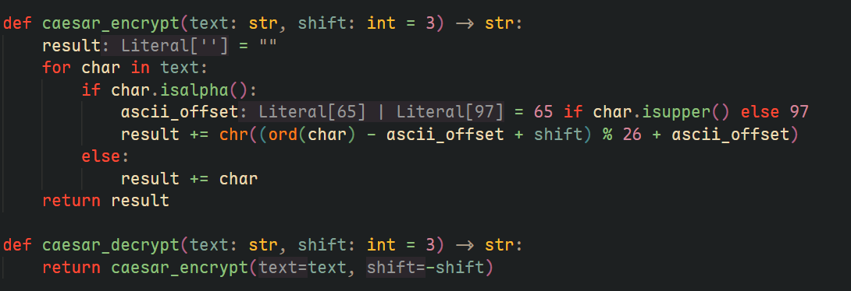
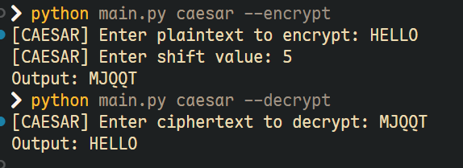

  - Playfair Cipher
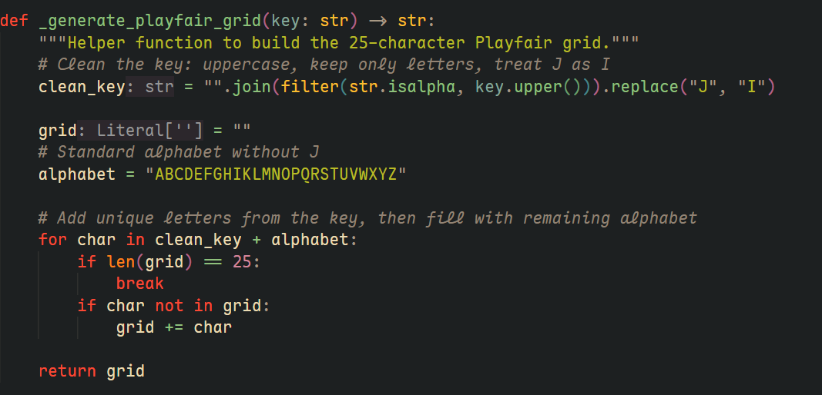
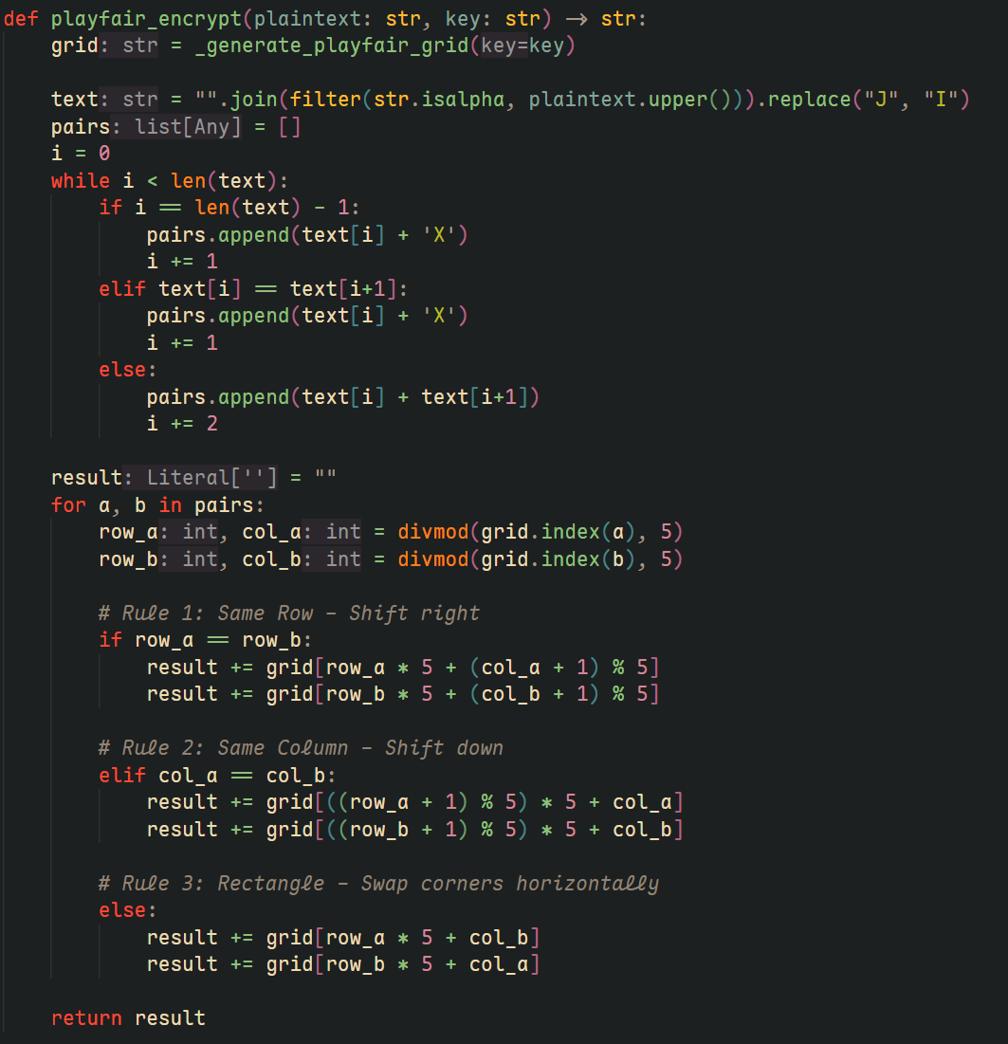
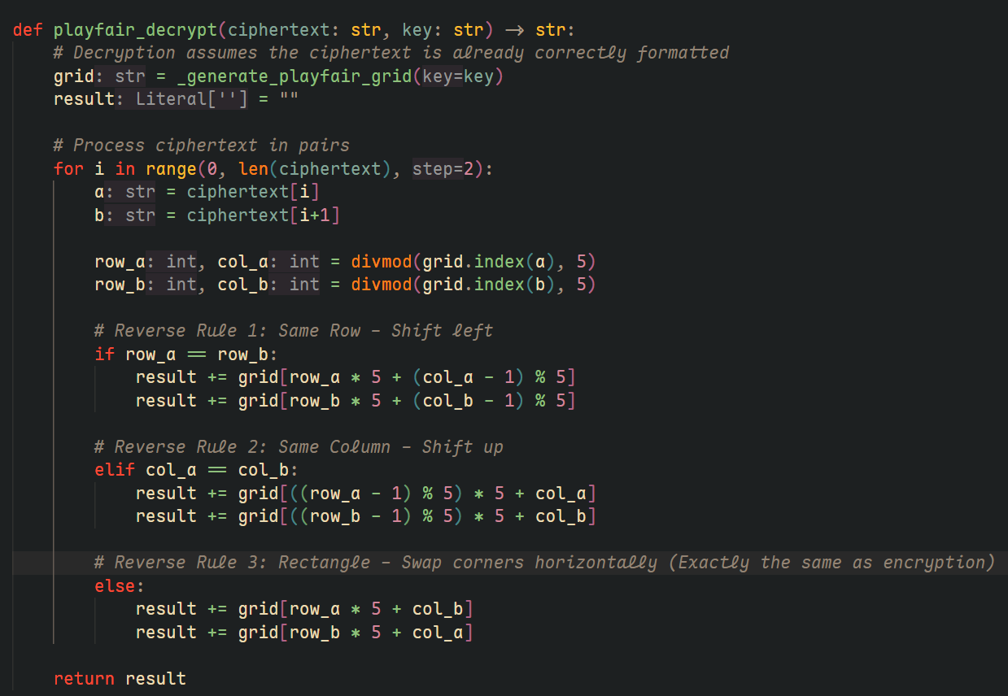
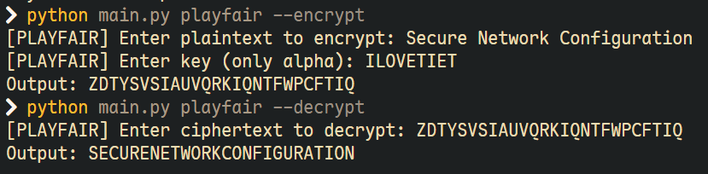

  - Hill Cipher
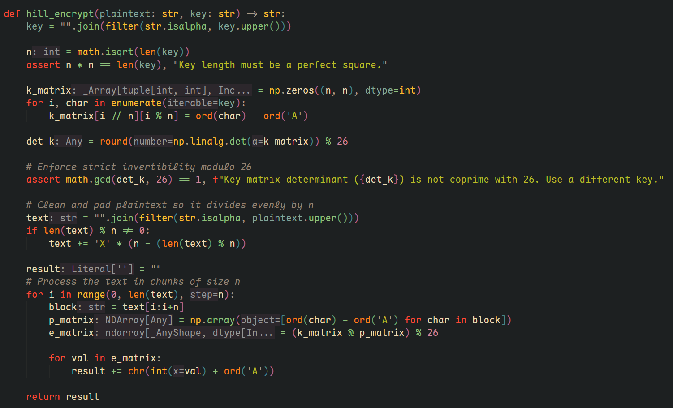
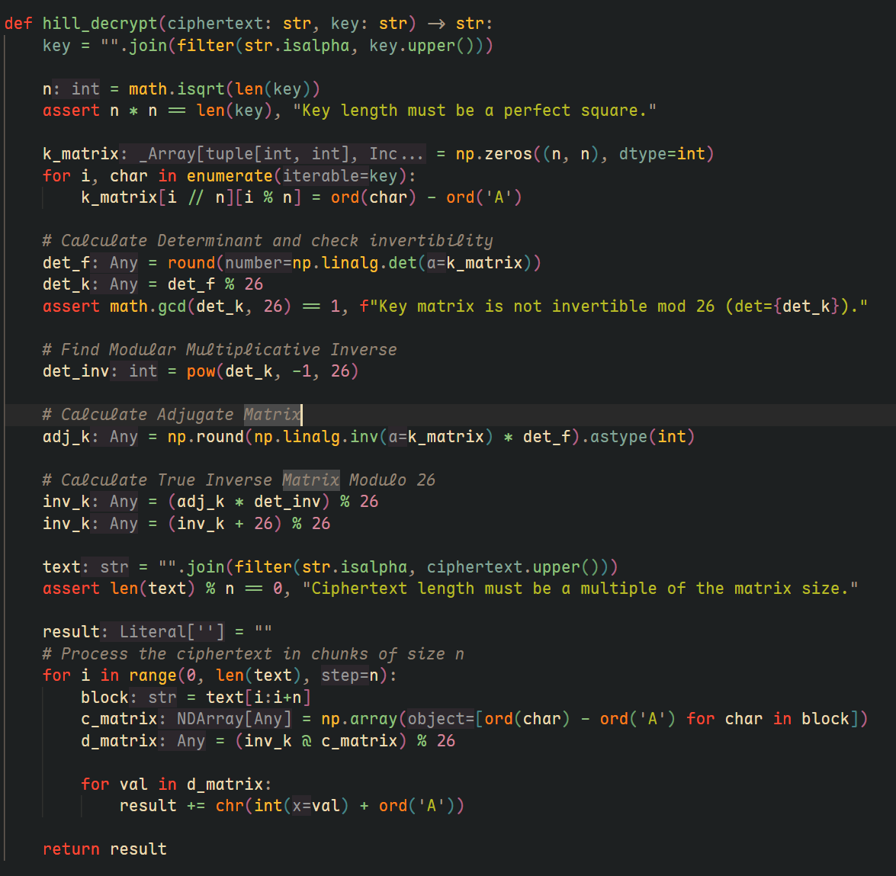
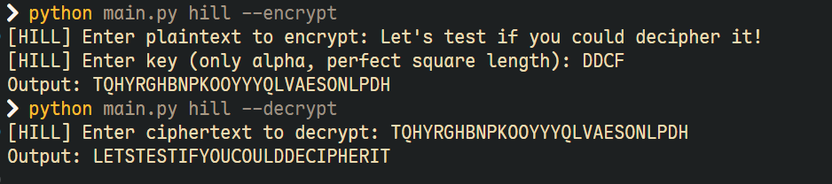

- Benchmarks
  - Encryption
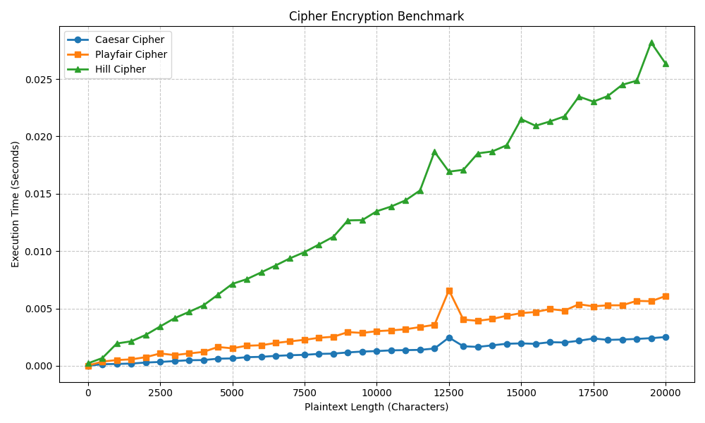
  - Decryption
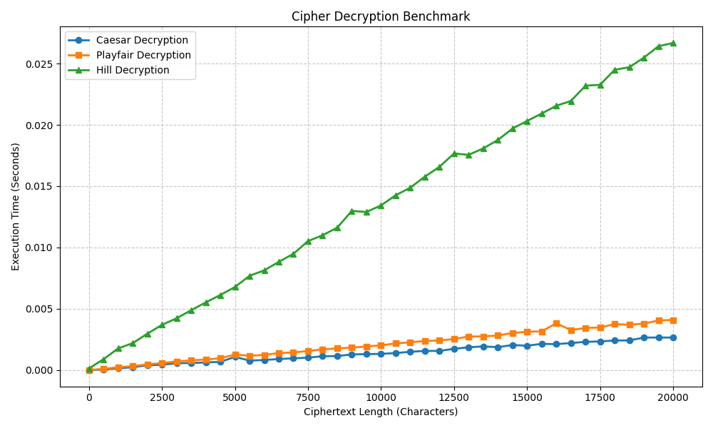

- What is your understanding of how these results reflect real-world use cases where encryption speed and security must be balanced?

- Caesar Cipher (Fastest, Least Secure):
- Trade-off: Maximizes speed and simplicity at the cost of essentially zero security.
- Real-World Use Case: Basic obfuscation rather than true encryption. Its modern equivalent (like ROT13) is used in environments where processing overhead must be zero and the threat level is non-existent such as hiding internet spoilers or simple puzzle answers.
2. Playfair Cipher (Moderate Speed, Moderate Security):
- Trade-off: Sacrifices some speed by encrypting pairs of letters (digraphs) to disrupt basic frequency analysis, offering "good enough" short-term security.
- Real-World Use Case: Tactical field communication. It was historically used by the military because it was quick enough for manual encryption under pressure, yet secure enough that the information would be outdated and useless by the time the enemy cracked it.

3. Hill Cipher (Slowest, Most Secure):
- Trade-off: Requires higher computational overhead (matrix mathematics) in exchange for significantly better security (polygraphic substitution that thoroughly scatters language patterns).
- Real-World Use Case: Foreshadows modern block ciphers. It reflects environments where dedicated hardware or automated computing is available to handle complex math, prioritizing absolute data confidentiality over instant, manual processing.

