SYNOPSIS

ON

“WATER PURITY ANALYZER”

Submitted in

Partial Fulfillment of requirements for the Award of Degree

*of*

Bachelor of Technology

*In*

Computer Science and Engineering

By

**(Project Id: 09)**

# ISMITA SINGH (2001640100138)

# AGRIMA SRIVASTAVA (2001641540009)

# ANUSHKA GUPTA (2001640100060)

# ARUSHI SRIVASTAVA (2001640100071)

Under the supervision of

**Supervisor Name**

**(Designation)**

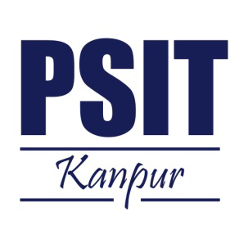

**Pranveer Singh Institute of Technology**.

 Kanpur - Agra - Delhi National Highway - 19

Bhauti -Kanpur - 209305.

(Dr. A.P.J. Abdul Kalam Technical University)

1. Introduction

Water is an essential resource for sustaining life, and access to clean and safe water is a fundamental right. However, water pollution has become a pressing global concern, with contaminants and impurities posing significant risks to both human health and the environment. Traditional water purification methods have limitations in terms of efficiency, cost, and adaptability to emerging contaminants. Machine learning, a branch of artificial intelligence, holds tremendous potential in revolutionizing water purification systems by enabling advanced monitoring, prediction, and optimization techniques.

In recent years, machine learning algorithms have gained popularity due to their ability to analyze large datasets and identify complex patterns and correlations. By leveraging this technology, water purification systems can be enhanced to ensure optimal performance and reliable water quality. Machine learning algorithms can process vast amounts of data from various sources, including sensor readings, historical records, and environmental factors, to make accurate predictions and informed decisions regarding water treatment processes.

One of the key applications of machine learning in water purification is contaminant detection and monitoring. These algorithms can analyze real-time sensor data and identify the presence of contaminants, including emerging pollutants that may not be detectable using traditional methods. By continuously monitoring water quality parameters, machine learning models can provide early detection of potential threats and enable prompt action to ensure the safety of the water supply.

Another important aspect of machine learning in water purification is treatment optimization. By analyzing historical data and learning from patterns, machine learning models can optimize operational parameters such as chemical dosing, filtration rates, and energy consumption. This optimization leads to improved purification efficiency, reduced costs, and enhanced overall system performance.

Machine learning also plays a crucial role in predictive maintenance of water purification systems. By analyzing sensor data and historical maintenance records, machine learning algorithms can identify patterns indicative of equipment failures or malfunctions. This enables proactive maintenance, reducing downtime and ensuring continuous and uninterrupted water purification operations.

However, implementing machine learning in water purification systems does come with challenges. Access to reliable and accurate data, addressing data scarcity in certain regions, and ensuring the transparency and interpretability of machine learning models are some of the hurdles that need to be overcome. Ethical considerations, such as fairness, privacy, and security, should also be taken into account to build trust among stakeholders.

In conclusion, machine learning holds immense potential for revolutionizing water purification systems.

**2. Project Objective**

The objectives to achieve by the end of a water purification system project using machine learning can vary depending on the specific goals and requirements of the project. However, here are some common objectives that such a project may aim to accomplish:

1. Enhance Water Quality: The primary objective of a water purification system project is to improve the quality of water by effectively removing contaminants, impurities, and pathogens. Machine learning algorithms can help identify and monitor contaminants, enabling more efficient and accurate purification processes.
2. Increase Efficiency: Machine learning can optimize various aspects of water purification systems, including treatment processes, resource allocation, and energy consumption. The objective is to maximize efficiency by reducing waste, minimizing operational costs, and improving overall system performance.
3. Predictive Maintenance: An important objective is to implement predictive maintenance strategies using machine learning algorithms. By analyzing sensor data and historical records, the system can predict equipment failures or maintenance needs in advance. This proactive approach helps minimize downtime, reduce maintenance costs, and ensure uninterrupted water purification operations.
4. Real-time Monitoring: Machine learning algorithms can provide real-time monitoring of water quality parameters, detecting anomalies and deviations from acceptable levels. This objective ensures early detection of potential issues, allowing for prompt action and preventing the distribution of contaminated water.
5. Adaptability to Emerging Contaminants: Another objective is to develop a water purification system that can adapt to the presence of emerging contaminants. Machine learning algorithms can analyze data and learn patterns to identify new contaminants, ensuring the system remains effective and up-to-date in addressing evolving water quality challenges.
6. Optimization of Treatment Processes: Machine learning models can optimize water treatment processes by adjusting operational parameters based on real-time data. The objective is to achieve the highest level of purification efficiency while minimizing the use of chemicals, energy, and other resources.
7. Data-driven Decision Making: By utilizing machine learning algorithms, the objective is to enable data-driven decision making in water purification systems. This includes leveraging historical data, sensor readings, and environmental factors to make informed decisions regarding treatment processes, maintenance schedules, and resource allocation.
8. Scalability and Integration: The objective is to develop a water purification system that is scalable and can be integrated into existing infrastructure. Machine learning algorithms should be designed to handle large volumes of data and be compatible with different types of sensors and purification technologies.
9. Regulatory Compliance: Compliance with water quality standards and regulations is a crucial objective. Machine learning can assist in monitoring and ensuring adherence to these standards, providing accurate and timely reporting on water quality parameters.

By achieving these objectives, a water purification system project using machine learning can significantly improve the efficiency, reliability, and safety of the water .

**3.Literature Survey**

This will describe the previous work which is done by the various authors/developers related to the project and already running project at any location.

4. Feasibility Study: Top of Form

Access to safe and clean drinking water is a fundamental human right that is essential for human health, environmental sustainability, and economic development. However, despite efforts to improve water quality worldwide, access to safe and clean drinking water remains a significant challenge in many parts of the world. According to the World Health Organization, an estimated 2.2 billion people lack access to safe drinking water, and around 829,000 people die each year from diseases related to unsafe water, sanitation, and hygiene.

One of the major challenges in providing access to clean drinking water is the purification process. Traditional water purification methods often require large quantities of chemicals, energy, and water, making them costly and environmentally damaging. There is a need for more efficient, cost-effective, and sustainable water purification methods that can improve the availability and quality of drinking water worldwide.

A water purification analyzer machine learning project has significant potential to address these challenges by predicting the most effective purification methods based on water content data. Machine learning algorithms are well-suited for analyzing water quality data because they can identify patterns and predict outcomes based on the available data. This can help optimize the purification process, reduce costs, and improve efficiency.

One of the main advantages of a water purification analyzer machine learning project is that it can analyze vast amounts of data from multiple sources. For example, data from water quality sensors, weather data, and demographic information can be combined to predict the most effective purification methods based on water content data. Machine learning algorithms can also be trained to detect anomalies in water quality data, which can help identify potential health risks and prevent waterborne diseases.

Moreover, the results of a water purification analyzer machine learning project can be used to develop more sustainable and efficient water treatment technologies. By identifying the most effective purification methods, researchers and engineers can develop new technologies that can improve the availability and quality of drinking water worldwide. This can have a significant impact on public health, environmental sustainability, and economic development, particularly in developing countries where access to clean drinking water is limited.

In conclusion, a water purification analyzer machine learning project is an important step towards addressing the challenge of providing safe and clean drinking water to people worldwide. By predicting the most effective purification methods based on water content data, this project can help optimize the purification process, reduce costs, and improve efficiency. Furthermore, this project can contribute to the development of sustainable and efficient water treatment technologies, which are essential for addressing the growing demand for clean water worldwide. Ultimately, the success of this project can have a significant impact on human health, environmental sustainability, and economic development.

Bottom of Form

Bottom of Form

(Should not exceed 2 page)

5. Methodology/ Planning of work

Methodology and Planning of a Water Purification System Using Machine Learning:

1. Problem Identification: Identify the specific challenges and goals of the water purification system project. Determine the contaminants to be addressed, the desired water quality parameters, and any specific constraints or requirements.
2. Data Collection and Preparation: Gather relevant data such as historical water quality records, sensor readings, and environmental factors. Ensure the data is accurate, reliable, and representative of the target water sources. Preprocess the data by cleaning, filtering, and normalizing it for further analysis.
3. Feature Selection: Identify the key features or variables that have a significant impact on water quality. Conduct a feature selection process to determine the most relevant features for the machine learning models. This step helps reduce dimensionality and improve model performance.
4. Algorithm Selection: Select appropriate machine learning algorithms based on the project objectives and available data. Commonly used algorithms in water purification systems include decision trees, support vector machines, random forests, artificial neural networks, and deep learning models. Consider the strengths and weaknesses of each algorithm and their compatibility with the project requirements.
5. Model Development: Train the selected machine learning models using the prepared data. Split the dataset into training and testing sets to evaluate the model's performance. Fine-tune the models by adjusting hyperparameters and optimizing model architecture to achieve the best results.
6. Validation and Evaluation: Validate the trained models using separate validation datasets or cross-validation techniques. Evaluate the models' performance metrics such as accuracy, precision, recall, and F1 score. Compare and analyze the results to select the most accurate and robust model.
7. System Integration: Integrate the developed machine learning models into the water purification system infrastructure. This may involve integrating the models with real-time sensor data, data acquisition systems, and control mechanisms. Ensure compatibility and seamless communication between the models and the purification system components.
8. Testing and Optimization: Conduct extensive testing of the integrated system to ensure its functionality, accuracy, and reliability. Identify any issues or discrepancies and optimize the system's performance by making necessary adjustments to the models, data sources, or operational parameters.
9. Deployment and Maintenance: Deploy the water purification system with integrated machine learning capabilities. Continuously monitor the system's performance and gather feedback to address any operational challenges or improvements. Implement regular maintenance protocols to ensure the reliability and longevity of the system.
10. Continuous Improvement: Regularly assess and update the machine learning models and system components based on new data, emerging contaminants, or changes in water quality regulations. Stay updated with the latest advancements in machine learning and water purification technologies to incorporate improvements and refinements into the system.
11. Throughout the methodology and planning process, it is essential to collaborate with domain experts, stakeholders, and water management professionals to ensure the alignment of project objectives with practical requirements and industry standards.

* When you are applying machine learning to your own datasets, you are working on a project. A machine learning project may not be linear, but it has a few well-known steps:

1. Define Problem
2. Prepare Data
3. Evaluate Algorithms
4. Improve Results
5. Present Results

* The best way to really come to terms with a new platform or tool is to work through a machine learning project end-to-end and cover the key steps. Namely, from loading data, summarizing data, evaluating algorithms and making some predictions.
* Here is an overview of what we are going to cover:

1. Installing the Python anaconda platform
2. Loading the dataset
3. Summarizing the dataset
4. Visualizing the dataset
5. Evaluating some algorithms
6. Making some predictions

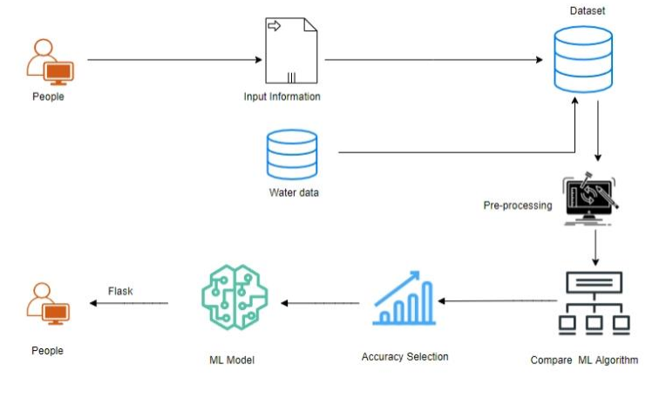

Fig: System Architecture

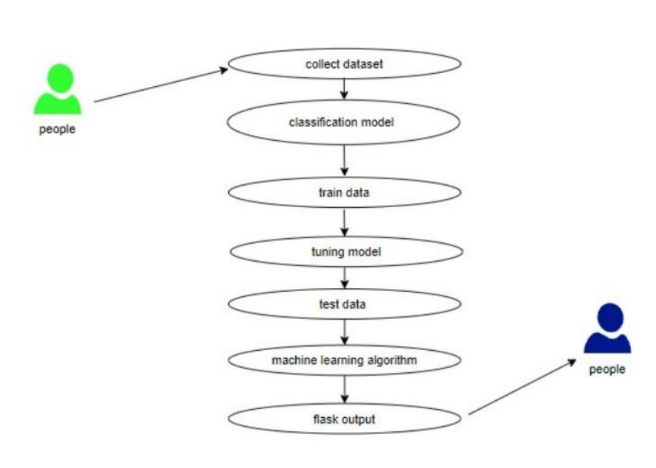

Fig: Use Case Diagram

* Use case diagrams are considered for high level requirement analysis of a system. So, when the requirements of a system are analyzed, the functionalities are captured in use cases. So, it can say that uses cases are nothing but the system functionalities written in an organized manner.

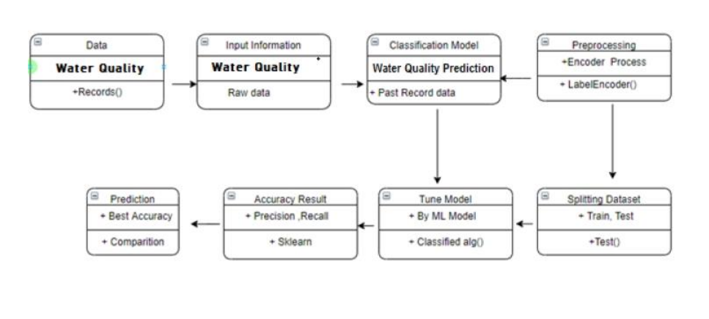

Fig: Class Diagram

* Class diagram is basically a graphical representation of the static view of the system and represents different aspects of the application. So, a collection of class diagrams represents the whole system.
* The name of the class diagram should be meaningful to describe the aspect of the system.
* Each element and their relationships should be identified in advance Responsibility (attributes and methods) of each class should be clearly identified for each class minimum number of properties should be specified and because, unnecessary properties will make the diagram complicated.

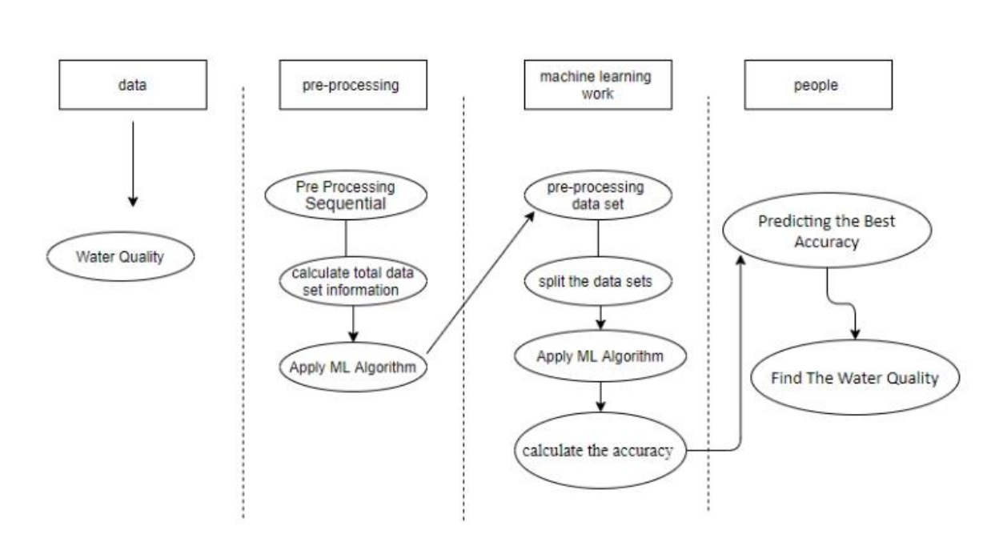

Fig: Activity Diagram

* Activity is a particular operation of the system. Activity diagrams are not only used for visualizing dynamic nature of a system but they are also used to construct the executable system by using forward and reverse engineering techniques.
* The only missing thing in activity diagram is the message part. It does not show any message flow from one activity to another.
* Activity diagram is some time considered as the flow chart. Although the diagrams look like a flow chart but it is not. It shows different flow like parallel, branched, concurrent and single.

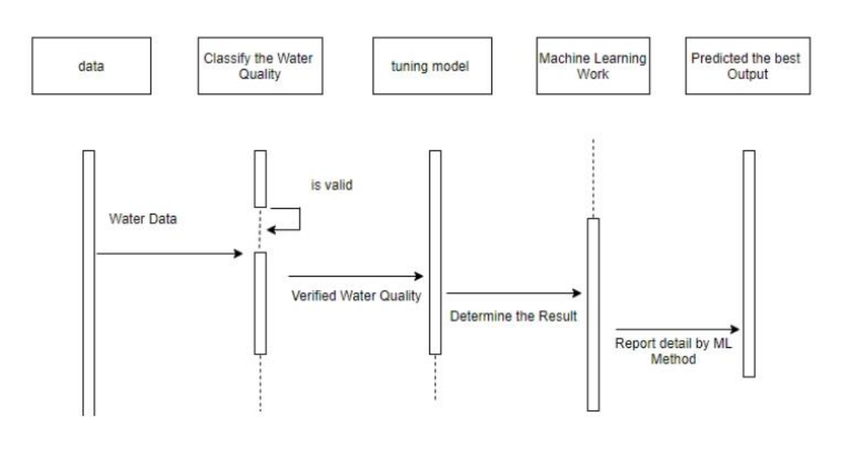

Fig: Sequence Diagram

* Sequence diagrams model the flow of logic within your system in a visual manner, enabling you both to document and validate your logic, and are commonly used for both analysis and design purposes.
* Sequence diagrams are the most popular UML artifact for dynamic modeling, which focuses on identifying the behavior within your system.

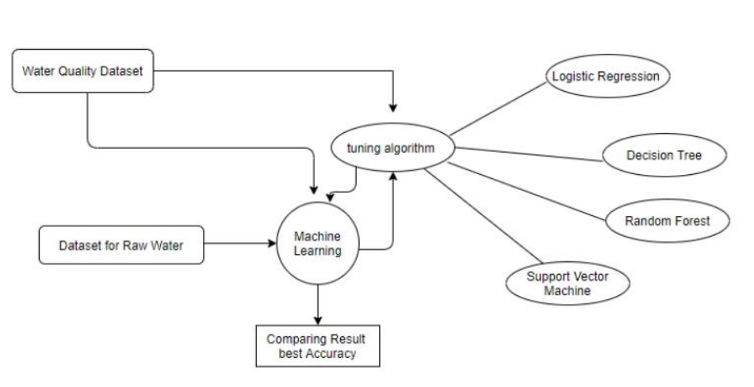

Fig: ER- diagram

* An entity relationship diagram (ERD), also known as an entity relationship model, is a graphical representation of an information system that depicts the relationships among people, objects, places, concepts, or events within that system.
* An ERD is a data modeling technique that can help define business processes and be used as the foundation for a relational database.
* Entity relationship diagrams provide a visual starting point for database design that can also be used to help determine information system requirements throughout an organization.
* After a relational database is rolled out, an ERD can still serve as a referral point, should any debugging or business process reengineering be needed later.

6. Tools/Technology Used:

6.1 Hardware Requirements

* 1.A powerful multi-core CPU such as Intel Core i7 or higher, or equivalent AMD Ryzen processor
* 2.A dedicated graphics processing unit (GPU) such as NVIDIA RTX 3090 or A100, for faster training of deep learning models
* 3.A minimum of 16 GB of RAM, preferably 32 GB or more for larger datasets
* 4.A solid-state drive (SSD) with at least 1 TB of storage for storing large datasets
* 5.A high-quality display monitor for data visualization
* 6.A high-speed internet connection for data acquisition
* 7.A power backup system to ensure uninterrupted operation.

6.2 Software Requirements

* 1.Python 3.x programming language
* 2.Machine learning libraries such as scikit-learn, TensorFlow, PyTorch, and Keras
* 3.Data preprocessing libraries such as Pandas and NumPy
* 4.Jupyter Notebook for interactive data analysis and sharing
* 5.Visualization libraries such as Matplotlib, Seaborn, and Plotly
* 6.Version control tools such as Git for code management
* 7.Integrated development environment (IDE) such as PyCharm or VS Code for code development and debugging

7. References [IEEE format]:

Here specifies the description of the study material(Research Papers/other references) referred for the development project.

**Guidelines:**

**Last Date of Submission: 08-May-2023**

1) Heading Font Size: 14

2) Content Font Size: 12

3) Font Name: Times New Roman

4) Line Spacing: 1.5”

5) Alignment: Left & Right both Justified

6) Margin: Normal (Top=2.54 cm, Bottom=2.54 cm, Left=2.54 cm, Right=2.54 cm)

7) Page No: At Bottom Right Side

Note: Consider this format for your reference.