Pizza Sales Analytics Dashboard
Using
SQL Server and Power BI

Created by-
AGRITA VATISH

Problem Statement
A pizza restaurant generates thousands of transactions throughout the year, making it difficult to manually track sales performance, customer purchasing patterns, and product profitability. The business requires a centralized analytics solution to monitor key performance indicators (KPIs), identify sales trends, evaluate product performance, and support data-driven decision-making.
This project aims to analyse pizza sales data using SQL Server and Power BI to provide meaningful insights into revenue generation, customer ordering behaviour, and overall business performance through interactive dashboards and visualizations.

KPI Requirements
To evaluate business performance, the following Key Performance Indicators (KPIs) were calculated:
1. Total Revenue
The total income generated from all pizza sales, calculated as the sum of the total price of all orders.
Formula:
Total Revenue = SUM(Total Price)
2. Average Order Value
The average amount spent by customers per order, calculated by dividing total revenue by the total number of orders.
Formula:
Average Order Value = Total Revenue / Total Orders
3. Total Pizzas Sold
The total number of pizzas sold during the selected period, calculated as the sum of quantities ordered.
Formula:
Total Pizzas Sold = SUM(Quantity)
4. Total Orders
The total number of unique customer orders placed during the selected period.
Formula:
Total Orders = COUNT(DISTINCT Order ID)
5. Average Pizzas per Order
The average number of pizzas purchased in each order, calculated by dividing the total pizzas sold by the total number of orders.
Formula:
Average Pizzas per Order = Total Pizzas Sold / Total Orders

Project Objective
The primary objective of this project is to leverage SQL Server and Power BI to analyze pizza sales data, monitor business KPIs, identify sales trends, evaluate product performance, and generate actionable insights that can help improve revenue, optimize inventory planning, and enhance overall business decision-making.

Chart Requirements
To visualize pizza sales performance and generate actionable business insights, the following charts were designed and implemented in Power BI:
1. Daily Trend for Total Orders
Chart Type: Bar Chart
Objective: Analyse the number of orders placed on each day of the week to identify peak business days and customer purchasing patterns.
Insight: Helps determine the busiest days for staffing, inventory planning, and promotional activities.

2. Monthly Trend for Total Orders
Chart Type: Line Chart
Objective: Track order volume across different months to identify seasonal trends and monthly sales performance.
Insight: Helps management understand demand fluctuations and plan marketing campaigns accordingly.

3. Percentage of Sales by Pizza Category
Chart Type: Donut Chart
Objective: Display the contribution of each pizza category (Classic, Supreme, Chicken, Veggie) to total revenue.
Insight: Identifies the categories generating the highest revenue and customer preference patterns.

4. Percentage of Sales by Pizza Size
Chart Type: Pie Chart
Objective: Analyze revenue contribution by pizza size (Small, Medium, Large, XL, XXL).
Insight: Helps understand customer size preferences and optimize inventory management.

5. Total Pizzas Sold by Pizza Category
Chart Type: Funnel Chart
Objective: Compare the total quantity sold across different pizza categories.
Insight: Highlights the most popular categories and supports demand forecasting.

6. Top 5 Best-Selling Pizzas
Chart Type: Bar Chart
Objective: Identify the top-performing pizzas based on:
- Revenue Generated
- Quantity Sold
- Total Orders
Insight: Helps management focus on high-performing products, improve marketing strategies, and maximize profitability.

7. Bottom 5 Worst-Selling Pizzas
Chart Type: Bar Chart
Objective: Identify the lowest-performing pizzas based on:
- Revenue Generated
- Quantity Sold
- Total Orders
Insight: Helps identify products that may require recipe improvements, promotional campaigns, or menu optimization.

Dashboard Objective
The dashboard combines KPI metrics, sales trends, category performance, and product-level analysis into an interactive business intelligence solution. It enables stakeholders to monitor sales performance, identify growth opportunities, optimize inventory planning, and make data-driven business decisions through real-time visual insights.

Abstract

In today's highly competitive food and restaurant industry, data-driven decision-making plays a crucial role in improving operational efficiency, enhancing customer satisfaction, and maximizing profitability. This project focuses on analyzing pizza sales data using Microsoft SQL Server and Power BI to uncover meaningful business insights and support strategic decision-making.

The primary objective of this project was to transform raw transactional sales data into an interactive and visually appealing business intelligence dashboard. SQL Server was used to perform data extraction, aggregation, and KPI calculations, while Power BI was utilized for data modelling, visualization, and dashboard development. Various key performance indicators (KPIs) such as Total Revenue, Average Order Value, Total Pizzas Sold, Total Orders, and Average Pizzas per Order were calculated to evaluate overall business performance.

The analysis further explored daily and monthly sales trends, revenue contribution by pizza category and size, customer ordering behaviour, and product-level performance. Interactive visualizations were developed to identify top-performing and underperforming pizzas based on revenue, quantity sold, and total orders. These insights provide valuable information for inventory planning, product optimization, marketing strategies, and resource allocation.

The dashboard enables stakeholders to monitor business performance in real time through dynamic filters and interactive reports. Key findings revealed peak sales periods, customer preferences for specific pizza categories and sizes, and products contributing the highest and lowest revenue. By leveraging SQL-based analytics and Power BI visualizations, this project demonstrates how business intelligence tools can convert large volumes of sales data into actionable insights that drive informed decision-making and improve overall business performance.

Objectives

The primary objective of this project is to analyze pizza sales data using SQL Server and Power BI to gain valuable insights into business performance and customer purchasing behavior. The project aims to transform raw transactional data into meaningful information through data analysis, visualization, and interactive dashboards.

The specific objectives of the project are:

To calculate and monitor key business KPIs such as Total Revenue, Average Order Value, Total Orders, Total Pizzas Sold, and Average Pizzas per Order.

To analyze daily and monthly sales trends in order to identify peak sales periods and customer ordering patterns.

To evaluate the revenue contribution of different pizza categories and pizza sizes to understand customer preferences and profitability.

To identify the top-performing and bottom-performing pizzas based on revenue, quantity sold, and total orders.

To develop an interactive Power BI dashboard that enables real-time exploration of sales data through dynamic visualizations and filters.

To support data-driven decision-making by providing actionable insights for inventory management, product optimization, marketing strategies, and operational planning.

To demonstrate the practical application of SQL Server for data analysis and Power BI for business intelligence and data visualization.

Tools & Technologies

SQL Server Management Studio (SSMS)
SQL Server Management Studio was used for data storage, querying, and analysis. SQL queries were written to calculate key performance indicators (KPIs), perform trend analysis, identify top and bottom-performing products, and extract meaningful insights from the pizza sales dataset.

Power BI
Power BI was used to create interactive dashboards and visual reports. It enabled the visualization of sales trends, revenue distribution, product performance, and business KPIs through dynamic charts and filters.

DAX (Data Analysis Expressions)
DAX was used to create custom measures and calculations within Power BI, including revenue metrics, order analysis, and performance indicators that enhanced dashboard functionality and analytical capabilities.

Power Query
Power Query was utilized for data cleaning, transformation, and preparation. It helped in handling missing values, formatting data, and ensuring data consistency before loading it into the Power BI data model.

Data Modeling
Data modeling techniques were applied to establish relationships between tables, optimize data structures, and improve the overall performance and accuracy of the dashboard.

SQL Aggregation Functions
Aggregation functions such as SUM(), COUNT(), COUNT(DISTINCT), AVG(), GROUP BY, and ORDER BY were used to summarize large volumes of sales data and generate meaningful business metrics.

Data Visualization
Various visualization techniques including KPI Cards, Bar Charts, Line Charts, Pie Charts, Donut Charts, and Funnel Charts were used to present insights in a clear, interactive, and business-friendly manner.

Dataset Overview

Dataset Description
The dataset used in this project contains transactional sales records from a pizza restaurant. It includes detailed information about customer orders, product categories, pricing, quantities sold, and order timestamps. The dataset was analyzed using SQL Server and Power BI to evaluate business performance and generate actionable insights.
Dataset Statistics
- Total Records: 48,620
- Total Columns: 12
- Dataset Type: Structured Transactional Sales Data
Dataset Features
Column Name | Description
pizza_id | Unique identifier for each pizza sold
order_id | Unique identifier for each customer order
pizza_name_id | Unique code assigned to each pizza type
quantity | Number of pizzas ordered
order_date | Date on which the order was placed
order_time | Time at which the order was placed
unit_price | Price of a single pizza unit
total_price | Total amount generated from the order item
pizza_size | Size of pizza (S, M, L, XL, XXL)
pizza_category | Category of pizza (Classic, Chicken, Supreme, Veggie)
pizza_ingredients | Ingredients used in each pizza
pizza_name | Name of the pizza product
Data Analysis Scope
The dataset was utilized to:
- Calculate key performance indicators (KPIs) such as Total Revenue, Total Orders, Total Pizzas Sold, Average Order Value, and Average Pizzas per Order.
- Analyze daily and monthly sales trends.
- Evaluate revenue contribution by pizza category and pizza size.
- Identify top-performing and bottom-performing pizzas based on revenue, quantity sold, and order volume.
- Generate business insights to support decision-making and operational planning.
Data Quality
The dataset was found to be structured and suitable for analysis. Data preparation activities included validating data types, checking for inconsistencies, and transforming fields for efficient reporting and visualization in Power BI.

Methodology

The project followed a structured data analytics approach to transform raw pizza sales transactions into meaningful business insights. The methodology consisted of the following phases:
1. Data Collection and Understanding
The pizza sales dataset was obtained in CSV format and contained transactional information such as order details, pizza categories, sizes, quantities sold, pricing, and order timestamps. The dataset was examined to understand its structure, attributes, and business relevance.
2. Data Cleaning and Preparation
The dataset was imported into SQL Server Management Studio (SSMS) for validation and preprocessing. Data quality checks were performed to ensure consistency, correct data types, and completeness. Relevant fields were prepared for analysis and reporting.
3. KPI Calculation Using SQL
SQL queries were developed to calculate key business metrics, including:
- Total Revenue
- Average Order Value
- Total Orders
- Total Pizzas Sold
- Average Pizzas per Order
Aggregation functions such as SUM(), COUNT(), COUNT(DISTINCT), GROUP BY, and CAST() were used to generate accurate business metrics.
4. Trend and Performance Analysis
Further SQL analysis was conducted to evaluate:
- Daily order trends
- Monthly order trends
- Sales contribution by pizza category
- Sales contribution by pizza size
- Top and bottom-performing pizzas based on revenue, quantity sold, and total orders
This analysis helped identify customer purchasing patterns and product performance.
5. Data Visualization and Dashboard Development
The processed data was imported into Power BI. Power Query was used for data transformation, while DAX measures were created to enhance analytical capabilities. Interactive dashboards were developed using KPI cards, bar charts, line charts, pie charts, donut charts, and funnel charts.
6. Business Insight Generation
The final dashboard was used to extract actionable insights regarding revenue trends, customer preferences, product profitability, and sales performance. These insights support strategic decision-making in areas such as inventory management, product optimization, marketing initiatives, and operational planning.

SQL Analysis

SQL Server Management Studio (SSMS) was used to perform comprehensive analysis of the pizza sales dataset and extract meaningful business insights. A series of SQL queries were developed to calculate key performance indicators (KPIs), analyze sales trends, and evaluate product performance.
KPI Analysis
SQL aggregation functions were used to calculate essential business metrics, including:
- Total Revenue – Total income generated from all pizza sales.
- Average Order Value – Average amount spent per customer order.
- Total Orders – Total number of unique orders placed.
- Total Pizzas Sold – Total quantity of pizzas sold.
- Average Pizzas per Order – Average number of pizzas purchased in each order.
Sales Trend Analysis
To understand customer purchasing behavior and sales patterns, SQL queries were used to analyze:
- Daily Order Trends to identify the busiest days of the week.
- Monthly Order Trends to evaluate seasonal demand and monthly sales performance.
Category and Size Performance Analysis
The contribution of different pizza categories and sizes to overall revenue was analyzed by calculating:
- Percentage of Sales by Pizza Category.
- Percentage of Sales by Pizza Size.
- Total Pizzas Sold by Category.
This analysis helped identify customer preferences and the most profitable product segments.
Product Performance Analysis
Further SQL queries were developed to identify:
- Top 5 Best-Selling Pizzas by Revenue.
- Top 5 Best-Selling Pizzas by Quantity Sold.
- Top 5 Best-Selling Pizzas by Total Orders.
- Bottom 5 Pizzas by Revenue.
- Bottom 5 Pizzas by Quantity Sold.
- Bottom 5 Pizzas by Total Orders.
These analyses provided valuable insights into product profitability, customer demand, and menu performance.
SQL Functions Used
The analysis extensively utilized SQL functions and clauses such as:
- SUM()
- COUNT()
- COUNT(DISTINCT)
- CAST()
- DATENAME()
- GROUP BY
- ORDER BY
- WHERE
The SQL analysis formed the foundation of the project by transforming raw transactional data into structured business metrics that were later visualized using Power BI dashboards for effective decision-making.

Key Findings

The analysis of pizza sales data revealed several important insights regarding business performance, customer preferences, and product profitability.
- The business generated a total revenue of approximately $817,860, indicating strong overall sales performance during the analyzed period.
- Friday recorded the highest number of customer orders, highlighting increased demand towards the weekend and indicating the need for optimized staffing and inventory planning.
- Large-sized pizzas contributed the highest share of total revenue, making them the most preferred and profitable pizza size among customers.
- The Classic pizza category generated the highest sales contribution, demonstrating strong customer preference for traditional pizza offerings.
- The Thai Chicken Pizza emerged as the highest revenue-generating product, making it one of the most valuable menu items in terms of profitability.
- The Classic Deluxe Pizza recorded the highest quantity sold and total orders, indicating strong customer demand and popularity.
- The Brie Carre Pizza consistently ranked among the lowest-performing products across revenue, quantity sold, and total orders, suggesting opportunities for menu optimization or targeted promotional campaigns.
- Monthly trend analysis revealed fluctuations in customer demand, helping identify peak sales periods and seasonal purchasing patterns.
- Category and size-based analysis provided valuable insights into customer preferences, enabling more effective inventory management and product planning.
- The dashboard successfully transformed raw sales transactions into actionable business insights, supporting data-driven decision-making and performance monitoring.
Overall, the analysis highlighted key growth opportunities, customer buying patterns, and product performance trends that can help improve operational efficiency, maximize profitability, and support strategic business decisions.

Business Recommendations

Based on the analysis of pizza sales data, the following recommendations are proposed to improve business performance, profitability, and operational efficiency:
1. Increase Inventory for High-Demand Products
Maintain adequate stock levels for top-performing pizzas such as the Thai Chicken Pizza and Classic Deluxe Pizza to prevent stock shortages and maximize sales opportunities during peak demand periods.
2. Optimize Staffing During Peak Sales Periods
Since Fridays recorded the highest order volume, additional staff and resources should be allocated during weekends and other peak periods to improve service efficiency and customer satisfaction.
3. Focus on High-Revenue Categories and Sizes
As the Classic category and Large-sized pizzas contribute the highest share of revenue, marketing efforts and promotional campaigns should prioritize these products to further increase sales.
4. Improve Performance of Low-Selling Products
Products such as the Brie Carre Pizza should be evaluated for pricing, recipe modifications, or promotional offers. If performance remains consistently low, menu optimization strategies may be considered.
5. Implement Targeted Marketing Campaigns
Customer preferences identified through category and product-level analysis can be leveraged to design targeted promotions, combo offers, and loyalty programs that encourage repeat purchases.
6. Utilize Data-Driven Decision Making
Regular monitoring of key performance indicators (KPIs) through Power BI dashboards can help management quickly identify trends, track performance, and make informed business decisions.

7. Forecast Demand Using Historical Trends
Daily and monthly sales trends should be used to forecast future demand, enabling better inventory planning, resource allocation, and operational management.
By implementing these recommendations, the business can improve customer satisfaction, optimize operational efficiency, increase revenue generation, and achieve sustainable growth.

Conclusion

This project successfully demonstrated the use of SQL Server and Power BI to transform raw pizza sales data into meaningful business insights. Through data analysis, KPI calculations, trend evaluation, and interactive visualizations, the project provided a comprehensive understanding of sales performance, customer purchasing behavior, and product profitability.
Key performance indicators such as Total Revenue, Total Orders, Average Order Value, Total Pizzas Sold, and Average Pizzas per Order were analyzed to assess overall business performance. Additionally, daily and monthly sales trends, category-wise revenue distribution, size-wise sales contribution, and product-level performance helped identify customer preferences and business opportunities.
The Power BI dashboard serves as an effective business intelligence solution by enabling stakeholders to monitor performance through interactive and data-driven reports. The insights generated can support strategic decision-making related to inventory management, marketing initiatives, product optimization, and operational planning.
Overall, this project highlights the importance of data analytics and visualization in driving business growth and demonstrates how SQL and Power BI can be leveraged to convert transactional data into actionable insights for improved decision-making and enhanced business performance.

Dashboard Overview

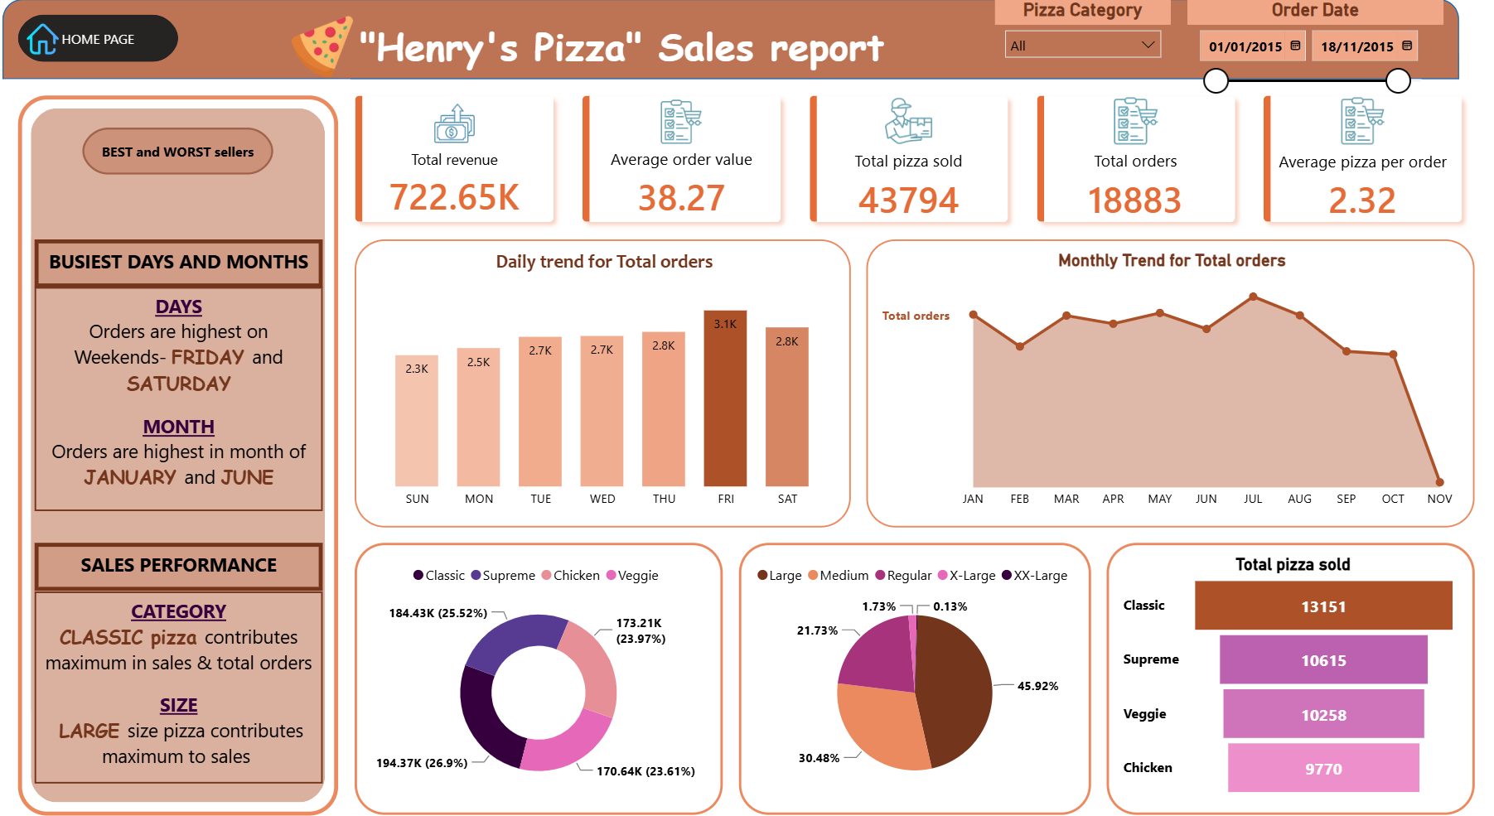
%age of sales by pizza category
%age of sales by pizza category
Total pizza sold
Daily trend
Monthly trend
KPI Requirements

Product Performance Dashboard
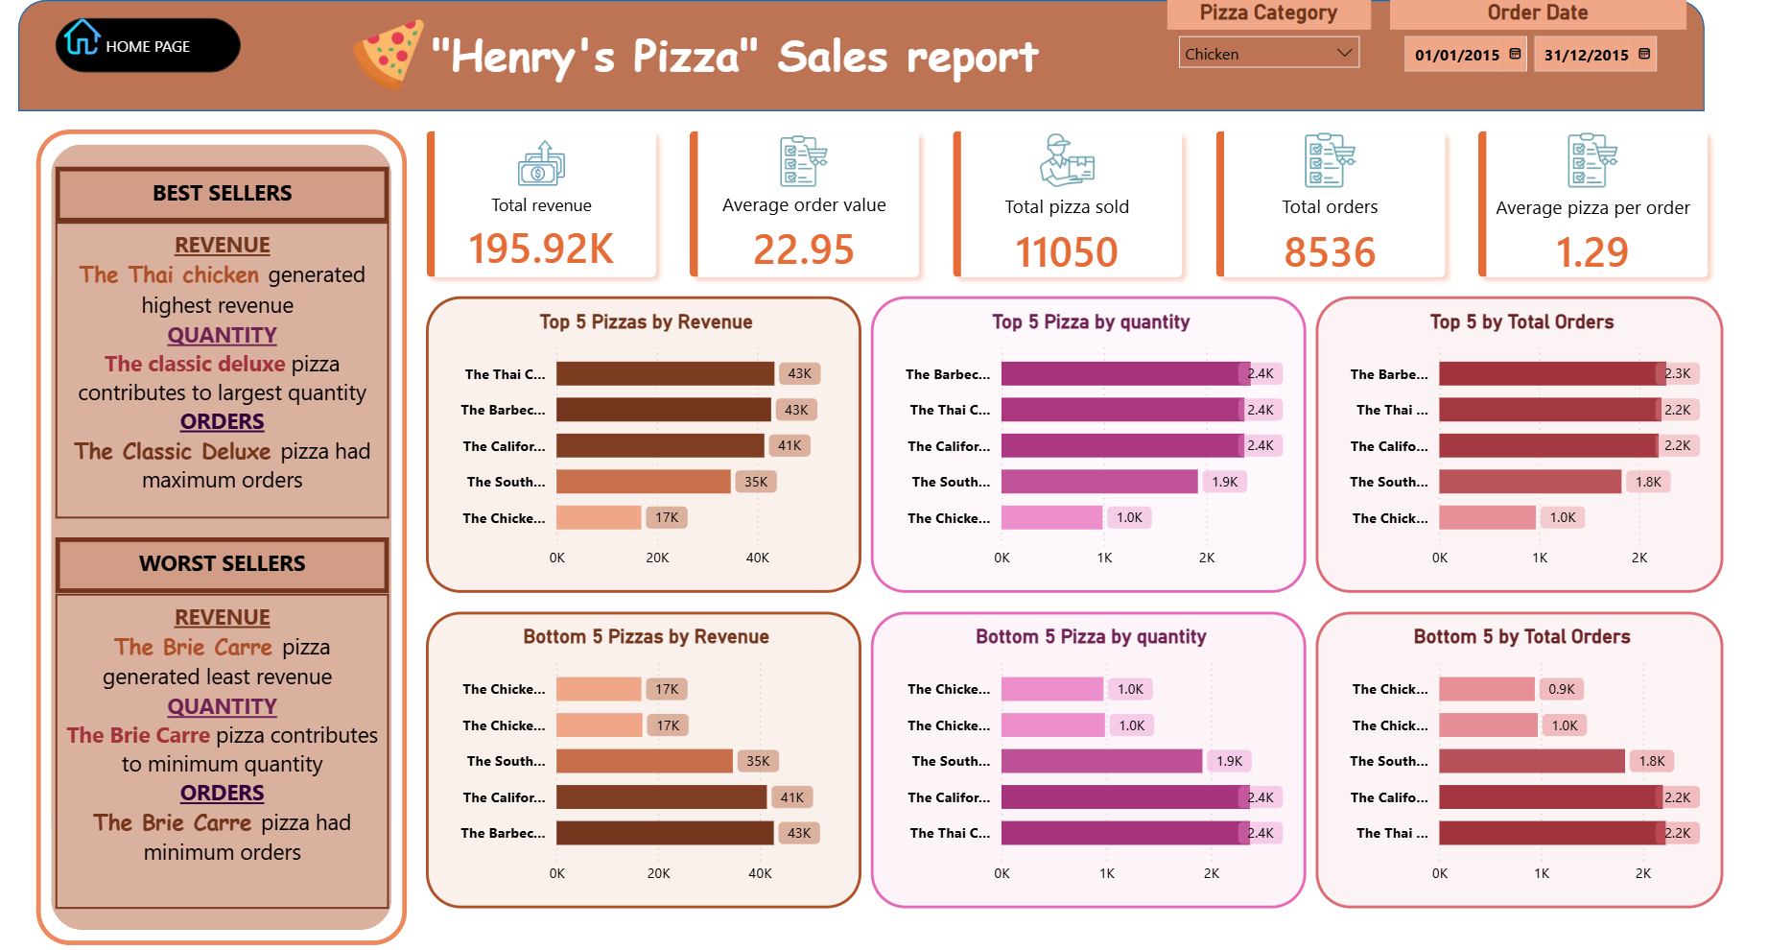
TOP 5 best sellers
BOTTOM 5 best sellers

