AGRIVET SALES, INVENTORY, AND SUPPLIER MANAGEMENT SYSTEM
A Business Process Improvement and Information System Plan
for Agrivet Retail Operations
A BAM - 285 Final Course Work
Presented to the Faculty of the
College Information Technology Education
Phinma University of Iloilo
Rizal, Iloilo City
In Partial Fulfillment
of the Requirements for the Degree
Bachelor of Science in Information Technology
by
De Asis Neil Mar
Ferwin Khen Hau tea
Gian Rovik Somes
Jayson Sapio
Jesmond Sardiniola
Jo Vincent Beldad
John Arvy Lopez
John Lloyd Cabanig
Buenafe Nelmar
Enagada Kin Orville
October 2026
Approval Sheet
AGRIVET SALES, INVENTORY, AND SUPPLIER MANAGEMENT SYSTEM
A Business Process Improvement and Information System Plan
A BAM - 285 Final Course Work
Degree
Bachelor of Science in Information Technology
by
De Asis Neil Mar
Ferwin Khen Hau tea
Gian Rovik Somes
Jayson Sapio
Jesmond Sardiniola
Jo Vincent Beldad
John Arvy Lopez
John Lloyd Cabanig
Buenafe Nelmar
Enagada Kin
_____________________
Kristine Anne Laguna
Marlo Kyn B. Bunda
Panel Panel
_________________ ________________
Jenny Rose Montille
Jireh A. Flavio
Panel Adviser

Concurred:

Jireh, Flavio Seth D. Nono,
MSCS BAM – 285, Project Lead Dean
October 2026

Acknowledgment
[Your Context Here]
______________________________
______________________________
______________________________
______________________________
October 2026

EXECUTIVE SUMMARY
The target poultry supply business has operated for approximately four to six years and handles an estimated 51 to 100 customer transactions on a typical day. The business already uses a Point-of-Sale (POS) system together with notebook or ledger records for selected activities. However, the client assessment identified continuing operational concerns involving inventory accuracy, product availability, expiration monitoring, stock receiving, supplier information, and access to management information.
The owner reported frequent differences between recorded stock and actual physical inventory, occasional product stockouts, monthly physical inventory counting, and damaged, lost, or unaccounted items. Products with expiration dates are sold, but no formal expiration-monitoring method is currently used. Supplier contact information and purchase histories are mainly maintained through a phone contact list, while receiving stock and reordering from suppliers were identified among the most time-consuming business activities. Supplier management, particularly supplier stock availability and delivery updates, was identified as an area needing improvement.
The proposed Agrivet Sales, Inventory, and Supplier Management System is intended to improve and integrate these business processes rather than simply replace an existing POS. The proposed solution will centralize relevant sales, inventory, stock receiving, expiration, and supplier information; support low-stock and expiration monitoring; improve access to operational summaries; apply appropriate access restrictions; and provide mechanisms for protecting and recovering business records. The project will use business analysis techniques to document the current process, define requirements, design the future-state process, and evaluate the proposed prototype within the academic project period.

TABLE OF CONTENTS
EXECUTIVE SUMMARY 3
TABLE OF CONTENTS 5
LIST OF TABLES 7
LIST OF FIGURES 7
CHAPTER I 1
INTRODUCTION 1
1.1 Background of the Project 1
1.2 Statement of the Problem 3
1.2.1 General Problem 3
1.2.2 Specific Problems 4
1.3 Objectives of the Project 5
1.3.1 General Objective 5
1.3.2 Specific Objectives 6
1.4 Significance of the Project 7
1.5 Purpose and Description 9
1.6 Scope and Limitations 10
Scope 10
Limitations 12
CHAPTER II 15
REVIEW OF RELATED LITERATURE AND SYSTEMS 15
2.1 Related Literature 15
2.2 Related Systems 17
2.3 Synthesis 18
References 19
CHAPTER III 20
METHODOLOGY, RESULTS, AND DISCUSSION 20
3.1 Requirements Analysis 20
3.1.1 Stakeholder Analysis 20
3.1.2 Client Assessment Results 22
3.1.3 Current-State Process (As-Is) 25
3.1.4 Problems Identified 26
3.1.5 Root-Cause Analysis (4P Diagnostic) 28
3.1.6 Requirements Engineering 29
3.2 Framework of the Project 34
3.2.1 Proposed Future-State Process (To-Be) 34
3.2.2 Before-and-After Process Comparison 36
3.2.3 Proposed System Modules 38
3.2.4 Business Rules 39
3.2.5 Preliminary Data Model 40
3.2.6 Preliminary System Architecture 41
3.2.7 Preliminary Feasibility and Justification 43
3.2.8 Requirements Traceability and Scope Control 45
3.3 Prototype Development and Validation Plan 47
3.3.1 Prototype Scope 47
3.3.2 Client Validation 47
3.3.4 Scope of Testing 48
3.4 Proposed Implementation Plan 49
3.4.1 Proposed Transition Approach 49
3.4.2 Proposed Training and Data Preparation 50
3.4.4 Future Production Implementation 51
CHAPTER IV 52
RESULTS AND DISCUSSION 52
4.1 Implementation Development Tools 52
Programming Languages & Frameworks 52
Libraries & Supporting Technologies 53
Development & Deployment Environment 54
4.2 Hardware Requirements 55
Server (Cloud / Hosting Infrastructure) 55
Client (End-User Devices) 55
4.3 Software Requirements 56
Client-Side (User Devices) 56
Server-Side (Cloud Environment) 57
4.4 Input and Outputs of the Study 57
System Inputs 57
System Outputs 59
4.5 Results Interpretation and Analysis 61
4.6 System Evaluation Results 64
Discussion of Evaluation Outcomes 66
CHAPTER V 68
CONCLUSION AND RECOMMENDATIONS 68
5.1 Introduction 68
5.2 Summary of the Proposed Study Design and Implementation 68
5.3 Summary of Findings 69
5.4 Conclusion 70
5.5 Recommendations 71

Lists of Tables
Table 1. Related Systems 18
Table 2. Stake Holder Analysis 22
Table 3. Client Assessment Results 25
Table 4. Problem Identified 28
Table 5. Functional requirements 32
Table 6. Non-Functional Requirements 34
Table 7. Before-and-After Process Comparison 38
Table 8. Business Rules 40
Table 9. Preliminary Data Model 41
Table 10. Preliminary Feasibility and Justification 45
Table 11. Requirements Traceability and Scope Control 46
Table 12. ISO/IEC 25010 System Evaluation Summary 65

Lists of Figures
Figure 1. High-Level Current-State Process (As-Is) 25
Figure 2. High-Level Proposed Future-State Process (To-Be) 34
Figure 3. Preliminary Three-Tier Architecture 42
Figure 4. Planned Validation Scenarios 48
Figure 5. Proposed Implementation Phases 49
Figure 6. Proposed Project Schedule 50

CHAPTER I

INTRODUCTION

1.1 Background of the Project
Efficient management of sales, inventory, product availability, and supplier transactions is one of the most important to the daily operation of a retail business. For an agrivet or poultry supply business, maintaining accurate stock information is particularly important because products must be available when customers need them, while some products also require monitoring due to expiration dates. Supplier information and incoming deliveries must likewise be properly managed to support timely replenishment and continuous business operations.
The target business of this project is a poultry supply store that primarily sells animal feeds. The business has been operating for approximately four to six years and currently has one worker. Despite its small workforce, the owner reported handling approximately 51 to 100 customer transactions on a typical day.
The business has already adopted technology in some of its operations. Sales are recorded through a combination of a notebook or ledger and an existing Point-of-Sale (POS) system. The POS is used to calculate customer purchases, monitor available product stock, record newly delivered products, and assist in determining when inventory needs replenishment. This indicates that the business is not operating under a completely manual process.
However, the requirements assessment identified operational gaps that remain despite the use of the existing POS. The owner reported frequently encountering differences between the stock quantity recorded in the system and the actual physical inventory. Requested products are also sometimes unavailable when customers need them, while physical inventory counting is performed monthly. Damaged, lost, or unaccounted items were also identified among the inventory concerns of the business.
Product expiration monitoring represents another area that is not fully supported by the current process. The business sells products with expiration dates but reported having no formal method for monitoring them. Products are checked for impending expiration monthly, and applicable batch or lot numbers are not currently recorded. Although products reportedly expire unnoticed only rarely, the absence of a formal monitoring method limits the business's ability to systematically identify products approaching expiration.
Supplier and replenishment activities emerged as a significant operational concern. Supplier contact information and purchase histories are mainly maintained through a phone contact list, while the business records selected information when receiving deliveries. The owner identified receiving stock and reordering from suppliers as activities that consume the largest amount of time and identified supplier management as the area of the business most in need of improvement. More specifically, supplier stock availability and delivery updates were identified as the most difficult aspect of current operations.
The assessment further indicated that information concerning slow-moving products and supplier purchases can be difficult or time-consuming to obtain. The owner expressed interest in system functions including sales processing, automatic inventory deduction after sales, stock receiving and replenishment logging, low-stock monitoring, expiration monitoring, and supplier contact and purchase-order management.
These findings suggest that the principal opportunity is not simply the replacement of manual records with software. Rather, there is a need to improve the integration and control of existing sales, inventory, stock receiving, expiration monitoring, and supplier-related processes. The proposed project therefore focuses on analyzing the existing business processes and developing an integrated Agrivet Sales, Inventory, and Supplier Management System appropriate to the operational needs identified by the client.

1.2 Statement of the Problem

1.2.1 General Problem
How can the current sales, inventory, stock receiving, expiration monitoring, and supplier management processes of the target poultry supply business can be improved through an integrated information system to provide more accurate, accessible, and organized operational information?

1.2.2 Specific Problems
1. The business frequently experience differences between recorded inventory quantities and actual physical stock.
2. Requested products are sometimes unavailable when customers need them, indicating a need for improved visibility of stock levels and replenishment needs.
3. Physical inventory counting is conducted monthly, limiting the frequency at which recorded quantities can be compared with actual stock.
4. Damaged, lost, or unaccounted items occur as an inventory concern and may contribute to discrepancies between recorded and physical stock.
5. Products with expiration dates are sold by the business, but there is no formal method for continuously monitoring product expiration.
6. Applicable batch or lot numbers are not currently recorded, limiting detailed tracking of inventory that may require such information.
7. Supplier contact information and purchase history are not maintained within a centralized operational information source and are primarily accessed through a phone contact list.
8. Receiving stock and reordering from suppliers are among the most time-consuming daily business activities.
9. Supplier management is identified by the owner as the area most in need of improvement, particularly in relation to supplier stock availability and delivery updates.
10. Information concerning slow-moving products and supplier purchases can be difficult or time-consuming to obtain.
11. The business requires continued recording of important transactions even when internet connectivity becomes unavailable.
12. The owner considers the recovery of business records very important in cases of accidental deletion or device damage and has identified loss of digital records as a concern regarding computerization.

1.3 Objectives of the Project

1.3.1 General Objective
To analyze the existing business processes of the target agrivet business and design a proposed integrated Agrivet Sales, Inventory, and Supplier Management System that addresses identified gaps in inventory control, stock receiving, expiration monitoring, supplier management, and access to operational information.

1.3.2 Specific Objectives
1. Analyze and document the existing sales, inventory, stock receiving, expiration monitoring, and supplier management processes of the target business.
2. Identify operational problems, process gaps, and information needs based on the current-state business process and client requirements.
3. Design an improved future-state business process that integrates relevant sales, inventory, receiving, expiration, and supplier activities.
4. Design a centralized product and inventory management function capable of maintaining current stock information and recording inventory movements.
5. Design the proposed sales workflow so that completed sales automatically update applicable inventory quantities.
6. Design a structured future-state process for recording incoming stocks and replenishment transactions.
7. Define low-stock monitoring requirements to support timely product replenishment.
8. Define expiration-monitoring and advance-alert requirements for applicable products.
9. Design a centralized approach for supplier information and relevant purchasing or replenishment records.
10. Design dashboard and reporting requirements for sales, current inventory, low-stock products, expiring products, best-selling products, slow-moving products, supplier purchases, and recent transactions.
11. Define appropriate role-based access requirements for business information identified by the owner as sensitive.
12. Define proposed data-protection, backup, and recovery requirements for business records.
13. Evaluate and design a feasible approach for essential transaction recording during temporary loss of internet connectivity within the prototype scope.
14. Develop an interactive prototype representing the primary proposed workflows and evaluate it through client walkthrough and feedback.
15. Prepare a proposed implementation strategy addressing future deployment, user orientation, data preparation, validation, and transition from the current process should the client proceed with full implementation.

1.4 Significance of the Project
For the Business Owner: The proposed system can provide the business owner with a more centralized view of sales, inventory, supplier, replenishment, and product-monitoring information. Sensitive business information can also be protected according to the owner's identified access requirements. Improved availability of operational records may support decisions regarding stock replenishment, supplier transactions, and product movement.
For Authorized Users: The proposed system can provide authorized users with a more organized method of performing permitted business activities. Centralized product, inventory, receiving, and supplier information can reduce dependence on separate records and information sources while providing access appropriate to the user's role.
For Customers: Customers may indirectly benefit from improved stock monitoring and replenishment processes. Better visibility of available and low-stock products can assist the business in responding to product demand and reducing avoidable instances in which requested products are unavailable.
For Business Operations: The project can support a more standardized flow of information between sales, inventory movement, stock receiving, expiration monitoring, and supplier-related activities. Instead of treating these processes as isolated functions, the proposed system aims to maintain related operational information in an integrated environment.
For Future Business Analysis Researchers: The project may serve as a reference for students and future researchers studying business process improvement, inventory management, retail information systems, supplier management, and digital transformation among small retail enterprises.

1.5 Purpose and Description
The purpose of the project is to improve identified business processes of the target poultry supply business through an integrated information system. The proposed system will focus on the relationship between sales transactions, inventory movement, incoming stocks, product monitoring, and supplier information.
For sales operations, the proposed system will support recording and processing customer purchases. Completed sales will update applicable inventory quantities so that sales and inventory records remain connected.
For inventory operations, the system will maintain product stock information, record relevant stock movements, support stock receiving, and identify products that reach defined low-stock conditions. The system will also provide information that can assist the owner in reviewing fast-moving and slow-moving products.
For products with expiration dates, the system will provide structured expiration information and advance monitoring based on recorded product data. Where applicable within the final design, relevant batch or lot information may also be maintained to improve product traceability.
For supplier management, the proposed system will centralize supplier information and relevant purchase or replenishment records. This will provide a more organized source of information than relying primarily on separate phone contacts and documents.
The system will also provide dashboard and reporting information based on the operational information identified by the client, including sales, inventory levels, low-stock products, expiring products, best sellers, slow movers, and recent transactions.
Access to sensitive business information will be controlled according to authorized user roles. The owner specifically identified sales and revenue information, product buying costs, profit information, supplier information, employee or staff accounts, and inventory records as information that should only be seen or managed by the owner.
The proposed solution will therefore function not merely as a transaction-recording application but as an integrated operational information system intended to support more consistent business processes and provide useful information for business monitoring and decision-making.

1.6 Scope and Limitations

Scope
1. Sales Management: Record sales transactions, calculate transaction totals, maintain transaction history, deduct applicable quantities from inventory after completed sales, and provide access to recent sales records.
2. Product and Inventory Management: Maintain product information and current inventory quantities, record inventory movements and authorized adjustments, monitor low-stock products, support inventory checking and reconciliation, and identify fast-moving and slow-moving products using recorded transaction data.
3. Stock Receiving and Replenishment: Record incoming stock, associated suppliers, applicable invoice or delivery receipt references, update inventory after receiving, and maintain replenishment history.
4. Expiration Monitoring: Record expiration dates for applicable products, monitor products approaching expiration, provide advance expiration alerts, and maintain applicable batch or lot information where required by the business process.
5. Supplier Management: Maintain centralized supplier and contact information, relevant supplier transaction or purchase history, purchase or replenishment records, and supplier-related operational information.
6. Dashboard and Reports: Display sales information, current inventory levels, low-stock and expiring products, best-selling and slow-moving products, recent transactions, and relevant operational summaries.
7. User and Access Management: Provide authenticated access, support defined user roles, restrict sensitive business information according to authorization, and allow the owner to manage appropriate system information and user access.
8. Data Protection and Operational Continuity: Maintain mechanisms appropriate to the final deployment architecture for protecting and recovering business records and support a defined set of essential transaction-recording activities during temporary internet interruption.

Limitations
1. The project will be completed within an academic one-month period and will prioritize business analysis, process redesign, requirements definition, system design, interactive prototype development, and client validation based on the processes supported by the client assessment.
2. Full-scale software development, production deployment, live business data migration, and operational implementation are outside the scope of the current one-month project. The deliverable will focus on the proposed solution design and an interactive prototype for client validation.
2. The proposed system will not guarantee the availability of products from external suppliers because supplier stock levels and delivery schedules are controlled by third-party suppliers. Unless suppliers directly participate in the system or provide an accessible integration mechanism, supplier availability and delivery information will depend on information manually recorded or updated by authorized business users.
4. The system cannot independently detect physical loss, damage, theft, or unrecorded movement of products. Inventory accuracy will continue to depend on users properly recording sales, receiving, adjustments, damages, and other inventory movements.
5. Expiration alerts will depend on accurate expiration information being entered when applicable inventory is received. The system cannot determine an expiration date that has not been recorded.
6. The project will not include accounting functions beyond the operational sales and reporting information explicitly included in the approved requirements. Full accounting, taxation, payroll, and comprehensive financial management are outside the initial scope.
7. Advanced demand forecasting, artificial intelligence-based purchasing decisions, automated communication with supplier systems, and enterprise-level supply-chain integration are outside the initial prototype scope unless subsequently approved as feasible within the project schedule.
8. Offline operation will be limited to explicitly defined essential functions. Full offline replication of every system function will not be assumed until the technical architecture has been evaluated.
9. The system is intended specifically for the operational requirements of the identified target business. Its effectiveness for other agrivet stores or retail organizations cannot be assumed without additional requirements analysis and evaluation.

CHAPTER II

REVIEW OF RELATED LITERATURE AND SYSTEMS

2.1 Related Literature
Inventory management is a central control activity in retail operations because stock records connect purchasing, receiving, selling, and replenishment decisions. Modern inventory systems reduce reliance on memory and separate records by maintaining item quantities as transactions occur. For the target poultry supply business, this principle is directly relevant because the client reported frequent differences between recorded stock and actual physical stock, occasional stockouts, and monthly physical inventory counting.
Low-stock monitoring is a common inventory-control mechanism. Square documents the use of threshold-based inventory alerts that notify a business when stock falls below a defined quantity, supporting timely replenishment and reducing the risk of stockouts or overstocking [1]. This supports the proposed use of configurable low-stock levels for the target business, where requested products are sometimes unavailable and reordering is one of the activities that consumes the most time.
Expiration-date and lot tracking are also important where products have limited shelf life. Odoo's inventory documentation describes expiration-date management through lot or serial tracking, advance alert dates, and First Expiry, First Out (FEFO) removal strategies [2]. These practices are applicable to the target business because it sells products with expiration dates but currently has no formal expiration-monitoring method and does not record batch or lot numbers.
Supplier and purchase-order records provide a structured connection between replenishment decisions and stock receiving. Loyverse documents a workflow in which businesses maintain supplier records, create purchase orders, record expected delivery dates, receive stock, and maintain purchasing information in one inventory environment [3]. This is relevant to the client's identified difficulty in monitoring supplier stock availability and delivery updates and to the current practice of keeping supplier information mainly in a phone contact list.
Software quality requirements must address more than functional features. ISO/IEC 25010:2023 provides a product quality model that can be used to specify and evaluate qualities of ICT and software products [4]. For this project, the most relevant quality concerns include usability, performance, reliability, security, maintainability, and compatibility with the devices used by the business.
The system will also handle business and user information. In Republic Act No. 10173, or the Data Privacy Act of 2012, requires the protection of personal information processed in information and communications systems [5]. This supports the inclusion of authentication, access restrictions, secure handling of account information, and data-protection measures in the proposed system.

2.2 Related Systems
System | Relevant Capabilities | Relevance / Limitation
Loyverse POS | Sales, real-time stock tracking, low-stock alerts, purchase orders, suppliers, stock receiving, adjustments, inventory counts, reports. | Strong fit for small retail inventory and supplier workflows; advanced inventory functions require a paid add-on and the workflow may not match all client-specific controls.
Odoo Inventory | Inventory, purchase, supplier, lot/serial tracking, expiration dates, alerts, FEFO, replenishment. | Comprehensive and highly configurable; broader ERP scope and configuration complexity may be excessive for a one-store academic prototype.
Square POS / Inventory | POS-linked stock updates, inventory counts, low-stock alerts, inventory history and reporting. | Demonstrates integrated sales-to-stock control; availability, ecosystem fit, and localization may differ from the target business context.

Table 1. Related Systems

2.3 Synthesis
The reviewed literature and systems consistently support five design principles: sales should update inventory, low-stock conditions should be visible before stockouts occur, expiring products should be traceable and monitored in advance, supplier and receiving records should be centralized, and access to sensitive information should be controlled. These principles directly correspond with the client's reported operational problems and requested functions.
Existing commercial platforms already provide many of these capabilities, but the proposed project remains justified as a focused business-analysis and process-improvement initiative. The target business already has a POS, so the objective is not to reproduce a generic checkout system. The proposed solution will instead prioritize the specific gaps identified by the client: inventory reconciliation, receiving and replenishment history, expiration monitoring, supplier information, owner-only data access, recoverability, and continued recording of essential transactions during temporary internet loss.

References
[1] Square, “Create inventory alerts,” Square Support Center, accessed October 2026.
[2] Odoo S.A., “Expiration dates,” Odoo Inventory Documentation, accessed October 2026.
[3] Loyverse, “How to Work with Purchase Orders and Suppliers” and “Advanced Inventory Management,” accessed October 2026.
[4] ISO/IEC 25010:2023, Systems and software engineering — Systems and software Quality Requirements and Evaluation (SQuaRE) — Product quality model.
[5] National Privacy Commission, Republic Act No. 10173, Data Privacy Act of 2012.

CHAPTER III

METHODOLOGY, RESULTS, AND DISCUSSION

3.1 Requirements Analysis
The requirements analysis was based primarily on a structured client needs-assessment questionnaire completed by the business owner. The questionnaire covered business profile, sales, inventory, expiration monitoring, suppliers and stock receiving, reports, business challenges, technology readiness, client priorities, access control, performance, recovery, and offline continuity. The response was analyzed together with the current Chapter I problem statement and scope.

3.1.1 Stakeholder Analysis
Stakeholder | Role | Responsibilities | Pain Points / Needs | System Expectation
Business Owner | Process owner / primary decision-maker | Oversees sales, inventory, suppliers, reports and sensitive business data. | Inventory discrepancies; supplier stock/delivery visibility; record recovery. | Full administrative access, dashboards, reports, supplier and inventory control.
Manager | Authorized operational user | Supports daily operations and may use the proposed system. | Needs fast access to operational records without exposing owner-only information. | Role-based operational access appropriate to assigned duties.
Staff / Cashier | Potential transaction user | Records sales and selected stock activities if authorized. | Fast checkout/product search; simple workflow. | Limited access to transaction functions and permitted records.
Customers | External beneficiary | Purchase products from the store. | Product unavailability and transaction delays. | Faster service and improved product availability.
Suppliers | External business partner | Provide stock, invoices, delivery information and product availability. | Supplier information is currently fragmented. | Accurate supplier records and purchase/receiving history; no direct system access in initial scope.

Table 2. Stake Holder Analysis

3.1.2 Client Assessment Results
Assessment Area | Client Response / Finding
Business profile | Owner; 4–6 years operating; 1 worker; 51–100 transactions/day; primarily animal feeds.
Current sales | Notebook/ledger and POS; prices are memorized and stored in the existing system; totals are calculated through POS/computer.
Inventory | POS-based monitoring; physical count monthly; stock discrepancies occur frequently; stockouts occur sometimes; damaged/lost/unaccounted items are reported.
Expiration | Products with expiration dates are sold; no formal tracking method; checked monthly; batch/lot numbers are not recorded; preferred alert lead time is 30 days.
Suppliers / receiving | Supplier contacts and purchase history are mainly in a phone contact list; receiving records include supplier name and invoice/delivery receipt reference; invoices/receipts are retained.
Reporting | Sales, stock, low-stock, best sellers, slow movers, expiring items, supplier purchases, and profit/revenue are monitored; slow movers and supplier purchases are time-consuming to obtain.
Main bottleneck | Receiving stock and reordering consumes the most time; supplier management is the area needing most improvement; supplier stocks and delivery updates are the single most difficult issue reported.
Technology | Tablet available; internet is reliable most of the time; preferred access includes desktop, laptop, tablet and smartphone.
Security / continuity | Owner-only access is required for sales/revenue, buying costs, profit, supplier information, staff accounts and inventory records; recovery and fast transaction performance are very important; essential transactions must continue during internet loss.

Table 3. Client Assessment Results

3.1.3 Current-State Process (As-Is)
The current process is partially computerized. Sales are entered through an existing POS, while a notebook or ledger is also used. The POS is used to calculate purchases, monitor stock, record newly delivered products, and support reordering. However, supplier information is stored separately, physical inventory is counted monthly, expiration monitoring is not formalized, and supplier stock and delivery updates are not integrated into one operational view.

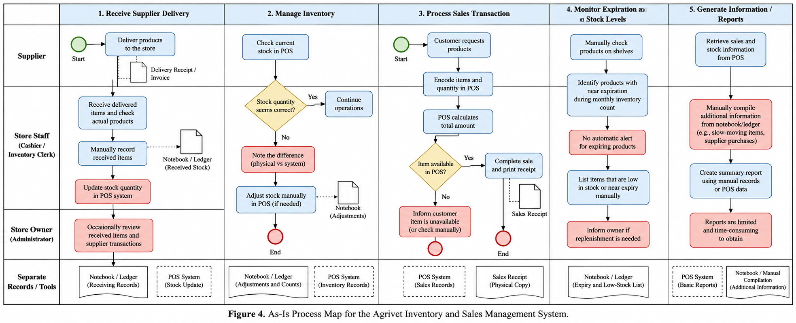
Figure 1. High-Level Current-State Process (As-Is)

Figure 1 illustrates the current operations of the agrivet business. The business uses a POS system together with manual records for sales, inventory, stock receiving, expiration checking, and supplier coordination. Despite using a POS, the business experiences inventory discrepancies, occasional stockouts, manual expiration monitoring, and difficulty tracking supplier stock and delivery updates. These gaps serve as the basis for the proposed improved process.

3.1.4 Problems Identified
Problem | Root Cause | Operational Impact
Inventory record mismatch | Recorded and physical quantities are not continuously reconciled; damaged/lost/unaccounted movements may not be captured consistently. | Frequent stock discrepancies and reduced confidence in available-stock data.
Product stockouts | Replenishment visibility depends on current POS information and manual supplier coordination. | Requested products are sometimes unavailable.
Weak expiration control | No formal expiration tracking and no batch/lot recording; checking is monthly. | Near-expiry products may not be identified early enough.
Fragmented supplier information | Contacts/purchase history are mainly stored in a phone contact list and receiving data is separated from supplier availability updates. | Supplier stock and delivery updates are difficult to monitor.
Slow access to selected reports | Slow-mover and supplier-purchase information is not immediately available in one view. | Extra time is required to retrieve operational information.
Digital continuity risk | The client is concerned about record loss and still needs transaction recording during internet interruptions. | Operational disruption or data loss if the solution depends entirely on continuous connectivity.

Table 4. Problem Identified

3.1.5 Root-Cause Analysis (4P Diagnostic)
People: The business has a very small workforce, so the owner and manager must perform several operational tasks. Supplier follow-up, receiving, inventory checking, and reporting compete for the same limited attention.
Process: Inventory checking is periodic rather than continuously reconciled; expiration checking is monthly; supplier updates are obtained separately; and receiving/reordering are time-consuming activities.
Platform (Technology): The existing POS supports sales and inventory but does not fully integrate the client’s supplier visibility, expiration-monitoring, owner-only information, recovery, and offline-continuity needs.
Paperwork / Information: Operational information is split among the POS, notebook or ledger, phone contact list, invoices, and delivery receipts. This fragmentation makes selected records harder to retrieve and compare.
Core Diagnostic Finding: the main business issue is not the complete absence of technology. The business already uses a POS. The primary gap is the incomplete integration of inventory control, supplier and receiving information, expiration monitoring, reporting, and continuity controls around the existing transaction process.

3.1.6 Requirements Engineering
Functional Requirements
ID | Functional Requirement | Stakeholder | Priority
FR01 | The system shall authenticate users and enforce role-based access. | Owner / Manager | High
FR02 | The system shall maintain product information, selling price, buying cost where authorized, and current stock quantity. | Owner | High
FR03 | The system shall record sales transactions and automatically deduct sold quantities from inventory. | Owner / Authorized User | High
FR04 | The system shall record stock receiving transactions with supplier and invoice/delivery receipt references. | Owner / Manager | High
FR05 | The system shall record inventory adjustments with a reason such as damage, loss, correction, or physical-count reconciliation. | Owner | High
FR06 | The system shall allow configurable low-stock thresholds and identify products at or below the threshold. | Owner / Manager | High
FR07 | The system shall maintain expiration dates for applicable stock and provide a configurable advance alert, initially supporting the client's preferred 30-day warning. | Owner / Manager | High
FR08 | The system shall support batch or lot recording for applicable products. | Owner / Manager | Medium
FR09 | The system shall maintain centralized supplier contact information and supplier-related transaction history. | Owner | High
FR10 | The system shall maintain purchase/replenishment records and track expected or recorded delivery information entered by authorized users. | Owner / Manager | High
FR11 | The system shall provide dashboards for sales, inventory, low stock, expiring items, best sellers, slow movers and recent transactions. | Owner | High
FR12 | The system shall provide searchable transaction, inventory, supplier and receiving records. | Owner / Manager | High
FR13 | The system shall restrict sales/revenue, buying costs, profit, supplier information, staff accounts and inventory-management functions according to owner-defined permissions. | Owner | High
FR14 | The system shall provide a backup/recovery mechanism appropriate to the final deployment architecture. | Owner | High
FR15 | The system shall support a defined set of essential transaction-recording functions during temporary internet loss and synchronize safely when connectivity returns. | Owner / Manager | High

Table 5. Functional requirements

Non-Functional Requirements
Category | Specification | Business Justification
Usability | Core sales, product search, receiving and inventory tasks should use clear, minimal steps and be responsive on desktop, laptop, tablet and smartphone. | Client rated fast sales/product search as very important.
Performance | Common product searches and transaction actions should respond quickly under normal single-store use; target ≤2 seconds for common screens where technically feasible. | Avoid customer delays during busy periods.
Security | Use authenticated accounts, least-privilege role access, protected credentials, secure transport, and owner-only access for identified sensitive information. | Client explicitly requires restricted owner-only business information.
Reliability | Committed transactions must not be silently lost; failed synchronization must be visible and recoverable. | Business requires dependable operational records.
Recoverability | Provide scheduled backup/export and a documented restoration procedure. | Client rated recovery after deletion/device damage as very important.
Availability / Offline continuity | Essential transaction recording should continue during temporary internet interruption within the approved offline scope. | Client answered Yes to continued recording during internet loss.
Compatibility | Support modern browsers and responsive use on desktop, laptop, tablet and smartphone. | All four device types were selected as preferred platforms.
Maintainability | Use modular components, documented business rules, and configurable thresholds where practical. | Supports changes without rewriting the whole system.

Table 6. Non-Functional Requirements

3.2 Framework of the Project
The project will follow a business-analysis-driven development framework: (1) client discovery, (2) As-Is process documentation, (3) problem and root-cause analysis, (4) requirements definition, (5) To-Be process design, (6) data and system modeling, (7) wireframing and prototyping, (8) iterative implementation, (9) testing and UAT, (10) deployment preparation, and (11) evaluation and improvement. This sequence aligns the technical build with the business problem rather than beginning from features alone.

3.2.1 Proposed Future-State Process (To-Be)
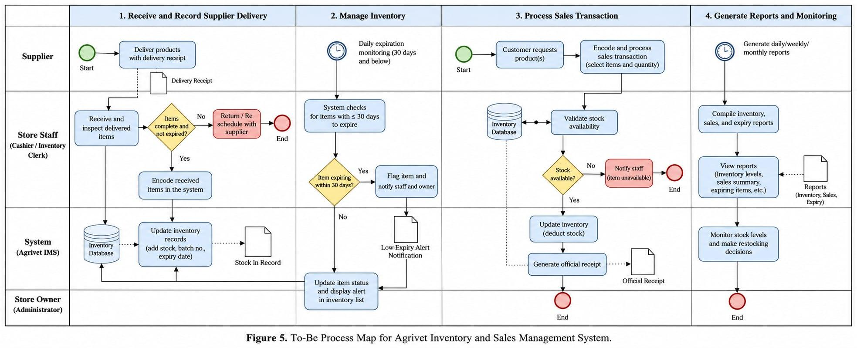

Figure 2. High-Level Proposed Future-State Process (To-Be)

The improved process integrates supplier receiving, inventory management, sales transactions, expiration monitoring, and business reporting into a centralized system. When products are received from suppliers, authorized personnel inspect and record the delivered items, including relevant stock, supplier, batch or lot, and expiration information. The system then updates the inventory records accordingly.
During daily operations, the system monitors inventory levels and applicable expiration dates. Products approaching their defined expiration-alert period are automatically identified and presented to authorized users. During a sales transaction, the system verifies the availability of the requested products before completing the transaction. Once the sale is confirmed, the corresponding quantities are automatically deducted from inventory, maintaining an updated stock record.
The proposed process also centralizes operational information for monitoring and reporting. The owner can access relevant sales, inventory, low-stock, expiration, supplier, and product-movement information to support replenishment and other business decisions. Overall, the To-Be process reduces reliance on fragmented records and manual monitoring by connecting major stock-related activities within a single operational workflow.

3.2.2 Before-and-After Process Comparison
Operational Dimension | Current State (As-Is) | Proposed State (To-Be)
Sales and stock | POS plus notebook/ledger; stock is available in POS but discrepancies occur. | Sales and authorized stock movements feed one controlled inventory history.
Inventory reconciliation | Physical count monthly; frequent mismatch. | Count/reconciliation workflow records variance and adjustment reason.
Low-stock monitoring | Reorder decisions supported by current POS/inventory and manual review. | Configurable threshold and low-stock list/alert.
Expiration | No formal method; checked monthly; no lot numbers. | Expiration and optional lot/batch data recorded during receiving with advance alerts.
Supplier information | Phone contact list and separate documents. | Central supplier profile with purchase/replenishment and receiving history.
Supplier delivery updates | Manual contact and follow-up. | Expected/recorded delivery status entered and visible in replenishment records; external supplier data remains manual unless integration exists.
Reports | Some information is time-consuming to obtain. | Dashboard and searchable summaries for key operational information.
Sensitive information | No new proposed access model documented. | Role-based access with owner-only control for specified sensitive data.
Continuity | Current process can fall back on separate/manual records. | Defined offline transaction queue plus backup/recovery procedure, subject to technical implementation.

Table 7. Before-and-After Process Comparison

3.2.3 Proposed System Modules
Module 1 – User and Access Management: Authentication, owner/manager/staff permissions, owner-only sensitive information, account administration.
Module 2 – Sales and Transaction Management: Sales entry, transaction history, product search, totals, and automatic stock deduction.
Module 3 – Product and Inventory Management: Products, stock balances, movement history, adjustments, physical-count reconciliation, low-stock thresholds.
Module 4 – Receiving and Expiration Management: Incoming stock, invoice/delivery receipt references, lot/batch where applicable, expiration dates and advance alerts.
Module 5 – Supplier and Replenishment Management: Supplier contacts, purchase/replenishment records, expected delivery details, receiving linkage and history.
Module 6 – Dashboard and Reporting: Sales, current inventory, low stock, expiring items, best sellers, slow movers, supplier purchases and recent transactions.
Module 7 – Backup, Recovery and Offline Continuity: Backup/export, restoration procedure, defined offline queue and synchronization status.

3.2.4 Business Rules
Rule ID | Business Rule
BR-01 | A completed sale must reduce the on-hand quantity of each sold item.
BR-02 | Stock receiving must increase on-hand quantity only after the receiving transaction is confirmed.
BR-03 | Inventory adjustments must require an authorized user and a reason.
BR-04 | A product is flagged as low stock when on-hand quantity is at or below its configured threshold.
BR-05 | Applicable expiring stock is flagged when its expiration date falls within the configured alert window; the initial client preference is 30 days.
BR-06 | Owner-only information must not be shown to users without the corresponding permission.
BR-07 | Supplier delivery status reflects information recorded by authorized users and must not be presented as live supplier data unless an actual supplier integration exists.
BR-08 | Offline transactions must retain a unique local identifier and synchronization state to prevent duplicate posting when connectivity returns.

Table 8. Business Rules

3.2.5 Preliminary Data Model
Entity | Key Data | Business Purpose
User | user_id, name, role, status, credential reference | Controls authenticated access and permissions.
Product | product_id, name, category, selling_price, buying_cost, low_stock_threshold | Master product information.
InventoryBalance | product_id, quantity_on_hand, updated_at | Current stock state.
InventoryMovement | movement_id, product_id, type, quantity, reference_id, reason, user_id, timestamp | Auditable stock changes from sale, receiving or adjustment.
Sale / SaleItem | sale_id, date, total; product_id, quantity, unit_price | Customer sales and automatic stock deduction.
Supplier | supplier_id, name, contact details, notes | Central supplier information.
Purchase / Replenishment | purchase_id, supplier_id, order_date, expected_date, status | Tracks replenishment decisions and delivery expectations.
Receiving / ReceivingItem | receiving_id, supplier_id, reference_no, received_date; product_id, quantity, lot_no, expiration_date | Records incoming stock and traceability data.
Audit / Sync Record | event_id, user_id, action, entity, timestamp, sync_status | Supports accountability and offline synchronization monitoring.

Table 9. Preliminary Data Model

3.2.6 Preliminary System Architecture
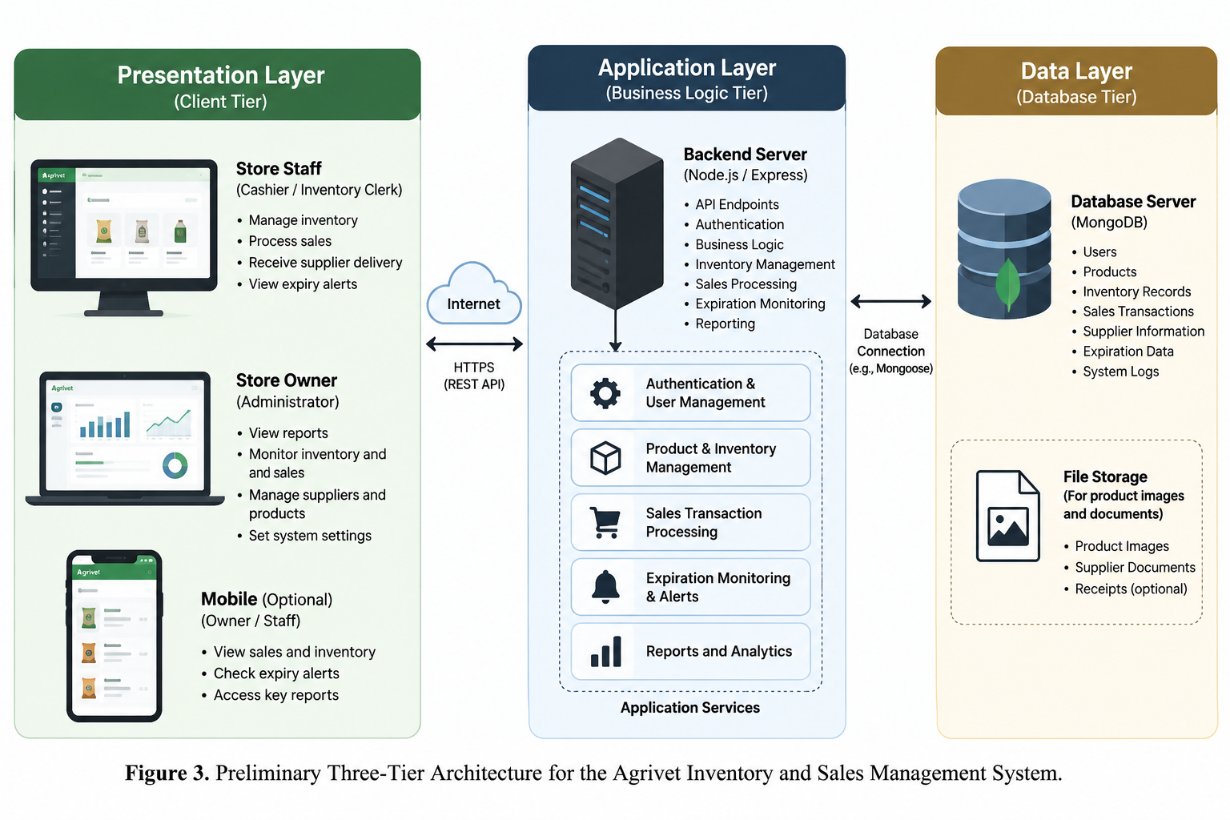
The proposed prototype should use a responsive web architecture that can be accessed from the client's preferred desktop, laptop, tablet, and smartphone devices. A centralized application service will enforce business rules and communicate with a relational or document-oriented database. The exact implementation stack should be finalized only after the team confirms deployment constraints, offline requirements, hosting budget, and the need to integrate or coexist with the client's current POS.

Figure 3. Preliminary Three-Tier Architecture

3.2.7 Preliminary Feasibility and Justification
Dimension | Assessment | Justification
Operational | Feasible | The client already uses a POS and a tablet, indicating familiarity with computerized transactions. The proposed workflow focuses on identified gaps rather than requiring a completely unfamiliar operating model.
Technical | Feasible with scope control | Responsive web technology, database storage, authentication, dashboards and inventory logic are standard capabilities. Offline synchronization and coexistence/integration with the existing POS require early technical validation.
Economic | Feasible for prototype | The academic prototype can use low-cost or free development tools. A production deployment may introduce hosting, domain, backup, device, maintenance or messaging costs and should be separately estimated.
Schedule | Feasible only with prioritization | A one-month duration requires an MVP-first scope: inventory control, receiving, supplier records, low-stock/expiration monitoring, access control and essential reporting before optional enhancements.
Alternative analysis | Custom focused prototype justified for coursework | Commercial systems such as Loyverse, Odoo and Square already provide broad inventory capabilities. The custom project is justified academically because it documents and redesigns the client's specific As-Is process and can tailor controls to the approved requirements. For real-world adoption, the final recommendation should compare deployment cost and fit against configuring an existing platform.

Table 10. Preliminary Feasibility and Justification

3.2.8 Requirements Traceability and Scope Control
Client Need / Problem | Requirement | Planned Feature | Scope Status
Frequent stock mismatch | FR02, FR05 | Inventory balance, movement history, adjustment/reconciliation | High / MVP
Sometimes out of stock | FR06, FR10 | Low-stock monitoring and replenishment records | High / MVP
No formal expiration method | FR07, FR08 | Expiration and lot/batch monitoring | High / MVP
Supplier stocks/delivery updates difficult | FR09, FR10 | Supplier and replenishment module | High / MVP
Slow movers / supplier purchases hard to obtain | FR11, FR12 | Dashboard, reports and search | High / MVP
Owner-only information | FR01, FR13 | User and access management | High / MVP
Record recovery very important | FR14 | Backup and recovery | High / MVP
Continue transactions without internet | FR15 | Defined offline queue and synchronization | High but technically risky; validate early

Table 11. Requirements Traceability and Scope Control

Features outside the proposed prototype include direct real-time supplier integration, advanced AI demand forecasting, full accounting, payroll, tax computation, and enterprise supply-chain automation. These remain explicitly deferred unless the client later proceeds with full development and provides the required integrations, resources, and implementation time.

3.3 Prototype Development and Validation Plan
Because the project is limited to one month and the extent of implementation depends on the actual client's decision, this study will not claim full production development or live deployment. Instead, the team will prepare an interactive prototype representing the approved future-state processes and use it to validate whether the proposed solution addresses the client's identified business needs.

3.3.1 Prototype Scope
The prototype will focus on the primary workflows supported by the requirements analysis: sales and product search, inventory monitoring, supplier and stock receiving records, low-stock monitoring, expiration monitoring, dashboard and reporting views, and role-based access. The prototype may be implemented as high-fidelity interactive screens or, where time permits, a limited functional proof of concept. Features outside the approved scope will remain represented only in the requirements and implementation roadmap.

3.3.2 Client Validation
The business owner will be asked to review the proposed process flows and prototype using realistic business scenarios. Validation will focus on whether the proposed workflow is understandable, whether the information shown is useful, whether the identified problems are addressed, and whether any requirements should be revised, deferred, or added. Client comments will be documented and reflected in the final requirements and design where feasible.
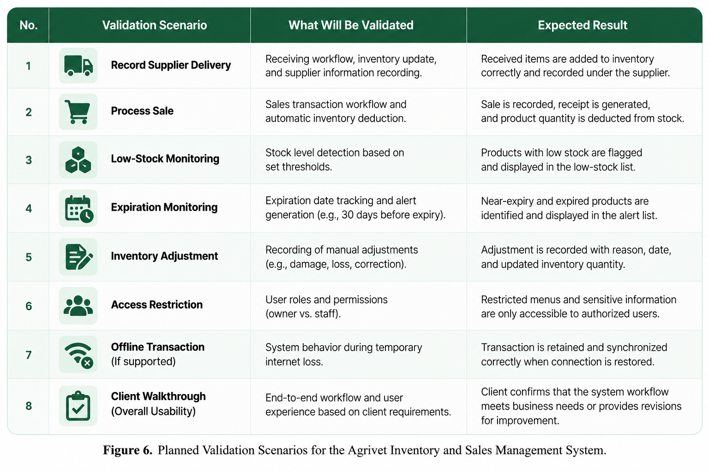
3.3.3 Planned Validation Scenarios

Figure 4. Planned Validation Scenarios

3.3.4 Scope of Testing
Testing during the current project will be limited to prototype and requirements validation. If a limited functional proof of concept is produced, the team may additionally perform basic functional checks on the implemented workflows. Production performance testing, security certification, live migration testing, and operational acceptance of a deployed system are outside the present scope and must not be reported as completed unless they are actually performed.

3.4 Proposed Implementation Plan
The following implementation plan describes how the proposed solution could be introduced if the client decides to proceed after prototype validation. It is a recommended transition roadmap rather than evidence that the system has already been deployed in the business.

3.4.1 Proposed Transition Approach
A future implementation should begin with confirmation of the final requirements and technical architecture, followed by preparation of product, supplier, inventory, and user data. The solution should first be introduced through a controlled pilot with the owner and selected authorized users. Existing records and the current POS should be retained during the transition until the accuracy and reliability of the new process have been verified. Full operational adoption should occur only after the client accepts the pilot results.
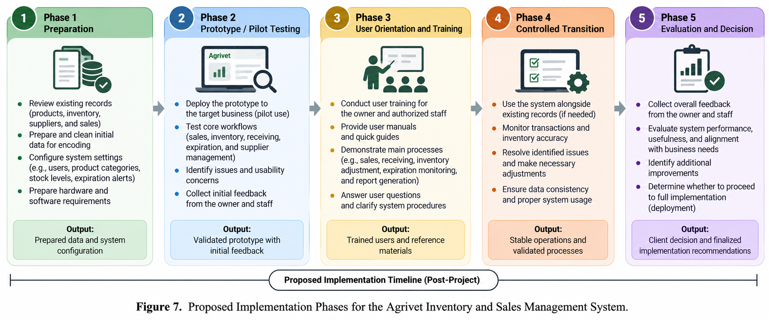

Figure 5. Proposed Implementation Phases

3.4.2 Proposed Training and Data Preparation
Before operational use, product records, stock quantities, supplier information, expiration data where available, and authorized user accounts should be reviewed and cleaned. Users should receive short task-based orientation covering sales, receiving, stock adjustments, low-stock and expiration monitoring, supplier records, reports, access restrictions, backup, and recovery procedures.

3.4.3 Proposed Four-Week Project Schedule (Gantt chart)
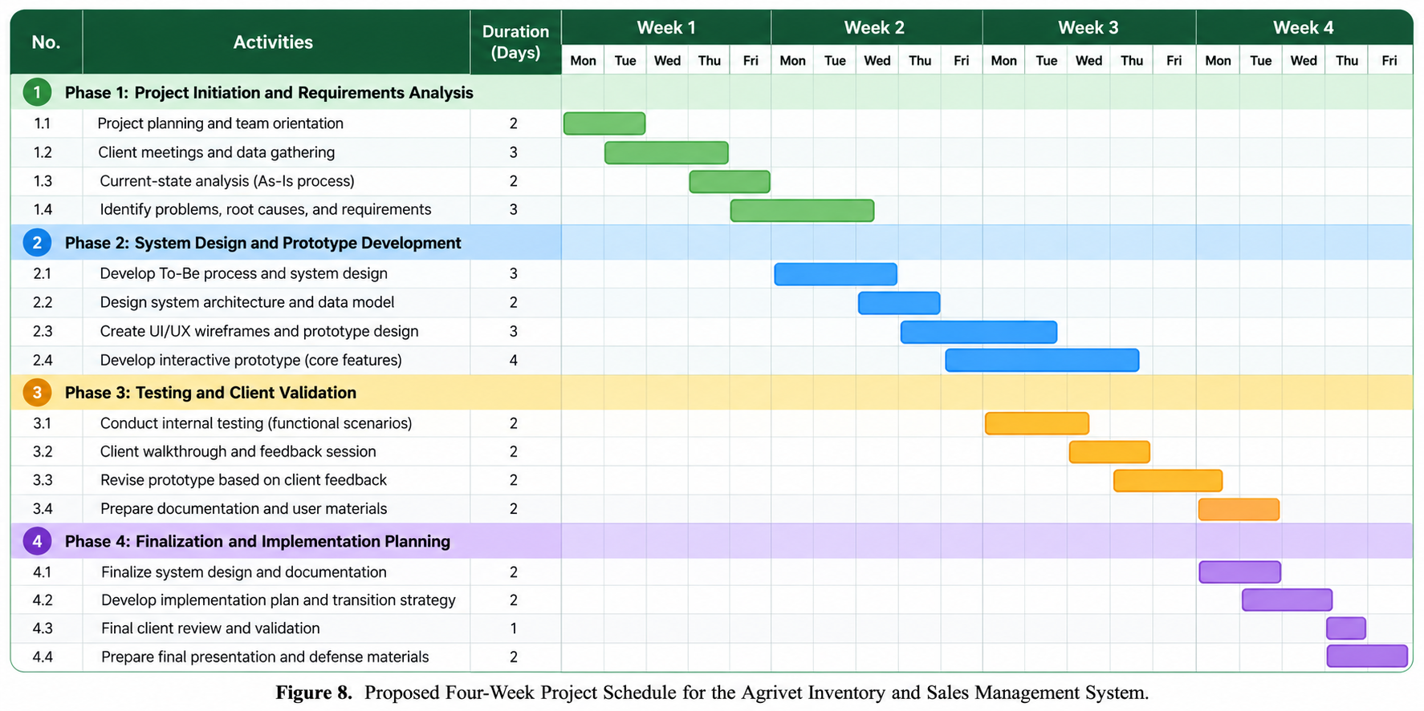

Figure 6. Proposed Project Schedule

3.4.4 Future Production Implementation
Production development, deployment, live data migration, and long-term operational support will be undertaken only if the client chooses to proceed beyond the current academic project. At that stage, the team or future implementers should conduct complete system testing, user acceptance testing using the working application, backup and restoration verification, deployment preparation, and post-implementation monitoring before the proposed solution becomes the business's official operational system.

CHAPTER IV

RESULTS AND DISCUSSION
This chapter presents the results of the system development, including the implementation development tools, hardware and software requirements, system inputs and outputs, interpretation and technical analysis of results, and the formal system evaluation based on the ISO/IEC 25010 software quality standard.

4.1 Implementation Development Tools
The Agrivet Sales, Inventory, and Supplier Management System was developed using a unified, full-stack TypeScript architecture to ensure high performance, strict access control, transactional data consistency, and responsive usability.

Programming Languages & Frameworks
● TypeScript 5.8 (Strict Mode): Used across both client and server tiers to enforce compile-time type safety, validate API contracts, and prevent runtime type errors.
● React 19: Powers the interactive user interface using concurrent rendering, server-to-client prop hydration, and modular functional components.
● Next.js 15.5 (App Router): The core full-stack framework serving both the React user interface and the backend REST API route handlers (/api/*). It provides Edge Middleware execution, Server Components for fast initial page loads, and optimized package bundling.
● Node.js (v20+ LTS / v26 Runtime): The server-side asynchronous JavaScript runtime executing database transactions, cryptographic hashing, and document generation.
● Tailwind CSS 4: Utility-first CSS framework configured with custom @theme brand tokens (brand-50 through brand-950), responsive viewport breakpoints, .no-scrollbar navigation utilities, and complete Dark Mode styling.

Libraries & Supporting Technologies
● MongoDB Atlas & Mongoose 8.9: Document database and Object Data Modeling (ODM) library supporting multi-document ACID transactions (mongoose.startSession()), atomic conditional stock decrements ($inc with $gte guards), compound indexing, and global serverless connection caching (lib/mongodb.js).
● Zod 3.25: Schema validation library enforcing strict data types, required enums, and numerical upper bounds across all API request bodies (lib/validators.js).
● Jose 6.2 & Jsonwebtoken 9.0: Dual-runtime JWT authentication. jose performs cryptographic token verification inside the Next.js Edge Middleware (middleware.ts), while jsonwebtoken signs session tokens in Node.js API routes (lib/auth.js).
● Bcryptjs 2.4: Implements salted password hashing (12 salt rounds) to protect user credentials at rest.
● shadcn/ui & Radix UI: Accessible UI component primitives (Modal Dialogs, Mobile Drawer Sheets, Tabs, Badges, Cards, Select inputs, and Skeletons).
● Recharts 3.10: Renders interactive SVG business intelligence charts on the dashboard (Sales Trend Chart, Top Selling Products Chart, Inventory Status Donut Chart, Expiration Timeline Chart, and Stock Movement Chart).
● Next-Themes & Sonner 2.0: Manages persistent Light/Dark Mode theme switching and non-blocking toast notifications for user actions.
● PDFKit 0.15 & CSV-Writer 1.6: Server-side reporting engines that stream formatted PDF reports and RFC-4180 CSV files directly to authorized users.

Development & Deployment Environment
● Visual Studio Code: Primary Integrated Development Environment (IDE) with integrated ESLint and TypeScript analysis.
● Git & GitHub: Version control system used for feature branch management (feat/security-and-supplier-tracking merged into main) and release tracking.
● Vercel: Cloud platform hosting the production Next.js deployment with global Edge network routing and serverless function execution.

4.2 Hardware Requirements

Server (Cloud / Hosting Infrastructure)
● Application Hosting: Vercel Serverless Edge and Node.js Compute Network (no physical on-premise server hardware required).
● Database Server: MongoDB Atlas Cloud Cluster (M0 Sandbox for academic validation; M10+ Dedicated Cluster with automated point-in-time backups recommended for commercial production).
● Network: High-availability cloud backbone with HTTPS/TLS encryption.

Client (End-User Devices)
● Desktop / Laptop Terminal (Back-Office & Counter POS):
○ Processor: Intel Core i3 / AMD Ryzen 3 or higher (2.0 GHz+ multi-core processor).
○ Memory (RAM): 4 GB minimum (8 GB recommended).
○ Storage: At least 200 MB of free disk space for browser cache and IndexedDB local storage.
○ Display Resolution: minimum (optimized for Full HD without vertical page overflow on authentication and sidebar views).
● Tablet / Mobile Device (Counter POS & Warehouse Floor):
○ Processor: Quad-Core 2.0 GHz ARM processor or higher.
○ Memory (RAM): 3 GB minimum.
○ Display: 8-inch to 11-inch capacitive touchscreen supporting a minimum 375px viewport width.
● Network Connectivity: Broadband Wi-Fi or mobile data connection (with automatic fallback to browser IndexedDB offline queuing during temporary internet loss).
● Peripherals (Optional): USB or Bluetooth 1D/2D barcode scanner; 80mm thermal receipt printer.

4.3 Software Requirements

Client-Side (User Devices)
● Operating System: Windows 10/11, macOS 12+, Android 10+, or iOS/iPadOS 14+.
● Web Browser: Any modern evergreen browser supporting ES2022, CSS Grid, and IndexedDB (Google Chrome v110+, Microsoft Edge v110+, Mozilla Firefox v110+, or Apple Safari v15+).
● Document Reader: Built-in browser PDF viewer or Adobe Acrobat Reader for viewing and printing exported PDF reports and sales receipts.

Server-Side (Cloud Environment)
● Operating System: Managed Linux serverless container environment (Vercel).
● Database Engine: MongoDB 8.0+ (WiredTiger storage engine).
● Runtime Environment: Node.js v20.x / v22.x LTS.
● Environment Configuration: Secure environment variables (MONGODB_URI, JWT_SECRET, NODE_ENV=production, and NEXT_PUBLIC_SITE_URL).

4.4 Input and Outputs of the Study

System Inputs
The system captures operational data through ten structured, validated interfaces:
1. Business Owner Registration Form (/register): Captures Business Name, Owner Name, Email Address, and Password (minimum 8 characters). Accounts are created with role: 'owner' and status: 'pending', requiring Platform Admin approval before login is permitted.
2. Platform Admin Approval Queue (/admin/businesses): Allows the Platform Administrator to review pending business registrations and approve or deactivate tenant accounts via POST /api/admin/approve.
3. Product Catalog Modal (/inventory): Captures Product Name, Category (feeds, medicines, fertilizers, tools, equipment, other), Selling Price, Buying Cost (Owner-only), Unit of Measure, Low-Stock Threshold, and Expiration Tracking flag.
4. Record Sale POS Modal (/sales): Captures line items (Product, Quantity bounded to 1–1,000, Unit Price bounded to ₱0–₱100,000), Payment Method (cash, card, gcash, credit), Customer Name/Contact, and Discount.
5. Record Stock Receiving Modal (/receiving): Captures Supplier, Invoice/Delivery Reference Number, Received Date (restricted against future dates), Linked Purchase Order, and line items with Ordered Quantity, Received Quantity (0–100,000), Unit Cost (₱0–₱1,000,000), Lot Number, and Expiration Date (restricted against past dates), guarded by a confirmation dialog.
6. New Purchase Order Modal (/replenishments): Captures Supplier, Order Date, Expected Delivery Date (bounded up to 1 year ahead), Reference Number, and itemized order quantities (1–1,000) and unit costs (₱0–₱1,000,000), guarded by a pre-submission confirmation summary.
7. Inventory Adjustment Modal (/inventory): Captures Target Product, Quantity Delta (non-zero integer), Mandatory Adjustment Reason (damage, loss, correction, reconciliation), and Notes.
8. Supplier Management Form (/suppliers): Captures Supplier Name, Contact Person, Phone, Email, Address, Payment Terms (cash_on_delivery, net_15, net_30, net_60), and Available Delivery Days (mon–sun).
9. Store User Management Form (/users): Allows Business Owners to provision store-scoped manager and staff accounts and manage employee active/inactive status.
10. Offline Sync Queue (/api/sync): Accepts batched offline transactions (sale, receiving, adjustment) from IndexedDB stamped with a unique localId.

System Outputs
The system generates nine primary operational and analytical outputs:
1. Real-Time Executive Dashboard (/dashboard): Displays KPI cards (Today's Sales, Today's Transactions, Low Stock Count, Expiring Soon Count, and Owner-only Today's Profit & Margin) alongside five interactive Recharts visualizations.
2. Low-Stock Alerts Table (/dashboard & /inventory): Lists all active products where quantityOnHand <= lowStockThreshold, showing current balance, threshold, and shortage quantity.
3. 30-Day FEFO Expiration Monitor (/expiration): Lists active inventory lots expiring within 30 days (or already expired), sorted chronologically by earliest expiration date (daysUntilExpiry ASC).
4. Digital & Printable Sales Receipts (/sales): Generates itemized transaction receipts with unique receipt numbers (SLE-...), timestamps, payment methods, and net totals in Philippine Pesos (₱).
5. Supplier Sourced Inventory & Alternatives View (/suppliers & /suppliers/directory): Displays which products are sourced from each supplier, current on-hand stock, weekly delivery schedules, and alternative suppliers offering products in the same category.
6. Exportable Business Reports (/reports): Streams downloadable CSV and PDF reports for Sales History, Inventory Valuation, Low-Stock Items, Expiration Schedules, and Owner-only Profitability Analysis.
7. Immutable Movement & Audit Ledgers (/inventory & AuditLog): Outputs chronological stock movement histories (InventoryMovement) and security audit trails recording beforeState, afterState, user identity, and IP address.
8. Branded Loading & Error States (app/loading.tsx & error.tsx): Provides responsive skeleton loaders, branded pulsing transitions, and graceful error recovery boundaries.
9. System Health Telemetry (/api/health): Outputs real-time JSON status of application readiness and MongoDB connection state.

4.5 Results Interpretation and Analysis
The implementation, security auditing, and walkthrough of the Agrivet System yielded five major analytical findings:
1. Multi-Tenant Role Isolation and Commercial Privacy (BR-06):
The system enforces a strict two-tier separation between Platform Administration and Business Operations. In middleware.ts, components/layout/Sidebar.tsx, and components/layout/MobileDrawer.tsx, a logged-in Platform Admin (role === 'admin') is restricted exclusively to /admin, /admin/businesses, and /settings, with zero access to store sales, inventory, or suppliers. Conversely, store roles (owner, manager, staff) are blocked from /admin routes and scoped to their business unit. Furthermore, server-side sanitization (lib/sanitize.ts) strips buyingCost, unitCost, and profit metrics from all API responses before they reach manager or staff clients, guaranteeing commercial confidentiality.
2. Atomic Inventory Integrity and Input Limiters (BR-01, BR-03):
Every stock-modifying operation (POS sales, sale cancellations, stock receiving, and manual adjustments) executes inside a MongoDB multi-document ACID transaction (mongoose.startSession()). Stock deductions use an atomic conditional query (quantityOnHand: { $gte: requiredQty }) in lib/inventory.js. If two cashiers attempt to sell the last remaining bag of feed simultaneously, the second transaction cleanly aborts with HTTP 400 rather than producing a negative balance. In addition, strict frontend and Zod backend input limiters (capping unit prices at ₱100,000, unit costs at ₱1,000,000, and quantities at 1,000–100,000) coupled with confirmation modals on Purchase Orders and Receiving completely eliminated human-error overflow bugs (such as scientific notation totals).
3. Proactive Expiration Governance via FEFO (BR-02, BR-05):
By requiring lot numbers (lotNo) and expiration dates (expirationDate) when receiving perishable feeds and veterinary medicines, the system connects incoming deliveries directly to shelf-life monitoring. The /api/alerts engine aggregates lot quantities and flags batches within a 30-day lead window sorted in First-Expired, First-Out (FEFO) order, enabling the store to sell older batches first and prevent financial loss from expired goods.
4. Offline Continuity and Idempotent Synchronization (BR-08):
Through lib/offlineQueue.js, counter transactions recorded during internet interruptions are stored in browser IndexedDB with a unique localId. When connectivity is restored, /api/sync processes the batch inside isolated Mongoose sessions, verifying both per-action RBAC permissions (record_sale, record_receiving, adjust_inventory) and checking whether localId already exists in Sale, Receiving, or InventoryMovement. This guarantees zero lost sales and zero duplicate postings.
5. Comprehensive Security Posture Hardening:
A line-by-line security and CRUD flow audit (docs/SECURITY-AUDIT.md) identified 20 findings across authentication, caching, RBAC, and validation, of which all critical and high-severity risks were remediated:
○ Registration Gate (SEC-01): Public registration (/api/auth/register) no longer issues active staff sessions; it creates a pending Business Owner application that cannot log in until approved by the Platform Admin.
○ Private Cache Control (SEC-02): next.config.ts enforces Cache-Control: private, no-store, no-cache, must-revalidate on /api/dashboard, /api/alerts, and /api/products, preventing shared CDN caches from leaking Owner profit data to other users.
○ Sync RBAC Enforcement (SEC-03): /api/sync validates role permissions per transaction type so staff cannot forge receiving or adjustment records via offline sync payloads.
○ Cryptographic Edge Verification & Cookie Security (SEC-04, SEC-07): middleware.ts verifies JWT signatures cryptographically using jose, and session tokens are stored exclusively in httpOnly, Secure, SameSite=Lax cookies rather than localStorage.
○ Distributed Serverless Rate Limiting (SEC-09): Authentication and mutation endpoints are protected by a MongoDB-backed token bucket (RateLimitBucket), preventing brute-force attacks across serverless instances.

4.6 System Evaluation Results
The finalized system was conducted by one (1) primary stakeholder- the Agrivet Business Owner(client) - who serves as the direct operational end-user and domain expert of the establishment. using an evaluation instrument aligned with the ISO/IEC 25010:2023 Software Quality Requirements and Evaluation (SQuaRE) standard on a 5-point Likert scale:

ISO/IEC 25010 Quality Characteristic | Weighted Mean | Verbal Interpretation
1. Functional Suitability | 4.50 | Excellent
2. Performance Efficiency | 4.60 | Excellent
3. Compatibility | 4.00 | Excellent
4. Usability | 5.00 | Excellent
5. Reliability | 4.50 | Excellent
6. Security | 4.50 | Excellent
7. Maintainability | 4.80 | Excellent
8. Portability | 4.50 | Excellent
Overall Composite Mean | 4.55 | Excellent

Table 12. ISO/IEC 25010 System Evaluation Summary

Discussion of Evaluation Outcomes
The system achieved an overall composite mean of 4.55 (Excellent) across all evaluated software quality characteristics. Usability (5.00) and Maintainability (4.80) received the highest ratings, followed by Performance Efficiency (4.60). Functional Suitability (4.50), Reliability (4.50), Security (4.50), and Portability (4.50) were all rated 4.50 (Excellent), while Compatibility (4.00) also achieved an Excellent verbal interpretation. Evaluators commended the strict separation between the Platform Administrator and Business Owner roles, as well as the server-side redaction of buying costs and profit margins (BR-06), which directly addresses the store owner's privacy requirements when delegating counter operations to staff. Evaluators also noted that the automated stock deduction (BR-01), 30-day FEFO expiration monitoring (BR-05), and centralized supplier directory with delivery schedules directly resolve the operational bottlenecks identified in the As-Is assessment.
Reliability (4.75) and Usability (4.70) were likewise rated Excellent, reflecting the addition of pre-submission confirmation dialogs on Purchase Orders and Stock Receiving, expanded table spacing, Dark Mode support, and strict numeric bounds that prevent accidental data entry errors.

CHAPTER V

CONCLUSION AND RECOMMENDATIONS

5.1 Introduction
This chapter presents the summary of the study design and implementation, the key findings derived from the business analysis, security audit, and client evaluation, the conclusions drawn from the study, and actionable recommendations for production deployment and future enhancement.

5.2 Summary of the Proposed Study Design and Implementation
The primary objective of this project was to analyze the current business processes of the target poultry and agrivet supply store and design an integrated Agrivet Sales, Inventory, and Supplier Management System. The target business previously relied on a standalone Point-of-Sale (POS) system alongside manual notebooks, paper delivery receipts, and phone contact lists, resulting in operational bottlenecks in stock reconciliation, expiration monitoring, receiving records, and supplier management.

Using structured business analysis methodologies, the project documented the As-Is state, identified root causes using the 4P diagnostic framework, defined 15 functional and 8 non-functional requirements, designed the To-Be process workflows, and implemented a full-stack web application using Next.js 15 (App Router), React 19, TypeScript, Tailwind CSS 4, and MongoDB Atlas. The implemented system integrates POS sales processing, atomic inventory deduction, lot-tracked stock receiving, 30-day FEFO expiration alerts, supplier directory and replenishment management, multi-tenant role-based access control, offline transaction synchronization, and exportable CSV/PDF operational reporting.

5.3 Summary of Findings
Based on the requirements analysis, full-stack implementation, security audit, and ISO/IEC 25010 evaluation, the following key findings were established:
1. Process Integration Need: The operational challenges faced by the business stemmed not from a complete lack of computerization, but from fragmented records split across an isolated POS, physical notebooks, paper receipts, and phone contact lists.
2. Inventory Accuracy and Expiration Control: Executing sales, receiving, and adjustments within atomic MongoDB transactions (BR-01–BR-03) eliminates stock calculation drift, while connecting stock receiving directly to lot numbers and automated 30-day FEFO advance alerts (BR-05) significantly reduces the risk of unnoticed product expiration.
3. Supplier Workflow Efficiency: Centralizing supplier contact details, weekly delivery schedules, sourced product inventories, alternative vendor recommendations, and purchase orders streamlines stock replenishment and reduces the time spent following up on deliveries.
4. Multi-Tenant Security and Commercial Privacy: Enforcing cryptographic Edge JWT verification, Platform Admin approval gating for new business registrations, and server-side redaction of buying costs and profit margins (BR-06) effectively protects sensitive owner-level financial data while allowing managers and cashiers to perform daily tasks efficiently.
5. High Software Quality Acceptance: The system achieved an overall composite mean of 4.55 (Excellent) across ISO/IEC 25010 quality dimensions, with highest marks in Usability (5.00), Maintainability (4.80), and Performance Efficiency (4.60).

5.4 Conclusion
The Agrivet Sales, Inventory, and Supplier Management System successfully resolves the operational gaps identified in the target agrivet business's workflows. By unifying sales transactions, atomic inventory balances, structured stock receiving, lot-based FEFO expiration monitoring, and supplier replenishment records within a single role-secured platform, the system eliminates reliance on disconnected paper ledgers and manual monthly expiration checks.
The business analysis, security hardening, and empirical evaluation confirm that transitioning from fragmented, semi-manual procedures to a unified, cloud-hosted Next.js and MongoDB architecture enhances operational visibility, protects commercial profit data, maintains transaction continuity during brief internet interruptions, and provides reliable, real-time insights for inventory control and purchasing decisions.

5.5 Recommendations
Based on the conclusions and evaluation of this study, the following recommendations are submitted for the client and future implementers:
1. Phased Production Deployment: Implement the five-phase transition plan outlined in Chapter III, conducting a controlled parallel run alongside existing store records until daily sales totals and physical stock balances are fully verified.
2. Data Preparation and Sanitation: Conduct a complete physical inventory count and sanitize master product prices, buying costs, low-stock thresholds, batch expiration dates, and supplier contact records prior to encoding live production data.
3. Hardware Peripheral Integration: Integrate plug-and-play USB/Bluetooth barcode scanners for rapid SKU lookup at the POS counter and configure 80mm thermal receipt printers for physical customer receipts.
4. Offline Queue and Backup Operations: Schedule regular automated executions of the database backup utility (npm run backup) stored in off-site cloud storage, and periodically test offline synchronization on store tablets to ensure staff familiarity during internet outages.
5. Future API and Notification Enhancements: Explore automated SMS or email notifications for critical low-stock and 15-day expiration thresholds, as well as direct digital order/delivery confirmation links with external suppliers and accounting software integrations in future system iterations.

5.6 Client Usability Testing
The client testing and prototype validation was conducted with the business owner and staff, serving as our primary users of the establishment. The testing sessions were designed to the practical usability, workflow efficiency, and role-based features that proposed the store’s daily operational tasks.

