Assignment One: Agronomy 508

Kelsie Ferin and Theo Hartman

March 3, 2018

## Assignment 1

### Part 1: Example problem from the physics text book (pg. 105)

Below are the constants that will be used throughout the first part of the code.

# Planck's constant [Js]  
h=6.62606896e-34  
# speed of light [m/s]  
c=2.99792458e8   
# Boltzman constant [J/K]  
k=1.3806504e-23   
# temperature used for sun in example [K]  
T = 5800

To calculate the following equations of a blackbody with a different waveband, change sequence range for lambda! This gives us the range from 600-605nm.

# the following lambda will not be used, this is for the entire spectrum of visible light  
#lambda = seq(3.4e-7,8.05e-7, by=1e-10)  
  
# this lambda sequence is for the band of wavelengths used in the example problem [currently in meters]  
lambda = seq(6.0e-7,6.05e-7, by=1e-10)

The following 3 equations are for each 3 steps in the example problem.

Equation 1: The exponential portion of Planck’s equation. This is unitless.

$y=\frac{hc}{λkT}$

# Equation 1  
y = (h*c)/(lambda*k*T)  
plot(lambda,y,xlab='Wavelength (m)',ylab='Plancks Exponential',main='Exponential from Plancks Equation')

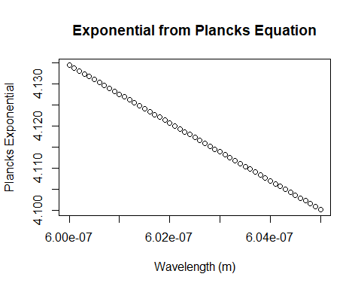

Equation #2: Spectral Emittance of the sun (I; W/m^2/m)

$I=\frac{2πhc^{2}}{λ^{5}e^{y}−1}$

I=((2*pi)*(h)*(c**2)/((lambda**5)*(exp(y)-1)))  
plot(lambda,I,xlab='Wavelength (m)',ylab='Spectral Emittance (W/m^2/m)',main='Spectral Emittance over specified wavelenghts')

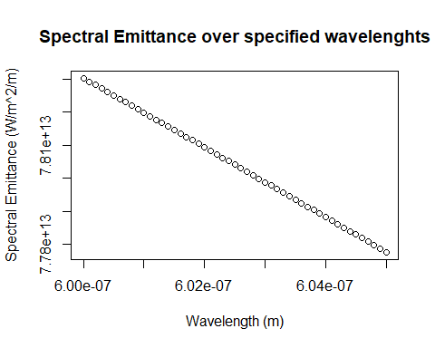

Equation #3: This plot is the intensity (MW/m^2) for the given spectral emittance (W/m^2/m) values calculated in equation 2.

$I(λ)=I[max(λ)−min(λ)]*{10}^{−6}$

The solid grey line is the median value for intensity.

Ilambda = (I*(max(lambda)-min(lambda)))*1e-6  
plot(I,Ilambda,xlab='Spectral Emittance (W/m^2/m)',ylab='Intensity (MW/m^2)',main='Intensity for range of spectral emittance')  
abline(h=median(Ilambda))

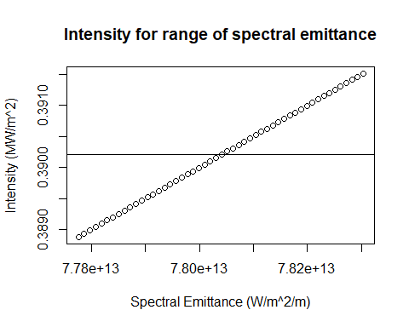

The next thing we are going to plot is how intensity changes throughout the wavelength band. The solid grey line is the median value for intensity.

plot(lambda,Ilambda,xlab='Wavelenght (m)',ylab='Intensity (MW/m^2)',main='Intensity for range of wavelengths')  
abline(h=median(Ilambda))

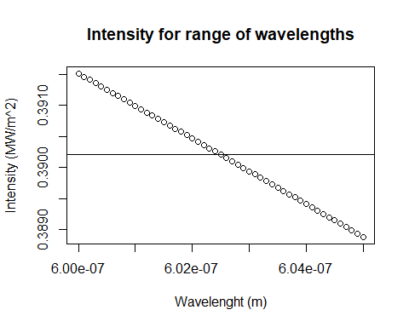

### Part 2: Power within a waveband

Here we will compare the total amount of power of the blackbody calculation to the data collected from the spectral radiometer in class. Just as a reminder, spectral emittance is what Plancks’s Law gives for the sun with this temperature. Spectral irradience is what is measured here on Earth. These values will NOT be the same due to Earth’s atmosphere and its absorbtion in some wavelengths

The equations in part 1 use [m] for the wavelengths. We need to convert these to nm to stay consistent with the collected data.

lambda_nm=lambda*1e+9  
I_new = I/1e+9  
plot(lambda_nm,I_new,xlab='Wavelength (nm)',ylab='Spectral Emittance (W/m^2/nm)',main='Spectral emittance over range of wavelenths (in nm)')

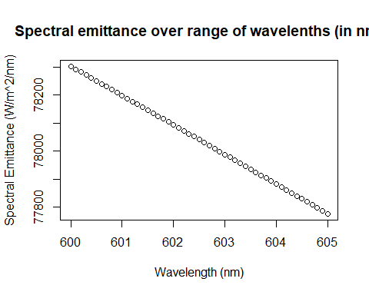

Now we need to use the values collected during class. The following chunk of code is from Anabelle:

# Some cleaning  
data<-tab[2:482,] # select rows  
data<-data %>% rename(waveL=Timestamp) # rename column   
data$waveL<-as.numeric(as.vector(data$waveL)) # to get a x_continous scale, data need to be numeric not factor  
  
#Plot the Spectral Irradiance as a function of wavelength (nm)  
time<-data[,82]# here I just pick a column randomly  
#class(time)  
# time has to be converted into numeric   
time<-as.numeric(unlist(time)) # I used unlist to convert all the element to a single numeric vector  
ggplot(data=data,aes(x=waveL,y=time))+  
 geom_line() +  
 scale_x_continuous(breaks = round(seq(min(data$waveL), max(data$waveL), by = 100),1)) +  
 scale_y_continuous(breaks = round(seq(min(time), max(time), by = 0.005),1)) +  
 ggtitle("Spectral irradiance from class") +  
 xlab("wavelength (nm)") +  
 ylab(expression(paste("Spectral Irradiance (W/m2/nm)")))

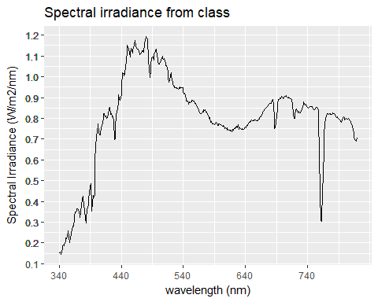

Here we are taking the data from the data.frame and putting it in a form of array where we can use it in the plot function (instead of using ggplot2):

irradiance = time  
wavelength = data$waveL  
plot(wavelength,irradiance,type="o",xlab='Wavelength (nm)',ylab='Spectral Irradiance (W/m^2/nm)',main='Spectral irradiance of data collected in class')

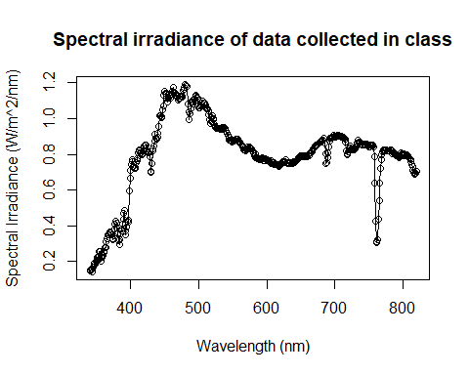

sum(irradiance)*diff(wavelength)[1]

## [1] 383.9243

We only want to use the wavelength band of 600-605nm to compare to the black body, which is shown in the following plot.

irradiance_data = irradiance[261:266]  
band_data = data$waveL[261:266]  
plot(band_data,irradiance_data,type="o",xlab='Wavelength (nm)',ylab='Spectral Irradiance (W/m^2/nm)',main='Spectral Irradiance from Collected Data')

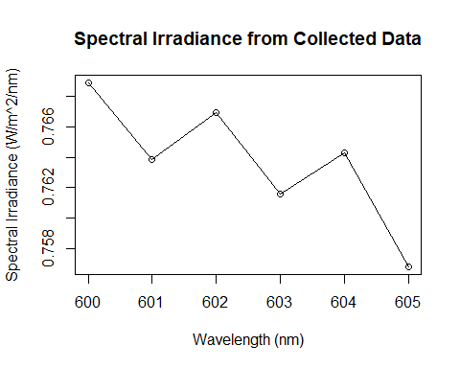

plot(lambda_nm,I_new,type="o",xlab='Wavelength (nm)',ylab='Spectral Emittance (W/m^2/nm)',main='Spectral Emittance from Textbook')

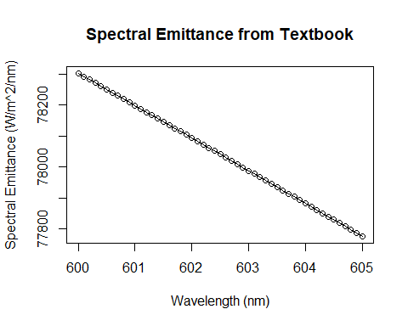

Lastly, we need to integrate the area under the curve for both the blackbody and observed values:

# Blackbody Integration (emittance)  
bb_E_integ = sum(I_new)*diff(lambda_nm)[1]  
cat("Blackbody value of total power: ", bb_E_integ, "W/m^2")

## Blackbody value of total power: 398006.3 W/m^2

# Observed Integration (irradiance)  
obs_I_integ = sum(irradiance_data)*diff(band_data)[1]  
cat("Observed value of total power: ", obs_I_integ, "W/m^2")

## Observed value of total power: 4.58241 W/m^2

If we were to calculate the total power for the entire band of wavelengths we would get:

T2 = 6000  
lambda2 = seq(3.4e-7,8.05e-7, by=1e-10)  
y2 = (h*c)/(lambda2*k*T2)  
I2=((2*pi)*(h)*(c**2)/((lambda2**5)*(exp(y2)-1)))  
plot(lambda2,I2,xlab='Wavelength (m)',ylab='Spectral Emittance (W/m^2/m)',main='Spectral emmittance for visible range')

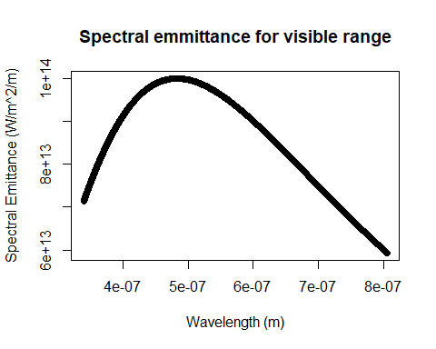

tot = sum(I2)*diff(lambda2)[1]  
cat("Observed value of total power: ", tot, "W/m^2")

## Observed value of total power: 39582472 W/m^2

### Part 3: Example problem; Photons required for sight!

First, we define the constants that will be used in these calculations:

#Intensity of radiation reaching the eye in order for the human eye to percieve light.  
I_eye = 4.0e-11 # Units - W/m^2  
  
#The following are called in the beginning of the assingment:  
#Plancks Constant: h = 6.63e-34 # Units - J*s  
#Speed of light in a vacuum: c = 3.0e8 # Units - m/s

Secondly, we calculate the area of the pupil:

$A_{pupil}=π(\frac{d}{2})^{2}$

(According to NCBI the diameter of a human pupil ranges from 2 mm to 8mm)

#Diameter of a human pupil  
d = seq(2,8,by = 1) # Units - mm  
  
#Convert the diameter to meters  
d = d*1e-3 # Units - m   
  
#Calculate the pupil area  
pupil_area = pi*((d/2)^2) # Units - m^2

Third, we calculate the power reaching the eye:

$PowerReached=Intensity*A_{pupil}$

#Power reaching the eye  
Power_reach_eye = I_eye*pupil_area # Units - W

Fourth, we calculate the energy of a photon for wavelengths in the visible spectrum:

$e=\frac{hc}{λ_{pupil}}$

#Range of wavelength in the visible spectrum  
#lam_pupil = seq(380e-9,780e-9,by = 1e-9) #Units - m  
lam_pupil = array(c(455e-9,492e-9,577e-9,597e-9,622e-9,780e-9))  
  
#Energy of a photon  
e = (h*c)/lam_pupil #Units - J

Fifth, we calculate the amount of photons reaching the eye:

$PhotonsReached=\frac{PowerReached}{e}$

#Create Vector for Calculations  
Photons_reach_eye = matrix(0,6,7)  
  
#Number of photons reaching the eye  
for(i in 1:6){  
 for(j in 1:7){  
 Photons_reach_eye[i,j] = Power_reach_eye[j]/e[i] #Units - photons/s  
 }  
}  
   
Photons_reach_eye = t(Photons_reach_eye)

Sixth, we plot the results of this experiment:

#Set data up in a frame to plot  
#data_pup = data.frame(x = lam_pupil,y1 = Photons_reach_eye[,1], y2 = Photons_reach_eye[,2], y3 = #Photons_reach_eye[,3], y4 = Photons_reach_eye[,4], y5 = Photons_reach_eye[,5], y6 = #Photons_reach_eye[,6], y7 = Photons_reach_eye[,7])  
  
#Plotting   
col_set = c("Violet","Blue","Green","Yellow","Orange","Red")  
palette(col_set)  
matplot(pupil_area,Photons_reach_eye,type = "l",main = "Photons That Reach The Human Eye at Different Wavelengths with Different Pupil Sizes",cex.main = .8,xlab = "Pupil Area (m^2)",ylab = "Number of Photons",lty = "solid", lwd = "2",col = col_set)  
leg.txt <- c("Wavelength = 455 nm","Wavelength = 492 nm","Wavelength = 577 nm","Wavelength = 597 nm","Wavelength = 622 nm","Wavelength = 780 nm")  
cex = .5  
legend(pupil_area[1],Photons_reach_eye[7,6],leg.txt,cex = .5,lwd = 2, col = col_set)

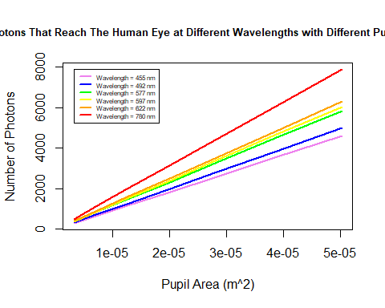

The equation to convert the number of photons to PPF is:

$PPF=\frac{NumberofPhotons}{(AvogadrosNumber){10}^{6}}$

#Lets convert these numbers into PPF to be able to compare them to what we know  
  
PPF_eye = (Photons_reach_eye /(6.02e23) * 1e6)  
  
#Now let's plot the results of this, like we plotted the others  
#Plotting   
col_set = c("Violet","Blue","Green","Yellow","Orange","Red")  
palette(col_set)  
matplot(pupil_area,PPF_eye,type = "l",main = "PPF That Reaches The Human Eye at Different Wavelengths with Different Pupil Sizes",cex.main = .8,xlab = "Pupil Area (m^2)",ylab = "PPF (micromoles/s)",lty = "solid", lwd = "2",col = col_set)  
leg.txt <- c("Wavelength = 455 nm","Wavelength = 492 nm","Wavelength = 577 nm","Wavelength = 597 nm","Wavelength = 622 nm","Wavelength = 780 nm")  
cex = .5  
legend(pupil_area[1],PPF_eye[7,6],leg.txt,cex = .5,lwd = 2, col = col_set)

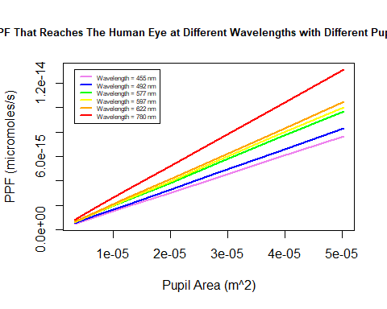

## Now Let’s Use The Measured Spectrum To See How Many Photons Our Eyes Were Intercepting

#Because we can calculate the number of photons by taking the Intensity of the Radiation in our pupil divided by the energy of a photon at that wavelength, we can take the intensity measured divided by the power at that wavelength and come up with a total number of photons!  
  
#Lets assume a pupil size of 6mm  
#Calculating the Intensity of radiation hitting your eye  
Intensity_pupil = time * pupil_area[5] #Units - W  
  
#Calculating the photon energy of the wavelengths that we measured  
  
e_meas = (h*c)/(wavelength*1e-9) #Units - J  
  
#Now to calculate the number of photons that are making it to our eyes  
  
Photons_reach_eye_measured = Intensity_pupil/e_meas#Units - Photons/s  
  
#If we sum up all of the photons from every wavelength, we see about how many photons per second are hitting our eyes  
  
Total_Photons = sum(Photons_reach_eye_measured)#Units - Photons/s  
cat("Total Photons Reaching Our Eyes With Our Measured Data:", Total_Photons," Photons/s")

## Total Photons Reaching Our Eyes With Our Measured Data: 3.219702e+16 Photons/s

### Some comments on the assumptions made here: We assumed that all of the incident radiation makes it into our eyes. We are also assuming that the minimum intensity of radiation needed for sight is the same for all wavelengths.