Assignment1

## Assignment1 Main

This is the main file for Assignment 1. Hello.

h=6.62606896e-34  
c=2.99792458e8  
k=1.3806504e-23   
lambda = seq(1e-8,1e-4, by=1e-8)  
T = 5770  
  
  
y=(2*pi*h*(c^2))/(lambda^5)*(1./(exp((h*c)/(lambda*k*T))-1))  
  
  
T2 = 288  
y2=(2*pi*h*(c^2))/(lambda^5)*(1./(exp((h*c)/(lambda*k*T2))-1))  
plot(1e6*lambda,1e-6*1e-6*y, xlim=c(0.0,5.0),ylim=c(0.0,100.0), xlab='Wavelength (um)', ylab='spectral emittance (MW/m2/um)')

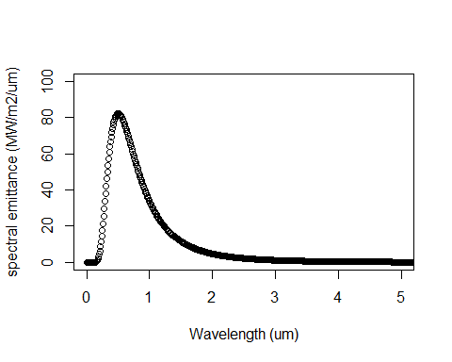

# par(new=T)  
# plot(1e6*lambda,1e-6*1e-6*y2, xlim=c(0.0,10.0), ylim=c(0.0,1/10000.0), xlab='', ylab='', axes=F)  
# par(new=F)  
plot(1e6*lambda,1e-6*1e-6*y2, xlim=c(0.0,50.0), ylim=c(0.0,3*1e-5), xlab='Wavelength (um)', ylab='spectral emittance (MW/m2/um)')

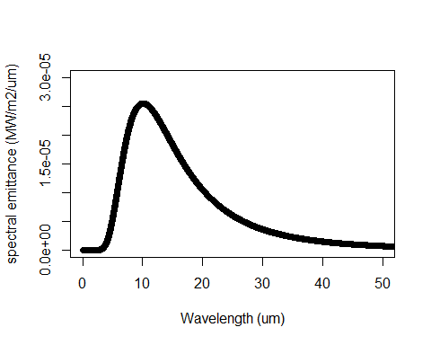

totalflux=sum(y)*5.25*1e-26  
solarpower=3.87e26  
solarirradiance=solarpower/6.09e18  
ratio=1368/solarirradiance  
plot(1e6*lambda,1e-3*1e-6*y*ratio, xlim=c(0.0,3.0),ylim=c(0.0,3.0), xlab='Wavelength (um)', ylab='spectral emittance (kW/m2/um)')

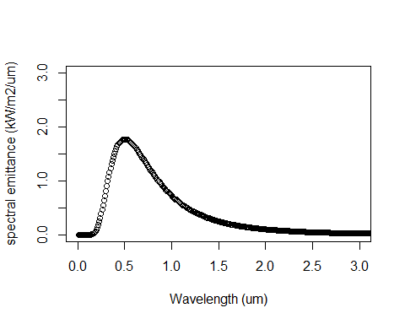

totalterrestiralflux=sum(y*ratio)

``