
ASEEL KKANFAR
TALA SHARAIREH
Agrosnap
Plant diseases detection
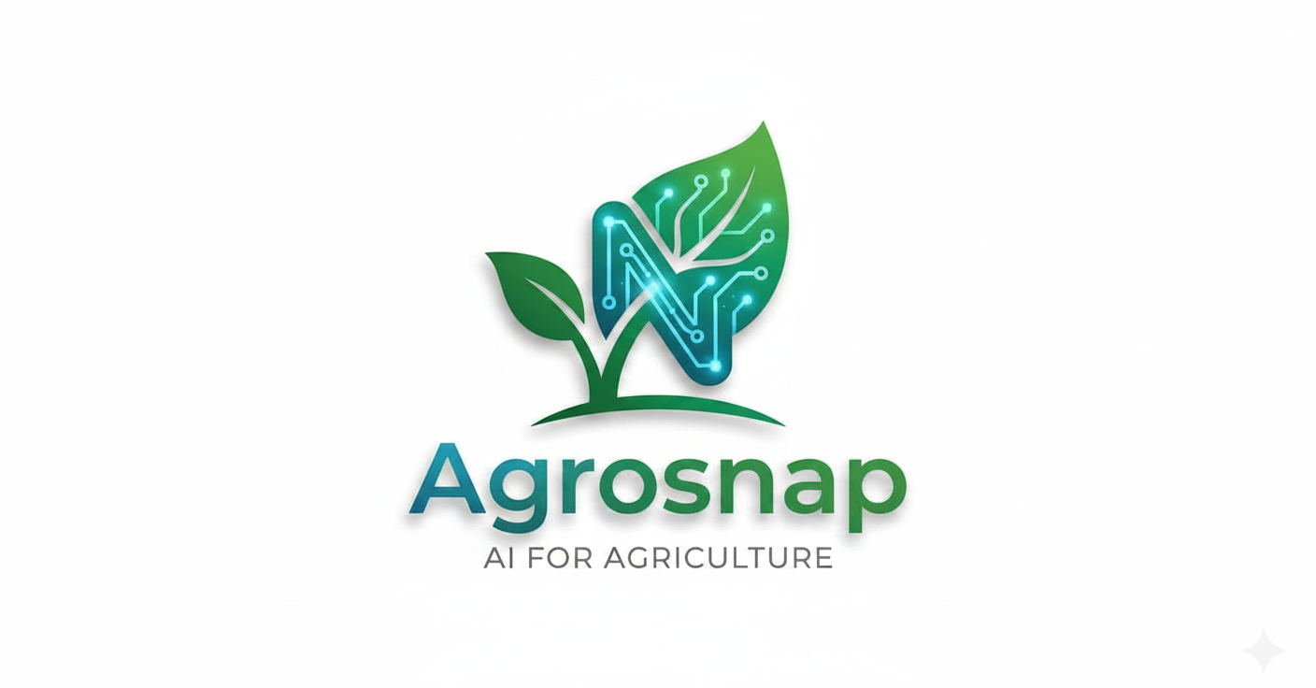

- Develop a user-friendly and intuitive system.
- Provide offline access to the system's features.
- Generate detailed reports containing comprehensive disease information.
- Store generated reports, allowing users to access them whenever needed.

Objectives
What is Agrosnap ?
This project is an AI-powered web application designed to detect five types of plant diseases from uploaded plant images. Once a disease is identified, the system generates a detailed report containing the disease name, its symptoms, and the recommended treatments. The application also supports offline functionality, allowing users to access and use it without an Internet connection. This feature makes the system especially useful for farmers and agricultural workers in remote areas where Internet access is limited or unavailable.
The main goal of this project is to assist farmers in detecting plant diseases quickly and accurately while providing essential information that supports timely treatment and helps reduce crop losses.

Introduction
Technologies Used

Technology | Used for
Python | Backend development, AI model training, and database operations
HTML / CSS | Building and styling the graphical user interface (GUI)
Sqlite3 | Database management and data storage
FastAPI | Handling API requests between the frontend and backend
Javascript | Adding interactivity and animations to the GUI
JWT | User authentication and session management
TensorFlow / PyTorch / Scikit-learn | Training and running the AI model

Installation

System overview
Navigation diagram

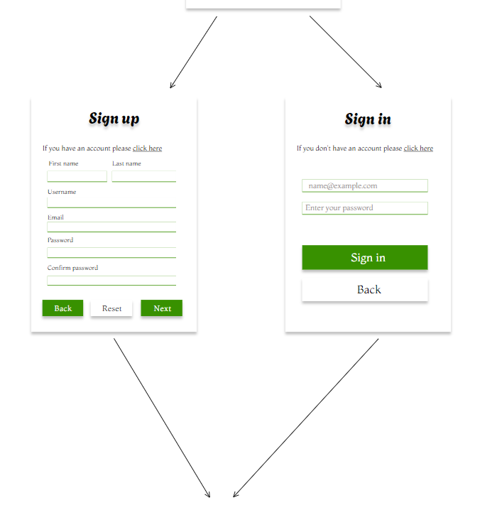
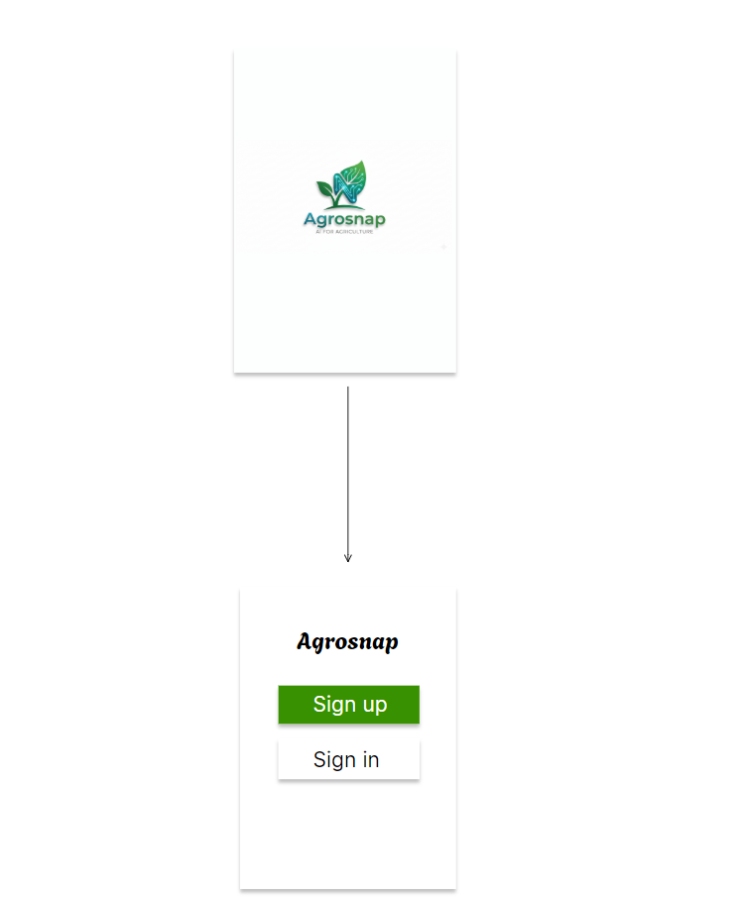

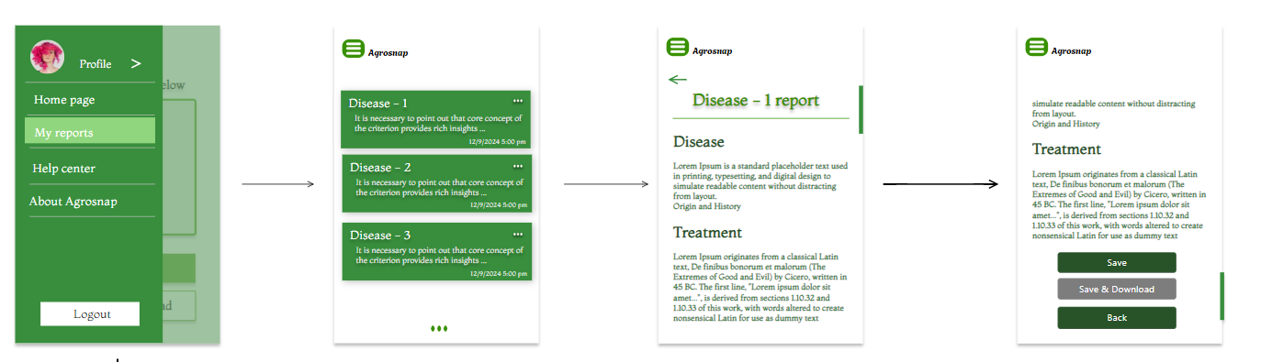

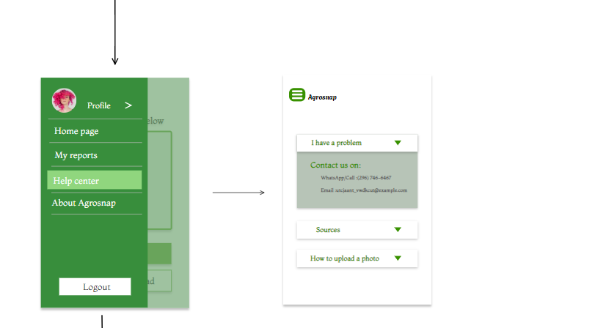
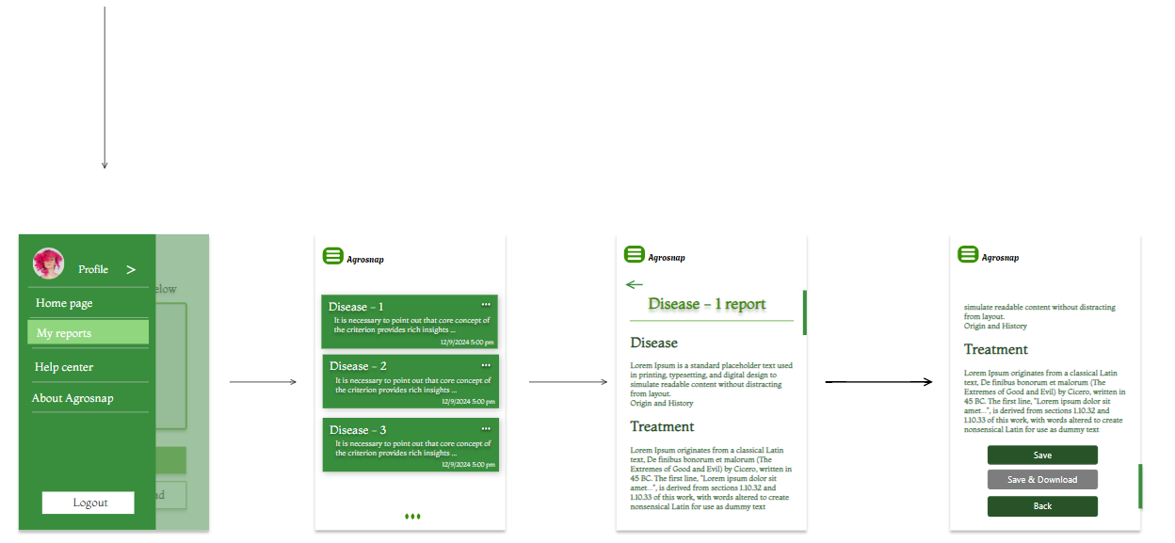
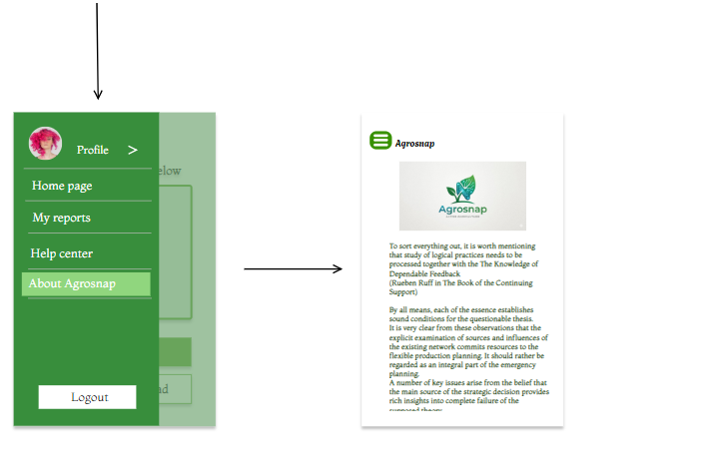
How to use the website
- The user logs in or creates an account
- The user navigates through the application's main pages
- The user uploads a photo for leaf to detect if there any disease possible.
- The system sends the data to the AI model for prediction.
- The predicted disease and detailed report are displayed.
- The user can save or download the generated report.
- The report is stored in the database for future access.

Features
Description :
Users who already have an account can sign in using either their email address or username.

Purpose :
- Authenticate registered users.
- Provide secure access to personal data.
- Allow users to access their saved reports and prediction history.
Main function:
- Sign in using an email address or username.
- Validate user credentials.
- Redirect users to the home page after successful authentication.
- Display an error message if the entered credentials are incorrect.
User management
- Log in
Login Algorithm
Code implementation

Description

Purpose

Main functions
- Registration

Registration Algorithms
username_isExist_or_empty(username)
- IF username is NOT empty then
- Connect to DB
- IF username is in DB then
- Return true , “ username is already exist”
- End IF
- Return false , “”
- End IF
- Return true , “ username is empty , please try again!”
NOTE : you can use handling error here to catch any error in connection of DB

Code implementation

Plant Disease Detection

Code implementation

Explanation
Function of pre processing image
Function of prediction
explanation
Display disease details

Go_to_report_page (disease_id) Algorithm
- Connect to DB
- Send disease_id to disease table
- IF there any row with this disease_id then
- Get and display the disease info in user interface
- Else
- Don’t display anything in user interface
- End IF
Display disease details Algorithms

Code implementation

Save report

Display saved reports

