WAVEFORM:

The following waveform represents the statement “I am son of Ruchi”. The gaps in between the word’s have not been silenced.

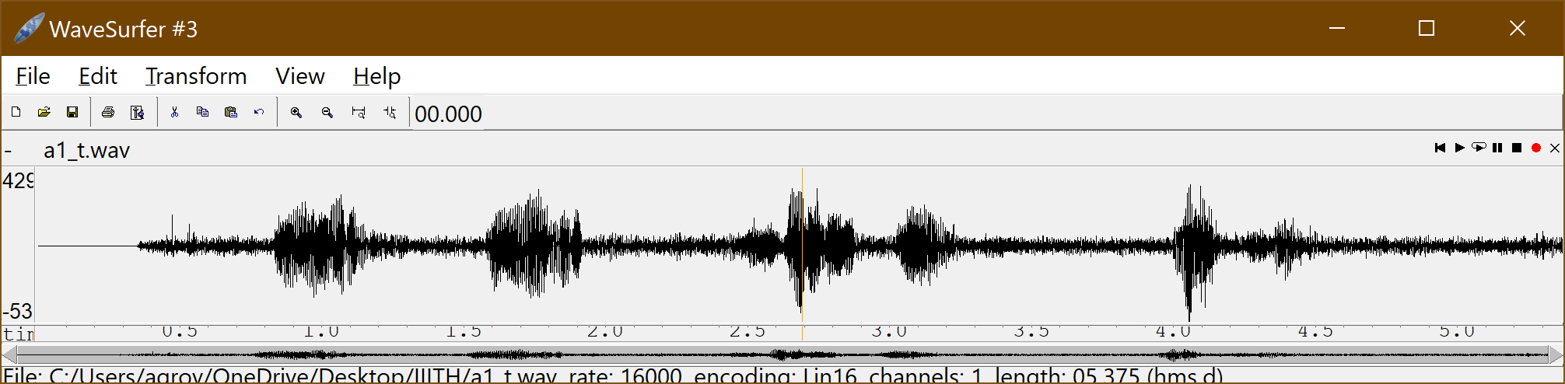

|  |  |
| --- | --- |
| **Word** | **Waveform** |
| I |  |
| am |  |
| son |  |
| of |  |
| Ruchi |  |

VOICED, UNVOICED, PLOSIVE and SILENCED REGIONS

The regions are marked in the transcription file. There is plosive region of /ph/ and /ch/

Voiced regions are characterized by high frequencies and irregular formant structures whereas , voiced regions show a distinct formant structure. Silent regions have 0 amplitude.

ACOUSTIC PHONETIC DESCRITPION

|  |  |
| --- | --- |
| **Word** | **Description of MOA and POA** |
| I (/A/, /e/) | Middle vowel followed by front vowel |
| am (/E/, /m/ | Front vowel followed by nasal |
| son (/s/, /a/ ,/n/) | Dental fricative followed by middle vowel followed by dental nasal. |
| of (/O/, /ph/ | Back vowel followed by unvoiced aspirated bilabial stop. |
| Ruchi (/r/, u/ ,/ch/, /i/) | Alevolar semivowel followed by back vowel followed by unaspirated platal plosive followed by front vowel |

TIME VARYING SYSTEM DESCRIPTION

|  |  |
| --- | --- |
| **Sound Unit** | **Description** |
| /A/ | Tongue hump is low, and it is in central position of the vocal tract (VT) system, VT system is widely open |
| /e/ | Tongue hump is medium, and it is in front position of the VT system, VT system is moderately open |
| /E/ | Tongue hump is medium, and it is in front position of the VT system, VT system is moderately open |
| /m/ | Opening of Nasal cavity and closure at lips |
| /s/ | Narrow constriction at Dental position |
| /a/ | Tongue hump is low and it is in central position of the vocal tract (VT) system, VT system is widely open |
| /n/ | Tongue hump is low and it is in central position of the vocal tract (VT) system, VT system is widely open |
| /O/ | Tongue hump is medium and it is in back position of the VT system, VT system is moderately open and cylindrical in shape |
| /ph/ | Complete Closure at lips |
| /r/ | Partial closure at VT with tongue tip at alveolar ridge. |
| /U/ | Tongue hump is high and it is in back position of the vocal tract (VT) system, VT system is narrowly open |
| /ch/ | Complete closure at palatal |
| /i/ | Tongue hump is high and it is in front position of the vocal tract (VT) system, VT system is narrowly open |

SPECTRAL DETAILS

|  |  |
| --- | --- |
| **Sound Unit** | **Description** |
| /A/ | Regular Formant structure (520, 1190, 2390), pitch harmonics |
| /e/ | Regular Formant structure (530, 1840, 2480), pitch harmonics |
| /E/ | Regular Formant structure (660, 1720, 2410), pitch harmonics |
| /m/ | Concentration of low frequency energy and mid range frequencies with no prominent peaks, pitch harmonics |
| /s/ | Concentration of high frequency energy |
| /a/ | Regular Formant structure (730, 1090, 2440), pitch harmonics |
| /n/ | Concentration of low frequency energy and mid range frequencies with no prominent peaks, pitch harmonics |
| /O/ | Regular Formant structure (600, 900, 2300), pitch harmonics |
| /ph/ | Concentration of high frequency energy |
| /r/ | Regular Formant structure (490, 1400, 2510), pitch harmonics |
| /u/ | Regular Formant structure (440, 1020, 2240), pitch harmonics |
| /ch/ | Concentration of high frequency energy |
| /i/ | Regular Formant structure (530, 1840, 2480), pitch harmonics |

