Q1. IPA transcription of the .wav file is provided **in p1­_ipa.lab file.**

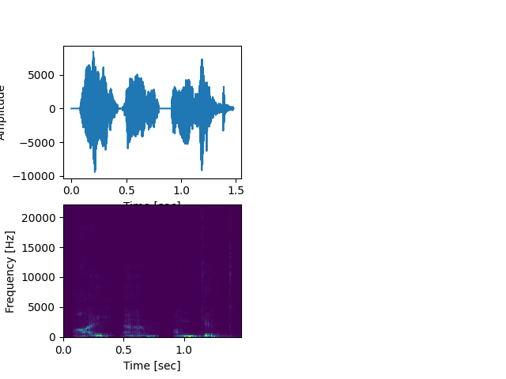

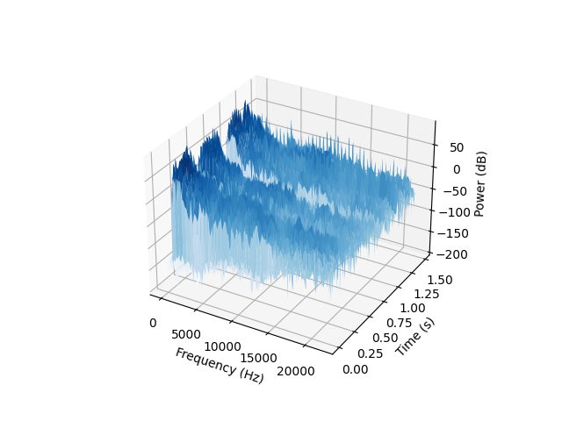

Q2. At 20ms segment was used which is plotted in time-domain . The second plot showcases the segment after being windowed by a Hamming window and then applying a DFT to it. The third plot showcases the cepstrum after undergoing subsequent log and real fft transformations. And is heavily **zoomed in.** The last plot shows the liftered signal. A sinusoidal liftering was performed with lifter value of 22 and number of mfcc chosen to be 13 as per most literature. The value is chosen to be 22 because for pitch estimation we need to perform high time liftering. Higher values help in extracting the excitation characteristics whereas lower quefrenct values extract vocal tract characteristics.

There are small pitch frequencies, however the maximum pitch frequency is observed to be 11030 Hz.

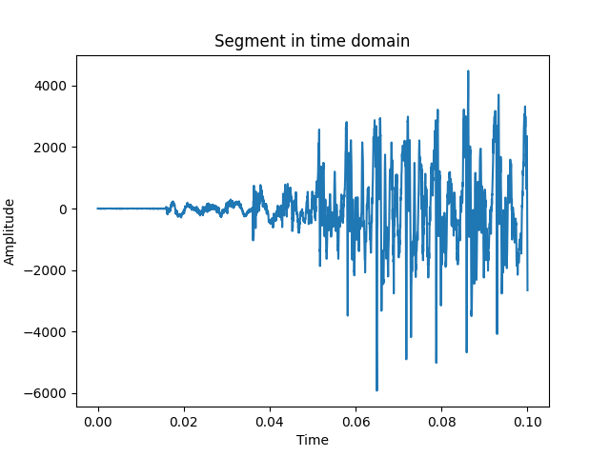

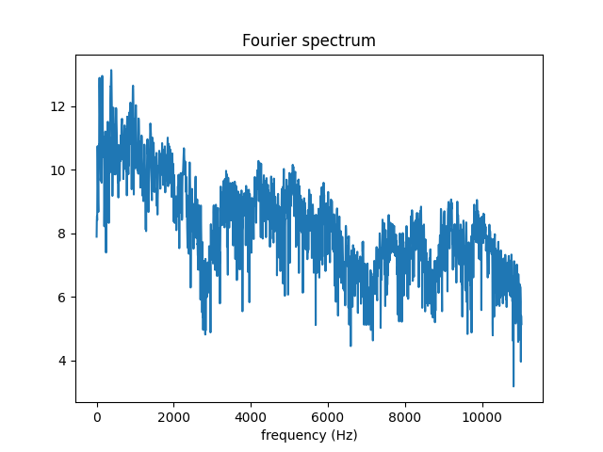

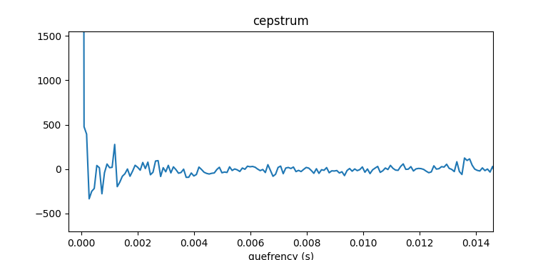

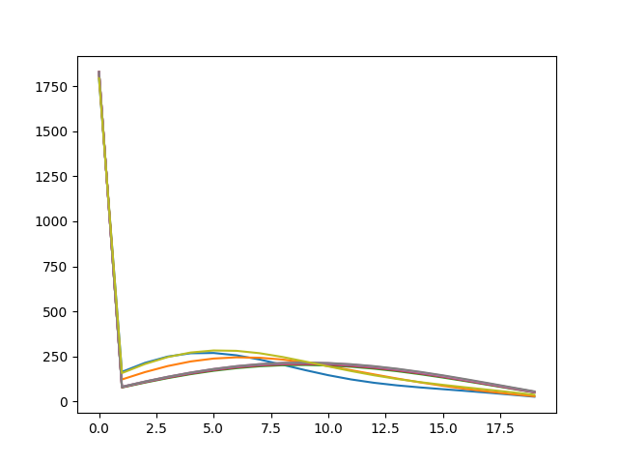

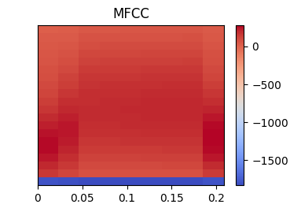

Q3.

First figure shows the signal after applying FFT on **voiced segment.**

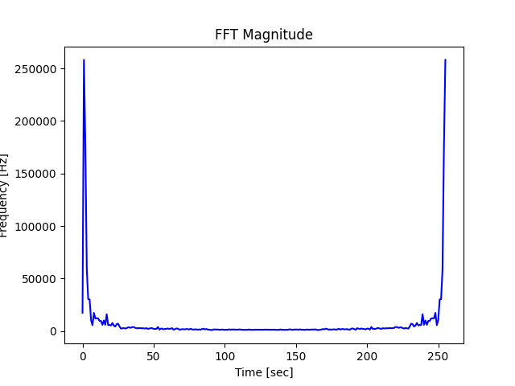

FFT from 256 ,512 to 1024. The two peaks merge into one peak towards 1024 point FFT and frequency increases.

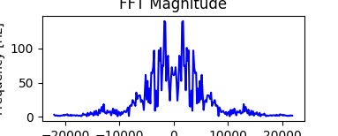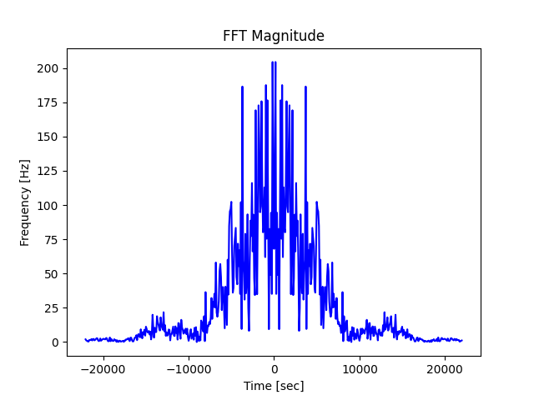

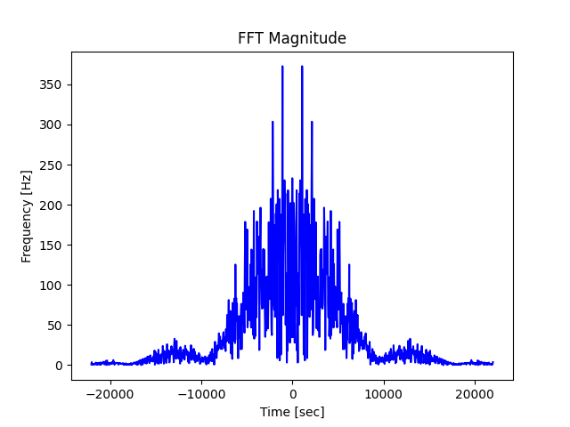

**From left :** Hamming, Hanning and Rectangular Windowed Signal

