Project Report: Autonomous RFID Patrol & Inventory Robot
Course: AI & DS 2001 - Programming for AI & Intro to DS
Date: December 07, 2025
Group Members:
- Abdul Ghafoor – 24I-0118
- Haseeb Ullah – 24I-0086
- Muhammad Faisal – 24I-6077
- Waiz Afzal – 24I-6536
- Talha Habib – 24I-0029

1. Introduction
This project falls under the domain of Physical AI and Internet of Things (IoT). We have designed an autonomous mobile robot capable of navigating a specific route, stopping at designated checkpoints, scanning RFID tags (simulating inventory or security checkpoints), and uploading the data in real-time to a cloud database (Google Sheets).
The system integrates hardware components (Motors, RFID sensors) with software logic (C++ algorithms, HTTP protocols) to create a functional automated agent.
2. Key Features
As required, the robot implements complex features involving navigation and data processing:
- Autonomous Route Navigation: The robot follows a pre-programmed timed path including forward movement, stops, and a complex U-Turn maneuver (Bridge crossing simulation).
- Wireless RFID Scanning: utilizing the MFRC522 sensor to detect Unique Identifiers (UIDs) from cards/tags during stops.
- IoT Cloud Integration: Real-time data logging via WiFi. The robot acts as an HTTPS client to POST scanned data to a Google Script macro.
- Audio Status Indicators: The system generates distinct beep sounds to provide feedback for startup, successful RFID scanning, and mission completion, allowing for "headless" operation without a display.
3. System Architecture & Modules
3.1 Hardware Modules
- Microcontroller: ESP32 (Selected for WiFi capabilities).
- Motor Driver: L298N H-Bridge (Controls 4 DC motors).
- Sensor: MFRC522 RFID Reader (SPI Communication).
- Actuators: 4x DC Motors (4WD Chassis).
- Power: Li-ion Battery Pack.

3.2 Block Diagram
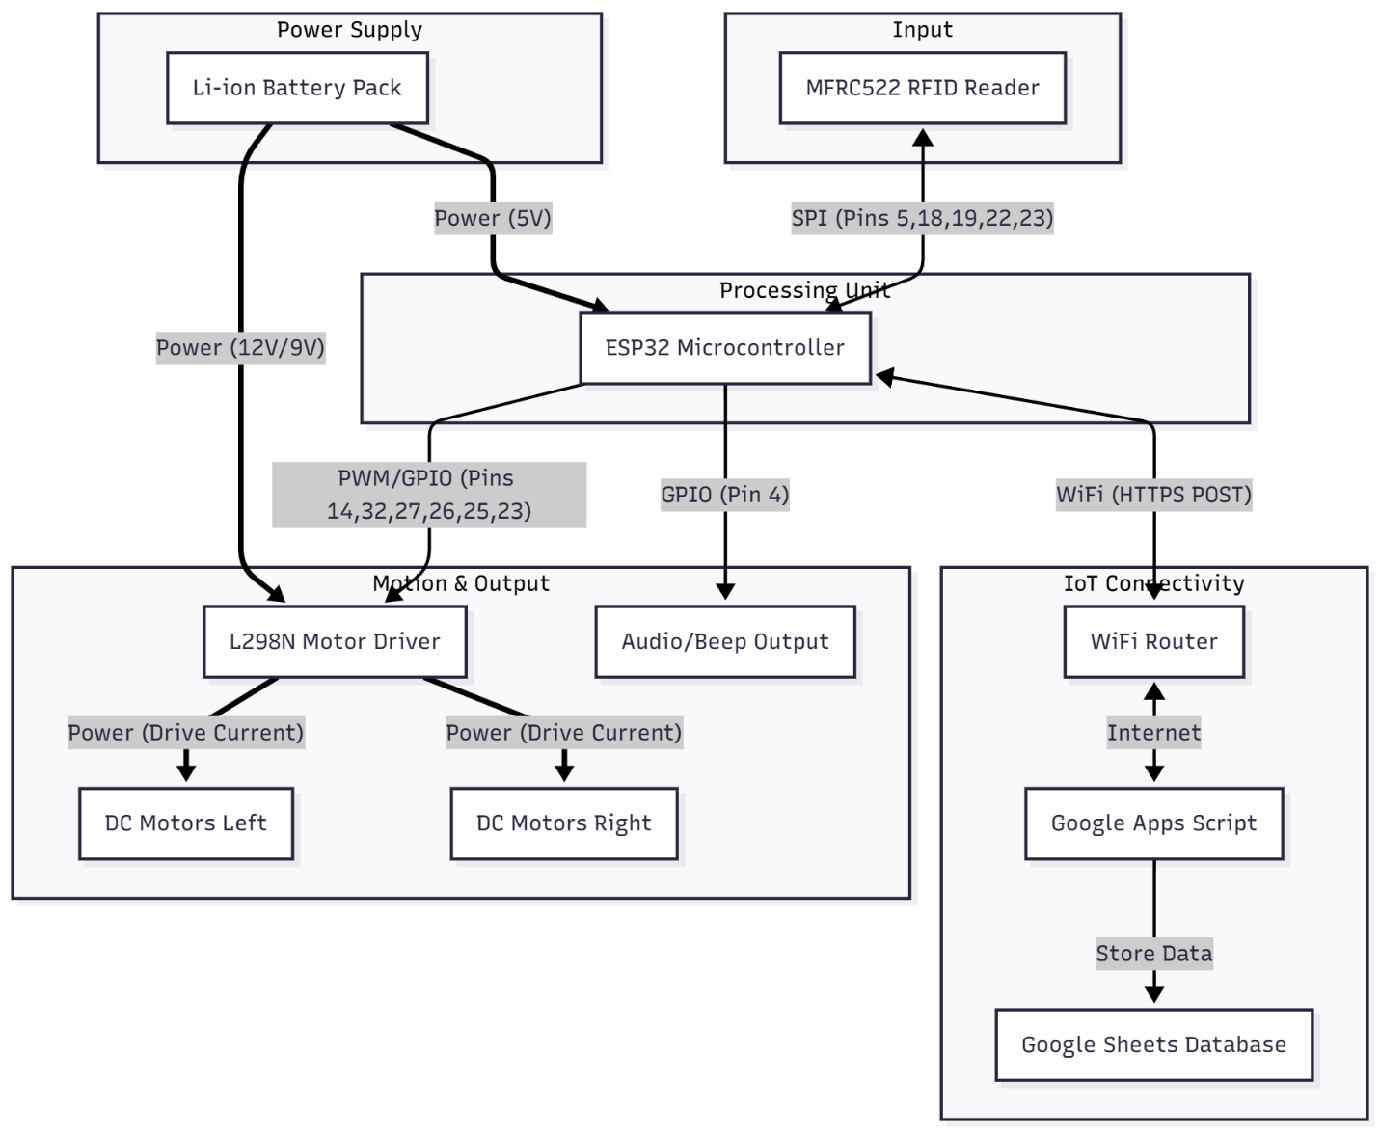
The system is centered around the ESP32 microcontroller, which manages all peripherals. The L298N driver handles high-current power distribution to the motors based on logic signals from the ESP32. The MFRC522 communicates via the SPI protocol for high-speed tag reading. Finally, the ESP32 utilizes its built-in WiFi module to transmit processed data to the Google Cloud ecosystem via HTTPS requests.
3.3 Circuit Diagram & Connections
The hardware is assembled with the following pin mapping based on the code:
- Motors (L298N):
  - Enable Pins: ENa (GPIO 14), ENb (GPIO 32).
  - Left Motor Logic: IN1 (27), IN2 (26).
  - Right Motor Logic: IN3 (25), IN4 (23).
- RFID (SPI):
  - SDA (SS): GPIO 5
  - SCK: GPIO 18, MOSI: GPIO 19, MISO: GPIO 22
  - RST: GPIO 23
- Audio Output: GPIO 4 (Controls beep signal)
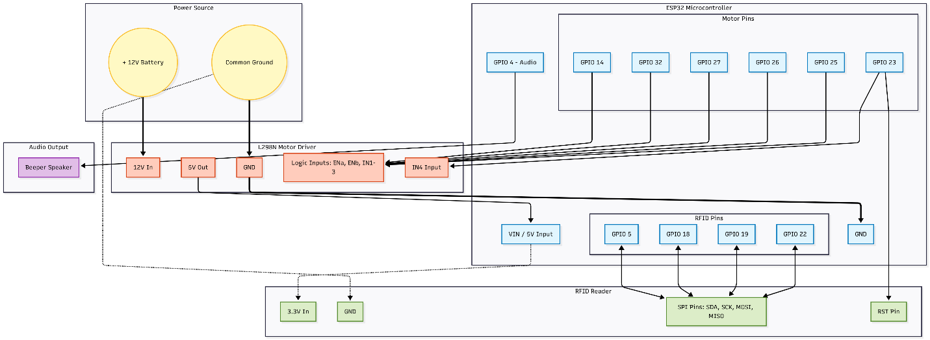
4. Functionality & Algorithm
The software processes sensor data and controls hardware output through a specific state machine loop.
4.1 Navigation Logic (The "Legs")
The robot does not move randomly; it follows a strict algorithmic path:
- Leg 1: Executes a loop 3 times. Move Forward (6s) Stop & Scan (4s).
- U-Turn Maneuver: Performs a complex "Bridge" turn: Rotate Right Move Across (3s) Rotate Right (to face return path).
- Leg 2: Executes the return loop 3 times. Move Forward (6s) Stop & Scan (4s).
4.2 RFID & Data Processing
When the robot enters the stopAndScan() state:
- The motors stop, but the processor remains active.
- The MFRC522 checks for new cards.
- Algorithm: If a card is detected, the UID bytes are converted to a Hex String.
- Output: The system generates a beep sound confirmation, and the sendData() function is triggered to upload the tag ID.
4.3 Cloud Communication
The sendData(String uid) function utilizes the HTTPClient library. It constructs a JSON payload {"uid": "..."} and sends a POST request to a deployed Google Apps Script URL. This ensures data persistency beyond the robot's physical memory.
5. Visual Evidence
5.1 Simulation
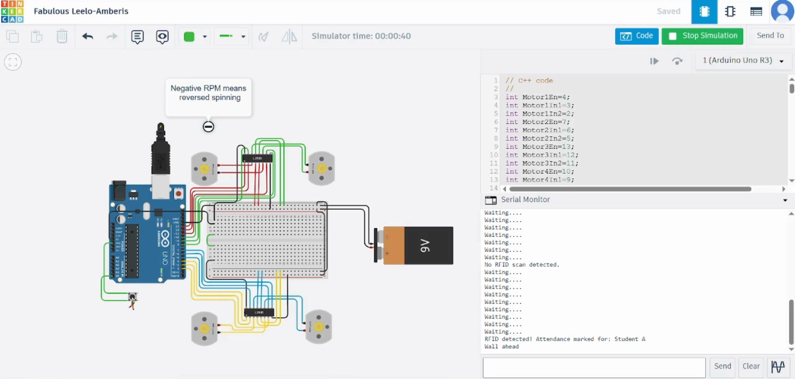
5.2 Physical Implementation (BTS)
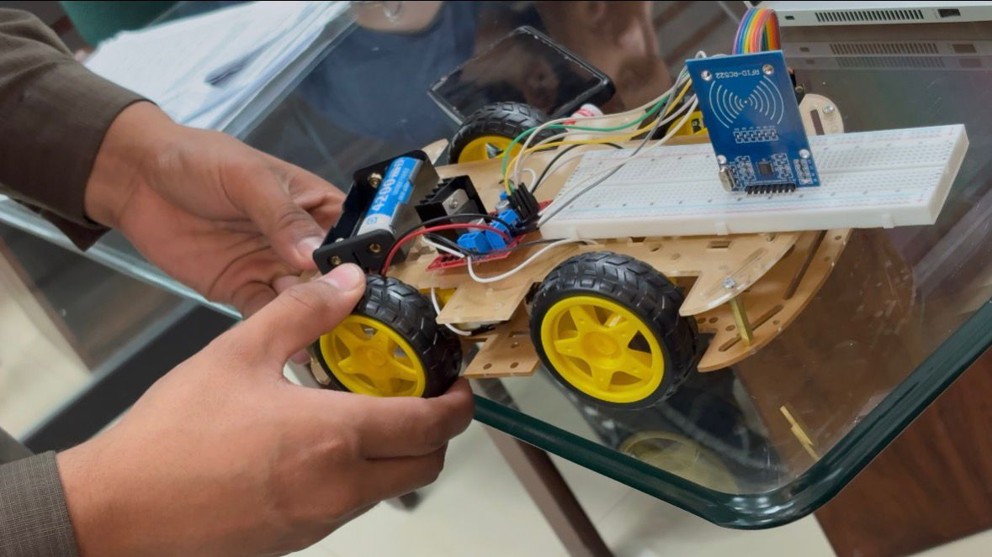
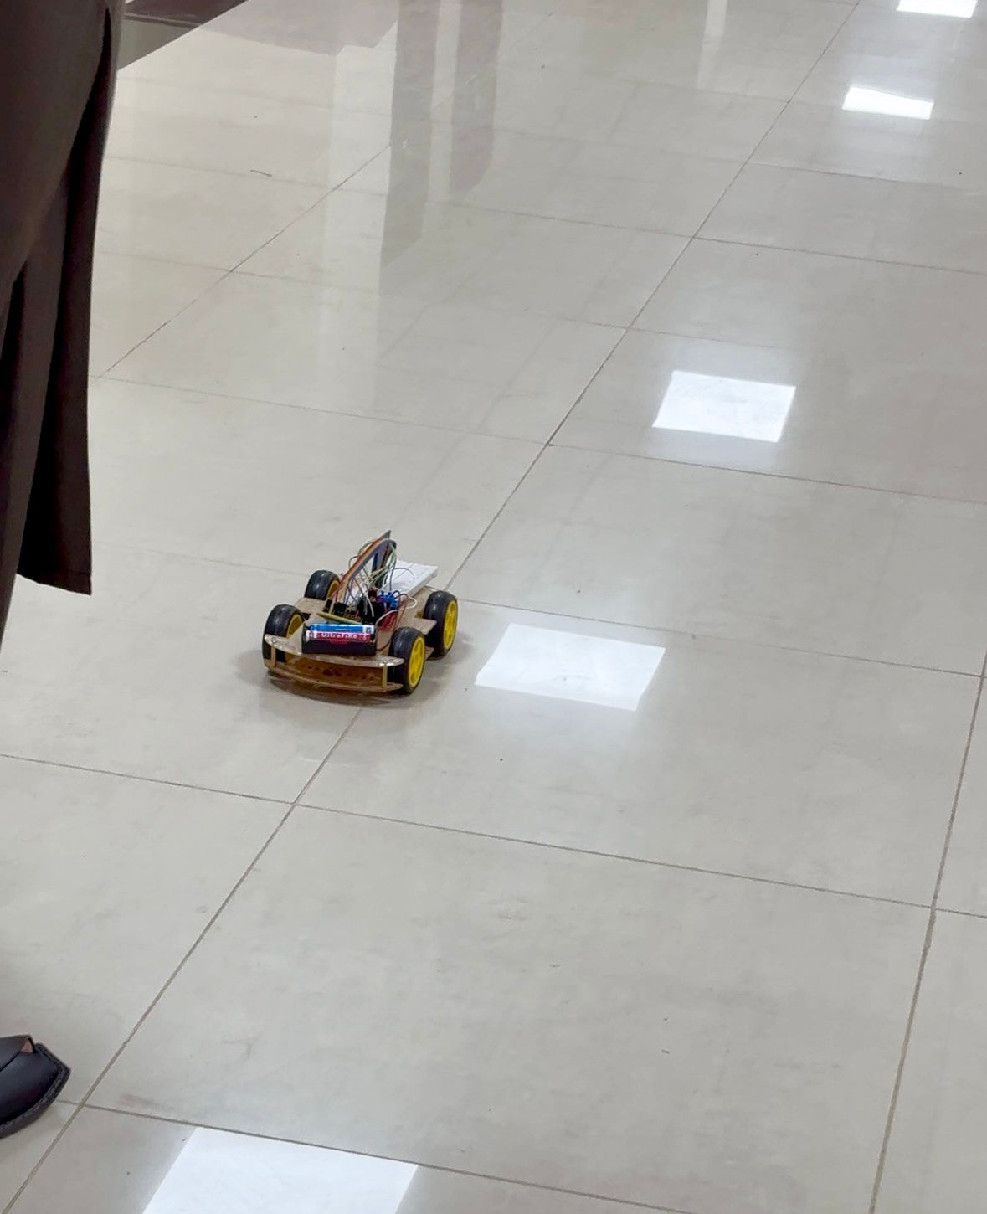

5.3 Working Output
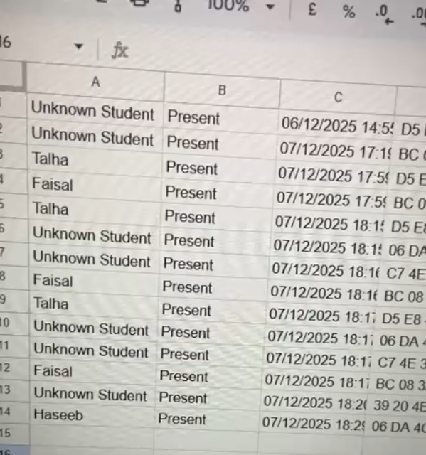
6. Work Division
- Haseeb Ullah: Hardware assembly, soldering, and chassis construction.
- Muhammad Faisal: Circuit design and power management (L298N integration).
- Waiz Afzal: Software implementation (Motion control algorithms).
- Talha Habib: Software implementation (RFID integration).
- Abdul Ghafoor: Report generation and Software implementation (integrating Google Sheets Database).
7. Conclusion
We successfully designed and implemented a physical AI robot that meets the semester project requirements. The robot autonomously navigates, gathers environmental data (RFID tags), and processes this data via the cloud, demonstrating a complete IoT pipeline.

Project Code
#include <WiFi.h>
#include <HTTPClient.h>
#include <WiFiClientSecure.h>
#include <SPI.h>
#include <MFRC522.h>
// ==========================================
// 1. SETTINGS
// ==========================================
const char* ssid = ""; // WiFi Credentials removed for security
const char* password = "";
String GOOGLE_SCRIPT_URL = "https://script.google.com/macros/s/AKfycbwgg-URroK90rq6HM8e79DnuYu5sgyjIWwHeiWiSZQlRNR3zd2gTbn1kJqSnBaZC8GsBw/exec";
// Timing Settings (Milliseconds)
const int MOVE_TIME = 3000; // 6 Seconds Move
const int STOP_TIME = 4000; // 4 Seconds Stop/Scan
const int GAP_MOVE_TIME = 3000;// 3 Seconds (The middle bridge)
const int TURN_TIME = 400; // Time to rotate 90 degrees
// ==========================================
// 2. PINS
// ==========================================
// Motors
const int ENa=14;
const int ENb=32;
const int IN1 = 27; const int IN2 = 26; // Left
const int IN3 = 25; const int IN4 = 23; // Right
// RFID
const int RFID_SS_PIN = 5;
const int RFID_SCK_PIN = 18;
const int RFID_MOSI_PIN = 19;
const int RFID_MISO_PIN = 22;
const int RFID_RST_PIN = 23;
// Buzzer
const int BUZZER_PIN = 4;
MFRC522 rfid(RFID_SS_PIN, RFID_RST_PIN);
bool routeComplete = false; // Flag to stop after finishing
void setup() {
Serial.begin(115200);
analogWrite(ENa, 200);
analogWrite(ENb, 255);
// Init Hardware
pinMode(IN1, OUTPUT); pinMode(IN2, OUTPUT);
pinMode(IN3, OUTPUT); pinMode(IN4, OUTPUT);
pinMode(BUZZER_PIN, OUTPUT);
SPI.begin(RFID_SCK_PIN, RFID_MISO_PIN, RFID_MOSI_PIN, RFID_SS_PIN);
rfid.PCD_Init();
// Connect WiFi
WiFi.begin(ssid, password);
Serial.print("Connecting WiFi");
while (WiFi.status() != WL_CONNECTED) {
delay(500); Serial.println(".");
}
Serial.println("\nWiFi Connected!");
// Signal Start
beep(3);
delay(2000); // 2 second delay before the mission starts
}
void loop() {
if (routeComplete) {
return;
}
// --- LEG 1: The First 3 Stops ---
Serial.println("--- STARTING LEG 1 ---");
for (int i = 1; i <= 3; i++) {
Serial.print("Segment "); Serial.println(i);
moveForward();
delay(4000);
stopAndScan(STOP_TIME);
}
// --- THE U-TURN MANEUVER ---
Serial.println("--- PERFORMING TURN ---");
rotateRight();
delay(TURN_TIME);
moveForward();
delay(GAP_MOVE_TIME);
rotateRight();
delay(TURN_TIME);
// --- LEG 2: The Return 3 Stops ---
Serial.println("--- STARTING LEG 2 ---");
for (int i = 1; i <= 3; i++) {
Serial.print("Segment "); Serial.println(i);
moveForward();
delay(4000);
stopAndScan(STOP_TIME);
}
// --- MISSION COMPLETE ---
Serial.println("--- ROUTE FINISHED ---");
stopCar();
beep(5);
routeComplete = true;
}
// ==========================================
// CUSTOM FUNCTIONS
// ==========================================
void stopAndScan(int duration) {
stopCar();
beep(1);
unsigned long startTime = millis();
while (millis() - startTime < duration) {
if (rfid.PICC_IsNewCardPresent() && rfid.PICC_ReadCardSerial()) {
String uidString = "";
for (byte i = 0; i < rfid.uid.size; i++) {
uidString += String(rfid.uid.uidByte[i] < 0x10 ? " 0" : " ");
uidString += String(rfid.uid.uidByte[i], HEX);
}
uidString.toUpperCase();
Serial.println("Scanned: " + uidString);
digitalWrite(BUZZER_PIN, HIGH); delay(100); digitalWrite(BUZZER_PIN, LOW);
sendData(uidString);
rfid.PICC_HaltA();
rfid.PCD_StopCrypto1();
}
}
}
void sendData(String uid) {
if (WiFi.status() == WL_CONNECTED) {
WiFiClientSecure client;
client.setInsecure();
HTTPClient http;
http.begin(client, GOOGLE_SCRIPT_URL);
http.setFollowRedirects(HTTPC_STRICT_FOLLOW_REDIRECTS);
http.addHeader("Content-Type", "application/json");
String payload = "{\"uid\": \"" + uid + "\"}";
int httpCode = http.POST(payload);
if (httpCode > 0) {
Serial.println("Data Uploaded.");
}
http.end();
}
}
void moveForward() {
digitalWrite(IN1, LOW); digitalWrite(IN2, HIGH);
digitalWrite(IN3, HIGH); digitalWrite(IN4, LOW);
}
void rotateRight() {
digitalWrite(IN1, HIGH); digitalWrite(IN2, LOW);
digitalWrite(IN3, HIGH); digitalWrite(IN4, LOW);
}
void stopCar() {
digitalWrite(IN1, LOW); digitalWrite(IN2, LOW);
digitalWrite(IN3, LOW); digitalWrite(IN4, LOW);
}
void beep(int times) {
for(int i=0; i<times; i++){
digitalWrite(BUZZER_PIN, HIGH); delay(100); digitalWrite(BUZZER_PIN, LOW); delay(100);
}
}

