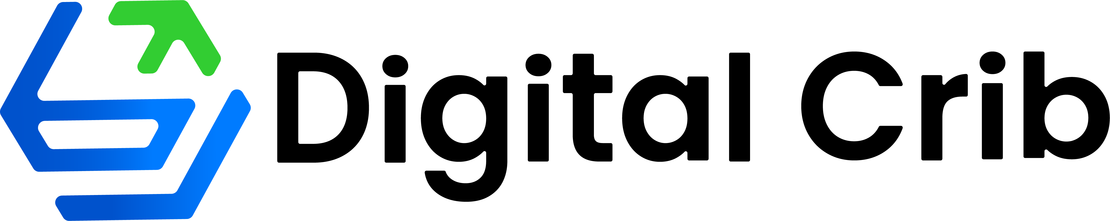
Fintech Brand, Landing Page & Partnership Readiness
Phase 1 Proposal and Indicative Product Build Budget
Prepared by  Digital Crib Technologies LTD | Immediate Phase 1 delivery  1 weeks
Recommended approach
Start with the public-facing foundation: a confident Digital Crib identity and a conversion-focused landing page. This gives the client a credible asset for partner conversations before committing to provider integrations. The remaining module budget is reserved for implementation only after the relevant commercial and API partnerships have been secured.
Phase 1 now: ₦500,000 for logo, brand identity, landing-page design and development.
Later implementation budget: ₦6,800,000 across five product modules, activated as provider partnerships are confirmed.
Phase 1 deliverables
Workstream | Deliverable | Cost
Logo & identity | Logo suite, colour and type system, social/profile assets, mini brand guide and visual direction. | ₦100,000
Landing-page design | Responsive website UX, page copy direction, service overview, trust sections and partner enquiry journey. | ₦125,000
Landing-page build | Responsive development, CMS/contact capture, analytics set-up, SEO essentials, QA and deployment support. | ₦275,000
Phase 1 total | Launch-ready identity and landing page for partnership outreach. | ₦500,000
What Phase 1 enables
• A polished public presence before outreach to crypto, card, bill-payment, travel and payment providers.
• Clear positioning for the planned product suite without promising live regulated services before partnerships are in place.
• A structured implementation backlog and integration plan that can begin module by module after partner selection.

IMPLEMENTATION BUDGET
Product modules - initiated after partnerships
The costs below are a scoped, indicative build budget. Each module starts only after its provider agreement, commercial terms and usable integration/API documentation are available.
Module | Delivery scope | Budget
Crypto module | Buy, sell and swap flows; provider integration; rates, transaction history, KYC hand-off and risk/error states. | ₦2,000,000
Gift card module | Catalogue, buy/sell flows, valuation, order tracking, partner/API integration and customer support states. | ₦1,000,000
VTU module | Data, airtime, betting, TV subscriptions and electricity bills; product selection, payment, fulfilment and receipt flows. | ₦1,300,000
Local flight module | Search, fare details, traveller information, booking/payment journey, ticket status and provider integration. | ₦1,200,000
Virtual card module | Card creation, funding, card controls, transaction history, security states and issuer/provider integration. | ₦1,300,000
Module implementation total | Five partner-dependent modules, including client and admin-facing flows, integration, QA and handover. | ₦6,800,000
Overall investment
Component | Amount (NGN)
Phase 1: logo, identity, landing-page design and development | ₦500,000
Partner-dependent product modules | ₦6,800,000
Total programme budget | ₦7,300,000
Delivery plan and payment terms
Timing | Milestone | Commercial trigger
Weeks 1-2 | Brand identity, landing-page UX, build, testing and launch. | 100% at kick off.
After partnerships | Each module moves into a dedicated 4-8 week build window, depending on provider API readiness and approvals. | 50% at module kickoff; 30% at build review; 20% at UAT/handover.
Exclusions: third-party licences, regulatory approvals, KYC/AML vendor fees, crypto custody or liquidity costs, card-issuer fees, travel inventory/API fees, payment processing charges, cloud hosting and any provider-specific commercial commitments. These will be contracted directly once partners are selected.

