Trend Following Study
Trend Following and Mean Reversion ETF Portfolios
A quantitative finance course project
Historical endpoint October 15 2026

Abstract
We study whether a combination of long or cash ETF trend-following and oversold-recovery strategies can improve risk-adjusted performance relative to passive QQQ. The project follows a broad 56-ETF, 379-configuration research campaign and evaluates four retained initial allocations across development in 2017–2020, validation in 2021–2023 and historical OOS from January 2024 through October 15, 2026. Each period starts with $1,000; the same strategies and weights are used at four trading-cost levels.
At baseline costs, the allocation fitted to a historical daily one-third sleeve cap has a 2.481 cash-excess Sharpe, 21.85% CAGR and −4.24% maximum daily drawdown in the fitted historical OOS window. Matched QQQ buy-and-hold has 0.996 Sharpe, 23.93% CAGR and −22.77% drawdown. The portfolio therefore sacrifices some growth while exhibiting a smoother examined path. Validation is materially weaker: its Sharpe is 0.381, and the UNG sleeve breaches one-third on 41 daily valuations.
These are descriptive results, not evidence of an untouched portfolio test. The final strategies, ETF pruning and optimized weights were chosen after historical OOS was examined. Replaying them in earlier periods does not remove that hindsight. The main contribution is a reproducible comparison of causal trading rules, costs, cash, portfolio construction and benchmark-relative risk, including the unfavorable findings.

1 Project Goal
Our goal is to research momentum and mean-reversion strategies in actual ETFs and assess whether combining them offers a useful return–risk trade-off. We use unlevered long or cash accounts, not short selling, market-neutral pairs, synthetic leverage or live trading. The central question is robustness across periods and execution costs, not which historical Sharpe is largest.

2 Research Outline
We focus on indicator horizons, persistent oversold recovery and diversification. Trend following assumes that a price move can persist long enough for delayed confirmation to be useful. Mean reversion assumes that an unusually weak price relative to recent daily history can subsequently recover. Neither assumption identifies the cause of a move or guarantees that a falling asset will rebound.

Research hypotheses
Hypothesis | Empirical comparison | Interpretation
Trend persistence | Two selected daily EMA gate strategies | Long participation above trend; cash after a confirmed exit
Oversold recovery | Four selected z score, RSI or EMA distance strategies | Buy a persistent dip and sell recovery; never short
Diversification | Six active return correlations and four wealth mixtures | Combining different exposures may smooth the path
Cost robustness | Same definitions and weights at 1, 3, 10 and 25 bp slippage | Costs are stressed without reselection
Temporal stability | Independent accounts in three historical periods | A diagnostic, not a fresh portfolio holdout

Time-series momentum is economically distinct from ranking securities against peers. Moskowitz, Ooi and Pedersen document own-return persistence in futures and forwards [1]. This motivates, but does not validate, our ETF price-versus-EMA gates. Our instruments, long/cash constraint, indicators and confirmation process differ from that paper.

Scope of the course research ideas
Indicator-window and threshold research is completed. ETF themes provide exposure context, not a tested theme-momentum signal. News or volume filters, weekday and intraday seasonality, mechanical rebalancing events, identified liquidation flows and macro-regime-conditioned signals remain future work. Calendar validation is not a seasonality test. The correlation analysis below measures portfolio diversification; it does not implement a correlated-spread reversal trade.
The original grid contains 289 trend definitions and 90 mean-reversion definitions per ETF. These 379 definitions are unique parameter specifications, not 379 independent hypotheses. Correlated variants, sequential pruning and repeated examination make winner-based statistics optimistic unless a genuinely future test is reserved [4].

Selected Strategy Definitions
The six sleeves are GDX, FXI, QQQ, UNG, FDN and BND. Each holds its own ETF or cash. The same selected configuration is retained at every cost and in every period. These are not portfolios that continuously hold the passive ETFs at the weights shown later.
ETF and role | Entry while in cash | Exit while long
GDX  Gold miners recovery | 20 day z score ≤ −2 | 20 day z score ≥ 0
FXI  China recovery | 50 day z score ≤ −2 | 50 day z score ≥ +0.5
QQQ  Nasdaq 100 trend | Price > projected EMA50 AND projected EMA200 | Price ≤ projected EMA200
UNG  Natural gas recovery | Wilder RSI14 ≤ 30 | Wilder RSI14 ≥ 50
FDN  Internet trend | Price > projected EMA50 AND projected EMA100 | Price ≤ projected EMA100
BND  Broad bond recovery | Price / projected EMA50 − 1 ≤ −2% | Price / projected EMA50 − 1 ≥ +1%

“Price” in these rules is the provisional forward total-return index at the current completed half-hour observation. QQQ and FDN are price-versus-EMA gates, not EMA50/EMA200 or EMA50/EMA100 crossover systems. The exit EMA also guards entry. Mean-reversion thresholds are inclusive; trend entry is strictly above both gates.
Every supported entry or exit condition must hold for seven consecutive eligible half-hour checks spanning three trading hours. A one-time threshold crossing is insufficient. Normal session closures do not count as observations and may carry a streak. After confirmation, an order executes at the next eligible bar open, not the signal bar close.

Causal daily indicator projection
Each intraday preview starts from the previous finalized daily state plus one provisional observation, never the preceding half-hour’s recursive state. EMA uses smoothing 2/(n+1). Wilder RSI14 seeds average gains and losses over 14 daily changes, then smooths by 1/14. The z score combines n−1 finalized daily values with the provisional value and sample SD (ddof=1); undefined variance gives no signal. Exact parameters are in the supplement.

3 Data
The parent campaign covers 56 actual ETFs: 6 US index products, 13 international or country products, 10 broad sectors, 13 industries or subsectors, 9 bond products and 5 commodity or precious-metal products. The present portfolio report uses only the six selected sleeves. It does not infer a category portfolio from pooled ETF results.
The research uses retrospectively captured Alpha Vantage records: native raw 30-minute observations where available and matching-vintage restored legacy records otherwise, plus daily prices and corporate actions. Checks use separate daily anchors, available same-provider 15-to-30-minute comparisons and native overlaps; these are not independent-vendor confirmations. An adjusted intraday series cannot be restored with a different adjustment vintage. The parent campaign checked corporate actions, exchange sessions, early closes, DST, duplicate and missing observations before freezing inputs.
Daily feature initialization begins in 2015 with sufficient completed daily observations before scoring. Historical accounts retain their original frozen data vintages and approved corporate-action choices. Causal features do not make these retrospectively captured records a point-in-time vendor database. This report neither merges vintages nor transfers QQQ-specific exceptions.
Stage | Scored calendar interval | Observed sessions | ACT 365 years
Development | 2017-01-01 to 2020-12-31 | 1,007 | 3.995377
Validation | 2021-01-01 to 2023-12-31 | 753 | 2.984418
Historical OOS | 2024-01-01 to 2026-10-15 | 700 | 2.787043

The first actual sessions are January 3, 2017; January 4, 2021; and January 2, 2024. Final scored valuations are December 31, 2020; December 29, 2023; and October 15, 2026. Daily valuations use 17:00 America/New_York; fills are not assumed to occur at 17:00. CAGR uses exact first-open-to-terminal elapsed time, not the count of calendar years in a label.

Evidence available for this project
The portfolio layer reads authenticated saved equity, cash and cost-matched passive benchmark paths. Independent arithmetic checks cover the derived metrics and capital-share diagnostics. Original frozen account/source checks remain intact. This is not a fresh raw-price reconciliation or independent intraday trade-ledger reconstruction; legacy QQQ trade/exposure values in particular are not newly certified. The supplement contains aggregate evidence and portable calculation code, not redistributable raw market data.

4 Backtesting

Trading and account mechanics
Each stage starts independently with $1,000 in cash, no holdings, pending orders or confirmation streaks. Feature history carries forward only to initialize causal indicators. Strategies buy the ETF with available account capital when entry is confirmed and return to cash after a confirmed recovery or trend exit. Fractional shares and proportional fees permit sleeve paths to be scaled by initial portfolio weights.
The forward total-return index combines the prior finalized index, current raw price, the split ratio and the ex-date distribution under the frozen corporate-action convention. A current daily observation is finalized only at its prescribed event. Eligible half-hour closes precede the next bar-open execution event; those events may share a clock instant without implying a same-close fill. Known blackouts reset streaks and cancel pending orders. Terminal valuation includes paid liquidation at the safe observed final regular-session close, followed by cash accrual to the daily valuation.

Original selection process and later hindsight
The original ETF selection gate was applied at 25-bp slippage: candidate net cash-excess Sharpe had to exceed that ETF’s matched buy-and-hold Sharpe, and net CAGR had to exceed two-thirds of buy-and-hold CAGR. The later explicit amendment required positive candidate CAGR whenever buy-and-hold CAGR was negative. Undefined or nonfinite candidates could not pass. ETF lists were filtered for more than five survivors before the next release; EWT was dropped after its disputed revised dividend.
The historical OOS release contained 800 locked configurations across 27 ETFs. All 800 remained in the record irrespective of subsequent outcomes. After examining OOS, 57 cases across 12 ETFs met the descriptive joint threshold. A further display filter removed ETFs with only one case OR maximum baseline Sharpe below 0.5, leaving 50 cases across 8 ETFs. One baseline-Sharpe leader per ETF was displayed, with fixed tie-breaking. SMH and XLK were then removed while QQQ was retained, leaving the six sleeves studied here.
Portfolio weights were subsequently fitted to the examined 2024–2026 paths. Therefore, “development,” “validation” and “historical OOS” identify the original account windows only. Applying the final configuration choices and OOS-fitted weights backward is retrospective. It is not an end-to-end strategy that could have been selected in 2017, and historical OOS is not a newly untouched portfolio test.
The course brief suggests an unconstrained starting backtest. Our adaptation instead has explicit long/cash, no-leverage and staged-account restrictions. We do not claim equivalence to an unspecified classroom implementation. There is no live order placement, portfolio optimization rerun or additional market-data evaluation in this project report.

5 Execution and Slippage
We retain the ETF study’s execution convention rather than the example’s cryptocurrency fees. Every buy and sell pays 1 bp commission plus the scenario’s one-way slippage. The baseline is 3 bp slippage, or 4 bp total one-way friction. Forced terminal sales are charged as well. A passive benchmark pays its matched entry and liquidation costs under the same timing and corporate-action conventions.
Scenario | Commission each way | Slippage each way | Total each way
Low | 1 bp | 1 bp | 2 bp
Baseline | 1 bp | 3 bp | 4 bp
Stress | 1 bp | 10 bp | 11 bp
High stress | 1 bp | 25 bp | 26 bp

Costs are embedded in the saved accounts before portfolio aggregation. We do not subtract an additional annual fee or charge portfolio rebalance costs because these are fixed initial-capital sleeves with no cross-sleeve rebalancing. The same full-precision weights are tested at all four costs; there is no cost-specific refit.

Cash accrual
Idle cash earns 3% nominal ACT/365, event compounded: for an event interval of Δ seconds, cash is multiplied by 1 + 0.03 × Δ/(365 × 86,400). Repeated accrual is not the same as a 3% APY promise. The matched cash return series follows the same clock, including weekends and stage endpoints. Cash-excess Sharpe subtracts that observed cash path; it does not mean return in excess of buy-and-hold.

Implementation limits
Fixed slippage is a sensitivity assumption, not an empirical order-book estimate. The model does not establish queue priority, market impact, bid–ask dynamics, broker constraints, capacity, taxes or a limit-order fill advantage. Fractional, proportionally scaled accounts can understate difficulties at small actual account sizes. ETF fund expenses and futures roll effects are already reflected in observed ETF prices; they are not assumed equal across products.
An implementable continuation would calibrate fills to tradable quotes, size, session liquidity and broker conventions, then add any actual portfolio rebalancing rule and its costs before a new prospective release. That work is not performed here. A high historical Sharpe at the tested slippages alone is not evidence that the strategy can be scaled.

6 Weighting
Four retained portfolios combine the same six strategy accounts. We exclude the standalone maximum-CAGR portfolio that allocated 100% to the GDX strategy; GDX remains inside the other portfolios. The allocation names describe their original historical fit, not a new optimization or guarantee of global optimality.
Strategy sleeve | Daily cap | Initial cap | Uncapped | Equal initial
GDX | 23.5729% | 29.0513% | 3.4761% | 16.6667%
FXI | 24.9703% | 27.9920% | 4.2909% | 16.6667%
QQQ | 5.6270% | 6.3045% | 1.0866% | 16.6667%
UNG | 23.8965% | 26.7293% | 4.6524% | 16.6667%
FDN | 8.6317% | 9.9229% | 1.1470% | 16.6667%
BND | 13.3015% | 0.0000% | 85.3469% | 16.6667%

Displayed allocations are rounded. Exact saved JSON values govern every calculation. Initial-cap BND has a tiny positive weight of 9.720788330706766 × 10⁻¹⁸, not an edited zero. The uncapped solution allocates about 85.35% to a BND strategy that is frequently in cash, not to a permanently invested 85.35% passive bond holding.

Static initial capital rather than daily rebalancing
Let E denote each saved sleeve equity divided by its $1,000 initial balance. Weights are nonnegative and sum to one. Normalized portfolio wealth and its daily return are
$V_{c,t}=\sum_{i=1}^{6}{w_{i}E_{i,c,t}}$ $r_{c,t}=\frac{V_{c,t}}{V_{c,t−1}}−1$
Each sleeve and the portfolio start at normalized wealth one. Applying constant weights to daily returns would instead impose an unmodeled daily rebalance and produce a different result.
The uncapped and initial-only-cap allocations maximize baseline cash-excess Sharpe over the nonnegative unit simplex, with initial weights at most one-third only in the latter. These are numerically best-found solutions, not certified global maxima. The equal-initial comparator starts each sleeve at one-sixth and subsequently drifts; it is not daily equal weighting.

Meaning of the daily capital cap
The daily-cap fit also limits each sleeve’s share of total portfolio wealth to one-third at every examined OOS daily valuation and all four costs. It selects initial weights satisfying those historical paths; it does not rebalance them. The constraint is on sleeve capital, not underlying ETF holdings, risk contributions, intraday exposure or future outcomes.

Capital Cap and Performance Definitions
The daily-cap allocation passes the observed one-third share bound in development and historical OOS, but not in validation. At baseline, UNG reaches 35.18% on a path with 41 breach days. Every validation cost has 41 breach days. We retain this finding rather than changing weights, suppressing the period or assuming free rebalance trades.
Period | Maximum share at 1 bp | At 3 bp | At 10 bp | At 25 bp
Development | 26.80% | 26.80% | 26.80% | 26.80%
Validation | 35.16% | 35.18% | 35.28% | 35.48%
Historical OOS | 33.33% | 33.27% | 33.05% | 32.57%

7 Performance Evaluation
All performance is net of the modeled commissions and slippage. We report the original three windows separately, never splice them into a continuous account or carry holdings across stage boundaries. QQQ buy-and-hold is the passive benchmark, not the active QQQ sleeve. Cash is a second matched control.
Statistic | Definition
Total return | Terminal wealth / initial wealth − 1
CAGR | Terminal wealth divided by initial wealth, raised to the reciprocal of elapsed ACT365 years, minus one
Return volatility | √252 × sample standard deviation of daily net returns
Cash excess Sharpe | √252 × mean(r − matched cash) / sample SD(r − matched cash)
Maximum drawdown | Minimum of Vt / running maximum(V0 … Vt) − 1, including initial balance
Alpha and beta | Intercept and slope(s) from daily cash-excess-return OLS; annual alpha = 252 × daily intercept

Volatility and Sharpe use sample standard deviations with denominator N−1 (ddof=1). Cash’s cash-excess Sharpe is undefined, not zero. Drawdown is daily, not intraday. The square-root-of-252 Sharpe is a descriptive convention, not a serial-correlation-adjusted significance statistic. Sharpe’s differential-return framework [2] motivates the cash benchmark; Lo [3] explains why sampling error and time dependence matter for inference.
The all-cost tables in Appendix A report CAGR, return volatility, cash-excess Sharpe, drawdown and QQQ-relative alpha/beta. The supplement retains all 48 portfolio outcomes, 24 controls and 48 cap diagnostics at full precision. Values in the report are rounded only for display.

Baseline Performance Across Three Periods

Development 2017 to 2020
Portfolio | Total return | CAGR | Volatility | Sharpe | Max DD
Daily cap | 73.40% | 14.77% | 8.43% | 1.321 | -7.52%
Initial cap | 81.81% | 16.14% | 9.60% | 1.295 | -8.48%
Uncapped | 27.24% | 6.21% | 2.32% | 1.320 | -2.32%
Equal initial | 90.01% | 17.43% | 8.95% | 1.506 | -6.56%
QQQ passive | 171.41% | 28.39% | 23.26% | 1.063 | -28.56%

Validation 2021 to 2023
Portfolio | Total return | CAGR | Volatility | Sharpe | Max DD
Daily cap | 22.04% | 6.90% | 11.30% | 0.381 | -17.52%
Initial cap | 25.01% | 7.77% | 12.55% | 0.419 | -19.24%
Uncapped | 5.54% | 1.82% | 4.49% | -0.243 | -9.70%
Equal initial | 23.41% | 7.30% | 9.50% | 0.473 | -13.48%
QQQ passive | 32.34% | 9.84% | 23.77% | 0.387 | -35.12%

Historical OOS 2024 to October 15 2026
Portfolio | Total return | CAGR | Volatility | Sharpe | Max DD
Daily cap | 73.46% | 21.85% | 6.88% | 2.481 | -4.24%
Initial cap | 84.46% | 24.57% | 7.78% | 2.487 | -4.67%
Uncapped | 20.30% | 6.86% | 1.47% | 2.497 | -0.82%
Equal initial | 68.02% | 20.46% | 7.24% | 2.204 | -4.27%
QQQ passive | 81.83% | 23.93% | 20.75% | 0.996 | -22.77%

Baseline means 1-bp commission plus 3-bp one-way slippage, each way. “Daily cap” is the OOS-fitted initial allocation, not a cap enforced in all three periods. Negative drawdown denotes loss from a prior daily peak. Total returns are not annualized and should not be compared across unequal period lengths without the accompanying CAGR.
Equal initial weights have the highest Sharpe of these four in development and validation. The uncapped fitted allocation has negative cash-excess Sharpe throughout validation despite positive CAGR. Growth and Sharpe answer different questions: a cash-heavy portfolio can have a high fitted Sharpe while delivering much less absolute growth.

Development Equity and Drawdown
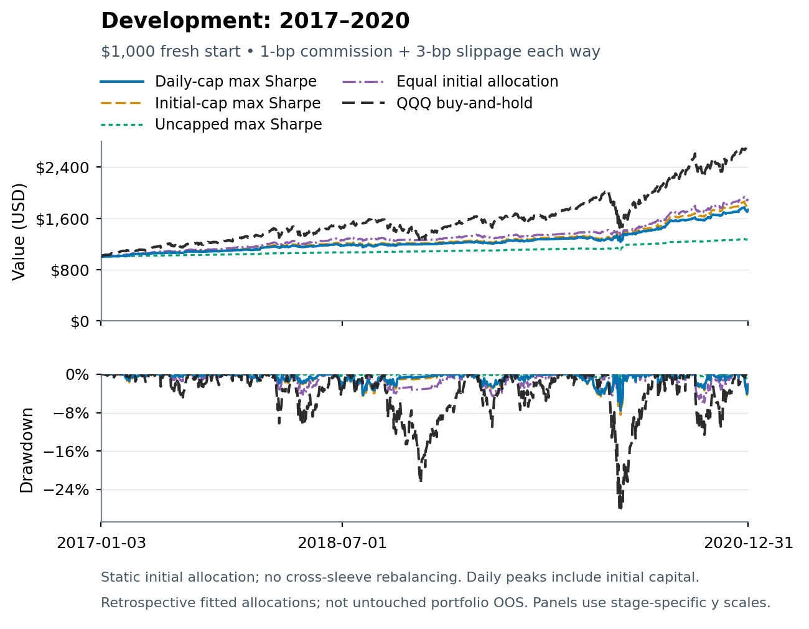
Figure 1. Development, 2017–2020. Five independent $1,000 accounts at baseline costs. The upper panel shows equity and the lower panel daily peak-to-trough drawdown. Axes are specific to this period; no stage returns are concatenated.
QQQ buy-and-hold compounds faster than all four mixtures in this window, but its maximum daily drawdown is −28.56%. Equal initial allocation has the highest mixture Sharpe of 1.506, 17.43% CAGR and −6.56% drawdown. This trade-off is not equivalent to beating buy-and-hold on every measure.
The final portfolio choices were not locked before this development window. This is a backward application of subsequently selected sleeves and weights, not proof of an implementable 2017 selection process.

Validation Equity and Drawdown
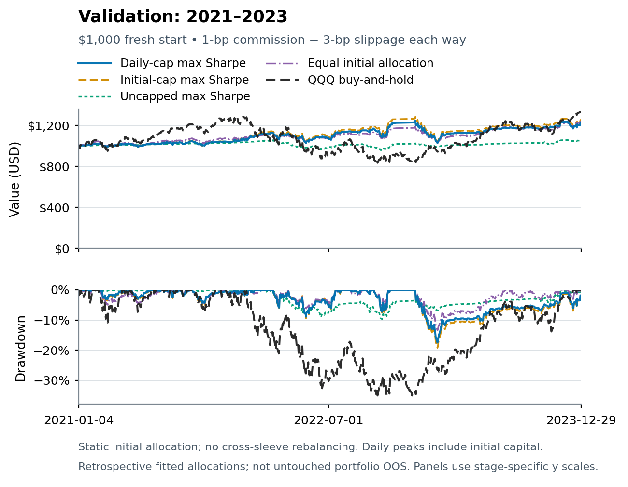
Figure 2. Validation, 2021–2023. The same definitions and initial weights restart with $1,000 and no inherited holdings. Baseline costs and daily drawdown conventions match Figure 1; axis scales differ.
Validation is the weak period. The daily-cap fit returns 6.90% CAGR with 0.381 Sharpe and −17.52% drawdown. Equal initial allocation has 0.473 Sharpe. The uncapped fit earns 1.82% CAGR with −0.243 cash-excess Sharpe and −9.70% drawdown; a positive nominal CAGR does not imply outperformance of the matched cash reference.
The UNG sleeve reaches 35.18% of daily-cap portfolio capital on the validation path, with 41 daily valuations above one-third. These saved weights have not been altered to repair the breach.

Historical OOS Equity and Drawdown
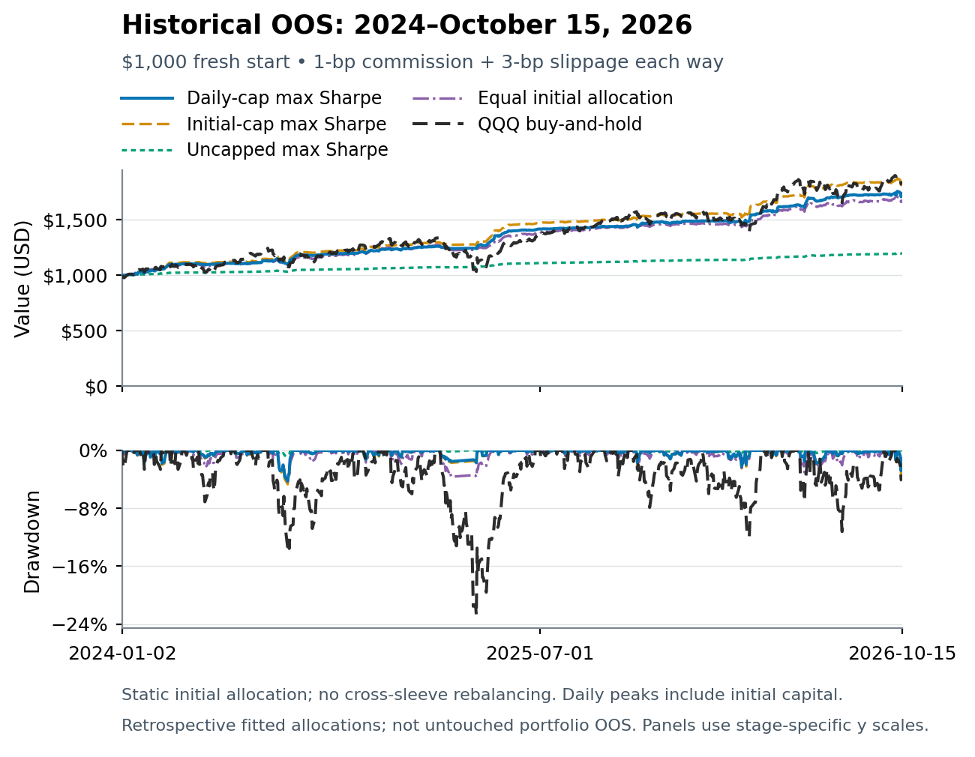
Figure 3. Historical OOS, January 2024–October 15, 2026. The configurations, ETF pruning and optimized weights were chosen after this history was examined. The curves are therefore descriptive fitted-window comparisons, not untouched portfolio OOS evidence.
The daily-cap mix has 2.481 Sharpe, 21.85% CAGR and −4.24% daily drawdown. The initial-only cap grows faster at 24.57% CAGR, while passive QQQ delivers 23.93% CAGR with a much larger −22.77% drawdown. The uncapped mix has the highest fitted Sharpe of 2.497 but only 6.86% CAGR; Sharpe alone does not express the growth preference.
At 25-bp slippage, daily-cap Sharpe is 2.351 and CAGR is 20.50%. Validation at the same cost has only 0.272 Sharpe and 5.59% CAGR. Cost resilience in one fitted period does not resolve period instability or post-selection bias.

Correlation and Diversification
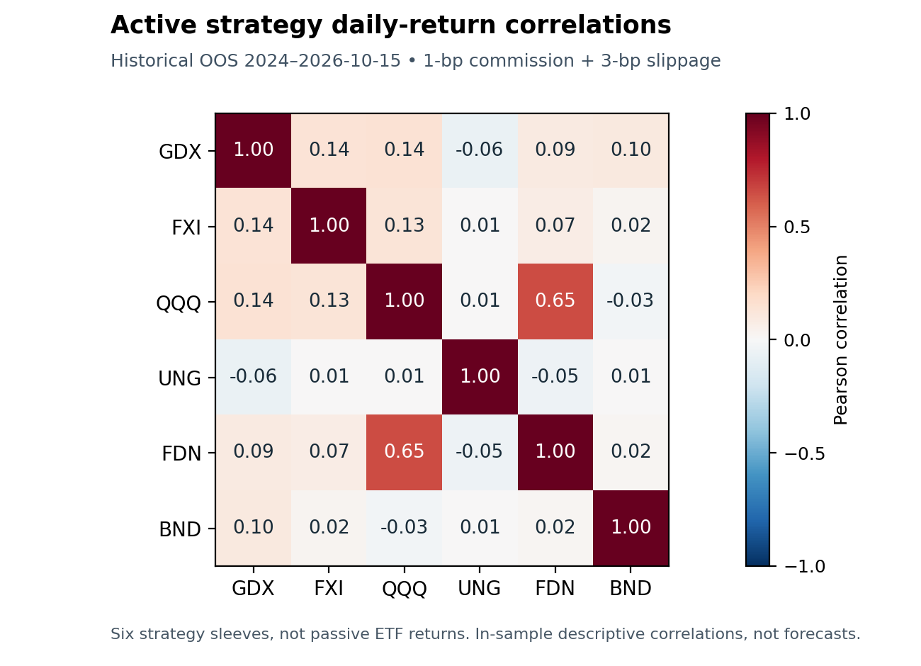
Figure 4. Pearson correlations of 700 aligned daily net active strategy returns in historical OOS, at baseline costs. All cash and flat periods remain included; these are not passive ETF price correlations or a spread-trading test.
QQQ and FDN have the strongest active-return correlation, about 0.650. Most other pairs are much closer to zero; for example, GDX–UNG is −0.063. This provides a historical rationale for combining different sleeves, but correlations can shift with market conditions and trading states. Near-zero linear correlation does not exclude common tail risk.
Removing SMH and XLK while retaining QQQ was a user-directed, post-OOS pruning decision. It reduces visible technology overlap in this selected set, but it is not an independently validated asset-selection rule. The portfolio’s smooth fitted path reflects both selected signals and selected allocation weights.

Alpha and Beta
For each period and cost we regress net portfolio return minus matched cash on matched passive QQQ return minus cash. The intercept is annualized arithmetically by 252; beta is unitless. Both are descriptive, conditional on the selected sample and benchmark. Alpha is not CAGR, a causal skill estimate or unexplained variance.
Period | Portfolio | Annual alpha | QQQ beta | R squared
Development | Daily cap | 6.34% | 0.194 | 0.287
Development | Initial cap | 7.09% | 0.216 | 0.274
Development | Uncapped | 2.17% | 0.036 | 0.130
Development | Equal initial | 6.65% | 0.276 | 0.515
Validation | Daily cap | 2.65% | 0.179 | 0.143
Validation | Initial cap | 3.44% | 0.197 | 0.140
Validation | Uncapped | -1.69% | 0.064 | 0.116
Validation | Equal initial | 2.55% | 0.211 | 0.279
Historical OOS | Daily cap | 13.78% | 0.159 | 0.230
Historical OOS | Initial cap | 15.69% | 0.177 | 0.222
Historical OOS | Uncapped | 3.00% | 0.032 | 0.202
Historical OOS | Equal initial | 10.79% | 0.249 | 0.510

Joint exposure to all six passive ETFs
We also fit an intercept and all six passive ETF cash-excess factors simultaneously. The following table shows the daily-cap portfolio; full results for four portfolios, three periods and four costs are in the supplement. These partial slopes are not allocation weights, and negative coefficients do not imply actual short positions.
Period | Alpha | GDX | FXI | QQQ | UNG | FDN | BND
Dev | 6.96% | 0.093 | 0.090 | 0.031 | 0.033 | 0.078 | -0.061
Val | 6.92% | 0.049 | 0.114 | 0.021 | 0.059 | 0.037 | 0.059
OOS | 12.59% | 0.037 | 0.037 | 0.075 | 0.009 | 0.052 | -0.017

All fits include an intercept and use the full aligned stage sample. Factor-rank and passive self-regression checks accompany the output. QQQ and FDN are related passive equity exposures, so joint coefficients should not be overinterpreted. Additional factors mechanically improve in-sample fit; they do not establish forecasting value. We do not report significance stars or assume independent residuals.

Discussion and Conclusion
The clearest historical result is a growth–risk trade-off. The four mixtures reduce daily drawdowns relative to passive QQQ in each examined period, but none consistently dominates on growth, Sharpe and drawdown together. Equal initial weights lead earlier-window Sharpe, whereas optimized fitted-window Sharpes near 2.5 are accompanied by weak validation. The cash-heavy uncapped solution also demonstrates why maximizing a ratio can produce an allocation with modest CAGR.

Limitations
Selection is the primary limitation. The research explored a large configuration grid, changed display filters after OOS examination, pruned ETFs and optimized weights on the same later history. No deflated Sharpe, probability-of-backtest-overfitting estimate or multiple-testing-adjusted significance is computed here [4]. Separate original stage authorizations protect data access, but they cannot make the final hindsight-conditioned portfolio untouched.
The sample is short for regime or tail-risk claims. Historical daily drawdowns miss intraday losses; fixed costs omit capacity and detailed fill risk. Factors omit nonlinear and time-varying exposures. Bond and commodity ETF dynamics differ from their labels. Data-vintage choices, survivorship in the chosen ETF universe and the absence of delisted alternatives further limit generalization. Independent saved-path arithmetic is not independent raw-data validation.

A prospective continuation
A credible next experiment would lock the universe, one configuration per sleeve, selection rule, full-precision weights, clock, costs and any rebalance/cap policy before accessing a genuinely future period. It should preserve unsuccessful cases, define failure criteria in advance and obtain a separately authorized data release. Activity, seasonality, spread and macro hypotheses should be separate preregistered extensions, not explanations retrofitted to these curves. We perform none of those new tests here.
We conclude that this is a complete retrospective portfolio research project with reproducible calculations and explicit negative findings. It supports further controlled research, not deployment or a claim of persistent alpha.

References
[1] Moskowitz, T. J., Ooi, Y. H., and Pedersen, L. H. (2012). Time series momentum. Journal of Financial Economics 104, 228–250. https://www.aqr.com/Insights/Research/Journal-Article/Time-Series-Momentum
[2] Sharpe, W. F. (1994). The Sharpe Ratio. Journal of Portfolio Management, Fall. https://web.stanford.edu/~wfsharpe/art/sr/sr.htm
[3] Lo, A. W. (2002). The Statistics of Sharpe Ratios. Financial Analysts Journal 58(4), 36–52. Author record: https://alo.mit.edu/publications/page/18/
[4] Bailey, D. H., Borwein, J. M., López de Prado, M., and Zhu, Q. J. (2017). The Probability of Backtest Overfitting. Journal of Computational Finance. DOI 10.21314/JCF.2016.322. https://scholarworks.wmich.edu/math_pubs/42/

Appendix A Development 2017 to 2020
Each row retains the same selected strategy definitions and initial weights. Costs are 1-bp commission plus the listed one-way slippage, each way. Volatility is annualized net return volatility; Sharpe is cash-excess; alpha is annualized arithmetic QQQ-relative intercept. CAGR, volatility, drawdown and alpha are percentages. Beta is unitless.
Portfolio | Slip bp | CAGR | Vol | Sharpe | Max DD | Alpha | Beta
Daily cap | 1 | 14.86% | 8.43% | 1.330 | -7.52% | 6.41% | 0.194
Daily cap | 3 | 14.77% | 8.43% | 1.321 | -7.52% | 6.34% | 0.194
Daily cap | 10 | 14.47% | 8.41% | 1.293 | -7.53% | 6.07% | 0.194
Daily cap | 25 | 13.82% | 8.37% | 1.230 | -7.54% | 5.51% | 0.195
Initial cap | 1 | 16.24% | 9.60% | 1.303 | -8.48% | 7.17% | 0.216
Initial cap | 3 | 16.14% | 9.60% | 1.295 | -8.48% | 7.09% | 0.216
Initial cap | 10 | 15.80% | 9.58% | 1.267 | -8.49% | 6.79% | 0.216
Initial cap | 25 | 15.08% | 9.55% | 1.205 | -8.51% | 6.17% | 0.217
Uncapped | 1 | 6.24% | 2.32% | 1.331 | -2.31% | 2.19% | 0.036
Uncapped | 3 | 6.21% | 2.32% | 1.320 | -2.32% | 2.17% | 0.036
Uncapped | 10 | 6.12% | 2.33% | 1.279 | -2.37% | 2.08% | 0.036
Uncapped | 25 | 5.93% | 2.34% | 1.193 | -2.48% | 1.90% | 0.036
Equal initial | 1 | 17.51% | 8.95% | 1.513 | -6.53% | 6.72% | 0.276
Equal initial | 3 | 17.43% | 8.95% | 1.506 | -6.56% | 6.65% | 0.276
Equal initial | 10 | 17.16% | 8.94% | 1.481 | -6.65% | 6.42% | 0.276
Equal initial | 25 | 16.58% | 8.93% | 1.427 | -6.85% | 5.94% | 0.277
QQQ passive | 1 | 28.40% | 23.26% | 1.063 | -28.56% | 0.00% | 1.000
QQQ passive | 3 | 28.39% | 23.26% | 1.063 | -28.56% | 0.00% | 1.000
QQQ passive | 10 | 28.35% | 23.26% | 1.061 | -28.56% | 0.00% | 1.000
QQQ passive | 25 | 28.25% | 23.26% | 1.058 | -28.56% | 0.00% | 1.000

QQQ passive alpha and beta are its self-control identity (0 and 1), not an extra source of active skill. Matched cash controls have undefined cash-excess Sharpe and remain in the machine-readable control table. Full precision and residual diagnostics are available in the supplement.
Baseline terminal values from $1,000: Daily cap $1,734.02; Initial cap $1,818.13; Uncapped $1,272.38; Equal initial $1,900.13.

Appendix A Validation 2021 to 2023
Each row retains the same selected strategy definitions and initial weights. Costs are 1-bp commission plus the listed one-way slippage, each way. Volatility is annualized net return volatility; Sharpe is cash-excess; alpha is annualized arithmetic QQQ-relative intercept. CAGR, volatility, drawdown and alpha are percentages. Beta is unitless.
Portfolio | Slip bp | CAGR | Vol | Sharpe | Max DD | Alpha | Beta
Daily cap | 1 | 7.02% | 11.30% | 0.391 | -17.50% | 2.76% | 0.180
Daily cap | 3 | 6.90% | 11.30% | 0.381 | -17.52% | 2.65% | 0.179
Daily cap | 10 | 6.48% | 11.30% | 0.346 | -17.59% | 2.27% | 0.179
Daily cap | 25 | 5.59% | 11.31% | 0.272 | -17.73% | 1.46% | 0.179
Initial cap | 1 | 7.90% | 12.55% | 0.429 | -19.22% | 3.56% | 0.198
Initial cap | 3 | 7.77% | 12.55% | 0.419 | -19.24% | 3.44% | 0.197
Initial cap | 10 | 7.30% | 12.56% | 0.385 | -19.33% | 3.02% | 0.197
Initial cap | 25 | 6.32% | 12.58% | 0.311 | -19.52% | 2.13% | 0.197
Uncapped | 1 | 1.88% | 4.49% | -0.231 | -9.66% | -1.63% | 0.064
Uncapped | 3 | 1.82% | 4.49% | -0.243 | -9.70% | -1.69% | 0.064
Uncapped | 10 | 1.63% | 4.48% | -0.285 | -9.85% | -1.87% | 0.064
Uncapped | 25 | 1.23% | 4.47% | -0.375 | -10.16% | -2.26% | 0.064
Equal initial | 1 | 7.42% | 9.50% | 0.485 | -13.45% | 2.66% | 0.211
Equal initial | 3 | 7.30% | 9.50% | 0.473 | -13.48% | 2.55% | 0.211
Equal initial | 10 | 6.89% | 9.50% | 0.432 | -13.56% | 2.17% | 0.211
Equal initial | 25 | 6.01% | 9.50% | 0.346 | -13.75% | 1.38% | 0.210
QQQ passive | 1 | 9.86% | 23.77% | 0.388 | -35.12% | 0.00% | 1.000
QQQ passive | 3 | 9.84% | 23.77% | 0.387 | -35.12% | 0.00% | 1.000
QQQ passive | 10 | 9.79% | 23.78% | 0.385 | -35.12% | 0.00% | 1.000
QQQ passive | 25 | 9.68% | 23.78% | 0.381 | -35.12% | 0.00% | 1.000

QQQ passive alpha and beta are its self-control identity (0 and 1), not an extra source of active skill. Matched cash controls have undefined cash-excess Sharpe and remain in the machine-readable control table. Full precision and residual diagnostics are available in the supplement.
Baseline terminal values from $1,000: Daily cap $1,220.37; Initial cap $1,250.15; Uncapped $1,055.36; Equal initial $1,234.05.

Appendix A Historical OOS 2024 to October 15 2026
Each row retains the same selected strategy definitions and initial weights. Costs are 1-bp commission plus the listed one-way slippage, each way. Volatility is annualized net return volatility; Sharpe is cash-excess; alpha is annualized arithmetic QQQ-relative intercept. CAGR, volatility, drawdown and alpha are percentages. Beta is unitless.
Portfolio | Slip bp | CAGR | Vol | Sharpe | Max DD | Alpha | Beta
Daily cap | 1 | 21.98% | 6.89% | 2.492 | -4.23% | 13.88% | 0.159
Daily cap | 3 | 21.85% | 6.88% | 2.481 | -4.24% | 13.78% | 0.159
Daily cap | 10 | 21.42% | 6.85% | 2.440 | -4.25% | 13.43% | 0.159
Daily cap | 25 | 20.50% | 6.78% | 2.351 | -4.29% | 12.69% | 0.158
Initial cap | 1 | 24.71% | 7.79% | 2.499 | -4.66% | 15.80% | 0.177
Initial cap | 3 | 24.57% | 7.78% | 2.487 | -4.67% | 15.69% | 0.177
Initial cap | 10 | 24.08% | 7.75% | 2.447 | -4.69% | 15.31% | 0.176
Initial cap | 25 | 23.04% | 7.68% | 2.358 | -4.74% | 14.49% | 0.176
Uncapped | 1 | 6.89% | 1.48% | 2.508 | -0.82% | 3.03% | 0.032
Uncapped | 3 | 6.86% | 1.47% | 2.497 | -0.82% | 3.00% | 0.032
Uncapped | 10 | 6.73% | 1.45% | 2.455 | -0.82% | 2.89% | 0.031
Uncapped | 25 | 6.46% | 1.41% | 2.351 | -0.82% | 2.64% | 0.031
Equal initial | 1 | 20.58% | 7.24% | 2.216 | -4.27% | 10.88% | 0.249
Equal initial | 3 | 20.46% | 7.24% | 2.204 | -4.27% | 10.79% | 0.249
Equal initial | 10 | 20.07% | 7.22% | 2.164 | -4.29% | 10.48% | 0.249
Equal initial | 25 | 19.25% | 7.19% | 2.077 | -4.31% | 9.82% | 0.249
QQQ passive | 1 | 23.95% | 20.75% | 0.997 | -22.77% | 0.00% | 1.000
QQQ passive | 3 | 23.93% | 20.75% | 0.996 | -22.77% | 0.00% | 1.000
QQQ passive | 10 | 23.87% | 20.75% | 0.993 | -22.77% | 0.00% | 1.000
QQQ passive | 25 | 23.73% | 20.76% | 0.988 | -22.77% | 0.00% | 1.000

QQQ passive alpha and beta are its self-control identity (0 and 1), not an extra source of active skill. Matched cash controls have undefined cash-excess Sharpe and remain in the machine-readable control table. Full precision and residual diagnostics are available in the supplement.
Baseline terminal values from $1,000: Daily cap $1,734.64; Initial cap $1,844.62; Uncapped $1,203.03; Equal initial $1,680.18.

Appendix B Reproducibility and Course Coverage
The companion archive separates portable arithmetic, public parameter definitions, aggregate results, raster figures and documentation. It omits licensed raw market data, full daily paths, private input locators, credentials and study authorizations. A reader can inspect results and run synthetic tests immediately; numerical replay of account-derived metrics requires the separately held, authenticated daily bundle described by the input schema.
Course requirement | Project evidence
Project Goal | ETF momentum and long/cash recovery question, controls and limits
Research Outline | Window/threshold research; hypotheses and honestly labeled extensions
Data | Frozen stages, daily seed, half-hour coverage and price-unit controls
Backtesting | Causal projections, seven checks, next eligible open, fresh stage accounts
Execution and Slippage | 1-bp commission and four one-way slippages; terminal costs and cash
Weighting | Four fixed initial allocations; wealth aggregation; observed cap breach
Performance Evaluation | Return, volatility, Sharpe, drawdown, cash and QQQ controls, single and joint alpha/beta

Verification boundary
The three-period aggregate report contains 48 portfolio rows, 24 control rows and 48 capital-share rows. Separately implemented saved-path arithmetic verified these statistics. This project adds 48 QQQ single-factor and 48 joint-six-factor regressions, plus passive self-control and rank checks. Input/source hashes are rechecked before and after calculation. New plotting reads saved arrays only and exports raster images without embedded daily numerical series.
The original three-period calculation passed 102 portable synthetic tests. Its independent oracle checked statistics and initial/terminal clocks. New attribution fixtures verify known coefficients, self-regressions and invalid input rejection. These tests establish calculation consistency under the specified inputs; they do not validate the economic hypotheses, original vendor truth or future performance.

Exact configuration identifiers
GDX mr_30m__zscore_20__entry_m2__exit_0__shared_hours_3
FXI mr_30m__zscore_50__entry_m2__exit_0p5__shared_hours_3
QQQ v5_30m__entry_ema_50__exit_ema_200__entry_hours_3__exit_hours_3
UNG mr_30m__rsi_14__entry_30__exit_50__shared_hours_3
FDN v5_30m__entry_ema_50__exit_ema_100__entry_hours_3__exit_hours_3
BND mr_30m__ema_distance_50__entry_m0p02__exit_0p01__shared_hours_3

