GIOI
Journey and QA Report
Customer, host and admin journeys, mapped to the end-to-end browser scenarios and their latest results.
Scope apps/web and apps/api
Run date 2026-11-07, managed Chromium + curl, dev DB
Sources docs/diagrams/*.png, docs/qa-e2e-browser-scenarios.md

Summary
135 scenarios were defined across the three journeys and the shared checks. 116 passed, 3 failed and 16 were not run.
Area | Scenarios | Pass | Fail | Not run
Customer | 30 | 23 | 1 | 6
Host | 32 | 29 | 0 | 3
Admin | 57 | 53 | 1 | 3
UI and security | 16 | 11 | 1 | 4
Total | 135 | 116 | 3 | 16

Open failures
ID | P | Scenario | Finding
G-12 | P1 | Required fields | Confirm is disabled until name and phone are valid, but no inline error message explains why.
D-11 | P1 | Export CSV button | Export CSV button in the dashboard table has no handler. CSV is available in Settings, Data export.
U-05 | P1 | Console clean | Dev-only hydration mismatch on /bali; cause not isolated.

Release read
- No P0 scenario failed. All P0 scenarios that ran passed.
- Three P1 items fail: G-12 and U-05 affect the public booking path; D-11 is a dead button on the admin dashboard.
- Several P1 checks were not run, mainly mobile layout (G-05, U-02), keyboard access (U-03) and API-down states (U-06). U-06 showed misleading "not found" text instead of an unavailable state.

Customer journey
A guest finds the restaurant, picks a date, party size and time, confirms with name and phone, and later leaves feedback. No login is involved. The booking starts as pending and the host confirms it.
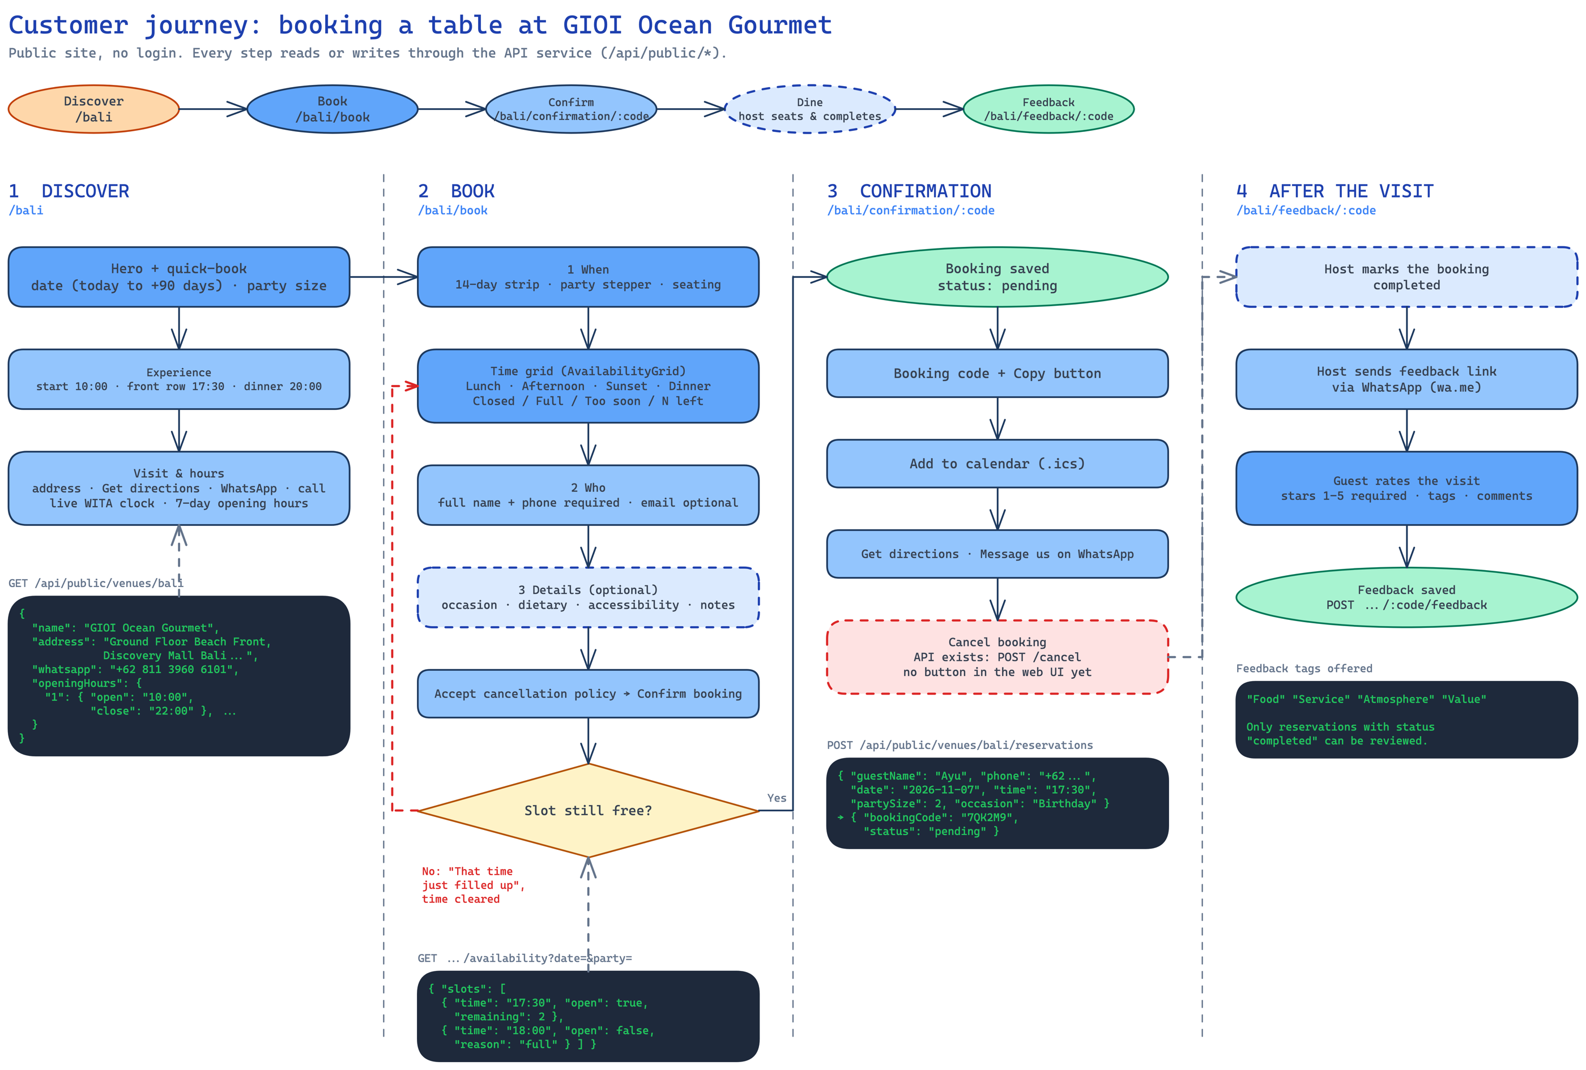

Stages and coverage
Stage | Route | Scenarios
1 Discover | /bali | G-01, G-02, G-03
2 Book | /bali/book | G-04 to G-15b
3 Confirmation | /bali/confirmation/:code | G-16 to G-21
4 Feedback | /bali/feedback/:code | G-22 to G-27

30 scenarios: 23 pass, 1 fail, 6 not run.

Discover — /bali
ID | P | Scenario | Expected | Status
G-01 | P0 | Landing loads | Redirects to /bali; hero, experience scenes, visit & hours render; no console errors | Pass
G-02 | P1 | Visit & hours | Values match venue settings; links valid; clock is Asia/Makassar | Pass
G-03 | P1 | Quick-book → booking | Lands on /bali/book with that date/party pre-filled; dates beyond +90 days not selectable | Pass

Book — /bali/book
ID | P | Scenario | Expected | Status
G-04 | P0 | Happy path | Redirect to /bali/confirmation/<code>; booking is pending; shows on /host | Pass
G-05 | P1 | Date strip on mobile | First pill has a left gutter (not flush to the edge); strip scrolls and snaps; "More dates" picker works | Not run
G-06 | P1 | Time grid states | Slots show N left, Full, Too soon, or Closed correctly; unavailable ones not selectable | Pass
G-07 | P1 | Closed day / closed date | Pill disabled or all slots Closed | Pass
G-08 | P0 | Capacity (no overbooking) | Last slot becomes Full; API never exceeds capacity | Pass
G-09 | P0 | Slot race | A sees "That time just filled up"; selected time is cleared; grid refreshes; no booking created for A | Pass
G-10 | P1 | Party-size bounds | UI blocks; API 422 | Pass
G-11 | P1 | Lead time and cutoff | Shown Too soon / not offered | Pass
G-12 | P1 | Required fields | Inline errors for name/phone; email optional; nothing created | Fail
G-13 | P1 | Details (optional) | Stored; visible on host card and guest profile | Pass
G-14 | P1 | Policy gate | Blocked | Pass
G-15 | P1 | Idempotency | Exactly one reservation, same booking code | Pass
G-15b | P1 | Turnstile (only if NUXT_PUBLIC_TURNSTILE_SITE_KEY set) | Blocked with message; with token succeeds | Not run

Confirmation — /bali/confirmation/:code
ID | P | Scenario | Expected | Status
G-16 | P0 | Details + pending state | Shows status pending, code, date/time/party/area | Pass
G-17 | P1 | Copy button | Code in clipboard; feedback shown | Not run
G-18 | P1 | Add to calendar | .ics downloads; opens with the right title/time/WITA zone | Pass
G-19 | P1 | Directions / WhatsApp | Correct maps URL and wa.me number | Pass
G-20 | P0 | No PII on lookup | No phone/email/internal notes; unknown code → 404 page | Pass
G-21 | P1 | Cancel (API only) | First → cancelled (visible on host view); others → rejected; a second cancel rejected. If a button was added, add a UI scenario | Pass

After the visit — /bali/feedback/:code
ID | P | Scenario | Expected | Status
G-22 | P1 | Only completed | Rejected (409) | Pass
G-23 | P0 | Happy path | Saved; thank-you state; appears in Admin → Guest feedback | Pass
G-24 | P1 | Stars required | Blocked (1–5 required) | Pass
G-25 | P1 | Tags offered | Food, Service, Atmosphere, Value (or the tags configured in Settings) | Not run
G-26 | P1 | One feedback per booking | Second rejected | Pass
G-27 | P1 | Unknown code | Not-found state, no crash | Pass

Public UI
ID | P | Scenario | Expected | Status
G-28 | P2 | Theme toggle | Smooth cross-fade (no per-element flicker); persists on reload; follows OS when unset; reduced-motion = instant | Not run
G-29 | P2 | Theme button vs summary bar | Button sits above the sticky summary | Not run

Host journey
Front-of-house staff sign in, run the day from one list, move each booking through its status machine, add walk-ins and look up guests. Hosts cannot reach settings, users or the audit log.
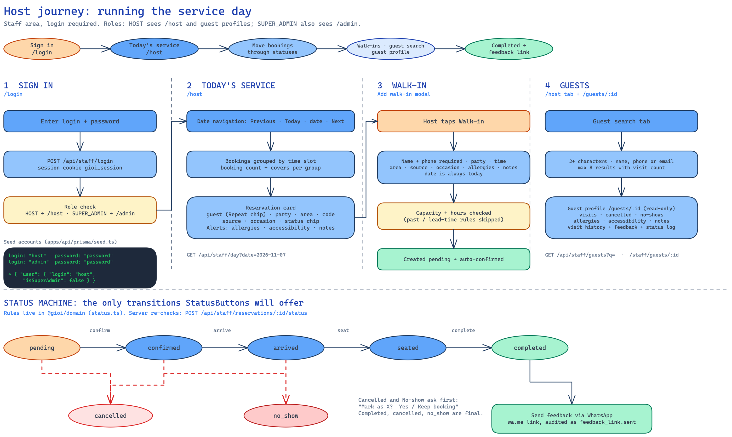

Stages and coverage
Stage | Route | Scenarios
1 Sign in | /login | A-01 to A-14
2 Today's service | /host | H-01 to H-13
3 Walk-in | modal on /host | W-01 to W-06
4 Guests | /host tab, /guests/:id | S-01 to S-13

32 scenarios: 29 pass, 0 fail, 3 not run.

Host journey — Today's service (/host)
ID | P | Scenario | Expected | Status
H-01 | P0 | Day view | Bookings grouped by time slot; per-group booking count + covers; header "N bookings · M active" correct | Pass
H-02 | P1 | Date navigation | List and header date update | Pass
H-03 | P1 | Live refresh | Appears within ~4 s, no reload | Pass
H-04 | P1 | Reservation card content | Guest (Repeat chip), party, area, code, source, occasion, status chip; alerts for allergies/accessibility/notes | Not run
H-05 | P0 | Status happy path | Each step allowed; chip/counts update; audit event written | Pass
H-06 | P0 | Invalid transitions | 409; UI never offers them | Pass
H-07 | P1 | Cancel / no-show allowed only from | Others not offered | Pass
H-08 | P1 | Destructive confirm | Prompt "Mark as X?" with Yes / "Keep booking"; Keep leaves status unchanged | Pass
H-09 | P1 | Final states | No further status buttons | Pass
H-10 | P0 | Open guest from a card | /guests/<id> renders the profile (regression: wrong route name + missing serviceTags crash) | Pass
H-11 | P1 | Feedback link | Opens wa.me link with the template; audited as feedback_link.sent (visible in Audit log) | Pass
H-12 | P1 | Empty day | "No bookings for this day." | Pass
H-13 | P2 | Tabs | Content swaps; no console errors | Pass

Walk-in modal
ID | P | Scenario | Expected | Status
W-01 | P0 | Create walk-in | Created; auto-confirmed (status confirmed, not pending); appears in the list | Pass
W-02 | P1 | Date fixed to today | Date is always today; no date picker | Pass
W-03 | P1 | Required fields | Inline error; nothing created | Not run
W-04 | P0 | Capacity checked | Rejected with message (409/422); no overbook | Pass
W-05 | P1 | Hours checked | Rejected | Pass
W-06 | P1 | Past / lead-time rules skipped | Allowed (diagram: these rules are skipped for walk-ins) | Pass

Host journey — Guests (/host tab + /guests/:id)
ID | P | Scenario | Expected | Status
S-01 | P0 | Search finds any guest | Listed with phone, N visits, badges | Pass
S-02 | P1 | Search fields | All match, case-insensitive | Pass
S-03 | P1 | Min length | "Type at least 2 characters."; no request | Pass
S-04 | P1 | Max 8 results | 8 rows | Pass
S-05 | P1 | No results | "No guests match." | Pass
S-06 | P1 | Fast typing | Debounced; final list matches final query | Pass
S-07 | P0 | Profile renders | /guests/<id>: contact, allergies, seating preference, internal notes, visits/cancelled/no-show counts, visit history | Pass
S-08 | P1 | Visit feedback | "Guest feedback: x/5", comment, "Stood out: …" | Pass
S-09 | P1 | Profile is read-only | None | Pass
S-10 | P1 | Back button | Returns to origin; direct load falls back to /host (host) or /admin (admin) | Pass
S-11 | P1 | Visit pagination | 10/page, Previous/Next, "Page x of y" | Not run
S-12 | P0 | Other venue's guest | No data (403 / not found) | Pass
S-13 | P1 | Unknown id | "Guest not found." | Pass

Admin journey
Venue admins use the dashboard and settings. Super admins also manage users and read the audit log. Every settings save writes a diffed audit event.
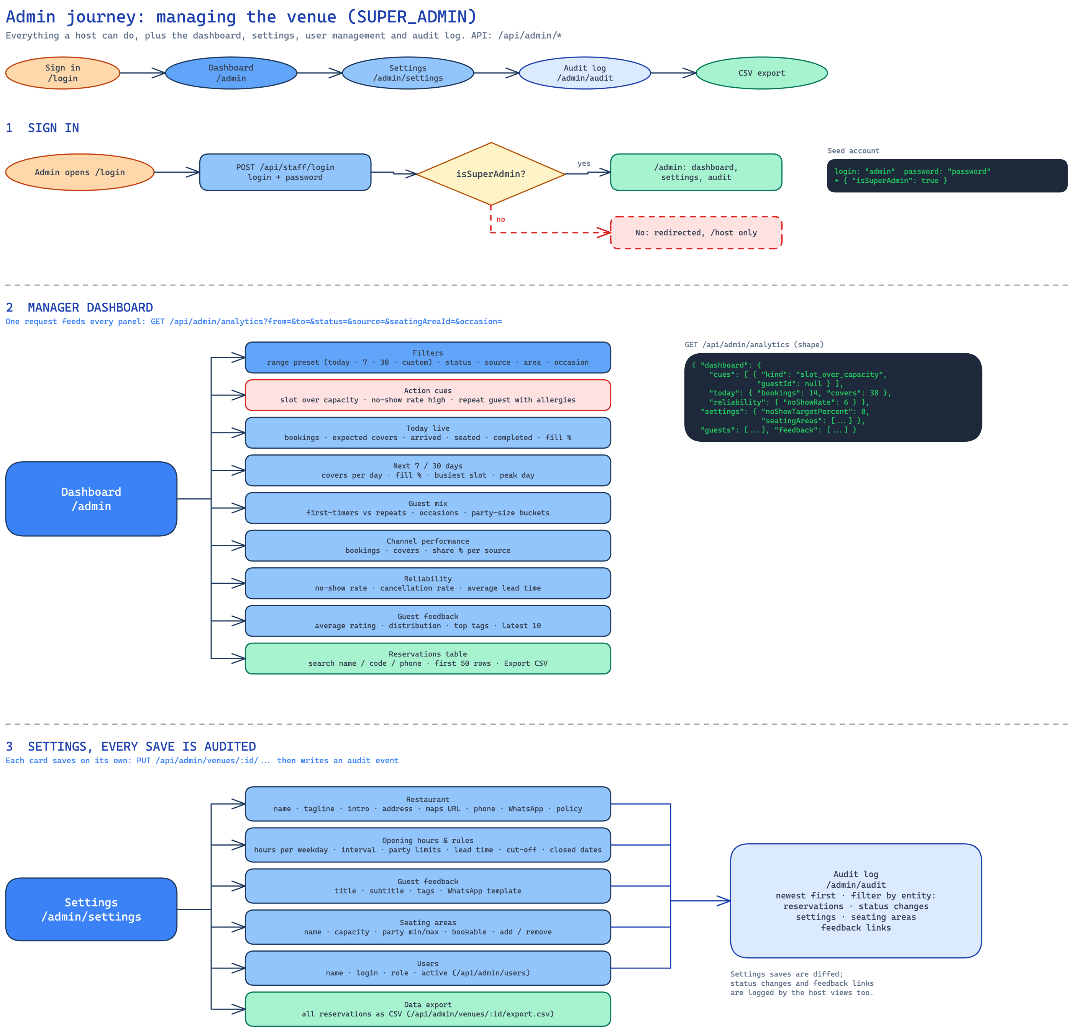

Stages and coverage
Stage | Route | Scenarios
1 Sign in, role gate | /login, /admin | A-02, A-03, R-01 to R-13
2 Dashboard | /admin | D-01 to D-12
3 Settings | /admin/settings | T-01 to T-12
4 Audit log | /admin/audit | L-01 to L-06

57 scenarios: 53 pass, 1 fail, 3 not run.

Authentication & session
ID | P | Scenario | Expected | Status
A-01 | P0 | Host login | → /host; nav shows Host only; chip "Host User · host" | Pass
A-02 | P0 | Super admin login | → /admin; nav Host, Dashboard, Settings, Audit; chip "· super admin" | Pass
A-03 | P0 | Venue admin login | → /admin; nav Host, Dashboard, Settings (no Audit) | Pass
A-04 | P0 | Bad credentials | Same generic error for all; no user enumeration | Pass
A-05 | P1 | Login rate limit | 11th → 429 "too many attempts"; correct password also blocked until the window ends; other logins unaffected | Pass
A-06 | P0 | Auth guard | → /login | Pass
A-07 | P0 | Single device per user | A's next action → 401 → /login?reason=session with "You were signed out…" banner; B keeps working | Pass
A-08 | P0 | Different users unaffected | Both stay logged in | Pass
A-09 | P1 | Logout | Cookie cleared → /login; Back button shows no data (API 401) | Pass
A-10 | P1 | Expiry / cleared cookie | Next API call → 401 → /login?reason=session | Pass
A-11 | P1 | Cookie flags | gioi_session: HttpOnly, Secure, SameSite=Lax, Path=/ | Pass
A-12 | P1 | Deactivated user | Next request 401 | Pass
A-13 | P1 | CSRF origin check | 403 "origin not allowed"; same-origin works | Pass
A-14 | P1 | Open redirect | Stays on this site | Pass

Role-based access
ID | P | Scenario | Expected | Status
R-01 | P0 | /admin | → /host / loads / loads | Pass
R-02 | P0 | /admin/settings | → /host / loads / loads | Pass
R-03 | P0 | /admin/audit | → /host / → /host / loads | Pass
R-04 | P0 | Settings content | — / loads, no Users section (no endless "Loading settings…") / all sections | Pass
R-05 | P0 | API settings reads (GET /api/admin/venues/:id, /opening-hours, /closed-dates, /seating-areas) | 403 / 200 / 200 | Pass
R-06 | P0 | API settings writes (PATCH/PUT) | 403 / 200 / 200 | Pass
R-07 | P0 | /api/admin/analytics, /api/admin/venues/:id/export.csv | 403 / 200 / 200 | Pass
R-08 | P0 | /api/admin/users, /api/admin/audit-log | 403 / 403 / 200 | Pass
R-09 | P0 | Cross-venue access | 403 for non-super users | Pass
R-10 | P1 | Front-of-house works for host | All allowed | Pass
R-11 | P1 | Venue admin can edit reservations | Allowed (regression: was 403) | Pass
R-12 | P1 | Role change takes effect | Nav/redirect match the new role | Pass
R-13 | P1 | Dashboard for venue admin | Loads; no 403 on audit-log (removed dead fetch) | Pass

Admin journey — Dashboard (/admin)
ID | P | Scenario | Expected | Status
D-01 | P0 | Loads | All panels render; no console errors | Pass
D-02 | P1 | Range presets | Numbers + labels update; custom range validated | Pass
D-03 | P1 | Filters | Panels respect them (one request: /api/admin/analytics?from&to&…) | Pass
D-04 | P1 | Action cues | Cue appears when its condition is met; "Open guest →" / "Open host view →" go to the right place | Pass
D-05 | P1 | Today live | Match /host | Pass
D-06 | P1 | Next 7 / 30 days | Plausible vs seeded data | Pass
D-07 | P1 | Guest mix, channels, reliability | No NaN / undefined; totals add up | Pass
D-08 | P1 | Guest feedback panel | Matches submitted feedback; 10 per page with Previous/Next; click opens detail modal (Esc closes) | Pass
D-09 | P1 | Reservations table search | Filters; "N matching" updates | Pass
D-10 | P1 | Reservations pagination | 25/page (was "first 50"); shrinking results clamps the page | Pass
D-11 | P1 | Export CSV button | Currently rendered without a handler — verify intent (use Settings → Data export) | Fail
D-12 | P2 | Empty range | Empty states, no NaN | Pass

Admin journey — Settings (/admin/settings, every save audited)
ID | P | Scenario | Expected | Status
T-01 | P0 | Load | All cards load; Users only for super admin | Pass
T-02 | P0 | Restaurant | "Saved at …"; persists; shown on /bali; audit event | Pass
T-03 | P1 | Name read-only | Disabled (not in the API whitelist) | Pass
T-04 | P1 | Opening hours & rules | Public availability follows each | Pass
T-05 | P1 | Guest feedback | Used on feedback page and the host's feedback link | Pass
T-06 | P1 | Seating areas | Public + walk-in options follow | Pass
T-07 | P1 | Users (super admin) | Persists; effective on next login; audit event | Pass
T-08 | P0 | Data export | File downloads with guest contact + allergy/accessibility notes; 403 for hosts | Pass
T-09 | P1 | Save is diffed | Audit event lists only the changed field(s) | Pass
T-10 | P1 | Failed save | "Save failed…" message, no silent success | Not run
T-11 | P1 | Concurrent edit | Last save wins; no crash; no stale data after reload | Not run
T-12 | P2 | Validation | Rejected with a clear message | Pass

Audit log (/admin/audit, super admin)
ID | P | Scenario | Expected | Status
L-01 | P1 | Events recorded | One event each with actor, entity, changed fields, time | Pass
L-02 | P1 | Newest first | Newest at top | Pass
L-03 | P1 | Filter | List narrows; page clamps | Pass
L-04 | P1 | Pagination | 25/page, Previous/Next | Pass
L-05 | P1 | Empty state | Friendly message | Not run
L-06 | P0 | Access | Redirect + API 403 | Pass

Shared checks

UI and cross-cutting
ID | P | Scenario | Expected | Status
U-01 | P1 | Staff theme toggle | Smooth cross-fade incl. header; persisted; staff default dark when unset | Pass
U-02 | P1 | Responsive | No unintended horizontal overflow; mobile nav is a second row; tap targets ≥ 44 px | Not run
U-03 | P1 | Keyboard | Visible focus, logical order, Esc closes modals | Not run
U-04 | P2 | Reduced motion | Theme switch and transitions instant/fade only | Not run
U-05 | P1 | Console clean | No uncaught errors/hydration warnings | Fail
U-06 | P1 | API down | Error states, not a blank page or endless "Loading…" | Not run
U-07 | P1 | Host-based routing | As in server/middleware/host-routes.ts | Pass
U-08 | P2 | Time zone | Same date/time on confirmation, host, admin, .ics | Pass

Security smoke
ID | P | Scenario | Expected | Status
X-01 | P0 | Every /api/staff/* and /api/admin/* call with no cookie | 401 | Pass
X-02 | P0 | Replay an old cookie after logging in elsewhere | 401 | Pass
X-03 | P0 | Public booking lookup response | No phone/email/internal notes | Pass
X-04 | P1 | XSS: guest name/notes <img src=x onerror=alert(1)> | Rendered as text on host, profile, admin, audit | Pass
X-05 | P1 | SQL-ish search ' OR 1=1 -- | Treated literally | Pass
X-06 | P1 | Tamper UUIDs (reservation/guest/venue from another venue) | 403/404 only | Pass
X-07 | P1 | Garbage or oversized bodies to public booking | 4xx, never 500 | Pass
X-08 | P1 | Error shape / headers | { error, message }; no stack traces | Pass

Run notes
- ✘ D-11 Export CSV button in the dashboard table has no handler (use Settings → Data export).
- ✘ G-12 Confirm is disabled until name/phone are valid; there are no inline error messages.
- ✘ U-05 Dev-only Hydration completed but contains mismatches on /bali (cause not isolated).
- ☐ not run: G-05, G-15b (no Turnstile key), G-17, G-28, G-29, H-04, L-05, S-11 (no guest with >10 visits), T-10, T-11, U-02 (no overflow at 390/768/1280; tap-target count not reviewed), U-03, U-04, U-06 (API down: pages show "Venue not found." / "couldn't find that booking code" instead of an unavailable state).
- A-13 verified on a temp API with CORS_ORIGIN set: foreign Origin → 403, same origin → 200.

Known gaps
- Guest cancel exists only as an API; no button on the confirmation page (per customer diagram).
- Dashboard "Export CSV" button has no handler.
- Login rate limiting is in-memory per serverless instance; needs a shared store for real brute-force protection.
- Sessions have a fixed 7-day life (no sliding expiry).
- Pagination is client-side; only the audit endpoint accepts limit.
- Diagrams are out of date on: venue-admin access, pagination (diagram says "first 50 rows"), and single-session login.

Diagram and code differences
- Diagrams say /admin is super admin only. Code lets venue admins use Dashboard and Settings, not Users or Audit.
- Diagrams show "first 50 rows"; the reservations table paginates at 25.
- Diagrams do not show single-session login: a second login signs the first device out.

