Done

Make wifi scanner
Wifi scanner to get dataset

Trilateration formula
def getCoordinate( temp,coordinate):
x_c = [-1]
y_c = [-1]
for item in coordinate:
x_c.append(item[0])
y_c.append(item[1])
r = [-1]
for item in range(len(temp)):
r.append(getDistance(temp[item], freq[item]))

A = 2*x_c[2] - 2*x_c[1];
B = 2*y_c[2] - 2*y_c[1];
C = r[1]*r[1] - r[2]*r[2] - x_c[1]*x_c[1] + x_c[2]*x_c[2] - y_c[1]*y_c[1] + y_c[2]*y_c[2];
D = 2*x_c[3] - 2*x_c[2];
E = 2*y_c[3] - 2*y_c[2];
F = r[2]*r[2] - r[3]*r[3] - x_c[2]*x_c[2] + x_c[3]*x_c[3] - y_c[2]*y_c[2] + y_c[3]*y_c[3];
x = (C*E - F*B) / (E*A - B*D);
y = (C*D - A*F) / (B*D - A*E);
return round(x,2),round(y,2)

prototype program

Todo

Get RSSI formula
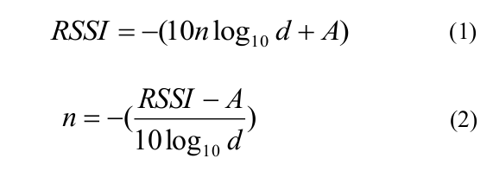
The value n is the signal propagation constant, where d is
the distance between the mobile phone and access points,
and A is the received signal strength in a meter’s distance
from the AP. The value A was obtained experimentally from
a meter’s distance to the AP. The constant n was calculated
using (2). Using (1), the distances between AP’s and the
mobile phones are calculated in terms of RSSI values.

Kalman filter

