Exercise 1: Traffic Capture

Packets are initially transmitted slowly but when the rate of transmission was increased, packets can be observed. ICMP (internet control message protocol) data packets appear to be used for echo request/reply. ARP (address resolution protocol) packets. MDNS (multicast domain name system) packets for standard query. ICMPv6 (internet control message protocol version 6) packet used for router solicitation, identify other routers on the network.

To capture http traffic I needed to search for web pages in the web browser
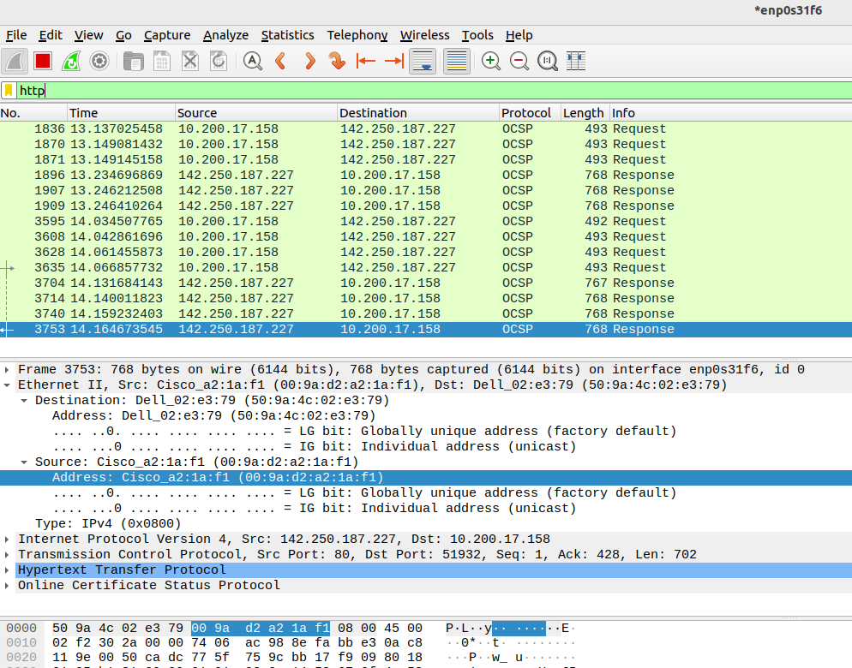
/home/ubuntu/Pictures/Screenshots/Screenshot from 2023-05-22 11-30-29.png

