Assignment 3

100 sent 200 received when mac adresses are swapped between sender and receiver using the corresponding table actions

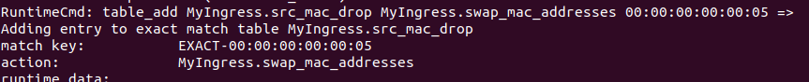
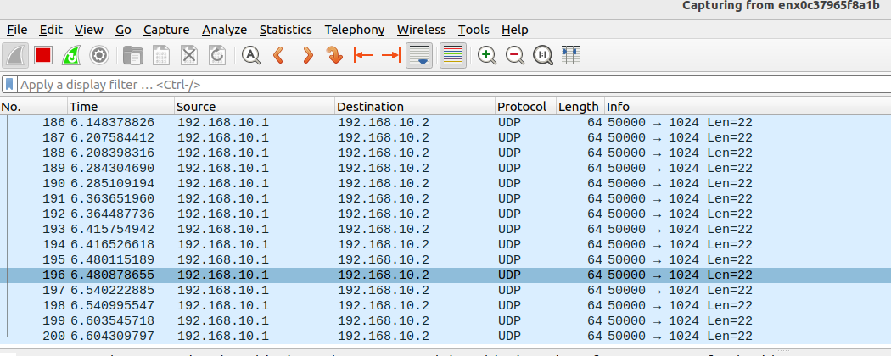

100 packets sent and 100 packets returned when the drop action action is activated so that packets with the same MAC address are dropped
