Outline Orchids

Functional traits mediate niche partitioning in epiphytic orchid communities.

Agustina Ventre-Lespiaucq^{1*}; Nhora H. Ospina-Calderón²; Nicola S. Flanagan³; Adrián Escudero¹, Marcos Méndez¹.

¹ Area of Biodiversity and Conservation, Department of Biology and Geology, Physics and Inorganic Chemistry, Universidad Rey Juan Carlos, Móstoles, Spain.
² Department of Biology, Edificio 320, Ciudadela Universitaria Melendez, Universidad del Valle, Cali, Colombia.
³ Department of Natural Sciences and Mathematics, Pontificia Universidad Javeriana Sede Cali, Cali, Colombia.
* aguslespiaucq@gmail.com

A basic principle in ecology is that coexistence is promoted by niche differences among species, mediated by functional traits. However, understanding how species partition their niches in hyper-diverse ecosystems such as tropical forests remains a considerable challenge in ecology. In particular, niche partitioning in epiphytic orchid assemblages is a major knowledge gap in current tropical ecology, with information restricted to a few focal species. To tackle this question, we investigated high-diversity assemblages of epiphytic orchids in the tropical Andes to explore biotic and abiotic predictors of species coexistence. We expected community composition and leaf functional traits to vary with the identity of the host tree, and with the gradient in abiotic factors over the vertical elevation in each tree. We sampled 500 individuals from 30 orchid species in 18 host trees at five trunk heights between 1 and 10 m. Host trees did not affect community composition or traits. By contrast, the vertical gradient of light, temperature and humidity affected several community features. Species richness and abundance increased with increasing elevation in the forest canopy. Specific leaf area increased and succulence decreased from high to low positions, consistent with a reduction in light availability and an increase in air humidity. These results suggest that functional traits mediate niche partitioning in epiphytic orchid communities along resource gradients. Our findings suggest that the physical structure of the forest, which determines the vertical environmental gradient, is an important factor promoting epiphytic orchid diversity.

Keywords: Epiphytic orchids; tropical diversity; functional traits; species coexistence; niche partitioning; environmental gradients.

Comentarios previos:
- Functional traits mediate niche partitioning in epiphytic orchid communities.
Para corroborar esto, hay que ver cómo es la estructura de las comunidades (turnover en bloque), identificar cuáles son estos bloques, y luego ver qué valores de rasgos funcionales presentan las spp. que los componen.
- En LH, en los estratos 5 y 4 hay structure clementsiana y en los 2 y 3 es estocástica.
- En RY es clementsiana en el estrato 5 y gleasoniana en los demás.

Introduction
P1:
P2:
P3:
P4: The aim of this study is to assess patterns of niche partitioning in epiphytic orchid assemblages and two potential drivers: host-tree identity and the vertical gradient of light availability.
H1:
H2:

Methods

Study site

Data analyses
We consider each combination of individual phorophyte and elevation as the sampling unit (sample hereafter).

(1) Community composition
To evaluate whether community composition differed between tree elevations, phorophytes and sites, we performed a NMDS analysis over a species presence-absence matrix using R package vegan (Oksanen et al., 2018). We tested for differences in species composition among sites, elevations and phorophytes using the command adonis in vegan, which performs a PERMANOVA. 999 permutations were used. We tested only the main effects (site with two levels, phorophyte with 18 levels, and elevation with five levels) and the site x elevation interaction.
We explored within-tree trends in community composition turnover with a graphical approach. [We do this because there is a lot of among tree variation. To this end, we obtained NMDS scores and line-connected the elevations of each tree.]

(2) Species richness
To assess how average species richness varied across tree elevations, we fitted a linear regression in each site separately, with the number of orchid species as a function of tree elevation. Asymptotic species richness per elevation was calculated using SpadeR online (Chao et al., 2015). We used four non-parametric richness estimators: Chao2, ICE-1, 1st order Jacknife, and 2nd order Jacknife, using presence-absence data per sample. As all estimators yielded qualitatively similar results, only 1st order Jacknife were presented.

(3) Species turnover
We calculated species turnover within and between elevations per site using function 'beta' with Jaccard index in R package BAT (Cardoso et al., 2015).

(4) RQL & fourth corner analysis

(5) Correlation between traits and environmental variables
Average trait value per sample (includes different number of individuals of various species). Since we do not have abundance data, we cannot compute CWM. [No estoy segura de que hacer este análisis tenga mucho sentido]. We assessed whether traits varied with environmental factors with trait by trait linear models in R.
5.1.) By location
5.2) By species (intra-specific trait variation)

(6) Coexistence analyses - meta-community structure
Data: species presence-absence matrices by sample.
To describe meta-community structure we performed three analyses. 1) coherence analysis using embedded ausences, 2) species turnover analysis, and 3) boundary clumping analysis using Morista's index. We used the function Metacommunity of the package metacom (ref) in R v.3.5.1 (R-Core Team), which performs the three analyses at once. Each matrix was analysed with two methods for building the null models, r1 and quasiswap (Heino XXX), and we ran the simulation for two ordination scores as recommended by Valanko et al. (2015) for obtaining a more complete description of metacommunity structure. We run 1000 simulations.
To assess whether the structure of the community varied with the scale of observation, we performed coexistence analyses at three spatial scales: tree height per location (9 matrices of varying dimensions, table S6.1), location (2 matrices, table S6.1), and the two locations together (1 matrix, table S6.1).
In LH, the lowest height led to a very small matrix, and therefore it was excluded from the small-scale analyses (improve phrasing). Nevertheless, this stratum was included in location and complete matrices.
To determine the type of community structure, we followed Mihaljevic et al. (2015) and Pressey et al. (2010).

Results

(1) Community composition
NMDS analyses ordered communities across 2 dimensions (stress = 0.107). A gradient was found along ordination axis 1 separating both sites (Fig. 1b). This was confirmed using a multivariate analysis of species composition. Significant differences were found between sites and phorophytes, but not among elevations (Table 1).

Table 1 Results of the PERMANOVA testing for differences in species composition between sites, phorophytes and tree elevations.

Factor | d.f. | SS | MS | F | R² | p
Site | 1 | 3.792 | 3.792 | 17.830 | 0.170 | 0.001
Phorophyte | 16 | 7.139 | 0.446 | 2.098 | 0.320 | 0.001
Elevation | 4 | 1.254 | 0.313 | 1.474 | 0.056 | 0.074
Site x Elevation | 4 | 0.963 | 0.241 | 1.132 | 0.043 | 0.285
Residuals | 43 | 9.144 | 0.213 | 0.410
Total | 68 | 22.292 |  | 1.000

(2) Species richness per site and tree elevation
A total of 37 morphospecies were found, 22 at La Hondonada and 23 at Yotoco. The average number of orchid species decreased from the highest to the lowest tree elevation (Fig. 2a) in both sites (LH: p = 0.02; Y: p = 0.04) (Summary 1). However, total species number was similar at all tree elevations (Fig. 2b). At each elevation, one or two orchid species were more frequent (Fig. 3). Restrepia incarnata and Stelis spathulata were the most frequent species at all elevations in La Hondonada (Fig. 3). Stelis argentata and S. spathulatha were the most frequent species at Yotoco (Fig. 3).

(3) Species turnover
Species turnover within elevation was higher than among elevations (Fig. 4). However, turnover among elevations was above the 50 %. Communities in La Hondonada showed an increased turnover from the highest to the lowest elevation (Fig. 4A). Most of the turnover was explained by a high species replacement between phorophytes (Fig. 4). Communities in Yotoco showed a similar turnover within elevations (Fig. 4B).

(4) RLQ & fourth corner analysis
RLQ showed a group of "pseudobulb orchids" with greater LDM, size, and succulence, located in open, diffuse light-rich sites (Fig. 5). The correlation between traits and environmental variables were low (0.22, 0.21) (Table 1). The variance of the environmental scores was well preserved in the two first axes, but in the trait values it was not. Correlation between species and sites is low.

Table 1:
RLQ analysis
Class: rlq dudi
Call: rlq(dudiR = acpR.orq, dudiL = afcL.orq, dudiQ = acpQ.orq, scannf = FALSE)

Total inertia: 1.137

Eigenvalues:
Ax1 Ax2 Ax3 Ax4 Ax5
9.325e-01 2.003e-01 3.919e-03 4.616e-06 4.024e-07

Projected inertia (%):
Ax1 Ax2 Ax3 Ax4 Ax5
8.203e+01 1.762e+01 3.447e-01 4.061e-04 3.540e-05

Cumulative projected inertia (%):
Ax1 Ax1:2 Ax1:3 Ax1:4 Ax1:5
82.03 99.65 100.00 100.00 100.00

Eigenvalues decomposition:
eig covar sdR sdQ corr
1 0.9324615 0.9656405 2.331105 1.882093 0.2200963
2 0.2003085 0.4475583 1.198366 1.768201 0.2112169

Inertia & coinertia R (acpR.orq):
inertia max ratio
1 5.434048 5.470740 0.9932930
12 6.870130 6.888547 0.9973264

Inertia & coinertia Q (acpQ.orq):
inertia max ratio
1 3.542273 6.372435 0.5558743
12 6.668807 10.044166 0.6639483

Correlation L (afcL.orq):
corr max ratio
1 0.2200963 0.8296877 0.2652760
2 0.2112169 0.7798542 0.270841

A fourth corner analysis revealed that the traits do not associate with the light environment (Table 2).

Table 2.
Monte-Carlo test
Call: fourthcorner2(tabR = orq$env, tabL = orq$spe, tabQ = orq$traits,
modeltype = 6, nrepet = nrepet, p.adjust.method.G = "fdr")

Observation: 1.136694

Based on 49999 replicates
Simulated p-value: 0.13452
Alternative hypothesis: greater

Std.Obs Expectation Variance
1.0798265 0.7836792 0.1068752
The combined methods showed that only diffuse light and openness correlated (weakly) with the RLQ axes (Table 3 and Fig. 6). Traits did not correlate significantly with RLQ axes. Axis AxcQ1 correlated negatively with diffuse light and axis AxcQ2 correlated negatively with openness.
Table 3
Test Stat Obs Std.Obs Alter Pvalue Pvalue.adj
1 Op / AxcQ1 r -0.14028772 -1.9835898 two-sided 0.04594 0.080395 .
2 DSF / AxcQ1 r -0.17987422 -2.0597354 two-sided 0.03244 0.05677 .
3 ISF / AxcQ1 r -0.21940698 -3.0481051 two-sided 0.00284 0.01988 *
4 TSF / AxcQ1 r -0.20412060 -2.3610007 two-sided 0.01204 0.033712 *
5 DirB / AxcQ1 r -0.17936437 -2.0627631 two-sided 0.0321 0.05677 .
6 DifB / AxcQ1 r -0.21875987 -3.0620954 two-sided 0.00272 0.01988 *
7 TotB / AxcQ1 r -0.20339795 -2.3671770 two-sided 0.01182 0.033712 *
8 Op / AxcQ2 r -0.15346306 -2.6193798 two-sided 0.00734 0.033712 *

(5) Correlation between traits and environmental variables
5.1.) By location: In LH, Chl_b increased with CI2 (more regular canopy) (R2=0.2, p=0.041). In RY, SLA decreased with ISF (R2=0.15, P=0.0169) and Openness (R2=0.1422, p=0.0234).
5.2) By species (intra-specific trait variation).
Una primera prueba con C. micranthum indica que los valores de los rasgos sí que se correlacionan con el ambiente vertical.

(6) Metacommunity structure
The null-model generation methods (r1 and quasiswap) led to the same description of the community structure in all analyses. For this reason, here we only report the results from analyses using r1 method. Statistics and p-values correspond to score 1 except when stated otherwise.

6.1 Smallest scale:
6.1.1. LH:
Decir primero cuanta varianza explica cada score. (cómo se averigua esto?).
Score 1: Coherence was significant and positive in all tree heights (Table S6.2), indicating embedded absences were lower than expected by chance and therefore, (matrix or community?) coherence was higher than expected by chance. Turnover was non-significant in all tree heights, indicating species replacement between samples did not differ from expectations derived from random models and therefore, communities showed a quasi-structure (Table S6.2). Boundary clumping differed between tree heights. In the two lower heights (H2 and H3), Morisita's I was non significant, indicating a Gleasonian community structure. By contrast, in the two higher heights (H4 and H5) I was significant and positive (I = 1.90; p = 0.013, and I = 1.49; p = 0.011; respectively), indicating a Clementsian community structure.
Score 2: exactly the same as score 1, except in the overall definition of the community (see table 6.1).

6.1.2. RY:
Decir primero cuanta varianza explica cada score. (cómo se averigua esto?).
Score 1: Tree heights 1 to 4 showed a non-significant I, indicating a Gleasonian type of community structure. Height 5 showed a significant and positive I (I = 1.28; p = 0.042), indicating a Clementsian type of structure. Since turnover was non-significant, all heights showed quasi-structures (table 6.1). In score 2 all heights showed a quasi-gleasonian structure (Table 6.1; Table S6.2).

Table 6.1. Meta-community structures.
Location | Height (m) | Score 1 | Score 2
LH | H5 - 10 | Quasi-nested with clumped species loss | Quasi-clementsian
 | H4 - 8 | Quasi-clementsian | Quasi-clementsian
 | H3 - 6 | Quasi-nested with stochastic species loss | Quasi-gleasonian
 | H2 - 3 | Quasi-nested with stochastic species loss | Quasi-nested with stochastic species loss
RY | H5 - 10 | Quasi-clementsian | Quasi-gleasonian
 | H4 - 8 | Quasi-nested with stochastic species loss | Quasi-gleasonian
 | H3 - 6 | Quasi-gleasonian | Quasi-gleasonian
 | H2 - 3 | Quasi-nested with stochastic species loss | Quasi-gleasonian
 | H1 - 1 | Quasi-gleasonian | Quasi-gleasonian
LH | All | Quasi-nested with clumped species loss | Quasi-clementsian
RY | All | Quasi-clementsian | Clementsian
All | All | Clementsian | Clementsian

6.2. Location scale: Both locations showed positive coherence, and clementsian-type quasi-structures (Table S6.2). In LH, the metacommunity of epiphytic orchids as described by score 1 showed a Quasi-nested structure with clumped species loss, and score 2 showed a quasi-clementsian structure (Table 6.1). In RY, score 1 showed a quasi-clementsian and score 2 a Clementsian structure (Table 6.1).

6.3. Regional scale: the metacommunity showed a higher turnover than expected from random models (observed turnover = 5.84 × 10⁴; p < 0.0001), indicating a high species replacement and therefore, a low nestedness. Boundary clumping was positive (I = 2.25; p < 0.0001), which indicates a Clementsian structure where variation in community composition occurs in blocks of species, instead of stochastically.

Discussion

(2) Species richness & turnover
The total number of species per elevation was similar (Fig.2b). Sin embargo, mientras que en los estratos altos aparecen varias especies por estrato, en los bajos aparecen unas pocas que no se repiten entre forófitos. Esto sugiere que en los estratos altos el turnover de sps entre forófitos es bajo, mientras que en los bajos es alto (son comunidades menos deterministas).

(6) Meta-community structure
Key messages:
1. The structure of the community varied with tree height: High trunk zones showed a quasi-clementsian structure, while low heights showed a quasi-gleasonian struicture.
2. The structure of the community changed with the scale of observation. At larger scales (location and all) the metacommunity structure was quasi-clementsian and clementsian.

Regional scale: Despite having X number of species in common, both location showed different communities of epiphytic orchids. The overall structure of both locations taken as a single community was Clementsian.

References
Cardoso P, Rigal F, Carvalho JC. 2015. BAT - Biodiversity Assessment Tools, an R package for the measurement and estimation of alpha and beta taxon, phylogenetic and functional diversity. Methods in Ecology and Evolution 6: 232–236.

Chao A, Ma KH, Hsieh TC, Chiu CH. 2015. Online Program SpadeR (Species-richness Prediction And Diversity Estimation in R). Program and User’s Guide published at http://chao.stat.nthu.edu.tw/wordpress/software_download/.

Oksanen J, Guillaume Blanchet F, Friendly M, Kindt R, Legendre P, McGlinn D, Minchin PR, O'Hara RB, Simpson GL, Solymos P, Stevens MHH, Szoecs E, Wagner H. 2018. vegan: Community Ecology Package. R package version 2.5-2. https://CRAN.R-project.org/package=vegan

Figures
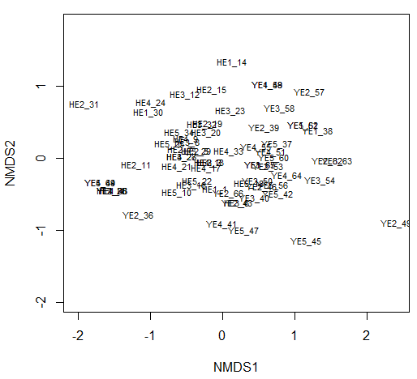
Fig. 1a Community composition differs more between sites than among elevations. H = La Hondonada, Y = Yotoco; E = Elevation (1: lowest; 5: highest). N = 18 trees. [output from script 180708_Sps_Presence.R]

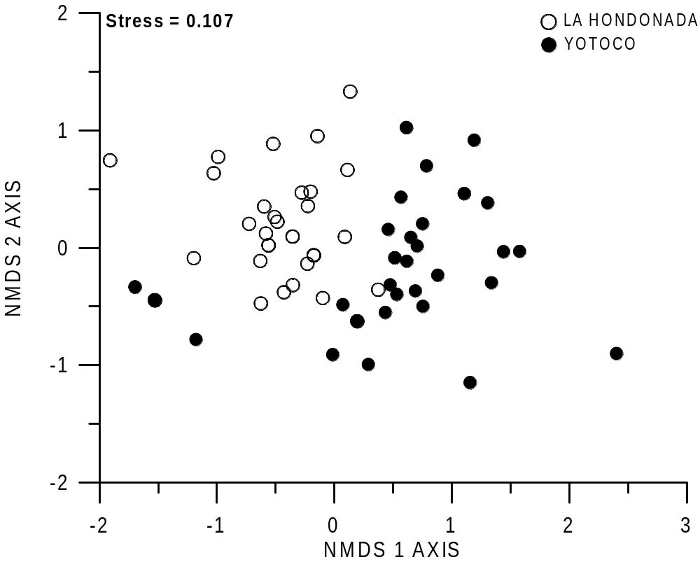
Fig. 1b NMDS analysis showing that locations differed in community composition. Each circle represents a sampling unit (elevation per tree). Open circles: La Hondonada, N = 27; Closed circles: Yotoco, N = 30.
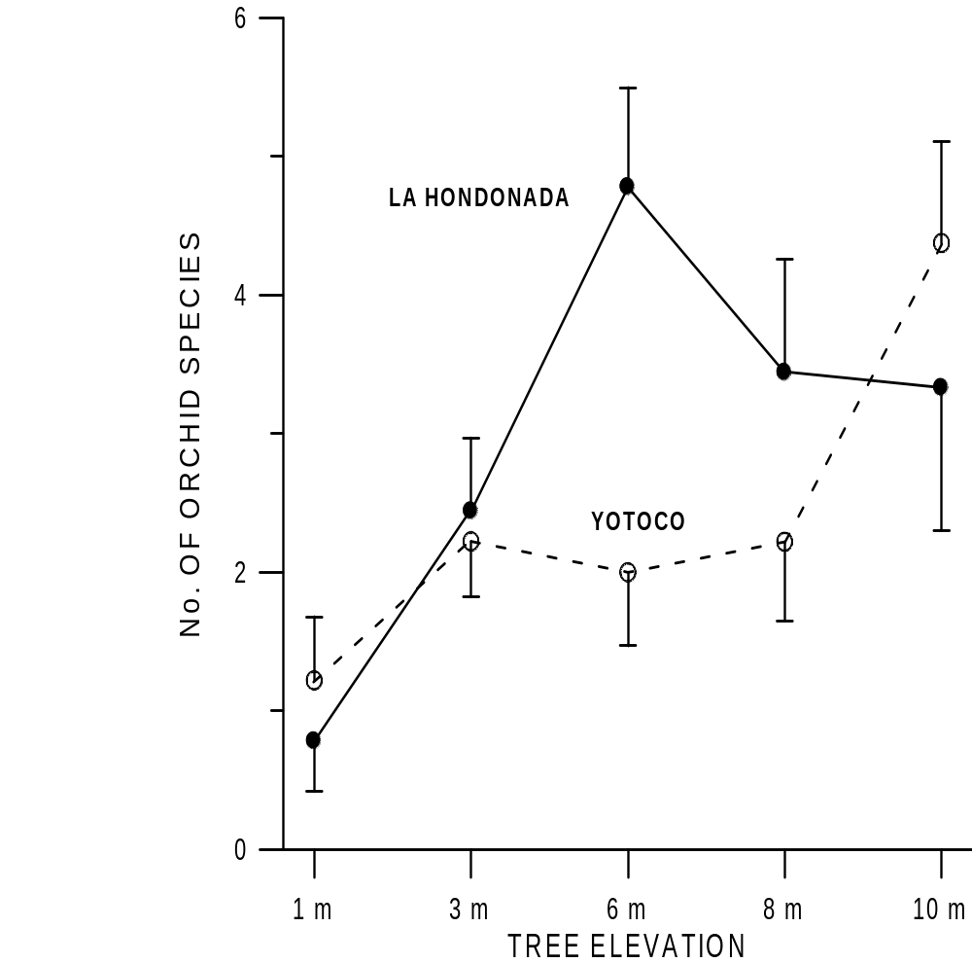

Fig. 2A Changes in the number of species with tree elevation. Bars denote SE. N = 9, excepting Yotoco at 10 m, N = 8.
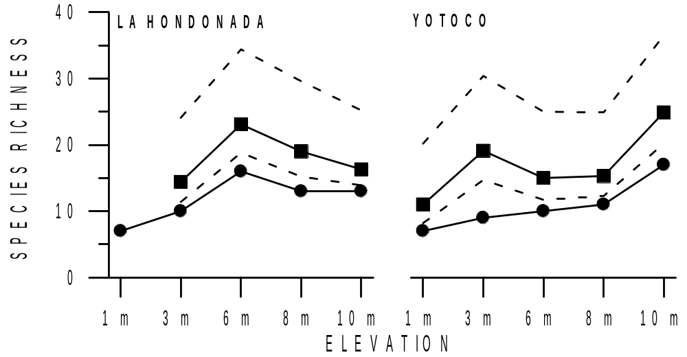

Fig. 2B. Observed (circles) and estimated (squares; 1st order Jacknife) number of species per tree elevation and site. Dashed lines indicate the 95% confidence intervals for the estimates.

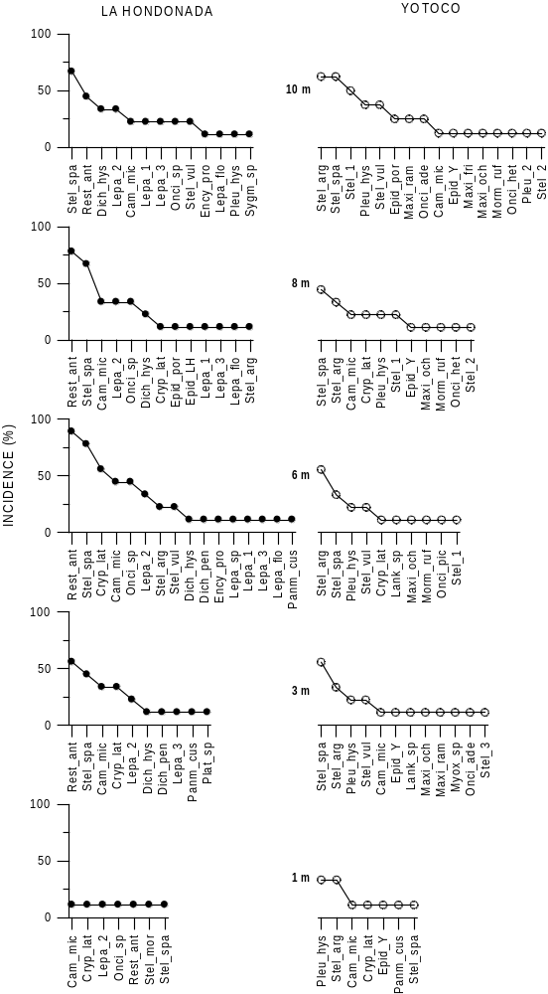

Fig. 3. Frequency of species per site and elevation. In each panel, orchid species are arranged in decreasing order of incidence, i.e., percentage of samples where they were present.
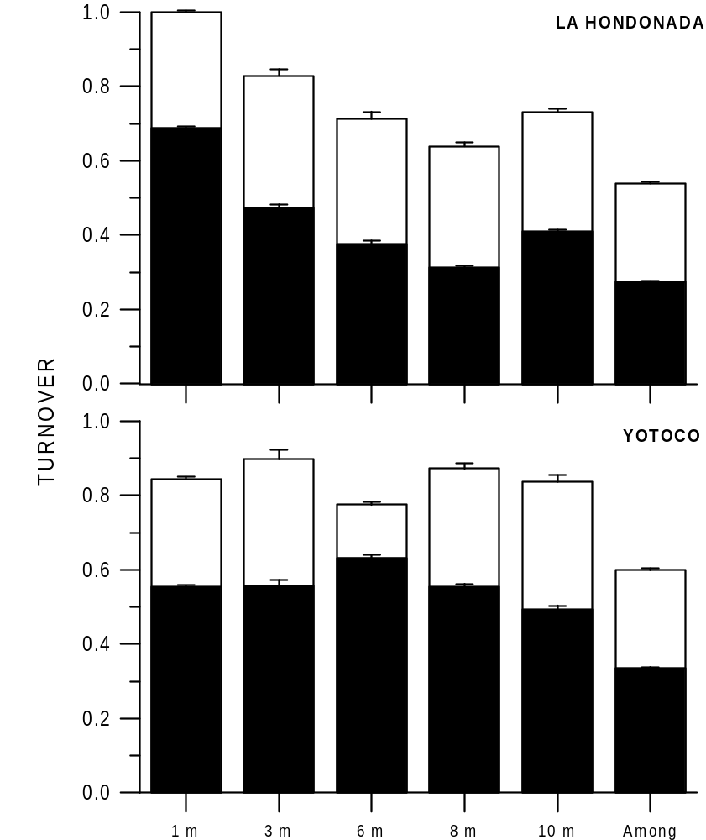

Fig. 4 Species turnover within elevation and among elevations in La Hondonada (A) and Yotoco (B). Bar height denotes total turnover, the black area is species replacement, and the white area is nestedness. Whiskers denote the variance around the mean. For N per elevation, see Methods.

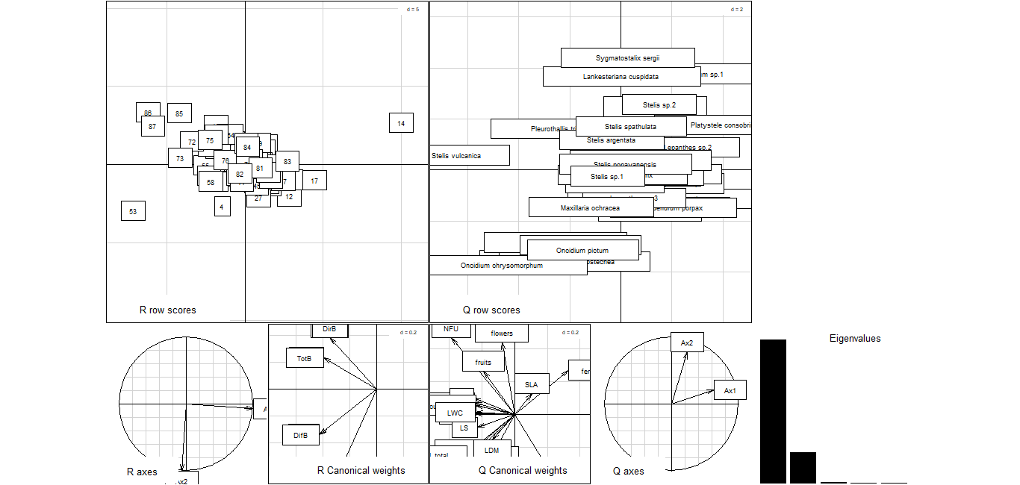
Fig. 5. RQL summary plot for all sites sampled (LH & RY). The tendencies are (sub-numbering from left to right and from top to bottom): [5.2.] Spp. are more or less grouped by succulence and size (Oncidium, etc.) and at the other extreme there are the smaller spp. (e.g., Lankesteriana). [5.4] Environmental variables go from open sites with diffuse light to less open sites with direct light. [5.5] Traits form 3 groups: (1) an axis with flowers, fruits and number of functional units; (2) with Chl, hmax, LA, LDM, in one extreme and SLA and fertility in the other; and (3) a "succulence" group that contains water-related traits.

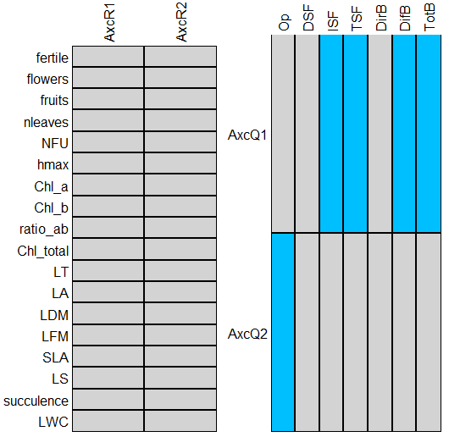
Fig. 6: Correlation between RLQ axes 1 and 2 and traits (6.1) or environmental variables (6.2).

Supplementary material

Table S6.1 List of matrices used in meta-community analyses and their dimensions.
Matrix | nrows (sample) | ncols (species)
LH H5 | 8 | 13
LH H4 | 9 | 14
LH H3 | 9 | 16
LH H2 | 6 | 10
LH H1 * | 2 | 4
RY H5 | 8 | 15
RY H4 | 8 | 11
RY H3 | 6 | 11
RY H2 | 9 | 11
RY H1 | 5 | 7
LH | 34 | 25
RY | 36 | 21
All | 70 | 36

Table S6.2 Descriptive statistics of metacommunity structure analyses
Resultados en excel (Result_Coexistence.xls)
Tabla en construcción en excel (TableS6-2_inprogress.xls). Ver si se puede hacer más rápido en R.

Summaries

Summary 1: LM of species richness among elevations
La Hondonada
Call:
lm(formula = Suma ~ Estrato, data = lh)

Residuals:
Min 1Q Median 3Q Max
-2.7778 -1.2659 0.2222 1.2222 4.2222

Coefficients:
Estimate Std. Error t value Pr(>|t|)
(Intercept) 3.7413 0.3271 11.436 2.89e-12 ***
Estrato1 -1.9913 0.7819 -2.547 0.0164 *
Estrato2 -0.9913 0.5994 -1.654 0.1089
Estrato3 1.0365 0.5755 1.801 0.0821 .
Estrato4 0.6873 0.6287 1.093 0.2833
---
Signif. codes: 0 ‘***’ 0.001 ‘**’ 0.01 ‘*’ 0.05 ‘.’ 0.1 ‘ ’ 1

Residual standard error: 1.834 on 29 degrees of freedom
Multiple R-squared: 0.3168, Adjusted R-squared: 0.2225
F-statistic: 3.361 on 4 and 29 DF, p-value: 0.02233

Yotoco
Call:
lm(formula = Suma ~ Estrato, data = ry)

Residuals:
Min 1Q Median 3Q Max
-2.3750 -0.9286 -0.2000 0.8889 2.6250

Coefficients:
Estimate Std. Error t value Pr(>|t|)
(Intercept) 2.93087 0.25044 11.703 1.04e-12 ***
Estrato1 -0.73087 0.56131 -1.302 0.203
Estrato2 -0.70865 0.45046 -1.573 0.126
Estrato3 0.06913 0.52251 0.132 0.896
Estrato4 -0.07373 0.49292 -0.150 0.882
---
Signif. codes: 0 ‘***’ 0.001 ‘**’ 0.01 ‘*’ 0.05 ‘.’ 0.1 ‘ ’ 1

Residual standard error: 1.45 on 30 degrees of freedom
Multiple R-squared: 0.2746, Adjusted R-squared: 0.1779
F-statistic: 2.839 on 4 and 30 DF, p-value: 0.04147

Summary 2: Species richness indexes
La Hondonada E2

(1) BASIC DATA INFORMATION:

Variable Value
Number of sampling units T 8
Number of observed species D 10
Total number of incidences U 22
Coverage estimate for entire dataset C 0.785
CV for entire dataset CV 0.619

Variable Value
Cut-off point k 10
Total number for incidences in infrequent group U_infreq 22
Number of observed species for infrequent group D_infreq 10
Estimated sample coverage for infrequent group C_infreq 0.785
Estimated CV for infrequent group in ICE CV_infreq 0.67
Estimated CV1 for infrequent group in ICE-1 CV1_infreq 0.881
Number of observed species for frequent group D_freq 0

Q1 Q2 Q3 Q4 Q5 Q6 Q7 Q8 Q9 Q10
Incidence freq. counts 5 1 2 1 1 0 0 0 0 0

(2) SPECIES RICHNESS ESTIMATORS TABLE:

Estimate s.e. 95%Lower 95%Upper
Homogeneous Model 12.739 2.625 10.563 23.327
Chao2 (Chao, 1987) 20.938 15.042 11.452 92.415
Chao2-bc 14.375 5.342 10.673 38.457
iChao2 (Chiu et al. 2014) 22.277 12.463 12.359 73.893
ICE (Lee & Chao, 1994) 15.602 5.612 11.093 38.705
ICE-1 (Lee & Chao, 1994) 17.677 8.792 11.276 56.173
1st order jackknife 14.375 2.864 11.357 24.104
2nd order jackknife 17.482 4.593 12.470 32.667
La Hondonada E3

(1) BASIC DATA INFORMATION:

Variable Value
Number of sampling units T 9
Number of observed species D 16
Total number of incidences U 43
Coverage estimate for entire dataset C 0.825
CV for entire dataset CV 0.891

Variable Value
Cut-off point k 10
Total number for incidences in infrequent group U_infreq 43
Number of observed species for infrequent group D_infreq 16
Estimated sample coverage for infrequent group C_infreq 0.825
Estimated CV for infrequent group in ICE CV_infreq 0.915
Estimated CV1 for infrequent group in ICE-1 CV1_infreq 1.267
Number of observed species for frequent group D_freq 0

Q1 Q2 Q3 Q4 Q5 Q6 Q7 Q8 Q9 Q10
Incidence freq. counts 8 2 1 2 1 0 1 1 0 0

(2) SPECIES RICHNESS ESTIMATORS TABLE:

Estimate s.e. 95%Lower 95%Upper
Homogeneous Model 19.396 2.751 16.844 29.664
Chao2 (Chao, 1987) 30.222 14.714 18.672 91.699
Chao2-bc 24.296 7.943 17.707 56.316
iChao2 (Chiu et al. 2014) 30.858 11.854 19.754 74.798
ICE (Lee & Chao, 1994) 27.509 8.683 19.088 58.897
ICE-1 (Lee & Chao, 1994) 34.959 17.063 20.189 101.800
1st order jackknife 23.111 3.665 18.747 34.411
2nd order jackknife 27.972 5.926 20.783 45.968
La Hondonada E4

(1) BASIC DATA INFORMATION:

Variable Value
Number of sampling units T 7
Number of observed species D 13
Total number of incidences U 31
Coverage estimate for entire dataset C 0.784
CV for entire dataset CV 0.922

Variable Value
Cut-off point k 10
Total number for incidences in infrequent group U_infreq 31
Number of observed species for infrequent group D_infreq 13
Estimated sample coverage for infrequent group C_infreq 0.784
Estimated CV for infrequent group in ICE CV_infreq 0.955
Estimated CV1 for infrequent group in ICE-1 CV1_infreq 1.361
Number of observed species for frequent group D_freq 0

Q1 Q2 Q3 Q4 Q5 Q6 Q7 Q8 Q9 Q10
Incidence freq. counts 7 1 3 0 0 1 1 0 0 0

(2) SPECIES RICHNESS ESTIMATORS TABLE:

Estimate s.e. 95%Lower 95%Upper
Homogeneous Model 16.572 3.035 13.842 28.149
Chao2 (Chao, 1987) 34.000 26.721 16.069 156.695
Chao2-bc 22.000 9.142 14.728 59.873
iChao2 (Chiu et al. 2014) 36.571 23.161 17.706 131.057
ICE (Lee & Chao, 1994) 24.715 9.473 15.917 60.046
ICE-1 (Lee & Chao, 1994) 33.102 19.662 17.035 113.143
1st order jackknife 19.000 3.338 15.168 29.602
2nd order jackknife 23.405 5.296 17.062 39.655
La Hondonada E5

(1) BASIC DATA INFORMATION:

Variable Value
Number of sampling units T 6
Number of observed species D 13
Total number of incidences U 30
Coverage estimate for entire dataset C 0.911
CV for entire dataset CV 0.466

Variable Value
Cut-off point k 10
Total number for incidences in infrequent group U_infreq 30
Number of observed species for infrequent group D_infreq 13
Estimated sample coverage for infrequent group C_infreq 0.911
Estimated CV for infrequent group in ICE CV_infreq 0.509
Estimated CV1 for infrequent group in ICE-1 CV1_infreq 0.6
Number of observed species for frequent group D_freq 0

Q1 Q2 Q3 Q4 Q5 Q6 Q7 Q8 Q9 Q10
Incidence freq. counts 4 5 2 1 0 1 0 0 0 0

(2) SPECIES RICHNESS ESTIMATORS TABLE:

Estimate s.e. 95%Lower 95%Upper
Homogeneous Model 14.268 1.553 13.194 21.279
Chao2 (Chao, 1987) 14.333 1.862 13.174 23.239
Chao2-bc 13.833 1.369 13.089 20.842
iChao2 (Chiu et al. 2014) 14.583 0.740 13.662 16.785
ICE (Lee & Chao, 1994) 15.408 2.781 13.396 27.628
ICE-1 (Lee & Chao, 1994) 15.849 3.490 13.436 31.602
1st order jackknife 16.333 2.472 13.911 25.201
2nd order jackknife 16.333 3.709 13.574 32.358
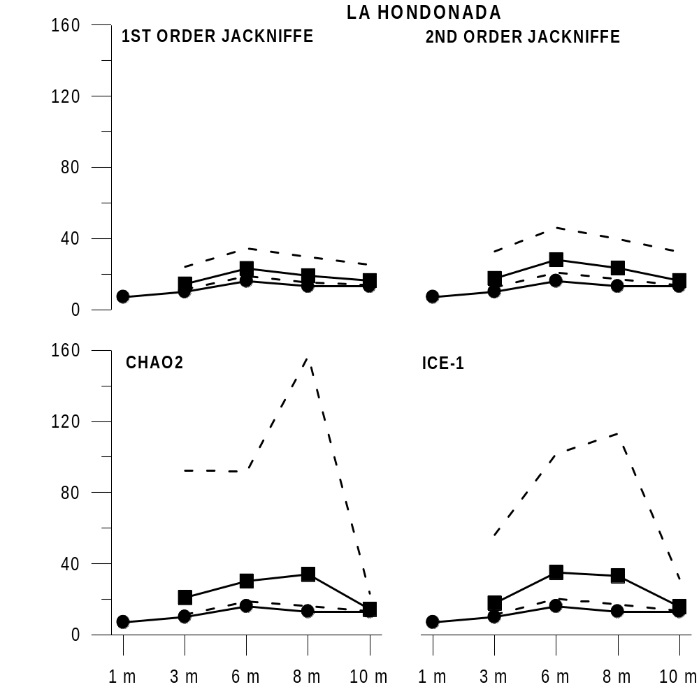
Yotoco E1

(1) BASIC DATA INFORMATION:

Variable Value
Number of sampling units T 5
Number of observed species D 7
Total number of incidences U 11
Coverage estimate for entire dataset C 0.596
CV for entire dataset CV 0.675

Variable Value
Cut-off point k 10
Total number for incidences in infrequent group U_infreq 11
Number of observed species for infrequent group D_infreq 7
Estimated sample coverage for infrequent group C_infreq 0.596
Estimated CV for infrequent group in ICE CV_infreq 0.776
Estimated CV1 for infrequent group in ICE-1 CV1_infreq 1.136
Number of observed species for frequent group D_freq 0

Q1 Q2 Q3 Q4 Q5 Q6 Q7 Q8 Q9 Q10
Incidence freq. counts 5 0 2 0 0 0 0 0 0 0

(2) SPECIES RICHNESS ESTIMATORS TABLE:

Estimate s.e. 95%Lower 95%Upper
Homogeneous Model 11.746 4.968 7.879 32.614
Chao2 (Chao, 1987) 15.000 8.132 8.535 48.702
Chao2-bc 15.000 8.532 8.449 51.154
iChao2 (Chiu et al. 2014) 16.000 6.907 9.372 41.155
ICE (Lee & Chao, 1994) 16.794 10.796 8.706 63.238
ICE-1 (Lee & Chao, 1994) 22.569 19.903 9.262 114.146
1st order jackknife 11.000 2.683 8.211 20.210
2nd order jackknife 14.000 4.099 9.415 27.289
Yotoco E2

(1) BASIC DATA INFORMATION:

Variable Value
Number of sampling units T 9
Number of observed species D 12
Total number of incidences U 20
Coverage estimate for entire dataset C 0.624
CV for entire dataset CV 0.79

Variable Value
Cut-off point k 10
Total number for incidences in infrequent group U_infreq 20
Number of observed species for infrequent group D_infreq 12
Estimated sample coverage for infrequent group C_infreq 0.624
Estimated CV for infrequent group in ICE CV_infreq 0.842
Estimated CV1 for infrequent group in ICE-1 CV1_infreq 1.232
Number of observed species for frequent group D_freq 0

Q1 Q2 Q3 Q4 Q5 Q6 Q7 Q8 Q9 Q10
Incidence freq. counts 8 2 1 0 1 0 0 0 0 0

(2) SPECIES RICHNESS ESTIMATORS TABLE:

Estimate s.e. 95%Lower 95%Upper
Homogeneous Model 19.245 5.911 13.787 41.382
Chao2 (Chao, 1987) 26.222 14.714 14.672 87.699
Chao2-bc 20.296 7.943 13.707 52.316
iChao2 (Chiu et al. 2014) 27.431 11.271 16.283 67.589
ICE (Lee & Chao, 1994) 28.346 14.051 15.804 82.233
ICE-1 (Lee & Chao, 1994) 38.716 27.958 16.951 156.153
1st order jackknife 19.111 3.665 14.747 30.411
2nd order jackknife 23.972 5.926 16.783 41.968
Yotoco E3

(1) BASIC DATA INFORMATION:

Variable Value
Number of sampling units T 6
Number of observed species D 10
Total number of incidences U 18
Coverage estimate for entire dataset C 0.706
CV for entire dataset CV 0.758

Variable Value
Cut-off point k 10
Total number for incidences in infrequent group U_infreq 18
Number of observed species for infrequent group D_infreq 10
Estimated sample coverage for infrequent group C_infreq 0.706
Estimated CV for infrequent group in ICE CV_infreq 0.816
Estimated CV1 for infrequent group in ICE-1 CV1_infreq 1.155
Number of observed species for frequent group D_freq 0

Q1 Q2 Q3 Q4 Q5 Q6 Q7 Q8 Q9 Q10
Incidence freq. counts 6 2 1 0 1 0 0 0 0 0

(2) SPECIES RICHNESS ESTIMATORS TABLE:

Estimate s.e. 95%Lower 95%Upper
Homogeneous Model 14.167 3.891 10.882 29.674
Chao2 (Chao, 1987) 17.500 8.551 11.254 54.864
Chao2-bc 14.167 4.694 10.707 34.561
iChao2 (Chiu et al. 2014) 18.175 5.857 12.315 38.864
ICE (Lee & Chao, 1994) 19.833 9.366 12.036 57.495
ICE-1 (Lee & Chao, 1994) 25.500 17.596 12.605 102.234
1st order jackknife 15.000 3.028 11.672 24.952
2nd order jackknife 17.933 4.691 12.713 33.202
Yotoco E4

(1) BASIC DATA INFORMATION:

Variable Value
Number of sampling units T 7
Number of observed species D 11
Total number of incidences U 20
Coverage estimate for entire dataset C 0.803
CV for entire dataset CV 0.198

Variable Value
Cut-off point k 10
Total number for incidences in infrequent group U_infreq 20
Number of observed species for infrequent group D_infreq 11
Estimated sample coverage for infrequent group C_infreq 0.803
Estimated CV for infrequent group in ICE CV_infreq 0.307
Estimated CV1 for infrequent group in ICE-1 CV1_infreq 0.375
Number of observed species for frequent group D_freq 0

Q1 Q2 Q3 Q4 Q5 Q6 Q7 Q8 Q9 Q10
Incidence freq. counts 5 4 1 1 0 0 0 0 0 0

(2) SPECIES RICHNESS ESTIMATORS TABLE:

Estimate s.e. 95%Lower 95%Upper
Homogeneous Model 13.705 2.690 11.533 24.738
Chao2 (Chao, 1987) 13.679 3.196 11.424 27.933
Chao2-bc 12.714 2.272 11.238 23.334
iChao2 (Chiu et al. 2014) 14.202 1.583 12.281 19.008
ICE (Lee & Chao, 1994) 14.290 3.777 11.546 30.845
ICE-1 (Lee & Chao, 1994) 14.582 4.532 11.527 35.341
1st order jackknife 15.286 2.821 12.322 24.891
2nd order jackknife 16.476 4.386 12.378 32.765
Yotoco E5

(1) BASIC DATA INFORMATION:

Variable Value
Number of sampling units T 8
Number of observed species D 17
Total number of incidences U 35
Coverage estimate for entire dataset C 0.765
CV for entire dataset CV 0.671

Variable Value
Cut-off point k 10
Total number for incidences in infrequent group U_infreq 35
Number of observed species for infrequent group D_infreq 17
Estimated sample coverage for infrequent group C_infreq 0.765
Estimated CV for infrequent group in ICE CV_infreq 0.703
Estimated CV1 for infrequent group in ICE-1 CV1_infreq 0.94
Number of observed species for frequent group D_freq 0

Q1 Q2 Q3 Q4 Q5 Q6 Q7 Q8 Q9 Q10
Incidence freq. counts 9 3 2 1 2 0 0 0 0 0

(2) SPECIES RICHNESS ESTIMATORS TABLE:

Estimate s.e. 95%Lower 95%Upper
Homogeneous Model 22.216 3.820 18.444 35.841
Chao2 (Chao, 1987) 28.812 10.970 19.518 72.411
Chao2-bc 24.875 7.115 18.733 52.794
iChao2 (Chiu et al. 2014) 30.955 7.735 22.060 55.487
ICE (Lee & Chao, 1994) 28.020 8.336 19.949 58.185
ICE-1 (Lee & Chao, 1994) 32.610 13.588 20.582 85.024
1st order jackknife 24.875 3.843 20.183 36.482
2nd order jackknife 29.696 6.140 22.170 48.182
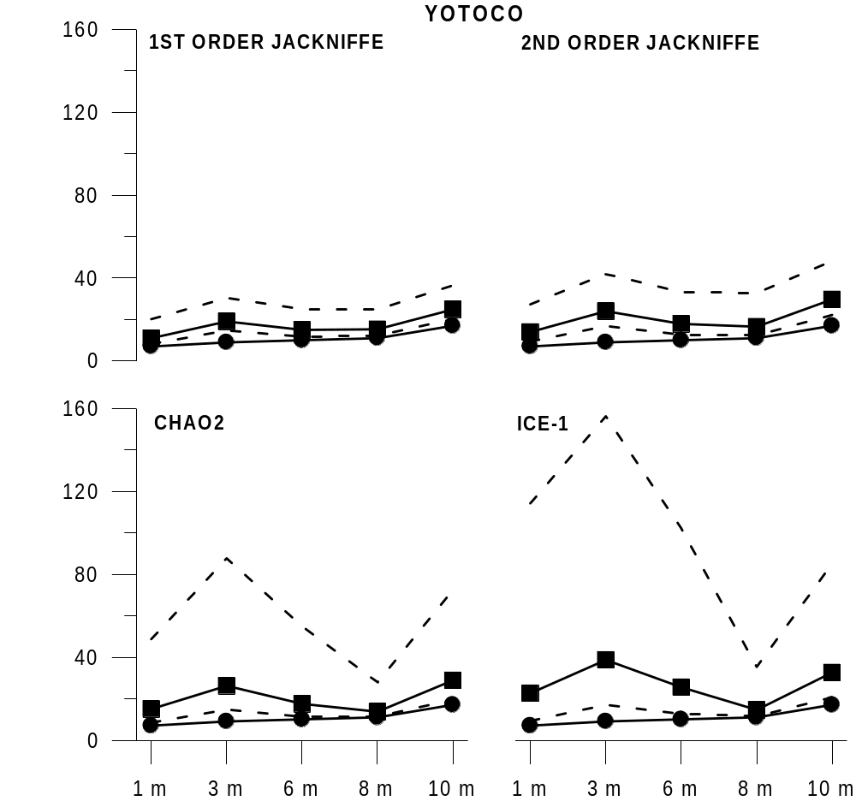

To-do methods
(see data available in Annex I below)

Light environment
1. Hemi pic analyses (Yo) - 3 h DONE
2. Build gradients (Yo) - 3 h DONE

Tree species
1. Compile evidence 3 h
2. Send to Nhora

Data arrangement
1. Overall check for NA 5 h

Orchids
1. Specific aim
2. Rarefaction curves (Curso Networks & Marcos) DONE
3. Diversity and abundance metrics (Adri)
4. NMDS fig. 1 (Marcos)

Leaf & Plant traits
1. Calculate chl content, succulence and SLA 5 h
2. Compile plant traits and fertility (fertility only for intra-sp comparisons) 2 h
3. Add root traits from floras (only for general trait analysis. Not valid for intra-sp variation) 10 h
4. Exploratory analysis PCA - PhyloPCA. Marcos. 5 - 10 h
5. Intra-specific vs. interspecific variation. 12 h.

Data analysis: 73 h aprox.

Annex I
Data types
Environment
-Light gradient
-tree species
-tree diameter
Orchids
-Abundance
-Species
Leaf traits
thickness
area
fresh mass
dry mass
SLA
Chlorophyll content
succulence
Plant traits
height
habit
number of leaves
Other traits
root type
stem type

Other analyses

1) CI and GF
I calculated the CV of CI and GF over the 384 cells of each picture [180709_CI_CV_Orchs] and tested whether it differed between heights, with tree as a random factor. They did not differ much. Variance among trees was huge [180710_Str_Orchids.R].

2) Annual variation of PAR (DifB and DirB)
I calculated the CV of Dir and Dif PAR below due to weekly variation in light availability. I tested whether it differed between heights, with tree as a random factor [180710_DifB; 180710_DirB]. They did not differ much [180710_Str_Orchids.R], and annual variation was low in general (CV < 0.1).

