High flexibility in the leaf position angles of the epiphytic orchid Rodriguezia granadensis

Agustina B. Ventre-Lespiaucq*

Departamento de Biología y Geología, Química Inorgánica y Física, Área de Biodiversidad y Conservación, Universidad Rey Juan Carlos. C/ Tulipán s/n (28933) Móstoles, Spain.

*Corresponding Author: aguslespiaucq@gmail.com.

Abstract

- The effects of leaf display and biomass partitioning on light capture efficiency were examined in a non-branching understorey palm, Licuala arbuscula, by using a three-dimensional geometric simulation model. This species has several fan-shaped laminae, attached on long petioles at a mostly constant deflection angle (D_{P}). The petiole of the youngest leaf was almost vertical, and slanted downwards as it aged.
- 2 The combination of large D_{P} and small Z_{max} (zenith angle of the oldest leaf’s petiole) maximized light capture for a plant with few leaves; this combination kept the lamina facing in the approximate direction of the zenith with high light intensity. For a plant with many leaves, the combination of large Z_{max} and small D_{P} increased light capture because it reduced self-shading.
- 3 For a given total leaf biomass, the plant increased its total leaf area by producing many small leaves. This occurred because the leaf area per unit biomass decreased with increasing biomass per individual leaf. This effect was most pronounced in larger plants. However, an increasing number of leaves intensified self-shading among leaves. Allocation of biomass to the petioles reduced self-shading, but decreased leaf area.
- 4 There was an optimal allocation of biomass to petioles and an optimal number of leaves that maximized the crown’s light capture. Greater investment in petioles as the number of leaves increased was the favoured strategy for larger plants.
- 5 In most cases, the leaf geometry and biomass partitioning in the plants were close to the optima predicted by a simulation model developed in this study. There were noticeable differences in a few cases, but the reduction in the crown’s light capture due to these differences was small.

Keywords: 6 keywords, using British spelling and avoiding general and plural terms and multiple concepts (avoid, for example, 'and', 'of'). Be sparing with abbreviations: only abbreviations firmly established in the field may be eligible. These keywords will be used for indexing purposes.
Highlights
3 to 5 bullet points (maximum 85 characters, including spaces, per bullet point
1. Introduction
Light interception is important for plants. In broad-leaved plants, light interception efficiency largely depends on the regulation of leaf position angles. The angles observed in fully-expanded leaves are likely the outcome of an orientation process that takes place throughout leaf maturation.
Unfortunately, our knowledge of leaf ontogeny in general and ontogenetic changes in leaf position in particular are meagre.
Plants growing in low-light environments enhance light interception by orienting their fully-expanded leaves towards the source of light (Ackerly and Bazzaz, 1995; REFS). However,

In general, soil plants – those using the soil as a substrate – tend to grow upwards and laterally in search for light. En general, las plantas terrestres - que usan el suelo como sustrato y soporte- tienden a crecer hacia arriba y lateralmente en busca de luz, pero, ¿qué ocurre en el caso de los epífitos vasculares, que crecen sobre otras plantas? Este grupo de plantas entraña una nueva dimensión del problema geométrico, y es que los individuos pueden crecer boca arriba, de lado o boca abajo, quedando estos últimos sombreados por su propio soporte.
Las plantas que crecen en diferentes orientaciones del soporte deberían de poder ajustar la posición de sus hojas para poder capturar la luz. De lo contrario, las hojas permanecerán sombreadas por el soporte y la eficacia fotosintética pasará a depender de que exista una aclimatación fisiológica a las condiciones de poca luz.

-La capacidad de ajustar la posición de las hojas requiere flexibilidad durante el desarrollo.

-In this study, we investigated whether
1) The difference between leaf and pseudobulb position angles is larger in mature than in young leaves. We expect an effect of the position of the plant in the trunk surface (measured as the position of the pseudobulb) in mature pseudobulbs. In particular, the intra-modular angle will be larger in pseudobulbs growing upside-down, intermediate in vertical ones and smaller in horizontal ones. In young pseudobulbs, we expect plant position effects to be negligible on the intra-modular angle.
2) The variance in the intra-modular angle will be larger among old than among young leaves.
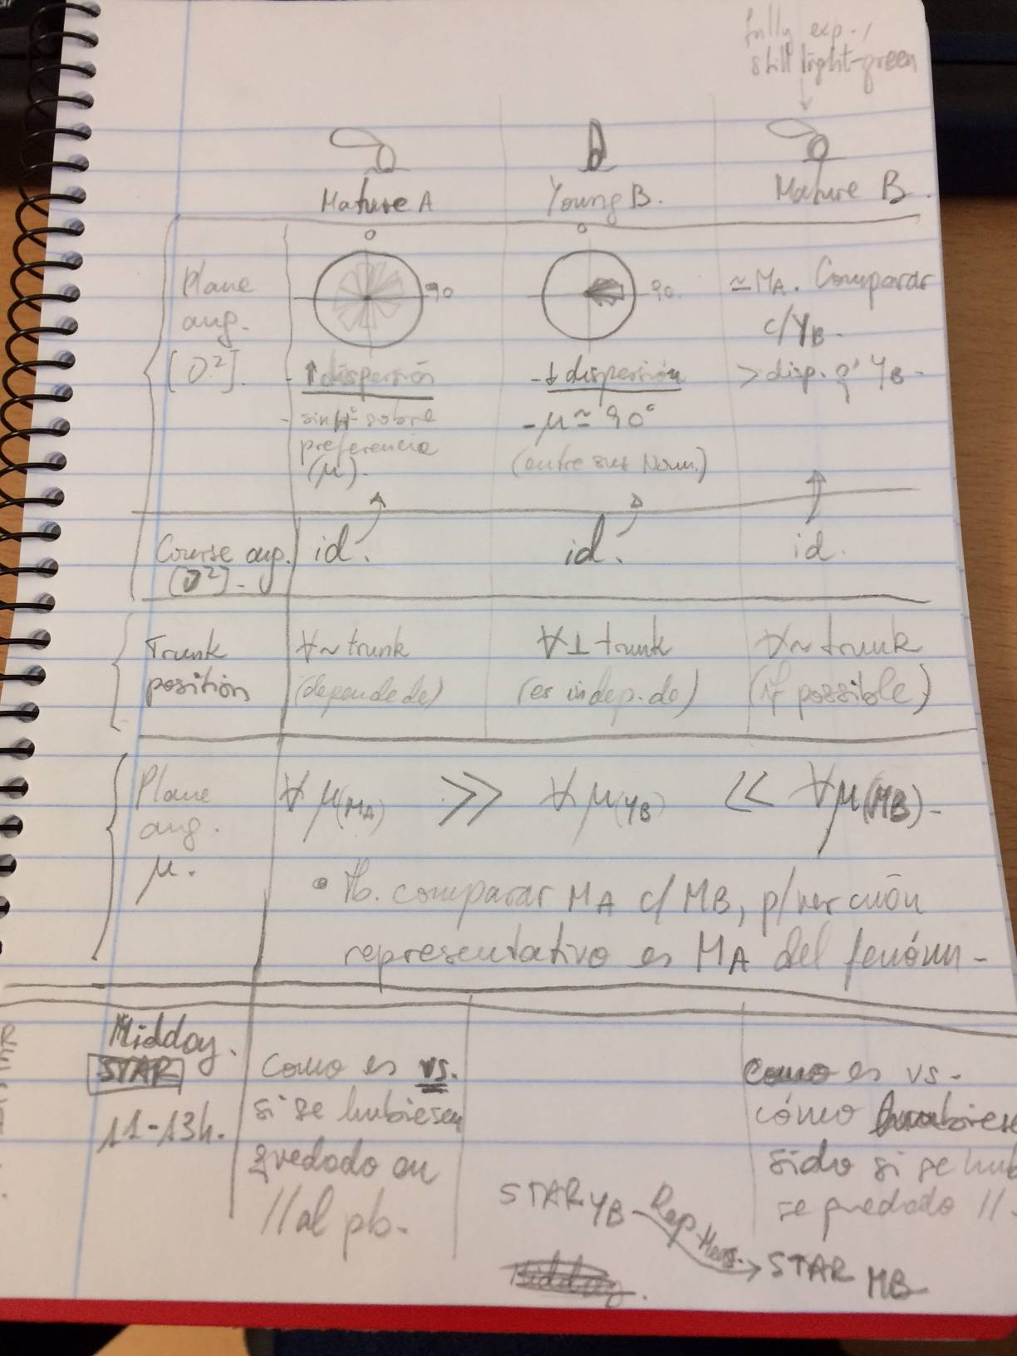
2. Material and Methods
2.1. Species and study site
Rodriguezia granadensis Rchb.f. (Oncidiinae) is a widespread Neotropical twig epiphytic orchid, occurring from Panama to Peru. In Colombia, it grows mainly in the tropical humid-dry transition forest, between 700 and 1900 m in the western and central Andes (Calderon-Saenz 2007). This species grows frequently in human-transformed habitats, where it is found forming small, patchy populations. R. granadensis shows a preference for guava trees (Psidium guajava) and Citrus sp. as phorophytes (Reina-Rodriguez & Otero 2011). As a twig epiphyte, individuals occupy the smaller axes of the phorophyte, in the periphery of the crown.
The growth habit of R. granadensis is sympodial. Each shoot is a pseudobulb of a single internode, and they grow clustered together in a phalanx strategy of clonal growth (Gibson 2002, Ospina-Calderon et al. 2015). Pseudobulbs are barrel-shaped, laterally compressed and more or less curved along its vertical axis (Fig. 1a). From the apex of the pseudobulb grows a single leaf without a sheathing base (REF). Leaves are oval-shaped and have a laterally-flattened cross-section, resulting in a plain leaf surface (Chase 1986, Dressler 1990). Leaf and pseudobulb maturation often take place at the same time. Young pseudobulbs carry a young leaf that grows parallel to the pseudobulb and is longitudinally folded through its “midvein” (ABVL, pers. Obs.) (Fig. 1b). Mature pseudobulbs carry a fully expanded leaf that may display a wide array of position angles relative to the longitudinal axis of the pseudobulb (ABVL, pers. Obs.) (Fig. 1b).
The group formed by a pseudobulb and its leaf will hereafter be referred to as the modular unit.

The study population was the same used in Ventre-Lespiaucq et al. (2017). It was located near the northern limit of the Yotoco Forest Natural Reserve, Cauca Valley, Colombia (3º 53' 0.6'' N, 76º 26' 23.4'' W), on the eastern slope of the Western Andes Mountains, at 1630 m altitude. The total population consisted of about 130 adult individuals of R. granadensis growing on six guava trees in the locality. Although other guava trees were present, they did not host R. granadensis plants. Two of the phorophytes were growing on a north-facing slope of 16º elevation in a pasture-like habitat and the remaining four were close together in an adjacent biological corridor about 100 -m away from pasture phorophytes, on the southern face of a patch of secondary dry forest (forest edge habitat). Approximately two thirds of the individuals were distributed on the two pasture phorophytes. All accessible adult individuals were sampled (104), 61 in the pasture and 43 in the forest edge.
Field sampling lasted a month between November and December 2012, coinciding with the end of the rainy season and the beginning of the vegetative growing season.

2.2. Measurements of leaf and pseudobulb position angles
2.2.1. Fundamentals [subtítulo provisional].
[Acá básicamente habría que definir lo que hicimos para testar cada hipótesis]

For this, I described the 3-dimensional spatial position of leaves and pseudobulbs.
2.2.2. Measurements [subtítulo provisional].
To describe the 3-dimensional spatial position of leaf and pseudobulbs, I took in-situ measurements of four angles descmely pitch, roll, lamina ou midrib azimuth (Figwith an appli(Ahmes 1.0) for smartphones (Nokia N86, Nokia Group, Espoo, Finland) (Escribano-Rocafort et al. 2014). The application gives the direction and sign of the orientation of plane surfaces relative to the Earth’s magnetic and gravitational fields, allowing to know whether the surfaces face up or down (Z axis), front or back (X axis), and left or right (Y axis). To take the measurements, the device has to be placed parallel to the surface of interest.
Fully expanded, mature leaves; mature pseudobulbs; closed, young leaves; and young pseudobulbs have some structural differences that required slightly different measuring solutions. Fully expanded leaves were measured with the cell-phone screen facing the same direction and sign as the leaf’s adaxial surface, and its upper part oriented towards the same direction and sign as the leaf tip, following Escribano-rocafort et al. (2014) (Fig. S1). To measure the position of pseudobulbs, which are curved volumes, I devised a reference system taking advantage of a conspicuous lateral flattening and slight vertical curving of the pseudobulbs (Fig. 1a). This allowed to determine their position in the three spatial axes. The orientation of the tip has biological meaning in itself, because it indicates whether the pseudobulb is growing upwards, downwards or prostrate. By contrast, the orientation of the lateral flattening and curved surface is intended to serve as a spatial reference only, and lack a clear biological meaning. The lamina of young leaves were measured while they still were longitudinally closed (Fig. 1b). To characterize their position, the cell phone was placed parallel to half-the leaf lamina. The resulting normal vector of leaves measured like this is deviated 90º from the normal vector of the same leaf had it been fully expanded in that exact position. This affects the way in which the results of young leaf orientation are presented. Young pseudobulbs showed the lateral flattening but lacked the vertical curving used to distinguish between a “front” and a “back”. To standardise its characterization, I defined the front as the lateral part of the pseudobulb that was closer-to-parallel to the half-leaf measured.

2.2.3. Treatment of the measurements [subtítulo provisional].
To find the minimum angle between a pseudobulb and its leaf, I approximated the problem as if both elements were two intersecting planes. The angle between the planes equals the angle between their normal vectors (REF). These are defined by their direction and sign in a 3-dimensional space and their magnitude. In this case, they are unit vectors, meaning their magnitude is the unity. The direction and sign components of the normal vectors were expressed as their projection in the X, Y, Z axes of the trihedron that contains them, as (cos(ρ), sin(ρ) · cos(β), sin(ρ) · cos(β)) (Eqn. S2 in Escribano-Rocafort et al. 2014); where ρ is the tilt angle and β is the course angle. Tilt angles range from 0º to 180º; 0º indicate a horizontal surface facing upwards, 180º a horizontal surface facing downwards, and 90º a vertical surface facing any azimuth. Course ranges from 0º (north) to 360º, clockwise. I calculated the angle between the two unit vectors as the arc cosine of their scalar product (Riley et al., 2010). To quantify the rotation of the leaf surface relative to the position of the pseudobulb, I projected both normal vectors in the horizontal plane with the components (sin(β), cos(β)), and obtained the course angle between them by calculating the arc cosine of their scalar product. The whole procedure was performed using the function plane.ang of staR package (Ventre and Santamaría In prep.) in R v. 3.3.2 (R-Core Team, 2017).

[Pitch angle: keep cell phone coordinates for now [0 and ±180 is vertical; ±90 is horizontal]. I’m interested in keeping the whole range from 0 to 180, because leaves may have re-positioned below the horizontal (130º e.g.). It is necessary to keep the negative values for our purposes, because a non-vertical position of the reference pseudobulb relative to the Earth’s gravitational field affects differently the leaf angles (explain this better. See “diagram” in notes 2/06/17).
Next day: check whether single angle values suffice to know their relative positions, or if it is necessary to calculate the angle of 2 intersecting planes…see page 2 in notes 2/06/17.]

3. Results

4. Discussion
5. Conclusions
Acknowledgements
I am thankful to Maria Andrea Sánchez for field assistance; D. Cristóbal and Valentín Hidalgo for providing logistic support at RNYB; and Nicola Flanagan, Nhora H. Ospina-Calderón and Tupac Otero for their scientific advice during my stay in Colombia.

Funding information
This work was supported by the former Spanish National Ministry of Science and Innovation [CROWN CONCERT xxxx]; a mobility grant from Asociación Universitaria Iberoamericana de Posgrado (AUIP), and the Program REMEDINAL-3 for a postdoctoral fellowship [XXX] to ABVL.

