Elaborate the different envisaged steps (experiments/activities) in your research, and motivate your strategic choices for reaching the objectives. Describe the set-up and cohesion of the work packages including intermediate goals (milestones).
Show where the proposed methodology (research approach) is according to the state of the art and where it is novel. Discuss risks that might endanger reaching project objectives and the contingency plans to be put in place should this risk occur.
The study will be conducted in natural, mostly undisturbed tropical forest ecosystems. I will sample communities of epiphytic orchids in three forest types along a humidity-altitude gradient in the western mountain range of the Colombian Andes (Fig. 3a). The forest types encompass dry forests in the Cauca River Valley, dry-humid transition forests (DHTF) in the valley slope, and cloud forests in the Pacific slope. In each forest type I will choose two plots 5 km apart and 10 host trees per plot. I will sample plants growing at a height of 10 m on tree trunks using the single-rope climbing method, collecting three 2-cm root fragments in up to five individuals per orchid species of all the species found. Sampling will not destroy the plants.
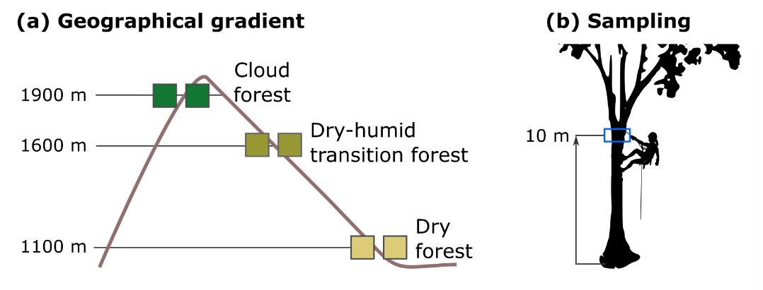
Fig. 3 Sampling design. (a) Geographical gradient including three forest types in the Andes Mountain Range, with two plots per altitude. (b) Sampling method.

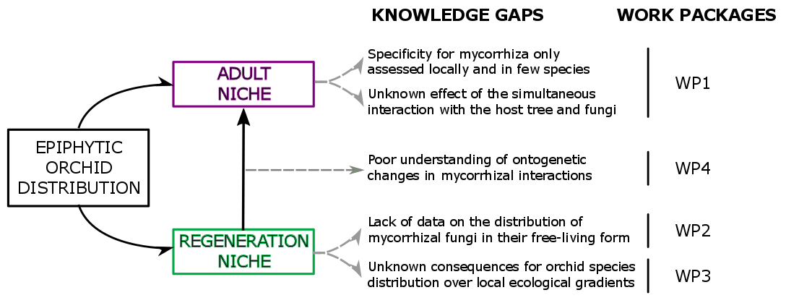
Fig. 2: Overview of the research project. I will address determinants of epiphytic orchid distribution during the regeneration and adult phases.

WP1 Assessing the influence of partner availability on epiphytic orchid distribution.

Studies over small spatial scales revealed terrestrial orchids have distinctive mycorrhizal communities and show strong spatial segregation, suggesting that mycorrhizal partners play a role in determining their distribution16, , . No such data are available for epiphytic orchids.
It is reasonable to assume that orchid germination frequency will be higher in species that associate selectively with common instead of rare fungal partners, so that partner availability in the substrate is probably an important determinant of orchid occurrence. Yet, orchid species differ in their degree of specialization in the interaction (partner breadth) , meaning that they can associate selectively with a few fungal partners (specialist species), or indistinctively with many of them (generalist species). Theory predicts that natural selection favours highly specialized interactions as a way to avoid cheaters . This view has been recently challenged on the basis that generalist interactions can be advantageous under environmental heterogeneity, where species should not be very choosy in order to associate with the partners at hand19,20. In this way, generalist species can broaden their distribution by shifting partners (partner turnover) when the preferred partner is not locally available. Species exhibiting such ability have more chances of germinating in a variety of microsites than highly-specialized species.
[Interactions with phorophytes] We ignore whether epiphytic orchids establish generalist or specialist interactions with mycorrhizal fungi. Recent studies suggest that they tend to associate with many mycorrhizal partners , , although highly specialized interactions also were documented21, .[Interacciones simultáneas] Partner breadth towards mycorrhiza and host trees9 are important knowledge gaps in our understanding of what limits the distribution of epiphytic orchids.
Some orchid species are expected to be unique to a particular forest type, while others are expected to occur in at least two of them. I will register the host tree species where the different epiphytic orchid species occur (host-tree breadth), and the mycorrhizal partners in orchid roots (mycorrhizal fungi breadth). With this information, I will be able to test H1, which states that the influence of partner availability on epiphytic orchid distribution depends on partner breadth and abiotic conditions.
Measuring abiotic conditions -
To characterize regional climate I will use climatic data from meteorological stations near the plots. To describe the light environment of host trees I will measure photosynthetically active radiation (PAR, mol·m⁻²·day⁻¹) by taking three hemispheric photographs in each tree at 10 m, where orchid roots will be sampled. To improve PAR estimation accuracy, I will measure the diffuse to direct PAR ratio with BF5 diffuse PAR sensors (Delta-T Devices, UK) in three randomly chosen host trees.

Assessing partner breadth - Since mycorrhizal fungi are microscopic and may form complex interactions with both host trees and orchids, I will combine meta-barcoding of mycorrhizal DNA with network analysis tools to assess mycorrhizal partner breadth,. An individual orchid can host 1-30 different fungal partners. To accurately describe mycorrhizal diversity associated with each individual plant I will extract DNA from 0.5 g mycorrhizal root fragments using UltraClean Plant DNA Isolation Kit (Mo Bio Laboratories Inc., CA, USA). I will use two complementary primer pairs (ITS3/ITS4OF and ITS86F/ITS4) for detailed characterization of diverse orchid mycorrhizal communities. I will use Illumina sequencing to obtain mycorrhizal operational taxonomic units (OTUs), which are the commonly used units of microbial diversity. I will identify orchids and host trees with the help of a local taxonomist (Nhora Ospina, Universidad del Valle, Cali) and confirm ambiguous tree and orchid records using genetic barcoding.

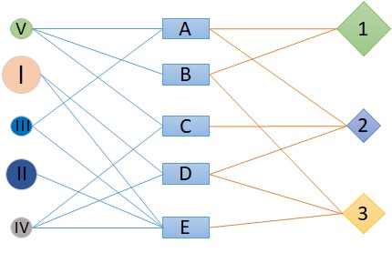
Describing inter-specific interactions - Network analysis capture patterns of interactions between species. I will build tripartite networks comprised of three types of nodes: i) epiphytic orchids, ii) mycorrhizal fungi, and iii) host trees (Fig. 4). Tripartite network analysis provides information on the number of links per species (which species are more connected) and layer interdependence (a measure of how much information about one layer predicts information in another layer), and allows to detect communities within the network ('blocks', a metric similar to modularity of bipartite networks)Error: Reference source not found,,. Tripartite network analysis is only recently being used to address multiple interactions and, despite the field evolves rapidlyError: Reference source not found, networks involving more than two partners have to be decomposed into bipartite networks to obtain other relevant metrics, such as modularity, nestedness, and specialization. A high modularity indicates there are subsets of strongly connected species interlinked through a few interactionsError: Reference source not found. A high nestedness indicates that there is a core of the most generalist species interacting among themError: Reference source not found. Partner breadth of a species can be quantified with the degree of interaction specialization at the species (d') and network (H') levelError: Reference source not found.
Fig. 4 Schematic representation of a tripartite interaction network between orchids (circles), mycorrhiza (squares) and host trees (rhombi). Characters depict different species; lines depict inter-specific interactions.

I expect nestedness and specialization to vary between forests. In cloud forests, where abiotic stress is lowest, epiphyte abundance is high and competition for resources is strongError: Reference source not found, orchid-mycorrhiza-host tree interactions will be weaker and orchids will establish generalist associations with the most abundant partner speciesError: Reference source not found. In dry forests, with opposite characteristics, physiological adaptation of the orchid will be a strong determinant of its distribution and also interaction networks will probably be more specializedError: Reference source not found,Error: Reference source not found.

WP2 Assessing how mycorrhizal fungi are distributed over the host trunk.
Nota. aquí solo vamos a testar esta hipótesis. Ver cómo los hongos se distribuyen sobre el árbol y entre árboles. Como vamos a encontrar posiblemente una diversidad mayor de hongos que en las micorrizas, vamos a testar coincidencias entre las OTU de la madera con las OTU de las demás orquídeas muestreadas en el WP 1 en el DHTF + nuevas muestreadas en los estratos 6 y 2. Asumiremos que las encontradas en las micorrizas corresponden a OTUs formadoras de micorrizas y no a patógenos u otro tipo de endobiontes.

Rationale: Most studies of orchid-mycorrhiza interactions assess mycorrhizal communities, which give information on which partners are selected from the local pool, instead of free-living fungi in the soil or the bark of the host , .
Background:

WP3 Assessing turnover in mycorrhizal fungi over epiphytic orchid ontogeny.
Nota. aquí vamos a hacer el diseño de connell para testar dos hipótesis:
H3: la diversidad de partners es mayor en los juveniles (oportunistas)
Vamos a testarla comparando cambios en la diversidad de OTUs entre seedlings y adultos.
H4: el recambio de partners se debe a sampling y no a complementarity.
Vamos a testarla comparando cambios en la composición de OTUs entre seedlings y adultos.

A handful of comparative studies between seedlings and adults did not show a single pattern, highlighting the complexity of the regeneration niche of epiphytic orchids11,

Study design:
To assess how light, partner breadth, and mycorrhizal fungi availability affect orchid germination and recruitment, I will use a design analogous to Connell's experiment of barnacle distribution over the intertidal zoneError: Reference source not found. I will compare the spatial distribution of adult plants of 4 species, 2 broadly- and 2 narrowly-distributed over the tree trunk, with the distribution of conspecific juveniles, and seedlings from in-situ germination assays.
The study will be conducted in natural, dry-humid transition tropical forests in the western mountain range of the Colombian Andes. I will work in two plots 5 km apart and select 20 host trees in each. I will sample juvenile and adult plants growing on tree trunks at heights of 2, 6, and 10 m (Fig. 5). At each height, I will collect (Fig. 5a): i) 3 root fragments in 3-5 individuals per species and age to identify mycorrhizal fungi; ii) 3 bark samples to assess fungal availability on the host tree; and iii) 3 hemispheric photographs to describe the vertical gradient of light of host trees. This research raises ethical issues regarding the collection of plant material in a non-EU country. However, sampling will not destroy the plants, and I will comply with Access and Benefit Sharing regulations as well as with the local and EU law.
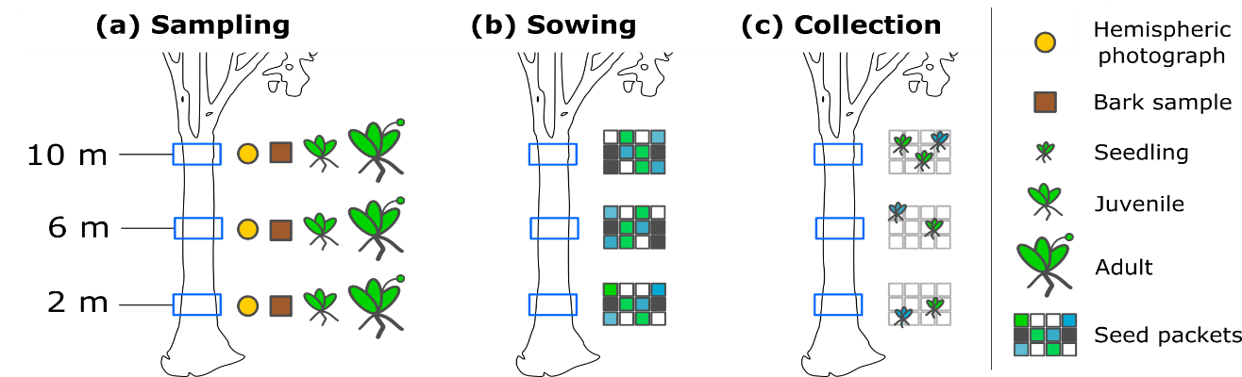

Fig. 5 Study design. (a) Sampling at 3 trunk heights, (b) in-situ germination assays (each colour denotes a different species), (c) collection of seedlings.

For germination assays, I will collect seeds from ripe capsules of the 4 species used in WP2 and prepare seed packets. I will attach 3 seed packets per orchid species in the same trees at 3 heights (1440 packets in total) (Fig. 5b) using plastic wrapsError: Reference source not found. In this way, I will evaluate whether seedlings and adults show the same vertical pattern of mycorrhizal partners. Eight months after sowing I will harvest the seedlings (Fig. 5c) to collect protocorm fragments for mycorrhizal DNA extraction. I will assess whether complementarity or sampling effects better explain ontogenetic partner turnover, by assuming that all partners are equally beneficial and by partitioning partner turnover into its nestedness and replacement components (Fig. 1).
An individual orchid can host 1-30 different fungal partners. To accurately describe fungal diversity associated to individual plants and host’s bark, I will extract DNA from root fragments and bark using two complementary primer pairs (ITS3/ITS4OF and ITS86F/ITS4). I will use Illumina sequencing to obtain fungi operational taxonomic units (OTUs), which are the commonly used units of microbial diversity.

Justification of design: Some orchid species are expected to be unique to a particular forest type, while others are expected to occur in at least two of them. I will register the host tree species where the different epiphytic orchid species occur (host-tree breadth), and the mycorrhizal partners in orchid roots (mycorrhizal fungi breadth). With this information, I will be able to test H2, which states that the availability of free-living fungi changes over the vertical gradient of light. The composition of free-living fungi communities will change over the trunk of the host tree.

I will assess fungal availability in the substrate.
The presence of fungal symbionts in the substrate15 and partner breadth towards mycorrhiza and host trees9 are major knowledge gaps in our understanding of what limits the distribution of epiphytic orchids.

Bascompte 2010. Science 329: 765-766
Jacquemyn et al. 2011. New Phytol. 192: 518–528
Jacquemyn et al. 2015. New Phytol. 206: 1127-1134
Herrera 2018. Interacción entre orquídeas epífitas y hongos micorrícicos en bosques tropicales del Sur de Ecuador. PhD Thesis URJC Spain.
Waud et al. 2014. Mol. Ecol. Res. 14: 679–699
Newman 2018. Networks 2nd Ed. Oxford University Press. 784 pp. Oxford.
De Bacco et al. 2017. Phys. Rev. E. 95: 042317
Kivelä et al. 2014. Journal of Complex Networks 2: 203–271
Kéfi et al. 2016. PLoS Biol. 14: e1002527
Melián et al. 2009. Oikos 118: 122-130
Olesen et al. 2007. P. Natl. Acad. Sci. USA. 104: 19891–19896
Bascompte et al. 2003. P. Natl. Acad. Sci. USA. 100: 9383–9387
Blüthgen et al. 2006. BMC Ecology 6: 9
Shao S-C, Burgess KS, Curse-Sanders JM, Liu Q, Fan X-L, Gao J-Y. 2017. Using in-situ symbiotic seed germination to restore over-collected medicinal orchids in Southwest China. Frontiers in Plant Science 8, 888.
Cardoso P, Rigal F, Carvalho JC. 2015. BAT – Biodiversity Assessment Tools, an R package for the measurement and estimation of alpha and beta taxon, phylogenetic and functional diversity. Methods in Ecology and Evolution 6, 232–236.
Herrera P. 2018. Interacción entre orquídeas epífitas y hongos micorrícicos en bosques tropicales del Sur de Ecuador. PhD Thesis URJC Spain.

