|  |
| --- |
| **APPLICATION POSTDOCTORAL FELLOWSHIP (junior/senior) PROJECT OUTLINE (MAX. 10 pages)** |

**Which factors affect the distribution of epiphytic orchids in mega-diverse tropical forests?**

# Rationale and positioning with regard to the state-of-the-art

[General paragraph and the factors driving species distributions] Understanding the various **factors that limit species distribution** is a longstanding question in ecology[1]. In land plants, the large-scale distribution of species is simultaneously limited by historical processes, environmental conditions, and biotic interactions1. Historical processes refer to … and …. Environmental conditions are … Biotic interactions …

[General paragraph on the effects of interspecific interactions on the distribution]

Whereas the effects of historical processes and environmental condtions on species distributions are relatively well understood, the ecological effects of obligate inter-specific interactions, such as symbioses, are far less understood. [2],[3]. Furthermore, a species can interact with more than one obligate partner at the same time, which adds complexity to the determinants of species distribution1.

In sessile organisms, such as plants, the distribution of adult individuals can largely depend on species' requirements during the earliest developmental life stages (the regeneration niche[4]). The regeneration niche includes preferences for different substrates[5], differential responses of seedlings to light gradients[6], and availability of mutualists[7].

**Epiphytes** live non-parasitically on tree trunks and branches, and therefore they need to find a **suitable host tree** for physical support. Because they live on trees, epiphytes face strong ecological gradients in short distances throughout their lives, such as the **vertical gradient of light** of the forest12, having to adapt to a broad range of environmental conditions6. **Epiphytic orchids,** however, stand out among other epiphytes because of two additional characteristics that might determine their regeneration niche at small scales: i) seed germination fully depends on microscopic **mycorrhizal fungi** that are not inherited from maternal plants[8],[9], and therefore, **free-living fungi** on the substrate might be a key component of microsite quality11; and ii) while early life stages lack chlorophyll and fully depend on mycorrhiza for nutrition, adults of most species are capable of photosynthesis (**partial mycoheterotrophy**), potentially reducing their dependency on mycorrhiza as compared to seedlings[10]. Epiphytic orchids thus need to find suitable host trees and mycorrhizal fungi for germination, but also might experience changes in their environmental and nutritional requirements throughout development, meaning that the **regeneration and adult niches might differ substantially**.

Although specialized partnerships with host trees have been reported, most evidence so far indicates that epiphytic orchids can grow on a broad range of tree species[11],[12],[13], suggesting that tree availability may not be a major constraint to the distribution of epiphytic orchids. Less, however, is known about how mycorrhizal fungi determine the distribution of epiphytic orchids. In terrestrial orchids, there is a continuum from specialists[14],[15] to generalists[16],[17]. For epiphytic orchids, we do not really know whether they are specialized or generalized[18]. The little evidence available suggests that epiphytic orchids may have a higher diversity of mycorrhizal interactions than terrestrial orchids[19] and that they tend to be generalists[20],[21], although highly specialized taxa have also been documented22,[22]. Studies over small spatial scales reveal terrestrial orchids to have distinctive mycorrhizal communities and show strong spatial segregation, suggesting that mycorrhizal partners play a role in determining their distribution[23]. No such data are available for epiphytic orchids.

An important unknown aspect in this interaction is **how mycorrhizal communities vary** among host trees and over the host tree surface, and **how this affects the distribution of epiphytic orchids**. It has been proposed that epiphyte turnover among host trees may be mediated by mycorrhizal fungi[24] and that orchids with many mycorrhizal partners have more host tree species[25]. However, exceptions to this pattern have been reported29, suggesting that interactions of epiphytic orchids with their two partners can be diverse and complex. Similarly, the vertical turnover in epiphytic orchids is known to relate to changes in bark characteristics as well as epiphytes' requirements for light15. Yet, whether those factors influence the distribution of mycorrhizal partners remains to be assessed29. In general, solid evidence of how host trees and mycorrhiza affect epiphytic orchid distribution is still lacking, because **studies have had a limited spatial scale and rarely included ecological gradients**.

After germination, seedlings experience a high death rate in later stages of development[26],[27]. Several factors may cause recruitment failure, from seedling predation to differences between the *regeneration* and *adult niches* of the species[28]. Plant physiological needs often change over ontogeny, and the successful transition from seedling (protocorm) to adult might depend on acquiring new mycorrhizal partners that help fullfill those new needs19. Such ontogenetic partner turnover can result from complementarity or sampling effects in time19. **Complementarity** consists of a replacement of partners from the seedling to the adult stage, under the assumption that new partners potentially play complementary roles. On the other hand, **sampling effects** consist of adults retaining a subset of their partners from the seedling stage.

# Scientific research objectives

The major aim of this research is to understand **how multiple partners interacting with abiotic conditions influence the distribution of epiphytic orchids in hyper-diverse tropical forests**. . In particular, the project aims at understanding how mycorrhizal fungi availability affects germination and recruitment of epiphytic orchids along natural light gradients. To this end, I will address three key aspects of the interaction: i) the availability of free-living fungi on the substrate as a key component of microsite quality; ii) changes in the interaction over the vertical gradient of light of the forest; and iii) ontogenetic turnover of mycorrhizal partners as a putative barrier to post-germination establishment.

In particular, I will test the hypotheses that:

H1: the influence of partner availability on epiphytic orchid distribution depends on partner breadth and abiotic conditions.

H2: the availability of free-living fungi changes over the vertical gradient of light. The composition of free-living fungi communities will change over the trunk of the host tree.

H3: seedlings will have a greater diversity of mycorrhizal fungi than adults. This would indicate that germination is opportunistic, using the fungi at hand in each sector of the host tree trunk.

H4: ontogenetic changes in mycorrhizal partners are due to sampling effects rather than total complementarity.

This study will provide **three innovative aspects to the field**:

**(1) Address an unresolved question in plant ecology**: how more than one partner affects plant species' distribution. This is not trivial because a considerable proportion of tropical plant diversity relies on more than one partner for successful establishment. In epiphytic orchids in particular, most studies have focused on bipartite interactions, *i.e.*, epiphyte-host tree or epiphyte-fungi interactions, while a tripartite network approach (epiphyte-mycorrhiza-host tree) better reflects the actual situation.

**(2)** The **first experimental test** of how tripartite interactions affect orchid distribution within a vertical light gradient. Combining **careful field observations and experiments with cutting-edge analyses and molecular techniques**, I will be able to decipher:

• whether and how mycorrhizal partners influence epiphytic orchid distribution within the host tree.

• how the vertical gradient of light within a host-tree affects epiphytic orchid germination.

• whether orchid mycorrhizal partners are replaced or retained over an individual's lifetime, and the underlying mechanisms.

**(3)** The **first comprehensive picture of the patterns and potential drivers of tropical epiphytic orchid distribution**. This research **will push the state-of-the-art forward**, moving from local studies of focal orchid species towards an integrative approach over larger scales, and providing novel insights into:

• how climatic factors influence the interaction network and community structure of epiphytic orchids.

• how orchid partner breadth and partner availability influence the large-scale distribution of epiphytic orchids.

I will build and analyse tripartite interaction networks to infer changes in the orchid-mycorrhiza-host tree interactions over a geographical gradient of temperature and moisture. I expect to find a continuum of orchid-partner interactions, from strict generalists to strict specialists. Forests with more stressful abiotic conditions (e.g., warm and dry) will harbour orchid species that depend more strongly on their partners, while moist forests will host a wider variety of strategies. This project will address for the first time the effect of two partners on the distribution of epiphytic orchids in megadiverse communities across geographical and local ecological gradients.

Solid evidence of how light gradients affect fungi availability and mycorrhizal symbioses in epiphytic orchids is still lacking . Furthermore, the few studies available deal mainly with adult plants, but neglect germination or transitions between ontogenetic stages. Such knowledge is key to design effective, evidence-based orchid conservation actions.

Our knowledge on how seedling and adult niche requirements ultimately affect epiphytic orchid distribution is only fragmentary. This is because the studies addressing this problem have focused on adults, which are more conspicuous than earlier life stages, in local studies in a few species. In addition, the technology for massive DNA sequencing of microscopic fungi has been developed only in the last 15-10 years, which now allows to quantify the molecular diversity of fungal partners with an unprecedented resolution. A major current need in the field is an integrated approach that addresses (i) how do host trees and mycorrhizal fungi limit epiphytic orchid distribution across geographical ecological gradients, (ii) how the regeneration niche as defined by mycorrhizal fungi and the abiotic environment, and the transition to the adult stage determine individual establishment in epiphytic orchid populations6 .

# Research methodology and work plan

The study will be conducted in natural, mostly undisturbed tropical forest ecosystems. I will sample communities of epiphytic orchids in three forest types along a humidity-altitude gradient in the western mountain range of the Colombian Andes (Fig. 3a). The forest types encompass dry forests in the Cauca River Valley, dry-humid transition forests (DHTF) in the valley slope, and cloud forests in the Pacific slope. In each forest type I will choose two plots 5 km apart. I will sample plants growing at a height of 10 m (H1) on tree trunks using the single-rope climbing method, collecting three 2-cm root fragments in up to five individuals per orchid species of all the species found. Sampling will not destroy the plants.

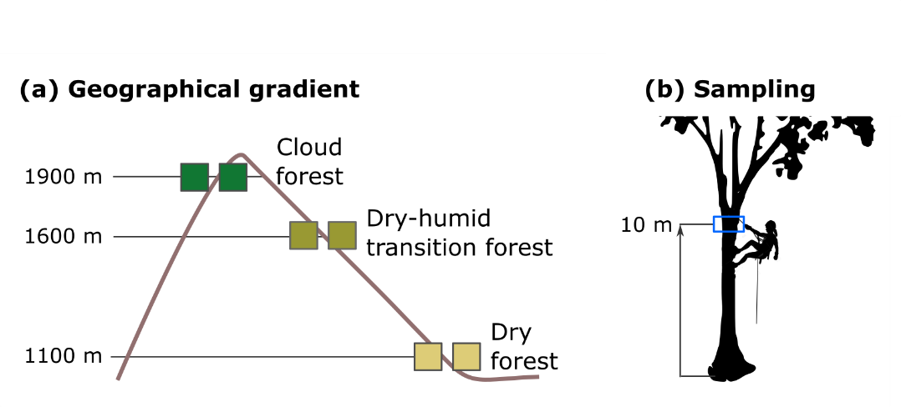

**Fig.** **3** Sampling design. **(a)** Geographical gradient including three forest types in the Andes Mountain Range, with two plots per altitude. **(b)** Sampling method.

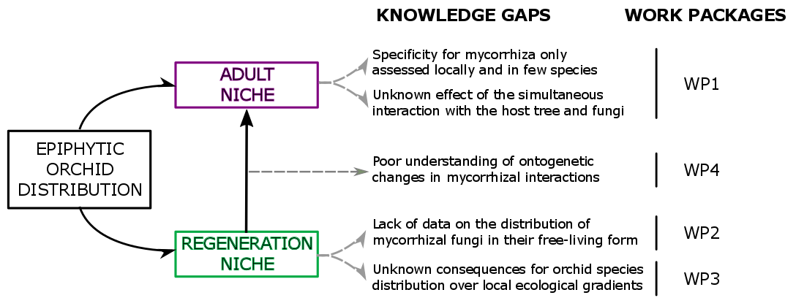

**Fig. 2:** Overview of the research project. I will address determinants of epiphytic orchid distribution during the regeneration and adult phases.

**WP1. Assessing the influence of partner availability on epiphytic orchid distribution.**

**WP2** Assessing how light, partner breadth, and mycorrhizal fungi availability affect orchid germination

**WP3** Assessing turnover in mycorrhizal fungi over epiphytic orchid ontogeny.

**RISKS AND CONTINGENCY PLANS**

I do not foresee major risks in the completion of this project given the supervisor's expertise in orchid-mycorrhiza interactions, statistical tools and molecular techniques; my experience in the study model and fieldwork in the chosen sites; and my solid contacts in Colombia, that will provide practical and administrative support during fieldwork stays. Nevertheless, I have identified potential contingencies for some WPs (Table 1). I will re-assess each risk and alternative strategies by monitoring tasks progress along with my supervisor and other team members.

**Table 1** Potential risks to the completion of work packages (WP), likelihood and contingency plan.

|  |  |  |  |
| --- | --- | --- | --- |
| **WP** | **Risk** | **Likelihood** | **Contingency plan** |
| 1, 2, 3 | Fieldwork is not finished in time | very low | Two extra weeks planned to buffer sampling delays |
| 1,2 | Delayed export licenses | low | Use Dr. Flanagan's licenses backed by PUJ. Extract mycorrhiza DNA in her molecular biology lab and export PCR products. |
| 3 | Not enough seeds in the wild | medium | Obtain seeds from local orchidaria |
| 3 | Low seed germination rate | medium | Large sample sizes to obtain workable numbers |

**WORK PLAN**

The feasibility and effectiveness of this project is supported by the experience of the host institution, the supervisor, and the candidate. The proposal consists of four work packages (**WP**), nine milestones (**M**) and four deliverables (**D**) (*Table 2*). Ideal start date is October 1st, 2019.

**Table 2** Gantt chart showing work packages (WP), milestones (M) and deliverables (D) of the project. Blue: research packages; yellow: training; green: seminars. The chart is not exhaustive.



In ***months 2 to 4*** we will sample the six plots for roots and collect fruits in DHTF plots **(M1)**. The second half of ***month 4*** will be used to request export licenses and up-load orchid species inventories to SiB database in order to comply with the Colombian law. Licenses for research purposes are often granted within 1-3 months (N Ospina, Pers. comm.), so by applying at the end of month 3 I leave sufficient time for the process to complete (over three months). During ***months 5 to 7*** I will prepare and sow the seed packets **(WP3, WP4)** with the help of a M.Sc. student. Completion of these tasks will mark the end of fieldwork **(M2)**. In the first half of ***month 8*** export licenses should have been granted, allowing me to ship the samples to Belgium **(M3)**. If licenses delay further I have two alternative contingency plans (Table 1). The first half of ***month 8*** is also intended for closing administrative tasks and as a contingency period for potential risks during fieldwork (*e.g*., delays for bad weather) (Table 1). In the second half of ***month 8*** I will return to the host institution in Belgium, where I will extract mycorrhizal DNA in Prof. Jacquemyn's lab **(M4)**. If delays do not occur I will advance my return to Belgium. I will offer a seminar to discuss fieldwork outcomes with the team members and discuss further steps in data analysis **(S1)**.

In ***month 9*** I will send samples for high-throughput gene sequencing in the University of Antwerp (Belgium). Meanwhile I will analyse environmental, orchid community and host-tree data **(WP1)**. I will also enrol in selected modules of the MSc. degree in Bioinformatics at the host **(T1),** where I will learn how to handle and analyse multiple gene sequence data. I will receive hands-on training on sequence alignment and network analyses **(T2)** during ***months 11 and 12***. Upon analyses completion **(M5)**, I will offer a seminar to discuss results and possible approaches to the papers **(S2)**. I will spend ***months 14 to 16*** writing the manuscript corresponding to **WP1** (**D1**). I will perform the analyses for **WP2** between ***months 17-19*** **(M6)**, offer a seminar to discuss results and possible approaches to the papers **(S3),** and write the manuscript between ***months 20-22*** **(D2)**.

Field and lab work for **WP3** and **WP4** will be in ***months 23 and 24.***I will return to Colombia with a M.Sc. student to collect the germinated seedling roots and ship the samples to Belgium **(M7)**. Back in Belgium (***month 25***), I will extract mycorrhiza DNA and send it for sequencing. While I wait for sequence data, I will meet with team members **(S4)** to discuss the germination assays data and the approach of the manuscript of **WP3** and work in the analyses. I will submit the resulting manuscript in ***month 30*** **(D3)**. From ***months 31 to 34*** I will analyse data of **WP4**. I will submit the last manuscript on ***month 36*** **(D4)** and offer a seminar to present an overview of the results of the whole project **(S5)**.

# References

*Give an overview of the bibliographical references that are relevant for your research proposal.*

Click here to insert your text.

1. Krebs 1972. *Ecology: the experimental analysis of distribution and abundance*. 694 pp. Harper & Row New York
2. Dunn et al. 2009. Proc. Proc. R. Soc. Lond. B. 276: 3037–3045
3. Afkhami et al. 2014. Ecol. Lett. 17: 1265-1273.
4. **Grubb PJ. 1977.** The maintenance of species richness in plant communities: the importance of the regeneration niche. *Biological Reviews* 52, 107–145.
5. **Lusk CH. 1995.** Seed size, establishment sites and species coexistence in a Chilean rainforest. *Journal of Vegetation Science* 6, 249–256.
6. **Denslow JS. 1980.** Gap partitioning among tropical rainforest trees. *Biotropica* 12, 47–55.
7. ## McCormick MK & Jacquemyn H. 2014. **What constrains the distribution of orchid populations? *New Phytologist* 202, 392–400.**

  
8. **Benzing DH. 1990.** *Vascular epiphytes: General Biology and Related Biota*. 354 pp. Cambridge University Press. Cambridge.
9. **Rasmussen HN. 2002.** Recent developments in the study of orchid mycorrhiza. *Plant and Soil* 244, 149–163.
10. **Leake JR. 1994.** The biology of myco-heterotrophic (Saprophytic) plants. *New Phytologist* 127, 171–216.
11. Rasmussen & Rasmussen 2018. Bot. J. Linn. Soc. 186: 456–472
12. Wagner et al. 2015. AoB Plants 7: plu092
13. Burns & Zotz 2010. Ecology 91: 377-385
14. McKendrick et al. 2002. New Phytol. 154: 233–247
15. Bidartondo & Read 2008. Mol. Ecol. 17: 3707–3716
16. Jacquemyn et al. 2016. Sci. Rep. 6: 37182
17. Ogura-Tsujita et al. 2018. Mol. Ecol. 27: 1324-1337
18. Otero et al. 2007. Am. J. Bot. 94: 1944–1950
19. Martos et al. 2012. Mol. Ecol. 21: 5098–5109
20. Suarez & Kottke 2016. Lankesteriana 16: 299-305
21. Herrera et al. 2018. Mycoscience 59: 38-48
22. Riofrío et al. 2013. Am. J. Bot. 100: 2339-2348
23. Jacquemyn et al. 2014. New Phytol. 202: 616-627
24. Clements 1987. Orchid-fungus-host associations of epiphytic orchids. In: *Proceedings of the 12th World Orchid Conference.* Tokyo (Saito K, Tanaka R Eds.)
25. Gowland et al. 2013. Am. J. Bot. 100: 764–777
26. **Harper JL. 1977.** *Population Biology of Plants*. Academic Press, NY.
27. **Batty AL, Dixon KW, Brundrett M, Sivasithamparam K. 2001.** Constraints to symbiotic germination of terrestrial orchid seed in a mediterranean bushland. *New Phytologist* 152,511–520.
28. **Eriksson O & Ehrlén J.** **2009.** Seedling recruitment and population ecology. *In* Seedling Ecology and Evolution (MA Leck, VT Parker, RL Simpson Eds.). Cambridge University Press.