|  |
| --- |
| **APPLICATION POSTDOCTORAL FELLOWSHIP (junior/senior) PROJECT OUTLINE (MAX. 10 pages)** |

*The titles below provide a list of aspects that should be discussed in the project outline. This is followed by a brief description of the expected content in italics. Please retain these titles in the final project description, but remove the description. You may add extra titles and subtitles as necessary. Please stick to the maximum number of 10 pages, without changing text layout (font Calibri 11, line distance 1, page margins etc.). Please also remove this explanatory paragraph before submitting this project description.*

**Tareas jueves 22: 1) Marco general de la propuesta (overview). Gantt chart.**

# Rationale and positioning with regard to the state-of-the-art

How biotic interactions affect species distribution in mega-diverse tropical forests?

**Aim1: How do host tree and mycorrhizal availability limit the distribution of epiphytic orchids across geographical gradients?**

Understanding the **factors that limit species distribution** is a longstanding question in ecology[1]. In land plants, the large-scale distribution of species is simultaneously limited by historical processes, environmental conditions, and biotic interactions1. Yet, the ecological requirements of **obligate inter-specific interactions**, such as symbioses, impose additional, often over-looked, limitations to species distribution[2],[3]. Furthermore, a species can interact with more than one obligate partner at the same time, which adds complexity to the determinants of species distribution1. How **complex interactions influence plant species distribution** has received little attention despite its relevance for species conservation in the face of global change[4]. EpiNet will address this gap by investigating how multiple partners interacting with abiotic factors influence epiphyte distribution in mega-diverse tropical assemblages*.*

**How do host tree and mycorrhizal availability limit the distribution of epiphytic orchids?** Although specialized partnerships with host trees have been reported, most evidence so far indicates that epiphytic orchids can grow on a broad range of tree species[5],[6],[7], suggesting that tree availability may not be a major constraint to the distribution of epiphytic orchids. Less, however, is known about how mycorrhizal fungi determine the distribution of epiphytic orchids. In terrestrial orchids, there is a continuum from specialists[8],[9] to generalists[10],[11]. For epiphytic orchids, we do not really know whether they are specialized or generalized[12]. The little evidence available suggests that epiphytic orchids may have a higher diversity of mycorrhizal interactions than terrestrial orchids[13] and that they tend to be generalists[14],[15], although highly specialized taxa have also been documented22,[16]. Studies over small spatial scales reveal terrestrial orchids to have distinctive mycorrhizal communities and show strong spatial segregation, suggesting that mycorrhizal partners play a role in determining their distribution[17]. No such data are available for epiphytic orchids.

An important unknown aspect in this interaction is **how mycorrhizal communities vary** among host trees and over the host tree surface, and **how this affects the distribution of epiphytic orchids**. It has been proposed that epiphyte turnover among host trees may be mediated by mycorrhizal fungi[18] and that orchids with many mycorrhizal partners have more host tree species[19]. However, exceptions to this pattern have been reported29, suggesting that interactions of epiphytic orchids with their two partners can be diverse and complex. Similarly, the vertical turnover in epiphytic orchids is known to relate to changes in bark characteristics as well as epiphytes' requirements for light15. Yet, whether those factors influence the distribution of mycorrhizal partners remains to be assessed29. In general, solid evidence of how host trees and mycorrhiza affect epiphytic orchid distribution is still lacking, because **studies have had a limited spatial scale and rarely included ecological gradients**.

**Aim 2: Which factors limit the recruitment of epiphytic orchids in tropical forests?**

Understanding the factors influencing community assembly is a longstanding problem in ecology[20],[21]. In sessile organisms, such as plants, species coexistence can be promoted by differences in their regeneration niche[22]. The regeneration niche includes preferences for different substrates[23], differential responses of seedlings to light gradients[24], and availability of mutualists[25]. The classic experiment by Connell[26] illustrated how a combination of abiotic (dessication) and biotic factors (competiton) influenced barnacle recruitment in rocky intertidal coasts at small scales. In WP3, I use a similar approach to disentangle how microsite conditions affect the germination and recruitment of epiphytic orchids in tropical forests, which is a major knowledge gap in orchid conservation and restoration[27].

**Epiphytic orchids** have three characteristics that might determine their regeneration niche at small scales: i) seed germination fully depends on **mycorrhizal fungi** that are not inherited from maternal plants[28],[29], and therefore, **free-living fungi** on the substrate might be a key component of microsite quality11; ii) epiphytes face strong ecological gradients in short distances, such as the **vertical gradient of light** of the forest12, ; iii) in most orchid species, adult plants rely on mycorrhizal fungi but are capable of photosynthesis (**partial mycoheterotrophy**), potentially reducing their dependency on mycorrhiza as compared to seedlings[30].

**How does fungi availability affect germination across ecological gradients?** Most studies of orchid-mycorrhiza interactions assess **mycorrhizal communities**, which give information on which partners are selected from the local pool, instead of **free-living fungi** in the soil or the bark of the host[31],[32]. Studies over small spatial scales revealed terrestrial orchids have distinctive mycorrhizal communities and show strong spatial segregation, suggesting that mycorrhizal partners play a role in determining their distribution16,[33],[34]. No such data are available for epiphytic orchids.

It is reasonable to assume that orchid germination frequency will be higher in species that associate selectively with common instead of rare fungal partners, so that **partner availability** is probably an important determinant of orchid germination. Yet, orchid species also differ in their degree of specialization in the interaction (**partner breadth**)[35], meaning that they can associate selectively with a few fungal partners (*specialist species*), or indistinctively with many of them (*generalist species*). Theory predicts that natural selection favours highly specialized interactions as a way to avoid cheaters[36]. This view has been recently challenged on the basis that generalist interactions can be advantageous under environmental heterogeneity, where species should not be very choosy in order to associate with the partners at hand19,20. In this way, generalist species can broaden their distribution by shifting partners (**partner turnover**) when the preferred partner is not locally available. Species exhibiting such ability have more chances of germinating in a variety of microsites than highly-specialized species. We ignore whether epiphytic orchids establish generalist or specialist interactions[37]. Recent studies suggest that they tend to associate with many mycorrhizal partners[38],[39], although highly specialized interactions also were documented21,[40]. A handful of comparative studies between seedlings and adults did not show a single pattern, highlighting the complexity of the regeneration niche of epiphytic orchids11,[41]. The presence of fungal symbionts in the substrate15 and partner breadth9 are major knowledge gaps towards understanding what limits the germination and recruitment of epiphytic orchids.

Solid evidence of how light gradients affect fungi availability and mycorrhizal symbioses in epiphytic orchids is still lacking[42]. Furthermore, the few studies available deal mainly with adult plants, but neglect germination or transitions between ontogenetic stages. Such knowledge is key to design effective, evidence-based orchid conservation actions.

**Which factors determine a successful transition from seedlings to adult****s?** After germination, seedlings experience a high death rate in later stages of development[43],[44]. Several factors may cause recruitment failure, from seedling predation to differences between the *regeneration* and *adult niches* of the species[45]. Plant physiological needs often change over ontogeny, and the successful transition from seedling (protocorm) to adult might depend on acquiring new mycorrhizal partners that help fullfill those new needs19. Such ontogenetic partner turnover can result from complementarity or sampling effects in time19. **Complementarity** consists of a replacement of partners from the seedling to the adult stage, under the assumption that new partners potentially play complementary roles. On the other hand, **sampling effects** consist of adults retaining a subset of their partners from the seedling stage.

Using these concepts, I derived four testable hypothetical scenarios of ontogenetic partner turnover and their putative driving processes (Fig. 1). Individuals can gain (Fig. 1a,b) or lose (Fig. 1c,d) partners throughout ontogeny. Ontogenetic partner gains would indicate a change in adult requirements relative to the seedling's, while partner losses would indicate that germination is opportunistic, and that at least some partners become dispensable at later ontogenetic stages. Partner gains can be due to **partial** (Fig. 1a) or **total complementarity** (Fig. 1b), and partner loss due to subsampling (**sampling effect**; Fig. 1c) or **total complementarity** (Fig. 1d). Partner turnover due to complementarity would allow the plant to fulfill its adult requirements, which differ from the seedling requirements; whereas partner turnover due to sampling effects would indicate that the regeneration and adult niches (as related to the mycorrhizal interaction) are similar.

Ontogenetic partner turnover through total complementarity is risky because a lack of suitable new partners can compromise survival to adulthood. Evidence from terrestrial orchids suggests that partner gains (Fig. 1a, b) are common11, while losses are less well documented[46]. [Develop this evidence a bit more] The role of mycorrhiza in germination and recruitment of epiphytic orchids remains to be assessed9,15.

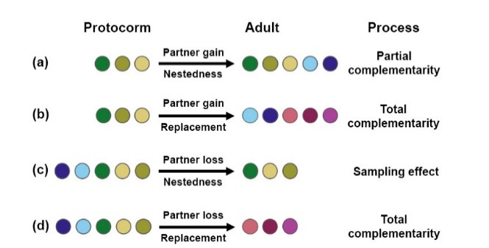

**Fig. 1** Hypothetical scenarios of ontogenetic partner turnover and their putative driving processes. Colours denote different partners. Text above arrows indicates changes in partner number; text below arrows indicates the prevailing component of composition turnover (nestedness or replacement)

# Scientific research objectives

*Describe explicitly the scientific objective(s) and the research hypothesis. Explain whether and how the research is specifically challenging and inventive, describing in particular the innovative aspects of the envisaged results. Discuss in detail the results (or partial results) that you aim to achieve, such as specific knowledge and academic breakthroughs.*

**Aim 1:** **understand how interactions with two partners, host tree and mycorrhizal fungi, influence the distribution of epiphytic orchids in hyper-diverse tropical forests.** In particular, I will test the hypothesis that:

**H1: The influence of partner availability on epiphytic orchid distribution depends on partner breadth and abiotic conditions.** I will build and analyse tripartite interaction networks to infer changes in the orchid-mycorrhiza-host tree interactions over a geographical gradient of temperature and moisture. I expect to find a continuum of orchid-partner interactions, from strict generalists to strict specialists. Orchid distribution will vary as stated in the four predictions above (page 1). Forests with more stressful abiotic conditions (*e.g.*, warm and dry) will harbour orchid species that depend more strongly on their partners, while moist forests will host a wider variety of strategies.

**Aim 2:** The scientific objective is to understand how mycorrhizal fungi availability affects germination and recruitment of epiphytic orchids along natural light gradients. To this end, I will address three key aspects of the interaction: i) the availability of **free-living fungi** on the substrate as a key component of microsite quality; ii) changes in the interaction over the **vertical gradient of light** of the forest; and iii) **ontogenetic turnover of mycorrhizal partners** as a putative barrier to post-germination establishment. Specifically, I will test three hypotheses:

**H1: The availability of free-living fungi changes over the vertical gradient of light.** The composition of free-living fungi communities will change over the host tree trunk.

**H2: Seedlings will have a greater diversity of mycorrhizal fungi than adults.** This would indicate that germination is opportunistic, using the fungi at hand in each sector of the host tree trunk.

**H3: Ontogenetic changes in mycorrhizal partners are due to sampling effects rather than total complementarity.** As total ontogenetic complementarity is risky, the nestedness component of mycorrhiza turnover (Fig. 1 a, c) will prevail over the replacement component (Fig. 1 b, d), regardless of whether adults gain or lose partners.

This project will address for the first time the effect of two partners on the distribution of epiphytic orchids in megadiverse communities across geographical and local ecological gradients.This study will provide **three innovative aspects to the field**:

**(1) Address an unresolved question in plant ecology**: how more than one partner affects plant species' distribution. This is not trivial because a considerable proportion of tropical plant diversity relies on more than one partner for successful establishment. In epiphytic orchids in particular, most studies have focused on bipartite interactions, *i.e.*, epiphyte-host tree or epiphyte-fungi interactions, while a tripartite network approach (epiphyte-mycorrhiza-host tree) better reflects the actual situation.

**(2)** The **first experimental test** of how tripartite interactions affect orchid distribution within a vertical light gradient. Combining **careful field observations and experiments with cutting-edge analyses and molecular techniques**, I will be able to decipher:

• whether and how mycorrhizal partners influence epiphytic orchid distribution within the host tree.

• how the vertical gradient of light within a host-tree affects epiphytic orchid germination.

• whether orchid mycorrhizal partners are replaced or retained over an individual's lifetime, and the underlying mechanisms.

**(3)** The **first comprehensive picture of the patterns and potential drivers of tropical epiphytic orchid distribution**. This research **will push the state-of-the-art forward**, moving from local studies of focal orchid species towards an integrative approach over larger scales, and providing novel insights into:

• how climatic factors influence the interaction network and community structure of epiphytic orchids.

• how orchid partner breadth and partner availability influence the large-scale distribution of epiphytic orchids.

# Research methodology and work plan

*Elaborate the different envisaged steps (experiments/activities) in your research, and motivate your strategic choices with the aim of reaching the objectives. Describe the set-up and cohesion of the work packages including intermediate goals (milestones).*

*Show where the proposed methodology (research approach) is according to the state of the art and where it is novel. Discuss risks that might endanger reaching project objectives and the contingency plans to be put in place should this risk occur.*

*Use a table or graphic representation of the planned course of activities (timing work packages, milestones, critical path) over the 3-years grant period.*

**The approach has been tailored to address major knowledge gaps in the field**. The study of many species across geographical spatial scales and ecological gradients will provide an unprecedented picture of the patterns of tropical epiphytic orchid distribution as related to host trees and mycorrhiza. In addition, germination experiments will provide novel insights into how ontogenetic partner turnover influences the distribution of epiphytic orchids. The expertise and equipment needed for gene sequencing and data analysis are provided by the host. I have experience in working with tropical epiphytes[47] and performing detailed light measurements in tropical forests[48],[49]. A collaboration with Dr. Nicola Flanagan, researcher at Pontificia Universidad Javeriana in Colombia, will facilitate sampling logistics. I will address each hypothesis in a separate work package.

**Aim 1:**

The study will be conducted in natural, mostly undisturbed tropical forest ecosystems. I will sample communities of epiphytic orchids in three forest types along a humidity-altitude gradient in the western mountain range of the Colombian Andes (Fig. 2a). The forest types encompass dry forests in the Cauca River Valley, dry-humid transition forests (DHTF) in the valley slope, and cloud forests in the Pacific slope. In each forest type I will choose two plots 5 km apart. I will sample plants growing at a height of 10 m (H1) on tree trunks using the single-rope climbing method, collecting three 2-cm root fragments in up to five individuals per orchid species of all the species found. Sampling will not destroy the plants.

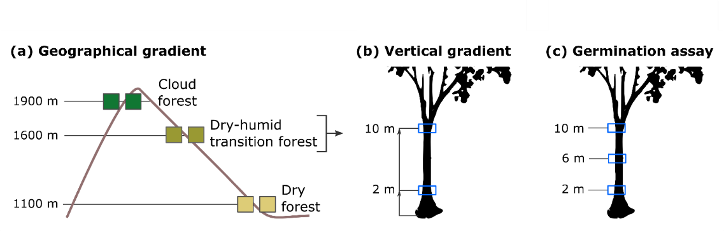

**Fig.** **2** Sampling design. **(a)** Geographical gradient including three forest types in the Andes Mountain Range, with two plots per altitude. **(b)** Sampling method. **(c)** *In-situ* germination assays in three trunk heights (only in transition forest plots).

To characterize regional climate I will use climatic data from meteorological stations near the plots. To describe the **light environment of host trees** I will measure photosynthetically active radiation (PAR, mol·m-2·day-1) by taking three hemispheric photographs in each tree at 10 m. To improve PAR estimation accuracy, I will measure the diffuse to direct PAR ratio with BF5 diffuse PAR sensors (Delta-T Devices, UK) in three randomly chosen host trees.

**Molecular analyses:** Since mycorrhizal fungi are microscopic and may form complex interactions with both host trees and orchids, I will combine meta-barcoding of mycorrhizal DNA with network analysis tools[50] to assess mycorrhizal partner breadth and availability[51],[52]. An individual orchid can host 1-30 different fungal partners[53]. To accurately describe **mycorrhizal diversity** associated with each individual plant I will extract DNA from 0.5 g mycorrhizal root fragments using UltraClean Plant DNA Isolation Kit (Mo Bio Laboratories Inc., CA, USA). I will use two complementary primer pairs (ITS3/ITS4OF and ITS86F/ITS4) for detailed characterization of diverse orchid mycorrhizal communities[54]. I will use Illumina sequencing to obtain mycorrhizal operational taxonomic units (OTUs), which are the commonly used units of microbial diversity. I will identify orchids and host trees with the help of a local taxonomist (Nhora Ospina, Universidad del Valle, Cali) and confirm ambiguous records using genetic barcoding.

**Network analyses:** Network analysis capture patterns of interactions between species[55]. I will build **tripartite networks** comprised of three types of nodes: i) epiphytic orchids, ii) mycorrhizal fungi, and iii) host trees (Fig. 3). Tripartite network analysis provides information on the *number of links per species* (which species are more connected) and *layer interdependence* (a measure of how much information about one layer predicts information in another layer)[56], and allows to *detect communities within the network* ('blocks', a metric similar to modularity of bipartite networks)42,[57],[58]. Tripartite network analysis is only recently being used to address multiple interactions and, despite the field evolves rapidly43, networks involving more than two partners have to be decomposed into bipartite networks to obtain other relevant metrics[59], such as *modularity*[60], *nestedness*[61], and *specialization*[62]. A high modularity indicates there are subsets of strongly connected species interlinked through a few interactions46. A high nestedness indicates that there is a core of the most generalist species interacting among them47. Partner breadth of a species can be quantified with the degree of interaction specialization at the species (d') and network (H') level48.

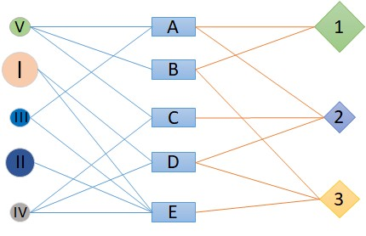

**Fig. 3** Schematic representation of a tripartite interaction network between orchids (circles), mycorrhiza (squares) and host trees (rhombi). Characters depict different species; lines depict inter-specific interactions.

I expect nestedness and specialization to vary between forests. In cloud forests, where abiotic stress is lowest, epiphyte abundance is high and competition for resources is strong9, orchid-mycorrhiza-host tree interactions will be weaker and orchids will establish generalist associations with the most abundant partner species39. In dry forests, with opposite characteristics, physiological adaptation of the orchid will be a strong determinant of its distribution and also interaction networks will probably be more specialized9,17.

**Aim 2:** To assess how light, partner breadth, and mycorrhizal fungi availability affect orchid germination and recruitment, I will use a design analogous to Connell's experiment of barnacle distribution over the intertidal zone10. I will compare the spatial distribution of adult plants of 4 species, 2 broadly- and 2 narrowly-distributed over the tree trunk, with the distribution of conspecific juveniles, and seedlings from *in-situ* germination assays.

The study will be conducted in natural, dry-humid transition tropical forests in the western mountain range of the Colombian Andes. I will work in two plots 5 km apart and select 20 host trees in each. I will sample juvenile and adult plants growing on tree trunks at heights of 2, 6, and 10 m (Fig. 2). At each height, I will collect (Fig. 2a): i) 3 root fragments in 3-5 individuals per species and age to identify mycorrhizal fungi; ii) 3 bark samples to assess fungal availability on the host tree; and iii) 3 hemispheric photographs to describe the vertical gradient of light of host trees. This research raises ethical issues regarding the collection of plant material in a non-EU country. However, sampling will not destroy the plants, and I will comply with Access and Benefit Sharing regulations as well as with the local and EU law.

For germination assays, I will collect seeds from ripe capsules of the 4 species and prepare seed packets[63]. I will attach 3 seed packets per orchid species in the same trees at 3 heights (1440 packets in total) (Fig. 2b) using plastic wraps31. In this way, I will evaluate whether seedlings and adults show the same vertical pattern of mycorrhizal partners. Eight months after sowing I will harvest the seedlings (Fig. 2c) to collect protocorm fragments for mycorrhizal DNA extraction. I will assess whether complementarity or sampling effects better explain ontogenetic partner turnover, by assuming that all partners are equally beneficial and by partitioning partner turnover into its nestedness and replacement components[64] (Fig. 1).

An individual orchid can host 1-30 different fungal partners[65]. To accurately describe **fungal diversity** associated to individual plants and host’s bark, I will extract DNA from root fragments and bark using two complementary primer pairs (ITS3/ITS4OF and ITS86F/ITS4). I will use Illumina sequencing to obtain fungi operational taxonomic units (OTUs), which are the commonly used units of microbial diversity.

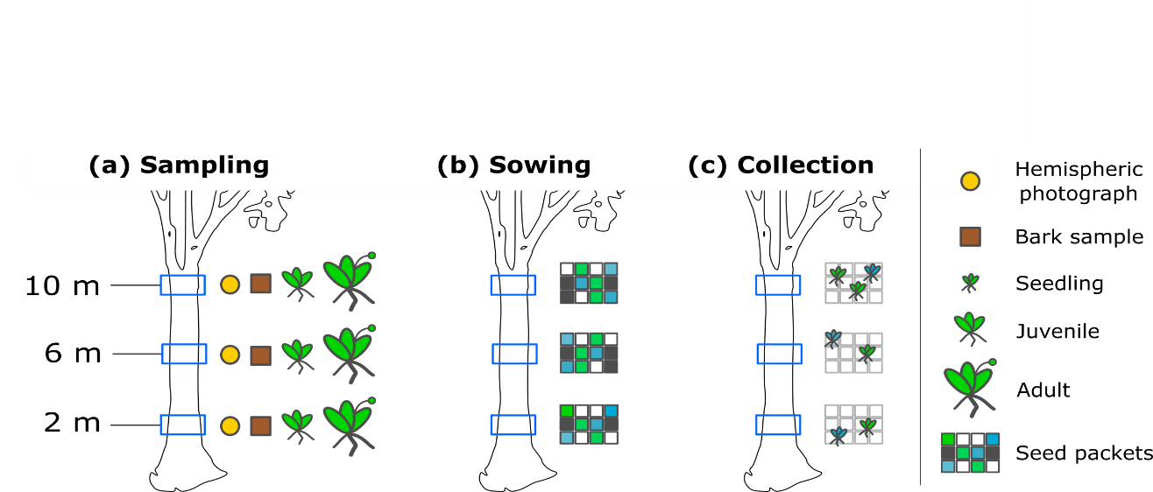

**Fig.** **2** Study design. **(a)** Sampling at 3 trunk heights, **(b)** *in-situ* germination assays, **(c)** collection of seedlings.

# References

*Give an overview of the bibliographical references that are relevant for your research proposal.*

Click here to insert your text.

1. Krebs 1972. *Ecology: the experimental analysis of distribution and abundance*. 694 pp. Harper & Row New York
2. Dunn et al. 2009. Proc. Proc. R. Soc. Lond. B. 276: 3037–3045
3. Afkhami et al. 2014. Ecol. Lett. 17: 1265-1273.
4. Gilman et al. 2010. Trends Ecol. Evol. 25: 325-331
5. Rasmussen & Rasmussen 2018. Bot. J. Linn. Soc. 186: 456–472
6. Wagner et al. 2015. AoB Plants 7: plu092
7. Burns & Zotz 2010. Ecology 91: 377-385
8. McKendrick et al. 2002. New Phytol. 154: 233–247
9. Bidartondo & Read 2008. Mol. Ecol. 17: 3707–3716
10. Jacquemyn et al. 2016. Sci. Rep. 6: 37182
11. Ogura-Tsujita et al. 2018. Mol. Ecol. 27: 1324-1337
12. Otero et al. 2007. Am. J. Bot. 94: 1944–1950
13. Martos et al. 2012. Mol. Ecol. 21: 5098–5109
14. Suarez & Kottke 2016. Lankesteriana 16: 299-305
15. Herrera et al. 2018. Mycoscience 59: 38-48
16. Riofrío et al. 2013. Am. J. Bot. 100: 2339-2348
17. Jacquemyn et al. 2014. New Phytol. 202: 616-627
18. Clements 1987. Orchid-fungus-host associations of epiphytic orchids. In: *Proceedings of the 12th World Orchid Conference.* Tokyo (Saito K, Tanaka R Eds.)
19. Gowland et al. 2013. Am. J. Bot. 100: 764–777
20. **Hutchinson GE. 1961.** The paradox of the Plankton. *The* *American Naturalist* 95, 137-145.
21. **Chesson P. 2000.** Mechanisms of maintenance of species diversity. *Annual Review of Ecology and Systematics* 31, 343–366.
22. **Grubb PJ. 1977.** The maintenance of species richness in plant communities: the importance of the regeneration niche. *Biological Reviews* 52, 107–145.
23. **Lusk CH. 1995.** Seed size, establishment sites and species coexistence in a Chilean rainforest. *Journal of Vegetation Science* 6, 249–256.
24. **Denslow JS. 1980.** Gap partitioning among tropical rainforest trees. *Biotropica* 12, 47–55.
25. ## McCormick MK & Jacquemyn H. 2014. **What constrains the distribution of orchid populations? *New Phytologist* 202, 392–400.**

   
26. ## Connell JH 1961. **The influence of interspecific competition and other factors on the distribution of the barnacle *Chthamalus stellatus. Ecology* 42,710–723.**

   
27. # Rasmussen HN, Dixon KW, Jersáková J, Těšitelová T. 2015. Germination and seedling establishment in orchids: a complex of requirements. *Annals of Botany* 116, 391–402.

   
28. **Benzing DH. 1990.** *Vascular epiphytes: General Biology and Related Biota*. 354 pp. Cambridge University Press. Cambridge.
29. **Rasmussen HN. 2002.** Recent developments in the study of orchid mycorrhiza. *Plant and Soil* 244, 149–163.
30. **Leake JR. 1994.** The biology of myco-heterotrophic (Saprophytic) plants. *New Phytologist* 127, 171–216.
31. **Jersáková J & Malinová T. 2007.** Spatial aspects of seed dispersal and seedling recruitment in orchids. *New Phytologist* 176, 237–241.
32. **McCormick MK, Whigham DF, Canchani-Viruet A. 2018.** Mycorrhizal fungi affect orchid distribution and population dynamics. *New Phytologist* In press*.*
33. **Waud M, Busschaert P, Lievens B, Jacquemyn H. 2016.** Specificity and localised distribution of mycorrhizal fungi in the soil may contribute to co-existence of orchid species. *Fungal Ecology* 20, 155–165.
34. **Jacquemyn H, Brys R, Merckx VSFT, Waud M, Lievens B, Wiegand T. 2014.** Co‐existing orchid species have distinct mycorrhizal communities and display strong spatial segregation. *New Phytologist* 202, 616–627.
35. **Batstone RT, Carscadden KA, Afkhami ME, Frederickson ME. 2018.** Using niche breadth theory to explain generalization in mutualisms. *Ecology* 99, 1039–1050.
36. **Frederickson ME. 2013.** Rethinking mutualism stability: cheaters and the evolution of sanctions. *Quarterly Review of Biology* 88, 263–295.
37. **Otero JT, Flanagan NS, Herre EA, Ackerman JD, Bayman P. 2007.** Widespread mycorrhizal specificity correlates to mycorrhizal function in the Neotropical, epiphytic orchid *Ionopsis utricularoides* (Orchidaceae). *American Journal of Botany* 94, 1944–1950.
38. **Suarez JP & Kottke I. 2016.** Main fungal partners and different levels of specificity of orchid mycorrhizae in the tropical mountain forests of Ecuador. *Lankesteriana* 16, 299–305.
39. **Herrera P, Kottke I, Molina MC, Méndez M, Suárez JP. 2018.** Generalism in the interaction of Tulasnellaceae mycobionts with orchids characterizes a biodiversity hotspot in the tropical Andes of Southern Ecuador. *Mycoscience* 59, 38–48.
40. # Riofrío ML, Cruz DJ, Torres E, de la Cruz M, Iriondo JM, Suárez JP. 2013. Mycorrhizal preferences and fine spatial structure of the epiphytic orchid *Epidendrum rhopalostele*. *American Journal of Botany* 100, 2339–2348.

   
41. **McKendrick SL, Leake JR, Taylor DL, Read DJ. 2000.** Symbiotic germination and development of myco-heterotrophic plants in nature: ontogeny of *Corallorhiza trifida* Chatel and characterisation of its mycorrhizal fungi. *New Phytologist* 145, 523–537.
42. **Gowland KM, van der Merwe MM, Linde CC, Clements MA, Nicotra AB. 2013.** The host bias of three epiphytic Aeridinae orchid species is reflected, but not explained, by mycorrhizal fungal associations. *American Journal of Botany* 100, 764–777.
43. **Harper JL. 1977.** *Population Biology of Plants*. Academic Press, NY.
44. **Batty AL, Dixon KW, Brundrett M, Sivasithamparam K. 2001.** Constraints to symbiotic germination of terrestrial orchid seed in a mediterranean bushland. *New Phytologist* 152,511–520.
45. **Eriksson O & Ehrlén J.** **2009.** Seedling recruitment and population ecology. *In* Seedling Ecology and Evolution (MA Leck, VT Parker, RL Simpson Eds.). Cambridge University Press.
46. **Bidartondo MI & Read DJ. 2008.** Fungal specificity bottlenecks during orchid germination and development. *Molecular Ecology* 17, 3707–3716.
47. Ventre-Lespiaucq et al. 2017. Biotropica 49: 318-327
48. Ventre-Lespiaucq et al. 2016. Trees 30: 995-1009
49. Ventre-Lespiaucq et al. 2018. Front. Pl. Sci. 9: 727
50. Bascompte 2010. Science 329: 765-766
51. Jacquemyn et al. 2011. New Phytol. 192: 518–528
52. Jacquemyn et al. 2015. New Phytol. 206: 1127-1134
53. Herrera 2018. Interacción entre orquídeas epífitas y hongos micorrícicos en bosques tropicales del Sur de Ecuador. PhD Thesis URJC Spain.
54. Waud et al. 2014. Mol. Ecol. Res. 14: 679–699
55. Newman 2018. Networks 2nd Ed. Oxford University Press. 784 pp. Oxford.
56. De Bacco et al. 2017. Phys. Rev. E. 95: 042317
57. Kivelä et al. 2014. Journal of Complex Networks 2: 203–271
58. Kéfi et al. 2016. PLoS Biol. 14: e1002527
59. Melián et al. 2009. Oikos 118: 122-130
60. Olesen et al. 2007. P. Natl. Acad. Sci. USA. 104: 19891–19896
61. Bascompte et al. 2003. P. Natl. Acad. Sci. USA. 100: 9383–9387
62. Blüthgen et al. 2006. BMC Ecology 6: 9
63. **Shao S-C, Burgess KS, Curse-Sanders JM, Liu Q, Fan X-L, Gao J-Y. 2017.** Using *in-situ* symbiotic seed germination to restore over-collected medicinal orchids in Southwest China. *Frontiers in Plant Science* 8, 888.
64. ## Cardoso P, Rigal F, Carvalho JC. 2015. **BAT – Biodiversity Assessment Tools, an R package for the measurement and estimation of alpha and beta taxon, phylogenetic and functional diversity. *Methods in Ecology and Evolution* 6, 232–236.**

   
65. **Herrera P. 2018.** Interacción entre orquídeas epífitas y hongos micorrícicos en bosques tropicales del Sur de Ecuador. PhD Thesis URJC Spain.