Automated Business Enquiry Handling System: Design Submission
Prepared by Agustar Alfonso

1. Architecture and Data Flow
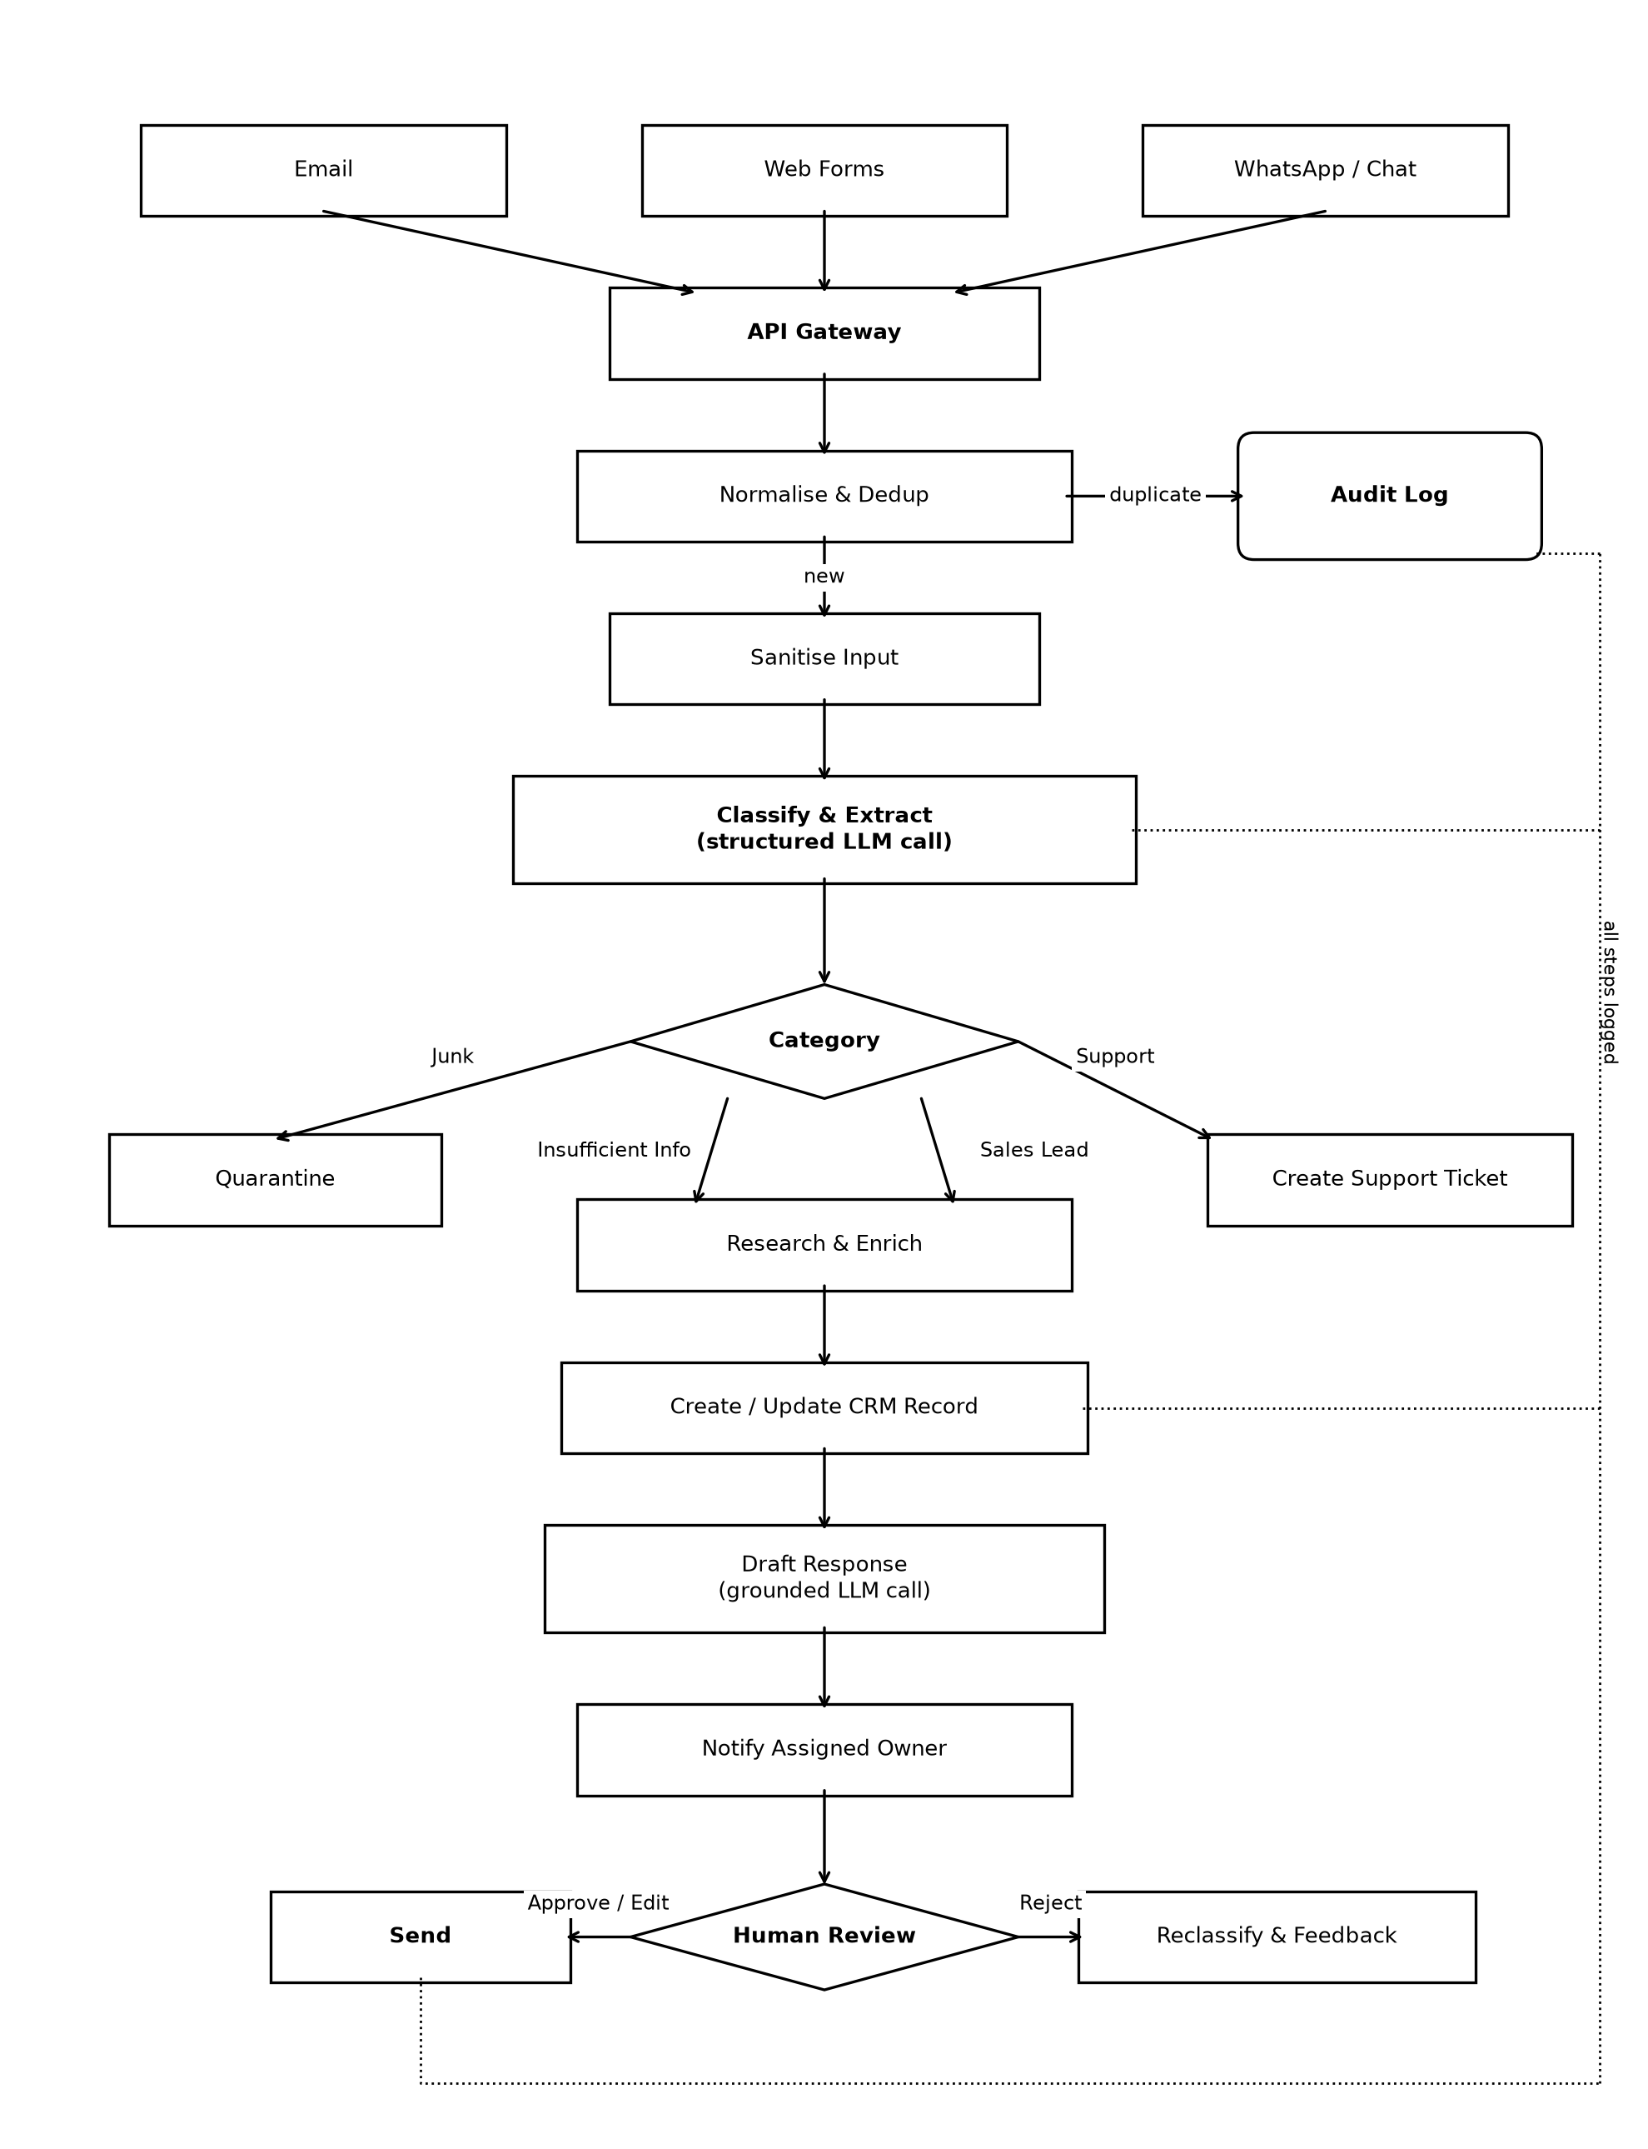

2. Model and Tool Choices
LLM usage in this pipeline is limited to two points, with the model at each chosen based on task complexity and call volume.

Classify & Extract — Claude Haiku 4.5
This step runs on every incoming enquiry, making it the highest-volume LLM call in the system. The task is narrow: assign a category (Sales Lead / Support / Junk / Insufficient Info) and extract structured fields (name, email, company, request summary). It's classification and extraction, not a job that needs deep reasoning.
The model returns structured output through tool-use/JSON schema (category, confidence, extracted_fields) instead of free text, so downstream deterministic code can validate and route the result reliably.
Haiku 4.5 fits because it's built for extraction, classification, and routing workloads, where latency and cost matter most. At roughly $1/$5 per million input/output tokens it's the cheapest tier in the lineup, which matters since this node fires on every single enquiry.

Draft Response — Claude Sonnet 5
This step only runs for enquiries that pass classification (not Junk, not duplicate), so call volume is naturally lower, which justifies a stronger model. The task is producing a natural, well-written reply grounded in CRM and research data, calling tools to pull in that context first.
Sonnet 5 is the balanced model for production coding, tool use, and agentic workloads, which fits a step needing grounded generation with tool calls to CRM/enrichment data before writing.
Pricing sits at $2/$10 per million input/output tokens, which keeps a medium-volume, higher-quality generation step affordable.

Non-LLM tooling (deterministic by design)
Component | Tool | Rationale
API Gateway | REST endpoint (e.g. AWS API Gateway / Fastify) backed by a queue (SQS/RabbitMQ) | Ingestion must be reliable and retryable, and the queue decouples "receive" from "process"
Normalise & Dedup | Plain code: content/email hashing + fuzzy matching (pg_trgm as the primary filter, Levenshtein as a secondary check) against existing CRM records | Matching records is a deterministic string/ID problem, so an LLM would only add cost and risk without benefit
Sanitise Input | Regex/HTML stripping + prompt-injection filtering, plus least-privilege tool scoping (the LLM can only read CRM/enrichment tools, never call ones that send or change data) | Mandatory before any externally-controlled text reaches a prompt, and it reinforces the no-autonomous-action rule at the tool-access level
CRM | HubSpot or Salesforce via API | Integrate with an existing standard CRM rather than building one
Research & Enrich | Web search / enrichment API called as a tool, with results summarised by the LLM | Factual lookups must be grounded in real data, not model memory
Audit Log | Append-only table in Postgres (actor, action, timestamp, result per step) | Needs to be reliable and queryable, which is not an LLM task
Orchestration | Temporal for the core pipeline (durable state, survives restarts, native support for a step that pauses and waits on human approval); n8n only if a simple glue automation is needed elsewhere | The approval-gate requirement is exactly the workload durable-execution engines are built for, not what visual automation tools are built for
Notifications | Slack/email API | Deterministic delivery

3. What Should Use an LLM/Agent vs. What Should Remain Deterministic
General principle applied throughout: an LLM is used only where natural-language understanding or generation is genuinely required and the task tolerates some variance. Anything with a correct/incorrect answer, a compliance implication, or a side effect on external systems stays in deterministic code.

Uses an LLM
Step | Why an LLM is appropriate
Classify & Extract | Incoming enquiries are unstructured, free-form text from multiple channels, with no fixed schema rules alone could parse. A forced JSON schema output handles that variance while still producing a structured, validatable result.
Draft Response | Writing a coherent, context-aware reply is a language-generation task by nature. The call is grounded, given extracted fields and CRM/research data as context, but phrasing is left to the model.
Research & Enrich (summarization only) | The lookup itself is deterministic (an API call); the LLM's role is limited to summarizing retrieved results into a concise CRM note, not generating facts from memory.

No step in this design is a fully autonomous multi-step "agent" that plans and executes its own tool sequence. Each LLM call is single, bounded, and structured inside a fixed pipeline, which keeps behavior predictable and auditable given the requirement that the system must not take consequential actions on its own.

Stays as deterministic code
Step | Why it must NOT be an LLM
Normalise & Dedup | Matching an enquiry against existing CRM records is a solvable string/ID-matching problem. An LLM would be slower, costlier, and non-deterministic: the same duplicate could be caught once and missed the next time.
Sanitise Input | Stripping HTML/scripts and filtering prompt injection must happen before any LLM sees the text. This is a security control, not a judgment call.
Category routing | Once the LLM outputs a category label, routing on it is a simple switch statement. Re-involving an LLM here adds cost and risk with no benefit.
Create/Update CRM Record | Writing to the CRM is a consequential, stateful action. It must be a direct API call with validated inputs, never something an LLM executes on its own initiative.
Human Review gate | Explicitly a human decision point, not automatable at all (see Question 7).
Send (after approval) | A deterministic action that fires only after explicit human approval, the core guardrail against autonomous consequential actions.
Audit logging | Must be complete and tamper-evident by construction, with every step writing to the log via code, not delegated to a model that could selectively omit entries
Notify Assigned Owner | Routing a notification to the correct person is a config/rule lookup, not inference.

The dividing line, stated plainly: if a step's output needs to be understood or phrased in natural language, it's an LLM call wrapped in strict output validation. If a step's output needs to be correct, repeatable, and auditable, whether that's matching records, writing to a database, sending a message, or deciding who gets notified, it's deterministic code.

4. Handling Incomplete Information, Hallucination, Duplicate Records, and Model/API Failure

Incomplete information
Not every enquiry contains enough detail to classify confidently or extract a full CRM record. This is handled explicitly rather than silently guessed at:
- The Classify & Extract step must always return a confidence score alongside the category and extracted fields.
- If required fields are missing or confidence falls below a threshold, the enquiry is routed to the "Insufficient Info" branch shown in the diagram, not force-classified into Sales/Support.
- From there, the enquiry goes through Research & Enrich first (a deterministic lookup) to try filling the gaps automatically before any human gets involved.
- If enrichment still can't resolve the gap, the system drafts a clarifying question back to the sender, still gated by Human Review, rather than fabricating the missing data or dropping the enquiry..

Hallucination
Hallucination risk is addressed structurally, not by hoping the model behaves:
- Grounding: the Draft Response call is only ever given real, retrieved data (CRM record and enrichment results) as context, never asked to recall facts from its own memory.
- Schema enforcement: Classify & Extract must return one of a fixed set of category enums and typed fields, leaving no room for free-text hallucination.
- No silent facts: the system prompt explicitly instructs the model to state only facts it was given, and to say it doesn't have the information rather than infer.
- Human Review as the final backstop: every LLM-drafted response is reviewed by a human before sending. That's the actual safety net, not a substitute for the above.

Duplicate records
Deduplication is kept out of the LLM's hands and done with layered, deterministic matching:
- Exact match: hash of sender email plus channel. A match is flagged as duplicate immediately, with no LLM call needed.
- Fuzzy match: for the same person contacting via a different channel or a slightly different email, fuzzy string matching against existing records catches near-duplicates.
- Anything flagged duplicate is logged to the Audit Log and short-circuited: it does not proceed to Sanitise/Classify, which avoids wasted LLM cost.
- Borderline fuzzy matches are not auto-merged. They're flagged as "possible duplicate of X" for a human to confirm, since incorrectly merging two customers is worse than a few duplicate records sitting unresolved.

Model or API failure
- The system assumes any external call can fail or time out, and is designed around that:
- Queue-based retries: enquiries are pushed onto a queue rather than processed inline; failed steps retry with exponential backoff instead of the enquiry being lost.
- Idempotency: each enquiry carries a unique ID from ingestion; retries and CRM writes are keyed on this ID so a retry doesn't create duplicate records or notifications.
- Timeouts and fallback: LLM calls have a hard timeout; repeated failure routes the enquiry to a manual queue visible in the Human Review dashboard, rather than dropping it.
- Dead-letter queue: after N retries, a message moves to a dead-letter queue with full context and triggers an alert.
Everything logged: every attempt, failure, and retry writes to the Audit Log, so failures are traceable after the fact.

5. Approach to Permissions, Secrets, and Sensitive Business Data

Permissions (least privilege by component)
Each component gets only the access it needs for its specific job:
- API Gateway / ingestion service: write-only access to the queue; no CRM or LLM access.
- Classify & Extract worker: read-only access to sanitized enquiry text plus LLM call access; no CRM write access.
- Research & Enrich worker: outbound access to the enrichment/search API only; no CRM write access.
- CRM write step: the only component with CRM write credentials, scoped to just create/update contact and enquiry record operations.
- Draft Response worker: read access to CRM/enrichment data for grounding, but no ability to send anything.
- Send step: the only component with credentials to dispatch email/messages, triggered only after Human Review "Approve."
- Human Review dashboard: SSO/role-based access; reviewers only see enquiries routed to them, not the full CRM.
This mirrors the diagram's structure deliberately. Separating the pipeline into discrete steps is also a permission boundary: a compromised or misbehaving LLM call in Draft Response can't send an email or write to the CRM, because it simply doesn't hold those credentials.

Secrets management
- All API keys (LLM provider, CRM, enrichment API, messaging channels) are stored in a dedicated secrets manager (e.g. AWS Secrets Manager / HashiCorp Vault), never in code or committed config.
- Secrets are injected at runtime and scoped per-service, so rotating one key doesn't require touching unrelated integrations.
- Webhook endpoints are authenticated with signed request verification (e.g. HMAC) so the API Gateway rejects spoofed inbound traffic before sanitization.

Sensitive business data
- PII minimization in LLM calls: only fields needed for classification/drafting are sent to the LLM provider; unrelated internal CRM fields are excluded from prompt context.
- Zero/short data-retention API settings with the LLM provider where available.
- Encryption in transit (TLS) between every component and at rest in the CRM/database/queue.
- Audit log access restricted to admins/compliance, separate from general Human Review dashboard access.
- Prompt-injection isolation: the deterministic Sanitise Input step strips anything resembling an attempt to manipulate downstream LLM behavior, since enquiry content originates from untrusted external parties.

6. Keeping Cost and Latency Under Control

Cost control
- Tiered model routing: high-volume Classify & Extract uses Haiku 4.5 (~$1/$5 per million tokens); only the lower-volume Draft Response uses Sonnet 5 (~$2/$10). Opus is not in the default path.
- Deterministic short-circuiting before any LLM call: duplicate detection happens before Sanitise/Classify, so a duplicate enquiry never reaches the LLM.
- Prompt caching: the stable system prompt/few-shot examples in Classify & Extract are cached, so only enquiry-specific content is billed at full input rate.
- Small, bounded prompts: both LLM steps receive tightly scoped context, keeping token usage per call small and predictable.
- Batching for non-urgent work: backlog reprocessing goes through batch processing rather than real-time calls, which typically carries a significant discount.
- Cost monitoring per step: token usage is logged per pipeline step tied to the enquiry ID, so cost spikes are caught early.

Latency control
- Async, queue-based architecture: the API Gateway acknowledges ingestion immediately; the sender doesn't wait on LLM calls synchronously.
- Fast model for the hot path: Haiku is also the faster model, important since Classify & Extract sits on the critical path for every enquiry.
- Parallelizable workers: enquiries are processed independently via the queue, so throughput scales horizontally by adding workers.
- Timeouts prevent stalls: each call has a hard timeout with fallback to a manual queue, so one slow call doesn't block the pipeline.
- Only draft what's needed: Draft Response only runs after Category routing has filtered out Junk and Duplicates.
- Human Review is an accepted latency trade-off. The design leaves that delay in place on purpose and puts all the optimization work into everything before that gate, not into shortening the safety step itself.

7. One Thing I Would Deliberately Refuse to Automate
Autonomous sending of a response or CRM action without human approval. The Human Review gate before "Send" is never removable, regardless of how confident the model is.
This is the one point in the entire architecture I would refuse to automate away, even under pressure to cut latency or reduce reviewer workload. Concretely, that means:
- No matter how high the confidence score from Classify & Extract is, and no matter how well-grounded the Draft Response looks, the system never sends an outbound message or finalizes a CRM action on its own initiative. Every reply goes through the Approve/Edit vs. Reject decision by a human before Send fires.
- I would specifically resist any future request to add a "fast path" (e.g., auto-sending high-confidence Support replies), because confidence scores measure the model's own certainty, not correctness. A model can be very confident and still wrong about facts, tone, or whether a reply commits the business to something. An autonomously sent wrong or inappropriate reply is a reputational and potentially commercial or legal risk that far outweighs the time saved.

Why this specific point, not another
Other parts of the system involve judgment calls too (dedup thresholds, categorization), but errors there are cheap and reversible. A wrongly flagged duplicate or misrouted ticket can be corrected internally with no external consequence. Sending a message, on the other hand, is an action that leaves the system and reaches a real person; it cannot be silently undone. That irreversibility, combined with direct external and customer-facing consequence, is what makes it the one place to hold the line, consistent with the requirement that the system must not autonomously take consequential actions.
This also means refusing to automate it even for "obviously safe" cases. A simple auto-acknowledgment might feel low-risk enough to auto-send, but it would still be routed through at minimum a lightweight review or a pre-approved template system with no free-generation involved, rather than letting the LLM draft-and-send anything unsupervised.

8. Sample Pseudocode / Configuration
The two most important pieces are shown here: (a) the JSON schema that forces structured, validatable output from the Classify & Extract LLM call, and (b) the deterministic worker logic around it, covering the dedup check, sanitize step, schema-enforced LLM call, confidence-based routing, and audit logging. Together they demonstrate the "LLM output is never trusted directly, only through validated structure" principle from Question 3.

a) Tool schema for Classify & Extract
{
"name": "classify_and_extract",
"description": "Classify an incoming enquiry and extract structured fields",
"input_schema": {
"type": "object",
"properties": {
"category": {
"type": "string",
"enum": ["sales_lead", "support", "junk", "insufficient_info"]
},
"confidence": {
"type": "number",
"minimum": 0,
"maximum": 1
},
"extracted_fields": {
"type": "object",
"properties": {
"sender_name": { "type": ["string", "null"] },
"sender_email": { "type": ["string", "null"] },
"company_name": { "type": ["string", "null"] },
"request_summary": { "type": ["string", "null"] },
"missing_fields": {
"type": "array",
"items": { "type": "string" }
}
},
"required": ["sender_name", "sender_email", "request_summary", "missing_fields"]
}
},
"required": ["category", "confidence", "extracted_fields"]
}
}

b) Worker logic — deterministic control flow around the LLM call
CONFIDENCE_THRESHOLD = 0.7

def process_enquiry(raw_enquiry, enquiry_id):
# 1. Deterministic dedup check — happens BEFORE any LLM call
dup = find_duplicate(raw_enquiry.sender_email, raw_enquiry.channel,
raw_enquiry.content_hash)
if dup.exact_match:
audit_log.write(enquiry_id, step="dedup", result="duplicate_exact",
ref=dup.record_id)
return # short-circuit, no LLM cost spent

# 2. Deterministic sanitisation — strip HTML/scripts, neutralise
# anything resembling prompt-injection before it reaches an LLM
clean_text = sanitise(raw_enquiry.content)
audit_log.write(enquiry_id, step="sanitise", result="ok")

# 3. LLM call — output is CONSTRAINED by the schema above,
# never treated as free text
try:
result = call_llm_with_tool(
model="claude-haiku-4-5-20251001",
system=CLASSIFY_SYSTEM_PROMPT,
tool=classify_and_extract_schema,
input_text=clean_text,
timeout_s=8
)
except (LLMTimeoutError, LLMAPIError) as e:
# Deterministic failure handling — never silently drop
audit_log.write(enquiry_id, step="classify", result="failed",
error=str(e))
route_to_manual_queue(enquiry_id, reason="classification_failed")
return

audit_log.write(enquiry_id, step="classify", result=result.category,
confidence=result.confidence)

# 4. Deterministic routing based on validated schema fields —
# the LLM never routes itself, code does
if result.category == "junk":
move_to_quarantine(enquiry_id)
return

if dup.fuzzy_match:
flag_possible_duplicate(enquiry_id, ref=dup.record_id)
# human confirms, not auto-merged

if (result.confidence < CONFIDENCE_THRESHOLD or
result.extracted_fields.missing_fields):
route_to_insufficient_info(enquiry_id, result.extracted_fields)
return

if result.category == "support":
create_support_ticket(enquiry_id, result.extracted_fields)
return

if result.category == "sales_lead":
enrich_and_continue(enquiry_id, result.extracted_fields)
# -> Research & Enrich -> CRM -> Draft -> Human Review
return

