Adding new stimuli to EARLY

- think of a name (cf. FS), say FOO
- create stimulus definition mfile stimdefFOO
- create stimulus generator mfile makestimFOO
- create stimulus parameter mfile stimparamsFOO
- test the stimulus generation
- introduce a pushbutton on the dashboard

1. Name

The stimulus name must be a valid Matlab identifier (see isvarname).

2. The stimdef mfile

Name. Assuming stimulus name FOO, the name of the definition mfile is stimdefFOO.

Location. This mfile must be located in one of the directories in the path returned by the function stimdefPath. The first directory in this path is an Early system directory (see stimdefDir); it is not safe to save your stimulus files here, as they will disappear when a new version of Early is installed. Instead, create your own stimulus directory or directories outside the Early folders and add them to the path by using stimdefPath.

Content. stimdefFOO is a function of s single input argument, EXP:

function Params = stimdefFOO(EXP);

The input argument EXP is an Experiment object, which contains aspects of stimulus generation that may change across experiments. Examples of such variable settings are: available DA channels, hardware connected to the system, and minimum sample rate required for AD recordings. A new experiment is defined by clicking the “new experiment” button on the dashboard, which brings up a GUI for specifying the settings of the experiment. The call current(experiment) returns an Experiment object containing the current experiment settings. The combination of experiment settings and stimulus parameters specified by the user uniquely determines the stimulus in full detail.

The output argument Params is a GUIpiece object. It contains the specifications of the Foo stimulus parameters in the form of a collection of GUI controls that “query” the user for their values. To view the GUI, type

draw(figure, Params),

which displays all the GUI elements in a new figure (Fig. 1). In practice, displaying the stimulus GUI is done indirectly, by calling stimGUI FOO. This embeds the stimulus parameter GUI elements in the general GUI used for stimulus specification (Fig. 2). Note that the stimGUI call results in a number of generic GUI elements, such as the CHECK button. These generic elements are common to all stimuli. Therefore, they are not defined in the stimulus-specific file stimdefFOO. Apart from adding generic GUI elements, stimGUI also takes care of retrieving previous values of the parameters, setting the window name, etc.

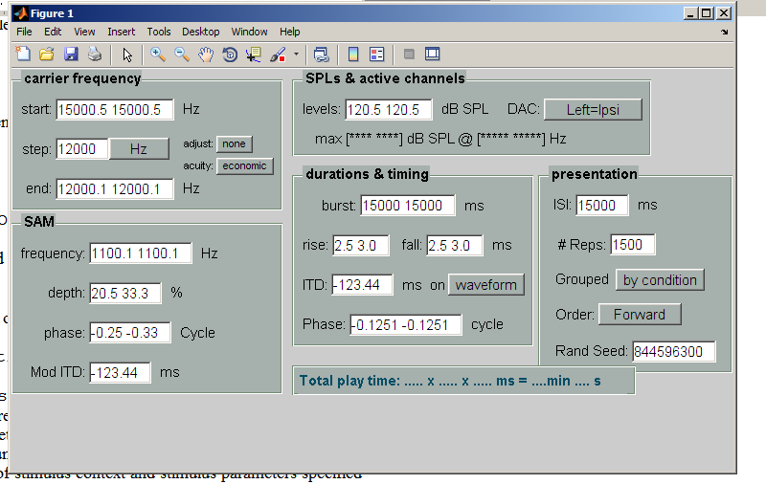

Fig 1. Example of stimulus-specific GUI elements only (generated using draw and stimdefFS output).

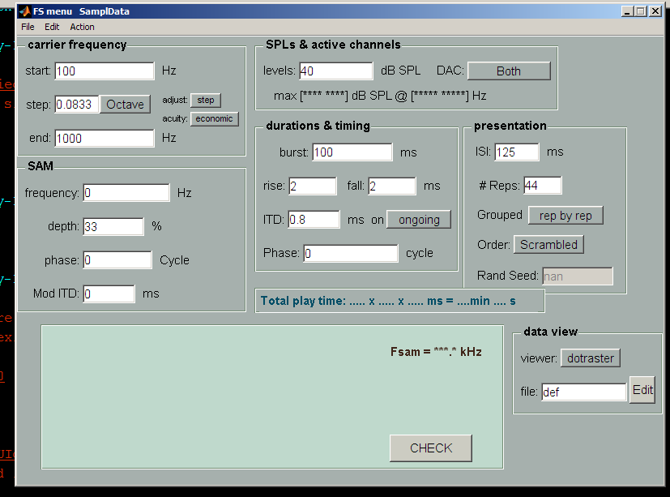

Fig 2. Complete stimulus GUI including generic elements such as the CHECK button (generated by calling stimGUI FS).
Implicitly, The GUI definition provided by stimdefFOO also fixes the set of parameters defining the FOO stimulus, including some constraints on their permitted values. This functionality is fully described in the constructor of the “elementary” GUI building block, paramquery. It is illustrated by calling GUIval after opening the stimulus GUI by calling StimGUI FS (as in Fig 2):

>> stimGUI FS;
>> P = GUIval(gcg)
P =
GUIname: 'FSmenu'
GUIhandle: 0.0034
CreatedBy: {[1x1 function_handle] 'FS' [1x1 experiment]}
i_________Fsweep_______: '_____Fsweep_____'
StartFreq: 100
StartFreqUnit: 'Hz'
StepFreq: 0.0833
StepFreqUnit: 'Octave'
EndFreq: 1000
EndFreqUnit: 'Hz'
AdjustFreq: 'step'
AdjustFreqUnit: ''
FreqTolMode: 'economic'
FreqTolModeUnit: ''
i_________Mod_______: '_____Mod_____'
ModFreq: 0
.....
.....
i_________Pres_______: '_____Pres_____'
ISI: 125
ISIUnit: 'ms'
Nrep: 44
NrepUnit: ''
Grouping: 'rep by rep'
GroupingUnit: ''
Order: 'Scrambled'
OrderUnit: ''
RSeed: 14426688
RSeedUnit: ''
i_________Dataview_______: '_____Dataview_____'
Dataviewer: 'dotraster'
DataviewerUnit: ''
DataviewerParamfile: 'def'
DataviewerParamfileUnit: ''
handle: [1x1 struct]
GUIgrab: [1x1 struct]
z_______________: '_________________'

GUIval returns a struct P. For each “query” displayed in the stimulus GUI, P contains one or more fields reporting the value(s) as specified by the user. For instance, the first edit field in the “carrier frequency” panel produces the pair of fields

StartFreq: 100
StartFreqUnit: 'Hz'

Most of the buttons of the GUI are toggles, which change their string value when clicked. An example is button next to the “Step” edit field in the second line of the “carrier frequency” panel. Clicking it changes its value between ‘Hz’ and ‘Octave’. The current value in Fig. 2 is apparent from the GUIval output field

StepFreqUnit: 'Octave'

For a full example of a stimulus definition, the reader is referred to stimdefFS and the functions called by it, such as FrequencyStepper. Here is a brief list of the functionalities to be implemented in a stimulus definition mfile:

- defining the stimulus parameters (see ParamQuery)
- providing basic constraints on their values (see ParamQuery)
- defining the layout of the GUI (see GUIpanel, GUIpiece/add)
- providing tooltips (see ParamQuery)

Finally, some style recommendations for designing stimulus GUIs:
- group any sets of related stimulus parameters by using panels;
- standardize any functionality shared by multiple GUIs (e.g. SPLpanel);
- use short prompts (note: grouping allows omitting info in individual prompts);
- provide comprehensive parameter descriptions in the tooltips.

3. The makestim mfile

Name. Assuming stimulus name FOO, the name of the stimulus generation mfile is makestimFOO.

Location. Like the stimdef file, the makestim mfile must be located in the stimdefPath.

Content. makestimFOO is a function of a single input argument, P:

function P = makestimFOO(P);

The input parameter P is the struct returned by applying GUIval to the stimulus GUI As described in the previous Section, P contains the parameters values and some additional bookkeeping variables. Using this input, makestimFoo does the following:

- perform detailed validity tests (range, mutual consistency, etc) on the parameters
- provide user feedback on ranges, duration, etc
- compute the actual waveforms to be sent to the D/A
- determine the attenuator settings needed
- provide the bookkeeping for the presentation order of conditions.

In practice this work is typically delegated to helper functions; see makestimFS for an example. Rang testing, reporting, and waveform generation may be interleaved: in some cases, problems involving the validity of parameter values will only surface when actually attempting to compute the waveforms . If a problem occurs, the following two conventions hold:

- the problem-finding function reports the error to the stimulus GUI
- makestimFOO aborts and returns an empty value [].

Here the “problem-finding function” may be one of the helper functions called by the stimulus generator (e.g., maxSPL called by makestimFS), or the makestim function itself. Reporting errors and warnings to the GUI is possible because the input argument P to makestimFOO contains information on the rendered GUI (see makestimFS). Error reporting includes changing the color of any relevant edits to red (see GUImessage).

Output format. The output generated by makestimFOO (apart from messages and warnings) is realized by adding the following fields to the struct P:

- Fsam: stimulus sample rate in Hz
- Waveform: the computed waveforms in an array of waveform objects
- <varied param> holding the the exact values of the varied parameter (e.g. Fcar)
- Presentation: object providing info on stimulus order, reps, etc
- Attenuation: struct providing info on numerical and hardware attenuation

When two parameters are varied (as in RF), there are two fields in P holding the respective sets of values (in RF: Fcar and SPL). The Presentation field is generated by a call (within makestimFOO) to sortConditions. The Attenuation field is generated by a call (within makestimFOO) to maxSPL.

In addition to these obligatory fields, which are used outside makestimFOO, there may be fields added for “internal use”, i.e., within makestimFOO and its helpers. An example is the Duration field for FS stimuli, which is provided by the generic tone generator toneStim (along with the waveforms).

4. The stimparams mfile

Note. Stimuli computed by the generic waveform generators tonestim and noisetim do not require a separate stimparams file. It is only necessary to provide a separate stimparams file when your stimulus generation is not delegated to one of these generic waveform generators.

Name. Assuming stimulus name FOO, the name of the stimulus generation mfile is stimparamsFOO.

Location. Like the other two stimulus files, the makestim mfile must be located in the stimdefPath.

Content. stimparamsFOO is a function of a single input argument, P:

function G = stimparamsFOO(P);

The input parameter P is the struct discussed before, in its final state after calling the makestim file. The output G is a struct with a fixed set of fields and sizes of the fields. The purpose of stimparamsFOO is to provide, in a fixed format, information on the stimuli. This allows generic analysis functions such as dataset/dotraster and dataset/rateplot to extract stimulus information without having to know the exact stimulus. In fact, the information provided by the stimParamsFoo files should make
these generic analysis forward compatible with respect to adding new stimuli.

A detailed list of specs for the stimparamsFOO mfile is provided in the help text of GenericStimparams.

5. Testing a new stimulus.

General. GUI: use short prompts and provide tooltips to all prompts. Waveform calculation: try to use as many generic stimulus tools as possible. This avoids double code and improves maintainability and reliability. For instance, most tonal stimuli should be realizable by only providing a “wrapper” around toneStim. Test as many different values of the stimulus parameters as possible; vary the number of D/A channels and test specifying different values for the two ears where permitted. View the waveforms using the View menu of the stimulus GUI. Listen to the stimulus over headphones; listen for clicks and other artifacts that betray any errors in the waveform calculations.

Tricks: the various stages of the struct P mentioned above may be retrieved as follows. Define a fake experiment for testing. Assuming that your stimdefFOO file works, type stimGUI FOO and provide the stimulus parameters. Make sure that the stimulus GUI is the current Matlab window (the most recent active window). To inspect the values of the parameter in a struct, type

>> P = GUIval(gcg)

This includes basic testing for validity, etc, as specified via stimdefFoo. An empty value will result if any specified parameter fail the tests.

To avoid having to fill in the stimulus parameters over and over, you may store them in a variable by typing

>> TMP = GUIgrab(gcg).

This bypasses any testing and accepts whatever you have typed in the GUI. To later restore those values, type

>> GUIfill(gcg, TMP).

Clicking the CHECK button will spawn a call to your makestimFOO mfile. To inspect the stimulus struct that results from this call, type

>> P = getGUIdata(gcg, ‘StimParam’).

If something goes wrong during the stimulus generation, an empty value will be returned.

As long as you have not provided a StimParamFoo file, Early will provide a warning that it is missing, but still proceed to generate the stimuli, etc. But once you have started writing a StimParamFoo file, it is called whenever you push CHECK or PLAY or REC. This will frustrate generating the stimuli as long StimParamFoo is unfinished or faulty, because any error caused by StimParamFoo will interrupt the stimulus generation. To temporarily restore the stimulus generation, edit StimParamFoo to return the string ‘waiver’ instead of the struct G described in the above. This will disable the interruption of stimulus generation due to problems with generic parameters.

6. Configuring stimulus pushbuttons on the Dashboard.

The collection of stimulus buttons on the Dashboard is configured by the function stimButtonTiling. The color of the buttons are derived from their names.

