Report

GROUP: 5

(SEC1: {Ahmed Mohammed AbdelFattah (25)-Ahmed Mohammed Fawzy (26)-Ahmed Morsy Abbas (29)-Ahmed Hendaway Maher (32)-Adham Mohammed Eid (34)-Eslam Khaled Kamal (37)})

SEC3 :{ Abdullah Hashem Rashad (2)}

RFID Attendance Project

# Overview:

This circuit is simply a counter for attendance of lectures, where each student has an assigned card that he uses on entrance to the lecture.

## Features:

The project has some basic abilities as:

1. A button that display the number of attendance and absent students.
2. A button that display the names of present students.

Also some characteristics as:

1. A timer to stop taking attendance as wanted (ex: after 30 minutes no allowed students to enter).

### Future modifications:

The actions taken after registration of a card can vary as:

1-It can be made to control the door of the lecture hall.

2-A keypad can be added to the circuit, where no attendance can be taken before a specified password entered by the management.

# Explanation:

The circuit works as an embedded system where a code is used to be burned on a microcontroller to carry out the desired procedures.

In this project we used an ATMEGA32 microcontroller programmed by the AVR studio to work as the system we wanted.

**Components:**

1. ATMEGA32 microcontroller.
2. LCD (16*2).
3. RFID module.
4. RFID sensor (coil).
5. IC 555 (timer).
6. Resistances.
7. LEDs.
8. Capacitors.
9. Buttons.
10. Crystal capacitor.
11. A power supply.

**Timer circuit:**

This circuit was made by an IC 555, a resistance and a capacitor.

The delay time given by the circuit depends on the value of the resistance and the capacitor, where

***Delay time=LN (3)*R*C.***

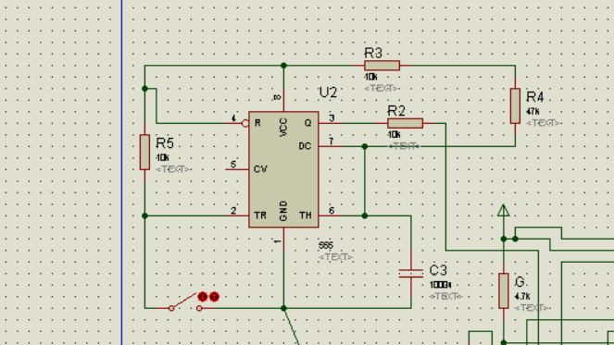

**Procedure:**

When the button of the timer is pushed it start to count and the code starts to run and the RFID cards can start to be registered.

As a card is run the name of the student is displayed, and if a wrong one is registered a red led flashes and a message “Wrong ID” appears on the screen.

At wish, the buttons can be used:

1. switch 1 :( display list of present students).
2. switch 2 :( displays number of present and absent students).

After the time of timer set to count the code is stopped and no more cards are allowed to enter.

switch 3: (timer button)

# Instruction:

To make it works, do as follows:

1. Close switch 3 then open it.
2. Open virtual terminal ,and start registering the ID cards (2014,2015,2016,2017,2018,2018,2019,2020)(any other code is invalid)
3. Wait for one minute and the circuit will not accept any code again.
4. Then you can use one of the switches (switch 1or switch 2).
5. That’s all THANK YOU.

# Simulation:

This is the simulation of the hardware of the circuit.

This is it working on entering one of the assigned cards of students.

This when an invalid card id entered.

This when display button 2 is pressed:

Absent number.

Present number

Displaying list of present students

(Ex. only one present)

PCB Design:

## Programs used:

1. Proteus (ISIS –ARES).
2. Atmel studio.
3. Microsoft word.