ATmega32:
The high-performance, low-power Microchip 8-bit AVR RISC-based microcontroller combines 32KB ISP flash memory with read-while-write capabilities, 1KB e, 2KB SRAM, 54/69 general purpose I/O lines, 32 general purpose working registers, a JTAG interface for boundary-scan and on-chip debugging/programming, three flexible timer/counters with compare modes, internal and external interrupts,serial programmable USART, a universal serial interface (USI) with start condition detector, an 8-channel 10-bit A/D converter, programmable watchdog timer with internal oscillator, SPI serial port, and five software selectable power saving modes. The device operates between 1.8-5.5 volts.
By executing powerful instructions in a single clock cycle, the device achieves throughputs approaching 1 MIPS per MHz, balancing power consumption and processing speed.

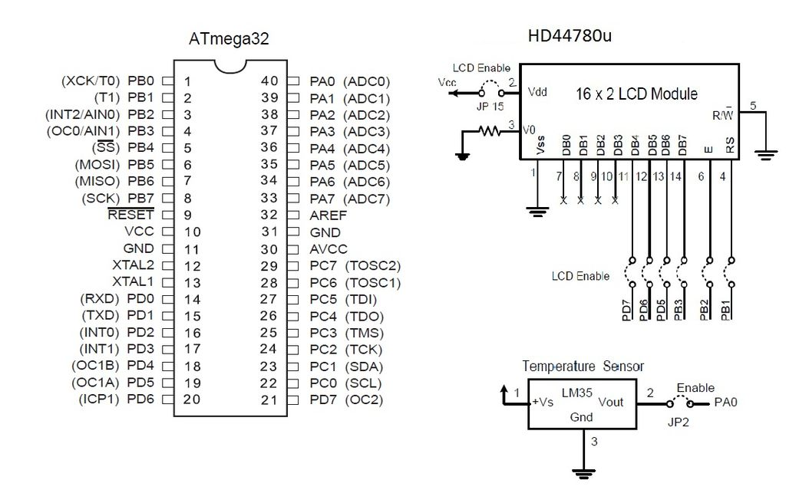
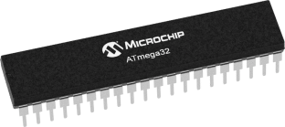

Data sheet for atmega32

liquid-crystal display (LCD):

A liquid-crystal display is a flat-panel display or other electronically modulated optical device that uses the light-modulating properties of liquid crystals. Liquid crystals do not emit light directly, instead using a backlight or reflector to produce images in colour or monochrome.LCDs are available to display arbitrary images (as in a general-purpose computer display) or fixed images with low information content, which can be displayed or hidden, such as preset words, digits, and 7-segment displays, as in a digital clock. They use the same basic technology, except that arbitrary images are made up of a large number of small pixels, while other displays have larger elements.

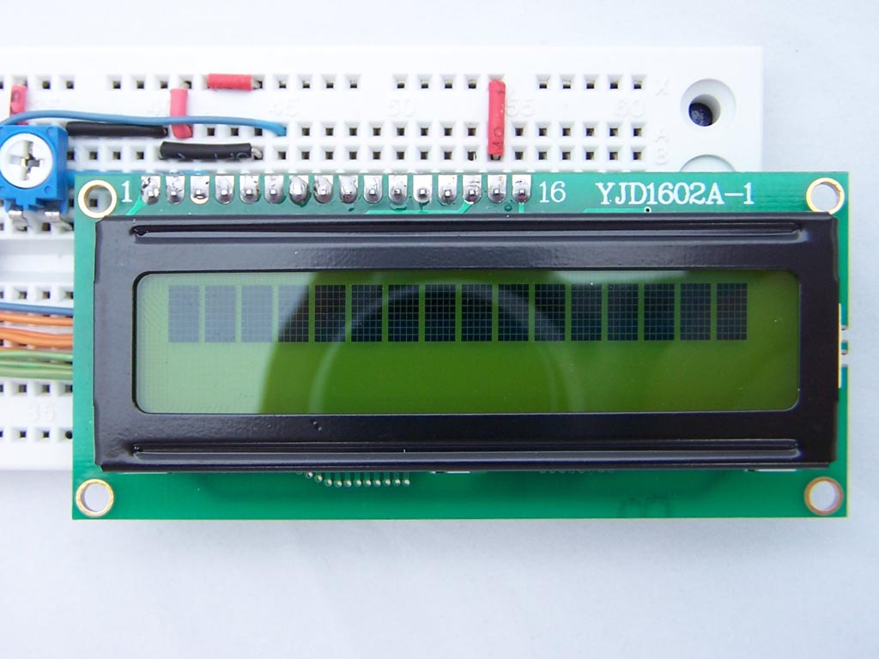
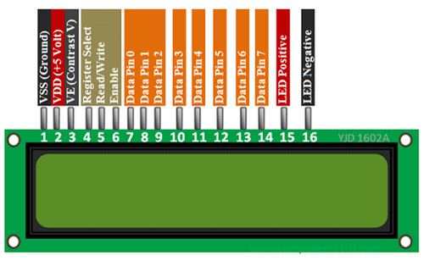

555 timer IC :
The 555 timer ic is an integrated circuit (chip) used in a variety of timer, pulse generation, and oscillator applications. The 555 can be used to provide time delays, as an oscillator, and as a flip-flop element. Derivatives provide two (556) or four (558) timing circuits in one package.
Introduced in 1972 by Signetics,the 555 is still in widespread use due to its low price, ease of use, and stability. It is now made by many companies in the original bipolar and in low-power CMOS technologies. As of 2003, it was estimated that 1 billion units were manufactured every year. The 555 is the most popular integrated circuit ever manufactured.
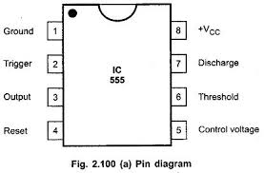
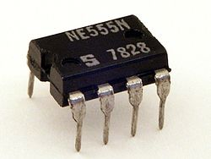
X

RFID:

RFID stands for Radio Frequency Identification. RFID is a basic technology that allows the identification of a device (read tag / sticker / label) to be read wirelessly by a reader (RFID reader) using radio frequency. The Tag contains a small IC containing the unique identity information. The IC is attached to an antenna which transmits its identity to a reader when it detects a reader. It detects a reader by detecting the electromagnetic energy produced by the reader. The unique identity information is transmitted as radio frequencies. The reader then converts the received radio frequencies into the identity data. Most RFID readers provide a serial interface for connecting to a microcontroller. Some of the readers also provide another interface called the Weigand Interface. The RFID Card Readers can be used in a wide variety of hobbyist and commercial applications, including access control, automatic identification, robotics navigation, inventory tracking, payment systems, and car immobilization. In this project we will use EM-18 RFID Reader. EM-18 is a 125 KHz RFID Reader module and comes with both Serial and Weigand interfaces. In serial interface, the EM-18 RFID Reader provides a 12 byte data when it reads any RFID tag.

