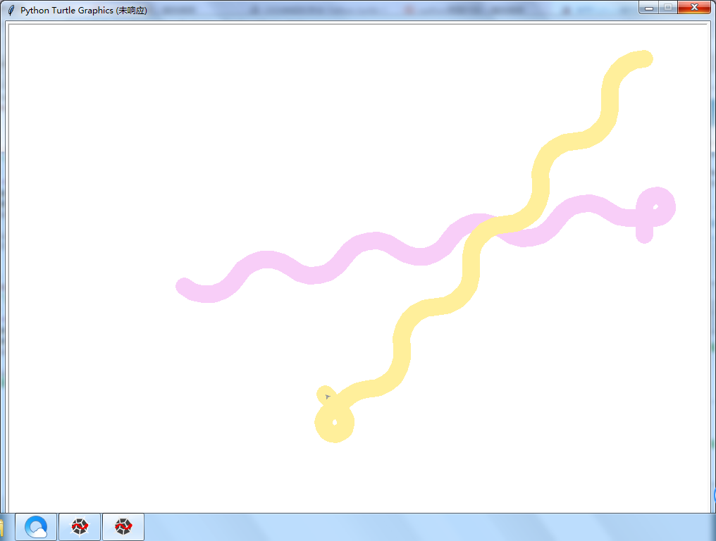

两条一起玩耍的蟒蛇

from turtle import \*

setup(1000,1500,100,0)

penup()

fd(-250)

pendown()

pensize(25)

pencolor("violet")

seth(-40)

for i in range(4):

circle(50,100)

circle(-50,100)

circle(40,80/2)

fd(40)

circle(16,270)

fd(40 \* 1)

penup()

fd(-250)

pendown()

pensize(25)

pencolor("gold")

seth(180)

for i in range(4):

circle(50,100)

circle(-50,100)

circle(40,80/2)

fd(40)

circle(16,270)

fd(40 \* 1)