Marcos Hernandez
CSD-325
4/12/2026
Assignment 4.2

Flow chart
Structure it like this:
Start
↓
Open CSV File
↓
Read Weather Data
↓
Extract Dates and High Temperatures
↓
Store Data in Lists
↓
Create Graph
↓
Plot High Temperatures
↓
Display Graph
↓
End

1.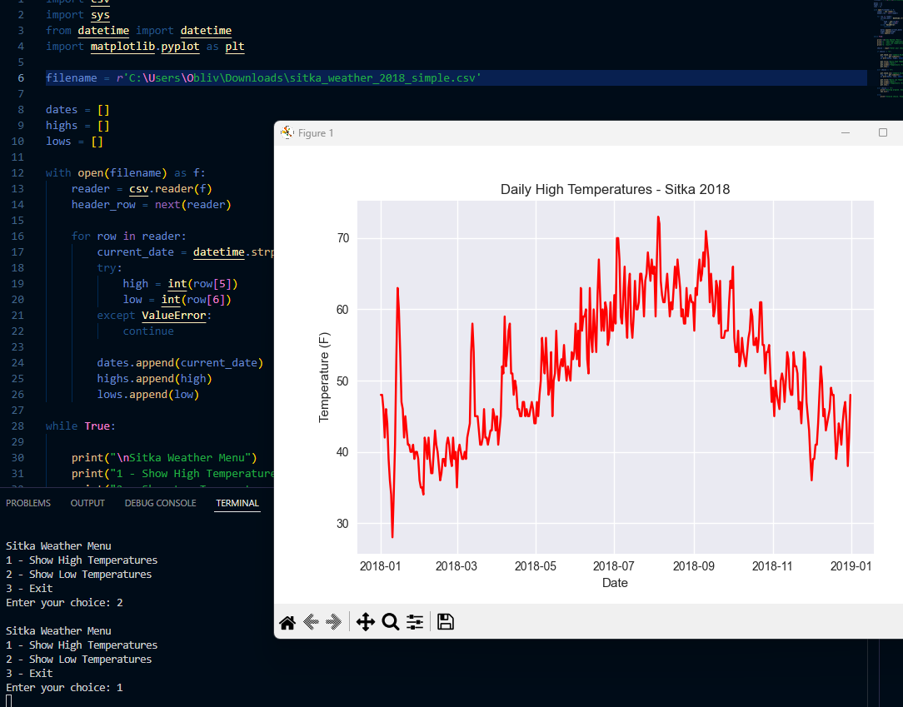
2.
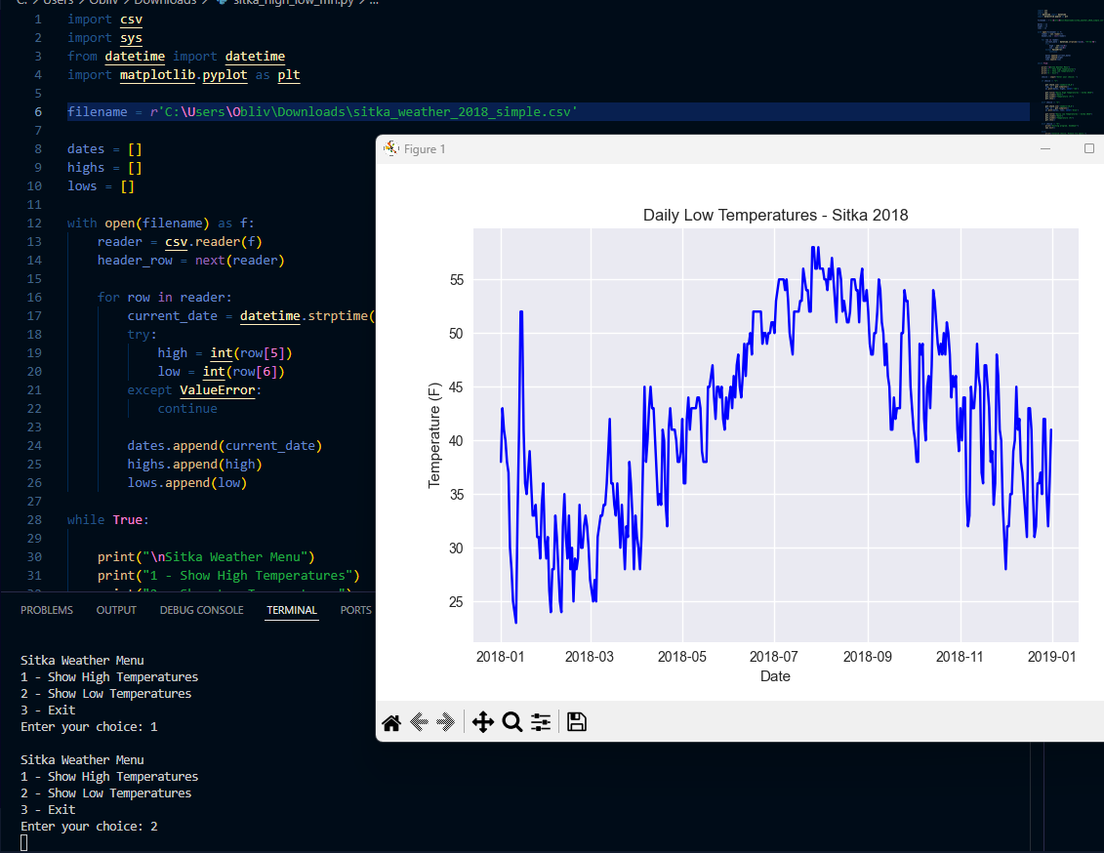

Revised flowchart
Start
↓
Load CSV Weather File
↓
Extract Dates, Highs, and Lows
↓
Display Menu
Highs | Lows | Exit
Decision: User Choice?
If Highs
→ Plot High Temperature Graph (Red)
→ Return to Menu
If Lows
→ Plot Low Temperature Graph (Blue)
→ Return to Menu
If Exit
→ Display Exit Message
→ End Program

