Final Report: Smart Fruit Decay Monitoring System
1. Introduction & Background
Fruits continue to release gases even after being harvested. As they ripen and decay, they emit ethylene (C₂H₄) and methane (CH₄), gases that directly indicate freshness levels. High ethylene concentration speeds up ripening, and if left unchecked in storage areas, it can cause entire batches to spoil faster. But in this Experiment we not only focus on these two specific gasses but also on combinations of gasses which found during decay of fruits. Detecting these gases early is important to reduce food waste and economic loss in markets and storage facilities.
Traditionally, fruit quality is judged by appearance or smell, methods that are manual, slow, and inaccurate. This motivated the idea of building a low-cost, automated system that can continuously monitor gas emissions and environmental conditions around fruits. The aim was to detect early signs of decay using gas sensors (MQ2 and MQ4) along with temperature, humidity, and pressure sensors (DHT22 and BMP280). A DS3231 RTC provided accurate timestamps, and a GPS module added location data for traceability.
In the first phase, the system used Bluetooth Low Energy (BLE) communication. An Arduino Mega 2560 collected sensor readings, formatted them into structured records, and sent them through an HM-10 BLE module to an ESP32 receiver. The Mega also saved each record to an SD card for backup. To make communication reliable, a custom protocol with sequence numbers, CRC checking, and acknowledgment (ACK) was implemented, so no data was lost even if wireless interference occurred. The ESP32 acted as a BLE central device, verifying each record and forwarding it to a local server via HTTP POST requests for data logging and analysis.
This BLE version successfully achieved real-time data transfer, but required a constant power supply and stable connection. In closed environments like our fruit decay experiment box, the BLE signal sometimes weakened or dropped, leading to data gaps. To solve this, the second phase introduced NFC (Near Field Communication) for offline data retrieval. Here, the Arduino wrote the latest readings to an NFC tag using a PN532 module. Later, another Arduino with a PN532 reader could simply tap near the tag to read all data instantly, no continuous power or wireless link needed.
Finally, a sealed banana decay box was built to test the system. The sensors recorded MQ2 and MQ4 readings over time as the bananas ripened and spoiled. The data showed clear trends, gas levels rising during ripening and peaking before decay, proving the system could effectively track fruit freshness.
In summary, this project combines sensor technology, embedded systems, and wireless communication to create a smart, low-cost solution for early fruit decay detection, first using BLE for live monitoring, and later NFC for simple, power-efficient data access.
2. Phase 1: BLE-Based System
In the first development phase, the system was designed around Bluetooth Low Energy (BLE) communication to achieve real-time wireless data transfer between the sensing unit and a monitoring server. The setup used an Arduino Mega 2560 as the main data-acquisition and transmission node, an HM-10 BLE module for short-range wireless transfer, and an ESP32 as the receiver and gateway to the server.
The overall flow was:
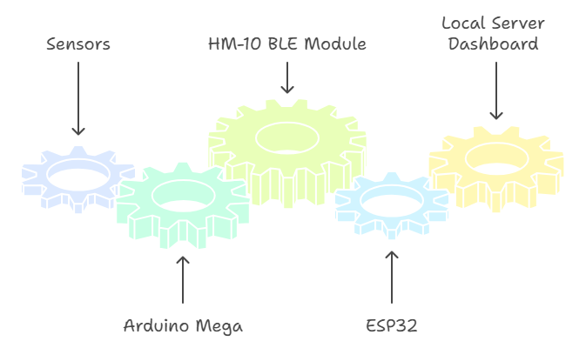
2.1 System Overview
The Arduino Mega continuously collects data from multiple sensors:
- MQ-2 for ethylene or general hydrocarbon gases,
- MQ-4 for methane,
- DHT22 for temperature and humidity,
- BMP280 for air pressure,
- GPS module for location,
- DS3231 RTC for accurate timekeeping.
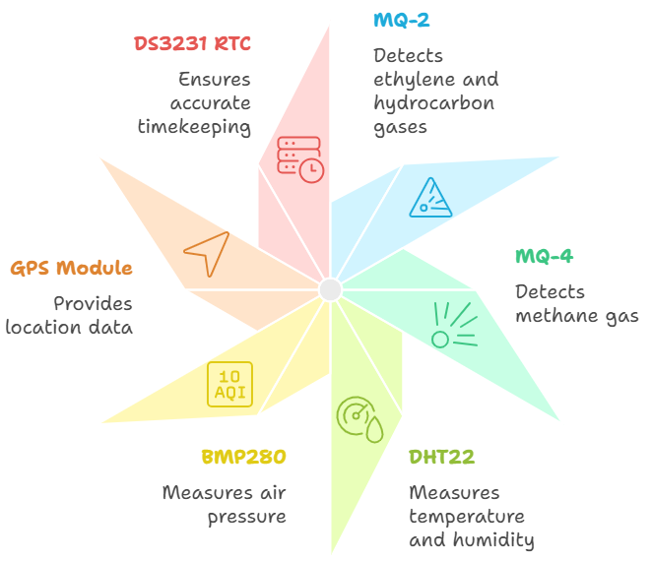
Every interval (millisecond time interval is set by us, for example: 30 seconds, 1 minute, or 10 minutes.), the Mega reads all sensors, converts the analog voltages into meaningful physical values (ppm, °C, % RH, hPa), and tags the readings with a precise UTC timestamp. The readings are stored locally on an SD card in a human-readable CSV file (datalog.csv).
Once a record is ready, the Mega sends it over BLE through the HM-10 module to the ESP32.
To make sure no packet is ever lost, a custom reliable-transfer protocol was implemented.
Each data frame contains:
- a fixed header,
- length and sequence number,
- the data payload (sensor record),
- a CRC checksum for error detection.
The Arduino waits for an ACK (acknowledgment) from the ESP32 after sending each frame.
If the ACK is not received within a short timeout, it automatically retries up to several times.
2.2 Sender Side (Arduino Mega + HM-10)
The sender acts as the brain of the system. It performs the following sequence:
- Measure: Read all sensors (MQ-2, MQ-4, DHT22, BMP280, IR, GPS).
- Timestamp: Get the exact time from the RTC; if GPS time becomes valid, it automatically corrects the RTC to true UTC.
- Store: Save readings both as text (CSV) and as a binary record in SD card for backup.
- Transmit: Package the same record, add header, sequence number, and CRC and send through HM-10.
- Confirm: Wait for ACK from ESP32; if not received, retry.
- Sync on request: When the ESP32 sends a “REQ” command, the Arduino streams all stored .bin files so any missed data can be recovered later.
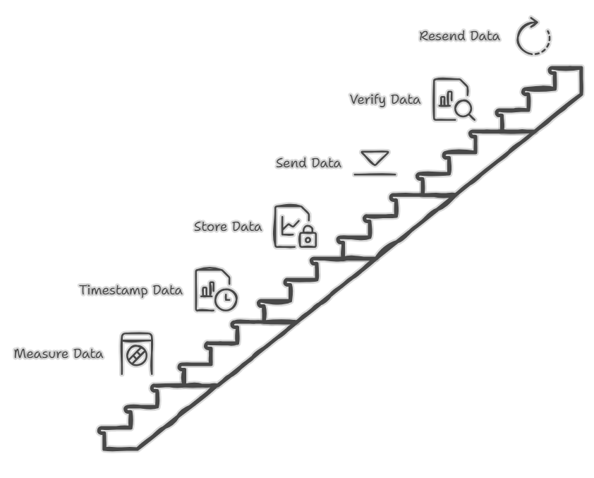
2.3 Receiver Side (ESP32 BLE Central)
The ESP32 operates as the central device in BLE mode. It automatically scans nearby peripherals, detects the HM-10 module, and establishes a connection.
Once connected, it enables notifications, allowing the HM-10 to push data in real time.
Incoming data arrives in small 20-byte pieces. The ESP32:
- Reassembles them into complete frames,
- Verifies the CRC checksum to confirm integrity,
- Sends an ACK containing the correct sequence number back to the sender,
- Parses the payload into a structured record (timestamp, lat/lon, gas values, temperature, humidity, etc.),
- Publishes it to a local Flask web server through an HTTP POST request in JSON format.
The web dashboard (like the one you designed—showing “Device Status,” “Temperature,” “Humidity,” “Gas Levels,” etc.) instantly updates whenever a new record arrives. Here’s is our local server dashboard
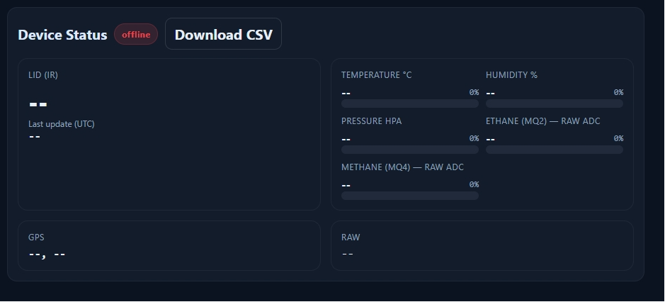
If a packet fails CRC validation, the ESP32 ignores it and waits for the sender’s retry, maintaining data accuracy.
2.4 BLE Working Explanation
The complete BLE data cycle can be summarized as:
- Sensor Reading: Arduino samples all connected sensors.
- Data Framing: It packs the readings with timestamp, sequence, and CRC.
- Transmission: The HM-10 sends the frame to the ESP32 in small BLE chunks.
- Acknowledgment: The ESP32 checks CRC and replies with the same sequence number to confirm success.
- Logging & Display: On receiving valid data, ESP32 posts it to the local server, which logs and visualizes it in real-time.
Three Liner Explaination:
The Arduino Mega collects and timestamps all sensor data, then reliably sends it through HM-10 BLE to an ESP32, which confirms every packet and uploads it to a web dashboard.
If any packet is lost, the system automatically resends it or allows the ESP32 to request old files.
3. Phase 2: NFC-Based System Integration
To make the system low-power and independent of any live (Wifi) wireless link, we integrated NFC. Unlike BLE (which needs two active radios), the NFC path lets the sensor node sleep at microamp levels and only wake long enough to write data when a tag is presented. This enables offline data pickup: a user taps a tag to pull the latest and historical summaries without any pairing, Wi-Fi.
3.1 Motivation
- Power saving: The PN532 (NFC module) stays in a light standby (~10 µA) with RF (Radio Frequency) detector enabled. When a passive tag is brought near, it wakes, writes at ~60 mA for a brief moment, then goes back to standby. The rest of the node can also sleep between samples, so average current is tiny.
- Offline data transfer: No BLE link, no phone/ESP32 dependency. Just tap a tag to carry the data.
- Simplicity & robustness: No pairing, no signal issues; taps are deterministic and quick.
3.2 NFC Sender (Writer)
Hardware: Arduino UNO + MQ2, MQ4, DHT22, PN532.
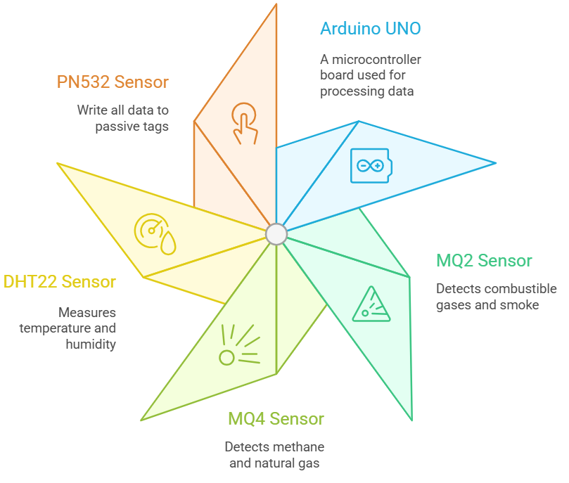
Sampling: Period set by us e.g., 30 s / 1 min / 10 min (or any ms interval).
What we record and store to the NFC passive tag (latest snapshot + dailies):
- Start date/time (when the experiment began).
- Latest/Now date/time (time of the most recent valid sample).
- Starting MQ2/MQ4 values (baseline at start).
- Latest MQ2/MQ4 values (most recent value).
- Daily checkpoints: MQ2/MQ4 values saved additionaly every 24 hours labeled Day 1, Day 2, … (to notice or just a quick view how much values changes).
- SD card Integration: Also append all the sensor values after every sampling in the SD card for backup.
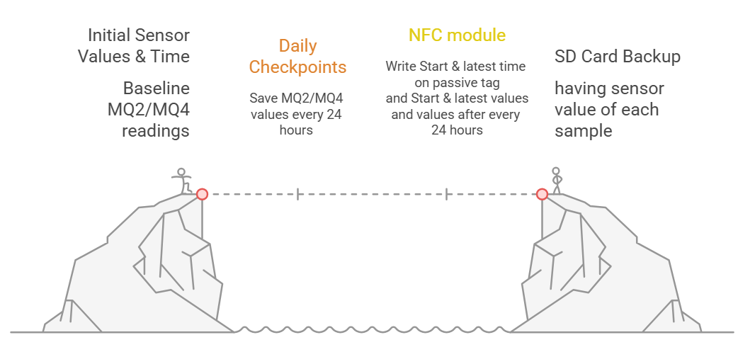
How it works at runtime:
- UNO samples MQ2/MQ4/DHT22 on the chosen interval and keeps the current record in RAM/EEPROM also append in SD card.
- PN532 (nfc module) sits in RF-detect standby.
- When any passive MIFARE (a series of integrated circuit (IC) chips used in contactless smart cards) 1K tag is presented, the writer:
  - Authenticates the target sector(s),
  - Writes the current “latest snapshot” (start/now times, start/latest MQ2/MQ4, and DHT22 values),
  - Updates/maintains the per-day entries (Day 1, Day 2, …),
  - Returns to standby.

Tag memory model (MIFARE Classic 1K):
- Total 1024 bytes = 64 blocks × 16 bytes.
- We use data blocks only (e.g., blocks 1–10 for the summary string; additional blocks for Day-entries).
- Write data on Passive tag like:
  - Blocks 1–10: Header & summary
    - Start: YYYY-MM-DD HH:MM:SS
    - Now: YYYY-MM-DD HH:MM:SS
    - MQ2_start / MQ4_start, MQ2_now / MQ4_now, Temp, Hum%
  - Blocks 8–15: Daily checkpoints (compact fixed-width fields like 1D:M2=x; M4=y\n, etc.) and then in last line all read data printed.
One LINER: the UNO measures; the PN532 only wakes to burn the latest facts into the tag when it “sniffs” a tag nearby then sleeps again.
3.3 NFC Reader (Receiver)
Hardware: A second Arduino + PN532 + 1.3″ I²C OLED.
Behavior:
- When a tag is tapped, the reader authenticates and reads the specific blocks we use.
- It reconstructs the full message and prints everything on the serial monitor (including all per-day entries).
- Read data from Passive tag also in same manner and print on Serial Moniter:
  - Blocks 1–8: Header & summary
    - Start: YYYY-MM-DD HH:MM:SS
    - Now: YYYY-MM-DD HH:MM:SS
    - MQ2_start / MQ4_start, MQ2_now / MQ4_now.
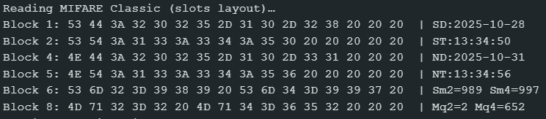
  - Blocks 9–15: Daily checkpoints (compact fixed-width fields like 1D:M2=x; M4=y\n, etc.) and then in last line all read data printed.
- On the OLED (limited space), it shows the key summary only:
  - Start time & date
  - Now time & date
  - Start MQ2/MQ4
  - Latest MQ2/MQ4
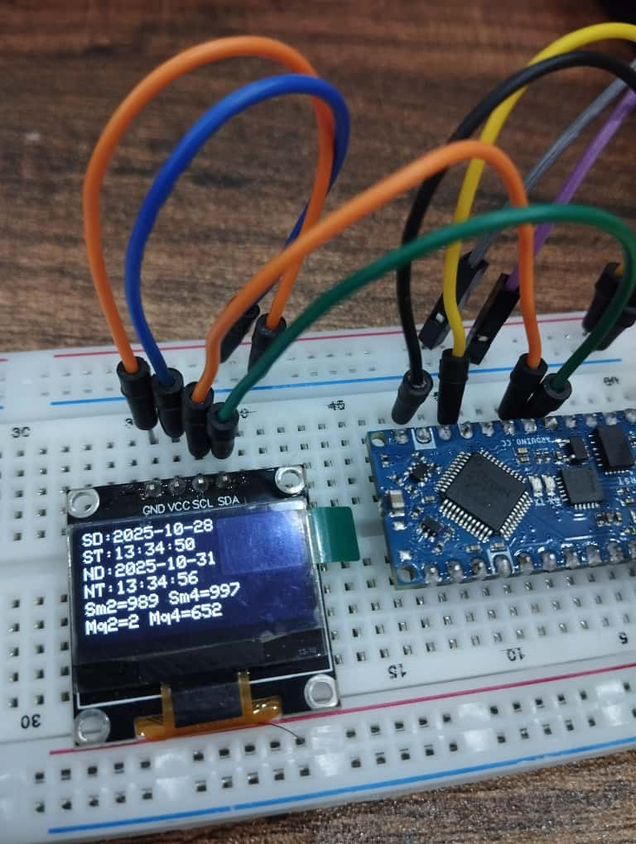
This gives a quick glance on the OLED, with the complete details available over serial.
3.4 NFC Working Explanation
End-to-end flow (write → read):
- Measure loop (UNO): MQ2/MQ4/DHT22 sampled on schedule; “Start” locked at T0; “Now” updated each cycle; daily checkpoint stored every 24 h.
- Wait for tag: PN532 idle with RF detector (~10 µA).
- Tag presented: PN532 wakes; writer updates blocks (summary + relevant daily entries) in a burst (~60 mA momentarily); back to standby.
- Read side: Reader PN532 authenticates the same blocks, reads & reconstructs the string/data, prints all on serial, and shows summary on OLED.
- Repeat: Tap any time to pull a fresh snapshot without ever turning on a radio.
BLE vs NFC (in this project):
- Speed/live view: BLE streams continuously to a server (good for dashboards). NFC gives snapshots on demand.
- Power: BLE keeps the radio alive on both ends; NFC tag is passive; writer’s PN532 sleeps until a tap, huge battery life win.
- Workflow: BLE is “always-on monitoring”; NFC is “walk-up, tap, and take the latest + dailies”.
- Complexity: BLE needs pairing and error-handling; NFC is simpler and deterministic.
4. Experimental Setup
4.1 Decay Box Experiment
To validate the Smart Fruit Decay Monitoring System, two complete rounds of laboratory experiments were carried out.
In each round, the sensing module MQ-2 + MQ-4 + DHT22 was placed inside a small sealed box containing ripe bananas connected with Arduino. The box created a storage environment where gases released during ripening could accumulate naturally. Temperature and humidity were monitored to understand their influence on gas buildup.
Each measurement cycle was automatically taken at a 10-minute sampling interval, controlled in code. The Arduino converted every analog reading to gas concentration using calibration formulas and stored time-stamped values. The main aim was to study how gas emission evolved as bananas ripened and decayed.
4.2 Data Collection Process
Each round contained three distinct experiments, repeated twice for consistency.
Round 1:
Experiment 1
- Y-axis (PPM): Parts per million; higher ppm = more target gas.
- Pipeline: ADC → Vout → Rs = RL·(5−Vout)/Vout → (Rs/R0) → PPM.
- Terms: Rs = sensor resistance (drops with more gas); R0 = clean-air baseline (from calibration); RL = fixed load resistor.
- Meaning: Rs/R0 shows overall gas effect (mixture). PPM is a per-gas estimate using a fitted curve.
- Curves used:
MQ-2 ≈ 50·(Rs/R0)^−2.3 (hydrocarbons/Ethylene);
MQ-4 ≈ 1000·(Rs/R0)^−2.95 (Methane).
- Reading the graph: More gas → lower Rs/R0 → higher ppm. Peaks = gas bursts; flat/low = clean or stable air.
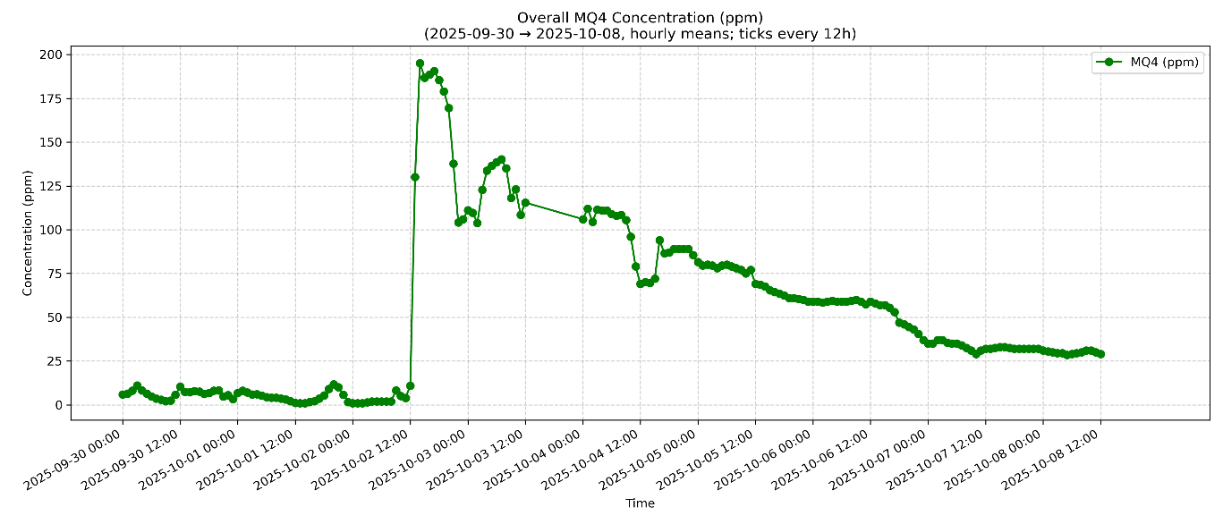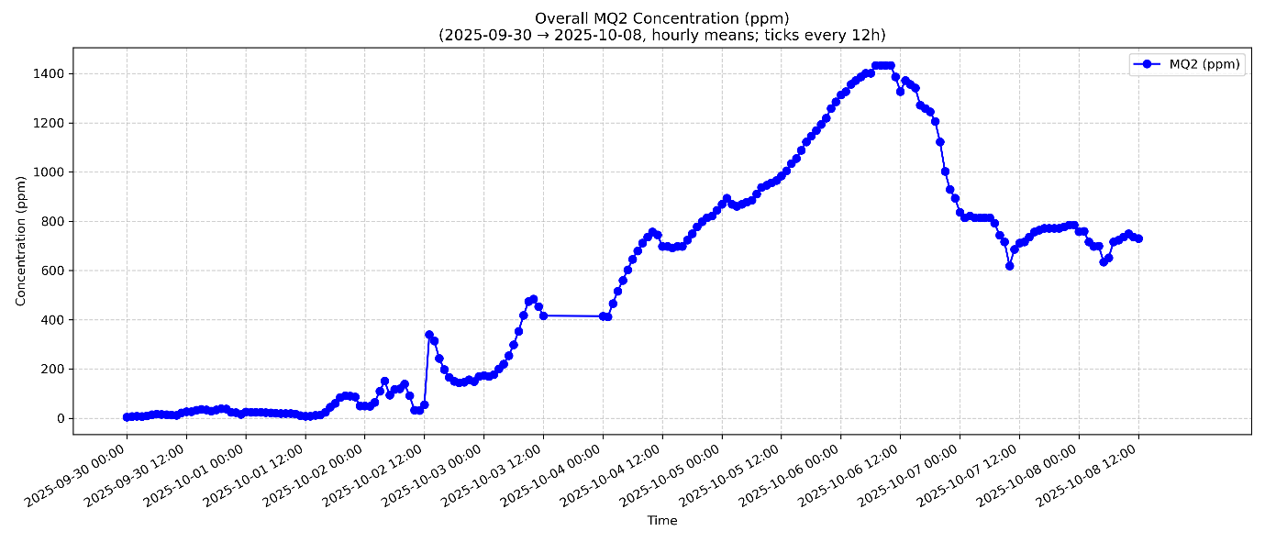
Experiment 2
- Y-axis (PPM): Parts per million; higher ppm = more target gas.
- Pipeline: ADC → Vout → Rs = RL·(5−Vout)/Vout → (Rs/R0) → PPM.
- Terms: Rs = sensor resistance (drops with more gas); R0 = clean-air baseline (from calibration); RL = fixed load resistor.
- Meaning: Rs/R0 shows overall gas effect (mixture). PPM is a per-gas estimate using a fitted curve.
- Curves used:
MQ-2 ≈ 50·(Rs/R0)^−2.3 (hydrocarbons/Ethylene); MQ-4 ≈ 1000·(Rs/R0)^−2.95 (Methane).
- Reading the graph: More gas → lower Rs/R0 → higher ppm. Peaks = gas bursts; flat/low = clean or stable air.
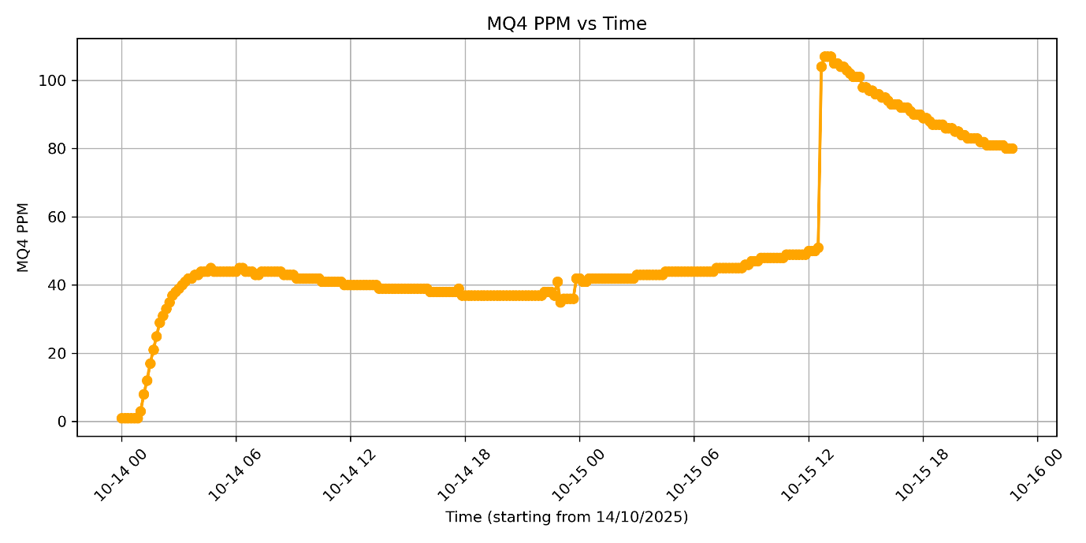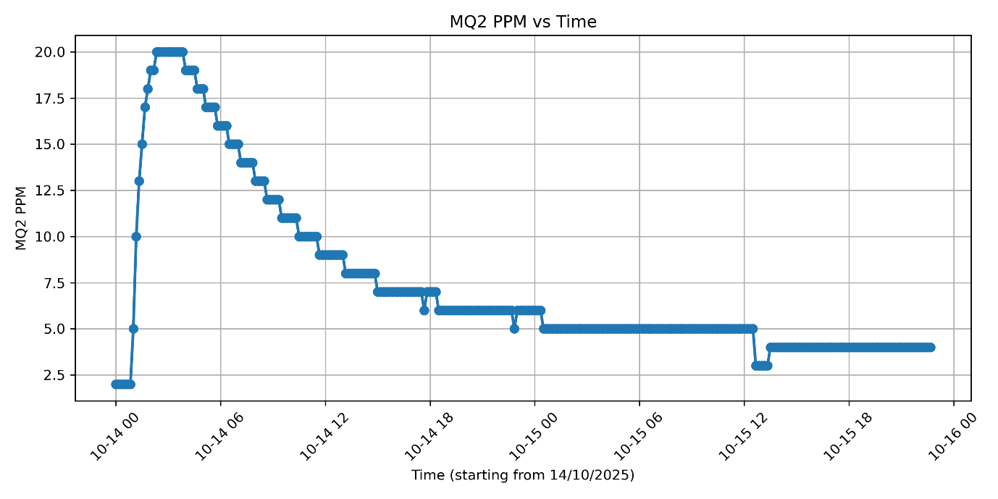
Experiment 3 – Combined Gas Effect (Gas Index 0–100)
- Y-axis (Gas Index 0–100): Higher index = more target gas.
- Pipeline: ADC → Vout → Rs = RL·(5/Vout − 1) → (Rs/R0) → GasIndex.
- Terms: Rs = sensor resistance (drops with more gas); R0 = clean-air baseline (from calibration); RL = fixed load resistor.
- Meaning: Rs/R0 captures overall gas effect (mixture). GasIndex is a normalized, human-friendly scale (not gas-specific ppm).
- Normalization mapping:
Rs/R0 ≥ 1.0 → GI = 0 (fresh air)
Rs/R0 ≈ 0.6 → GI ≈ 40
Rs/R0 ≈ 0.3 → GI ≈ 80
Rs/R0 ≤ 0.1 → GI = 100
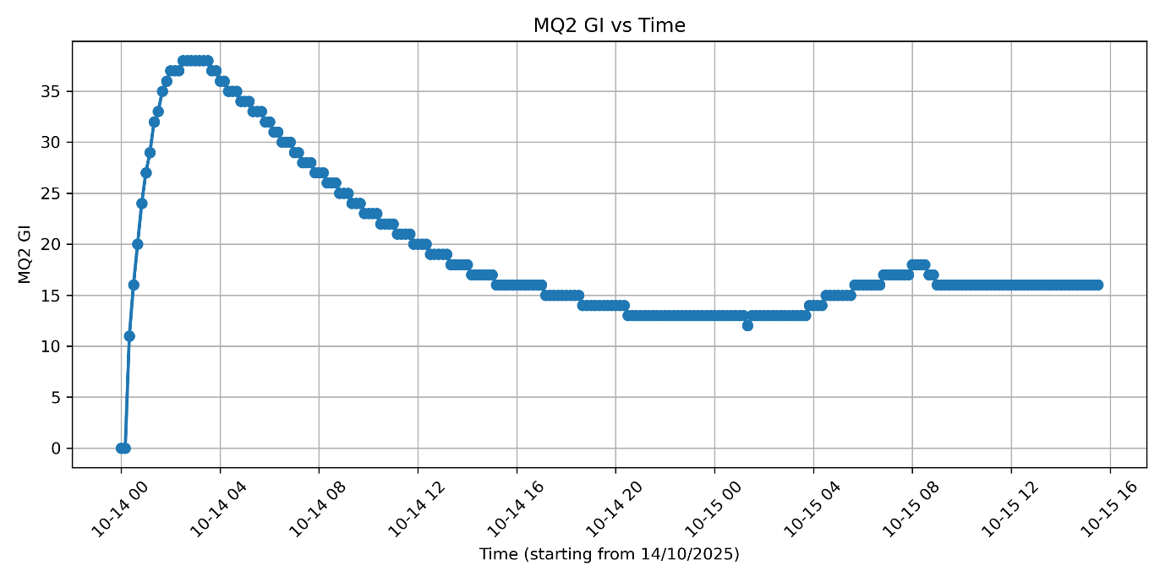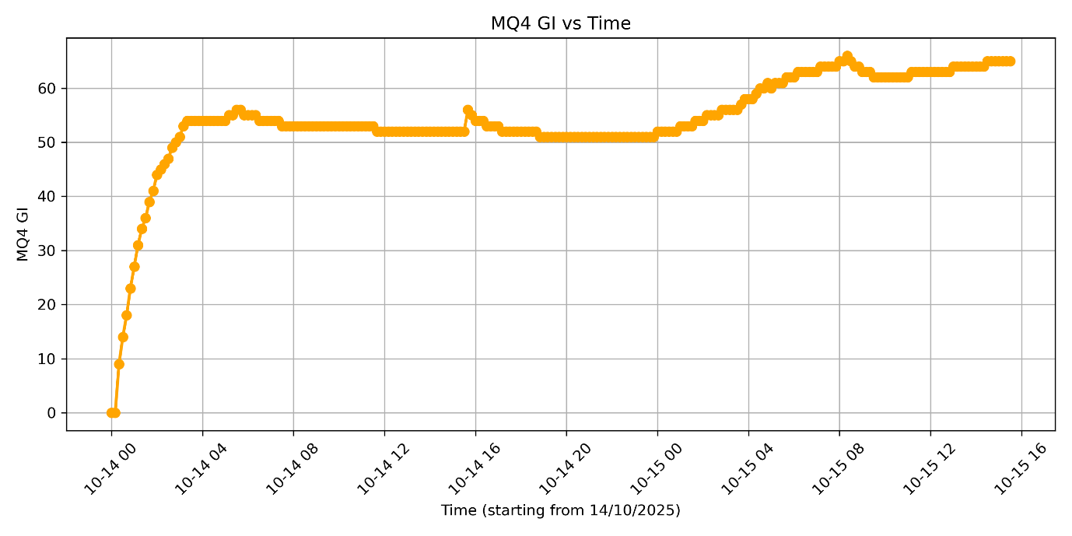Round 2:
Experiment 1
- Y-axis (PPM): Parts per million; higher ppm = more target gas.
- Pipeline: ADC → Vout → Rs = RL·(5−Vout)/Vout → (Rs/R0) → PPM.
- Terms: Rs = sensor resistance (drops with more gas); R0 = clean-air baseline (from calibration); RL = fixed load resistor.
- Meaning: Rs/R0 shows overall gas effect (mixture). PPM is a per-gas estimate using a fitted curve.
- Curves used:
MQ-2 ≈ 50·(Rs/R0)^−2.3 (hydrocarbons/Ethylene);
MQ-4 ≈ 1000·(Rs/R0)^−2.95 (Methane).
- Reading the graph: More gas → lower Rs/R0 → higher ppm. Peaks = gas bursts; flat/low = clean or stable air.
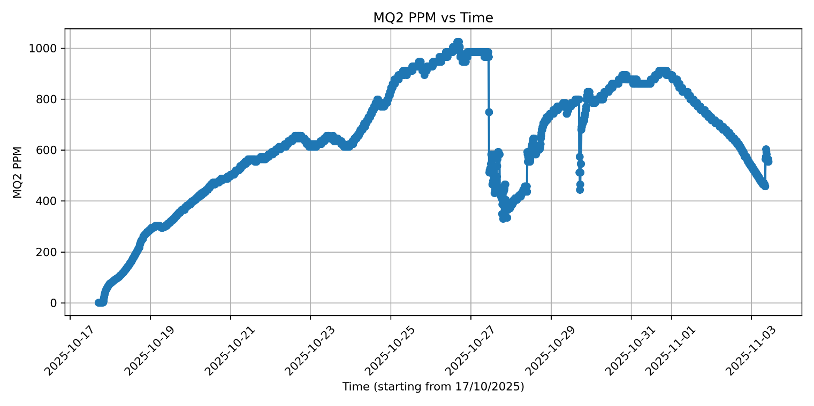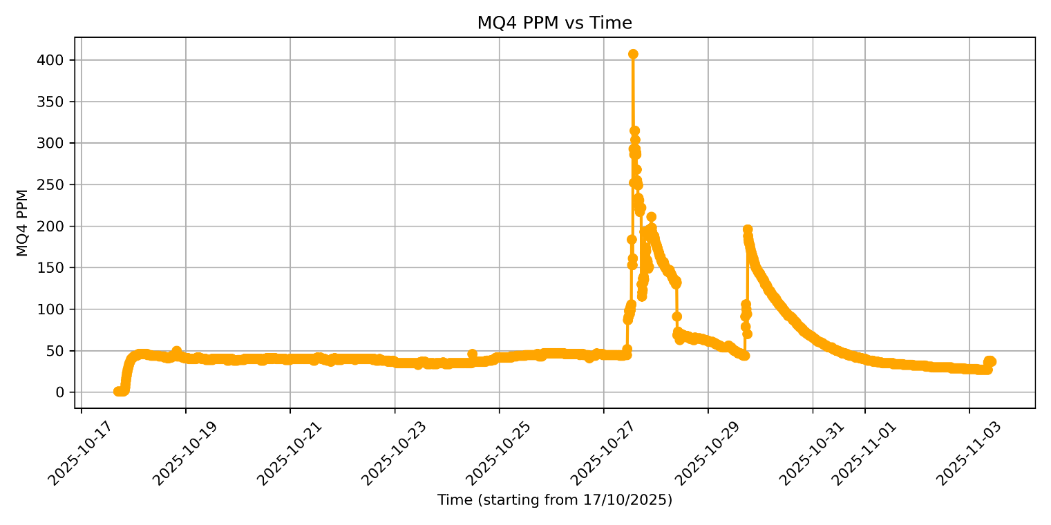
Experiment 2
- Y-axis (PPM): Parts per million; higher ppm = more target gas.
- Pipeline: ADC → Vout → Rs = RL·(5−Vout)/Vout → (Rs/R0) → PPM.
- Terms: Rs = sensor resistance (drops with more gas); R0 = clean-air baseline (from calibration); RL = fixed load resistor.
- Meaning: Rs/R0 shows overall gas effect (mixture). PPM is a per-gas estimate using a fitted curve.
- Curves used:
MQ-2 ≈ 50·(Rs/R0)^−2.3 (hydrocarbons/Ethylene); MQ-4 ≈ 1000·(Rs/R0)^−2.95 (Methane).
- Reading the graph: More gas → lower Rs/R0 → higher ppm. Peaks = gas bursts; flat/low = clean or stable air.
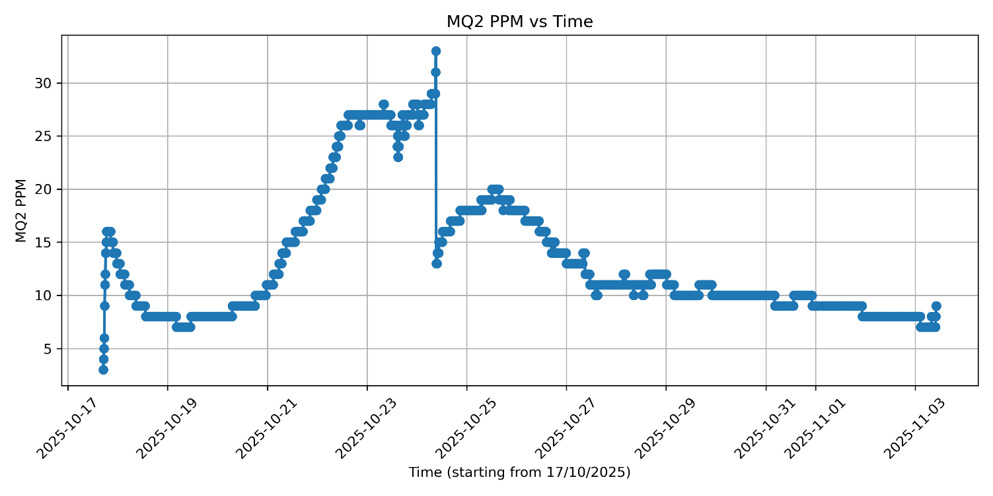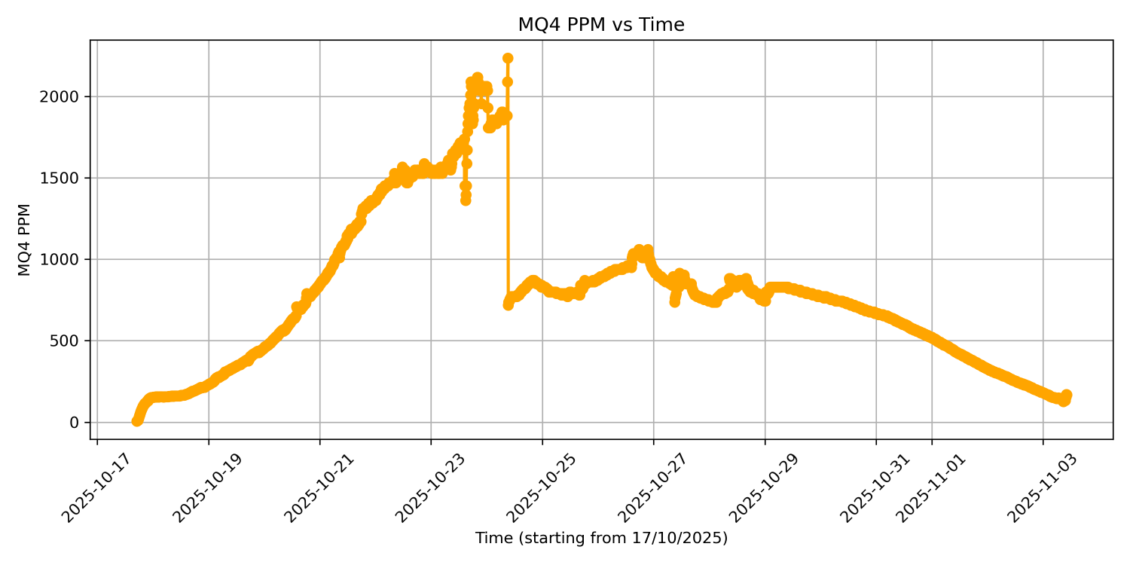

Experiment 1 & 2 Combine:
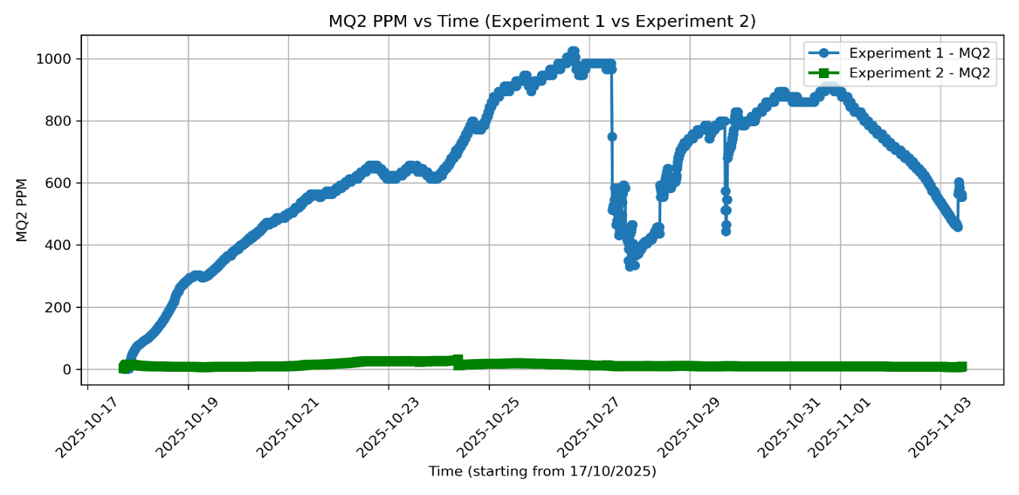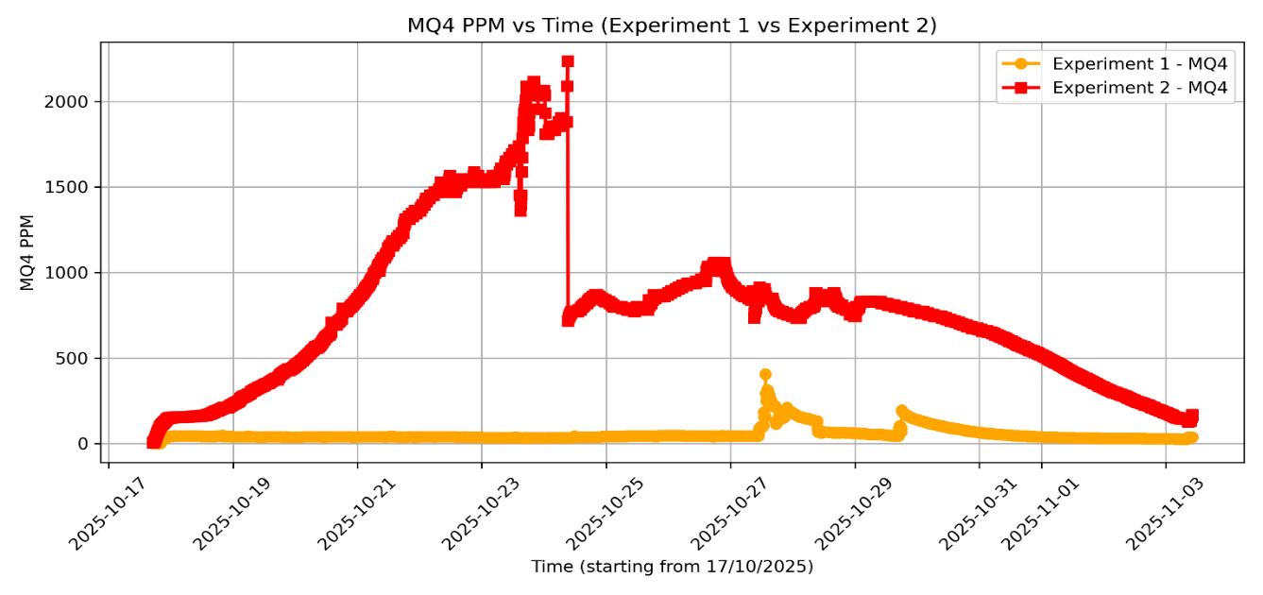
Experiment 3: Combined Gas Effect (Gas Index 0–100)
- Y-axis (Gas Index 0–100): Higher index = more target gas.
- Pipeline: ADC → Vout → Rs = RL·(5/Vout − 1) → (Rs/R0) → GasIndex.
- Terms: Rs = sensor resistance (drops with more gas); R0 = clean-air baseline (from calibration); RL = fixed load resistor.
- Meaning: Rs/R0 captures overall gas effect (mixture). GasIndex is a normalized, human-friendly scale (not gas-specific ppm).
- Normalization mapping:
Rs/R0 ≥ 1.0 → GI = 0 (fresh air)
Rs/R0 ≈ 0.6 → GI ≈ 40
Rs/R0 ≈ 0.3 → GI ≈ 80
Rs/R0 ≤ 0.1 → GI = 100
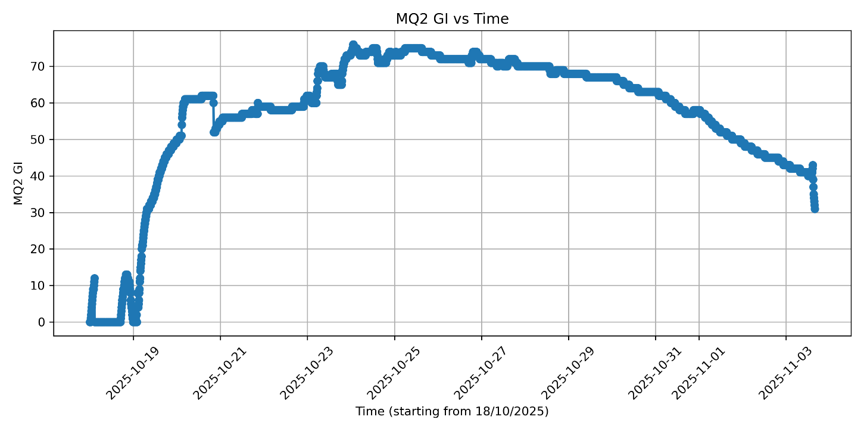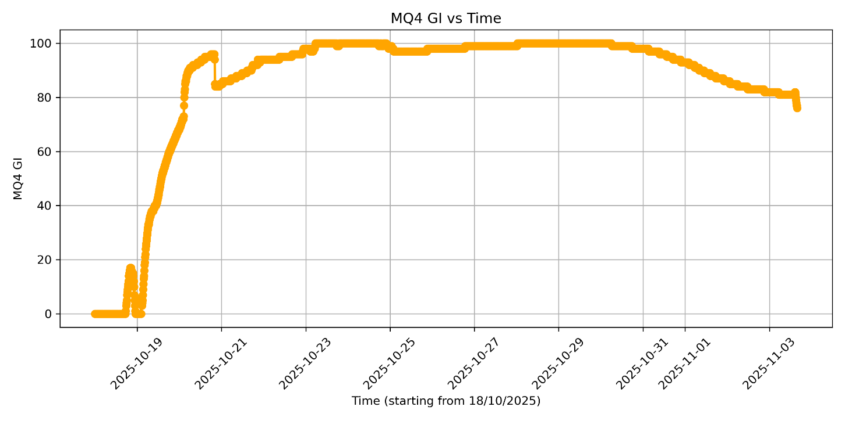
5. Conclusion
This project successfully demonstrated a Smart Fruit Decay Monitoring System capable of detecting and analyzing gas emissions during the ripening and spoilage of fruits. Using MQ-2 and MQ-4 sensors, the system effectively tracked variations in ethylene and methane concentrations, which directly correlate with fruit freshness. The first BLE-based phase enabled real-time wireless monitoring and data logging, while the second NFC-based phase introduced a low-power, offline alternative that made the setup more practical for long-term experiments and field use.
Through two experimental rounds with banana samples, consistent gas trends were observed, ethylene rising early during ripening, methane peaking later with decay, and a clear Gas Index increase representing the combined gas effect. These results confirmed that gas sensors can reliably indicate fruit freshness and decay stages.
Overall, the project achieved its objectives by integrating sensor technology, embedded systems, and wireless communication into one compact, low-cost solution. In the future, the system can be enhanced by combining both BLE and NFC for hybrid operation, adding cloud connectivity, AI-based spoilage prediction, and LoRa for long-range data transfer, transforming it into a scalable, intelligent fruit monitoring platform.

