###### ­­DESIGN AND IMPLEMETATION ………..

by

Sha Ay

(02-6-2-005-2017)

Thesis is submitted to Faculty of Engineering at PIEAS in partial fulfillment of Degree of B.S/M.S. Electrical Engineering



Pakistan Institute of Engineering and Applied Sciences, Nilore, Islamabad, Pakistan.

October, 2017

**Declaration of Originality**

.

I hereby declare that the work confined in this thesis and the design related content of this thesis are creation of my own study work. This thesis has not been earlier published in any form nor does it contain any verbatim of the published resources which could be treated as intrusion of the international copyright law. I also declare that I do understand the terms copyright and plagiarism, and that in case of any copyright violation or plagiarism found in this work, for any such violation I would held fully responsible.

Signature

Name: Sah Ay

Date: May 16, 2017

Place: PIEAS

**Certificate of Approval**

*This is to certify that the work contained in this thesis entitled*

“Design of a 400A Current Source Power Supply for a DC Plasma Torch”

Was carried out by

Sha Ay

Under our supervision and that in our opinion, it is fully adequate, in scope and quality, for the degree of M.S. Electrical Engineering from Pakistan Institute of Engineering and Applied Sciences (PIEAS).

Approved by:

Signature: _____________________

Supervisor: DR. XYZ

Signature: _______________

Co-Supervisor: Mr. XYZ

Verified by:

Signature: __________________

Head, Department of Electrical Engineering

Stamp:

­­

­­To my loving and caring family

**Acknowledgement**

First of all, all praise to ALLAH for bestowing me with knowledge and blessings. All respect to Prophet Muhammad (peace be upon him) for their kindness to this world and hereafter.This Thesis would have been possible with the assistance, support and supervision of many people. For keeping me focused, believing in me, and offering the project in the first place, I am very thankful to my supervisor, Mr. Tanveer Abbas and Mr. Zia-ur-Rehman who always kept me motivated and provided firm support for carrying this project. I express my sincere gratitude to Mr. Tanveer Abbas in understanding of basic concepts and theory of power electronics related to switch mode power supplies. Further, I acknowledge my gratitude to my parents and siblings who have always been a source of inspiration and motivation for me during my studies.

**Xyz**

Contents

**Abstract** xi

**1. Introduction** 1

**1.1 Plasma Torches** 1

**1.1.1 Types of Plasma Devices** 1

**1.1.2 Plasma Torch Behavior as Electrical Load** 4

**1.2 Background and Motivation** 4

**1.3 Specification of Required Power Supply** 4

**1.4 Goal and Objectives** 5

**1.5 Scope and Deliverable** 5

**1.6 Approach and Methodology** 5

**1.7 Overview of Remainder of Thesis** 6

**2. Literature Review** 7

**2.1 Rectifier Design Techniques** 7

**2.1.1 Six Pulse Three phase Bridge Configuration** 7

**2.1.2 Twelve Pulse Three phase Bridge Configuration** **Error! Bookmark not defined.**

**2.1.4 Other Rectifier Topologies for Plasma Torches** **Error! Bookmark not defined.**

**2.2 Power Converter Design Techniques** **Error! Bookmark not defined.**

**2.2.1 Buck converter** **Error! Bookmark not defined.**

**2.2.2 Bridge Converter** **Error! Bookmark not defined.**

**2.2.3 Resonant Inverter with High Frequency Transformer** **Error! Bookmark not defined.**

**2.3 Discussion** **Error! Bookmark not defined.**

**3. Proposed Topology for Rectification** **Error! Bookmark not defined.**

**3.1 Topology** **Error! Bookmark not defined.**

**3.2 Design Calculations** **Error! Bookmark not defined.**

**3.2.1 LC Filter Design** **Error! Bookmark not defined.**

**3.2.2 Inductor Design of LC filter** **Error! Bookmark not defined.**

**3.3 Simulations with Calculated Values of LC Filter** **Error! Bookmark not defined.**

**3.4 Discussion** **Error! Bookmark not defined.**

**3.4.1 Problem Associated with Proposed Topology** **Error! Bookmark not defined.**

**4. Power Converter Design** **Error! Bookmark not defined.**

**4.1 Design Calculations** **Error! Bookmark not defined.**

**4.1.1 Designing Output Filter** **Error! Bookmark not defined.**

**4.1.2**  **Designing of Pulse Transformer** **Error! Bookmark not defined.**

**4.1.3 Designing Elements of Resonant Tank** **Error! Bookmark not defined.**

**4.2 Simulations with Designed Values** **Error! Bookmark not defined.**

**4.3 Discussion** **Error! Bookmark not defined.**

**5. Simulations Results of IntegrateD System and Selection of Components** **Error! Bookmark not defined.**

**5.1 Simulation Results of Power Supply** **Error! Bookmark not defined.**

**5.2 Selection of Switching Devices for Power Supply** **Error! Bookmark not defined.**

***5.2.1 Switching Characteristics*** **Error! Bookmark not defined.**

***5.2.2 Component Rating*** **Error! Bookmark not defined.**

**6.3 Discussion** **Error! Bookmark not defined.**

**6. Conclusion** 9

References 10

Fig 1.1 Applications of plasma torch 2

Fig 1.2 Types of plasma devices 3

Fig 1.3 Current source power supply block diagram 6

Fig 2.1 PSIM model of six pulse rectifier 8

Fig 2.2 Rectifier output voltage and input source current in Six-pulse rectifier 8

Fig 2.3Total harmonic distortion in input source current 8

Fig 2.4 Simulink model of twelve pulse transformer **Error! Bookmark not defined.**

Fig 2.5 Twelve pulse output rectifier voltage **Error! Bookmark not defined.**

Fig 2.6Twelve pulse output rectifier voltage **Error! Bookmark not defined.**

Fig 2.7Twelve pulse rectifier input current THD **Error! Bookmark not defined.**

Fig 2.8Twelve pulse diode rectifier followed by chopper **Error! Bookmark not defined.**

Fig 2.9Schematic of buck converter **Error! Bookmark not defined.**

Fig 2.10Schematic of bridge converter **Error! Bookmark not defined.**

Fig 2.11Resonant inverter **Error! Bookmark not defined.**

Fig 3.1 Total harmonic distortion in input source current at different conduction angle **Error! Bookmark not defined.**

Fig 3. 2 Total harmonic distortion in input current of proposed topology **Error! Bookmark not defined.**

Fig 3.3 Simulink model of proposed topology **Error! Bookmark not defined.**

Fig 3.4 Single unit of proposed rectifier topology **Error! Bookmark not defined.**

Fig 3.5 Input current and output voltage waveform of proposed topology **Error! Bookmark not defined.**

Fig 3.6 Single-phase rectifier with switch and LC filter **Error! Bookmark not defined.**

Fig 3.7 Inductor Current **Error! Bookmark not defined.**

Fig 3.8 PSIM model **Error! Bookmark not defined.**

Fig 3.9 Output voltage at rectifier **Error! Bookmark not defined.**

Fig 3.10 Output Current **Error! Bookmark not defined.**

Fig 3.11 Input source Current **Error! Bookmark not defined.**

Fig 3.12 Total harmonic distortion in input current source **Error! Bookmark not defined.**

Fig 4. 1 Rectifier output voltage with and without capacitor **Error! Bookmark not defined.**

Fig 4. 2 PSIM model of power electronic converter **Error! Bookmark not defined.**

Fig 4.3 Load voltage **Error! Bookmark not defined.**

Fig 4.4 Load Current **Error! Bookmark not defined.**

Fig 4.6 Phenomenon of soft-switching in resonant inverter **Error! Bookmark not defined.**

Fig 5.1Schematic of power supply with proposed topology **Error! Bookmark not defined.**

Fig 5.2Load current for proposed topology **Error! Bookmark not defined.**

Fig 5.3Load voltage for proposed topology **Error! Bookmark not defined.**

Fig 5.4Output of inverter with proposed topology **Error! Bookmark not defined.**

Fig 5.5Current through LC tank on primary side of transformer **Error! Bookmark not defined.**

Fig 5.6Phenomenon of soft-switching in resonant inverter **Error! Bookmark not defined.**

Fig 5.7Phase current through three phase source **Error! Bookmark not defined.**

Fig 5. 8 THD in input source current **Error! Bookmark not defined.**

Table 1: Component rating and model used in power supply design **Error! Bookmark not defined.**

# **Abstract**

This thesis focuses on the design of a constant current source supply for a DC plasma torch. DC plasma torch requires constant 400A current for its continuous operation. The design of a high current and high power supply with high efficiency is a challenging task, especially with the consideration of providing short circuit current for long time. These power supplies are normally used for plasma arc cutting, gasification of waste disposal i.e. nuclear waste, medical waste. List of some specification is given for the power supply by the end user, who is national tokamak Fusion Programed (NTFP) is working at NILOPE. They have purchased a DC plasma torch, but the suppliers are not willing to send its power supply. So, they have given this project to PIEAS to design and give hardware development suggestion of the required power supply in first phase of this project. In this thesis, comparative study of rectifier topologies and power electronic converter are performed. Finally, we proposed a novel topology for high current rectifier with reduced THD in input source current, and for better power factor compared to other available three phase rectifiers at reduced cost. Similarly we have selected a best suited power electronic converter for our application.

# **1. Introduction**

Gasification using plasma torch is one of the techniques in the area of nuclear waste management. Plasma torches have some other applications as well such as plasma arc cutting, plasma spraying and plasma arc welding as shown in Fig. 1.1. Plasma torches have different types and generally all of them require strong electrical power sources to establish high current between electrodes. This thesis focuses on design of a current source to be used as a power supply for a DC plasma torch of 400A. This chapter presents some basic information of plasma torches, their types, and the background and motivation of this work.

## **1.1 Plasma Torches**

A plasma torch is a device in which a gas is passed through an electric arc which produces plasma. Plasma is fourth state of matter which consists of free electrons, ions and neutral atoms [1]. Plasma is produced when stable molecules of a gas are resolved by an electric arc formed between two electrodes. Plasma can be generated in plasma torch by alternating current, DC current, Radio frequency (RF) ­­­current and by other discharge methods, but mostly we use DC torches. A DC plasma torch has many advantages over other techniques. As compared to AC plasma torch, it has less flicker generation and noise, more stable operation, better control, lower electrode consumption and lower power consumption as well.

### ***1.1.1 Types of Plasma Devices***

In daily life we come across different types of plasma which may be naturally occurring or manmade. Plasma is classified on the basis of its electron number density and electron temperature. Plasma produced in laboratory is classified in two types: thermal plasma and non-thermal plasma, depending upon its thermal equilibrium state. Thermal equilibrium state is related to electron temperature and heavy particles temperature which is related to kinetic energy of electrons and atoms. In case of thermal plasma electron temperature is equal to heavy particle, while in non-thermal plasma, it is different from each other. For example radiofrequency plasma and glow discharges are non-thermal plasma because they are produced at low pressure. Thermal plasma is produced at atmospheric pressure, such as DC plasma and inductively coupled plasma [2]. Hence non-thermal plasma are characterized by low electron number density and low gas temperature while thermal plasma is due to high electron number density and high gas temperature.

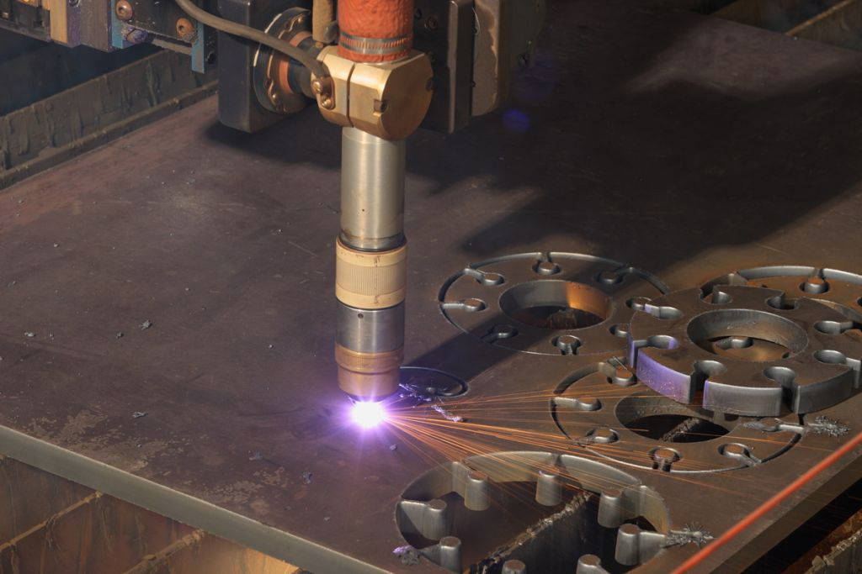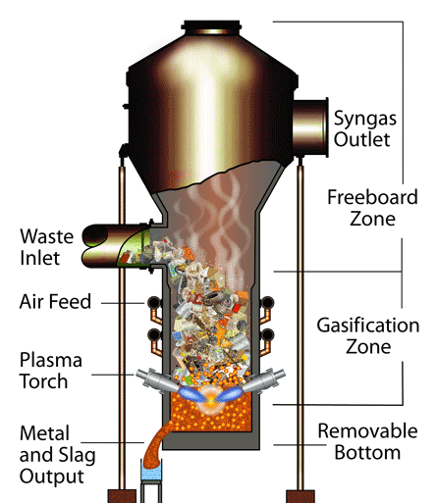

(a) Plasma arc cutting (b) Plasma gasification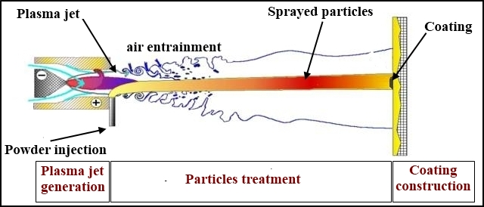

(c) Plasma spraying

Fig 1.1 Applications of plasma torch

Thermal plasma devices are classified into AC plasma devices and DC plasma devices according to the type of applied electric field to produce plasma. AC plasma devices are further classified into two types one with electrodes working at 50Hz frequency AC and produce plasma through oh-mic heating. Other is frequency coupled electrodeless plasma devices, where the energy is produced by electromagnetic induction and through oh-mic heating of arc formed by eddy current generated in plasma.

DC plasma devices are also classified into two types: transferred arc plasma and non-transferred arc plasma devices. In transferred plasma arc devices, arc is produced between the cathode and job which acts as an anode which is not the part of circuit. While in non-transferred plasma devices anode is a part of the circuit as shown in Fig. 1.3. The plasma devices working at atmospheric pressure are classified in to different types as shown in Fig. 1.2.

Non-Transferred Dc Arc Plasma DEVICES

Thermal Plasma Devices

Non-Thermal Plasma Devices

AC Plasma Devices

DC Plasma Devices

Atmospheric Pressure Plasma Jet

Plasma Devices

Transferred Dc Arc Plasma Devices

AC Plasma Torches with Electrode Working at 50Hz

Inductively Coupled Plasma Devices

Fig 1.2 Types of plasma devices

### ***1.1.2 Plasma Torch Behavior as Electrical Load***

Plasma reacts electrically as any static conductor would, in that it confirms to Ohm’s law. Its resistance is proportional to conductivity and physical dimension of plasma. Current is unidirectional from cathode to anode, results in a very low inductive quality. Although, there is small parasitic capacitance element between the electrically charged arc and the surrounding, normally grounded, environment, this influence is swamped by the resistive nature of the arc [3].

## **1.2 Background and Motivation**

National Tokamak Fusion Program (NTFP), under Pakistan Atomic Energy Commission, is a project on fusion studies. They have purchased a DC plasma torch for ­­gasification of waste disposal which includes nuclear waste, medical waste and other contaminated parts. The plasma torch requires constant DC power supply with open circuited voltage of 150V and terminal voltage of 120V at full load of 400A.

The motivations behind this work are:

* The suppliers are not willing to deliver the required power supply to Pakistan,
* This power supply is very expensive,
* This work will open a new area of expertise for development of high current power supplies that will be beneficial for many other projects,
* Indigenization is a priceless outcome of this work.

## **1.3 Specification of Required Power Supply**

For the plasma torch under discussion, the specifications for the required power supply are given below:

* Input voltage: AC220V±10%, 3 phases, 50Hz±1%,
* Rated Output current: 400ADC Output max. operating current,
* Rated output voltage: 120VDC output max. operating voltage ,
* Open circuit voltage(OCV): 150V,
* Control method: controlled by current, constant current mode,
* Power factor: 0.9 or better  (As better as possible),
* ITHD: less than 10% (As better as possible),
* Ripple: better than 5%   (As better as possible),
* Efficiency: ≥90% at full load (As better as possible).

## **1.4 Goal and Objectives**

The goal of this project is to design a power supply for the specifications listed in section 1.3 and following is the list of objectives to achieve the goal:

* Literature review and comparative study of power supplies topologies for plasma torches,
* Selection of design and its understanding through simulation and analytical analysis,
* Design calculation and verification in simulation,
* Thesis writing of constant current source power supply for plasma torch.

## **1.5 Scope and Deliverable**

Scope of this project is to design the power supply and testing in simulation for the DC plasma torch. Hardware and testing is beyond the scope of this project. This project delivers the complete design report of the power supply, detailed simulation and results with discussion. It provides suggestions regarding hardware implementation of the power supply in future.

## **1.6 Approach and Methodology**

This project consists of two parts: design of rectifier and design of power converter as shown in Fig 1.3. In design of rectifier different topologies were discussed with simulation results, we had also discussed a proposed topology as well. In power converter design we have different design techniques which are discussed in thesis and we had select a resonant inverter with high frequency transformer for the power supply, which was better suited to our application. Finally, we had simulated the complete design in PSIM and Simulink (MATLAB).

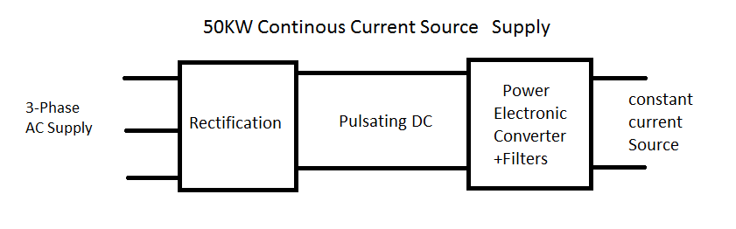

Fig 1.3 Current source power supply block diagram

## **1.7 Overview of Remainder of Thesis**

Later part of the thesis contain six chapters. In chapter 2, I have discussed different rectifier and power converter techniques for the design of power supply for plasma torch. In chapter 3, I have proposed a novel topology and discussed its design and simulation results. In chapter 4, resonant based converter is designed and verified through simulations. In chapter 5, rectifier and converter are integrated and simulated in PSIM. Finally, in chapter 6 I have discussed different power switches and suggest which is better for our design for hardware implementation.

# **2. Literature Review**

High power DC supplies have many applications that led to different design topologies to meet the specific requirements of the targeted applications and to address specific challenges arising from the requirements. In this regard, this chapter discuss the different design option and their pros and cons. This project has two major parts: design of rectifier and design of power electronic converter as shown in Fig 1.3. Rectifier decides the input power factor and total harmonic distortion of input current. Power converter decides the output current and voltage of the load. This chapter is organized as follow section 2.1 discusses possible three phase rectifier design and section 2.2 discusses about available techniques for power converter design for high current and high power application.

## **2.1 Rectifier Design Techniques**

We are required high current rectifier for our application and we have three possible rectifier technique according to our requirement. We have listed some specification in chapter 1 and most prominent are current total harmonic distortion which should be less than 10% and output voltage ripple should be less than 5%. Rectifier design decides the input power factor and total harmonic distortion in input source current. In this section we will discuss about these rectifier design.

### ***2.1.1 Six Pulse Three phase Bridge Configuration***

In a bridge configuration, the number of pulses are double the number of phases. It is possible to attain the same number of rectified voltage and ripple factor using same phases. In six pulse configuration as shown in Fig 2.1, we have three phases coming out of secondary of distribution transformer and at the rectifier output six pulse waveform is generated. In three-phase six-pulse rectifier THD in input source current is around 30% [4] as shown in Fig. 2.3, and rectifier output waveform is shown in Fig. 2.2 with ripple frequency 6 times the main frequency [5].

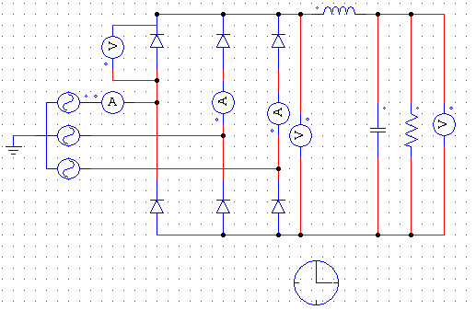

Fig 2.1 PSIM model of six pulse rectifier

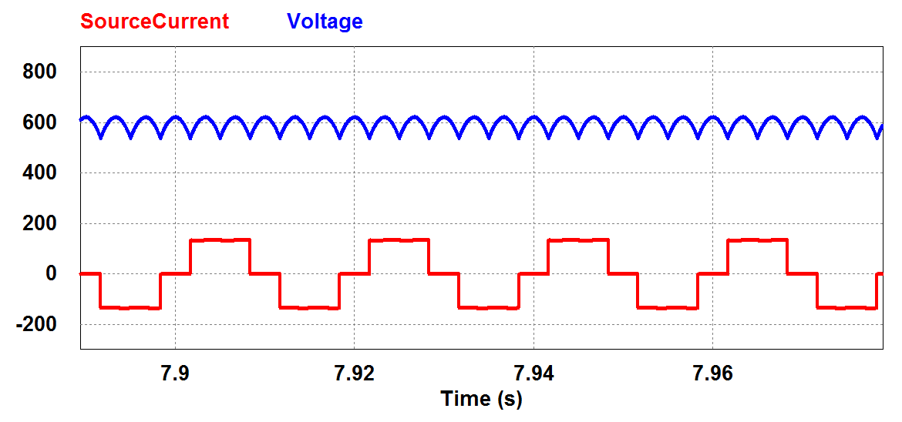

Fig 2.2 Rectifier output voltage and input source current in Six-pulse rectifier

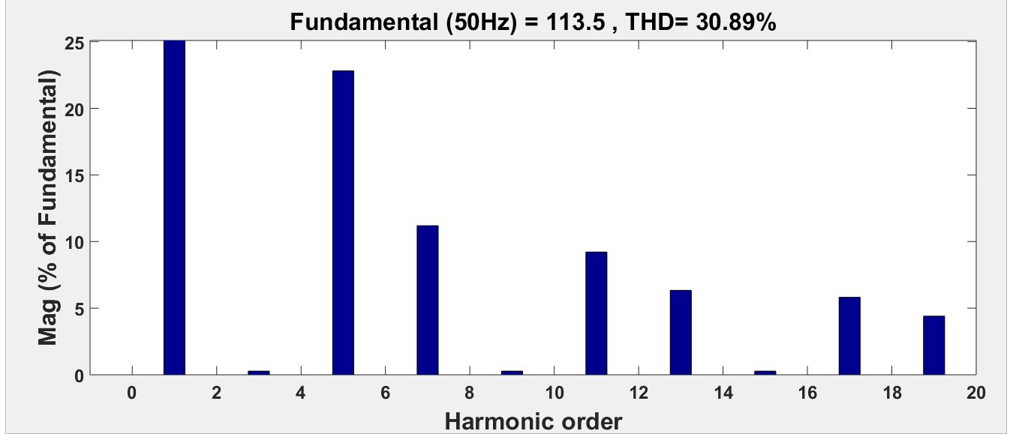

Fig 2.3Total harmonic distortion in input source current

# **6. Conclusion**

The full design of high power and high current switch mode power supply is discussed in this thesis. Literature review of different rectifier and current regulated converter topologies is performed. In rectification part, we had three phase rectifier such as: six pulse rectifier and twelve pulse rectifier. THD in input current for six-pulse rectifier is not in the required limits and in case of 12-pulse rectifier ITHD is less than 10% (recommended) but for this purpose, we are required phase shifting transformer at the input side of rectifier. Phase shifting transformer adds a huge amount of cost to this power supply which is not accepted at this stage. That’s why, we have proposed a novel topology with reduced THD as compared to six pulse but more than 12–pulse rectifier. But this topology has its own pros and cons which I had discussed in chapter 3.

I had tried my best to have a best design for this power supply, but still we can improve this design with some modifications.

In future recommendations, hardware implementation can be performed based on this design, but we need to consider some more factors which are necessary to understand, when we develop the power supply. We need snubber circuit, contactor, circuit breaker, fuses and other protective circuit for hardware implementation.

# References

|  |  |
| --- | --- |
| [1] | B. M. I, "Thermal Plasma Processing," *IEEE Transactions on Plasma Science,* pp. Vol.-19, No.-6, pp.-1078-1089, 1991. |
| [2] | M. &. F. P. &. P. E. Boulos, "DC Plasma Torch Design and Performance.," 2017, p. 10. |
| [3] | W. V. D. Merwe, "PWM Converter for a Highly Non-Linear Plasma Load," University of Stellenbosch, Stellenbosch, 2005. |
| [4] | G. &. J. K. Conway, "Harmonic currents produced by variable speed drives with uncontrolled rectifier inputs," *conference,* pp. 4/1 - 4/5, 1993. |
| [5] | R. Visintini, "Rectifiers," Elettra Synchrotron Light Laboratory, Trieste, Italy. |
| [6] | R. &. B. I. Alves, " Analysis and Implementation of a Hybrid High-Power-Factor Three-Phase Unidirectional Rectifier," *IEEE Transactions,* vol. TPEL.2008.2010219, p. 24, 2009. |
| [7] | M. &. N. J. &. B. M. Villablanca, "A 12-Pulse AC–DC Rectifier With High-Quality Input/Output Waveforms," *Power Electronics, IEEE Transactions,* vol. TPEL.2007.904185., p. 22, 2007. |
| [8] | S. &. L. S. Bai, "New Method to Achieve AC Harmonic Elimination and Energy Storage Integration for 12-Pulse Diode Rectifiers," *Industrial Electronics, IEEE Transactions,* vol. TIE.2012.2196903., p. 60, 2013. |
| [9] | N. F. J. B. P. W. Jitendra Solanki, "Comparison of Thyristor-Rectifier with Hybrid Filter and ChopperRectifier for High-Power, High-Current Application," *PCIM,* p. 8, 2013. |
| [10] | S. &. H. S. &. H. M. &. C. T. Lopa, "Design and Simulation of DC-DC Converters," *International Research Journal of Engineering and Technology.,* vol. 3, pp. 62-70, 2016. |
| [11] | M. H. Rashid, Power Electronics, New York, Boston,Londan, Sydney: Academic Press, 2001. |
| [12] | C.-C. &. C. H.-J. Huang, "A PWM switch model of isolated full-bridge converter," *Conference,* vol. IGBSG.2018.8393523., p. 10, 2018. |
| [13] | S. &. X. H. Pan, "A resonant inverter and its soft switching boundary conditions analysis," *2012 7th International Power Electronics and Motion Control Conference,* vol. IPEMC.2012.6258919., p. 10, 2012. |
| [14] | Z. &. O. J. &. Z. J. &. S. K. &. Y. W. Wang, "Resonant power electronic transformer for power grid.," *IEEE Energy Conversion Congress and Exposition,* vol. ECCE.2014.6954021., p. 10, 2014. |
| [15] | W.-Y. S. B. K. L. Geun Wan, "Comparison and Design of Resonant Network Considering the Characteristics of a Plasma Generator," *Energies,* Vols. 1996-1073/12/16/3156, p. 10, 2019. |
| [16] | G. &. H. C. Hinow, "Analysis of a series resonant inverter," vol. EPE.2005.219682, 2005. |
| [17] | D. M. Robert W. Erickson, Fundamentals of Power Electronics, 2nd Edition, New York: KLUWER ACADEMIC PUBLISHERS, 2004. |
| [18] | D.-H. &. Y. P. Zhang, "Study of the series resonant capacitor charging power supply with sinusoidal analysis," *conference paper,* vol. 33, pp. 201-204, 2007. |
| [19] | J. Lazar, "Analysis of single phase rectifier circuits," 1997. |
| [20] | &. T. D. Harik, "Average value analysis of single-phase uncontrolled rectifier," *conference paper,* 2019. |
| [21] | &. T. D. Harik, "Average value analysis of single-phase uncontrolled rectifier," *conference paper,* 2019. |
| [22] | K. C. Meher, "Study of thermal, electrical and fluid dynamic," Bhabha Atomic Research Centre, Mumbai, April, 2015. |
| [23] |  |