FYPIFY
Course: SE323L- Software Construction and Development
Project Type: Open Ended Lab (OEL)



Submitted By:
Ahmed Javaid 2023-SE-09
Hafiz Abdullah 2023-SE-22
Ahmed Raza 2023-SE-24
Muhammad Ahad 2023-SE-31
Submitted To:
Sir Ali Raza
Dated: 29th Dec , 2025

Department of Computer Science
University of Engineering and Technology Lahore,
New Campus
Contents
FYPIFY 1
1 Introduction 4
1.1 Project Summary 4
1.2 Core Functionality 4
2 Tools and Technologies 4
3 Design Patterns Used 8
3.1 Singleton Pattern (Creational) 8
3.2 Builder Pattern (Creational) 8
3.3 Factory Method Pattern (Creational) 9
3.4 Template Method Pattern (Behavioral) 9
3.5 Chain of Responsibility Pattern (Behavioral) 9
3.6 Strategy Pattern (Behavioral) 10
3.7 Adapter Pattern (Structural) 10
3.8 Repository Pattern (Architectural) 10
3.9 Pattern Categories Summary (Creational Patterns) 11
3.10 Behavioral Patterns 11
4 Functional Requirements 11
4.1 Functional Requirements Student (Leader + Member) 11
4.2 Functional Requirements (Supervisor) 12
4.3 Functional Requirements (Evaluation Committee) 12
4.4 Functional Requirements (FYP Committee) 13
4.5 Functional Requirements (Admin) 14
4.6 System / BackGround Jobs 14
5 DIAGRAMS 15
5.1 Class Diagrams 15
5.2 Use-Case Diagram 16
5.3 Sequence Diagrams 17
5.3.1 Upload Document 17
5.3.2 Register Project 17
5.3.3 Login 18
5.3.4 Accept /Reject Invite 19
5.3.5 Approve Project 19
5.3.6 Create Group 20
5.3.7 Add Deadline 20
5.3.8 Add Document Type 21
5.3.9 Add User 21
5.3.10 Evaluate Submission 22
5.3.11 Manage Groupe Size 23
5.4 ERD Design 24
5.5 Architecture Diagrams 24
5.5.1 Module Layered Diagram 24
5.5.2 High-Level System Architecture 25
5.5.3 Security Architecture 26

FYPIFY

Introduction

Project Summary
FYPify is a comprehensive, web-based Final Year Project (FYP) Management System designed to modernize and automate the academic project life-cycle in universities. It addresses critical institutional challenges such as manual tracking, fragmented communication, and inconsistent evaluation processes by providing a centralized, transparent platform for all stakeholders.
The platform utilizes a robust and modern technology stack:
- Backend: Java 17, Spring Boot 3.x, Spring Security (JWT), and PostgreSQL.
- Frontend: Next.js 14 (React), TypeScript, and TailwindCSS.
- Infrastructure: Cloudinary for document storage, WebSockets for real-time updates, and Docker for containerization.

Core Functionality
FYPify implements Role-Based Access Control (RBAC) to provide tailored experiences for four primary users:
- Students: Manage group formation, document submissions, and result tracking.
- Supervisors: Oversee project progress, approve proposals, and provide feedback.
- Committee Members: Evaluate projects using standardized digital rubrics.
- Administrators: Manage users, configure committees, and generate audit reports.
By following a Clean Layered Architecture, FYPify ensures scalability and security, effectively streamlining the entire workflow from initial proposal submission to final graduation requirements.

Tools and Technologies
Technology | Version | Purpose
Java | 21 (LTS) | Primary programming language
Spring Boot | 3.4.0 | Application framework for building production-ready applications
Maven | 3.9+ | Build automation and dependency management

Spring Boot Modules
Module | Purpose
Spring Web | RESTful API development, MVC architecture
Spring Data JPA | Object-Relational Mapping (ORM) with Hibernate
Spring Security | Authentication, authorization, and security features
Spring Validation | Request validation using Jakarta Bean Validation
Spring Mail | Email sending functionality
Spring WebSocket | Real-time bidirectional communication for notifications
Spring Actuator | Application monitoring and health checks

Security & Authentication
Technology | Version | Purpose
JWT (JSON Web Tokens) | 0.12.6 | Stateless authentication tokens
JJWT Library | 0.12.6 | JWT creation, parsing, and validation
BCrypt | Built-in | Password hashing algorithm

Database & Migrations
Technology | Version | Purpose
PostgreSQL | 15+ | Primary relational database
Flyway | Latest | Database schema migrations and version control
Hibernate | 6.x | JPA implementation for ORM

Frontend Technologies
Technology | Version | Purpose
React | 19.2.1 | UI component library
Next.js | 16.0.7 | React framework with App Router, SSR, and file-based routing
TypeScript | 5.x | Type-safe JavaScript superset

UI Component Library
Library | Version | Purpose
shadcn/ui | Latest | Pre-built accessible React components
Radix UI Primitives | Various | Unstyled, accessible UI component primitives
Lucide React | 0.556.0 | Icon library

Forms & Validation
Library | Version | Purpose
React Hook Form | 7.68.0 | Performant form state management
Zod | 4.1.13 | TypeScript-first schema validation
@hookform/resolvers | 5.2.2 | Zod integration with React Hook Form

File Handling
Library | Version | Purpose
React Hook Form | 7.68.0 | Performant form state management
Zod | 4.1.13 | TypeScript-first schema validation
@hookform/resolvers | 5.2.2 | Zod integration with React Hook Form

Cloud Services
Feature | Purpose
File Storage | Document uploads (PDFs, images)
CDN | Fast content delivery
Transformations | Image optimization and resizing

Email Service
Service | Purpose
SMTP Server | Email delivery (configurable - Gmail, SendGrid, etc.)
Thymeleaf Templates | HTML email templates

Development Tools
Tool | Purpose
Visual Studio Code | Primary code editor
Thymeleaf Templates | HTML email templates
IntelliJ IDEA | Java/Spring Boot development
Tool | Purpose
Maven | Java dependency management and builds
npm | Node.js package management
Turbo Pack | Next.js development bundler (faster than Webpack)
Visual Studio Code | Primary code editor
IntelliJ IDEA | Java/Spring Boot development
Maven | Java dependency management and builds
npm | Node.js package management
Turbopack | Next.js development bundler (faster than Webpack)
Git | Source code version control
GitHub | Repository hosting and collaboration

Design Patterns Used
This document explains the Gang of Four (GOF) Design Patterns implemented in the FYPify backend with references to specific files.
Pattern | Type
Singleton | Creational
Builder | Creational
Factory Method | Creational
Template Method | Behavioral
Chain of Responsibility | Behavioral
Strategy | Behavioral
Adapter | Structural
Repository | Architectural
DTO (Data Transfer Object) | Architectural

Singleton Pattern (Creational)
Purpose: Ensure a class has only one instance and provide global access to it.
Where Used: Spring's IoC container manages all beans as singletons by default.
File | Path
SecurityConfig | SecurityConfig.java
JwtAuthenticationFilter | JwtAuthenticationFilter.java
GlobalExceptionHandler | GlobalExceptionHandler.java
UserService | UserService.java

Builder Pattern (Creational)
Purpose: Construct complex objects step by step, separating construction from representation.
Where Used: Entity creation, DTO construction, API responses.
File | Path
ApiResponse | ApiResponse.java
ApiError | ApiError.java
SecurityConfig | SecurityConfig.java
UserService | UserService.java

Factory Method Pattern (Creational)
Purpose: Define an interface for creating objects, letting sub-classes decide which class to instantiate.
Where Used: Static factory methods for creating API responses and exceptions.
File | Path
ApiResponse | ApiResponse.java
BaseException | BaseException.java

Template Method Pattern (Behavioral)
Purpose: Define the skeleton of an algorithm, deferring specific steps to sub-classes.
Where Used: Security filters extending OncePerRequestFilter, exception hierarchy.
File | Path
JwtAuthenticationFilter | JwtAuthenticationFilter.java
BaseException | BaseException.java
GlobalExceptionHandler | GlobalExceptionHandler.java

Chain of Responsibility Pattern (Behavioral)
Purpose: Pass requests along a chain of handlers, where each handler decides to process or pass to the next.
Where Used: Spring Security filter chain, exception handler chain.
File | Path
SecurityConfig | SecurityConfig.java
JwtAuthenticationFilter | JwtAuthenticationFilter.java
GlobalExceptionHandler | GlobalExceptionHandler.java

Strategy Pattern (Behavioral)
Purpose: Define a family of algorithms, encapsulate each one, and make them interchangeable.
Where Used: Authentication providers, password encoding.
File | Path
SecurityConfig | SecurityConfig.java
JwtTokenProvider | JwtTokenProvider.java

Adapter Pattern (Structural)
Purpose: Convert the interface of a class into another interface clients expect.
Where Used: Converting exceptions to standardized API responses.
File | Path
GlobalExceptionHandler | GlobalExceptionHandler.java

Repository Pattern (Architectural)
Purpose: Mediate between domain and data mapping layers, acting like an in-memory collection.
Where Used: All data access operations via Spring Data JPA.
File | Path
User | modules/user/repository/UserRepository.java
Group | modules/group/repository/GroupRepository.java
Project | modules/project/repository/ProjectRepository.java
Submission | modules/submission/repository/SubmissionRepository.java
Committee | modules/committee/repository/CommitteeRepository.java

Pattern Categories Summary (Creational Patterns)
File | Path | Example
Singleton | Single instance | @Service,@Component classes
Builder | Complex object construction | ApiResponse, Entity classes
Factory Method | Object creation encapsulation | ApiResponse.success()

Behavioral Patterns
Pattern | Purpose | Example File
Chain of Responsibility | Request handling chain | Security Filters
Template Method | Algorithm skeleton | OncePerRequestFilter
Strategy | Interchangeable algorithms | PasswordEncoder

Functional Requirements

Functional Requirements Student (Leader + Member)
FR-ID | Functional Requirement | Actor | Priority | Description | Constraints / Rules
STU-01 | User Registration & Login | Student | H | Student logs in using credentials | Based on role; JWT authentication
STU-02 | View Profile | Student | M | Student can view personal info | Read-only
STU-03 | Create Group | Student | H | Student creates a group with member emails | Must respect group_min_size & group_max_size
STU-04 | Join Group | Student | H | Student accepts invite from group | Cannot join multiple groups
STU-06 | Register Project | Leader | H | Leader submits title, abstract, domain, proposed supervisors | Project → status = “PENDING_APPROVAL”
STU-07 | View Group Project Status | Student | H | Student sees current project approval state | Both leader & members can view
STU-08 | Upload Document | Leader | H | Leader uploads submission file | Only leader; versioned uploads
STU-09 | Re-upload After Revision | Leader | H | Leader uploads new version after supervisor request | Creates new version number
STU-10 | View All Submissions | Student | H | Students view documents, comments, statuses | Marks remain hidden until final release
STU-11 | View Deadlines | Student | M | Students view deadlines per document | Read-only
STU-12 | Receive Notifications | Student | H | Student receives system notifications | WS or polling
STU-13 | View Final Results | Student | H | Student views results ONLY after release | Access blocked before release

Functional Requirements (Supervisor)
FR-ID | Functional Requirement | Actor | Priority | Description | Constraints
SUP-01 | View Assigned Projects | Supervisor | H | See list of groups assigned post-approval | Assigned by FYP Committee
SUP-02 | View Student Submissions | Supervisor | H | See latest versions submitted | Including file preview
SUP-03 | Review Submission | Supervisor | H | Add comments, approve or request revision | Status change stored
SUP-04 | Give Supervisor Marks | Supervisor | H | Score document (0–100) | Hidden from students
SUP-05 | Request Revision | Supervisor | H | Send revisions to leader with comments | Triggers notification
SUP-06 | Approve Submission | Supervisor | H | Approving locks submission (if deadline passed) | Auto-lock
SUP-07 | Track Progress | Supervisor | M | View submission completeness per group | Read-only

Functional Requirements (Evaluation Committee)
FR-ID | Functional Requirement | Actor | Priority | Description | Constraints
EVAL-01 | View Locked Submissions | Evaluator | H | View documents ready for evaluation | Only for LOCKED_FOR_EVAL
EVAL-02 | View Submission Details | Evaluator | H | Preview file, supervisor comments | Marks from supervisor hidden
EVAL-03 | Score Submission | Evaluator | H | Assign committee score per document | Stored per evaluator
EVAL-04 | Save Draft Evaluation | Evaluator | M | Save partial evaluation without finalizing | Draft not counted
EVAL-05 | Finalize Evaluation | Evaluator | H | Submit final score & comments | Triggers FYP Committee notification
EVAL-06 | View Evaluation History | Evaluator | M | See their past evaluations | Only own evaluations

Functional Requirements (FYP Committee)
FR-ID | Functional Requirement | Actor | Priority | Description | Constraints
FYP-01 | View Pending Projects | FYP Member | H | List of submitted projects awaiting approval | Status → "PENDING_APPROVAL"
FYP-02 | Approve/Reject Project | FYP Member | H | Approve project and assign supervisor | Required step
FYP-03 | Set Deadlines Per Document | FYP Member | H | Choose due dates for required doc types | Used for locking process
FYP-04 | Monitor Submissions & Evaluations | FYP Member | M | See progress and pending evaluations | Read-only
FYP-05 | Compute Final Results | FYP Member | H | Combine supervisor + evaluator scores using weights | Produces final result object
FYP-06 | Release Final Results | FYP Member | H | Publish results to students | Not reversible unless special flow
FYP-07 | Approve Result Release (Committee) | FYP Member | H | Multiple member approval (if configured) | Optional feature

Functional Requirements (Admin)
FR-ID | Functional Requirement | Actor | Priority | Description | Constraints
ADM-01 | Manage Users | Admin | H | Create, update, delete users; assign roles | Must maintain audit logs
ADM-02 | Manage Committees | Admin | H | Add/remove FYP Committee and Evaluation Committee members | Committees must always have at least 1 member
ADM-03 | Manage Document Types | Admin | H | Add/edit doc types with weights | Total weights must sum correctly
ADM-04 | Manage System Settings | Admin | H | Group size settings, deadline | Stored centrally
ADM-05 | View Audit Logs | Admin | M | View all system actions | Read-only
ADM-06 | Trigger Backup / Restore | Admin | L | Backup system data | Sensitive action

System / BackGround Jobs
FR-ID | Functional Requirement | Actor | Priority | Description | Constraints
SYS-01 | Auto-Lock Submissions | System | H | Lock document after deadline to evaluators | No upload allowed after lock
SYS-02 | Auto-Notify Events | System | H | Send notifications for all important events | Works via logs + triggers
SYS-03 | Cloud File Storage | System | H | Store submissions in Cloudinary securely | Return secured URL
SYS-04 | Audit Logging | System | H | Log all critical actions | Immutable logs
SYS-05 | Role-Based Access Control | System | H | Ensure all actions respect permissions | Enforced in backend

DIAGRAMS

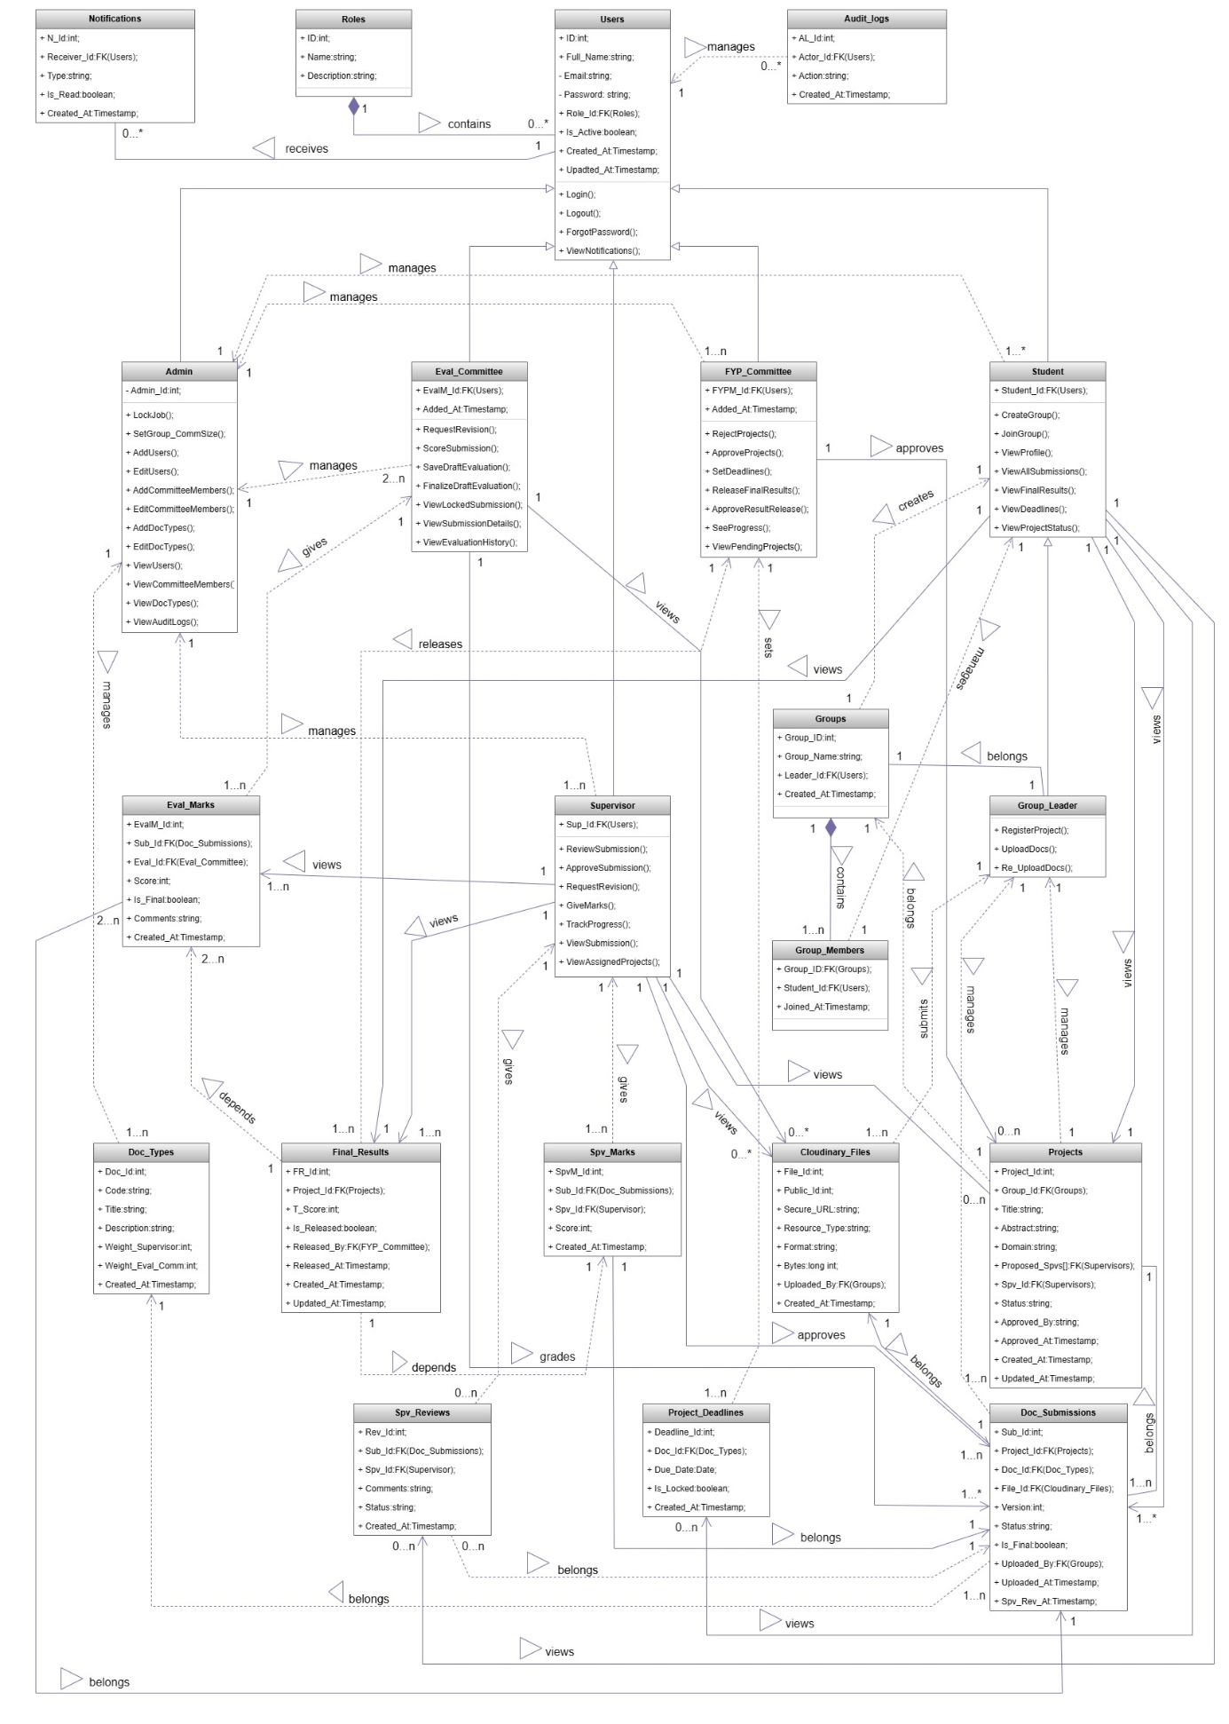
Class Diagrams

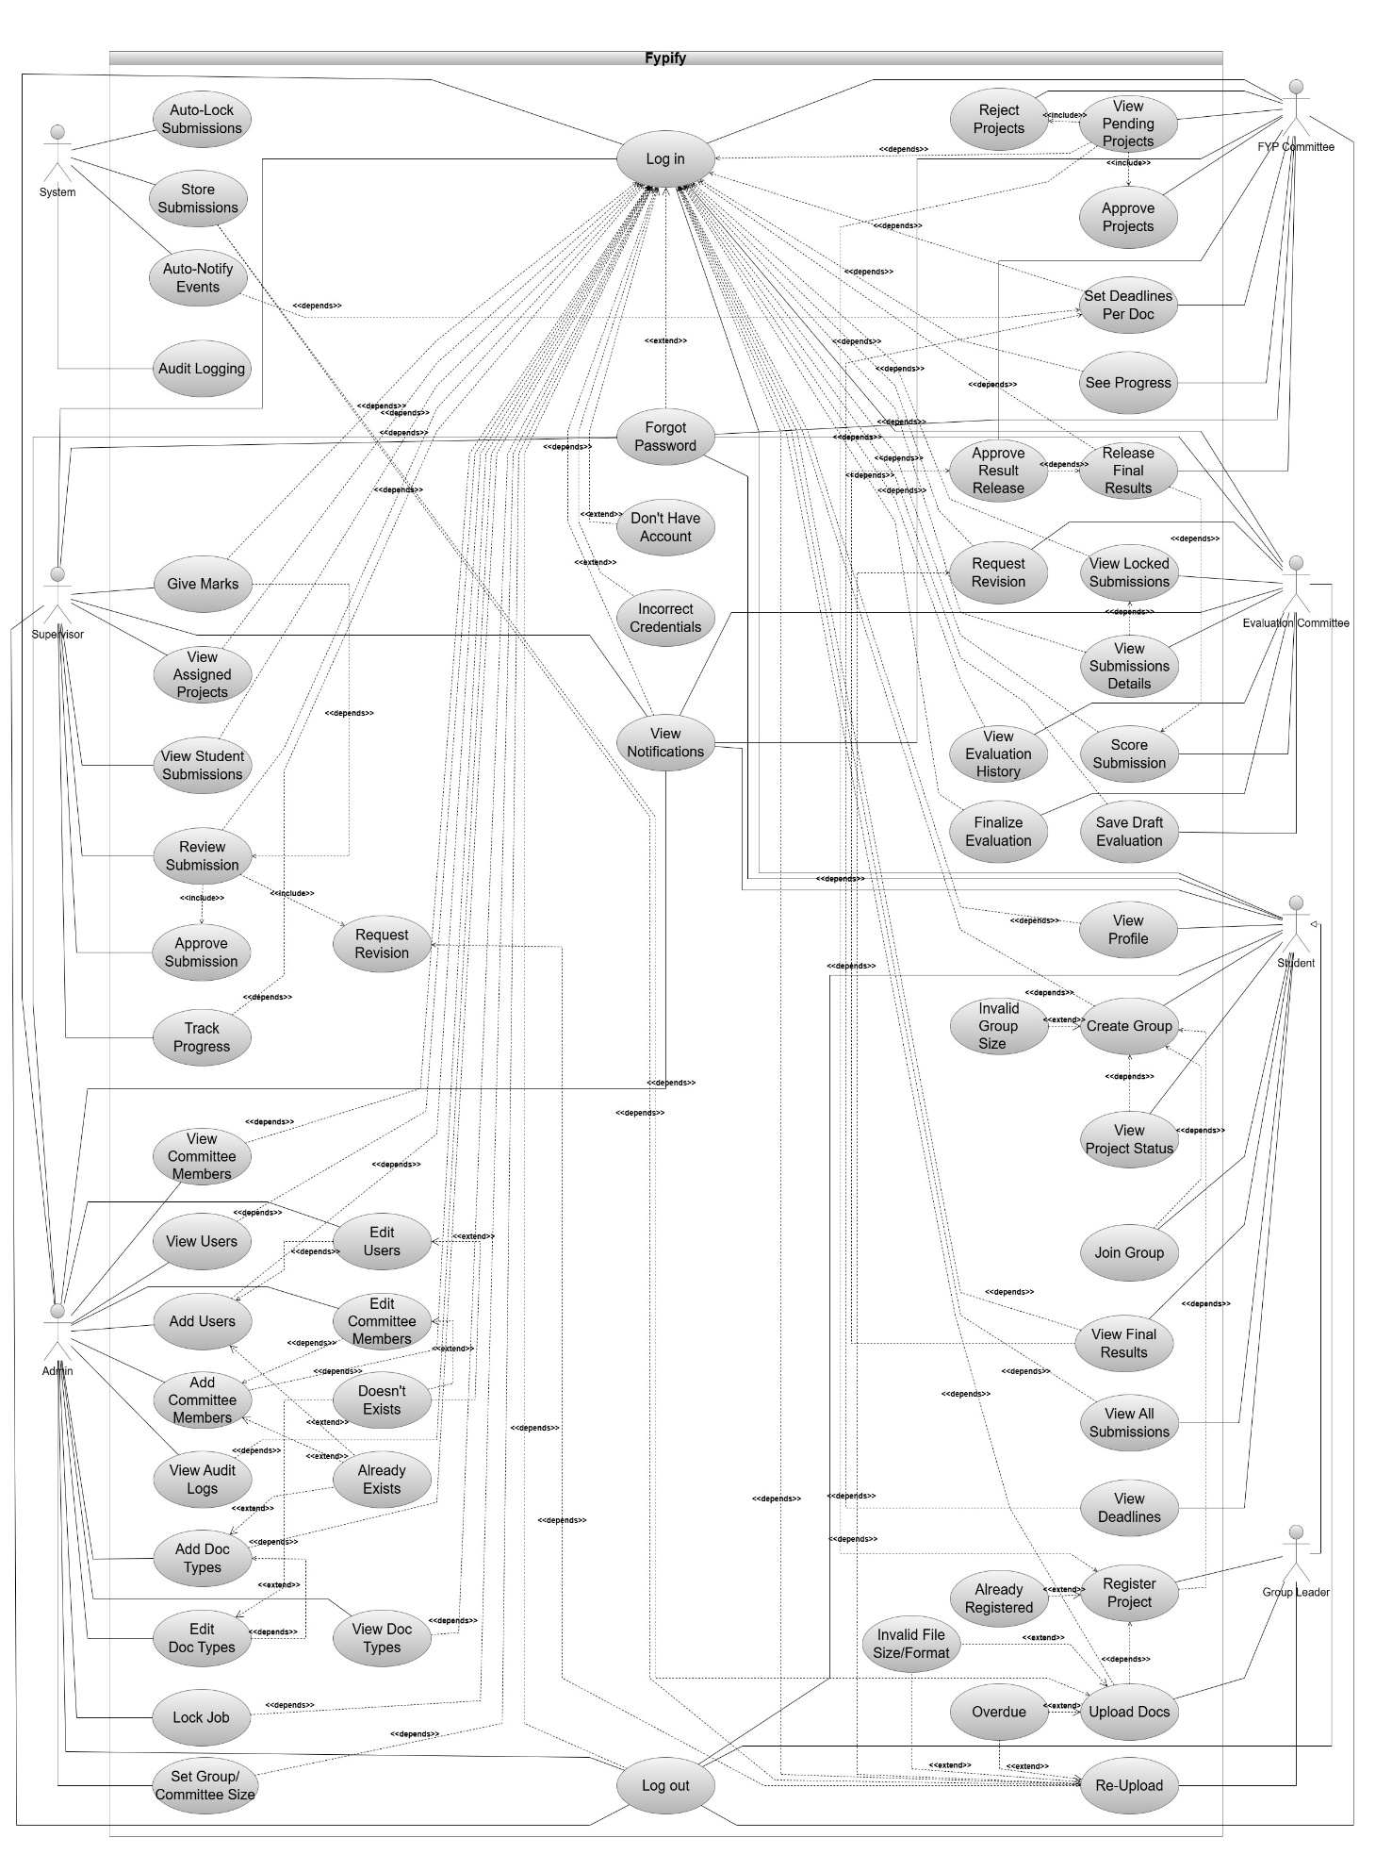
Use-Case Diagram

Sequence Diagrams

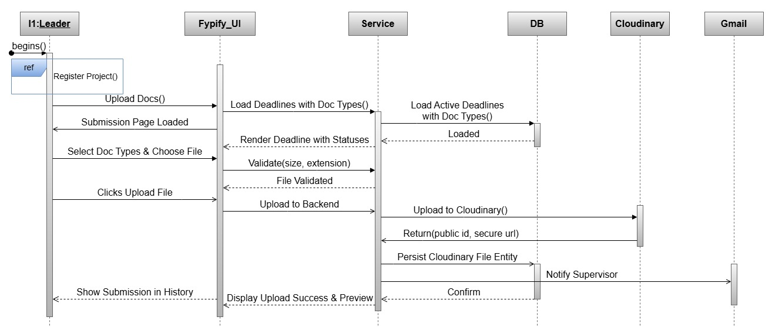
Upload Document

Register Project

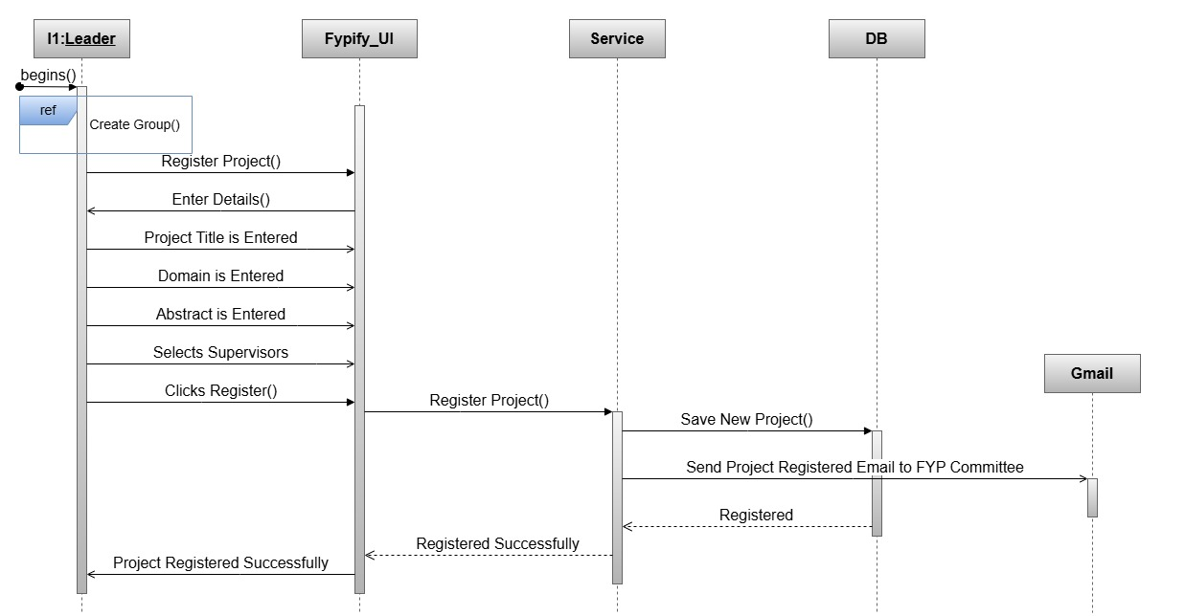

Login
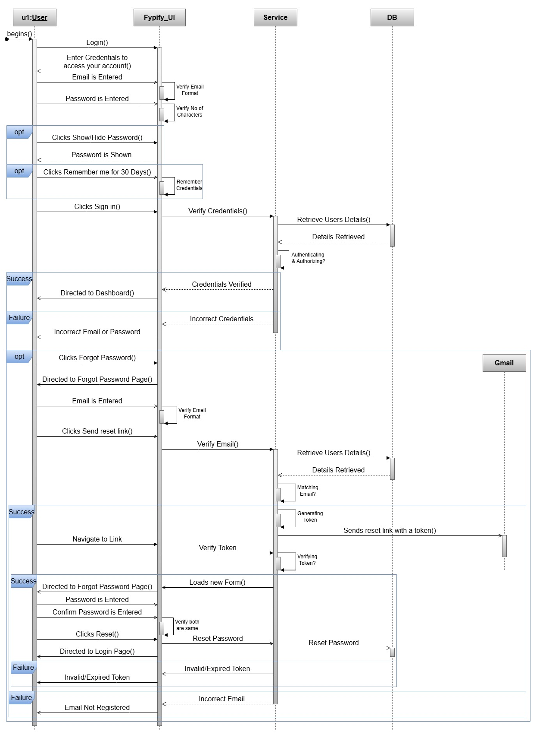

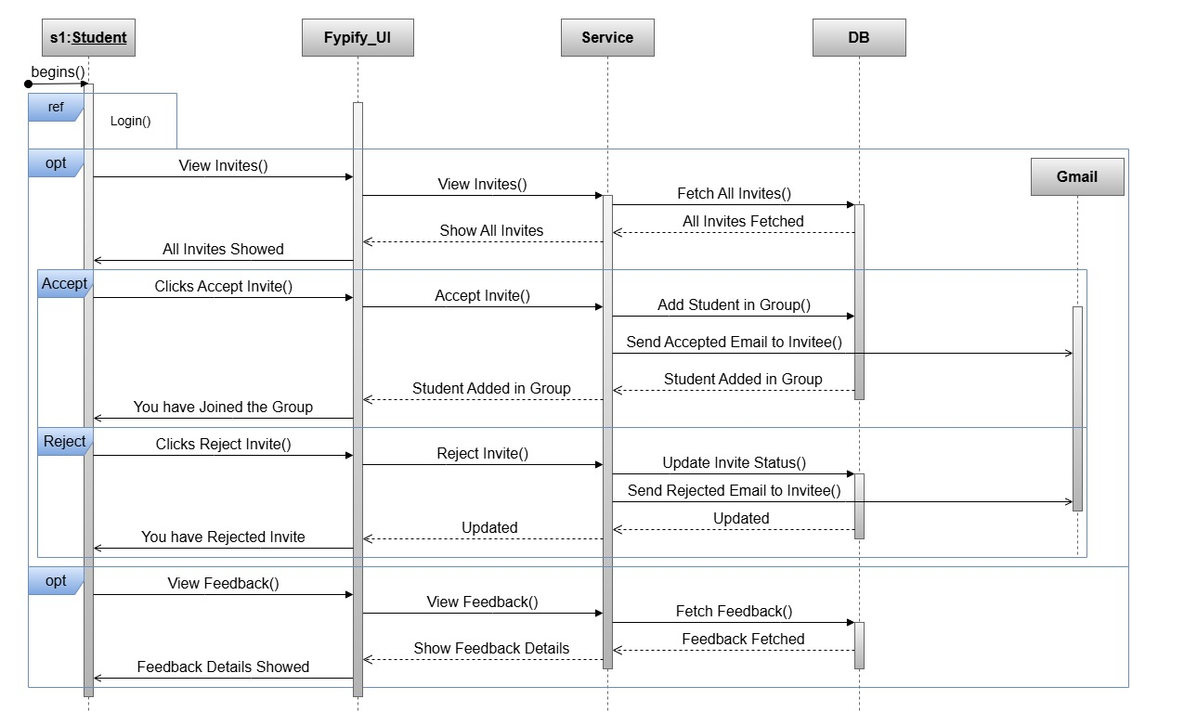
Accept /Reject Invite

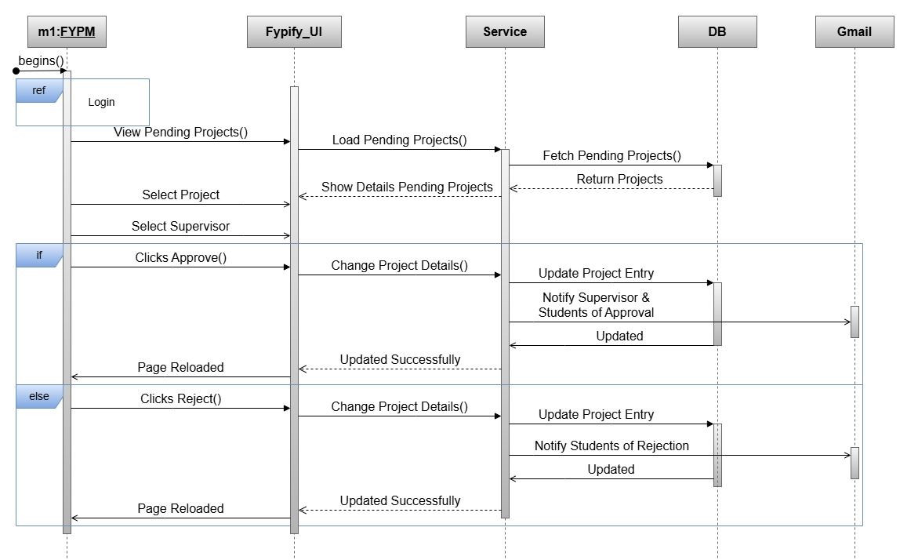
Approve Project

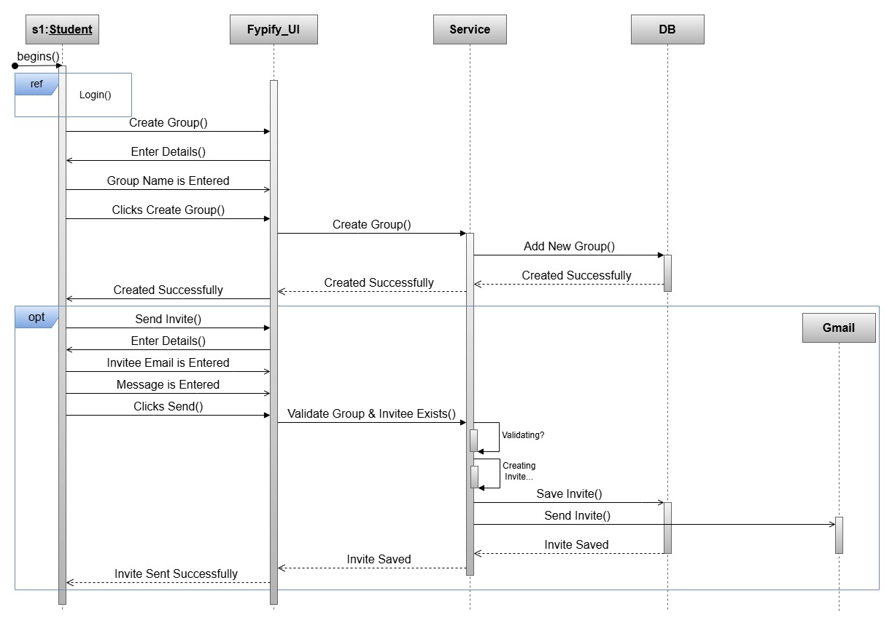
Create Group

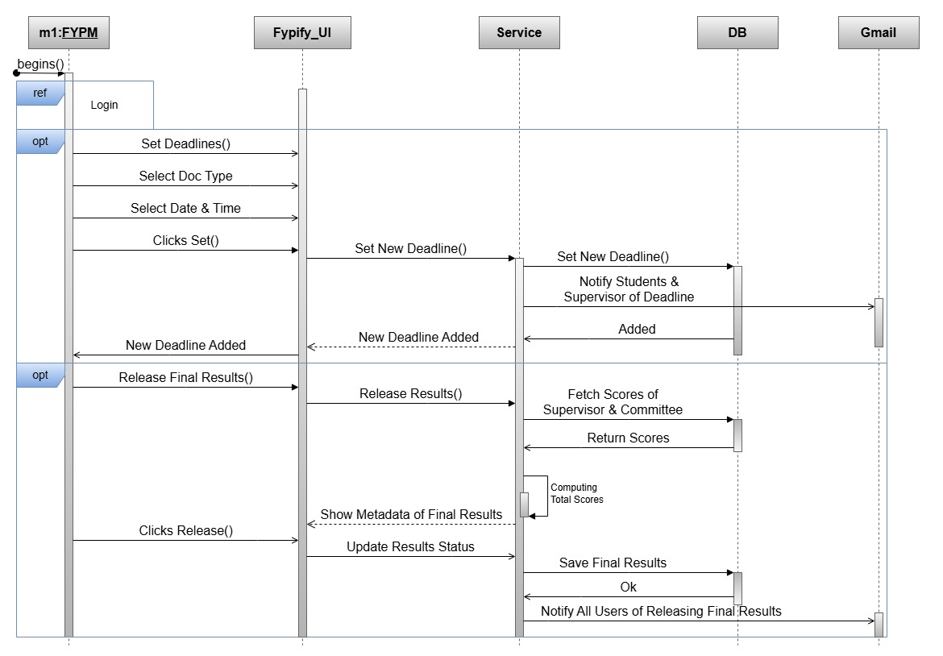
Add Deadline

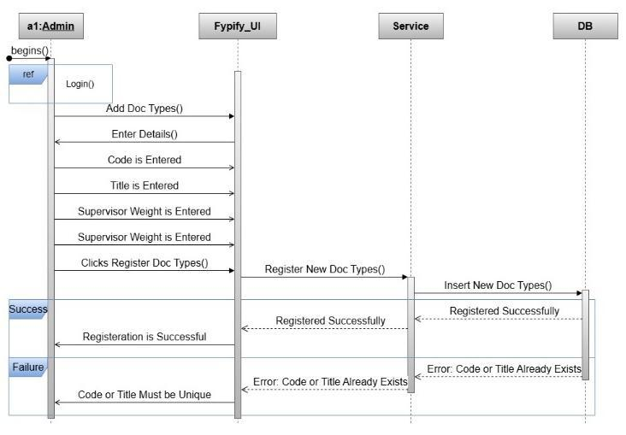
Add Document Type

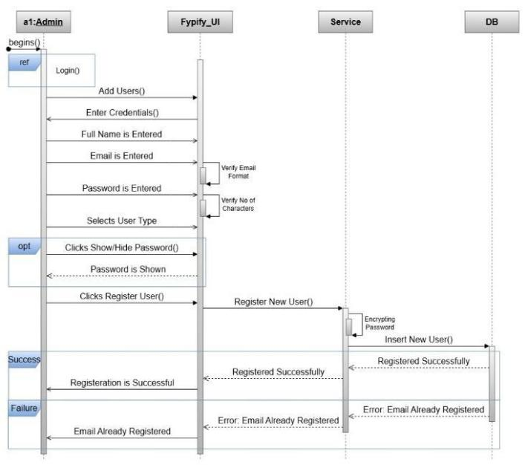
Add User

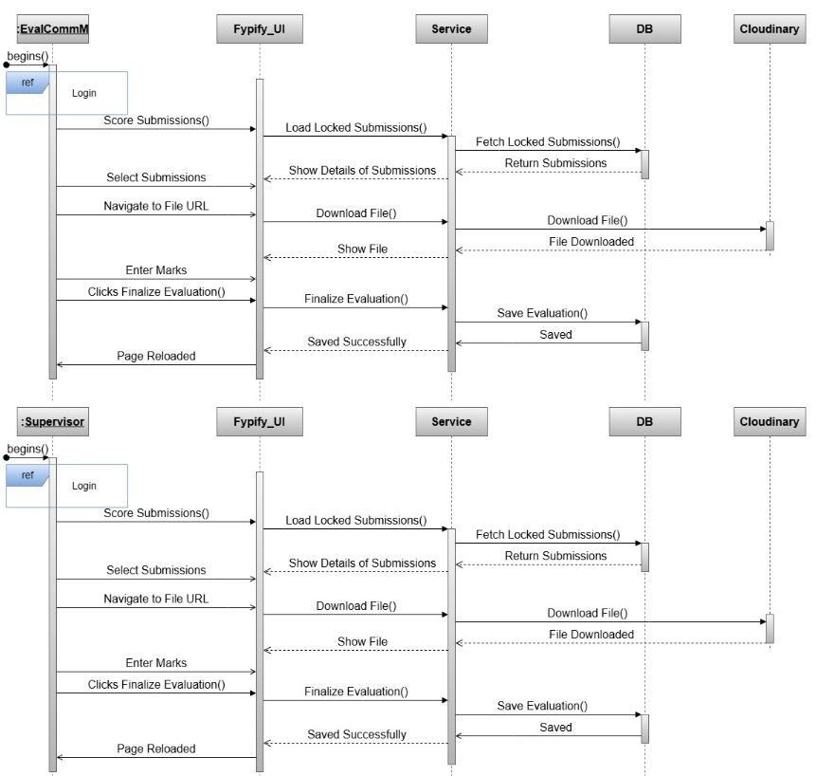
Evaluate Submission

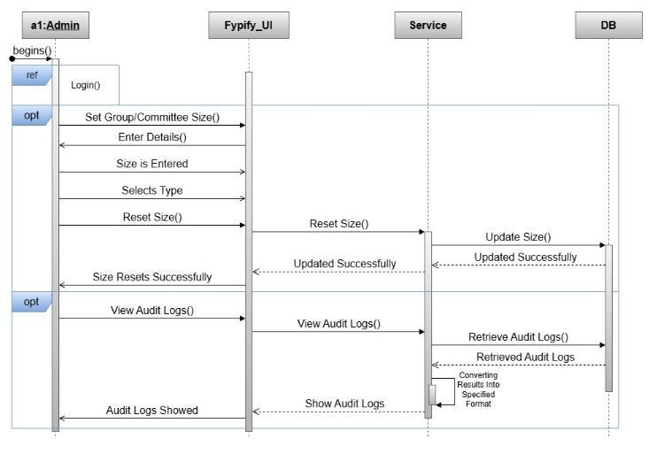
Manage Groupe Size

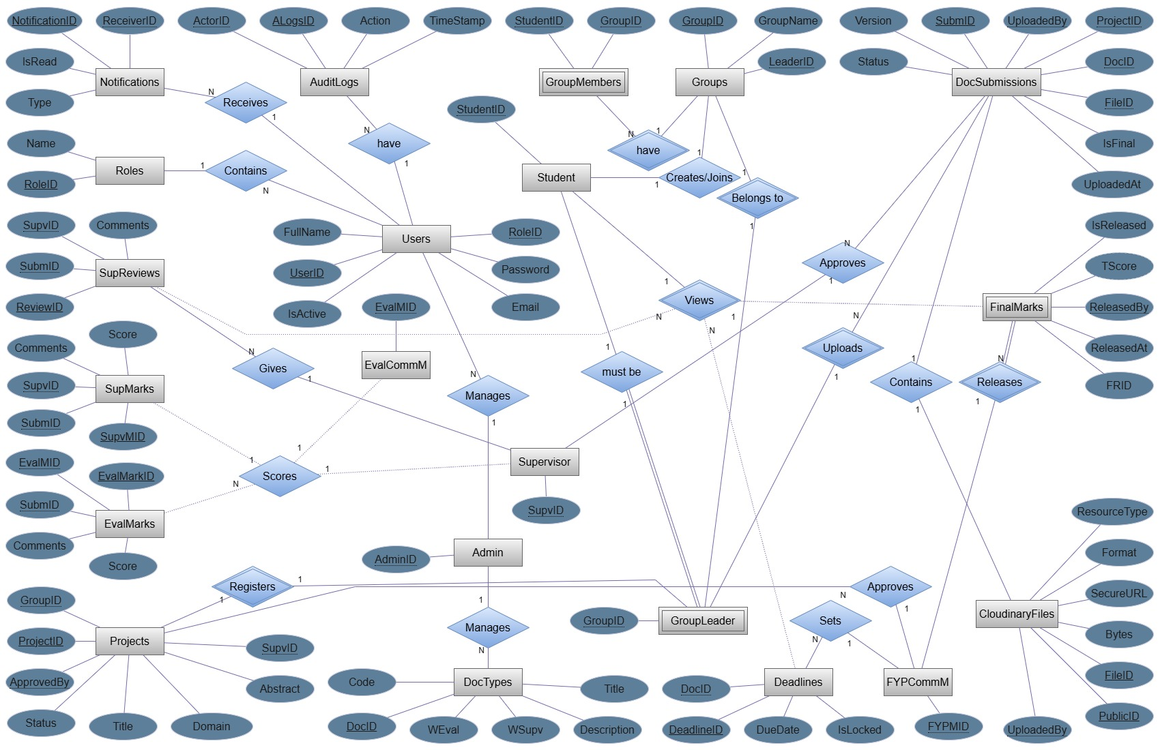
ERD Design

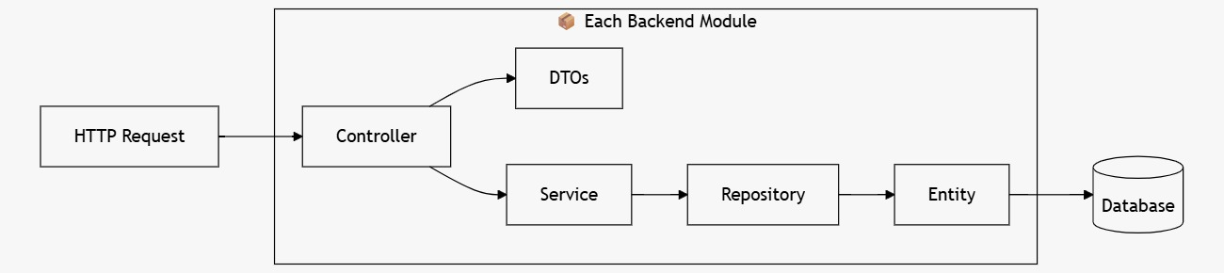
Architecture Diagrams

Module Layered Diagram

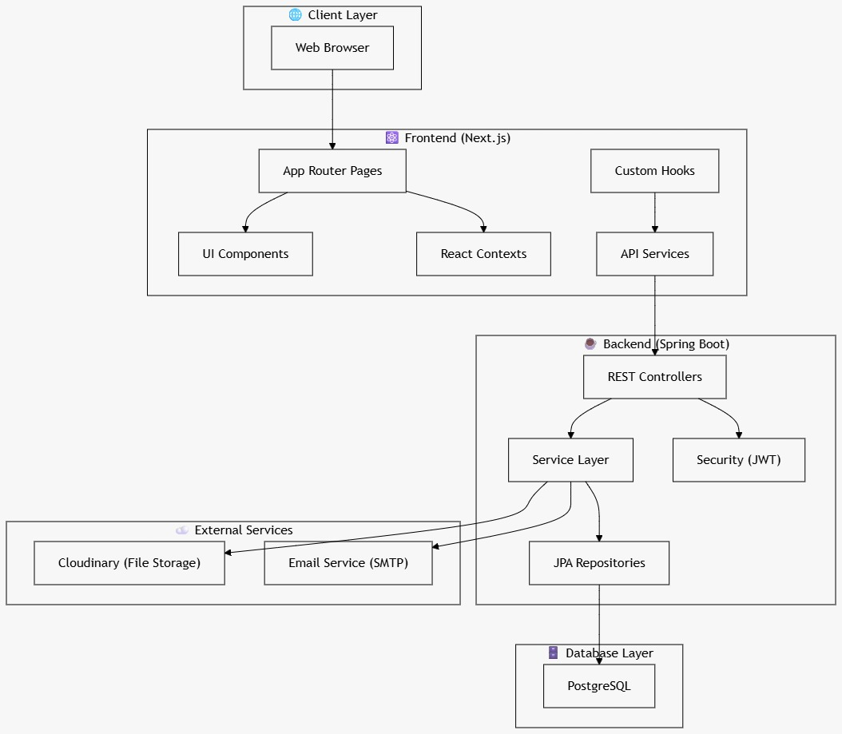
High-Level System Architecture

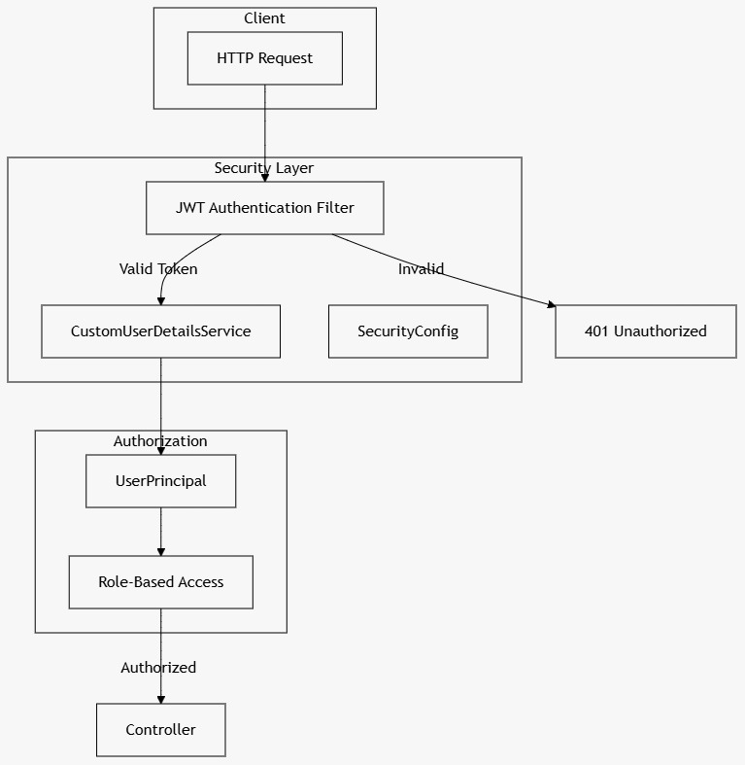
Security Architecture

