**Name: Muhammad Ahad Imran**

**ID: F2360734**

**PFAI LAB MIDS**

**Q2)**

**1)**

library(dplyr)

data(mtcars)

result <- mtcars %>%

filter(mpg > 20) %>%

arrange(desc(hp))

print(result)

**OUTPUT**

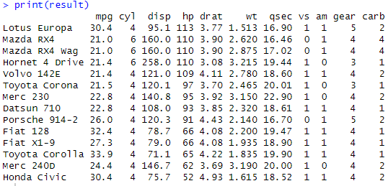

**2)**

library(ggplot2)

data(mtcars)

ggplot(mtcars, aes(x = wt, y = mpg)) +

geom_point() +

geom_smooth(method = "lm", se = FALSE) +

labs(title = "Relationship between Weight and MPG",

x = "Weight (1000 lbs)",

y = "Miles per Gallon")

**OUTPUT**

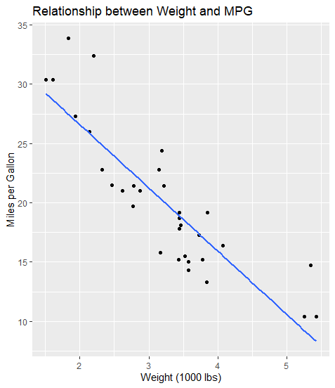

**3)**

# Sample data

data <- c(9, 10, 11, 12, 8, 9, 10, 11)

# One-sample t-test

t.test(data, mu = 10)

print(result)

**OUTPUT**

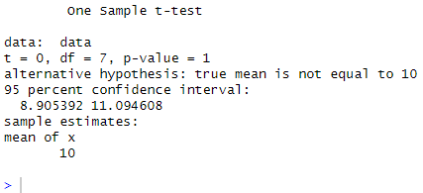

**4)**

library(caret)

data(mtcars)

# Split data into training and testing sets (80-20 split)

set.seed(123)

trainIndex <- createDataPartition(mtcars$mpg, p = 0.8, list = FALSE)

trainData <- mtcars[trainIndex, ]

testData <- mtcars[-trainIndex, ]

# Preprocess: scale the data

preProc <- preProcess(trainData, method = c("center", "scale"))

trainScaled <- predict(preProc, trainData)

testScaled <- predict(preProc, testData)

# Train linear regression model

model <- train(mpg ~ ., data = trainScaled, method = "lm")

# Predict on test set

predictions <- predict(model, newdata = testScaled)

# Evaluate with RMSE

rmse <- sqrt(mean((predictions - testScaled$mpg)^2))

print(paste("RMSE:", rmse))

**OUTPUT**

