Robot Sensors - Boston Dynamics’ Spot
Name: Ahad Maredia
Date: October 4, 2025
Course: Robot Operating Sys & Platform-14325

Introduction
Spot, a four-legged, semi-autonomous robot developed by Boston Dynamics, is designed for inspection, surveying, and data collection in industrial and hazardous environments. Its robust design enables it to operate in construction sites, energy facilities, and remote terrains where human access poses risks. Spot can carry customized payloads and sensors, making it suitable for applications in maintenance, security, and research.

Key Sensors
- LiDAR: Creates high-resolution 3D maps for localization, navigation, and obstacle avoidance.
- Cameras (Stereo, Depth, and Panoramic): Provide visual perception for terrain analysis, visual odometry, and object tracking.
- IMU (Inertial Measurement Unit): Measures angular velocity and acceleration to maintain balance and estimate movement.
- Ultrasonic Sensors: Detect close-range obstacles and support safe navigation in cluttered spaces.
- Thermal Camera (Optional Payload): Helps identify heat leaks, equipment malfunctions, or human presence in low-light environments.
- GPS/RTK System: Offers precise outdoor localization and route planning accuracy within centimeters.

Key Actuators
- Brushless Electric Motors: Control each leg’s joints for smooth, adaptive gait and precise motion.
- Servo Actuators: Enable balance recovery and terrain adaptation in real time.
- Articulated Arm (Attachment): Allows Spot to open doors, turn valves, or manipulate tools.
- Battery & Power Management System: Provides up to 90 minutes of runtime with swappable batteries for continuous operation.

Autonomy Level
Spot, a semi-autonomous system, can autonomously walk, map environments, and follow patrol routes. However, it still relies on human supervision for mission planning and complex task execution. Spot utilizes AI-based vision and mapping algorithms to detect humans, avoid collisions, and dynamically adapt to changing environments.

Data Pipeline
Sensors → Sensor Fusion → Perception (SLAM & Object Detection) → Path Planning → Motion Control → Actuators
The onboard NVIDIA computing unit processes sensor data using SLAM (Simultaneous Localization and Mapping) and computer vision to generate real-time decisions.
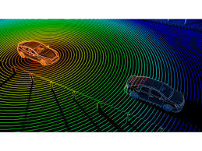
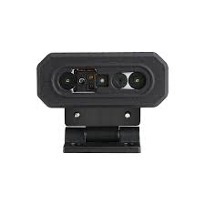
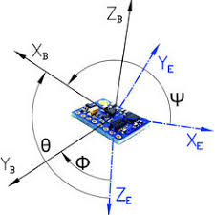

Sensor Fusion

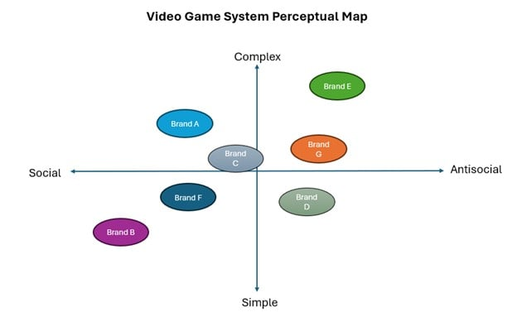

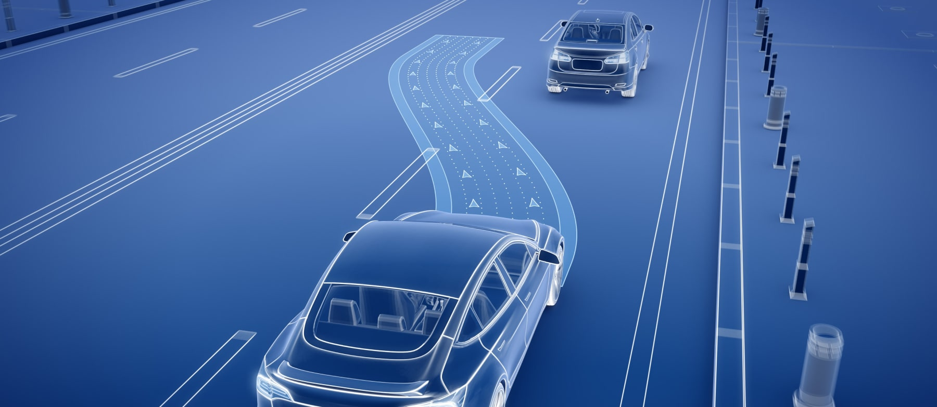
Path Planning and Decisions

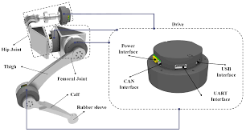
Actuators and Commands

Safety Concerns
- Collision Risk: Navigation errors or human proximity could cause physical accidents.
- Sensor Failure or Data Drift: LiDAR or IMU malfunction may compromise localization accuracy.
- Cybersecurity Threats: Unauthorized access could manipulate or disable Spot remotely.

Mitigations
- Sensor Redundancy: Overlapping LiDAR, vision, and IMU data ensure reliable perception.
- Emergency Stop Protocol: Spot automatically halts motion when detecting faults or unsafe conditions.
- Secure Communication: Encrypted wireless links and authentication prevent hacking.
- Human-Safe Interaction Design: Smooth, predictable motion patterns reduce injury risk near people.

