Term | Definition | Application | Visual Aid
Actuator | A device that converts electrical energy into physical motion, such as rotation or movement. | Used in robotic arms to move joints or control grippers. | 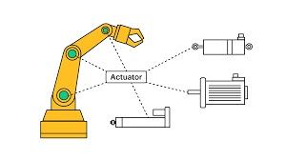
Artificial Intelligence (AI) | The ability of machines to perform tasks that usually require human intelligence, like learning or problem-solving. | AI enables robots like Boston Dynamics Spot to make decisions and navigate independently. | 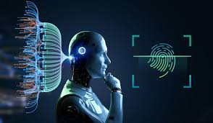
Autonomous System | A system capable of performing tasks or making decisions without human control. | Self-driving cars are autonomous systems that navigate roads safely. | 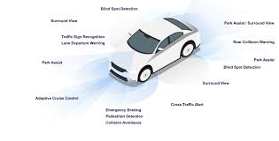
Battery Management System (BMS) | A system that monitors and manages the battery’s health, charge, and safety. | Used in mobile robots and drones to ensure efficient power use. | 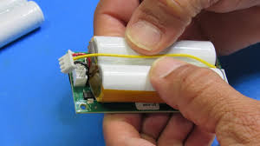
Computer Vision | The field that enables computers and robots to understand images and video from the real world. | Used in factory robots to detect product defects or count items. | 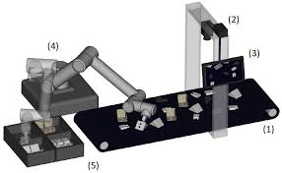
Control System | A system that manages and regulates the behavior of other devices or systems. | Used in drones to maintain stable flight using feedback loops. | 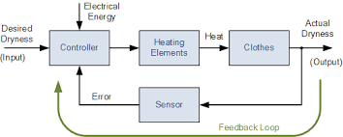
Deep Learning in Robotics | A subset of AI that uses neural networks to help robots learn complex tasks from large amounts of data. | Used in humanoid robots to recognize gestures and respond appropriately. | 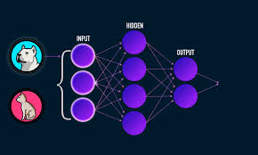
End Effector | The part of a robotic arm that interacts with the environment, like a gripper or welding tool. | Industrial robots use end effectors to pick and place parts on assembly lines. | 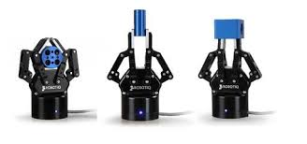
Human-Robot Interaction (HRI) | The study of how humans and robots communicate and work together. | Used in healthcare robots that assist elderly patients safely. | 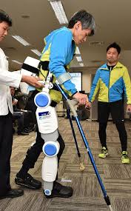
Kinematics | The study of motion without considering the forces causing it. | Used to calculate how robotic arms move between points in space. | 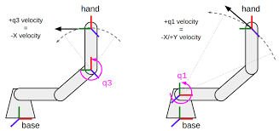
LiDAR (Light Detection and Ranging) | A sensor that measures distances using laser light to map the environment. | Used in autonomous vehicles for 3D mapping and obstacle detection. | 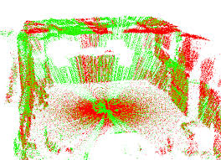
Localization | The process by which a robot determines its position within an environment. | Used in warehouse robots to know their location while delivering goods. | 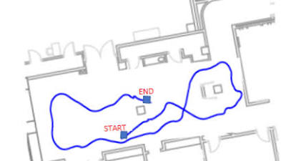
Machine Learning in Robotics | A method where robots improve their performance based on data and experience. | Used in cleaning robots that learn the layout of a home over time. | 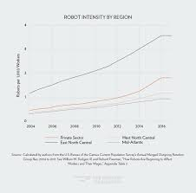
Motion Planning | The process of determining how a robot should move from one point to another safely. | Used in robotic arms to avoid collisions during assembly tasks. | 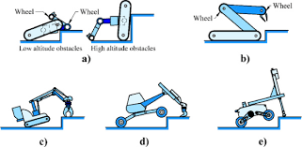
Pathfinding | Algorithms that help robots find the best route between two points. | Used in delivery robots to navigate city sidewalks efficiently. | 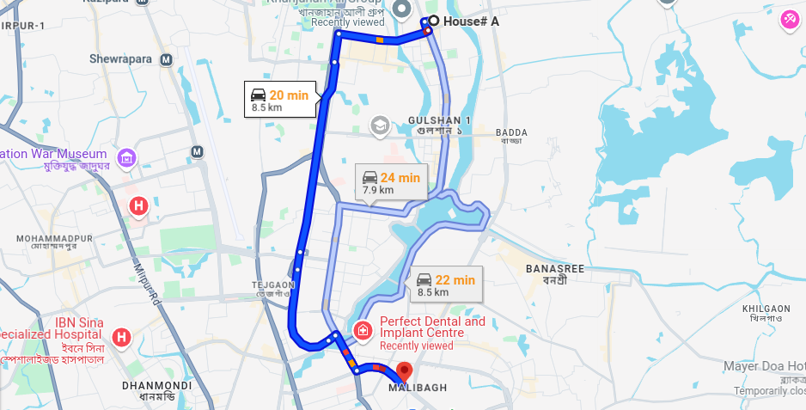
Perception | The ability of a robot to sense and interpret its surroundings using sensors. | Used in autonomous drones to detect buildings and adjust flight paths. | 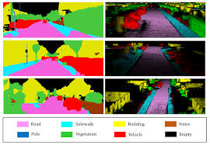
Reinforcement Learning | A machine learning method where robots learn by trial and error using rewards or penalties. | Used in robotic dogs that learn to walk or balance better over time. | 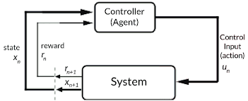
Robotic Operating System (ROS) | An open-source framework for building and controlling robots through modular software components. | Used in research robots for controlling sensors, motors, and data exchange. | 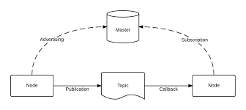
Sensor Fusion | Combining data from multiple sensors to get more accurate information about the environment. | Used in autonomous vehicles to merge data from cameras, LiDAR, and radar. | 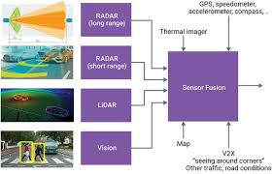
SLAM (Simultaneous Localization and Mapping) | A technique that allows robots to build a map of an unknown area while keeping track of their location. | Used in vacuum robots to map homes and clean efficiently. | 