**Lab Report:** *02*

**Title:** *Detection of Spectrum of a Periodic Pulse Train*

***Course Title:*** *Data and Telecommunication Laboratory*

***Course Code:*** *CSE-260*

*2nd Year 2nd Semester Examination 2023*



**Submitted to :-**

***Sarnali Basak***

*Associate Professor*

***Dr. Md. Imdadul Islam***

*Professor*

***Dr. Md. Abul Kalam Azad***

*Professor*

*Department of Computer Science and Engineering*

*Jahangirnagar University*

*Savar, Dhaka-1342*

|  |  |
| --- | --- |
| Class Roll | Name |
| 371 | Md. Ahad Siddiki |

Date of Submission: 01/12/2024

## Detection of Spectrum of a Periodic Pulse Train

The analysis of periodic pulse trains is essential in understanding the frequency-domain characteristics of signals, particularly in communication systems. A periodic pulse train consists of repeating rectangular pulses with specific amplitude, period, and width parameters. This experiment explores how the pulse width $(τ)$ and period $(T)$ affect the spectrum of the signal. By examining the Fourier series representation, the amplitude spectrum, and phase characteristics, we gain insights into the behavior of spectral components. Understanding these impacts is vital for designing and optimizing signals for transmission, filtering, and other signal processing applications.

**Objective:**

The objective of this experiment is to analyze the impact of the period (T) and width (τ) of a rectangular pulse train on its spectrum. The experiment demonstrates the use of Fourier series to calculate and visualize the spectral characteristics of periodic signals.

To analyze the influence of pulse width $(τ)$ and period $(T)$ on the spectrum of a rectangular periodic pulse train by observing changes in amplitude, spectral separation, and zero-crossing points using Fourier series principles.

**The period of the pulse train is $T$**

**The frequency of the pulse train is $f_{c}=1/T$**

$$C_{n}=A*τ*sinc\left(\frac{n*τ}{T}\right)$$

## Experimental Equipment and Software

* MATLAB R2018a Software.
* Computer Workstation.

## Q1. Spectrum of periodic signal is discrete:

**Code:**

A=2;

n=-15:1:15;

T=2;

tau=0.2;

Cn=A*tau*sinc(n*tau/T);

stem(n/T,Cn, 'k')

xlabel('nf')

ylabel('Cn')

title('Spectrum of rectangular pulse train A=2, T=2 and Tau=0.2 units')

grid on

**Output:**

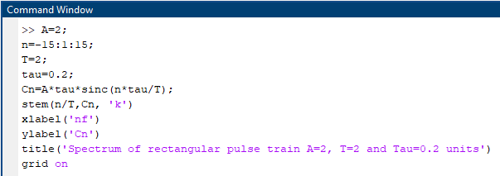



**Fig : Rectangular Pulse Train**

## Q2. Impact of impact of τ on shifting of zero crossing points:

$τ$ is directly proportional to $d$. Changing $τ$ modifies $d$, which is the scaling factor for the argument of the $sinc$ function **($n .d)$**

**Code:**

subplot(2,1,1)

n=-20:1:20;

T=10;

tau=2;

d=tau/T;

y=sinc(n*d);

stem(n/T,y, 'k')

title('tau=10')

subplot(2,1,2)

tau=5; %reduced

d=tau/T;

y=sinc(n*d);

stem(n/T,y, 'k')

title('tau=5')



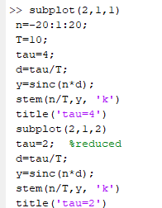**Output:**

**Fig : Impact of** τ

**Result:**

**Graph Characteristics:**

1. First Subplot $(τ=4)$:
   * With a higher $τ$, $d$ is larger, so the oscillations of the $sinc$ function are more compressed.
   * The zero-crossing points are closer to each other along the $x$-axis.
2. Second Subplot $(τ=2)$:
   * With a reduced $τ$, $d$ is smaller, so the oscillations of the $sinc$ function are more spread out.
   * The zero-crossing points move farther apart on the $x$-axis.

## Q3. Impact of impact of $T$:

**Code:**

subplot(2,1,1)

n=-10:1:10;

T=2;

tau=0.2;

d=tau/T;

y=sinc(n*d);

stem(n/T,y, 'k')

title('T=2')

subplot(2,1,2)

n=-5:1:5;

T=1;

tau=0.2;

d=tau/T;

y=sinc(n*d);

stem(n/T,y, 'k')

title('T=1')



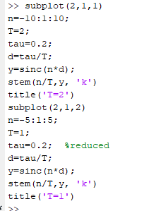**Output:**

**Fig : Impact of $T$**

* For Period T=0.5 , T=0.3

**Code:**

subplot(2,1,1)

n=-10:1:10;

T=0.5;

tau=0.2;

d=tau/T;

y=sinc(n*d);

stem(n/T,y, 'k')

title('T=0.5')

subplot(2,1,2)

n=-5:1:5;

T=0.3;

tau=0.2;

d=tau/T;

y=sinc(n*d);

stem(n/T,y, 'k')

title('T=0.3')

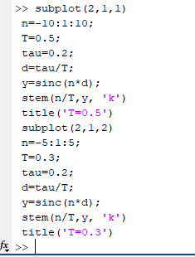**Output:**

**Fig : Impact of $T$**

**Result:**

• is used to scale the $x$-axis values by dividing the indices $n$. As $T$ changes, the distance between consecutive points $(n/T)$ on the $x$-axis adjusts.

• Larger $T$: Points are more spread out, leading to a "**compressed**" appearance in terms of the $x$-axis scale.

• Smaller $T$: Points are closer together, leading to a "**stretched**" appearance in terms of the $x$-axis scale.

## Q4. Impact of impact of 𝑵 :

**Code:**

subplot(2,1,1)

n=-41:1:41;

T=2;

tau=0.2;

d=tau/T;

y=sinc(n*d);

stem(n/T,y, 'k')

title('n=41')

subplot(2,1,2)

n=-14:1:14;

T=2;

tau=0.2;

d=tau/T;

y=sinc(n*d);

stem(n/T,y, 'k')

title('n=14')

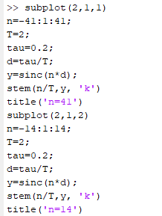

**Output:**

**Fig : Impact of $n$**

**Graph Characteristics:**

**First Subplot $(n=-41:41):$**

* The range of the xxx-axis is wider $(-41/T to 41/T).$
* This larger range shows more oscillations of the $sinc$ function, including more side lobes.
* The graph will be smoother because more samples are plotted.

**Second Subplot $(n=-14:14):$**

* The range of the $x$-axis is smaller $(-14/T to 14/T)$
* This smaller range captures fewer oscillations, primarily focusing on the main lobe and possibly the first few side lobes.
* The graph will appear less detailed due to fewer samples.

**Range of the Graph:**

* **Larger $n$:** Expands the range, showing more of the $sinc$ function’s oscillations (more side lobes).
* **Smaller $n$:** Limits the range, showing only the central part of the $sinc$ function (main lobe and a few side lobes).

**Conclusion**

The experiment demonstrated the significant role of pulse width $(τ)$ and period $(T)$ in determining the spectral characteristics of a periodic pulse train. Key observations include the following:

* Increasing $τ$ reduces the frequency spacing between spectral lines, resulting in fewer zero-crossing points and a more concentrated spectrum.
* Decreasing $T$ leads to an increase in the separation between spectral lines, reflecting a higher repetition rate.
* The zero-crossing points on the amplitude spectrum align with theoretical expectations, confirming that spectral components shift as $τ$ and $T$ vary.  
  These findings provide a deeper understanding of signal design and its implications in frequency-domain analysis.