FILIGREE HOME DECOR
Product Scoring Sheet - User Guide
Version 3.5 | April 2026
Part 1 - Running the Product Scoring
Use this section every time you receive a new Kalalou or Melrose supplier catalog and want to generate a fresh Top 15 product selection.

Step 1 - Paste Kalalou Raw Data
- Click the Kalalou Raw tab at the bottom of the screen
- Select all existing data by pressing Ctrl+A (Windows) or Cmd+A (Mac) by clicking at top Left ( Red Box).
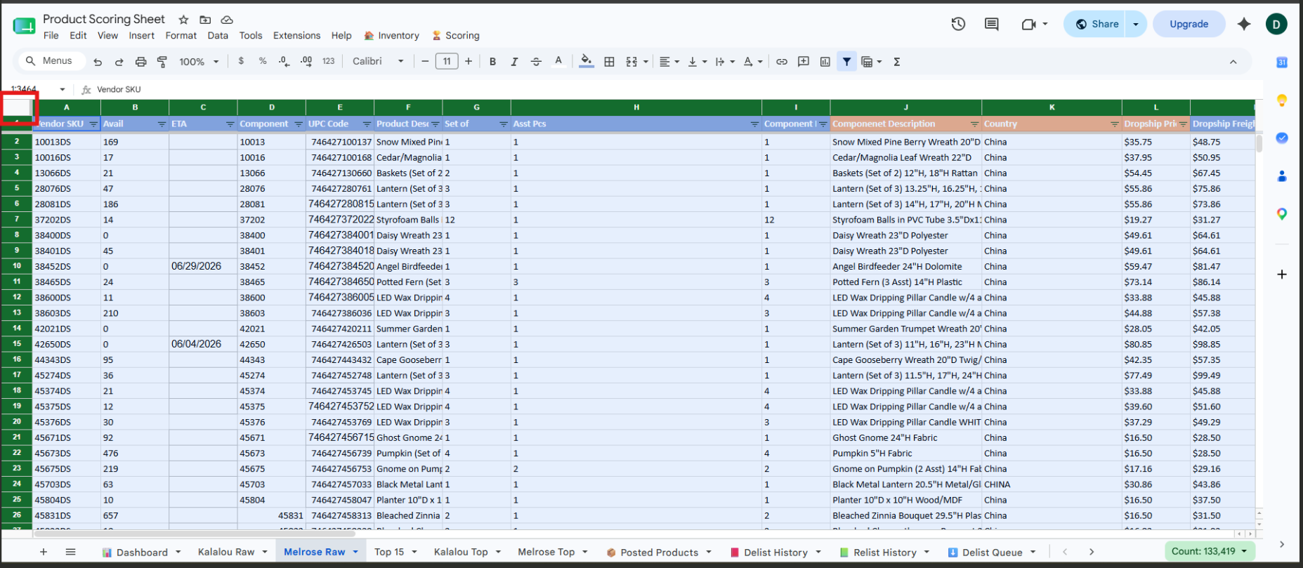
3. Delete the selected data by pressing the Delete key
4. Open the new Kalalou supplier catalog file received from Kalalou
5. Select all data including the header row in the Kalalou file ( by same way clicking at top right RED BOX).
6. Copy the data by pressing Ctrl+C (Windows) or Cmd+C (Mac)
7. Click on cell A1 in the Kalalou Raw tab
8. Paste the data by pressing Ctrl+V (Windows) or Cmd+V (Mac)
Note: The Kalalou Raw tab must have these column headers exactly as they appear in the Kalalou catalog: Name, Display Name, Available, Freight Only, Discontinued, Function, Theme, Material, Color, Product Copy, Construction, and the cost and MAP columns. Do not rename or rearrange columns.

Step 2 - Paste Melrose Raw Data
1. Click the Melrose Raw tab at the bottom of the screen
2. Select all existing data by Clicking Top Right RED BOX.
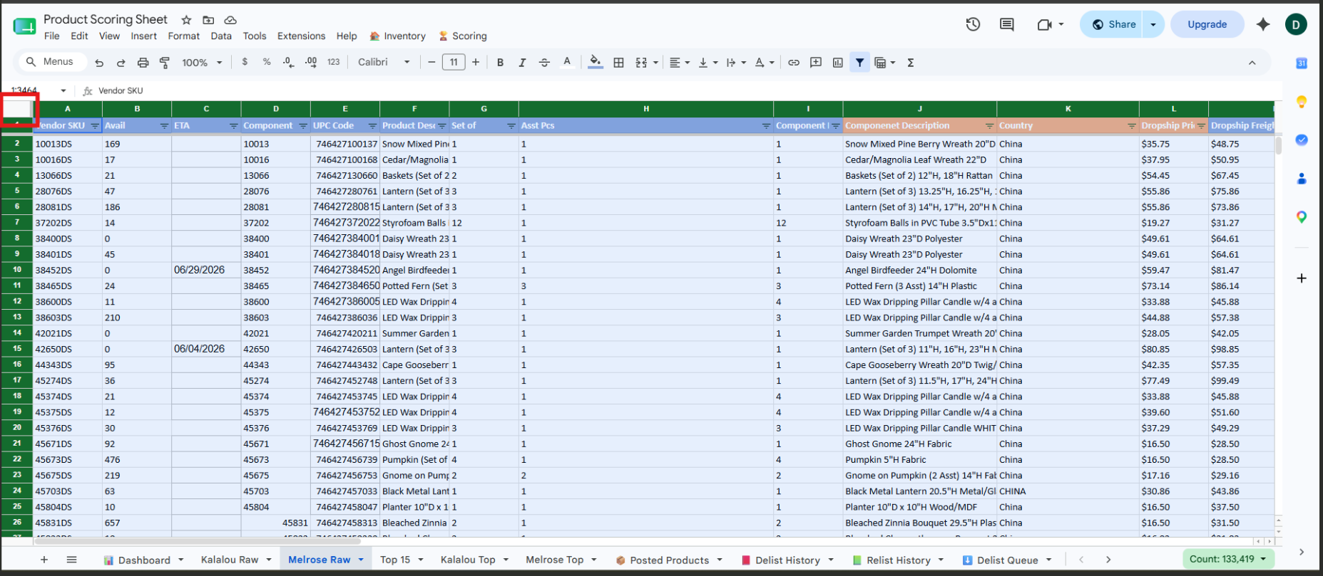
3. Delete the selected data by pressing the Delete key
4. Open the new Melrose supplier catalog file received from Melrose
5. Select all data including the header row in the Melrose file Same way by clicking on the top Right
6. Copy the data by pressing Ctrl+C (Windows) or Cmd+C (Mac)
7. Click on cell A1 in the Melrose Raw tab
8. Paste the data by pressing Ctrl+V (Windows) or Cmd+V (Mac)
Note: The Melrose Raw tab must have these column headers exactly as they appear in the Melrose catalog: Vendor SKU, Web Title, Dropship Freight Included Price, MSRP, New Avail, Product Category, Style, Item Materials, Color, Marketing Copy, and Set of. Do not rename or rearrange columns.

WRONG WAY OF ADDING DATA The header must always start from Row 1:
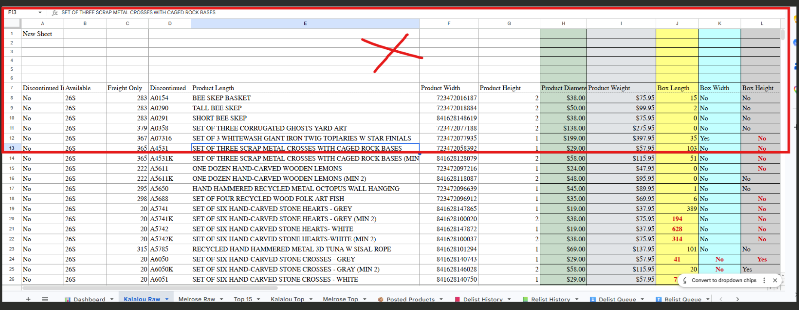

Step 3 - Run the Scoring
1. Click the Scoring menu in the top menu bar
2. Click Run Scoring and Generate All Tabs
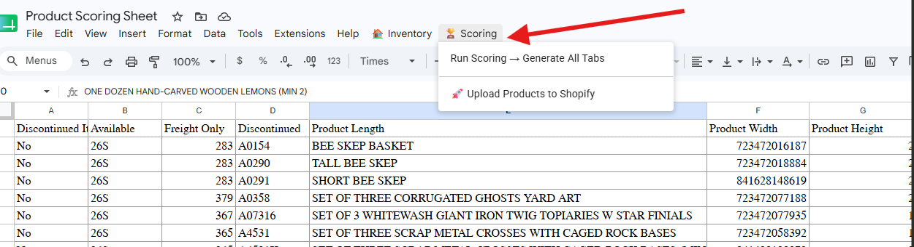
- A keyword prompt will appear. If you want to force include specific products by theme or keyword, type the keywords separated by commas. For example: bee, butterfly, mushroom. Leave blank and click OK if you do not want to use keywords.
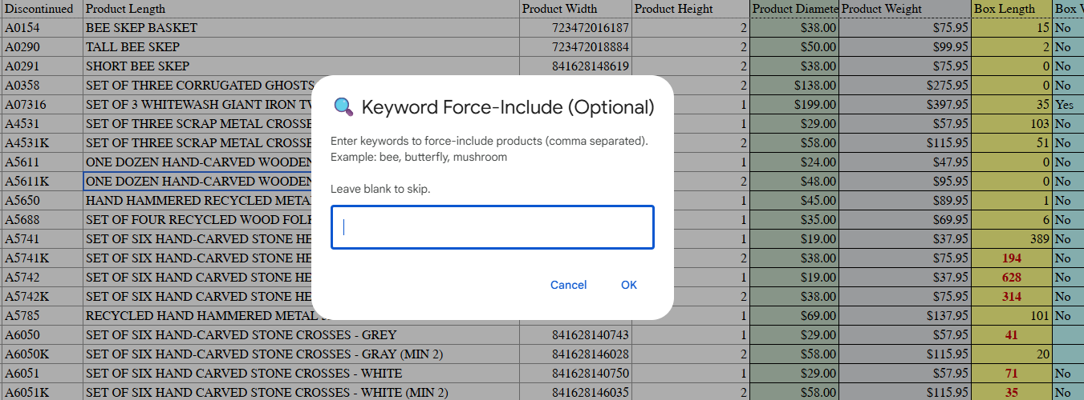
4. Wait a few seconds for the scoring to complete
5. A summary popup will appear showing how many products were selected. Click OK to close it.
Note: Keywords force include up to 5 matching products from each supplier into the Top 15 regardless of their score. Use this for seasonal buying decisions. For example during summer type: coastal, seashell to ensure those products appear.

Step 4 - Review the Top 15
1. Click the Top 15 tab at the bottom of the screen
2. Review the combined list of top products from both Kalalou and Melrose
3. Check the TIER column to see the recommendation for each product:
STRONG BUY: score 72 and above — recommended to purchase
CONSIDER: score 58 to 71 — review carefully before purchasing
LOW PRIORITY: score below 58 — not recommended
4. Use the SKU in column B and Supplier in column A to prepare your purchase order
5. To see the full scored list for each supplier individually click the Kalalou Top or Melrose Top tabs
Note: The Eligible column in Kalalou Top and Melrose Top shows a green tick for products included in scoring and a red cross for excluded products along with the reason for exclusion such as Discontinued, Zero Stock, or Missing Cost.

Step 5 - Upload Products to Shopify
1. After reviewing and finalising the Top 15 selection, click the Scoring menu in the top menu bar
2. Click Upload Products to Shopify
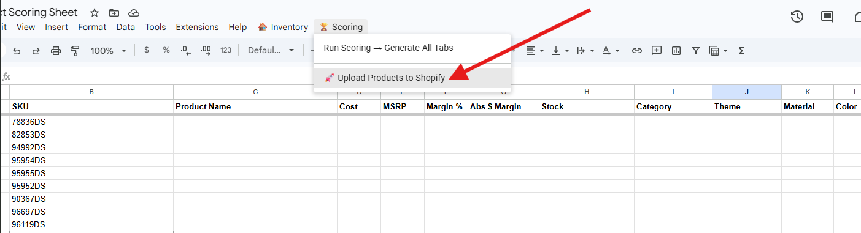
3. This will automatically trigger the product upload flow and add the selected products to your Shopify store
4. The uploaded products will also be automatically added to the Posted Products tab so they are tracked for inventory monitoring
Note: Do not close the sheet while the upload is in progress. Wait for a confirmation before proceeding.

ISSUES WHILE ADDING THE PRODUCTS TO SHOPIFY:
- MAKE SURE THE SKU’S WHICH YOU HAVE IN SHEET ‘TOP 15’ REALLY EXISITS IN THE SUPPLIER SHEETS OF KALOLU AND MELAROSE.

Part 2 - Managing Inventory (Delist and Relist)
Use this section on a regular basis to keep your Shopify store in sync with supplier stock. Products that go out of stock should be delisted. Products that come back in stock should be relisted. Only products in the Posted Products tab are monitored.
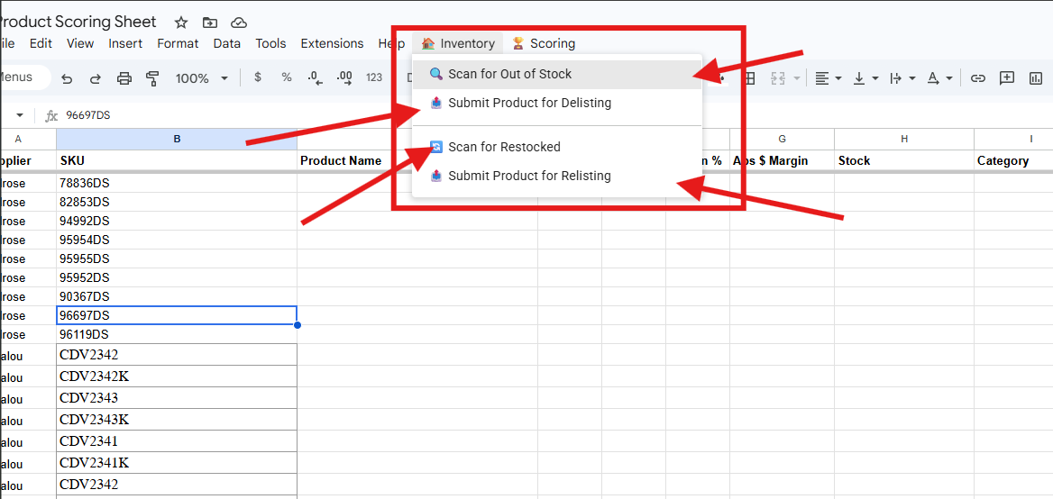

Step 6 - Scan for Out of Stock Products
1. Make sure the Kalalou Raw and Melrose Raw tabs have the latest supplier catalogs pasted in
2. Click the Inventory menu in the top menu bar
3. Click Scan for Out of Stock
4. The system will scan all products in the Posted Products tab and check their stock against the raw catalog data
5. Products with zero stock will appear in the Delist Queue tab for your review
6. Go to the Delist Queue tab and review the products flagged for delisting before proceeding

Step 7 - Submit Products for Delisting
1. After reviewing the Delist Queue tab and confirming the products should be delisted, click the Inventory menu
2. Click Submit Product for Delisting
3. The system will process the delist and remove the products from your Shopify store
4. A record of all delisted products will be saved in the Delist History tab
Note: Always review the Delist Queue before submitting. Once submitted the products will be removed from your live store.

Step 8 - Scan for Restocked Products
1. Make sure the Kalalou Raw and Melrose Raw tabs have the latest supplier catalogs pasted in
2. Click the Inventory menu in the top menu bar
3. Click Scan for Restocked
4. The system will check previously delisted products to see if they now have stock available
5. Products that are back in stock will appear in the Relist Queue tab for your review
6. Go to the Relist Queue tab and review the products flagged for relisting before proceeding

Step 9 - Submit Products for Relisting
1. After reviewing the Relist Queue tab and confirming the products should be relisted, click the Inventory menu
2. Click Submit Product for Relisting
3. The system will process the relist and bring the products back to your Shopify store
4. A record of all relisted products will be saved in the Relist History tab
Note: Always review the Relist Queue before submitting. Once submitted the products will go live on your store immediately.

Recommended Weekly Workflow
When new supplier catalogs arrive:
1. Paste new Kalalou and Melrose catalogs into the raw tabs
2. Run Scoring to generate fresh Top 15
3. Review Top 15 and place purchase order
4. Upload selected products to Shopify
For ongoing inventory management:
1. Paste the latest supplier catalogs into the raw tabs
2. Scan for Out of Stock and submit delist if needed
3. Scan for Restocked and submit relist if needed

Filigree Home Decor | Product Scoring Sheet v3.5 | April 2026

