# GENESIS –Embedded Learning Report

./

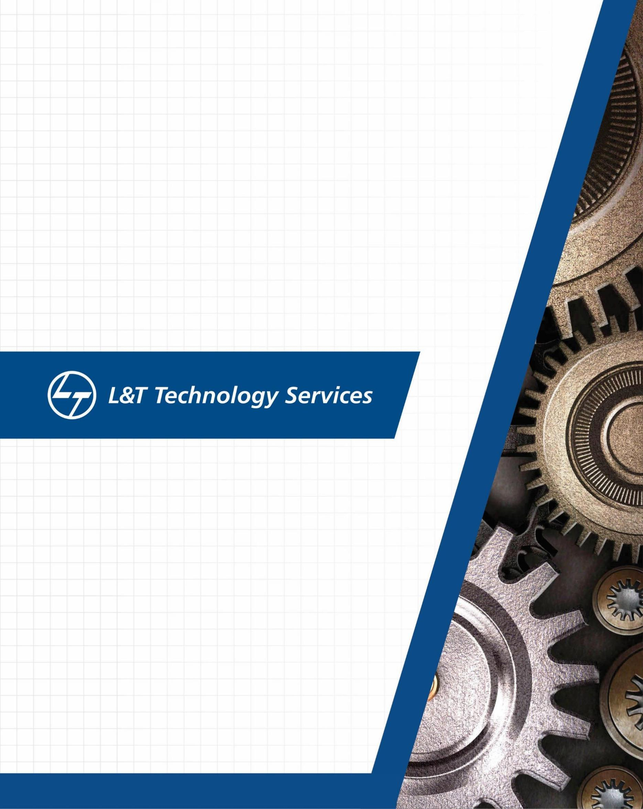

**Details**

|  |  |  |  |  |  |
| --- | --- | --- | --- | --- | --- |
| **Ver. Rel.**  **No.** | **Release Date** | **Prepared. By** | **Reviewed By** | **To be Approved** | **Remarks/Revision Details** |
| 1.0 | 03/01/2021 | Siddi.Ahalya |  |  |  |
|  |  |  |  |  |  |
|  |  |  |  |  |  |
|  |  |  |  |  |  |
|  |  |  |  |  |  |

## LIST OF FIGURES

## Activity 1…………………………………………………………………………………………………………………………………4

**FIGURE…………………………………………………………………………………………………….……………………………………………..5**

**MASTER CODE………………………………………………………………………………………………………………………………………..6**

**SLAVE CODE …………………………………………………..……………………………………………………………………..………………7**

## Activity 1:

## GIT link: <https://github.com/Ahalyasiddi/Embedded-Project>

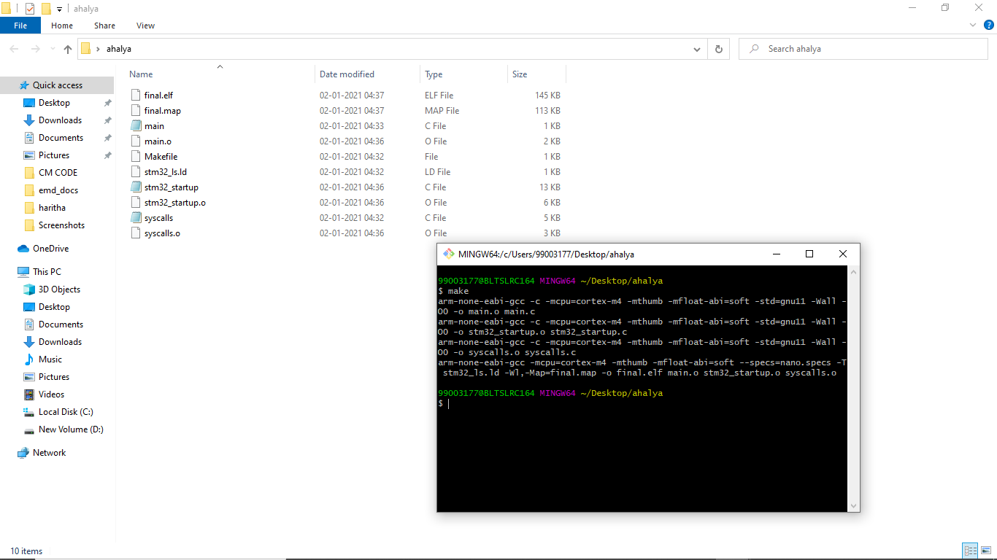

**MINI PROJECT**

**GIT LINK:** <https://github.com/Ahalyasiddi/Embedded-Project>

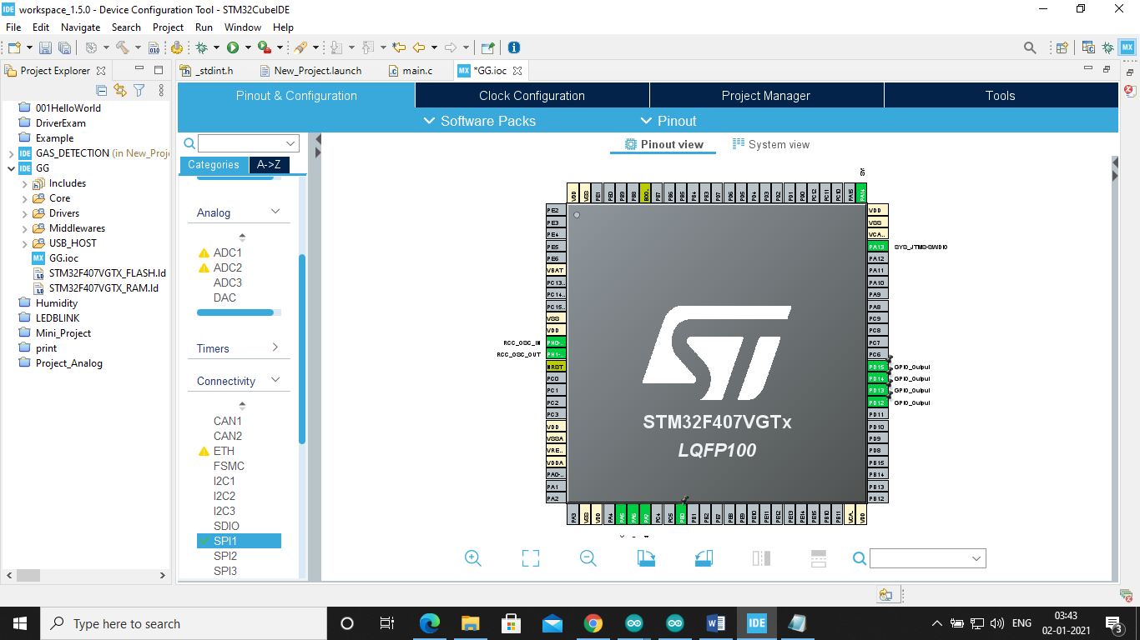

MASTER CODE:

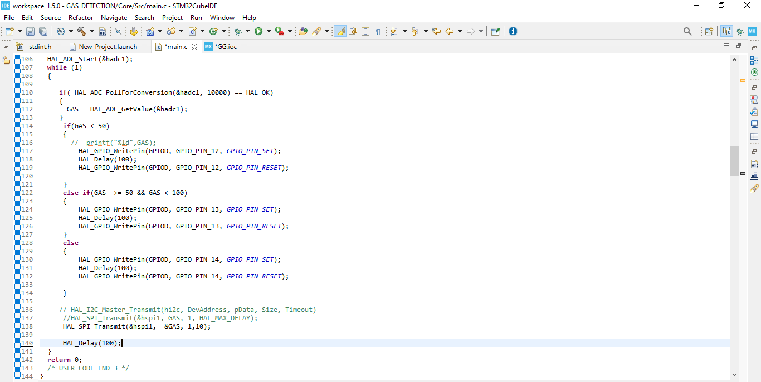

SLAVE CODE:

