Name: S.Dhanish Ahamed
Reg No: 25BCE0001

Python Code Review

1) Remote Code Execution & Command Injection
- The /exec endpoint takes a cmd parameter and passes it directly to subprocess.check_output with shell=True. An attacker can run any command.
- Fix: Remove this webpoint entirely. There is rarely need for such functionality in a web app.
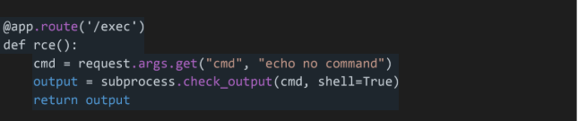

- The /ping endpoint inserts user input directly into a shell command string. An attacker can append commands using delimiters.
- Fix: Validate that the input is an ip address using ipaddress library
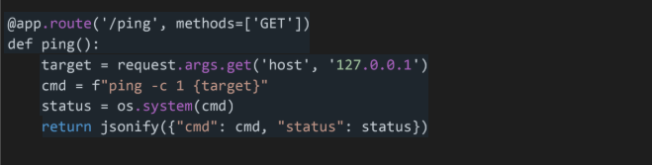
- The /deserialize endpoint accepts a file and passes its contents to “pickle.loads”. Pickle allows arbitrary code execution during deserialization. An attacker can craft a malicious pickle file that runs code when loaded
- Fix: Never use pickle on untrusted data

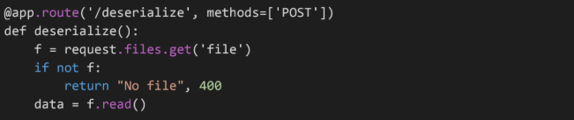
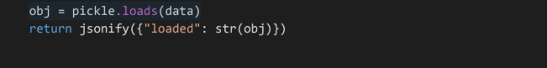
2) SQL Injection

- The application constructs SQL queries using string formatting with unsanitized user input
- The login query inserts username directly into the SQL string.
- An attacker can login as any user without a password (e.g. ‘ OR ‘1’=’1’)
- The /profile endpoint injects the uid from the token into a query
- /super_admin endpoint injects username
- Use parametrized queries to fix this vulnerability

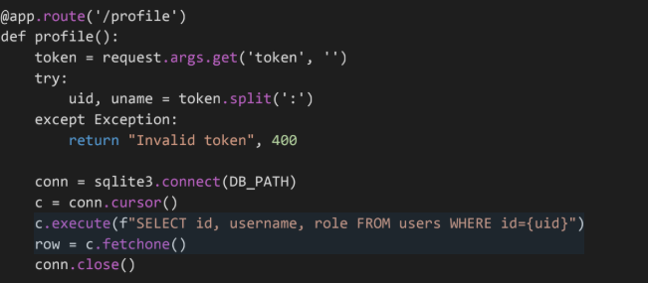
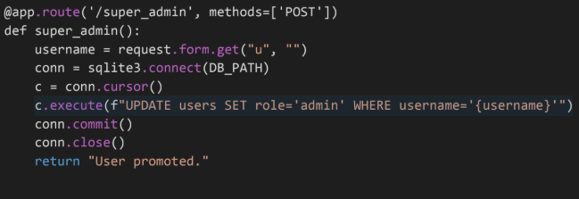
3) Broken Authentication and Session management

1) Logging Credentials: The application writes plain-text passwords to a log file.
- Risk: If the log file is accessed (e.g., via the Local File Inclusion vulnerability below), attackers gain all user passwords.
- Fix: Never log passwords or sensitive data.
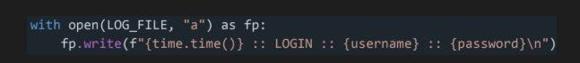
2) Hardcoded Secret Key: The application uses a hardcoded secret key.
- Risk: If tokens were signed (which they aren't here, but in general), anyone with the code could forge valid sessions.
- Fix: Load secrets from environment variables.

4. File System Vulnerabilities

1) Arbitrary File Read (Path Traversal): The /read endpoint opens any filename provided by the user.
  - Risk: Attackers can read sensitive system files (e.g., /etc/passwd, auth.log, source code).
  - Fix: Validate that the requested file exists within a specific allowed directory and does not contain traversal characters (..)
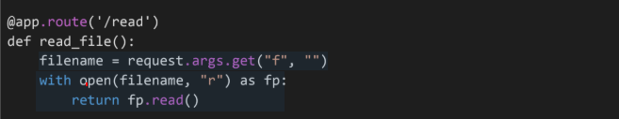
2) Unrestricted File Upload: The /upload endpoint saves files using the user-provided filename without validation.
  - Risk: Attackers can upload malicious scripts (e.g., webshells) or overwrite critical system files by using paths like ../../overwrite_me.
  - Fix: Use werkzeug.utils.secure_filename and validate the file extension/content type.
