Name: S.Dhanish Ahamed
Reg No: 25BCE0001
Email: dhanish.ahamed2025@vitstudent.ac.in
Domain: Cybersecurity

Task1: Capture The Flag

1) Question: https://play.picoctf.org/practice/challenge/18

Solution:
- The question asks us to find a flag that is hidden somewhere within the website
- When the source code of the website is exmined by opening developer tools by pressing F12, we find three parts of the flag in (index), myjs.js, mycss.css
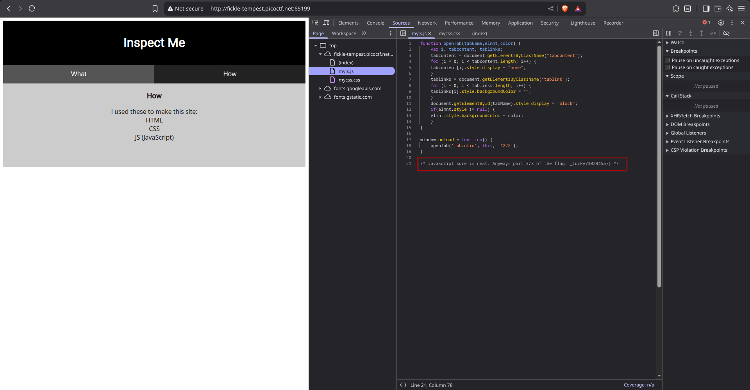
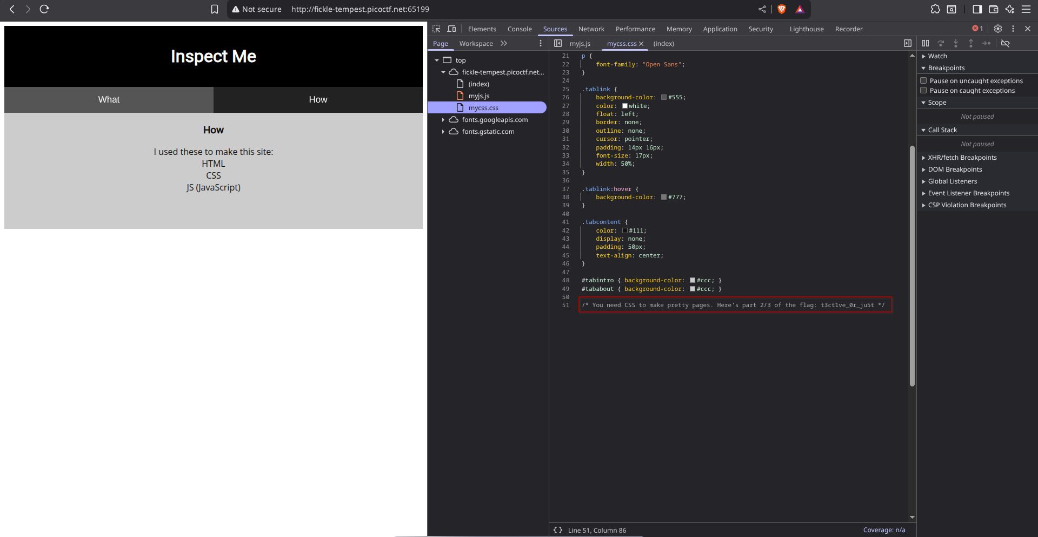
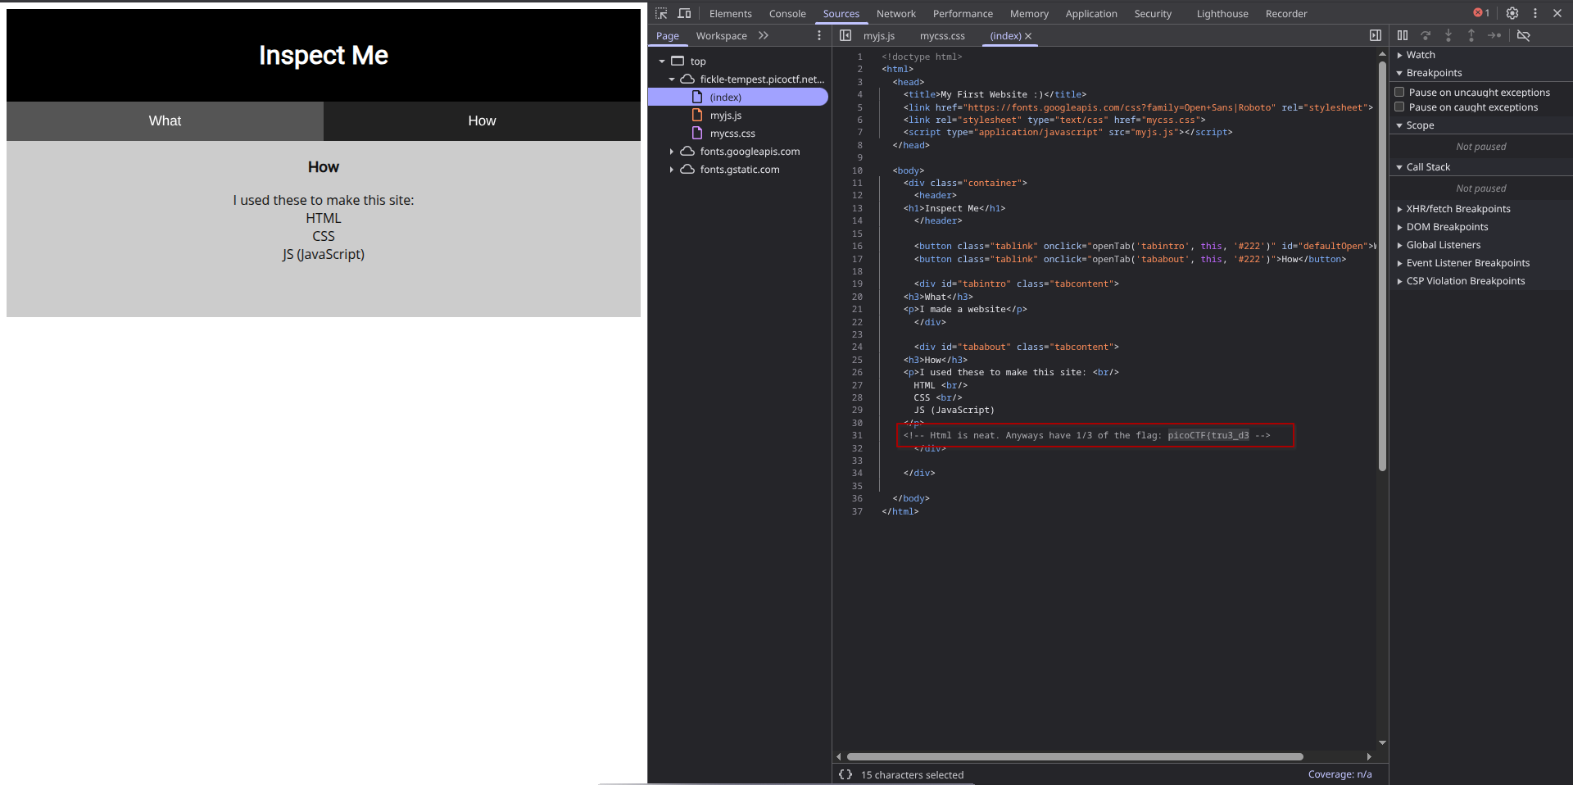
2) Question: https://play.picoctf.org/practice/challenge/8

- A link to a website is given. When you go to the login page it asks you to enter the password for admin
- Press F12 to enter developer tools. In the HTMl the line and replace the value with 1. This will show the actual SQL query that is being run in the background
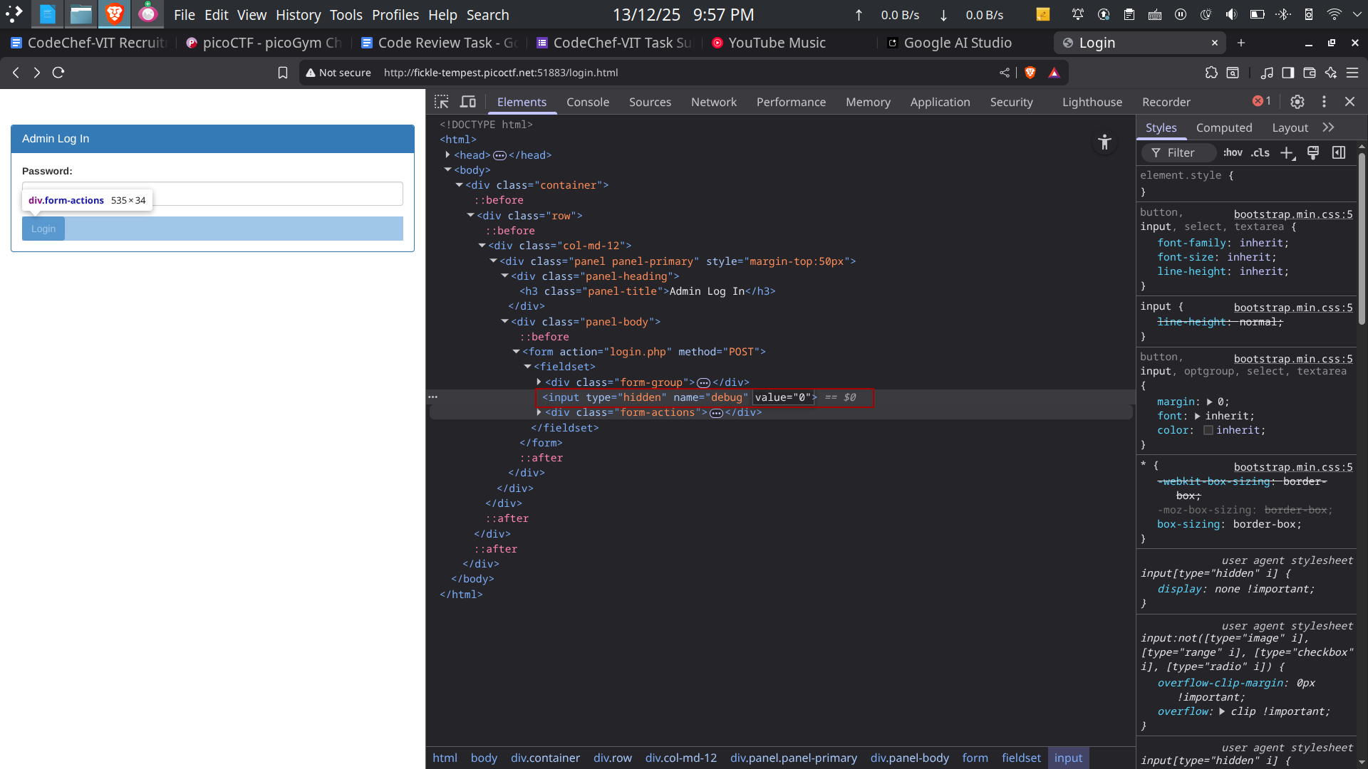
- Enter any random password and click login. This will reveal the actual SQL query being run in the background. We can see that the password we enter is being encrypted. The encryption used in ROT13 (a simple substitution cipher that replaces a letter with the 13th letter after it)
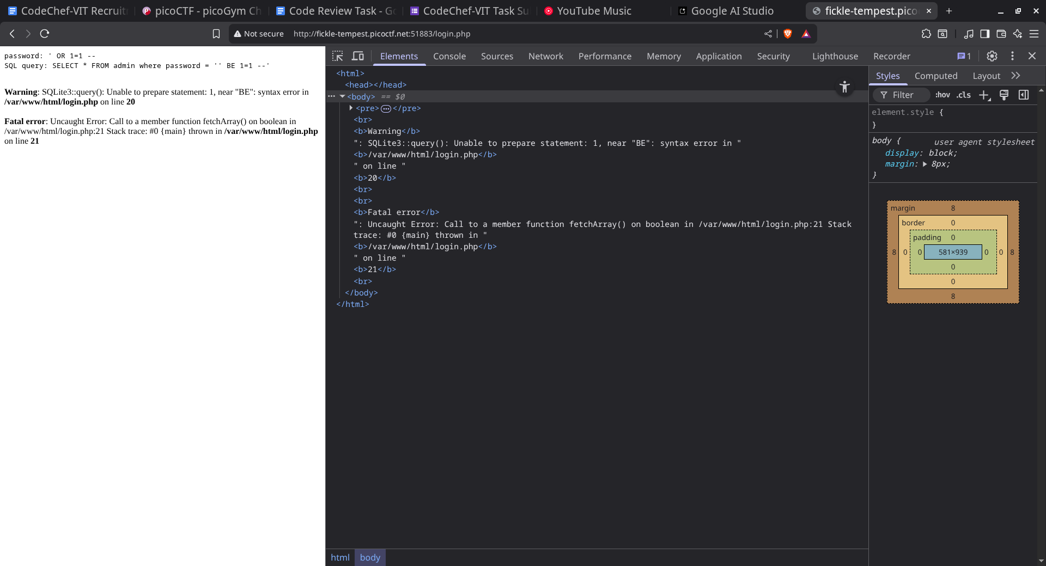
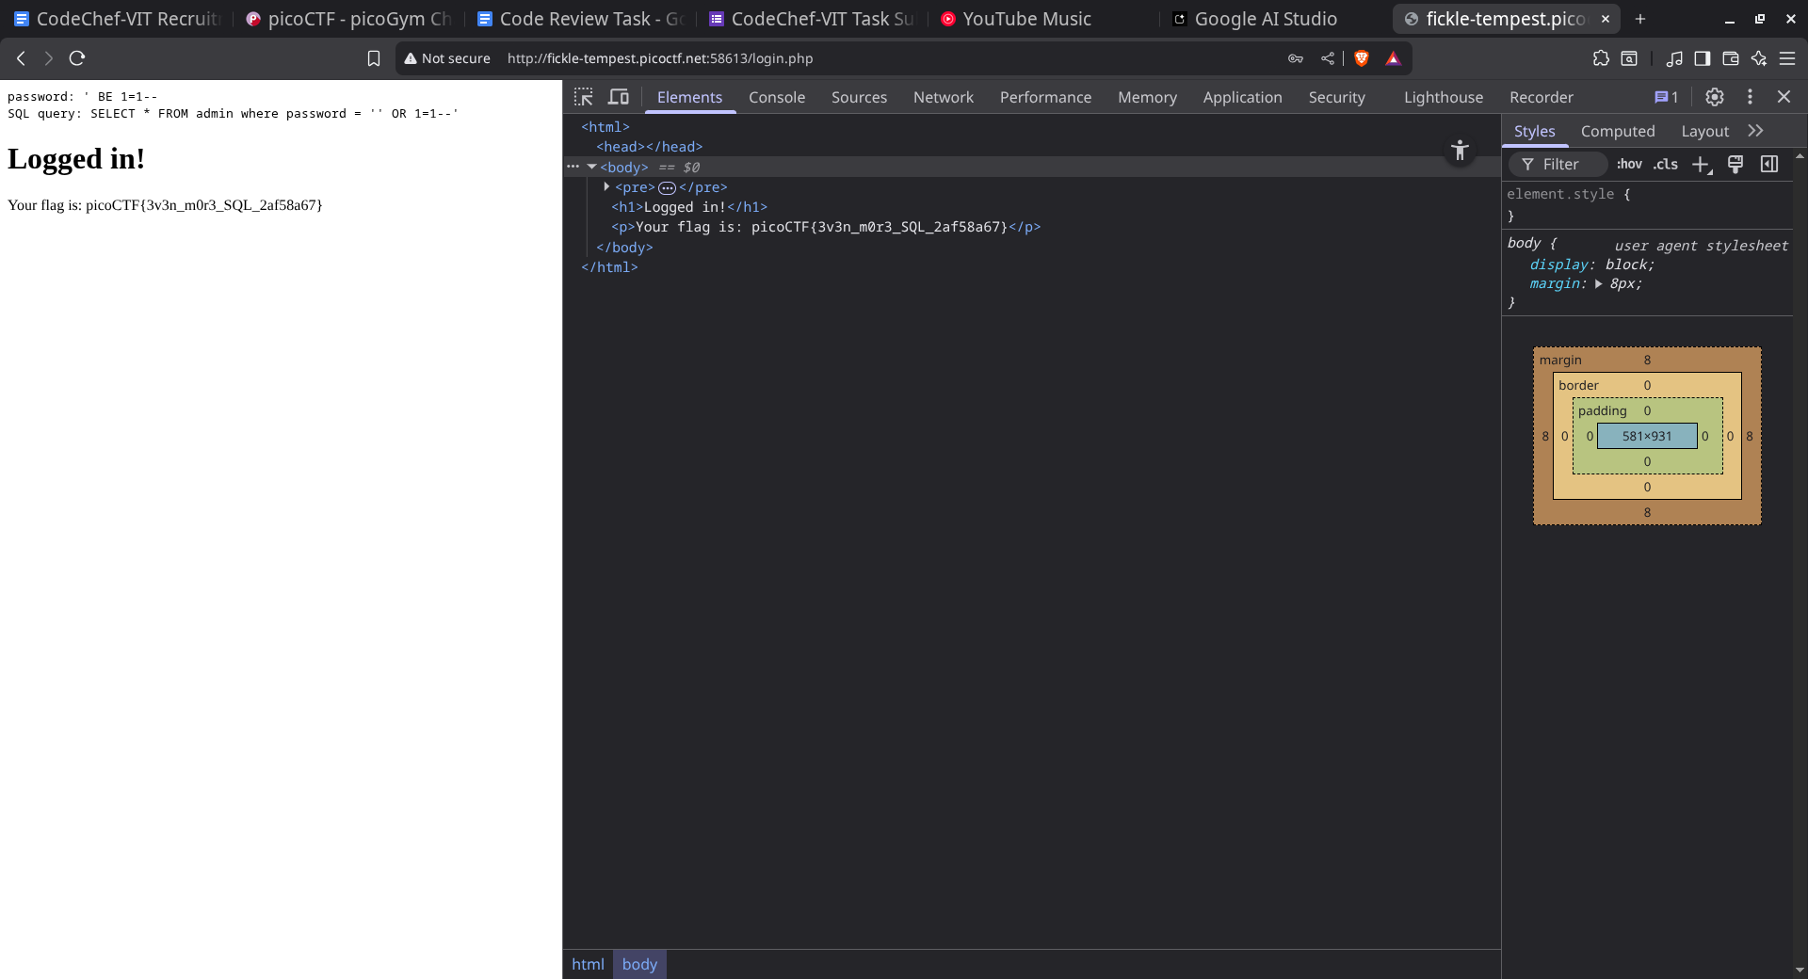
- Now if we do SQL injection and enter the query ' OR 1=1-- we get the key. We have to enter the ROT13 version of the query ' OR 1=1--, which is ' BE 1=1--

Question3: https://play.picoctf.org/practice/challenge/116

- A netcat command is given in the question. When we run the netcat command we get a bunch of CNC machine codes also known as G-Code
- A CNC machine code is a type of code which gives a manufacturing machine exact coordinates of the point to move.
- When the G-codes are converted into a 3D model using an online converter we get the Flag
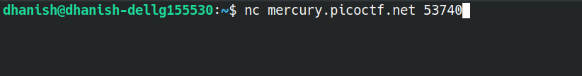
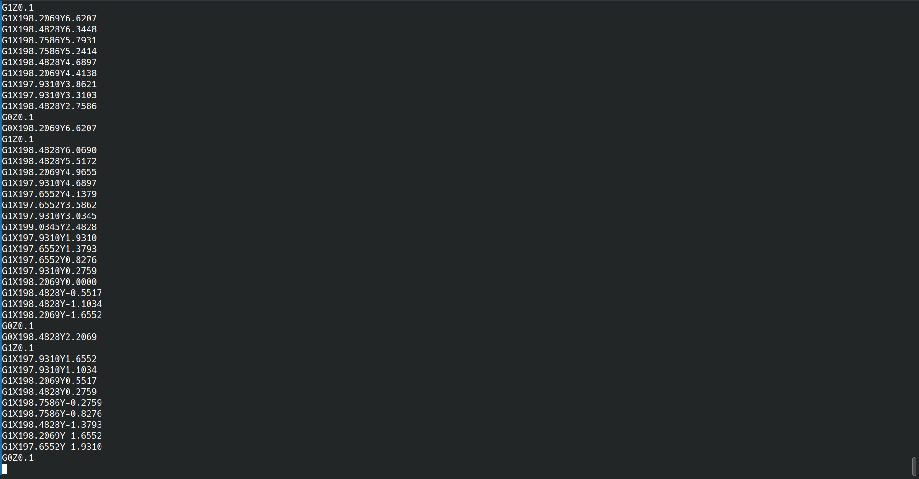
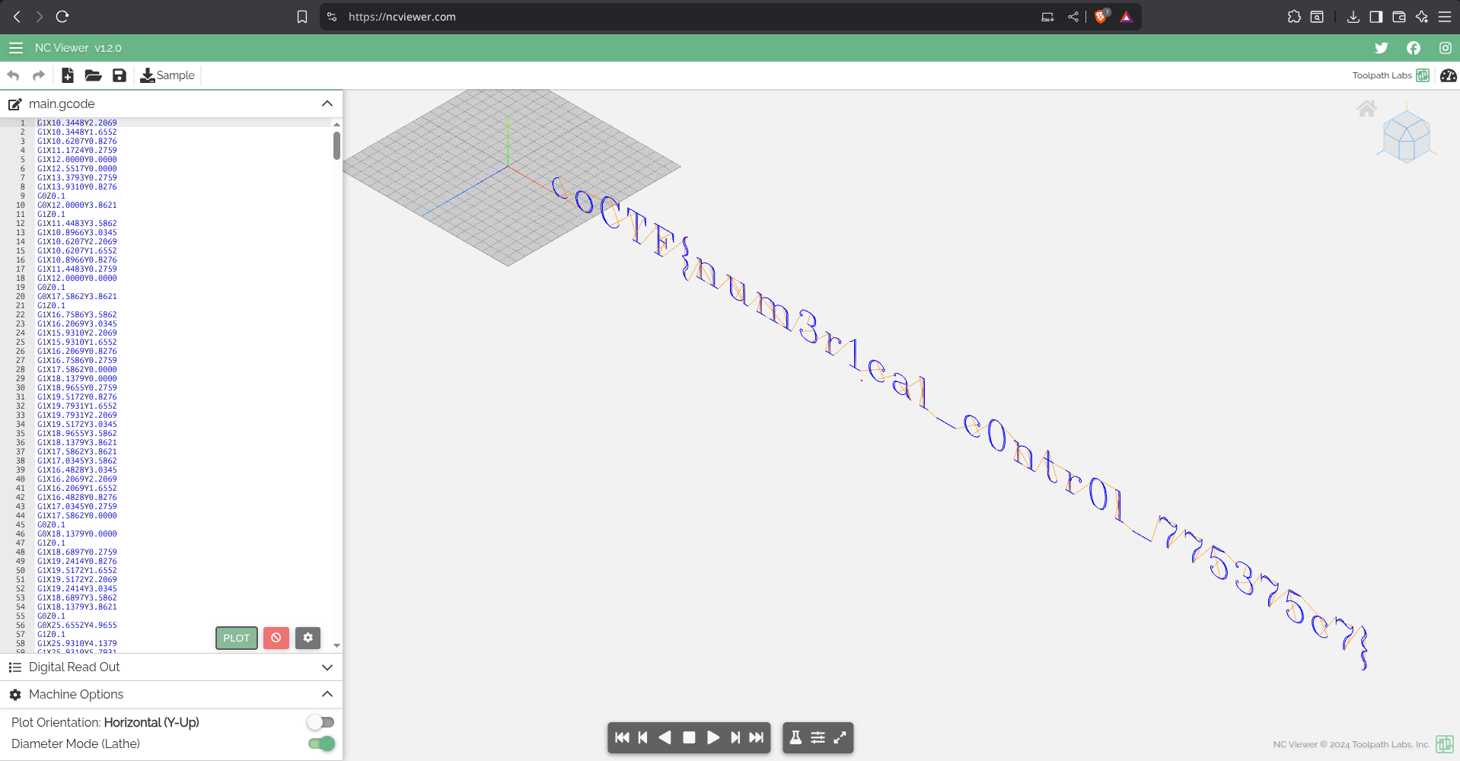
Question 4: https://play.picoctf.org/practice/challenge/128

- A link to a website is provided which we have to exploit using SQL injection to reveal the flag
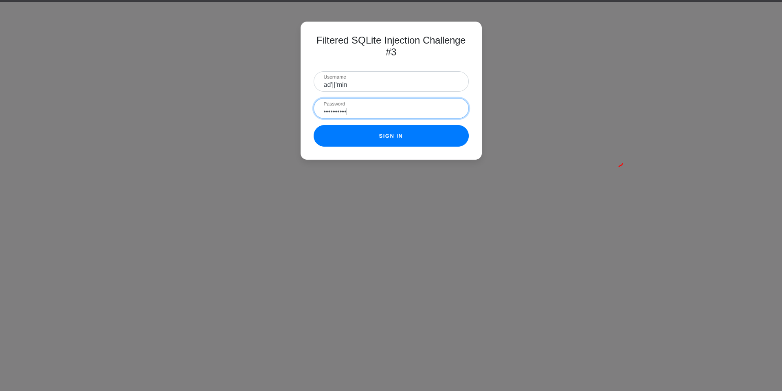
- We know that the username is ‘admin’ , but a bunch of filter words are provided which when entered in as username will be filtered and ‘admin’ is also a filter words.
- So, we have to find a way to pass admin to the SQL query running in the background without explicitly typing ‘admin’.
- We use the concatenation ( || ) in SQL to achieve this. When we type ad’||’min username it will be evaluated as ‘admin’.
- In the password field we enter ‘a’ GLOB *. GLOB is an operator in SQL that checks if a pattern exists. Assuming that a is not the password then the first condition will evaluate to 0. Then the query becomes 0 GLOB *. ‘*’ means everything, so the result will always be True, no matter what the password it
- After successfully logging in we get the key in another website which is also provided in the question
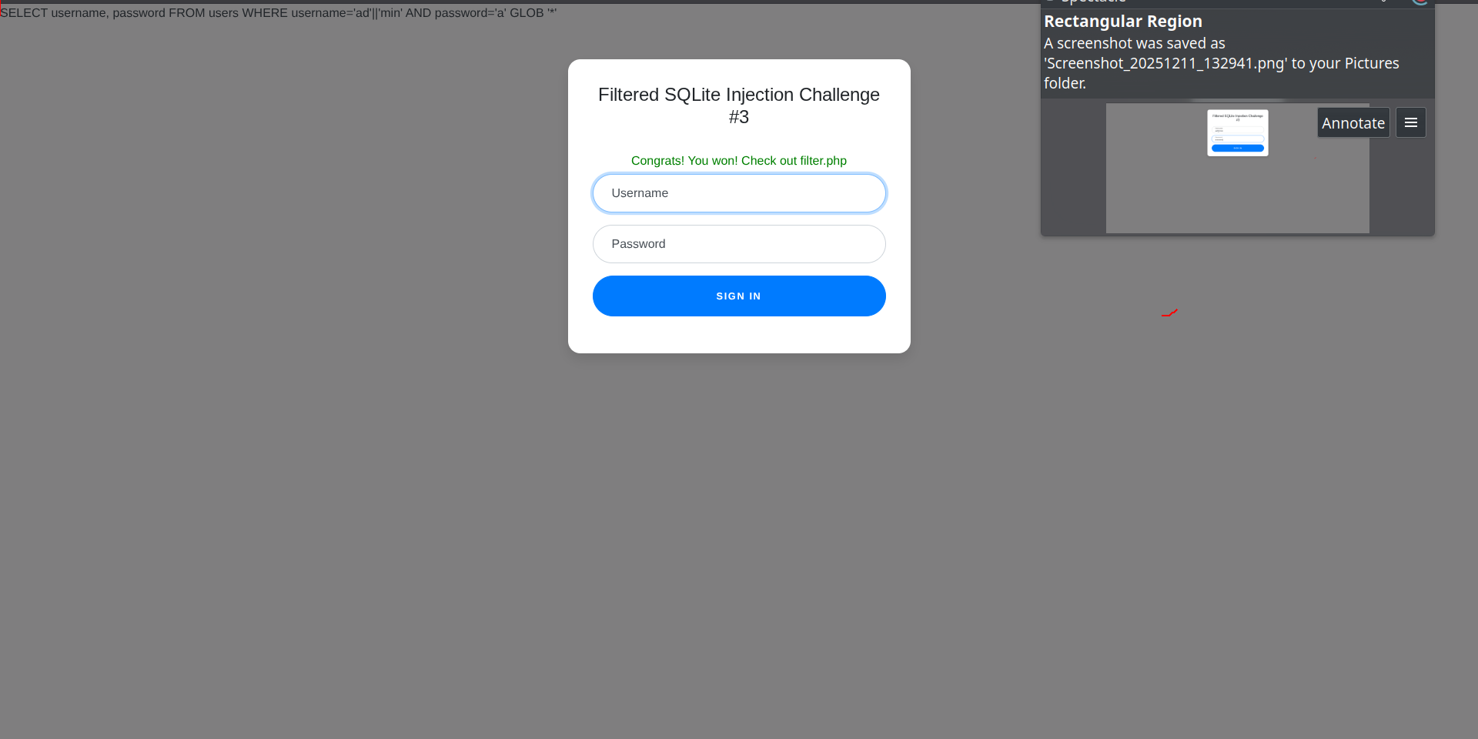
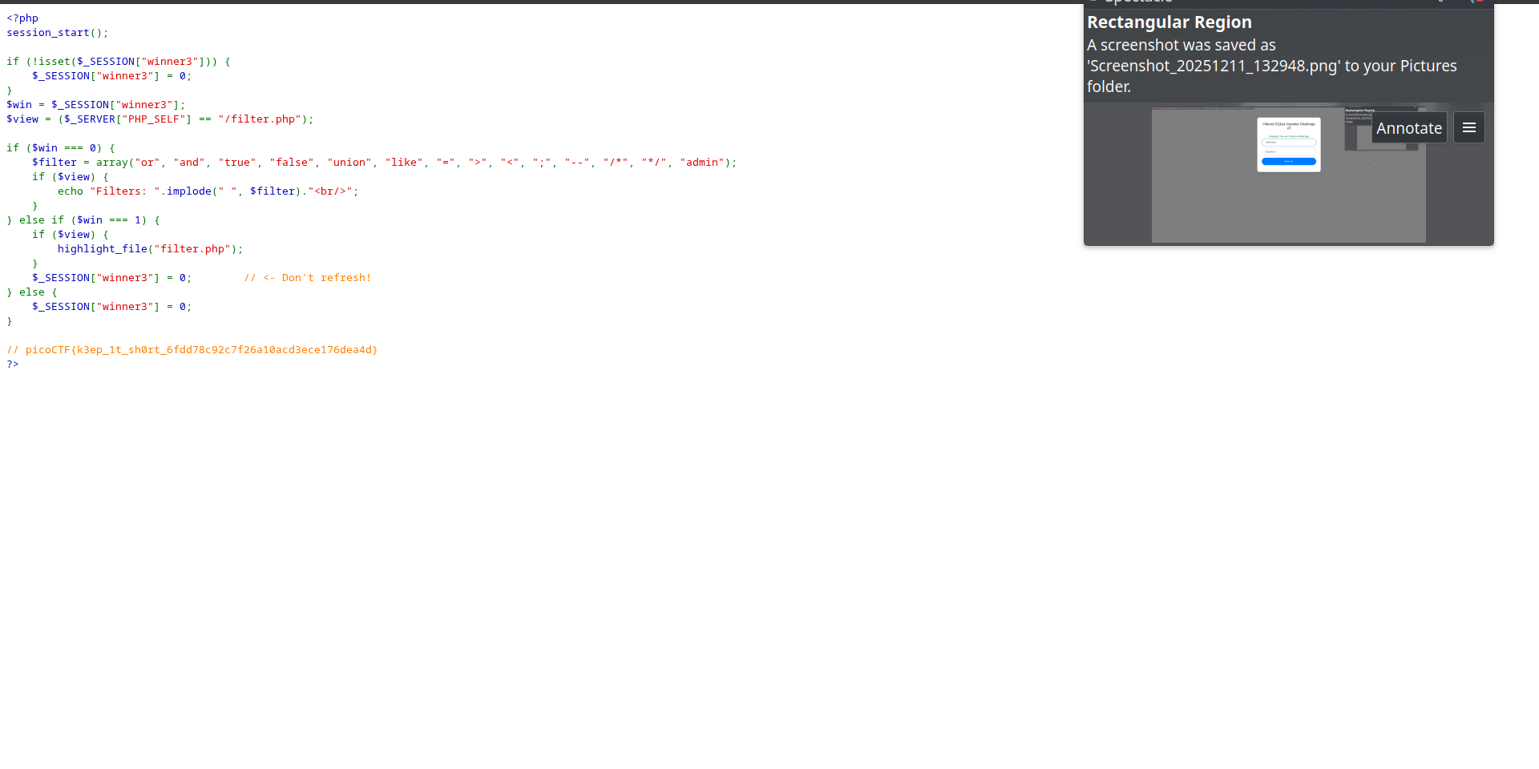

Question 5: https://play.picoctf.org/practice/challenge/243

- A netcat command is provided in the question. When we run command in the terminal it asks us to enter the MD5 hash of some strings, which we can go to the website https://www.md5hashgenerator.com/ and find the required hash.
- When all the hashes are given the flag is revealed.
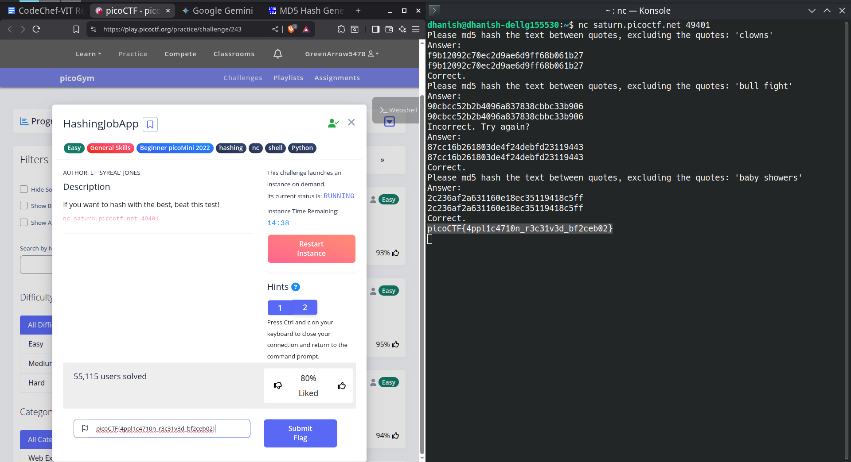
Question 6: https://play.picoctf.org/practice/challenge/291

- The question contains a link to a website in which the flag is hidden
- In web exploitation CTF challenges it is a general rule to check robots.txt for valuable information
- When we check robots.txt we find a Base64 encoded string
- When this string is decrypted it gives another endpoint. When we visit that endpoint we find the flag

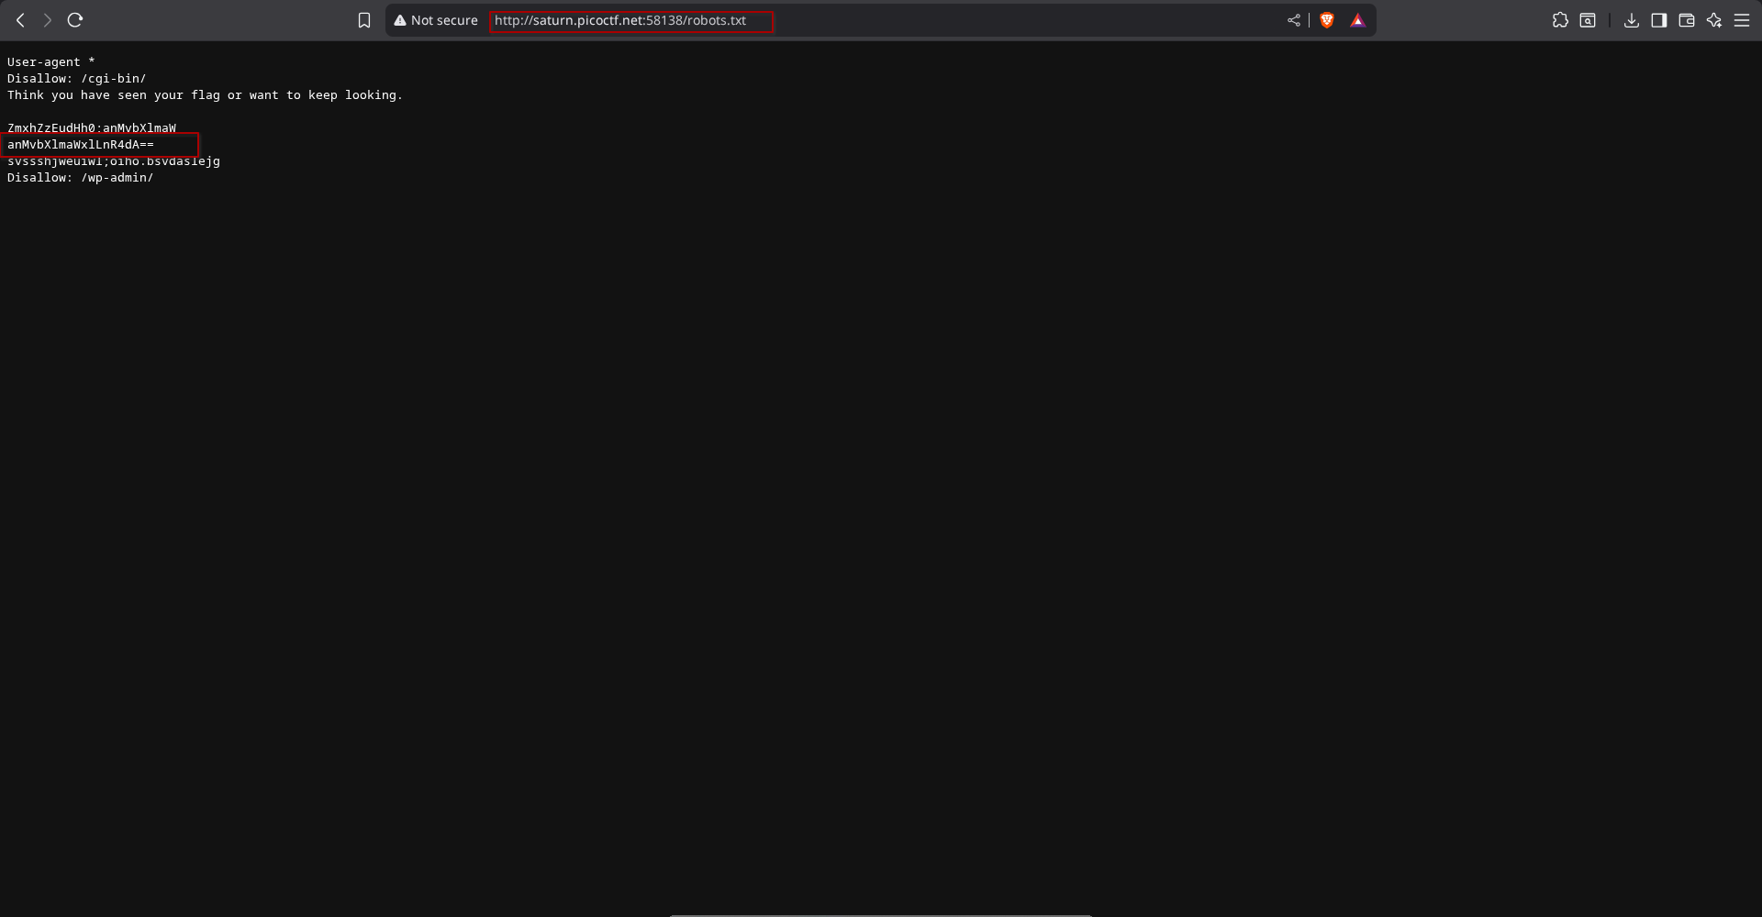

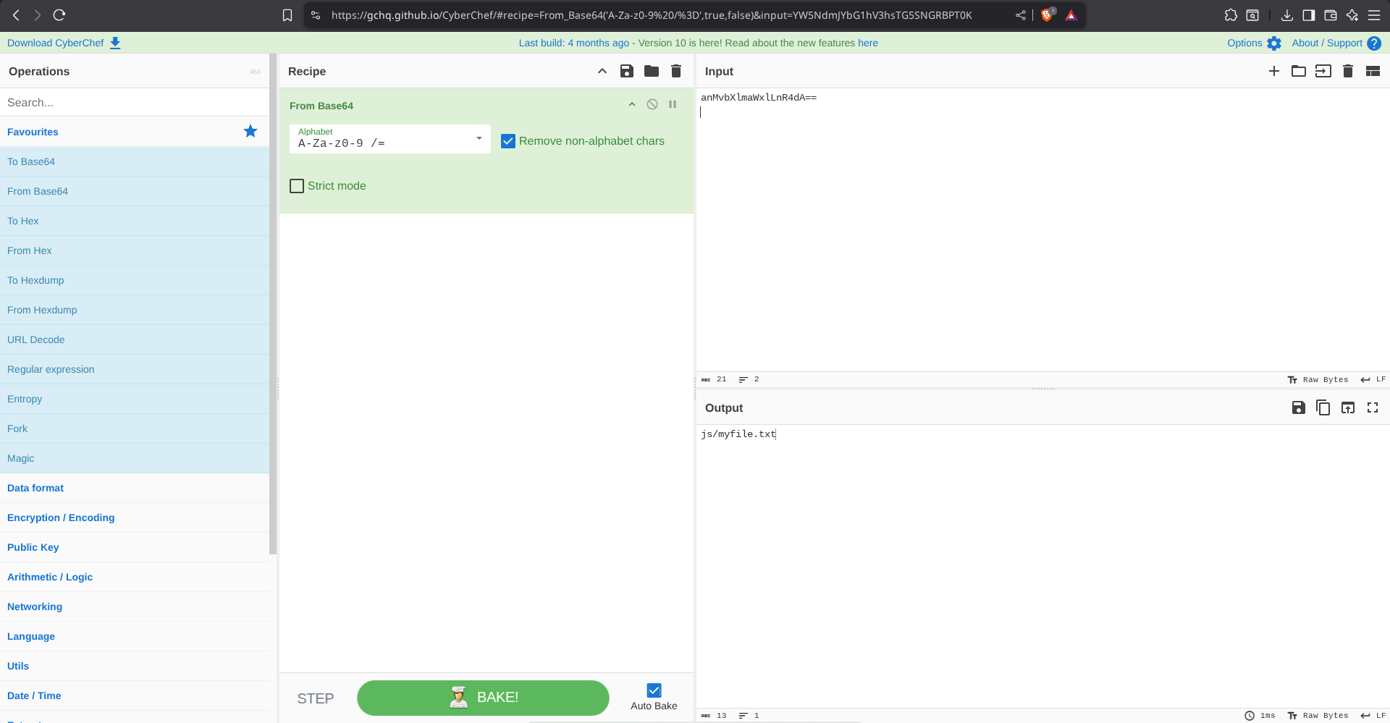
Question 7: https://play.picoctf.org/practice/challenge/298
- A pin checker program is given. We have to brute force the pin by using a techniques called Timing Side Channel attack
- Timing Side Channel attack: This vulnerability accurs when developers write code that checks password character by character and stops when it encounters the first chracter mismatch. For example if the correct pin is 2478 and attacker guesses 1000 then the code returns wrong after comparing the first character. Next the attacker tries the code 2000, this time also it returns wrong but it took slightly longer because the program compared the first character, it was correct then it moved to the next character.
- By exploiting this vulnerability the pin can easily be guessed. We write a python script to measure the time differences which are often in nanoseconds and guess the pin

import subprocess
import time
import sys

BINARY_PATH = "./pin_checker"
PIN_LENGTH = 8

def check_pin(pin_attempt):

start_time = time.perf_counter()

process = subprocess.Popen(
[BINARY_PATH],
stdin=subprocess.PIPE,
stdout=subprocess.PIPE,
stderr=subprocess.PIPE,
text=True
)
stdout, stderr = process.communicate(input=pin_attempt + "\n")
end_time = time.perf_counter()
return end_time - start_time, stdout
def solve():
current_pin = ""
print(f"[*] Starting Timing Attack on {BINARY_PATH}...")
for i in range(PIN_LENGTH):
max_time = 0
best_digit = None
for digit in range(10):
d_str = str(digit)
candidate = current_pin + d_str + ("0" * (PIN_LENGTH - 1 - len(current_pin)))
total_duration = 0
runs = 10
for _ in range(runs):
duration, output = check_pin(candidate)
total_duration += duration
avg_duration = total_duration / runs
if avg_duration > max_time:
max_time = avg_duration
best_digit = d_str

if best_digit:
current_pin += best_digit
print(f"[{i+1}/{PIN_LENGTH}] Found digit: {best_digit} | PIN so far: {current_pin}")
else:
print("[-] Failed to find a statistically significant digit.")
sys.exit(1)
print(f"\n[+] PIN FOUND: {current_pin}")
print("[*] Submitting final PIN to get flag...")
_, final_output = check_pin(current_pin)
print(final_output)

if __name__ == "__main__":
solve()

