Layered Smart Cyber Defence against Backdoor Attacks on Deep Learning Models: Implications for Intrusion Detection Systems

A thesis paper submitted in partial fulfillment of the requirements for the Degree of Bachelor of Science (Engg.) in Computer Science & Engineering
THESIS SUPERVISOR
Mr. Omar Faruk
Lecturer
Department of Computer Science & Engineering
Faculty of Science & Engineering
Feni University, Bangladesh
SUBMITTED BY
Sheikh Ahamed
Id: 222031005
Faisal Ahmed Ayan
Id: 222031012
Naimul Huda Nivir
Id: 222031018
Department of Computer Science & Engineering
School of Science, Engineering & Technology
Submission: October 27, 2026
The undergraduate thesis titled Layered Smart Cyber Defence against Backdoor Attacks on Deep Learning Models: Implications for Intrusion Detection Systems submitted by Sheikh Ahamed (222031005), Faisal Ahmed Ayan (222031012) & Naimul Huda Nivir (222031018) has been accepted as satisfactory in fulfillment of the requirement for the degree of Bachelor of Science (B.Sc.) in Computer Science and Engineering (CSE) to be awarded by Feni University.
BOARD OF EXAMINERS
______________________________
Muhammad Afsar Uddin Chairman
Assistant Professor and Chairperson
Department of Computer Science & Engineering
Feni University
______________________________
Ms. Saba Siddika Member
Lecturer
Department of Computer Science & Engineering
Feni University
______________________________
Mr. Omar Faruk Supervisor
Lecturer
Department of Computer Science & Engineering
Feni University
DECLARATION
It is hereby declared that
1. The thesis submitted is our own original work while completing our degree at Feni University.
2. The thesis does not contain material previously published or written by a third party, except where this is appropriately cited through full and accurate referencing.
3. The thesis does not contain material which has been accepted, or submitted, for any other degree or diploma at a university or other institution.
4. We have acknowledged all main sources of help.
Student’s full name & Id:
______________________________
Sheikh Ahamed
222031005
______________________________
Faisal Ahmed Ayan
222031012
______________________________
Naimul Huda Nivir
222031018
ACKNOWLEDGEMENTS
Alhamdulillah, alhamdulillah we would like to express our sincere gratitude to the supervisor, Mr. Omar Faruk, whose supervision, guidance and suggestions shaped this work from its initial idea to its final form. We are also thankful to the faculty members of the Department of Computer Science & Engineering at Feni University for their support, and to family and friends for their encouragement and patience throughout this study.
TABLE OF CONTENTS
Acknowledgements iv
List of Figures viii
List of Tables ix
Nomenclature x
Abstract xi
Chapter 1 1
1 Introduction 1
1.1 Background of the Research 1
1.2 Research Aim and Objectives 2
1.2.1 Contributions 2
1.2.2 Scope and Positioning 3
1.3 Organisation of the Thesis 3
Chapter 2 4
2 Literature Review 4
2.1 Backdoor Attacks and Their Taxonomy 4
2.2 Adversarial Machine Learning in Security Settings 4
2.3 Backdoor Defences 5
2.3.1 Data-Level Defences 5
2.3.2 Model-Level Detection 5
2.3.3 Recovery and Mitigation 5
2.4 Privacy, Explainability and Monitoring 5
2.5 Toolkits and Benchmarks 6-7
Chapter 3 8
3 Research Methodology 8
3.1 Overview of the Implemented Framework 8
3.2 Threat Model 8-9
3.3 Defence Layers 10
3.3.1 Layer 1: Data Protection 10
3.3.2 Layer 2: Model Protection 10
3.3.3 Layer 3: Recovery 10-11
3.3.4 Layer 4: Access Control and Monitoring 11
3.4 Mapping to the Reference Framework 11-12
3.5 Experimental Setup 12
3.5.1 Dataset and Model 12
3.5.2 Attack Configuration 12
3.5.3 Evaluation Metrics 12
3.5.4 Experiment Inventory and Hyperparameters 13
3.5.5 Primary Results and Treatment of Earlier Logs 13-14
Chapter 4 15
4 Experimental Result and Discussion 15
4.1 Results and Quantitative Analysis 15
4.1.1 Undefended Baseline and Poisoning Rate 15
4.1.2 Data-Level and Model-Level Detection at 10% Poisoning 16-17
4.1.3 Injection Rate versus Detection Effectiveness 17-19
4.1.4 Model-Level Analysis 19
4.1.5 Recovery by Fine-Pruning 20-22
4.1.6 Filtering Only and the Sequential Pipeline 22-23
4.1.7 Component Comparison (Not a Full Ablation) 23
4.1.8 Computational Overhead 24
4.1.9 Attacker Knowledge: Grey-Box versus White-Box 25
4.1.10 Trigger Size, Position and Shape 26
4.1.11 Access Control and Monitoring Simulation 30
4.1.12 Summary of Findings 30
4.2 Discussion 31
4.2.1 Interpretation of the Main Results 31
4.2.2 Why Detection Did Not Translate into Recovery 31
4.2.3 Trade-offs of Fine-Pruning 31
4.2.4 False Positives, False Negatives and Cost 32
4.2.5 Realistic Defender Assumptions 32
4.2.6 Transferability to Deep Learning-Based Intrusion Detection 33
4.2.7 Limitations and Threats to Validity 33
4.2.8 Negative and Unexpected Findings 34
Chapter 5 36
5 Conclusion and Future Work 36
5.1 Conclusions 36
5.2 Future Work 36
Appendix A: Detection Confusion Counts 38
Appendix B: Reproducibility Settings 39
Appendix C: Reconciliation of Earlier Logs 40
References 42
LIST OF FIGURES
Figure 3.1 Layered smart cyber defence prototype: data protection, model protection, recovery and monitoring 8
Figure 3.2 Threat model: attack surfaces covered by the prototype and attacker and defender capabilities 9
Figure 3.3 Two recovery configurations: (A) standalone fine-pruning of the backdoored model; (B) sequential detect, filter, retrain and prune 11
Figure 4.1 A clean CIFAR-10 image and the same image with the BadNets trigger at the bottom-right corner 15
Figure 4.2 Clean accuracy and ASR for poisoning rates of 1%, 5% and 10% 16
Figure 4.3 Detection accuracy of the four detection methods at 10% poisoning 17
Figure 4.4 True positive rate and false positive rate of the detection methods at 10% poisoning 17
Figure 4.5 Detection accuracy versus poisoning rate 18
Figure 4.6 True positive rate versus poisoning rate 19
Figure 4.7 False positive rate versus poisoning rate 19
Figure 4.8 ASR after fine-pruning at 20%, 30% and 40% configured pruning 21
Figure 4.9 ASR reduction in percentage points for each pruning ratio 21
Figure 4.10 Clean accuracy and ASR across pruning configurations 22
Figure 4.11 Recovery rate for each fine-pruning configuration 22
Figure 4.12 ASR across recovery strategies: filtering did not help, the sequential pipeline raised ASR, and standalone fine-pruning reduced it 23
Figure 4.13 Total fine-pruning time for each configuration 25
Figure 4.14 Clean accuracy and ASR in the grey-box and white-box scenarios, which analyse the same trained model 26
Figure 4.15 The same image with the four trigger configurations: 2x2, 3x3 and 4x4 at bottom-right and 3x3 at top-left 27
Figure 4.16 ASR for each trigger size and position 27
Figure 4.17 Clean accuracy and ASR for each trigger size and position 28
Figure 4.18 The four 3x3 trigger masks (white pixels are set to the trigger value) 28
Figure 4.19 ASR by trigger shape 29
Figure 4.20 Clean accuracy versus ASR for each trigger shape 29
LIST OF TABLES
Table 2.1 Summary of the Defence Methods Used in This Thesis 7
Table 3.1 Attacker Capabilities and Defender Assumptions Per Experiment 9
Table 3.2 Mapping Between Framework Components and the Implementation 11
Table 3.3 Experiment Inventory and Training Settings 13
Table 4.1 Effect of the Poisoning Rate on the BadNets Model 15
Table 4.2 Detection Results at 10% Poisoning 16
Table 4.3 Injection Rate versus Detection Performance (5,000-Sample Inspection Set) 18
Table 4.4 Fine-Pruning Recovery Results 20
Table 4.5 Filtering-Based Recovery versus Standalone Fine-Pruning 23
Table 4.6 Component Comparison Under the Current Implementation 24
Table 4.7 Recovery Time for Fine-Pruning Configurations 24
Table 4.8 Inference Latency and Memory Benchmark (CPU, Batch 64) 25
Table 4.9 Attacker Access Comparison 26
Table 4.10 Trigger Size and Position (10% Poisoning, 8 Epochs, LR 0.001) 27
Table 4.11 Trigger Shape (3x3 Bottom-Right, 10% Poisoning, 8 Epochs, LR 0.0005) 28
Table 4.12 Model Monitoring Log (Simulation) 30
Table A.1 Confusion Counts for the Data-Level Detectors 38
Table B.1 Reproducibility Settings 39
Table C.1 Reconciliation of the Earlier Log with the Final Results 40
Table C.2 Historical 10% Fine-Pruning Log (Unverified; Not Reproduced) 41
Nomenclature
CA : Clean Accuracy
ASR : Attack Success Rate
TPR : True Positive Rate
FPR : False Positive Rate
RR : Recovery Rate (relative reduction of ASR)
pp : Percentage points
TP : True Positive
FP : False Positive
TN : True Negative
FN : False Negative
IDS : Intrusion Detection System
CNN : Convolutional Neural Network
ML : Machine Learning
IF : Isolation Forest
AC : Activation Clustering
SS : Spectral Signatures
STRIP : STRong Intentional Perturbation
ABS : Artificial Brain Stimulation
LIME : Local Interpretable Model-Agnostic Explanations
SHAP : SHapley Additive exPlanations
CPU : Central Processing Unit
ABSTRACT
This thesis evaluates a layered smart cyber defence framework against backdoor attacks on deep learning models, using image classification as a controlled testbed with implications for intrusion detection systems. In a backdoor attack, a hidden trigger implanted through poisoned training data makes a model behave normally on clean inputs but output an attacker-chosen class when the trigger appears. A prototype was implemented with data-level poison detection (Isolation Forest, Activation Clustering and Spectral Signatures), model-level analysis (a Neural Cleanse-style search, STRIP and ABS-style stimulation), fine-pruning-based recovery, and a simulated access-control and monitoring layer. A BadNets attack on CIFAR-10 with a simple CNN is evaluated by clean accuracy (CA), attack success rate (ASR), detection accuracy, true and false positive rates, recovery rate and overhead. At 10% poisoning the undefended model reaches 78.40% CA and 94.17% ASR. Spectral Signatures and Activation Clustering detect poison with 97.92% and 97.42% accuracy, but their true positive rates fall below 40% at 1% and 5% poisoning. Fine-pruning at 40% lowers ASR to 40.54% (56.94% recovery rate) for a 5.16 percentage-point loss of clean accuracy without eliminating the backdoor, and a sequential detect-filter-retrain-prune pipeline raised ASR to 98.58%. A historical 10% fine-pruning result (2.51% ASR) was not reproduced: the saved recovery checkpoint gave 97.10% ASR under the standardised protocol, and the cause remains unresolved. Detection alone did not remove the backdoor, and effectiveness depends on the poisoning rate and defender assumptions. Experiments are limited to image classification; extension to intrusion detection is discussed as future work.
Keywords: Backdoor attacks, data poisoning, deep learning security, fine-pruning, intrusion detection, smart cyber defence.

CHAPTER 1

INTRODUCTION

1.1 Background of the Research
Deep neural networks now sit inside many security-critical pipelines. In network security they are used to learn representations of traffic and to flag anomalous or malicious flows, for example through ensembles of autoencoders for online detection [1], and they are trained and benchmarked on public corpora such as CICIDS2017 [2] and the NSL-KDD derivative of KDD Cup 99 [3]. In smart manufacturing, the same techniques monitor industrial networks and sensor streams, where a missed intrusion can translate into physical damage or production loss. Machine learning for intrusion detection has long been recognised as harder to deploy safely than in other domains because adversaries adapt and the cost of errors is asymmetric [4].
A particularly insidious threat arises before a model is ever deployed. Training pipelines routinely consume data from third parties, pre-trained checkpoints and outsourced training services. A backdoor attack exploits this supply chain: the adversary inserts a small number of trigger-bearing training samples relabelled to a target class, so that the trained model retains normal accuracy but classifies any input carrying the trigger as the target class [5]. Subsequent work generalised the idea to targeted data-poisoning backdoors with small, hard-to-notice triggers [6] and to trojaning of already-trained networks [7]. Surveys of the area document the breadth of attack and defence families [8], and work on dataset security emphasises that training-time threats cannot be handled by test-time defence alone [9]. For an intrusion detection system the consequence is concrete: a backdoored detector can be made to label attacker traffic carrying a chosen feature pattern as benign.
Defences have been proposed at several points of the pipeline. Neural Cleanse reverse-engineers minimal triggers per class [10]; STRIP perturbs inputs at run time and watches prediction entropy [11]; Activation Clustering [12] and Spectral Signatures [13] look for poisoned samples in latent space; Fine-Pruning removes dormant neurons and fine-tunes [14]; ABS stimulates neurons to find compromised ones [15]; and generic anomaly detectors such as Isolation Forest [16] can be applied to learned features. Each of these makes different assumptions about what the defender can see and what the attacker can do, and published evaluations rarely report them together under one threat model, one dataset and one set of metrics. The reference smart cyber defence framework that motivates this thesis [17] proposes exactly such a multi-layer arrangement, covering data protection, model protection, access control and monitoring, but it still requires an empirical evaluation of how its layers behave when combined.
The gap addressed here is the lack of an empirical, reproducible assessment of how a layered defence behaves when its components are actually combined. Three questions are rarely answered in one study: (i) how detection quality changes as the poisoning rate falls, (ii) whether detecting and filtering poison is sufficient to remove a backdoor, and (iii) the accuracy and computational costs of recovery. Without this information a practitioner cannot judge which layer to rely on or whether combining layers helps.

1.2 Research Aim and Objectives
This thesis follows the guidelines supplied by the supervisor and is organised around four research questions:
RQ1. How does a BadNets backdoor behave as a function of poisoning rate, trigger size, trigger position and trigger shape?
RQ2. How accurately do data-level and model-level detectors identify poisoned samples or backdoored models, and how does this change with the injection rate?
RQ3. How much of the backdoor can be removed by fine-pruning, and at what cost in clean accuracy, training time and inference overhead?
RQ4. Does composing detection, recovery and monitoring layers improve on the best single layer?

1.2.1 Contributions
• A modular prototype that maps each implemented component onto a layer of the smart cyber defence framework, with an explicit threat model per experiment.
• A quantitative evaluation using CA, ASR, detection accuracy, TPR, FPR, recovery rate, training time, inference latency and memory.
• An injection-rate study (1%, 5%, 10%) showing that the strongest detectors at 10% poisoning fail at lower rates.
• A component comparison and a sequential-pipeline experiment expose a negative result: filtering followed by pruning did not remove the backdoor.
• A sensitivity analysis over trigger size, position and shape, and a comparison of grey-box and white-box access assumptions.

1.2.2 Scope and Positioning
Deep learning-based intrusion detection is a primary application of such defences. The experiments, however, follow the supervisor's guidelines and use image classification on CIFAR-10 as a controlled testbed, with a simple CNN and a visible-trigger BadNets attack at the Data Collection attack surface. This choice isolates the behaviour of the defence from the additional difficulties of tabular and flow-based traffic features. Results therefore establish how the defence layers behave in a well-understood setting; whether they transfer to intrusion detection data is argued in Section 4.2.6 and left for future work. Likewise, the adversarial-robustness and explainability layers of the conceptual framework are discussed but not experimentally evaluated, and only BadNets is implemented among the attack families listed in the guidelines. These boundaries are repeated in Section 4.2.7 so that no result is read as a claim beyond its scope.

1.3 Organisation of the Thesis
Chapter 1 introduces the problem, the research questions and the contributions. Chapter 2 reviews backdoor attacks, defences and related toolkits. Chapter 3 presents the framework components, the threat model and the experimental setup. Chapter 4 reports and discusses the results, including limitations and realistic defender assumptions. Chapter 5 concludes the thesis and suggests future work.

CHAPTER 2

LITERATURE REVIEW

2.1 Backdoor Attacks and Their Taxonomy
A backdoor attack has two phases: implantation during training and activation at inference. Attacks are commonly organised by the surface through which the adversary gains influence. In the Data Collection surface, the attacker contributes or modifies training samples; BadNets stamps a small visible patch on a fraction of images and relabels them to a target class [5], and blended-key variants mix a pattern into the image at low opacity [6]. In the Pre-trained Model surface, the attacker distributes a compromised checkpoint, as in the trojaning attack that retrains selected neurons to respond to a trigger [7]. Latent backdoors are designed to survive transfer learning, so that a student model inherits the vulnerability from a teacher [18]. In Outsourcing, the adversary controls the training run itself. In Collaborative Learning, a participant sends poisoned updates, as demonstrated for federated learning through model replacement [19].
Attacks also differ in trigger visibility and label consistency. Clean-label attacks keep the label of poisoned samples correct by crafting feature-collision examples [20] or by hiding the trigger in a way that is not visible in the poisoned images [21], which defeats defences that look for label inconsistencies. Frequency-domain analysis shows that many triggers leave high-frequency artefacts and motivates smoother, harder-to-detect triggers [22], while input-aware attacks generate a different trigger for every input [23]. The present thesis implements the simplest member of this taxonomy, the visible BadNets trigger, because it allows a clean study of detector behaviour and parameter sensitivity before moving to stealthier attacks.

2.2 Adversarial Machine Learning in Security Settings
Backdoors are one branch of adversarial machine learning, which spans training-time and test-time attacks [24]. At test time, adversarial examples show that small perturbations change predictions [25], with fast gradient methods [26], projected gradient descent training [27] and optimisation-based attacks [28] forming the standard toolkit for both attack and robustness evaluation. The difference that matters here is the threat timing: adversarial examples are crafted against a deployed model, whereas a backdoor is planted during training and is activated by a trigger chosen by the attacker. A defence that improves test-time robustness does not by itself address backdoors, which is why backdoor robustness and adversarial robustness appear as separate items in the framework.

2.3 Backdoor Defences

2.3.1 Data-Level Defences
Data-level defences inspect the training set. Activation Clustering extracts last-hidden-layer activations of each class, reduces their dimension and clusters them into two groups; a poisoned class tends to split into a large clean cluster and a small poisoned one [12]. Spectral Signatures observe that poisoned samples leave a detectable trace in the top singular direction of the centred representation covariance and score samples by their projection onto it [13]. Isolation Forest isolates anomalies through random partitioning and assigns short average path lengths to outliers [16]; applied to CNN features it provides a generic unsupervised baseline. These methods need access to training data and, usually, to a model's internal representations, and they differ in how much they presuppose about the poisoning rate.

2.3.2 Model-Level Detection
Model-level defences analyse a trained model without needing the poisoned samples. Neural Cleanse searches, for each class, for the smallest input perturbation that flips all inputs to that class and flags classes whose minimal trigger is anomalously small [10]. STRIP superimposes a suspect input with random clean images and measures the entropy of the resulting predictions, since triggered inputs remain confidently classified [11]. ABS stimulates individual internal neurons and looks for neurons whose elevated activation drives one label regardless of input [15]. All three are sensitive to implementation choices and to the thresholds that convert a score into a decision.

2.3.3 Recovery and Mitigation
Fine-Pruning prunes convolutional filters that are dormant on clean data, on the assumption that backdoor behaviour is carried by otherwise unused capacity, and then fine-tunes to recover clean accuracy [14]. Neural Attention Distillation uses a fine-tuned teacher to realign the attention maps of the backdoored student [29], and Anti-Backdoor Learning exploits the observation that backdoor samples are learned faster and unlearns them during training [30]. Fine-pruning is selected here because it is simple, inexpensive and well documented, which suits a prototype whose main goal is to compare components rather than to maximise recovery.

2.4 Privacy, Explainability and Monitoring
The data-protection layer of the framework includes differential privacy, which bounds how much any single training record can influence the model [31], and statistical and density-based anomaly detection. Explainability tools such as Grad-CAM [32], SHAP [33] and LIME [34] expose which inputs drive a prediction and have been used to reveal trigger regions. Operational monitoring and access control complete the framework by restricting who may query or modify a model and by tracking model health over time. Of these, the thesis implements a simple simulation of access control and monitoring and uses activation- and neuron-level signals as partial explanatory evidence; differential privacy and post-hoc explanation methods are not evaluated.

2.5 Toolkits and Benchmarks
Open-source toolkits reduce the effort of reproducing attacks and defences. BackdoorBox provides implementations of many attacks and defences [35], TrojanZoo offers a unified evaluation harness for neural backdoors [36], and BackdoorBench supplies a large benchmark across attacks, defences and architectures [37]. These resources report results over multiple models and attacks. The contribution of this thesis is complementary: a transparent, small-scale prototype in which every layer is explicit, the threat model is stated per experiment, and negative outcomes are reported alongside positive ones.
Table 2.1 Summary of the Defence Methods Used in This Thesis
Method | Level | Needs | Key assumption
Isolation Forest [16] | Data | Training data, CNN features | Poison is rare and isolable
Activation Clustering [12] | Data | Data, activations | Poison forms a separate cluster
Spectral Signatures [13] | Data | Data, representations | Poison shifts top singular direction
Neural Cleanse [10] | Model | Model, clean inputs | Target class has small trigger
STRIP [11] | Model / input | Model, clean inputs | Triggered inputs stay confident
ABS [15] | Model | Model, neurons | One neuron drives target label
Fine-Pruning [14] | Recovery | Model, trusted data | Backdoor uses dormant filters

CHAPTER 3

RESEARCH METHODOLOGY

3.1 Overview of the Implemented Framework
The prototype realises the smart cyber defence framework as four cooperating layers (Figure 3.1). The first layer protects data by detecting suspicious training samples. The second layer protects the model by testing whether a trained network carries a backdoor. The third layer recovers a compromised model. The fourth layer provides operational controls: role-based access to the model and monitoring of its health. Components are implemented as separate modules so that each can be switched on or off, which supports the component comparison in Section 4.1.7.
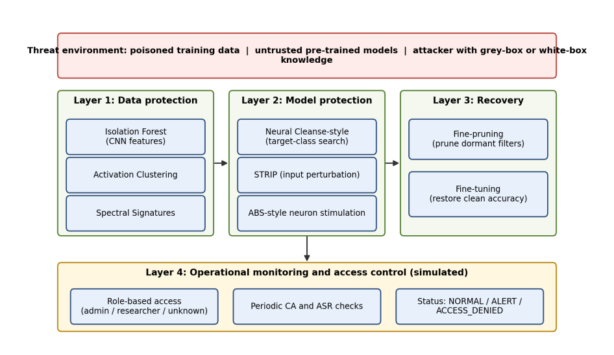
Figure 3.1 Layered smart cyber defence prototype: data protection, model protection, recovery and monitoring

3.2 Threat Model
Following the guidelines and the threat model of the reference framework [17], each experiment states the attacker capabilities. The adversary acts through the Data Collection surface by inserting trigger-bearing samples relabelled to target class 0 (airplane) into the training set. For the attacker-access comparison, two knowledge levels are distinguished. In the grey-box setting the attacker can contribute training data but cannot read parameters or activations and sees only limited predictions. In the white-box setting the attacker, or an analyst acting on the attacker's behalf, can additionally inspect parameters, internal features and convolutional activations. The defender is assumed to observe the training data, to hold the trained model and its activations, and to possess a trusted subset of data for recovery, which is the standard assumption of fine-pruning [14]. The Pre-trained Model surface is represented by applying model-level analysis and recovery to an already backdoored network, but no separate compromised third-party checkpoint is evaluated. Outsourcing and Collaborative Learning are out of scope (Figure 3.2).
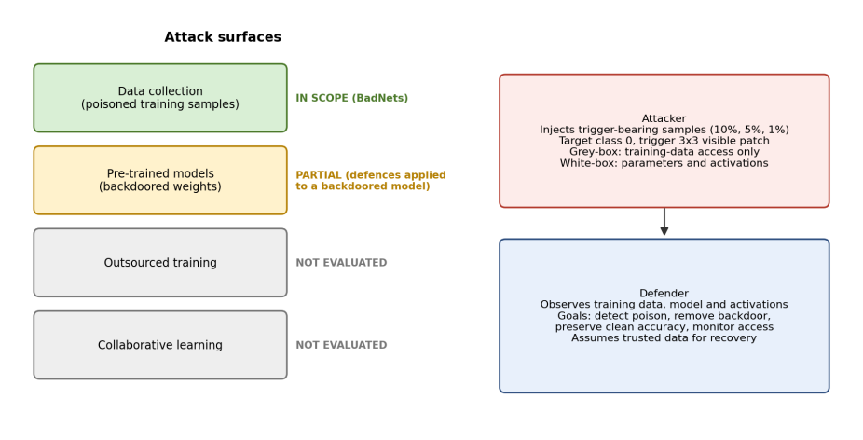
Figure 3.2 Threat model: attack surfaces covered by the prototype and attacker and defender capabilities
Table 3.1 Attacker Capabilities and Defender Assumptions Per Experiment
Experiment | Surface | Attacker capability | Defender assumption
Baseline and poison-rate study | Data collection | Injects 1, 5 or 10% trigger samples; knows trigger | None (undefended)
Data-level detection | Data collection | Same as baseline; no model access | Training data and CNN features
Model-level detection | Pre-trained model | Delivers backdoored model | Model weights, clean test inputs
Fine-pruning recovery | Pre-trained model | Same as above | Weights, activations, trusted data
Sequential pipeline | Data collection | Same as baseline | Data, features, retraining budget
Attacker access | Data collection | Grey-box vs white-box view | Same trained model analysed twice
Trigger variation | Data collection | Chooses size, position, shape | None (attack study)

3.3 Defence Layers

3.3.1 Layer 1: Data Protection
Three detectors are applied to a 5,000-sample inspection set drawn from the training data. Isolation Forest is applied to 256-dimensional CNN features and is configured with a contamination parameter equal to the expected poisoning fraction. Activation Clustering clusters activations with K-means and designates the smaller cluster as suspicious. This is a label-independent heuristic: ground-truth poison labels are used only to compute metrics. Spectral Signatures scores samples by their projection onto the leading singular direction and removes the highest-scoring samples; in this implementation the number of samples to remove equals the known number of poisoned samples, which is a favourable assumption discussed in Section 4.2.5.

3.3.2 Layer 2: Model Protection
Model-level analysis comprises three prototypes. The Neural Cleanse-style experiment performs a localised target-class search rather than the full per-class optimisation of the original method. STRIP is applied by superimposition and entropy thresholding, with a threshold chosen using labelled data. The ABS-style experiment stimulates convolutional channels and reports the most suspicious channel, its associated class and a stimulation score. These are simplified prototypes and are reported as such.

3.3.3 Layer 3: Recovery
Fine-pruning is implemented as activation-based filter pruning followed by fine-tuning. Activations are collected on clean data, filters with the lowest mean activation are zeroed across the three convolutional layers (32, 64 and 128 filters, 224 in total), and the network is fine-tuned for a small number of epochs with the best epoch retained. Three configured pruning ratios of 20%, 30% and 40% are evaluated, which correspond to actual ratios of 19.20%, 29.46% and 39.29% after rounding per layer. Figure 3.3 contrasts this standalone use with the sequential pipeline in which detection output feeds retraining before pruning.
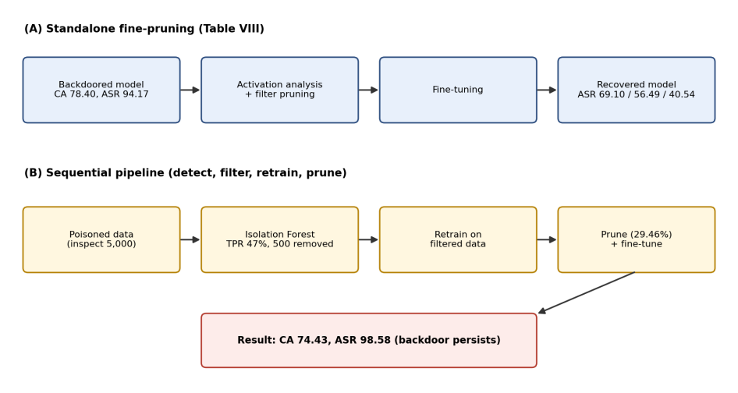
Figure 3.3 Two recovery configurations: (A) standalone fine-pruning of the backdoored model; (B) sequential detect, filter, retrain and prune

3.3.4 Layer 4: Access Control and Monitoring
The monitoring layer is a simulation. Three principals are defined: an administrator, a researcher and an unknown user. Each inference request is logged with a timestamp, user, access type, clean accuracy and ASR of the model that served it, and a status of NORMAL, ALERT or ACCESS_DENIED. The layer does not alter model predictions; its role is operational, as the component comparison treats it, and its output is evaluated qualitatively in Section 4.1.11.

3.4 Mapping to the Reference Framework
Table 3.2 maps each framework element to its implementation and status, so that the reader can see which parts were realised, which were simplified and which remain future work.
Table 3.2 Mapping Between Framework Components and the Implementation
Framework component | Implementation | Status
Statistical and density-based detection | Isolation Forest on CNN features | Implemented
Clustering-based detection | Activation Clustering (size heuristic) | Implemented
Spectral analysis of poison | Spectral Signatures (known count) | Implemented, favourable assumption
Autoencoder-based detection | Not implemented | Future work
Differential privacy | Not implemented | Future work
Backdoor robustness: detection | Neural Cleanse-style, STRIP, ABS-style | Simplified prototypes
Backdoor robustness: recovery | Fine-pruning with fine-tuning | Implemented
Adversarial robustness (evasion) | Not evaluated | Future work
Explainability | Neuron-level ABS signal only | Partial
Access control and monitoring | Role-based log simulation | Simulated
Testing and validation | CA, ASR, component comparison, overhead | Implemented

3.5 Experimental Setup

3.5.1 Dataset and Model
CIFAR-10 [38] is the primary dataset: 50,000 training and 10,000 test colour images of size 32x32 in ten classes. Following the guidelines, a simple CNN is used for the initial experiments, with three convolutional layers (32, 64 and 128 channels, 224 in total), two linear layers, a 256-dimensional feature layer and 620,362 trainable parameters (2.37 MB of parameters). Deeper architectures such as ResNet [39] and VGG-16 [40], and the GTSRB [41] and MNIST [42] datasets named in the guidelines, are not used in this study and are listed as future work. The implementation uses Python with PyTorch [43] for modelling and scikit-learn [44] for Isolation Forest and clustering. The source code, configuration and result files are available at https://github.com/AhamedFozle/smart-cyber-defense.

3.5.2 Attack Configuration
The attack is BadNets with a visible 3x3 trigger of value 1.0 placed at the bottom-right corner (Figure 4.1 in Chapter 4). Target class is 0 (airplane). The poisoning rate is 10% unless stated, which corresponds to 5,000 poisoned training samples. The random seed is 42. ASR is computed on the 9,000 test images that do not belong to the target class, so that images already correctly labelled as the target do not inflate the score. The main experiments train for 20 epochs with batch size 64 and learning rate 0.0005 on CPU.

3.5.3 Evaluation Metrics
Clean accuracy and attack success rate are defined as
CA = (1/|T|) Σ 1[f(x) = y], x ∈ T (clean test set) (1)
ASR = (1/|T′|) Σ 1[f(x ⊕ t) = c], x ∈ T′ (non-target test images) (2)
where t is the trigger and c the target class. Detection quality is measured with accuracy, true positive rate TPR = TP/(TP+FN), false positive rate FPR = FP/(FP+TN), precision TP/(TP+FP) and F1. The recovery rate used throughout this thesis is the relative reduction of ASR,
RR = (ASR_base − ASR_rec) / ASR_base × 100% (3)
which is reported together with the change in CA and the absolute ASR reduction in percentage points (pp). All ASR reductions and recovery rates are computed from the success counts out of 9,000 and not from rounded percentages; for example, the 40% run corresponds to 3,649 of 9,000 successes (40.54%), giving 53.62 pp and 56.94%. The ablation log lists 53.63 pp and 56.95%, which result from subtracting rounded values, and the thesis uses the count-based figures throughout. The guidelines describe recovery as the accuracy after mitigation; for that reason CA after mitigation is always reported alongside RR. Computational overhead comprises pruning and fine-tuning time, inference latency per batch and per image, and memory.

3.5.4 Experiment Inventory and Hyperparameters
Because experiments were run at different times, their training settings differ. Table 3.3 lists them explicitly. Results from experiments with different settings must not be compared directly; this matters in Section 4.1.10, where the same nominal trigger gives different ASR under different hyperparameters.
Table 3.3 Experiment Inventory and Training Settings
Experiment | Epochs | Batch | Learning rate | Poison rate
Main baseline, detection, recovery | 20 | 64 | 0.0005 | 10%
Poisoning-rate study | 20 | 64 | 0.0005 | 1, 5, 10%
Trigger-shape study | 8 | 128 | 0.0005 | 10%
Trigger size and position study | 8 | 128 | 0.001 | 10%

3.5.5 Primary Results and Treatment of Earlier Logs
The primary results in this thesis come from the final standardised runs: the baseline BadNets model (CA 78.40%, ASR 94.17%), the detection experiments, and fine-pruning at configured rates of 20%, 30% and 40%, all sharing the same baseline. An earlier development log reports a baseline ASR of 95.77% (8,619/9,000), a clean-CNN accuracy of 11.79%, and a 10% fine-pruning run with a reported starting ASR of 51.77% and recovered ASR of 2.51% (CA 78.58%). These historical values could not be reproduced and are excluded from the primary analysis. In a new identical-protocol evaluation, backdoored_cnn_best.pth and backdoored_cnn_10percent_best.pth both produced 94.17% ASR (8,475/9,000); their saved parameter tensors were identical despite different file hashes and metadata. The saved historical recovery checkpoint, fine_pruned_cnn_best.pth, produced 97.10% ASR (8,739/9,000), not 2.51%. Therefore, the earlier hypothesis that the 51.77% value was explained by a different baseline checkpoint is unsupported, and the origin of the 51.77%, 2.51%, and separate 95.77% values remains unresolved. The 11.79% clean-CNN accuracy is close to the 10% chance level for ten classes and is also excluded. The Isolation Forest contamination sweep is retained as indicative because its 0.10 row matches the final results; the full-dataset filtering run is also indicative because it came from an earlier log. The primary fine-pruning result remains the 40% configuration (CA 73.24%, ASR 40.54%, RR 56.94%). Appendix C records the discrepancies and the new checkpoint evaluation.

CHAPTER 4

EXPERIMENTAL RESULT AND DISCUSSION

4.1 Results and Quantitative Analysis

4.1.1 Undefended Baseline and Poisoning Rate
The undefended BadNets model reaches 78.40% CA and 94.17% ASR, with 8,475 of 9,000 triggered images classified as the target class. Figure 4.1 shows a clean image and its triggered counterpart.
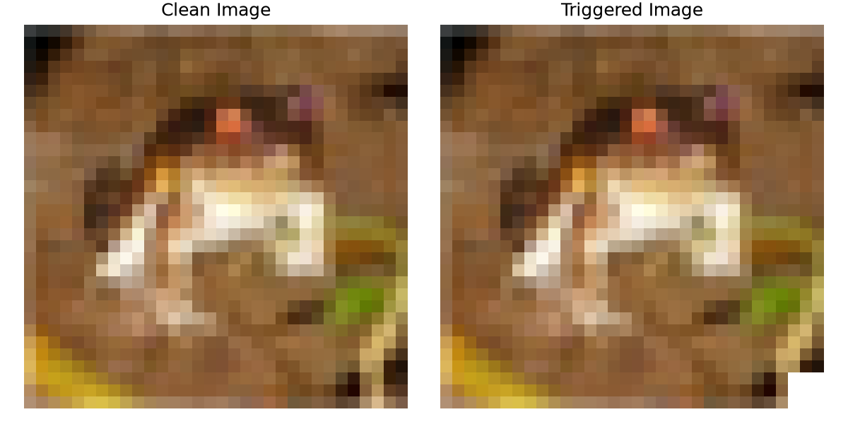
Figure 4.1 A clean CIFAR-10 image and the same image with the BadNets trigger at the bottom-right corner
Table 4.1 and Figure 4.2 show the effect of the poisoning rate. Clean accuracy is essentially unchanged (78.91%, 78.83%, 78.40%), so the backdoor cannot be noticed from accuracy alone. ASR rises steeply: 57.86% with only 500 poisoned samples (1%), 86.92% at 5% and 94.17% at 10%. A backdoor is thus already effective at a poisoning rate that is small enough to be hard to see in a data audit.
Table 4.1 Effect of the Poisoning Rate on the BadNets Model
Poison rate | Poisoned samples | Clean accuracy (%) | ASR (%)
1% | 500 | 78.91 | 57.86
5% | 2,500 | 78.83 | 86.92
10% | 5,000 | 78.40 | 94.17

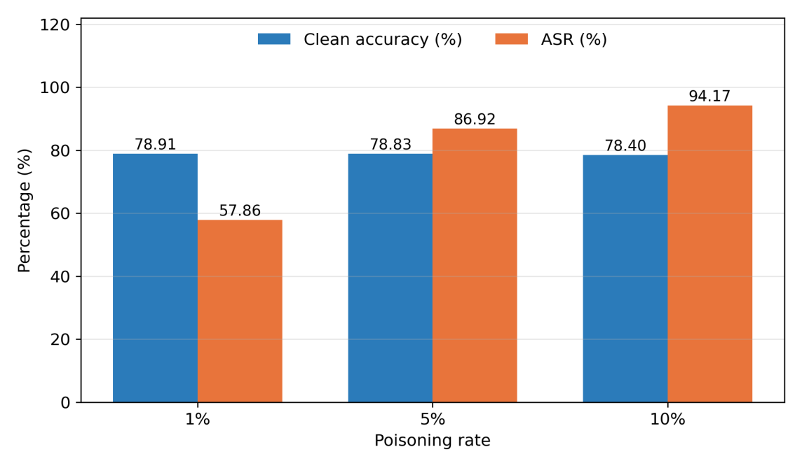
Figure 4.2 Clean accuracy and ASR for poisoning rates of 1%, 5% and 10%

4.1.2 Data-Level and Model-Level Detection at 10% Poisoning
Table 4.2 summarises detection at 10% poisoning on the 5,000-sample inspection set (500 poisoned, 4,500 clean), together with STRIP, which operates at the input level and was evaluated separately on 1,000 balanced input samples (not the 5,000-sample data-level inspection set). Spectral Signatures reaches 97.92% accuracy with 89.60% TPR and 1.16% FPR. Activation Clustering reaches 97.42% accuracy with 74.20% TPR and 0.00% FPR: the smaller of the two clusters contained 371 samples and every one of them was poisoned, so precision is perfect on this sample (a property of this heuristic at 10% poisoning, not a general guarantee) but 129 poisoned samples were missed. Isolation Forest on CNN features gives 89.40% accuracy with 47.00% TPR and 5.89% FPR, and STRIP gives 71.90% accuracy with 67.20% TPR and a high FPR of 23.40% (Figures 4.3 and 4.4).
Table 4.2 Detection Results at 10% Poisoning
Method | Accuracy (%) | TPR (%) | FPR (%) | Note
Isolation Forest (CNN features) | 89.40 | 47.00 | 5.89 | Contamination 0.10
Activation Clustering | 97.42 | 74.20 | 0.00 | Smaller cluster flagged
Spectral Signatures | 97.92 | 89.60 | 1.16 | Known poison count
STRIP | 71.90 | 67.20 | 23.40 | 1,000 balanced samples; labelled threshold

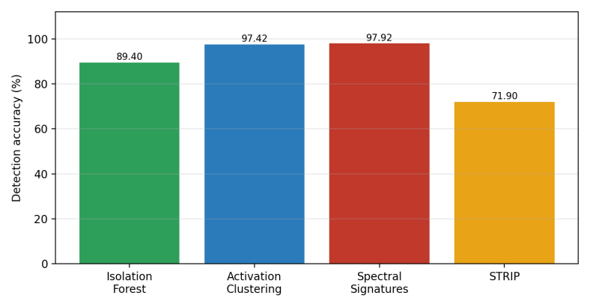
Figure 4.3 Detection accuracy of the four detection methods at 10% poisoning
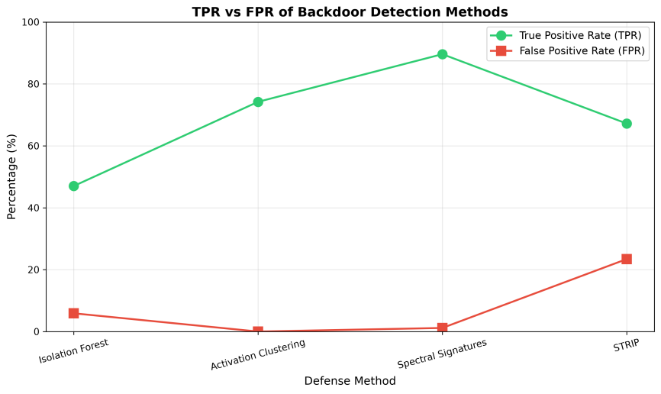
Figure 4.4 True positive rate and false positive rate of the detection methods at 10% poisoning
Detection accuracy is a weak indicator when classes are imbalanced, so the true and false positive rates matter more. The contamination experiment for Isolation Forest illustrates this trade-off: raising the assumed contamination from 0.05 to 0.20 raises TPR from 32.40% to 68.00% but also raises FPR from 1.96% to 14.67% and lowers accuracy from 91.48% to 83.60%.

4.1.3 Injection Rate versus Detection Effectiveness
Detection effectiveness depends strongly on the poisoning rate (Table 4.3, Figures 4.5 to 4.7). At 1% poisoning the accuracy of Isolation Forest (98.08%) and Spectral Signatures (98.04%) looks excellent, but this is almost exactly the share of clean samples in the set (99%), and their TPR is only 4.00% and 2.00%. At 5% Spectral Signatures reaches 3.20% TPR and Isolation Forest 26.80%. Activation Clustering is the only method with non-trivial TPR at low rates (38.00% and 36.40%), but at the cost of FPR above 30% and precision of 1.23% and 5.95%, because its size heuristic mislabels large clusters. Only at 10% do Activation Clustering and Spectral Signatures separate poison well under the tested assumptions, while Isolation Forest still misses more than half of the poisoned samples. A defender whose attacker uses a low injection rate therefore cannot rely on any of these detectors.
Table 4.3 Injection Rate versus Detection Performance (5,000-Sample Inspection Set)
Rate | Method | Acc. (%) | TPR (%) | FPR (%) | Prec. (%) | F1 (%)
1% | Isolation Forest | 98.08 | 4.00 | 0.97 | 4.00 | 4.00
1% | Activation Clustering | 68.78 | 38.00 | 30.91 | 1.23 | 2.38
1% | Spectral Signatures | 98.04 | 2.00 | 0.99 | 2.00 | 2.00
5% | Isolation Forest | 92.68 | 26.80 | 3.85 | 26.80 | 26.80
5% | Activation Clustering | 68.04 | 36.40 | 30.29 | 5.95 | 10.22
5% | Spectral Signatures | 90.32 | 3.20 | 5.09 | 3.20 | 3.20
10% | Isolation Forest | 89.40 | 47.00 | 5.89 | 47.00 | 47.00
10% | Activation Clustering | 97.42 | 74.20 | 0.00 | 100.00 | 85.19
10% | Spectral Signatures | 97.92 | 89.60 | 1.16 | 89.60 | 89.60

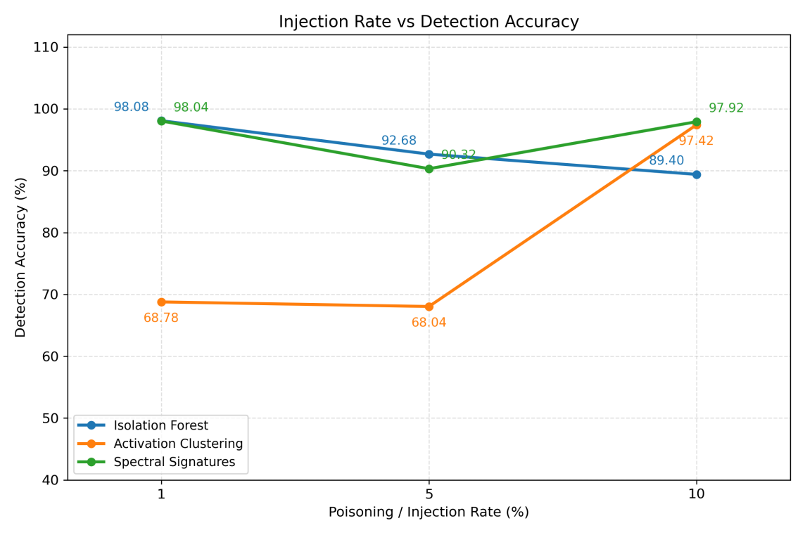
Figure 4.5 Detection accuracy versus poisoning rate
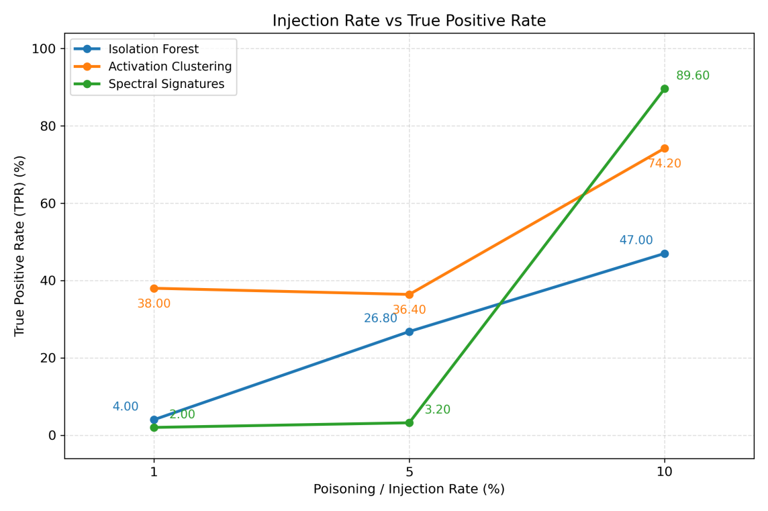
Figure 4.6 True positive rate versus poisoning rate
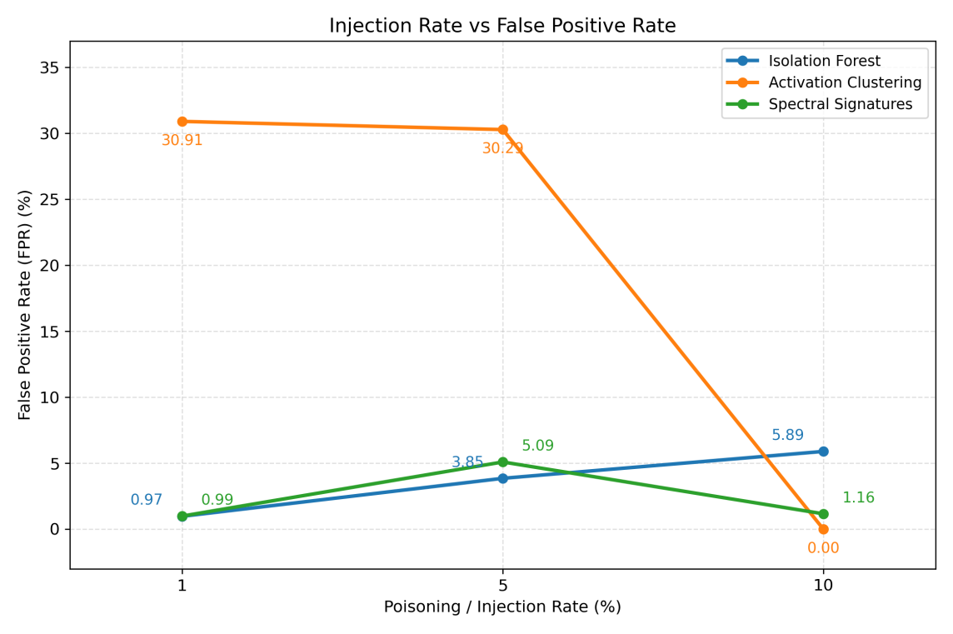
Figure 4.7 False positive rate versus poisoning rate

4.1.4 Model-Level Analysis
The Neural Cleanse-style search identified class 0 as the target class, and the corresponding target-class ASR reached 99.80%. The ABS-style stimulation flagged channel 47 of the second convolutional layer, associated with class 0, with a stimulation score of 5.3586. Both prototypes thus point to the correct target, which supports the use of model-level analysis as a complement to data-level detection when poisoned samples are not available. The implementations are simplified, so the numbers should be read as evidence that the target is recoverable in this setting, not as a benchmark of the original methods.

4.1.5 Recovery by Fine-Pruning
Fine-pruning reduces ASR monotonically with the pruning ratio at a moderate cost in clean accuracy (Table 4.4, Figures 4.8 to 4.11). At 20% configured pruning, ASR falls from 94.17% to 69.10% (25.07 pp, RR 26.62%) and CA to 74.97%. At 30%, ASR is 56.49% (37.68 pp, RR 40.01%) and CA 74.06%. At 40%, ASR is 40.54% (53.62 pp, RR 56.94%) and CA 73.24%, a loss of 5.16 pp. The backdoor is therefore substantially mitigated but not removed; more than 40% of triggered images still reach the target class. Increasing the pruning ratio further would be expected to reduce ASR more, but with a growing price in CA, which was not tested. These three runs share one baseline (ASR 94.17%) and form the primary fine-pruning result, the best being the 40% configuration. The earlier 10% run in Table C.2 of Appendix C is a historical log entry, not a reproduced result: identical-protocol testing gave 94.17% ASR for both saved backdoored checkpoints and 97.10% ASR for the saved historical recovery checkpoint. The origin of the logged 51.77% starting ASR and 2.51% recovered ASR remains unresolved, so these values are excluded from comparisons.
Table 4.4 Fine-Pruning Recovery Results
Configured | Actual | CA (%) | ΔCA (pp) | ASR (%) | ΔASR (pp) | RR (%)
Baseline | 0 | 78.40 | 0 | 94.17 | 0 | 0
20% | 19.20% | 74.97 | −3.43 | 69.10 | −25.07 | 26.62
30% | 29.46% | 74.06 | −4.34 | 56.49 | −37.68 | 40.01
40% | 39.29% | 73.24 | −5.16 | 40.54 | −53.62 | 56.94

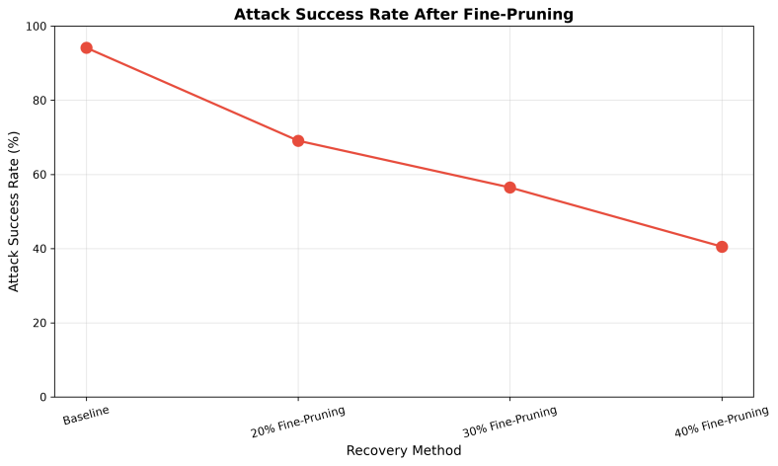
Figure 4.8 ASR after fine-pruning at 20%, 30% and 40% configured pruning
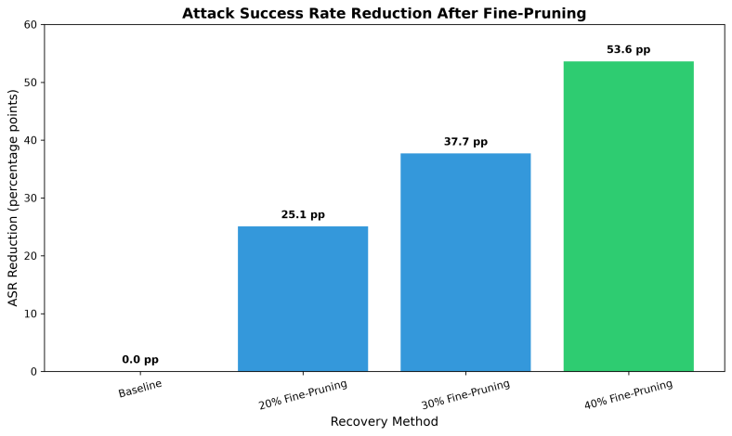
Figure 4.9 ASR reduction in percentage points for each pruning ratio
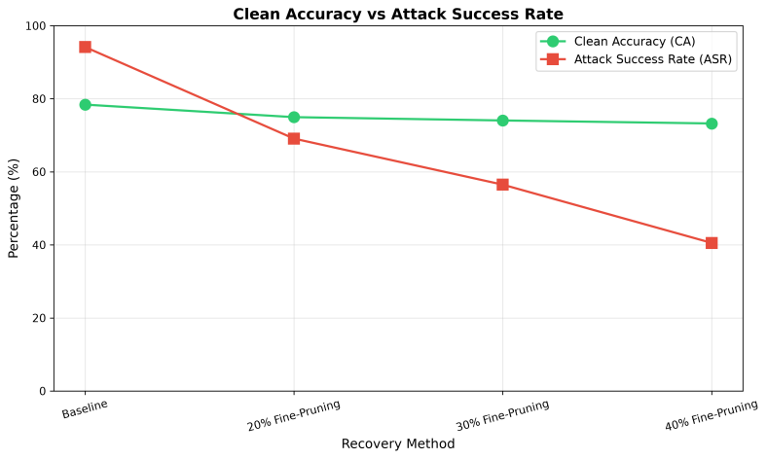
Figure 4.10 Clean accuracy and ASR across pruning configurations
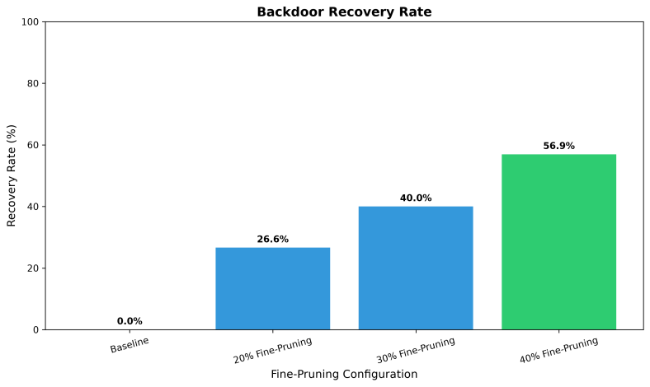
Figure 4.11 Recovery rate for each fine-pruning configuration

4.1.6 Filtering Only and the Sequential Pipeline
Two experiments tested whether acting on detection output helps. In the first, Isolation Forest was applied to the full 50,000-sample training set; it flagged samples with 46.00% TPR and 6.00% FPR in 152.51 s (0.00305 s per sample), 5,000 samples were removed, and a model retrained on the remaining 45,000 reached 76.21% CA and 94.56% ASR. These values come from an earlier experiment log and are indicative only. ASR increased by 0.39 percentage points (94.17% to 94.56%), so filtering did not improve the attack success rate. Because the recall is 46%, the log reports 2,700 missed poisoned samples (2,300 of 5,000 detected), which is evidently enough to implant the backdoor, a result consistent with the 57.86% ASR obtained with only 500 poisoned samples (Table 4.1).
In the second experiment, the sequential pipeline of Figure 3.3(B), detection on the 5,000-sample set removed 500 samples, the model was retrained on 49,500 samples (CA 76.34%, ASR 96.89%), and fine-pruning at 29.46% followed. The final model had CA 74.43% and ASR 98.58%, an ASR change of +4.41 pp and a recovery rate of −4.68% (Table 4.5, Figure 4.12). Total recovery time was 1,383.56 s. Detection and filtering at a TPR near 47% thus failed to remove the backdoor, and subsequent pruning did not recover the 56.49% ASR that standalone pruning at 30% achieved. A likely explanation is that pruning and fine-tuning on a dataset that still contains thousands of poisoned samples re-establish the trigger pathway, but the experiments here do not isolate that mechanism and it should be treated as a hypothesis.
Table 4.5 Filtering-Based Recovery versus Standalone Fine-Pruning
Strategy | CA (%) | ASR (%) | RR (%) | Time (s)
Undefended baseline | 78.40 | 94.17 | 0 | —
Filter only, retrain (full set, indicative) | 76.21 | 94.56 | −0.41 | 152.51 detection
Sequential, partial inspection | 74.43 | 98.58 | −4.68 | 1,383.56
Fine-pruning 30% (standalone) | 74.06 | 56.49 | 40.01 | 435.59

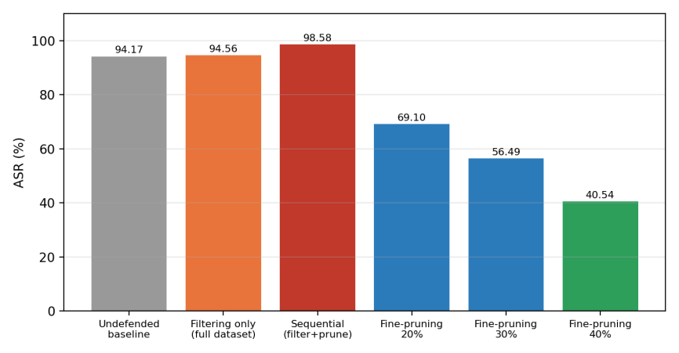
Figure 4.12 ASR across recovery strategies: filtering did not help, the sequential pipeline raised ASR, and standalone fine-pruning reduced it

4.1.7 Component Comparison (Not a Full Ablation)
Table 4.6 compares the implemented components; it is not a full causal ablation. The undefended model and detection-only configuration have identical CA and ASR (78.40% and 94.17%) because the detectors flag samples but do not modify the model. All configurations that include recovery use the values of the 40% fine-pruning run (73.24% CA, 40.54% ASR, RR 56.94%). The Detection+Recovery and Full Framework rows equal the Recovery-only row because recovery operates directly on the backdoored model and does not consume detection output, and monitoring does not change predictions. These rows therefore do not show that combining layers adds benefit. When detection output is actually used to filter data before recovery, the result is worse (Section 4.1.6). The answer to RQ4 is accordingly negative for the tested composition.
Table 4.6 Component Comparison Under the Current Implementation
Configuration | Det. | Rec. | Mon. | CA (%) | ASR (%) | ΔASR (pp) | RR (%)
Baseline | No | No | No | 78.40 | 94.17 | 0.00 | N/A
Detection only | Yes | No | No | 78.40 | 94.17 | 0.00 | N/A
Recovery only | No | Yes | No | 73.24 | 40.54 | 53.62 | 56.94
Detection + Recovery | Yes | Yes | No | 73.24 | 40.54 | 53.62 | 56.94
Full framework | Yes | Yes | Yes | 73.24 | 40.54 | 53.62 | 56.94

4.1.8 Computational Overhead
Table 4.7 and Figure 4.13 give the recovery cost. Filter pruning took 13.77–16.09 s and fine-tuning took 368.61–602.93 s. The remaining 50.73–74.40 s (the reported total minus these two stages) is not itemised in the run files and probably includes activation collection and evaluation. Together the three parts sum to the reported totals of 436.69 s, 435.59 s and 692.78 s. The 40% configuration costs about 59% more time than the 20% configuration, although its ASR is also much lower. The sequential pipeline costs 1,383.56 s, over three times the standalone 30% run, for a worse outcome.
Table 4.7 Recovery Time for Fine-Pruning Configurations
Configuration | Other, not itemised (s) | Pruning (s) | Fine-tuning (s) | Total (s) | Best epoch
20% | 50.73 | 13.77 | 372.19 | 436.69 | 9
30% | 50.89 | 16.09 | 368.61 | 435.59 | 10
40% | 74.40 | 15.45 | 602.93 | 692.78 | 10

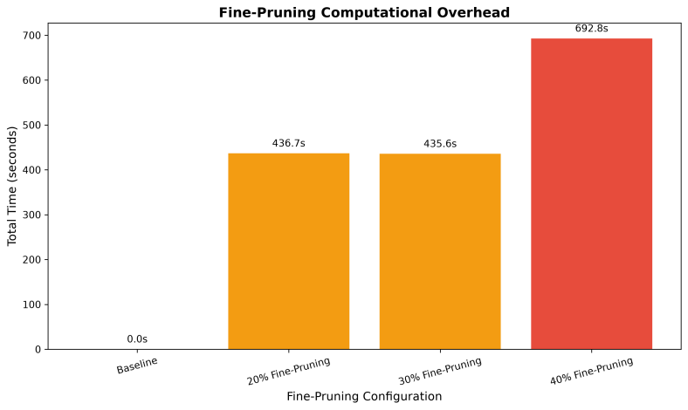
Figure 4.13 Total fine-pruning time for each configuration
Inference cost was measured on CPU with batch size 64 over 50 timed batches (Table 4.8). Parameter count and parameter memory are identical for all models (620,362 parameters, 2.37 MB), consistent with pruning implemented by zeroing filters rather than removing them. The measured latencies (60.68 ms per batch for the baseline; 73.61, 56.07 and 55.01 ms for 20%, 30% and 40%) differ by amounts that are within the variation expected for single, CPU-based timing runs, and the negative memory increase for the 20% model is a measurement artefact. No inference speed-up or memory saving can therefore be claimed from this pruning scheme; structural pruning that removes filters would be needed for that.
Table 4.8 Inference Latency and Memory Benchmark (CPU, Batch 64)
Model | Params | Batch latency (ms) | Image latency (ms) | Mem. increase (MB)
Baseline | 620,362 | 60.68 | 0.948 | 13.35
Fine-pruning 20% | 620,362 | 73.61 | 1.150 | −8.19
Fine-pruning 30% | 620,362 | 56.07 | 0.876 | 6.04
Fine-pruning 40% | 620,362 | 55.01 | 0.859 | 2.00

4.1.9 Attacker Knowledge: Grey-Box versus White-Box
Table 4.9 and Figure 4.14 compare the two knowledge settings. Both report CA 78.40%, ASR 94.17% (8,475 of 9,000). The grey-box case grants training-data access without parameters or activations; the white-box case grants controlled data access plus parameters, internal features and convolutional activations (620,362 parameters, 3 convolutional and 2 linear layers, 256 features, 224 channels, mean activation 0.7249). Because both settings analyse the same trained model, the identical outcomes do not show that the two attackers are equally effective. The experiment documents which information each setting observes. A genuine comparison would require training separate attacks under each assumption.
Table 4.9 Attacker Access Comparison
Scenario | Training data | Parameters | Activations | CA (%) | ASR (%)
Grey-box | Yes | No | No | 78.40 | 94.17
White-box | Controlled | Yes | Yes | 78.40 | 94.17

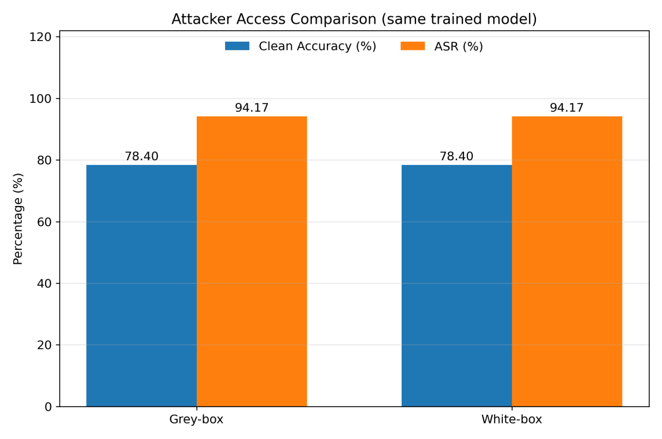
Figure 4.14 Clean accuracy and ASR in the grey-box and white-box scenarios, which analyse the same trained model

4.1.10 Trigger Size, Position and Shape
Trigger size and position were varied with 8 epochs, batch size 128 and learning rate 0.001 (Table 4.10, Figures 4.15 to 4.17). A 2x2 bottom-right trigger gives 88.53% ASR, while 3x3 and 4x4 bottom-right triggers give 97.84% and 97.96%, so the benefit of a larger trigger saturates near 3x3. A 3x3 trigger at the top-left gives the highest ASR (98.94%), so the corner chosen does not weaken the attack. CA stays between 74.19% and 75.66%.
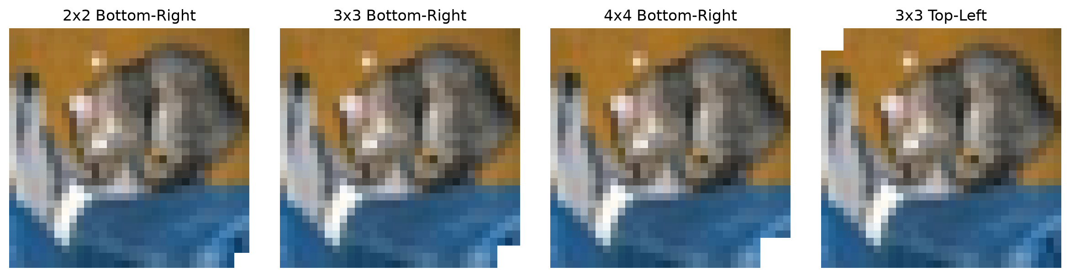
Figure 4.15 The same image with the four trigger configurations: 2x2, 3x3 and 4x4 at bottom-right and 3x3 at top-left
Table 4.10 Trigger Size and Position (10% Poisoning, 8 Epochs, LR 0.001)
Configuration | CA (%) | ASR (%) | Successful attacks | Train time (s)
2x2 bottom-right | 74.55 | 88.53 | 7,968 / 9,000 | 922
3x3 bottom-right | 75.66 | 97.84 | 8,806 / 9,000 | 945
4x4 bottom-right | 74.79 | 97.96 | 8,816 / 9,000 | 977
3x3 top-left | 74.19 | 98.94 | 8,905 / 9,000 | 987

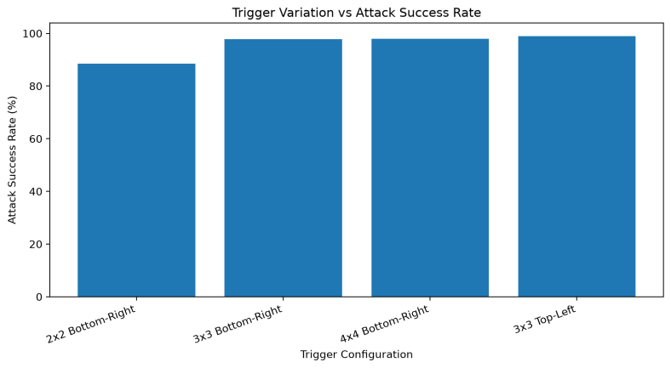
Figure 4.16 ASR for each trigger size and position
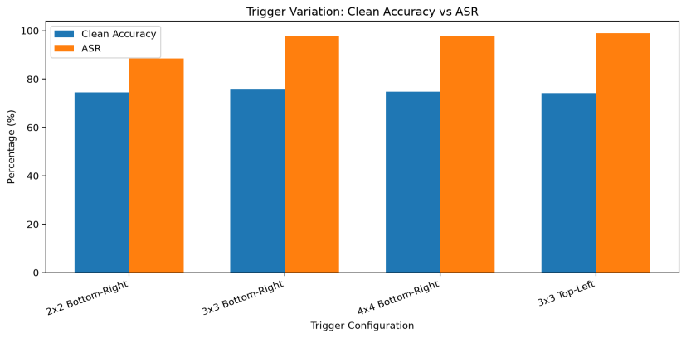
Figure 4.17 Clean accuracy and ASR for each trigger size and position
Trigger shape was varied within a 3x3 footprint (Table 4.11, Figures 4.18 to 4.20) with 8 epochs, batch size 128 and learning rate 0.0005. Checkerboard gives the highest ASR (92.04%), followed by square (89.93%), cross (86.71%) and horizontal bar (81.84%), a range of 10.20 pp. CA lies between 70.45% and 71.94%. A pattern with more alternating pixels thus appears easier for the network to learn than a single bar, but the experiment uses one seed and one configuration, so the ordering is suggestive rather than established.
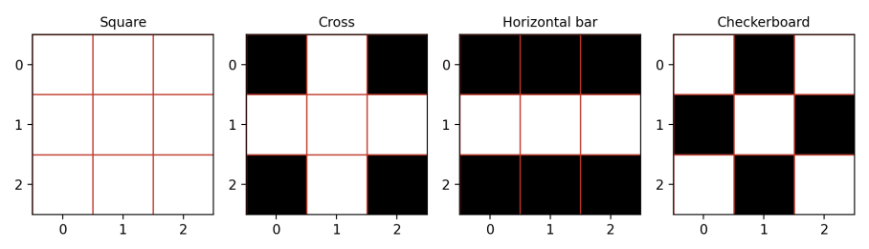
Figure 4.18 The four 3x3 trigger masks (white pixels are set to the trigger value)
Table 4.11 Trigger Shape (3x3 Bottom-Right, 10% Poisoning, 8 Epochs, LR 0.0005)
Shape | CA (%) | ASR (%) | Successful attacks | Train time (s)
Square | 70.45 | 89.93 | 8,094 / 9,000 | 1,169
Cross | 71.67 | 86.71 | 7,804 / 9,000 | 1,146
Horizontal bar | 71.17 | 81.84 | 7,366 / 9,000 | 1,134
Checkerboard | 71.94 | 92.04 | 8,284 / 9,000 | 1,122

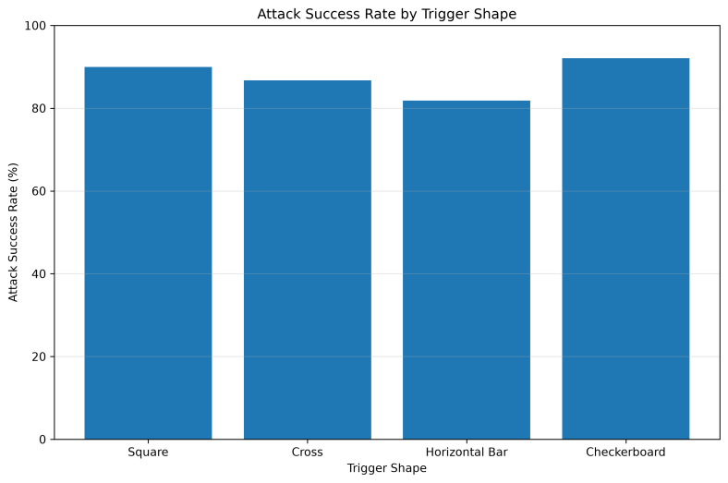
Figure 4.19 ASR by trigger shape
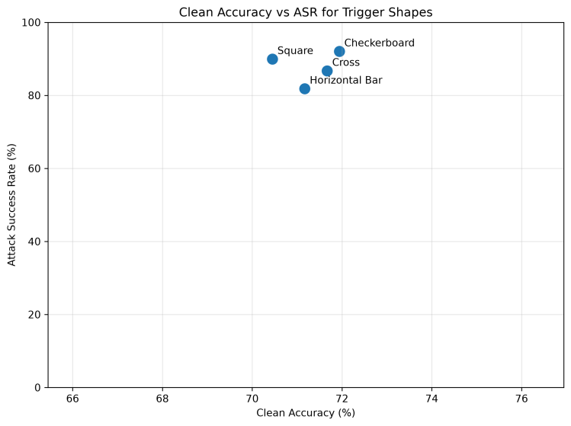
Figure 4.20 Clean accuracy versus ASR for each trigger shape
The two 8-epoch studies cannot be pooled with the main baseline. A 3x3 square at the bottom-right gave 94.17% ASR (20 epochs, lr 0.0005), 89.93% (8 epochs, lr 0.0005) and 97.84% (8 epochs, lr 0.001). The spread of 7.9 pp for the same nominal trigger shows that ASR is sensitive to the training schedule, and it implies that the shape ordering above may partly reflect training variance.

4.1.11 Access Control and Monitoring Simulation
Table 4.12 shows the monitoring log. The administrator's request against the undefended model (CA 78.40%, ASR 94.17%) raises an ALERT. The researcher's request against the recovered model (CA 73.24%, ASR 40.54%) is logged as NORMAL. The request from the unknown user is denied; its metric cells show n/a because a denied request produces no model measurement. The log demonstrates the intended operational behaviour: unauthorised access is blocked and a model with very high ASR is flagged. It also shows a weakness: a model whose ASR is still 40.54% is treated as normal, so the alert threshold is permissive. The log does not record the threshold, and the simulation does not measure detection latency or false alarms, so no quantitative claim is made about the monitoring layer.
Table 4.12 Model Monitoring Log (Simulation)
User | Access | CA (%) | ASR (%) | Status
admin | inference | 78.40 | 94.17 | ALERT
researcher | inference | 73.24 | 40.54 | NORMAL
unknown_user | inference | n/a | n/a | ACCESS_DENIED

4.1.12 Summary of Findings
RQ1. ASR depends on poisoning rate (57.86% at 1% to 94.17% at 10%), on trigger size (saturating near 3x3) and, in this setup, on trigger shape and training schedule, while CA barely changes.
RQ2. At 10% poisoning Spectral Signatures (89.60% TPR) and Activation Clustering (74.20% TPR, 0% FPR) detect poison well; at 1% and 5% every data-level detector either misses most poison or raises many false alarms.
RQ3. Fine-pruning at 40% cuts ASR by 53.62 pp (RR 56.94%) for a 5.16 pp loss in CA and about 693 s of compute, without removing the backdoor and without reducing inference cost.
RQ4. Combining detection, filtering and pruning did not beat standalone fine-pruning; the sequential pipeline raised ASR to 98.58%.

4.2 Discussion

4.2.1 Interpretation of the Main Results
Three observations stand out. First, a BadNets backdoor is cheap and quiet: 500 poisoned images out of 50,000 give 57.86% ASR with no measurable change in clean accuracy, so accuracy monitoring cannot reveal the attack. Second, the quality of data-level detection depends on the poisoning rate far more than on the choice of detector; every method that worked at 10% failed at 1%. Third, recovery by fine-pruning works partially, and the one experiment that tried to couple detection with recovery made things worse. A defender who deploys the layers as independent safeguards gets a measurable gain from recovery and information from detection, but should not expect their effects to add up.

4.2.2 Why Detection Did Not Translate into Recovery
Removing poison helps only if almost all of it is removed. With Isolation Forest at roughly 47% TPR, thousands of poisoned samples stayed in the training set, and the experiments in Table 4.1 show that even 500 samples suffice for a majority-success backdoor. Filtering also removes clean samples (265 in the 5,000-sample test, 2,700 in the full-set run), which slightly lowers CA (76.21%, against 78.40%). The sequential pipeline shows that the failure is not merely one of omission: ASR after pruning rose to 98.58%, above the 94.17% baseline. Plausible reasons are that retraining on partially filtered data strengthened rather than weakened the trigger pathway and that fine-tuning after pruning re-learned it from the remaining poison. These explanations are consistent with the data but untested; isolating them would need controlled runs that vary the number of surviving poisoned samples.

4.2.3 Trade-offs of Fine-Pruning
Fine-pruning offers a transparent trade-off between ASR and CA: each additional 10 points of pruning removed roughly 12 to 16 pp of ASR and cost about 0.8 to 0.9 pp of CA over the tested range. It is cheap to apply but not free to retrain (up to about 11.5 minutes on CPU), and because filters were masked rather than removed, it brings no inference speed or memory benefit. Even the best configuration leaves an ASR above 40%, which is unacceptable for a security-critical detector. Fine-pruning is best seen as a partial mitigation to be combined with stronger methods such as distillation-based unlearning [29] or anti-backdoor training [30], not as a complete remedy.

4.2.4 False Positives, False Negatives and Cost
The cost of errors differs by layer. A false negative at the data level lets poison into training and is the dominant failure at low poisoning rates. A false positive discards a clean sample, which is harmless for a large dataset but can bias class balance when it is systematic, as in Activation Clustering at 1% and 5% where about 30% of clean samples were flagged. In operation, STRIP's 23.40% FPR would flag nearly a quarter of legitimate inputs, a burden for a monitoring team. In terms of compute, detection on the full set took 152.51 s, while recovery cost 436 to 693 s for fine-pruning and 1,384 s for the sequential pipeline; all are acceptable for offline defence but too slow for per-request protection.

4.2.5 Realistic Defender Assumptions
Several results rest on assumptions that a real defender may not meet:
• Known poison count. Spectral Signatures removes exactly as many samples as there are poisoned ones. Its 89.60% TPR at 10% is an upper bound; at 5% and 1% the same method gave 3.20% and 2.00%.
• Cluster-size heuristic. Activation Clustering assumes that the smaller cluster is poisoned. This held at 10% (0% FPR) but led to about 30% FPR when poison is rarer.
• Labelled threshold. STRIP's threshold was chosen with labelled data, which a defender would not have; the 71.90% accuracy is therefore optimistic for its operating point.
• Trusted data and model access. Fine-pruning, Neural Cleanse and ABS require model weights and a trusted clean subset, which are not available when a model is obtained as a black box from a third party.
• Known contamination. Isolation Forest's contamination parameter was set to the true poisoning fraction.

4.2.6 Transferability to Deep Learning-Based Intrusion Detection
Intrusion detection is a primary application of such defences, whereas the experiments use images. The arguments for transfer are that a backdoored intrusion detector is also trained on possibly untrusted data, that its decision depends on learned representations, and that latent-space detectors operate on those representations regardless of input type. There are, however, important differences. A trigger in network traffic must be a feature pattern that survives feature extraction and remains valid as traffic (a fixed header value, packet-size signature or timing pattern), and attackers face protocol constraints that image attackers do not. Intrusion data are tabular, heavily imbalanced and subject to concept drift [4], so clean-sample statistics and class-conditional clusters behave differently, and a low poisoning rate relative to a rare attack class could be proportionally large. Datasets such as CICIDS2017 [2] and NSL-KDD [3] and detectors such as autoencoder ensembles [1] provide a natural next testbed. Until those experiments are run, the quantitative conclusions of this thesis should be considered valid for the image domain only.

4.2.7 Limitations and Threats to Validity
• Single seed and no confidence intervals. All results use seed 42. Differences of a few percentage points, such as 3x3 versus 4x4 triggers (97.84% versus 97.96%) or top-left versus bottom-right, cannot be ranked.
• Heterogeneous training schedules. Experiments use 20 or 8 epochs and two learning rates (Table 3.3); the same nominal trigger yielded 94.17%, 89.93% and 97.84% ASR.
• Small model and one dataset. A three-layer CNN on CIFAR-10 may not reflect the behaviour of deeper networks.
• One attack family. Only BadNets was implemented. Clean-label, invisible, latent and multi-trigger attacks, and attacks on pre-trained models and collaborative learning, remain untested.
• Simplified defences. Neural Cleanse and ABS are reduced prototypes; Activation Clustering, Spectral Signatures and STRIP use the favourable assumptions of Section 4.2.5.
• Detection evaluated on a 5,000-sample subset of the training set, with different absolute poison counts at each rate (50, 250 and 500).
• CPU timing. Latency and memory were measured in single runs on CPU, so small differences are noise.
• Attacker-access comparison uses one trained model and is not an independent comparison.
• Oracle assumptions in detection. Spectral Signatures uses the known poison count, STRIP's threshold was selected with labelled data, and Isolation Forest's contamination equals the true poisoning fraction. Reported detection results are therefore optimistic (Section 4.2.5).
• Unreconciled earlier results. An early development log contains baseline, fine-pruning and clean-model values that differ from the standardised runs (Section 3.5.5, Appendix C). Identical-protocol re-evaluation produced 94.17% ASR for both saved backdoored checkpoints and 97.10% ASR for the saved historical recovery checkpoint; the logged 51.77% starting ASR and 2.51% recovered ASR remain unexplained and were excluded.
• Unevaluated layers. Explainability, differential privacy, autoencoder-based detection and evasion-type adversarial robustness are part of the framework but were not evaluated, and the monitoring layer is a qualitative simulation.

4.2.8 Negative and Unexpected Findings
Several results contradict what a layered defence is expected to deliver. They are reported here deliberately, because they are informative about where such frameworks fail.
• Filtering did not remove the backdoor. Removing 5,000 suspected samples from the full training set left ASR at 94.56%, because detector recall of about 46% left thousands of poisoned samples in place.
• The sequential framework degraded the model. Detect, filter, retrain and prune raised ASR from 94.17% to 98.58% and CA fell to 74.43%, at more than three times the cost of standalone pruning.
• Layer combination added nothing in the component comparison. The Detection+Recovery and Full Framework rows equal Recovery only, because recovery does not use detection output.
• Detectors failed at low poisoning rates. Spectral Signatures and Isolation Forest reached 2.00% and 4.00% TPR at 1% poisoning, and Activation Clustering raised about 30% false positives.
• Detection accuracy was misleading. Accuracy above 98% at 1% poisoning reflects the 99% clean majority, not detection ability.
• Pruning gave no efficiency gain. Parameter count and memory were unchanged, and latency differences were noise.
• The monitor was too permissive. A model with 40.54% ASR was logged as NORMAL.
• The access comparison was not independent. Grey-box and white-box results are identical because one model was analysed twice.

CHAPTER 5

CONCLUSION AND FUTURE WORK

5.1 Conclusions
This thesis implemented a layered smart cyber defence prototype and evaluated it quantitatively against BadNets backdoors on CIFAR-10. The undefended model reached 78.40% CA and 94.17% ASR, and a backdoor with 57.86% ASR was already achievable with 1% poisoning. Spectral Signatures and Activation Clustering detected poison accurately at 10% (97.92% and 97.42% accuracy), but their TPR collapsed or their FPR rose sharply at 1% and 5%. Model-level prototypes identified the target class. Fine-pruning at 40% lowered ASR to 40.54% (RR 56.94%) for a 5.16 pp reduction in CA and 692.78 s of compute, without eliminating the backdoor or reducing inference cost. The most informative finding is negative: filtering followed by retraining and pruning raised ASR to 98.58%, so the composition of layers did not improve on the best single layer. A historical 10% fine-pruning result reported as 2.51% ASR was not reproduced; the saved recovery checkpoint yielded 97.10% ASR under the standardised protocol, and the original discrepancy remains unresolved.
For practitioners, the results suggest not relying on any one data-level detector across poisoning rates, treating detection output as evidence rather than as a filter unless its recall is high, and measuring ASR directly with a held-out triggered set rather than inferring model health from clean accuracy. For the research programme, the main limitation is scope: one attack, one small model, one dataset and one seed.

5.2 Future Work
Future work should (i) repeat the experiments over multiple seeds with confidence intervals and a unified training schedule; (ii) add ResNet-18 and VGG-16 models and the GTSRB and MNIST datasets; (iii) implement clean-label, invisible, latent and multi-trigger attacks and the Pre-trained Model and Collaborative Learning surfaces; (iv) replace the simplified defences with complete Neural Cleanse and ABS implementations, add Neural Attention Distillation or anti-backdoor learning, and remove the oracle assumptions on poison count, thresholds and contamination; (v) design an explainability layer using attribution methods such as Grad-CAM, SHAP or LIME to explain detector decisions; (vi) isolate why the sequential pipeline failed; (vii) use structural pruning to obtain real inference savings; and (viii) port the framework to intrusion detection data, namely CICIDS2017 and NSL-KDD, with feature-space triggers and autoencoder-based detectors.

APPENDIX A

DETECTION CONFUSION COUNTS
Table A.1 lists the confusion counts behind the detection results of Section 4.1.3. Each inspection set contains 5,000 samples.
Table A.1 Confusion Counts for the Data-Level Detectors
Rate | Method | TP | FP | FN | TN
1% | Isolation Forest | 2 | 48 | 48 | 4902
1% | Activation Clustering | 19 | 1530 | 31 | 3420
1% | Spectral Signatures | 1 | 49 | 49 | 4901
5% | Isolation Forest | 67 | 183 | 183 | 4567
5% | Activation Clustering | 91 | 1439 | 159 | 3311
5% | Spectral Signatures | 8 | 242 | 242 | 4508
10% | Isolation Forest | 235 | 265 | 265 | 4235
10% | Activation Clustering | 371 | 0 | 129 | 4500
10% | Spectral Signatures | 448 | 52 | 52 | 4448

APPENDIX B

REPRODUCIBILITY SETTINGS
Table B.1 collects the settings needed to reproduce the main results. Experiment-specific settings are in Table 3.3.
Table B.1 Reproducibility Settings
Item | Value
Dataset | CIFAR-10 (50,000 train, 10,000 test)
Model | SimpleCNN: 3 conv (32/64/128), 2 linear, 256-d features, 620,362 parameters
Attack | BadNets, 3x3 trigger (value 1.0), bottom-right, target class 0
Poison rates | 1%, 5%, 10% (10% = 5,000 samples)
ASR population | 9,000 non-target-class test images
Main training | 20 epochs, batch 64, learning rate 0.0005
Seed | 42
Baseline checkpoint | models/backdoored_cnn_10percent_best.pth (SHA-256 prefix E2FE6AE3)
Device | CPU
Hardware | CPU: Core i3-6100U, OS: Microsoft Windows 10 Pro. RAM: 8 GB
Library versions | Python 3.12.6 (64-bit). PyTorch 2.13.0+cpu. scikit-learn 1.9.0
Inference benchmark | Batch 64, 50 timed batches
Fine-pruning ratios | 20%, 30%, 40% configured (19.20%, 29.46%, 39.29% actual)
Software | Python, PyTorch, scikit-learn
Code repository | https://github.com/AhamedFozle/smart-cyber-defense

APPENDIX C

RECONCILIATION OF EARLIER LOGS
Table C.1 compares the earlier development log (experiment_summary.txt) with the final results (final_results.txt, the fine_pruning_*percent.txt files and sequential_framework_results.txt). The last column states which values are primary, preliminary or unresolved (Section 3.5.5).
Table C.1 Reconciliation of the Earlier Log with the Final Results
Quantity | experiment_summary.txt (earlier log) | final_results.txt and run files | Status
Undefended BadNets ASR | 95.77% (8,619/9,000) | 94.17% (8,475/9,000) | 94.17% primary; 95.77% unresolved, excluded
Undefended BadNets CA | 78.40% | 78.40% | Consistent
Clean CNN accuracy | 11.79% (near chance) | Not reported | Unresolved, excluded
Fine-pruning start ASR | 51.77% (historical log; unverified) | 94.17% (standardised baseline; 8,475/9,000) | 51.77% unverified, excluded; origin unresolved
Baseline checkpoint file | backdoored_cnn_best.pth (SHA-256 prefix 9979D9E9...) | backdoored_cnn_10percent_best.pth (SHA-256 prefix E2FE6AE3...); same parameter tensors | Both yield 94.17% ASR under identical protocol; file difference does not explain 51.77%
Pruning ratios | 10% (actual 9.38%) | 20, 30, 40% (fine_pruning_*percent.txt) | 40% primary; 10% preliminary
Recovered CA after pruning | 78.58% | 74.97, 74.06, 73.24% | Not comparable
Recovered ASR after pruning | 2.51% (historical log; unverified) | Historical recovery checkpoint re-test: 97.10%; standardised runs: 69.10%, 56.49%, 40.54% | 2.51% not reproduced; cause unresolved
Filtered model, partial inspection | CA 76.34%, ASR 96.89% | Same values (sequential_framework_results.txt) | Consistent, primary
Full-set filtering, contamination sweep | ASR 94.56%, 152.51 s; sweep 0.05 to 0.20 | Not repeated (0.10 row matches) | Retained as indicative
Historical recovery checkpoint re-evaluation | 2.51% reported in earlier log | fine_pruned_cnn_best.pth: 97.10% (8,739/9,000) under identical protocol | Historical 2.51% not reproduced; cause unresolved

Table C.2 preserves the values recorded in the earlier development log; it is not a verified result. Under the same standardised evaluation protocol, backdoored_cnn_best.pth and backdoored_cnn_10percent_best.pth both produced 94.17% ASR (8,475/9,000), while fine_pruned_cnn_best.pth produced 97.10% ASR (8,739/9,000). The logged 51.77% starting ASR and 2.51% recovered ASR were therefore not reproduced. The reason for the discrepancy remains unknown, and the historical figures must not be compared with the standardised 20%, 30% and 40% fine-pruning results.
Table C.2 Historical 10% Fine-Pruning Log (Unverified; Not Reproduced)
Metric | Before recovery | After recovery
Clean accuracy (%) | 78.40 | 78.58 (+0.18 pp)
ASR (%) | 51.77 | 2.51 (−49.26 pp)
Relative ASR reduction (%) | n/a | 95.15
Filters pruned | n/a | 21 of 224 (9.38%, configured 10%)
Activation collection / pruning / fine-tuning (s) | n/a | 100.41 / 0.05 / 1,476.15
Status | Historical values only; not reproduced under the standardised protocol | Historical values only; not comparable with Table 4.4

REFERENCES
[1] Y. Mirsky, T. Doitshman, Y. Elovici, and A. Shabtai, "Kitsune: An ensemble of autoencoders for online network intrusion detection," in Proc. Netw. Distrib. Syst. Secur. Symp. (NDSS), San Diego, CA, USA, 2018.
[2] I. Sharafaldin, A. H. Lashkari, and A. A. Ghorbani, "Toward generating a new intrusion detection dataset and intrusion traffic characterization," in Proc. Int. Conf. Inf. Syst. Secur. Privacy (ICISSP), 2018, pp. 108–116.
[3] M. Tavallaee, E. Bagheri, W. Lu, and A. A. Ghorbani, "A detailed analysis of the KDD CUP 99 data set," in Proc. IEEE Symp. Comput. Intell. Secur. Defense Appl. (CISDA), 2009, pp. 1–6.
[4] R. Sommer and V. Paxson, "Outside the closed world: On using machine learning for network intrusion detection," in Proc. IEEE Symp. Secur. Privacy, 2010, pp. 305–316.
[5] T. Gu, K. Liu, B. Dolan-Gavitt, and S. Garg, "BadNets: Evaluating backdooring attacks on deep neural networks," IEEE Access, vol. 7, pp. 47230–47244, 2019.
[6] X. Chen, C. Liu, B. Li, K. Lu, and D. Song, "Targeted backdoor attacks on deep learning systems using data poisoning," arXiv:1712.05526, 2017.
[7] Y. Liu et al., "Trojaning attack on neural networks," in Proc. Netw. Distrib. Syst. Secur. Symp. (NDSS), 2018.
[8] Y. Li, B. Wu, Y. Jiang, Z. Li, and S.-T. Xia, "Backdoor learning: A survey," IEEE Trans. Neural Netw. Learn. Syst., vol. 35, no. 1, pp. 5–22, Jan. 2024.
[9] M. Goldblum et al., "Dataset security for machine learning: Data poisoning, backdoor attacks, and defenses," IEEE Trans. Pattern Anal. Mach. Intell., vol. 45, no. 2, pp. 1563–1580, Feb. 2023.
[10] B. Wang et al., "Neural Cleanse: Identifying and mitigating backdoor attacks in neural networks," in Proc. IEEE Symp. Secur. Privacy, 2019, pp. 707–723.
[11] Y. Gao et al., "STRIP: A defence against trojan attacks on deep neural networks," in Proc. Annu. Comput. Secur. Appl. Conf. (ACSAC), 2019, pp. 113–125.
[12] B. Chen et al., "Detecting backdoor attacks on deep neural networks by activation clustering," in Proc. AAAI Workshop Artif. Intell. Saf. (SafeAI), 2019.
[13] B. Tran, J. Li, and A. Madry, "Spectral signatures in backdoor attacks," in Adv. Neural Inf. Process. Syst. (NeurIPS), vol. 31, 2018.
[14] K. Liu, B. Dolan-Gavitt, and S. Garg, "Fine-pruning: Defending against backdooring attacks on deep neural networks," in Proc. Int. Symp. Res. Attacks, Intrusions, Defenses (RAID), 2018, pp. 273–294.
[15] Y. Liu et al., "ABS: Scanning neural networks for back-doors by artificial brain stimulation," in Proc. ACM SIGSAC Conf. Comput. Commun. Secur. (CCS), 2019, pp. 1265–1282.
[16] F. T. Liu, K. M. Ting, and Z.-H. Zhou, "Isolation forest," in Proc. IEEE Int. Conf. Data Mining (ICDM), 2008, pp. 413–422.
[17] I. Arshad, S. H. Alsamhi, Y. Qiao, B. Lee, and Y. Ye, "A novel framework for smart cyber defence: A deep-dive into deep learning attacks and defences," IEEE Access, vol. 11, pp. 88527–88548, 2023, doi: 10.1109/ACCESS.2023.3306333.
[18] Y. Yao, H. Li, H. Zheng, and B. Y. Zhao, "Latent backdoor attacks on deep neural networks," in Proc. ACM SIGSAC Conf. Comput. Commun. Secur. (CCS), 2019, pp. 2041–2055.
[19] E. Bagdasaryan, A. Veit, Y. Hua, D. Estrin, and V. Shmatikov, "How to backdoor federated learning," in Proc. Int. Conf. Artif. Intell. Statist. (AISTATS), 2020, pp. 2938–2948.
[20] A. Shafahi et al., "Poison frogs! Targeted clean-label poisoning attacks on neural networks," in Adv. Neural Inf. Process. Syst. (NeurIPS), vol. 31, 2018.
[21] A. Saha, A. Subramanya, and H. Pirsiavash, "Hidden trigger backdoor attacks," in Proc. AAAI Conf. Artif. Intell., vol. 34, no. 7, 2020, pp. 11957–11965.
[22] Y. Zeng, W. Park, Z. M. Mao, and R. Jia, "Rethinking the backdoor attacks' triggers: A frequency perspective," in Proc. IEEE/CVF Int. Conf. Comput. Vis. (ICCV), 2021, pp. 16473–16481.
[23] T. A. Nguyen and A. Tran, "Input-aware dynamic backdoor attack," in Adv. Neural Inf. Process. Syst. (NeurIPS), vol. 33, 2020.
[24] B. Biggio and F. Roli, "Wild patterns: Ten years after the rise of adversarial machine learning," Pattern Recognit., vol. 84, pp. 317–331, 2018.
[25] C. Szegedy et al., "Intriguing properties of neural networks," in Proc. Int. Conf. Learn. Represent. (ICLR), 2014.
[26] I. J. Goodfellow, J. Shlens, and C. Szegedy, "Explaining and harnessing adversarial examples," in Proc. Int. Conf. Learn. Represent. (ICLR), 2015.
[27] A. Madry, A. Makelov, L. Schmidt, D. Tsipras, and A. Vladu, "Towards deep learning models resistant to adversarial attacks," in Proc. Int. Conf. Learn. Represent. (ICLR), 2018.
[28] N. Carlini and D. Wagner, "Towards evaluating the robustness of neural networks," in Proc. IEEE Symp. Secur. Privacy, 2017, pp. 39–57.
[29] Y. Li, X. Lyu, N. Koren, L. Lyu, B. Li, and X. Ma, "Neural attention distillation: Erasing backdoor triggers from deep neural networks," in Proc. Int. Conf. Learn. Represent. (ICLR), 2021.
[30] Y. Li, X. Lyu, N. Koren, L. Lyu, B. Li, and X. Ma, "Anti-backdoor learning: Training clean models on poisoned data," in Adv. Neural Inf. Process. Syst. (NeurIPS), vol. 34, 2021.
[31] C. Dwork, "Differential privacy," in Proc. Int. Colloq. Automata, Languages, Programming (ICALP), 2006, pp. 1–12.
[32] R. R. Selvaraju et al., "Grad-CAM: Visual explanations from deep networks via gradient-based localization," in Proc. IEEE Int. Conf. Comput. Vis. (ICCV), 2017, pp. 618–626.
[33] S. M. Lundberg and S.-I. Lee, "A unified approach to interpreting model predictions," in Adv. Neural Inf. Process. Syst. (NeurIPS), vol. 30, 2017.
[34] M. T. Ribeiro, S. Singh, and C. Guestrin, "'Why should I trust you?': Explaining the predictions of any classifier," in Proc. ACM SIGKDD Int. Conf. Knowl. Discovery Data Mining, 2016, pp. 1135–1144.
[35] Y. Li, M. Ya, Y. Bai, Y. Jiang, and S.-T. Xia, "BackdoorBox: A Python toolbox for backdoor learning," in Proc. ICLR Workshop Backdoor Attacks Defenses Mach. Learn., 2023.
[36] R. Pang et al., "TrojanZoo: Towards unified, holistic, and practical evaluation of neural backdoors," in Proc. IEEE Eur. Symp. Secur. Privacy (EuroS&P), 2022, pp. 684–702.
[37] B. Wu et al., "BackdoorBench: A comprehensive benchmark of backdoor learning," in Adv. Neural Inf. Process. Syst. (NeurIPS) Datasets Benchmarks Track, vol. 35, 2022.
[38] A. Krizhevsky, "Learning multiple layers of features from tiny images," Univ. Toronto, Toronto, ON, Canada, Tech. Rep., 2009.
[39] K. He, X. Zhang, S. Ren, and J. Sun, "Deep residual learning for image recognition," in Proc. IEEE Conf. Comput. Vis. Pattern Recognit. (CVPR), 2016, pp. 770–778.
[40] K. Simonyan and A. Zisserman, "Very deep convolutional networks for large-scale image recognition," in Proc. Int. Conf. Learn. Represent. (ICLR), 2015.
[41] J. Stallkamp, M. Schlipsing, J. Salmen, and C. Igel, "Man vs. computer: Benchmarking machine learning algorithms for traffic sign recognition," Neural Netw., vol. 32, pp. 323–332, 2012.
[42] Y. LeCun, L. Bottou, Y. Bengio, and P. Haffner, "Gradient-based learning applied to document recognition," Proc. IEEE, vol. 86, no. 11, pp. 2278–2324, Nov. 1998.
[43] A. Paszke et al., "PyTorch: An imperative style, high-performance deep learning library," in Adv. Neural Inf. Process. Syst. (NeurIPS), vol. 32, 2019.
[44] F. Pedregosa et al., "Scikit-learn: Machine learning in Python," J. Mach. Learn. Res., vol. 12, pp. 2825–2830, 2011.

