### Streamlining Ticket Assignment for Efficient Support Operations

**Team Id : NM2025TMID13893**

**Team Members: 5**

**Team Leader** **: Ahamed shameer N**

**Team Member 1** **: Misbahul hameed M**

**Team Member 2 : Saran V.D**

**Team Member 3 : Samuel raj G**

**Team Member 4 : Syed asif M**

**Problem Statement:**

ABC Corporation currently experiences delays in resolving support tickets due to manual assignment processes. Tickets are often routed incorrectly or take longer to reach the appropriate teams, leading to inefficient use of resources and reduced customer satisfaction. This creates a need for an automated system that can assign tickets accurately and efficiently.

**Objective:**

The objective of this initiative is to implement an automated system for ticket routing at ABC Corporation, aimed at improving operational efficiency by accurately assigning support tickets to the appropriate teams. This solution aims to reduce delays in issue resolution, enhance customer satisfaction, and optimize resource utilization within the support department.

**Skills:**

Tensorflow,Spring

**TASK INITIATION**  
  
Milestone 1 : Users  
  
Activity 1: Create Users

**Steps:**

1. Open **ServiceNow** and log in.
2. Navigate to **All → System Security → Users**.
3. Click **New** to create a user.
4. Fill in the required details for the first user.
5. Click **Submit** to save the user account.
6. Repeat steps 3–5 to create a second user with the specified details

Using the steps above, two users were successfully created:   
**Manne Niranjan** and **Katherine pierce**.

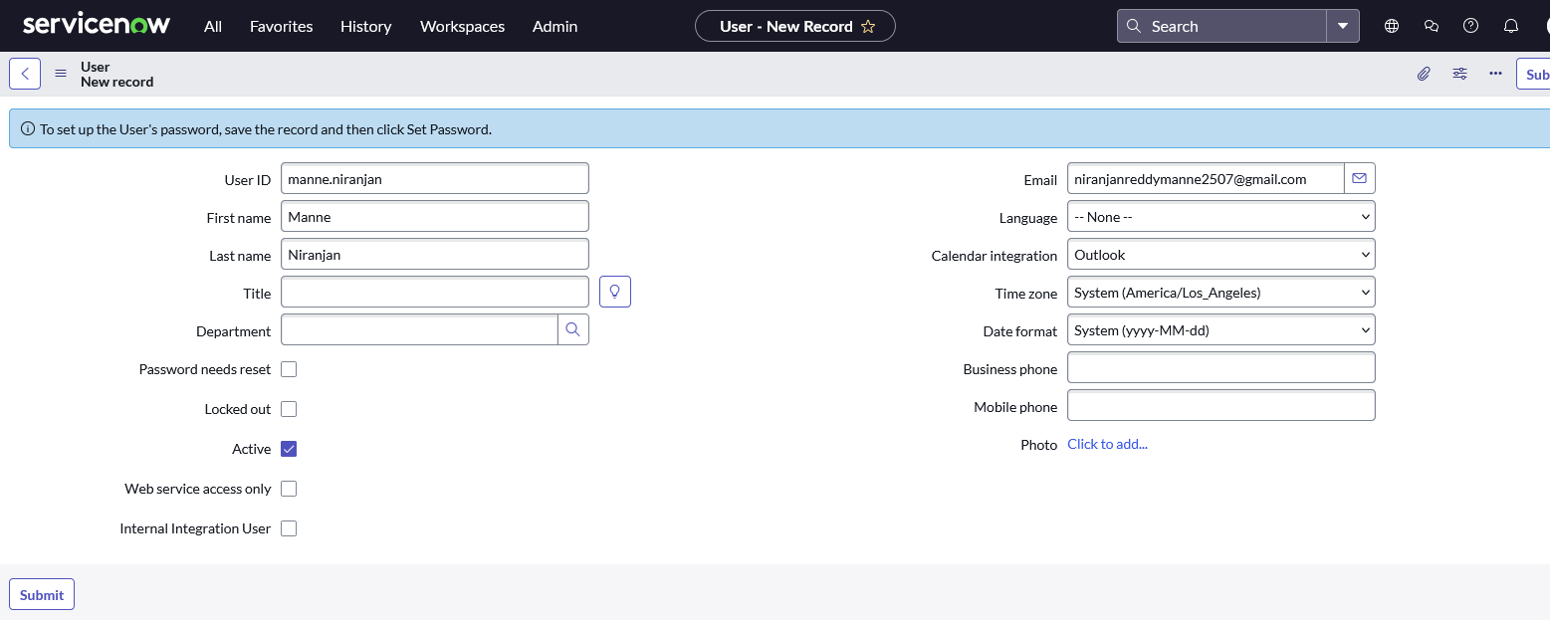

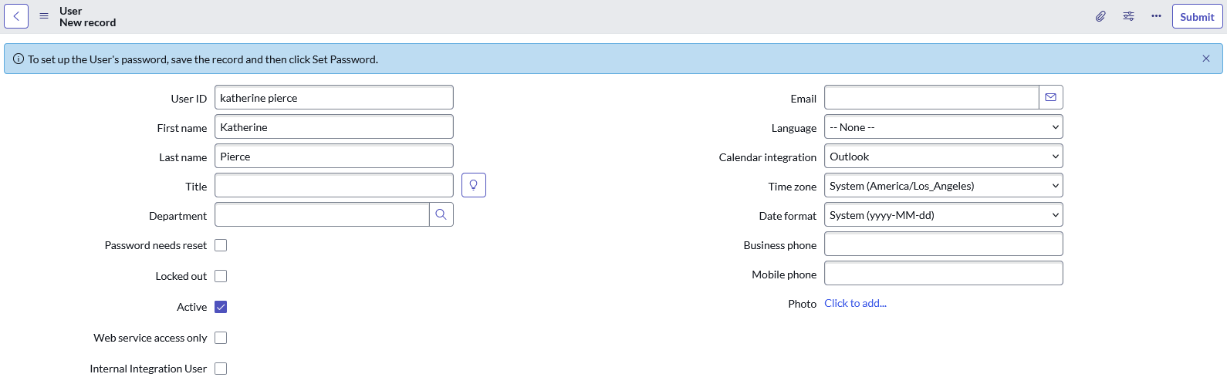

**Milestone 2 :** Groups

**Activity 1**: Create Groups  
  
**Steps:**

1. Open **ServiceNow** and log in.
2. Navigate to **All → System Security → Groups**.
3. Click **New** to create a group.
4. Fill in the required details for the first group.
5. Click **Submit** to save the group.
6. Repeat steps 3–5 to create a second group with the specified details.

Using the steps above, two groups were successfully created: **platform** and **Certificates**

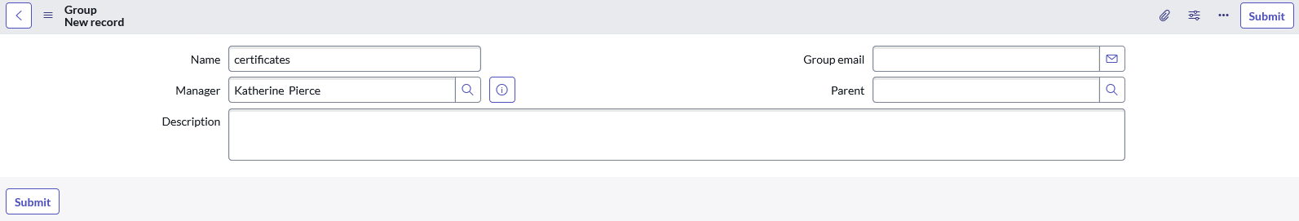

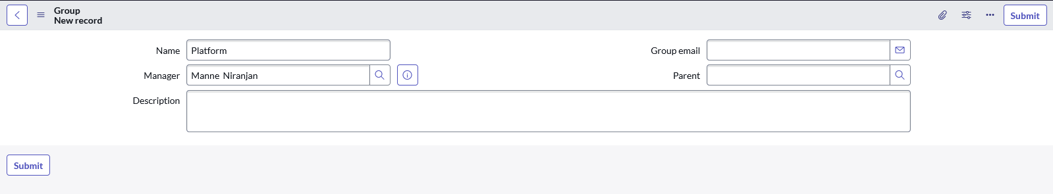

**Milestone 3 :** Roles

**Activity 1:** Create Roles

**Steps:**

1. Open **ServiceNow** and log in.
2. Navigate to **All → System Security → Roles**.
3. Click **New** to create a role.
4. Fill in the required details for the first role.
5. Click **Submit** to save the role.
6. Repeat steps 3–5 to create a second role with the specified details.

Using the steps above, two roles were successfully created: **Certificate_role** and **Platform_Role.**

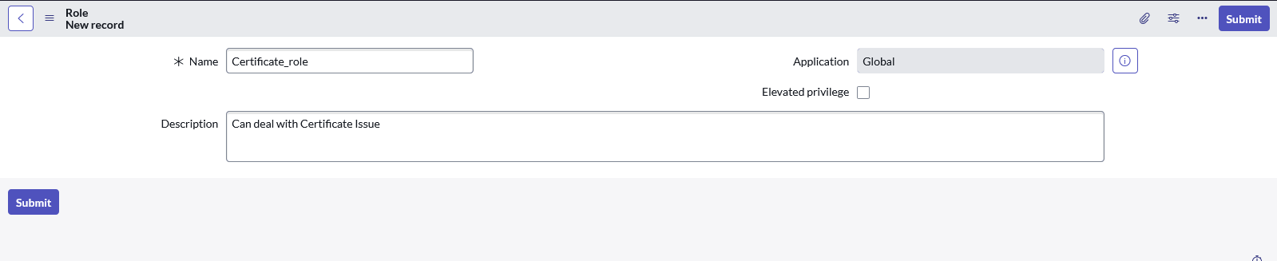

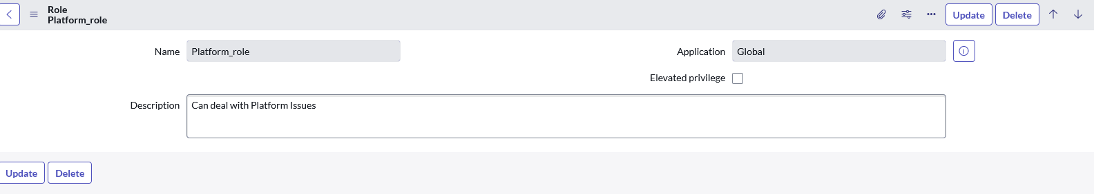

### Milestone 4 : Table

**Activity 1:** Create Table

**Steps:**

1. Open **ServiceNow** and log in.
2. Navigate to **All → System Definition → Tables**.
3. Click **New** to create a table.
4. Fill in the following details:
   1. **Label:** Operations related
   2. Check the boxes **Create module** and **Create mobile module**
   3. **New menu name:** Operations related

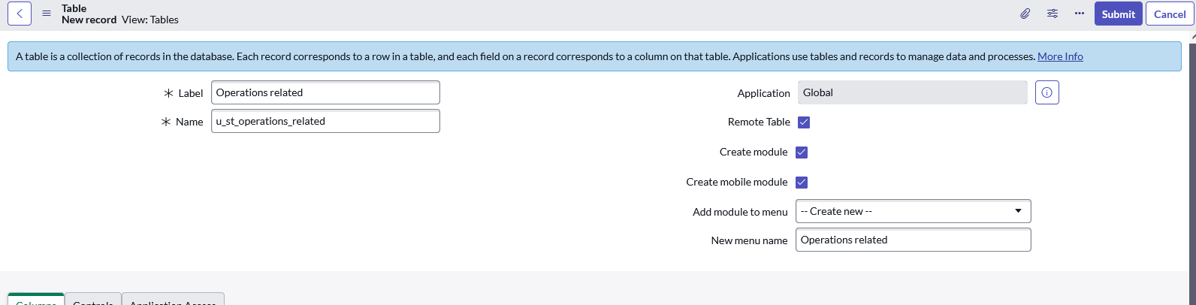

1. Under table columns give the columns

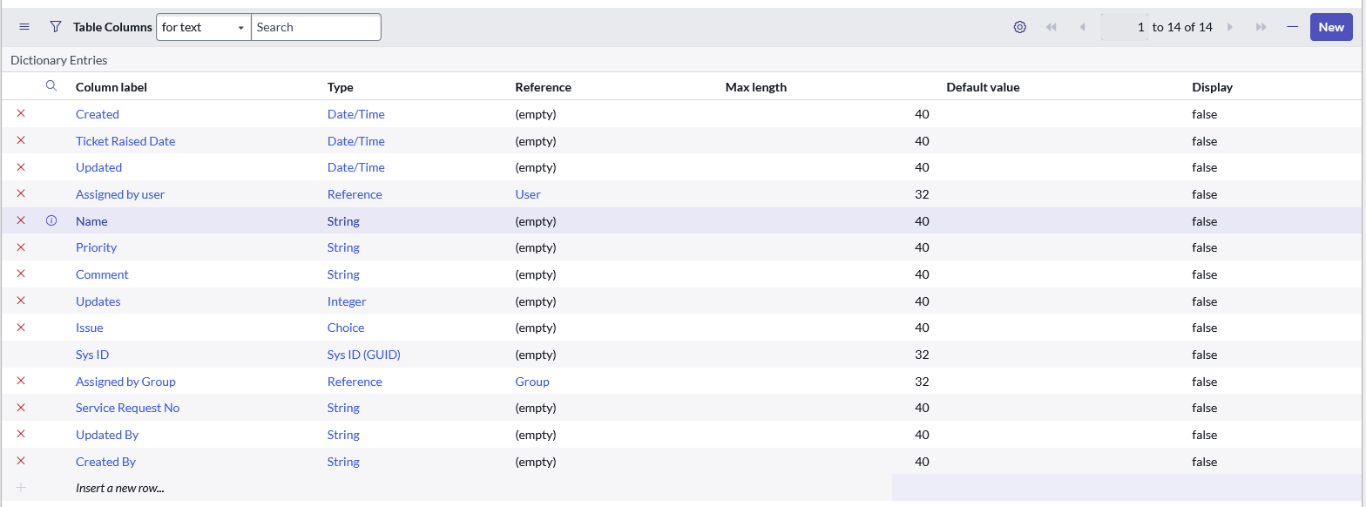

1. Click **Submit** to save the table.
2. Create choices for the issue filed by using form design

Choices are

* unable to login to platform
* 404 error
* regarding certificates
* regarding user expired

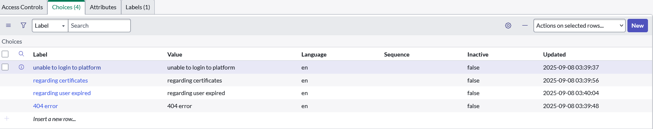

### Milestone 5 : Assign roles & users to groups

### Activity 1: Assign roles & users to certificate group

**Steps:**

1. Open **ServiceNow** and log in.
2. Go to **All → User Administration → Groups.**
3. Search and open the **Certificates** group.
4. In the **Group Members** related list, click **Edit**, add **Katherine Pierce**, and **Save**.

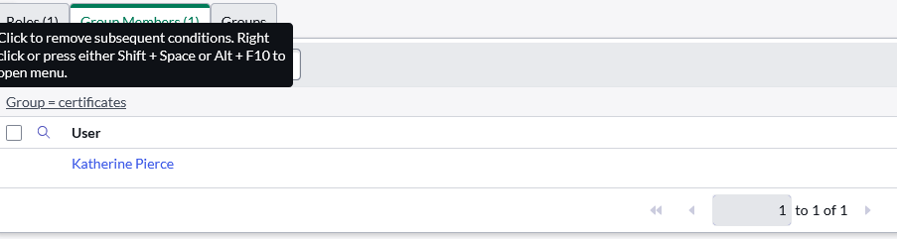

1. In the **Roles** related list (still on the group form), click **Edit**, add **Certification_role**, and **Save**

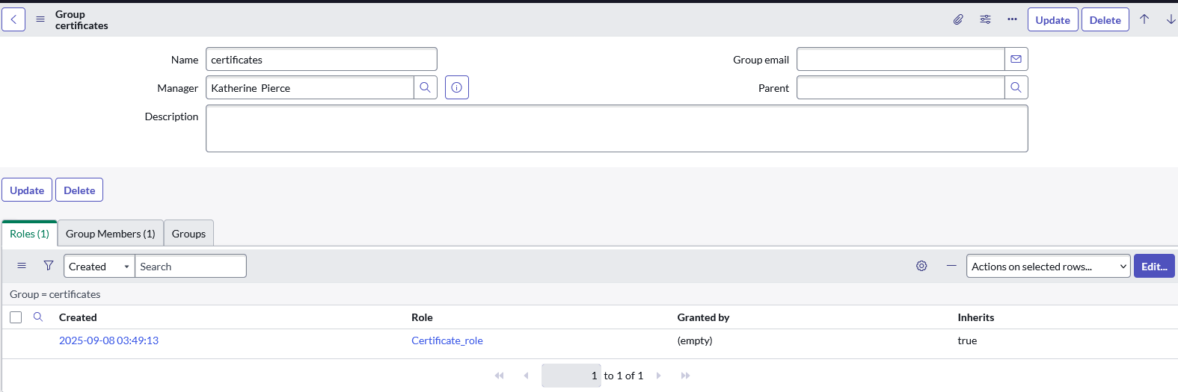

### Activity 2: Assign roles & users to platform group

**Steps**:

1. Open **ServiceNow** and log in.
2. Go to **All → User Administration → Groups.**
3. Search and open the **Platform** group.
4. In the **Group Members** related list, click **Edit**, add **Manne Niranjan**, and **Save**.

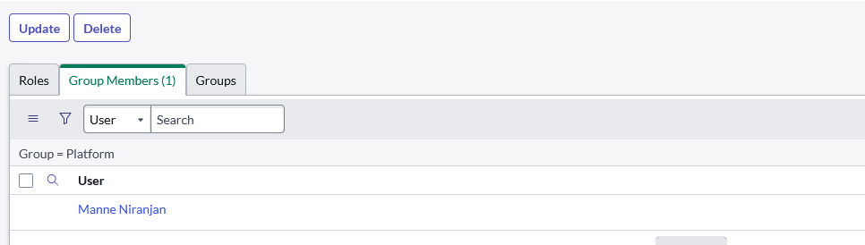

5)In the **Roles** related list (still on the group form), click **Edit**, add **Certification_role**, and **Save**

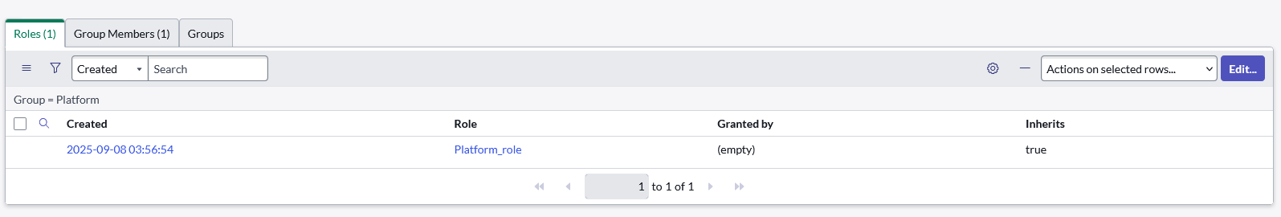

### Milestone 6 : Assign role to table

### Activity 1 : Assign role to table

Steps:

1)Open service now.

2)Click on the profile on top right side

3)Click on elevate role

4)Click on security admin and click on update

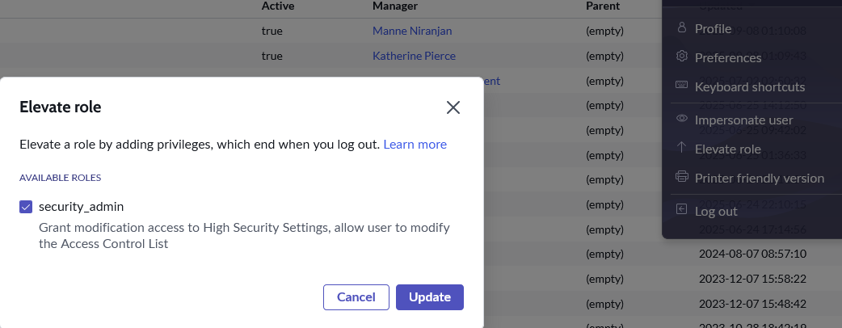

5)Click on All  >> search for ACL

6)Select on **u_operations_related read**

7)Under Requires role

8)Double click on insert a new row

9)Give platform role

10)And add certificate role

11)Click on update

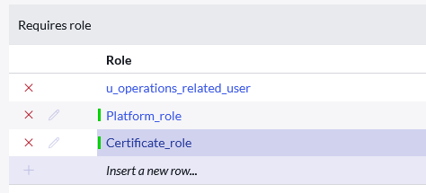

12)Select on **u_operations_related write**

13)Under Requires role

14)Double click on insert a new row

15)Give platform role

16)And add certificate role

17)Click on update

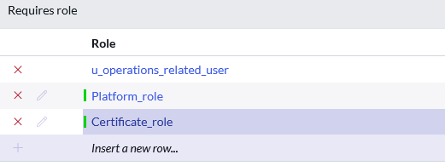

### Milestone 7 : Create ACL

### Activity 1 : Create ACL

**Steps:**

1)Open service now.

2)Click on All  >> search for ACL

3)Select Access Control(ACL) under system security

4)Click on new

5)create a new ACL by following details  
 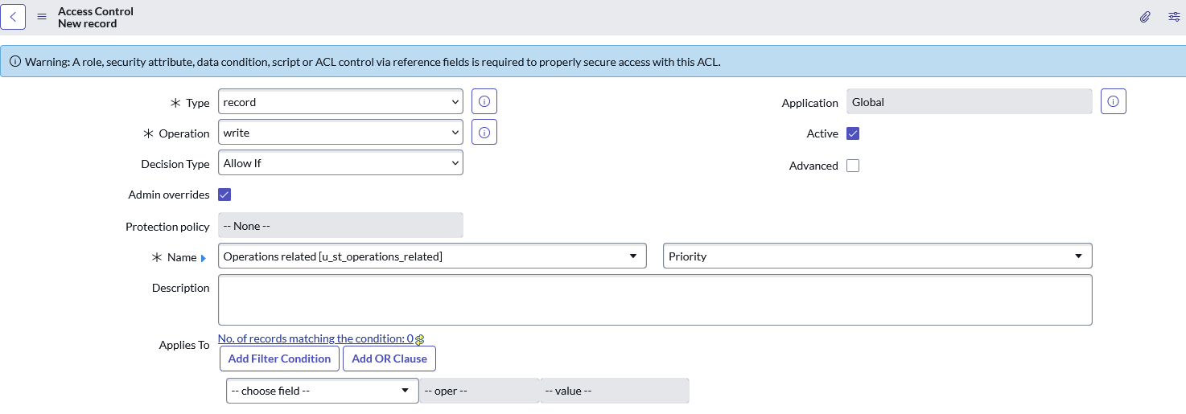

6)Scroll down under requires role

7)Double click on insert a new row

8)Give admin role

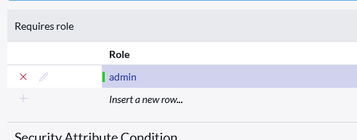

9)Click on submit

10)Similarly create 4 acl for the following fields

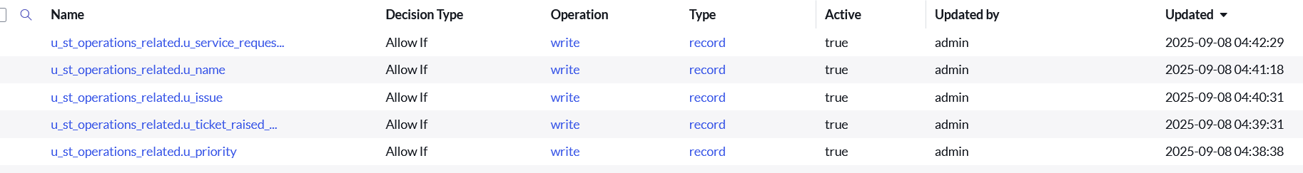

### Milestone 7 : Flow

### Activity 1 : Create a Flow to Assign operations ticket to Certificate group

**Steps**:

1)Open service now.

2)Click on All  >> search for Flow Designer

3)Click on Flow Designer under Process Automation.

4)After opening Flow Designer Click on new and select Flow.

5)Under Flow properties Give Flow Name as “ Regarding Certificate”.

6)should be Global.

7)Select Run user as “ System user ” from that choice.

8)Click on Submit.

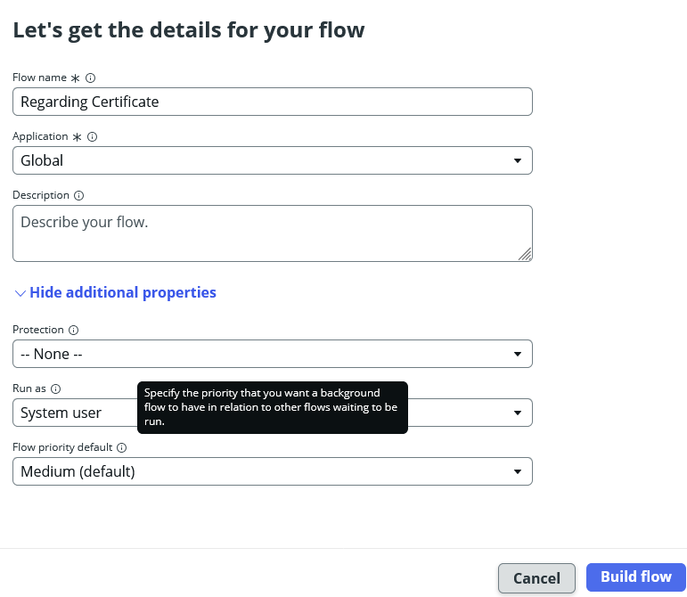

9)Click on Add a trigger

10)Select the trigger in that Search for “create or update a record”  and select that.

11)Give the table name as “ Operations related ”.

12)Give the Condition as  
Field : issue

Operator : is

Value : Regrading Certificates

1. After that click on Done.

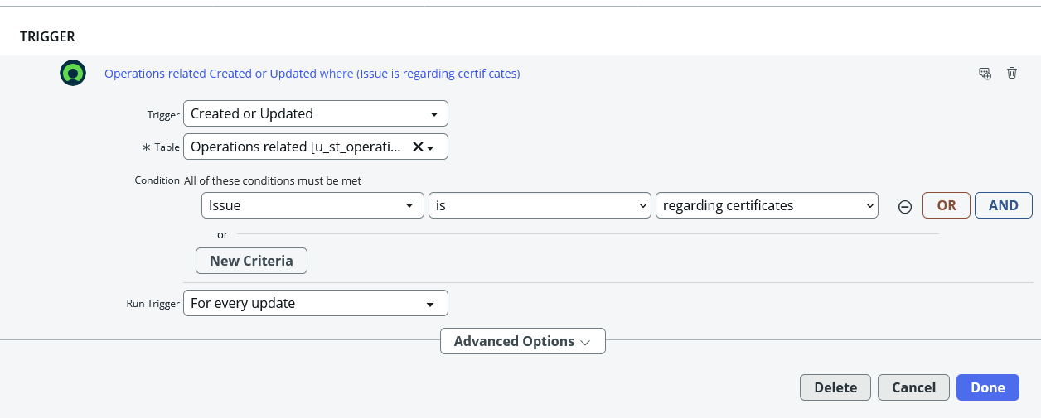

14)Now under Actions.

15)Click on Add an action.

16)Select action in that search for “ Update Record ”.

17)In Record field drag the fields from the data navigation from left side

18)Table will be auto assigned after that

19)Give the field as “ Assigned to group ”

20)Give value as “ Certificates ”

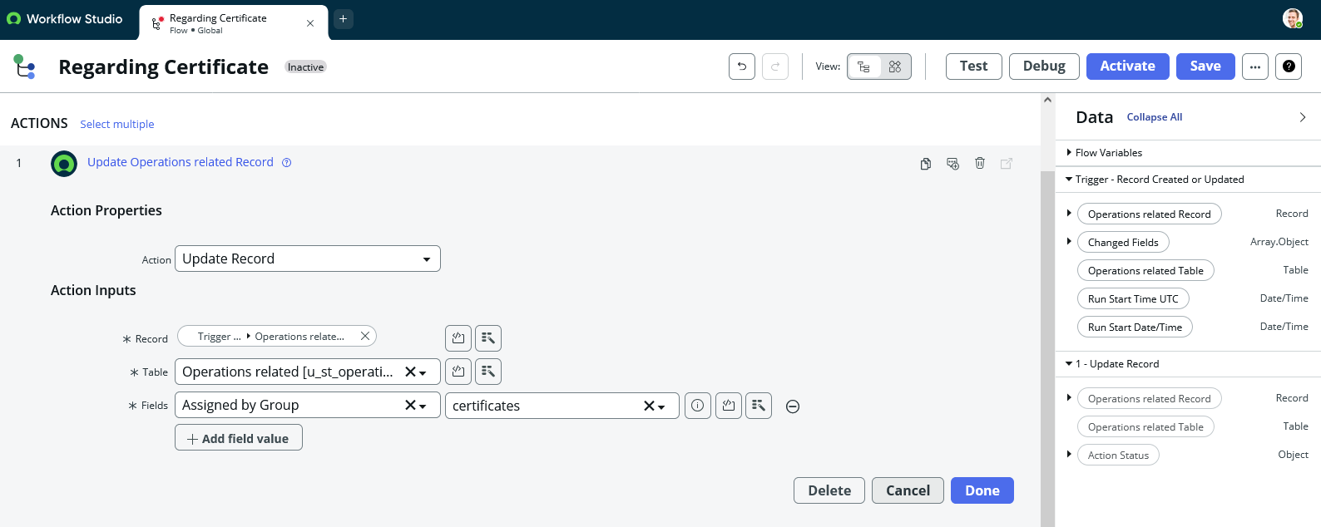

21)Click on Done.

22)Click on Save to save the Flow.

23)Click on Activate.

### Activity 1 : Create a Flow to Assign operations ticket to Platform group

Steps:

1)Open service now.

2)Click on All  >> search for Flow Designer

3)Click on Flow Designer under Process Automation.

4)After opening Flow Designer Click on new and select Flow.

5)Under Flow properties Give Flow Name as “ Regarding Platform”.

6)should be Global.

7)Select Run user as “ System user ” from that choice.

8)Click on Submit.

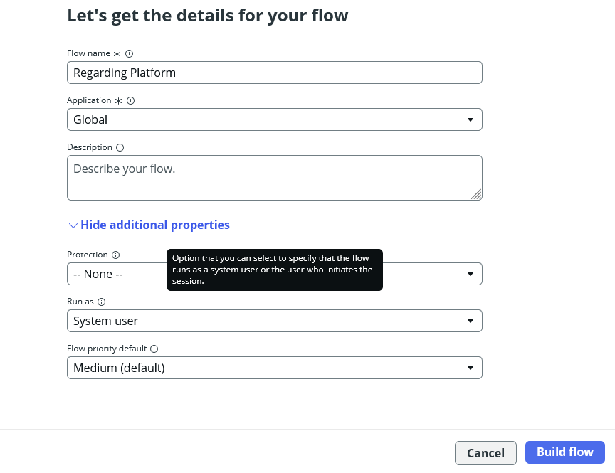

9)Click on Add a trigger

10)Select the trigger in that Search for “create or update a record”  and select that.

11)Give the table name as “ Operations related ”.

12)Give the Condition as  
 Field : issue

Operator : is

Value : Unable to login to platform

Click on New Criteria

Field : issue

Operator : is

Value : 404 Error

Click on New Criteria

Field : issue

Operator : is

Value : Regrading User expired

13)After that click on Done.

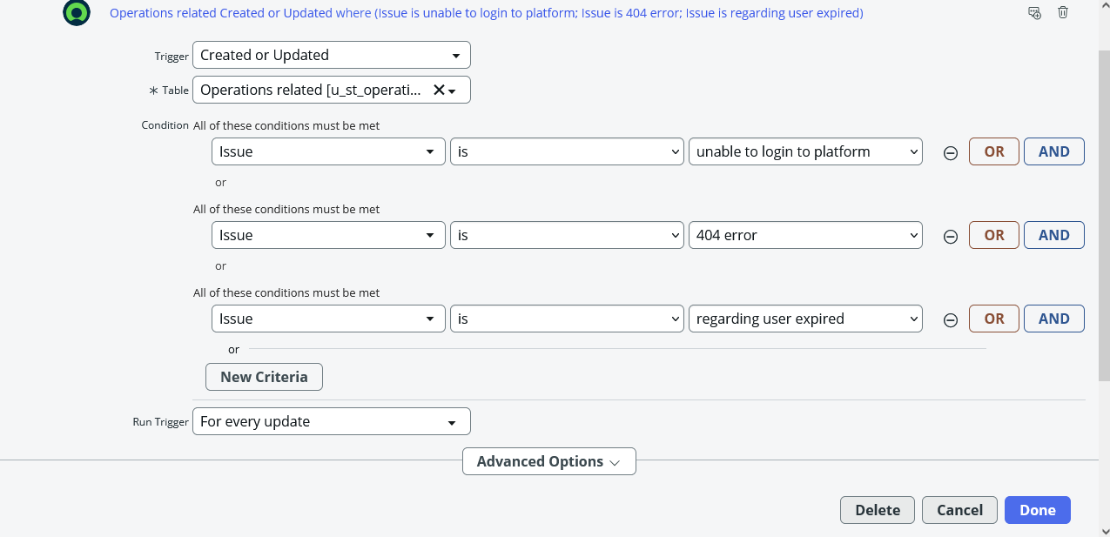

14) Now under Actions.

15) Click on Add an action.

16) Select action in that search for “ Update Record ”.

17) In Record field drag the fields from the data navigation from left side

18) Table will be auto assigned after that

19) Give the field as “ Assigned to group ”.

20) Give value as “ Platform ”.

21) Click on Done.

22) Click on Save to save the Flow.

23) Click on Activate.

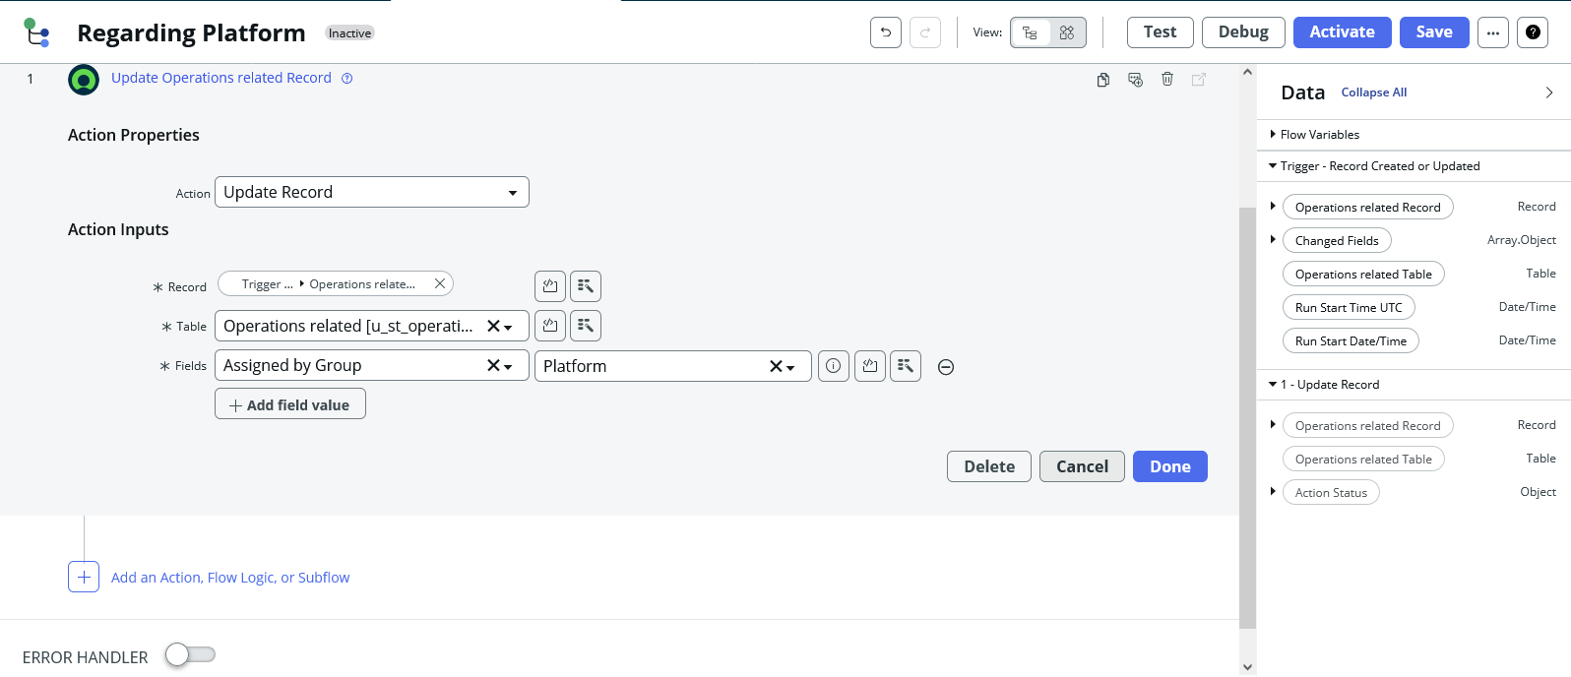

**Conclusion**:

This document outlined the end-to-end process of streamlining ticket assignment in ServiceNow for ABC Corporation. The steps covered include creating users, groups, and roles; designing a custom operations table; applying access controls; and building flows for automated ticket routing.

By following these milestones, an automated ticket assignment framework was successfully implemented. This solution eliminates manual routing, ensures tickets are directed to the correct support groups, and reduces delays in issue resolution.

**Key Outcomes:**

Two user accounts and two groups were created to represent support teams.

Roles were defined and assigned to manage access rights.

A custom operations table was created with relevant issue categories.

ACLs were configured to enforce role-based security.

Automated flows were built to assign tickets to the correct groups based on issue type.

s