AHAMMED NAFIL J
251901006

Ex.No.2 | Study of Network cables.  Understand different types of Network cables.  Make a cross-wired cable and straight through cable using clamping/crimping tool.
Date:
- Understand different types of network cable.
Different type of cables used in networking are:
  - Unshielded Twisted Pair (UTP) Cable
  - Shielded Twisted Pair (STP) Cable
  - Coaxial Cable
  - Fibre Optic Cable

Cable type | Category | Maximum Data Transmission | Advantages/ Disadvantages | Application/Use | Image
UTP | Category 3 | 10 bps | Advantages  - Cheaper in cost  - Easy to install as they have a smaller overall diameter.  Disadvantages  - More prone to (EMI)  Electromagnetic interference and noise | 10Base-T Ethernet | 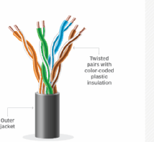
UTP | Category 5 | Up to 100 Mbps |  | Fast Ethernet, Gigabit Ethernet
UTP | Category 5e | 1Gbps |  | Fast Ethernet, Gigabit Ethernet
STP | Category6,6a | 10Gbps | Advantages  - Shielded.  - Faster than UTP.  - Less susceptible to noise and interference  Disadvantages  - Expensive  - Greater installation effort | Gigabit Ethernet, 10G Ethernet (55m)  Widely used in data centres | 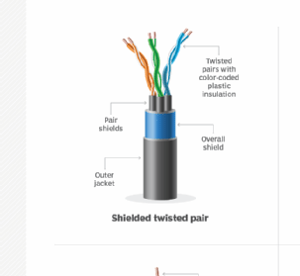  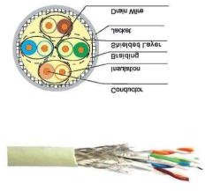
SSTP | Category 7 | 10Gbps |  | Gigabit Ethernet, 10G Ethernet (100m)

Coaxial cable | RG-6 RG-59 RG-11 | 10-100Mbps | - High bandwidth  - Immune to interference  - Low loss bandwidth  - Versatile  - Disadvantages  - Limited distance  - Cost  - Size is bulky | Speed of signal is 500m  Television network High speed internet connections | 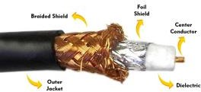
fibre optics cable | Single mode Multi mode | 100Gbps | Advantages  - High speed  - High bandwidth  - High security  - Long distance  Disadvantages  - Expensive  - Requires skilled installers | - Maximum distance of fibre optics cable is around 100meters | 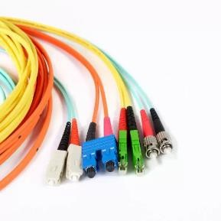

- Make Your Own Ethernet Cross-Over Cable/ Straight cable
Tools and parts needed:
- Ethernet cabling. CAT5e is certified for gigabit support, but CAT5 cabling works as well, just over shorter distances.
- A crimping tool. This is an all-in-one networking tool shaped to push down the pins in the plug and strip and cut the shielding off the cables.
- Two RJ45 plugs.
- Optional two plug shields.
• Ethernet Cable (CAT5e/CAT5)
- CAT5e is recommended because it supports Gigabit Ethernet (1000 Mbps).
- CAT5 also works but supports lower speeds and shorter distances.
• Crimping Tool
- A networking tool used to:
  - Strip the outer insulation of the cable.
  - Arrange and trim the wires.
  - Crimp (press) the RJ45 connector onto the cable.
• RJ45 Connectors (2)
- Plastic connectors fitted at both ends of the Ethernet cable.
- Used to connect the cable to computers, switches, routers, etc.
• Plug Shields (Optional)
- Protective covers placed over the RJ45 connectors.
- Prevent damage to the locking clip and reduce strain on the cable.

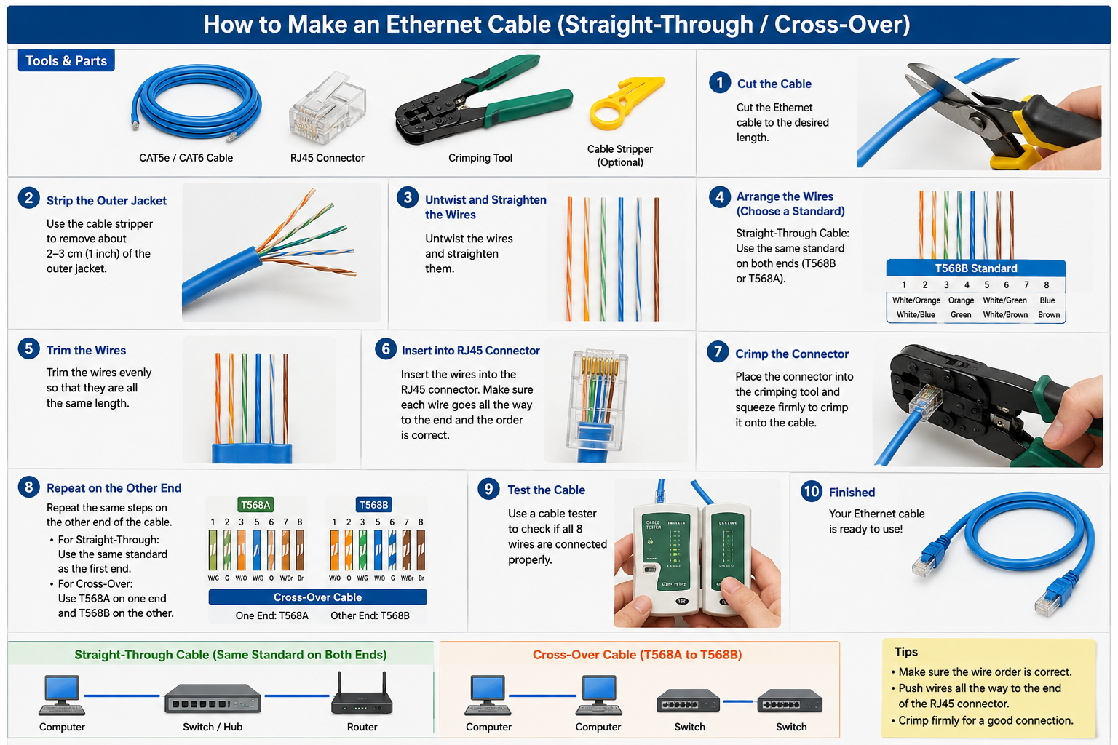

RESULT:

