ASSIGNMENT – 1
Probability and Bayesian Classification

Submitted By
Ahammed Sameer

Course
M.Sc. Computer Science (Data Analytics)
Department
Department of Computer Science

Register Number | 26CS1035
Subject | INFERENTIA STATISTICS
Faculty Name | DR. SABEEN
Date of Submission | 30-07-2026

Academic Year 2026–2028

Table of Contents
Table of Contents 1
1. Probability Concept 1
1.1 Introduction 1
1.2 Definition 1
1.3 Importance of Probability 1
1.4 Basic Terminology 1
Experiment 1
Random Experiment 1
Outcome 1
Event 1
Sample Space 1
Equally Likely Events 1
Impossible Event 1
Certain Event 1
Independent Events 1
Dependent Events 1
Mutually Exclusive Events 1
1.5 Formula 1
1.6 Explanation of the Formula 1
1.7 Real-life Applications 1
1.8 Summary 1
1.9 Solved Example 1
2. Addition Rule of Probability 1
2.1 Introduction 1
2.2 Definition 1
2.3 Explanation 1
2.4 When the Addition Rule Is Used 1
2.5 Mutually Exclusive Events 1
2.6 Non-Mutually Exclusive Events 1
2.7 Real-life Applications 1
2.8 Solved Example 1
3. Multiplication Rule of Probability 1
3.1 Definition 1
3.2 Independent Events 1
3.3 Dependent Events 1
3.4 Explanation 1
3.5 Applications 1
3.6 Solved Example 1
4. Conditional Probability 1
4.1 Introduction 1
4.2 Definition 1
4.3 Explanation 1
4.4 Why Conditional Probability Is Important 1
4.5 Applications 1
4.6 Solved Examples 1
Question 1 (Original) 1
Question 2 (Adapted from GATE CS 2015 style) 1
5. Total Probability Theorem 1
5.1 Introduction 1
5.2 Definition and Statement 1
5.3 Formula Explanation 1
5.4 Applications 1
5.5 Solved Examples 1
Question 1 (Original) 1
Question 2 (Adapted from GATE EC / CS style) 1
6. Bayes’ Theorem 1
6.1 Introduction 1
6.2 Definition 1
6.3 Explanation of Terms 1
6.4 Applications 1
6.5 Solved Examples 1
Question 1 (Original University-Level) 1
Question 2 (Classic – required) 1
Question 3 (Difficult GATE-style) 1
7. Bayesian Classification 1
7.1 Introduction 1
7.2 Definition 1
7.3 History 1
7.4 Bayes’ Theorem in Machine Learning 1
7.5 Naïve Bayes Classifier 1
7.6 Assumptions of Naïve Bayes 1
7.7 Types of Naïve Bayes 1
Gaussian Naïve Bayes 1
Multinomial Naïve Bayes 1
Bernoulli Naïve Bayes 1
7.8 Working Principle 1
7.9 Mathematical Formula 1
7.10 Training Process 1
7.11 Prediction Process 1
7.12 Advantages 1
7.13 Disadvantages 1
7.14 Real-world Applications 1
7.15 Conclusion 1
References 1

1. Probability Concept

1.1 Introduction
Probability theory forms the mathematical foundation for quantifying uncertainty. In virtually every scientific discipline—ranging from statistical physics to modern machine learning—researchers must reason about outcomes that are not deterministically known in advance. The formal language of probability enables precise statements about the likelihood of events and provides a coherent calculus for updating beliefs when new information becomes available.
For a student of data analytics, a firm grasp of probability is indispensable. Classification algorithms, regression models, and Bayesian inference procedures all rest upon probabilistic assumptions. This section therefore develops the elementary notions that will be used throughout the remainder of the assignment.

1.2 Definition
The classical (or a priori) definition of probability states that if a random experiment can result in n equally likely, mutually exclusive and exhaustive outcomes, and if m of those outcomes are favourable to an event A, then the probability of A is given by
P(A) = m / n = (Number of favourable outcomes) / (Total number of possible outcomes).
A more general axiomatic definition, introduced by Kolmogorov, treats probability as a real-valued set function P defined on a σ-algebra of events that satisfies three axioms: non-negativity, normalisation (P(Ω) = 1), and countable additivity for pairwise disjoint events.

1.3 Importance of Probability
Probability supplies the only rigorous framework for decision-making under uncertainty. In machine learning it underpins maximum-likelihood estimation, Bayesian model comparison, and the construction of probabilistic classifiers. In everyday life it governs risk assessment, insurance pricing, and the interpretation of medical diagnostic tests. Without a probabilistic vocabulary one cannot meaningfully discuss the reliability of a prediction or the strength of empirical evidence.

1.4 Basic Terminology

Experiment
An experiment is any process that generates a well-defined set of possible results. The process need not be laboratory-based; tossing a coin, surveying voters, or observing the next token produced by a language model are all experiments in the probabilistic sense.

Random Experiment
A random experiment is one whose outcome cannot be predicted with certainty before the experiment is performed, even though the set of all possible outcomes is known. The essential feature is variability of the result under identical conditions.

Outcome
An outcome is a single possible result of a random experiment. Outcomes are the atomic elements of the sample space.

Event
An event is any subset of the sample space. When the experiment is performed and an outcome ω is observed, we say that event A has occurred if ω ∈ A.

Sample Space
The sample space, customarily denoted Ω (or S), is the set of all possible outcomes of a random experiment. It may be finite, countably infinite, or uncountable.
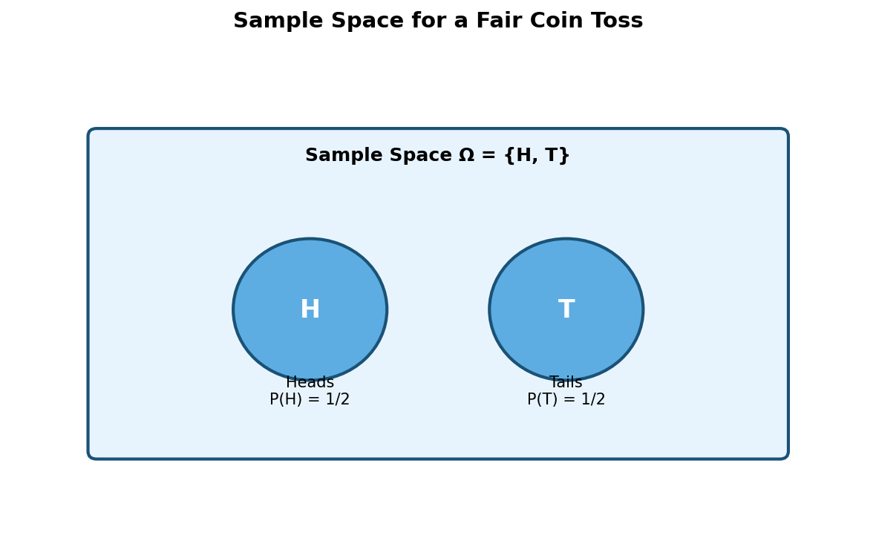
Figure 1.1: Sample space for a single fair coin toss. The two outcomes Heads (H) and Tails (T) are equally likely.
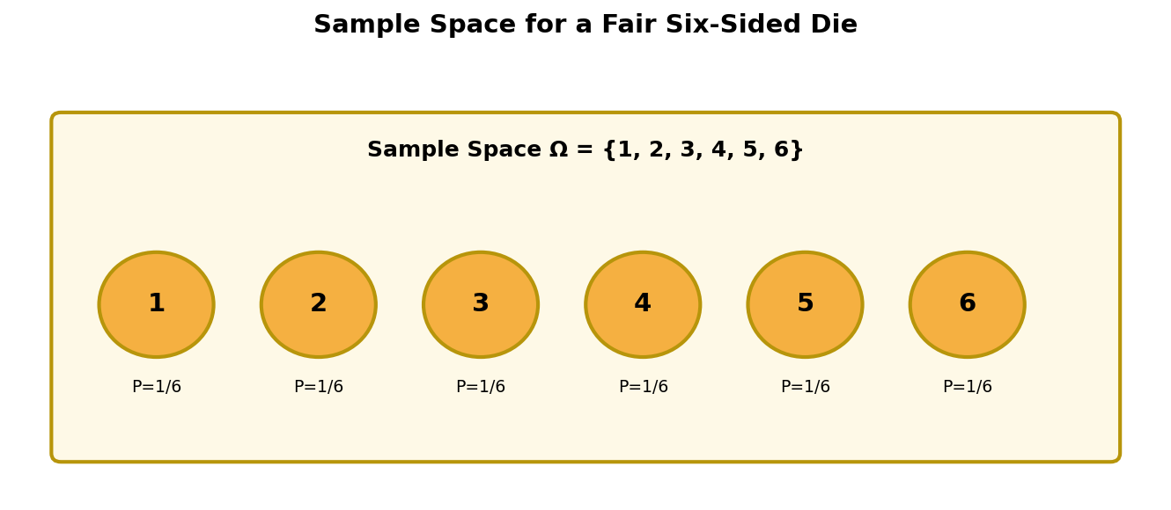
Figure 1.2: Sample space for a fair six-sided die. Each face is an elementary outcome with probability 1/6.

Equally Likely Events
Two or more events are said to be equally likely when there is no reason to expect one to occur in preference to the others. In the classical setting this symmetry justifies assigning equal probability to each elementary outcome.

Impossible Event
The empty set ∅ is called the impossible event; it contains no outcomes and therefore has probability zero: P(∅) = 0.

Certain Event
The entire sample space Ω is the certain event; it is guaranteed to occur and therefore satisfies P(Ω) = 1.

Independent Events
Events A and B are independent if the occurrence of one does not alter the probability of the other. Formally, P(A ∩ B) = P(A) · P(B). Independence is a modelling assumption that must be justified by the physical or logical structure of the experiment.

Dependent Events
Events that fail the equality above are dependent (or associated). Knowledge that one has occurred changes the probability assigned to the other.

Mutually Exclusive Events
Two events are mutually exclusive (or disjoint) if they cannot occur simultaneously, i.e., A ∩ B = ∅. For such events the addition rule simplifies to P(A ∪ B) = P(A) + P(B).
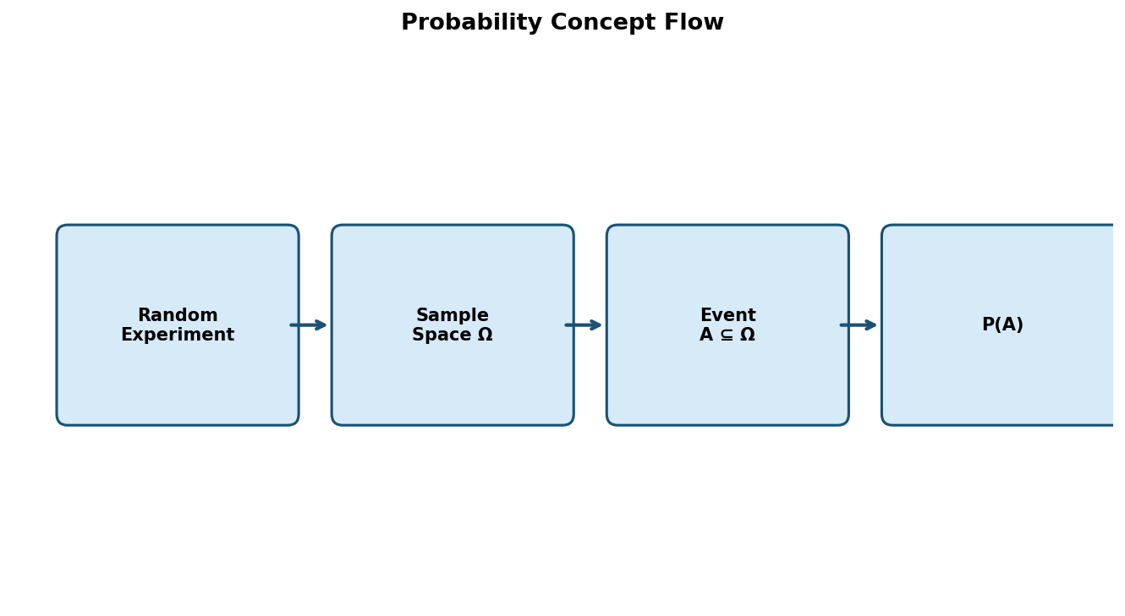
Figure 1.3: Conceptual flow from a random experiment through the sample space to the assignment of probability.

1.5 Formula
P(A) = n(A) / n(Ω), where 0 ≤ P(A) ≤ 1.
Here n(A) denotes the cardinality of the set of favourable outcomes and n(Ω) the cardinality of the sample space (when both are finite).

1.6 Explanation of the Formula
The ratio counts the proportion of the sample space that is occupied by the event of interest. Because every outcome is assumed equally likely, the proportion coincides with the long-run relative frequency of the event under repeated independent trials. The bounds 0 and 1 follow at once from the fact that a subset cannot contain more elements than the whole set, nor fewer than none.

1.7 Real-life Applications
Probability calculations appear in weather forecasting (chance of precipitation), quality control (defect rates), clinical trials (efficacy of a drug), and financial risk management (Value-at-Risk). In computer science they underlie hashing analysis, randomised algorithms, and the evaluation of classifiers via ROC curves.

1.8 Summary
Probability assigns a numerical measure of likelihood to events defined on a sample space. The elementary terminology—experiment, outcome, event, independence, mutual exclusivity—provides the vocabulary needed for all subsequent developments. The classical formula P(A) = n(A)/n(Ω) is the starting point for discrete uniform models; the Kolmogorov axioms extend the theory to arbitrary probability spaces.

1.9 Solved Example
Question (Original University-Level Problem). A bag contains 5 red balls, 4 blue balls and 3 green balls. Two balls are drawn at random without replacement. Find the probability that both balls are of the same colour.
Given: Red = 5, Blue = 4, Green = 3; total balls N = 12. Two balls drawn without replacement.
To find: P(both same colour).
The favourable outcomes are the three mutually exclusive cases: both red, both blue, or both green. Because the draws are without replacement, the hypergeometric (combinatorial) model is appropriate.
Total ways of choosing 2 balls out of 12:
C(12,2) = 12 × 11 / 2 = 66.
Ways of choosing 2 red balls:
C(5,2) = 5 × 4 / 2 = 10.
Ways of choosing 2 blue balls:
C(4,2) = 4 × 3 / 2 = 6.
Ways of choosing 2 green balls:
C(3,2) = 3 × 2 / 2 = 3.
Hence the number of favourable outcomes is 10 + 6 + 3 = 19.
Therefore,
P(both same colour) = 19 / 66.

Final Answer: 19/66 ≈ 0.2879

Exam Tip:
When sampling without replacement, always prefer combinations over sequential probabilities if the order of selection is irrelevant; the combinatorial approach is less error-prone.

2. Addition Rule of Probability

2.1 Introduction
Many practical questions ask for the probability that at least one of several events occurs. The addition rule supplies the precise relationship between the probability of a union and the probabilities of the constituent events.

2.2 Definition
For any two events A and B defined on the same sample space,
P(A ∪ B) = P(A) + P(B) − P(A ∩ B).
The subtracted term corrects for the double-counting of the intersection that occurs when the two individual probabilities are simply added.

2.3 Explanation
Imagine the sample space represented by a Venn diagram. The region corresponding to A ∪ B is the total area covered by the two circles. Adding the areas of the two circles counts the overlapping lens twice; subtracting the area of the lens once restores the correct measure.

2.4 When the Addition Rule Is Used
The rule is invoked whenever one needs the probability of the occurrence of at least one of two (or more) events. Special cases arise when the events are mutually exclusive or when one event is contained in the other.

2.5 Mutually Exclusive Events
If A ∩ B = ∅, then P(A ∩ B) = 0 and the formula collapses to
P(A ∪ B) = P(A) + P(B).
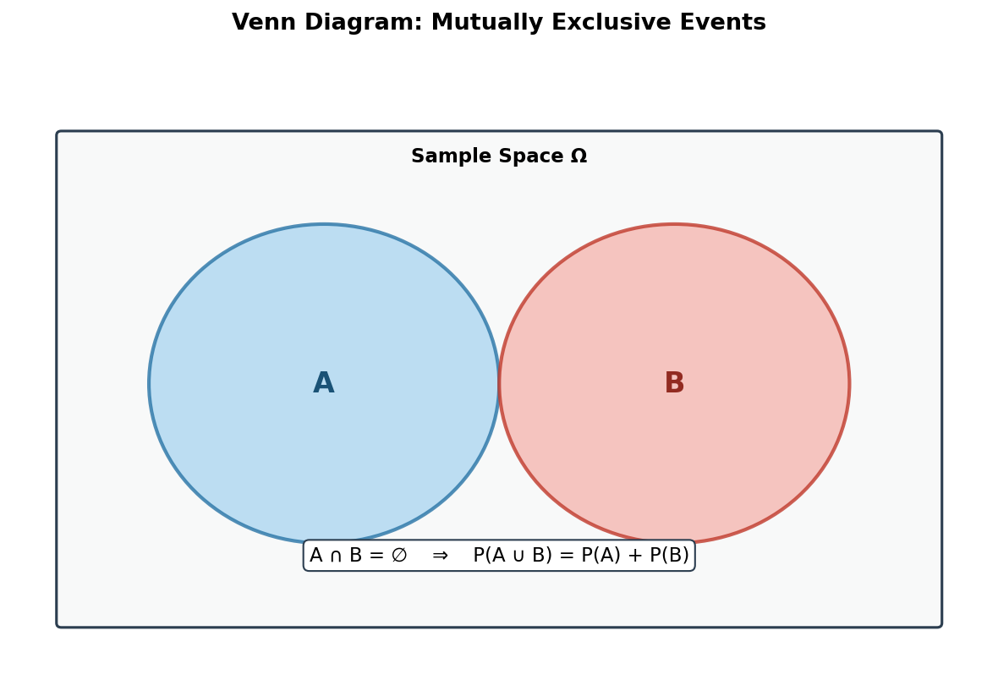
Figure 2.1: Venn diagram of two mutually exclusive events. The intersection is empty, so probabilities add directly.

2.6 Non-Mutually Exclusive Events
When the events may overlap, the full subtraction formula must be retained. Failure to subtract the intersection is one of the most common sources of error in elementary probability calculations.
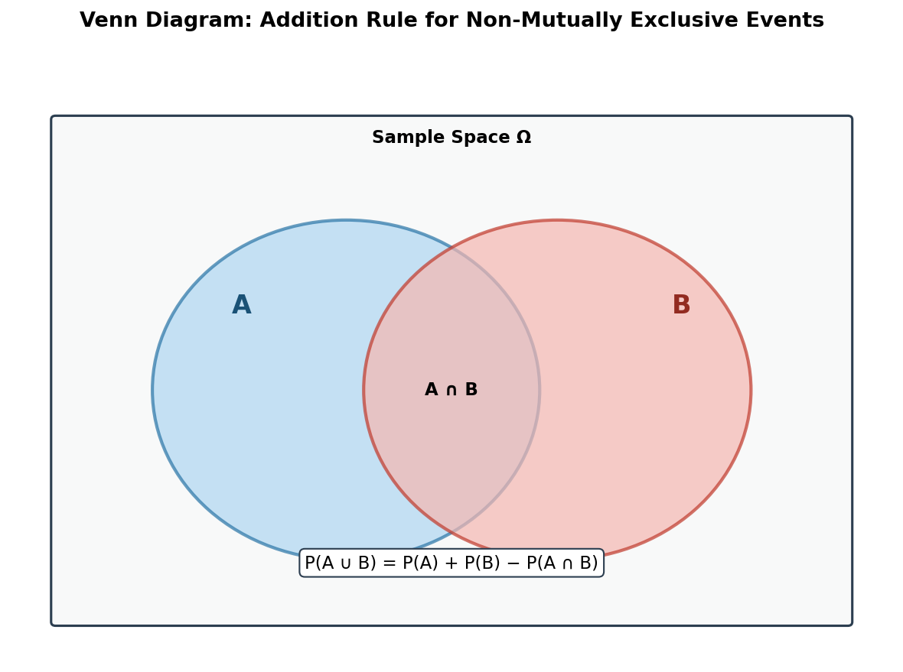
Figure 2.2: Venn diagram illustrating the addition rule for overlapping events. The intersection A ∩ B is counted twice if simply added and must therefore be subtracted once.

2.7 Real-life Applications
A quality-control engineer may wish to know the probability that a manufactured item is either defective in dimension or defective in surface finish (or both). An actuary may compute the probability that a policyholder files a claim for either fire or theft. In each case the addition rule, possibly with an estimated intersection term, yields the required probability.

2.8 Solved Example
Question (Adapted from GATE Probability Questions – style similar to GATE CS 2005). In a class of 100 students, 40 like Mathematics, 50 like Physics and 20 like both. A student is selected at random. Find the probability that the student likes either Mathematics or Physics (or both).
Given: n(Ω) = 100, n(M) = 40, n(P) = 50, n(M ∩ P) = 20.
To find: P(M ∪ P).
Apply the addition rule:
P(M ∪ P) = P(M) + P(P) − P(M ∩ P)
Substitute the relative frequencies:
P(M) = 40/100 = 0.40, P(P) = 50/100 = 0.50, P(M ∩ P) = 20/100 = 0.20.
P(M ∪ P) = 0.40 + 0.50 − 0.20 = 0.70.
Equivalently, in fractional form:
P(M ∪ P) = (40 + 50 − 20)/100 = 70/100 = 7/10.

Final Answer: 7/10 or 0.70

Exam Tip:
Always verify whether the events are mutually exclusive before deciding whether to subtract the intersection. In GATE-style questions the intersection is frequently given explicitly; omitting it loses marks.

3. Multiplication Rule of Probability

3.1 Definition
The multiplication rule expresses the probability of the joint occurrence of two events in terms of a marginal probability and a conditional probability:
P(A ∩ B) = P(A) · P(B|A) = P(B) · P(A|B).

3.2 Independent Events
When A and B are independent, the conditional probabilities reduce to the unconditional ones, yielding the familiar product rule
P(A ∩ B) = P(A) · P(B).

3.3 Dependent Events
If the events are dependent, one must retain the conditional factor. The value of P(B|A) is obtained either from the definition of conditional probability or from the physical description of the experiment (for example, sampling without replacement).

3.4 Explanation
Intuitively, the probability that both events occur is the probability that the first occurs multiplied by the probability that the second occurs given that the first has already occurred. The order of conditioning may be chosen for computational convenience.

3.5 Applications
Reliability engineering uses the multiplication rule to compute the probability that a series system functions (all components must work). In sequential sampling the rule yields the probability of any particular sequence of draws. In Bayesian networks the chain rule—a generalisation of the multiplication rule—factors a joint distribution into a product of conditional distributions.
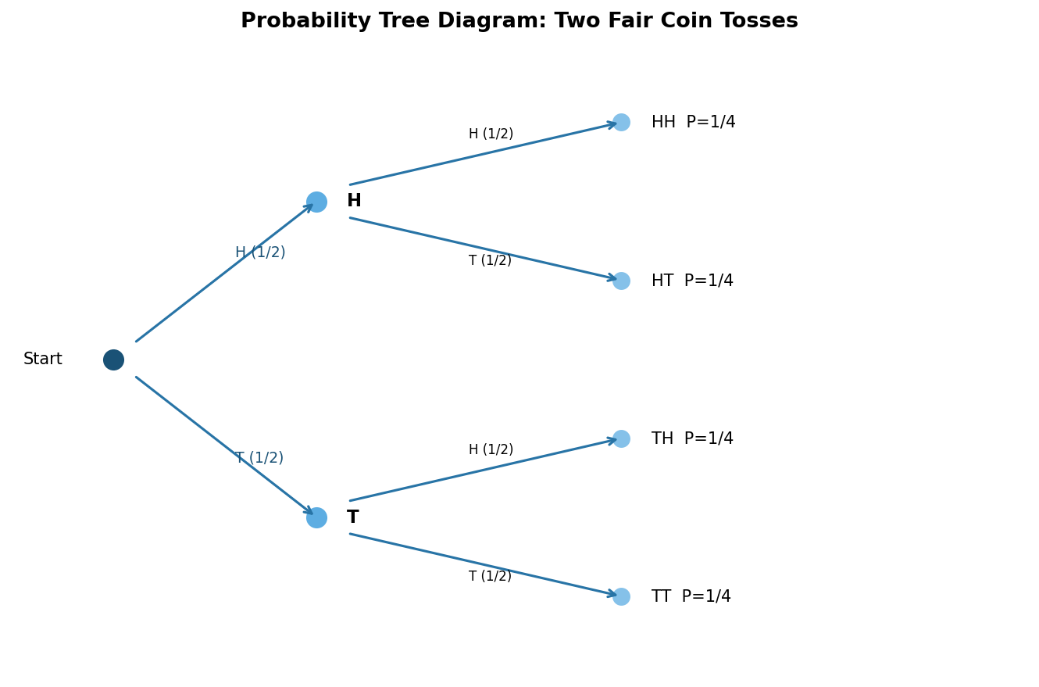
Figure 3.1: Probability tree for two successive fair coin tosses. Each path multiplies the branch probabilities to obtain the joint probability of a particular sequence.

3.6 Solved Example
Question (Adapted from GATE-style). An urn contains 6 white and 4 black balls. Two balls are drawn successively without replacement. Find the probability that the first ball is white and the second ball is black.
Given: White = 6, Black = 4, Total = 10. Sampling without replacement.
To find: P(W₁ ∩ B₂).
By the multiplication rule for dependent events,
P(W₁ ∩ B₂) = P(W₁) · P(B₂ | W₁).
The probability that the first ball is white is
P(W₁) = 6/10 = 3/5.
Given that a white ball has been removed, 9 balls remain of which 4 are black, so
P(B₂ | W₁) = 4/9.
Therefore,
P(W₁ ∩ B₂) = (3/5) × (4/9) = 12/45 = 4/15.

Final Answer: 4/15 ≈ 0.2667

Exam Tip:
When sampling without replacement, the denominators decrease by one at each step and the numerators change according to the colour already drawn. Draw a small tree if the sequence is longer than two draws.

4. Conditional Probability

4.1 Introduction
Conditional probability formalises the idea that the occurrence of one event can change the probability assigned to another event. It is the central concept that links the multiplication rule, the law of total probability, and Bayes’ theorem.

4.2 Definition
Let A and B be events with P(B) > 0. The conditional probability of A given B is defined by
P(A|B) = P(A ∩ B) / P(B).

4.3 Explanation
Conditioning on B means that the original sample space Ω is replaced by the smaller space B. Only those outcomes that lie inside B remain possible; the probability measure is renormalised by dividing by P(B) so that the new measure still sums to one.
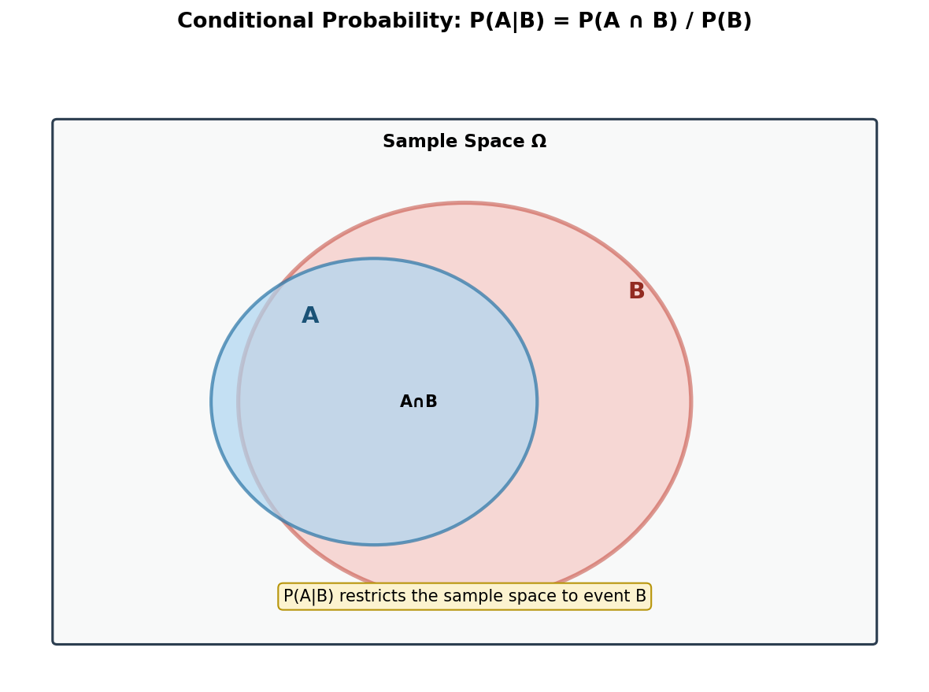
Figure 4.1: Geometric interpretation of conditional probability. The sample space is restricted to the region B; the probability of A inside that region is the relative area of the intersection.

4.4 Why Conditional Probability Is Important
Virtually every sequential or hierarchical probabilistic model relies on conditioning. Diagnostic reasoning (“What is the probability of disease given a positive test?”), filtering in signal processing, and the update step of Bayesian inference are all instances of conditional probability.

4.5 Applications
Medical screening, spam filtering, speech recognition, and reinforcement learning all compute or estimate conditional probabilities. In each domain the quantity of interest is the probability of a latent state given observed data.

4.6 Solved Examples

Question 1 (Original)
A fair die is rolled. Let A be the event that the outcome is even, and let B be the event that the outcome is greater than 3. Find P(A|B).
Given: Fair die, Ω = {1,2,3,4,5,6}. A = {2,4,6}, B = {4,5,6}.
First compute the intersection:
A ∩ B = {4,6}, so P(A ∩ B) = 2/6 = 1/3.
P(B) = 3/6 = 1/2.
Hence
P(A|B) = (1/3) / (1/2) = 2/3.

Final Answer: 2/3

Exam Tip:
List the outcomes explicitly when the sample space is small; this avoids algebraic mistakes and makes the restriction of the sample space transparent.

Question 2 (Adapted from GATE CS 2015 style)
Two cards are drawn successively without replacement from a well-shuffled deck of 52 cards. Find the probability that the second card is an ace given that the first card was an ace.
Given: Standard deck, 4 aces, sampling without replacement.
Let A₁ = first card is an ace, A₂ = second card is an ace.
P(A₂ | A₁) = (3 remaining aces) / (51 remaining cards) = 3/51 = 1/17.

Final Answer: 1/17

Exam Tip:
After an ace has been removed, both the numerator (remaining aces) and the denominator (remaining cards) decrease. Never use the original 4/52 for the second draw.

5. Total Probability Theorem

5.1 Introduction
When the sample space can be partitioned into mutually exclusive and exhaustive events B₁, …, Bₖ, the probability of an arbitrary event A may be obtained by conditioning on each cell of the partition and then averaging. This is the content of the law (or theorem) of total probability.

5.2 Definition and Statement
Let {B₁, …, Bₖ} be a partition of Ω, i.e., the Bᵢ are pairwise disjoint and their union is Ω. Then for any event A,
P(A) = Σᵢ P(A | Bᵢ) P(Bᵢ).

5.3 Formula Explanation
Each term P(A | Bᵢ) P(Bᵢ) equals P(A ∩ Bᵢ) by the multiplication rule. Summing over i recovers P(A) because the events A ∩ Bᵢ form a partition of A.
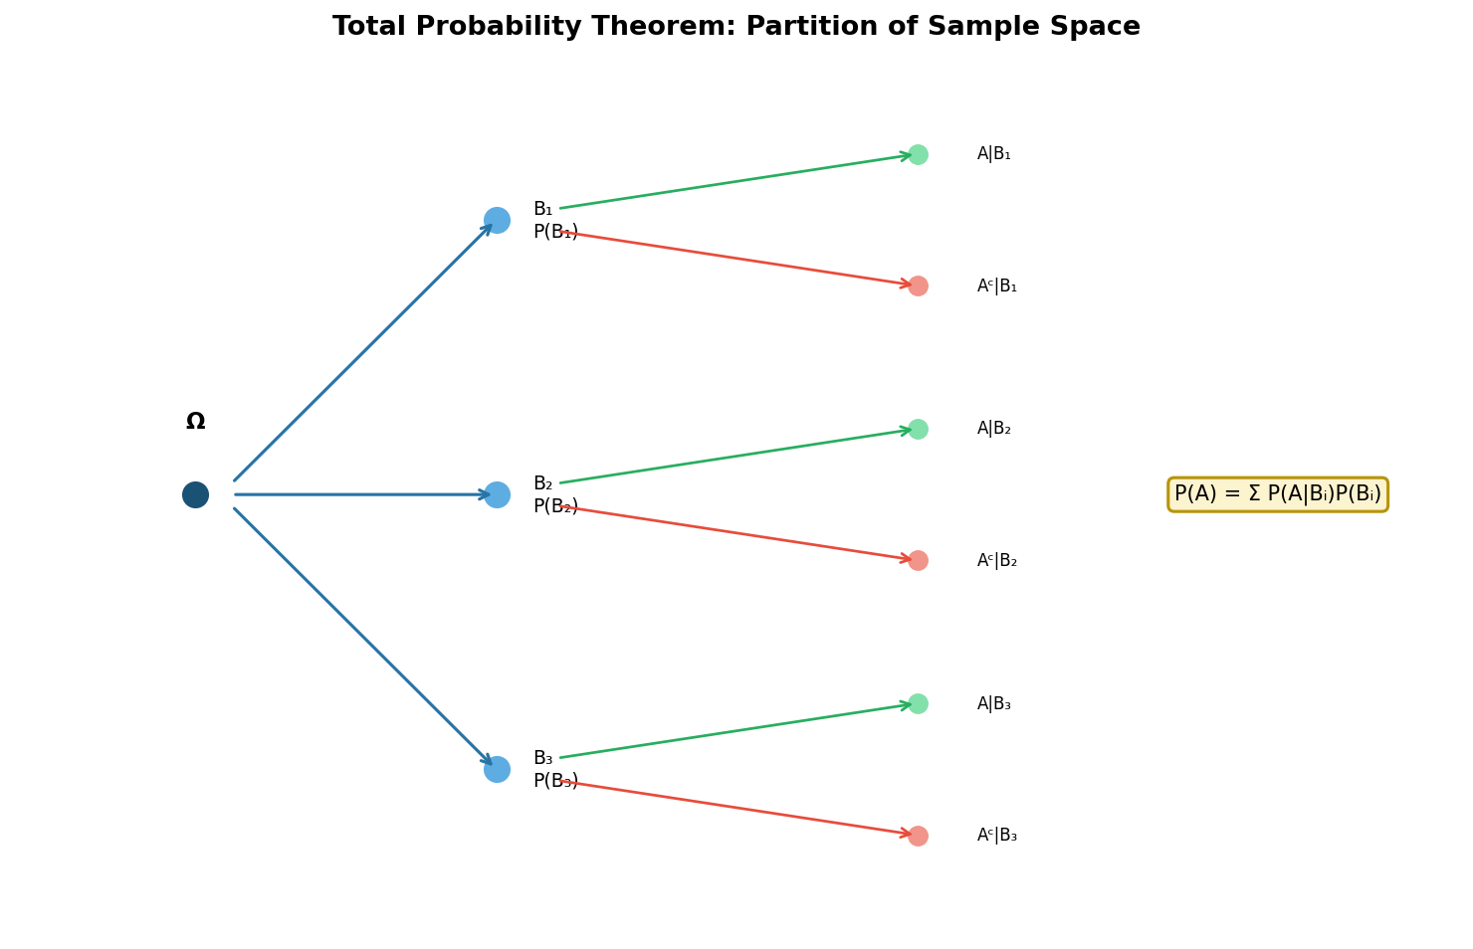
Figure 5.1: Tree representation of the law of total probability. The probability of A is the sum of the probabilities of all paths that end in A.

5.4 Applications
The theorem is used to compute the overall error rate of a diagnostic test when the disease prevalence is known, to obtain the marginal probability of evidence in a Bayesian network, and to evaluate the performance of a mixture model.

5.5 Solved Examples

Question 1 (Original)
A factory has three machines M₁, M₂ and M₃ that produce 30 %, 45 % and 25 % of the total output, respectively. The defect rates of the three machines are 2 %, 3 % and 4 %. An item is selected at random from the output. What is the probability that it is defective?
Given: P(M₁)=0.30, P(M₂)=0.45, P(M₃)=0.25; P(D|M₁)=0.02, P(D|M₂)=0.03, P(D|M₃)=0.04.
By the law of total probability,
P(D) = P(D|M₁)P(M₁) + P(D|M₂)P(M₂) + P(D|M₃)P(M₃)
= (0.02)(0.30) + (0.03)(0.45) + (0.04)(0.25)
= 0.006 + 0.0135 + 0.010 = 0.0295.

Final Answer: 0.0295 (or 2.95 %)

Exam Tip:
Write the partition probabilities and the conditional probabilities in a neat table before substituting; this reduces arithmetic slips.

Question 2 (Adapted from GATE EC / CS style)
A binary communication channel carries data as 0 or 1. The probability that a transmitted 0 is received as 0 is 0.9, and the probability that a transmitted 1 is received as 1 is 0.8. If the probability that a 0 is transmitted is 0.45, find the probability that a received bit is 0.
Let T₀, T₁ be the events that 0 or 1 is transmitted, and R₀ the event that 0 is received.
P(T₀)=0.45, P(T₁)=0.55,
P(R₀|T₀)=0.9, P(R₀|T₁)=1−0.8=0.2.
Then
P(R₀) = P(R₀|T₀)P(T₀) + P(R₀|T₁)P(T₁) = (0.9)(0.45) + (0.2)(0.55) = 0.405 + 0.110 = 0.515.

Final Answer: 0.515

Exam Tip:
In communication-channel problems the “false” conditional probabilities are often given indirectly as 1 minus the correct-reception probability; compute them carefully.

6. Bayes’ Theorem

6.1 Introduction
Bayes’ theorem provides the mechanism for updating the probability of a hypothesis in the light of new evidence. It is the mathematical embodiment of learning from data and occupies a central place in both classical statistics and modern machine learning.

6.2 Definition
Let H be a hypothesis and E an observed piece of evidence with P(E) > 0. Bayes’ theorem states
P(H|E) = [P(E|H) · P(H)] / P(E).

6.3 Explanation of Terms
Prior probability P(H): the degree of belief in H before the evidence is observed.
Likelihood P(E|H): the probability of observing the evidence if the hypothesis were true.
Evidence (marginal likelihood) P(E): the total probability of the evidence, obtained by the law of total probability when several competing hypotheses exist.
Posterior probability P(H|E): the updated degree of belief in H after the evidence has been taken into account.
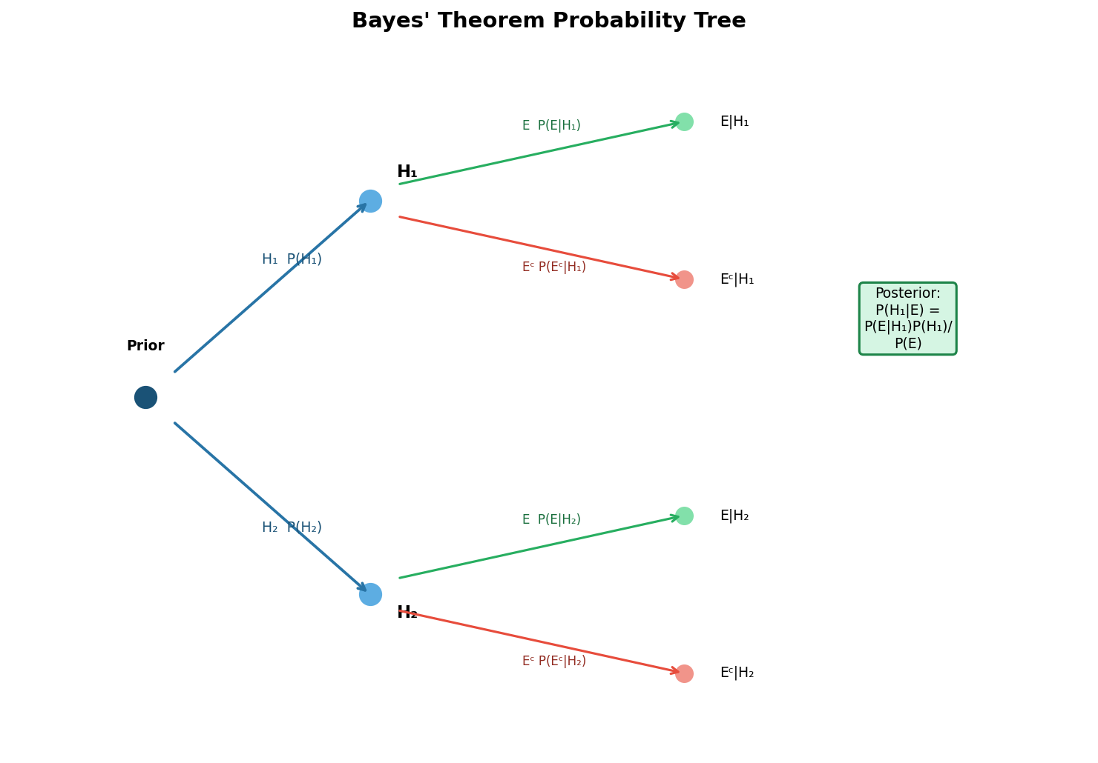
Figure 6.1: Probability tree illustrating the components of Bayes’ theorem. The posterior is obtained by normalising the joint probabilities of the paths that produce the observed evidence.
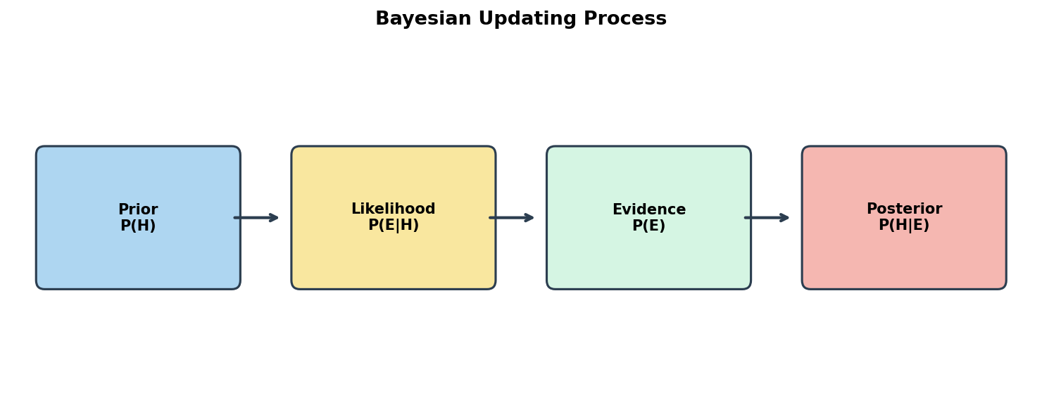
Figure 6.2: Schematic of the Bayesian updating process: prior belief is combined with likelihood and then normalised by the evidence to produce the posterior.

6.4 Applications
Spam filtering, medical diagnosis, document classification, sensor fusion, and sequential decision-making under uncertainty all rely on repeated applications of Bayes’ theorem.

6.5 Solved Examples

Question 1 (Original University-Level)
In a certain city, 60 % of the population supports party X and 40 % support party Y. A survey organisation reports the true preference of a voter with probability 0.85 (and the opposite preference with probability 0.15). If a randomly chosen voter is reported to support party X, what is the probability that the voter truly supports party X?
Let X = voter supports X, R_X = report says X.
P(X)=0.60, P(Y)=0.40,
P(R_X|X)=0.85, P(R_X|Y)=0.15.
By Bayes’ theorem,
P(X|R_X) = [P(R_X|X)P(X)] / [P(R_X|X)P(X)+P(R_X|Y)P(Y)]
= (0.85×0.60) / (0.85×0.60 + 0.15×0.40) = 0.510 / (0.510+0.060) = 0.510/0.570 ≈ 0.8947.

Final Answer: ≈ 0.8947 (or 89.47 %)

Exam Tip:
Always compute the marginal probability of the evidence in the denominator; forgetting the second term in the law of total probability is a frequent mistake.

Question 2 (Classic – required)
A man is known to speak the truth three out of four times. He throws a die and reports that it is a six. Find the probability that the die actually showed a six.
Define the events:
S = the die shows six, Sᶜ = the die does not show six,
R = the man reports six.
P(S) = 1/6, P(Sᶜ) = 5/6,
P(R|S) = 3/4 (truthful report),
P(R|Sᶜ) = 1/4 (false report of six).
By Bayes’ theorem,
P(S|R) = [P(R|S)P(S)] / [P(R|S)P(S) + P(R|Sᶜ)P(Sᶜ)]
= [(3/4)(1/6)] / [(3/4)(1/6) + (1/4)(5/6)]
= (3/24) / (3/24 + 5/24) = (3/24) / (8/24) = 3/8.

Final Answer: 3/8

Exam Tip:
Identify carefully the two ways the report “six” can arise: a true six reported truthfully, or a non-six reported falsely. These are the only two paths that contribute to the evidence.

Question 3 (Difficult GATE-style)
A digital communication system transmits bits 0 and 1 with equal probability. Because of channel noise, a transmitted 0 is received as 1 with probability 0.1 and a transmitted 1 is received as 0 with probability 0.2. A bit is received as 1. Using Bayes’ theorem, find the probability that the transmitted bit was 1.
Let T₁ = transmitted 1, T₀ = transmitted 0, R₁ = received 1.
P(T₁)=P(T₀)=1/2,
P(R₁|T₁)=0.8, P(R₁|T₀)=0.1.
Then
P(T₁|R₁) = [0.8 × ½] / [0.8 × ½ + 0.1 × ½] = 0.4 / (0.4 + 0.05) = 0.4 / 0.45 = 8/9 ≈ 0.8889.

Final Answer: 8/9 ≈ 0.8889

Exam Tip:
When the prior is uniform the posterior odds equal the likelihood ratio; here the likelihood ratio is 0.8/0.1 = 8, so the posterior probability is 8/(8+1) = 8/9.

7. Bayesian Classification

7.1 Introduction
Bayesian classification is a family of supervised learning techniques that apply Bayes’ theorem to assign class labels to feature vectors. The most widely used member of the family is the naïve Bayes classifier, which makes a strong conditional-independence assumption that dramatically simplifies computation while remaining surprisingly effective on many real-world tasks.

7.2 Definition
A Bayesian classifier selects the class label c* that maximises the posterior probability of the class given the observed features x:
c* = arg max_c P(c|x) = arg max_c [P(x|c) P(c) / P(x)].
Because the evidence P(x) does not depend on c, it may be ignored for the purpose of maximisation, leaving the decision rule
c* = arg max_c P(x|c) P(c).

7.3 History
The conceptual roots of Bayesian classification lie in the work of Thomas Bayes (1763) and Laplace. The modern computational form emerged in the 1950s and 1960s with the development of pattern-recognition theory. The naïve Bayes algorithm became popular in the 1990s for text categorisation after the success of the Reuters-21578 experiments.

7.4 Bayes’ Theorem in Machine Learning
In the machine-learning setting the hypothesis H is a class label and the evidence E is a feature vector. Training data supply estimates of the prior P(c) and of the class-conditional densities P(x|c). At prediction time these estimates are inserted into Bayes’ theorem to obtain a posterior distribution over classes.

7.5 Naïve Bayes Classifier
The naïve Bayes classifier assumes that the features are conditionally independent given the class:
P(x|c) = Πⱼ P(xⱼ|c).
Under this assumption the posterior becomes
P(c|x) ∝ P(c) Πⱼ P(xⱼ|c),
which can be evaluated in linear time with respect to the number of features.

7.6 Assumptions of Naïve Bayes
The central modelling assumption is conditional independence of features given the class. In addition, each class-conditional distribution is assumed to belong to a simple parametric family (Gaussian, multinomial, or Bernoulli). Although the independence assumption is almost never strictly true, the resulting classifier often performs well because classification only requires that the correct class receive the highest posterior, not that the posterior be perfectly calibrated.

7.7 Types of Naïve Bayes

Gaussian Naïve Bayes
Each feature is assumed to follow a normal distribution within each class. Means and variances are estimated from the training data by maximum likelihood. Suitable for continuous-valued features.

Multinomial Naïve Bayes
Features are assumed to follow a multinomial distribution. This model is the standard choice for document classification when the features are word counts or TF-IDF weights.

Bernoulli Naïve Bayes
Each feature is a binary indicator of presence or absence. The class-conditional distribution is a product of independent Bernoulli random variables. Useful for short text or binary sensor data.

7.8 Working Principle
Training consists of estimating the class priors and the parameters of each class-conditional distribution. Prediction consists of evaluating the un-normalised posterior for every class and returning the class with the largest value.
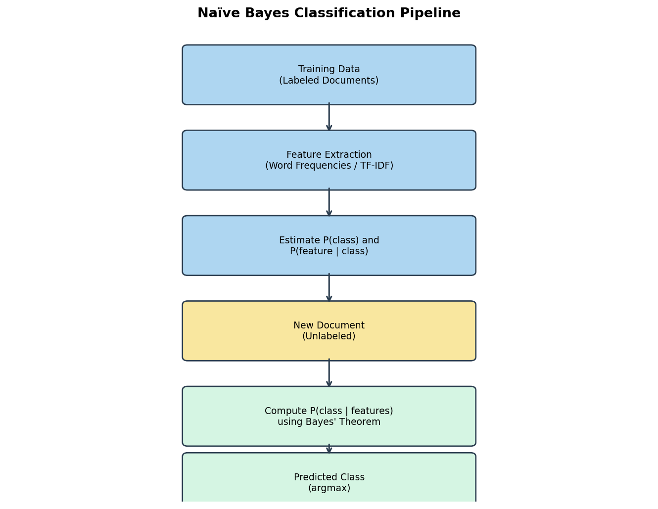
Figure 7.1: Flowchart of the naïve Bayes classification pipeline, from labelled training data through parameter estimation to prediction on a new instance.

7.9 Mathematical Formula
For a feature vector x = (x₁,…,xₐ) the predicted class is
ĉ = arg max_c [ log P(c) + Σⱼ log P(xⱼ|c) ],
where the logarithm is taken for numerical stability.

7.10 Training Process
1. Estimate class priors: P̂(c) = N_c / N.
2. For each class and each feature, estimate the parameters of P(xⱼ|c) (sample mean and variance for Gaussian; smoothed relative frequencies for multinomial or Bernoulli).
3. Store the estimated parameters for use at prediction time.

7.11 Prediction Process
1. For a new feature vector x, compute the log-posterior score for every class.
2. Return the class that attains the maximum score.
3. Optionally convert the scores into a normalised posterior distribution by the softmax transformation.

7.12 Advantages
Computational efficiency (linear in the number of features), robustness to irrelevant features, ability to handle missing data by simply ignoring the corresponding factors, and surprisingly good accuracy on high-dimensional sparse data such as text.

7.13 Disadvantages
The conditional-independence assumption can be unrealistic, leading to poorly calibrated probability estimates. Performance may degrade when features are strongly correlated. Continuous features require a distributional assumption that may not match the data.

7.14 Real-world Applications
Email spam detection remains the classic success story of multinomial naïve Bayes. Sentiment analysis of product reviews, medical diagnosis from clinical indicators, topic-based document classification, and fraud detection in transactional data are further domains in which Bayesian classifiers are routinely deployed.
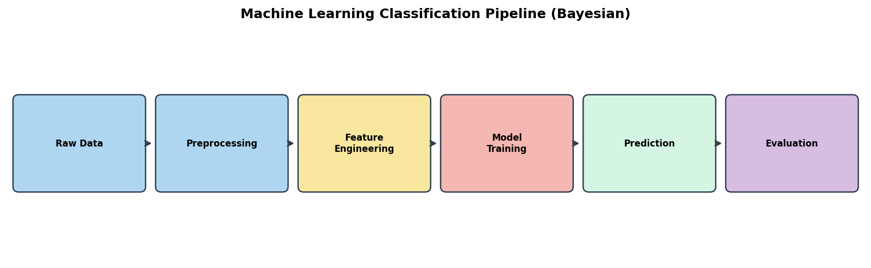
Figure 7.2: High-level machine-learning pipeline in which a Bayesian classifier occupies the model-training and prediction stages.

7.15 Conclusion
Bayesian classification provides a principled probabilistic framework for assigning class labels. The naïve Bayes algorithm, despite its simplifying assumptions, continues to serve as a strong baseline for text categorisation and as an instructive introduction to the broader field of probabilistic machine learning. Understanding the relationship between Bayes’ theorem, the law of total probability, and the resulting decision rule equips the practitioner with both theoretical insight and practical tools for solving classification problems.
References

Alpaydin, E. (2020). Introduction to machine learning (4th ed.). MIT Press.
Bishop, C. M. (2006). Pattern recognition and machine learning. Springer.
Durrett, R. (2019). Probability: Theory and examples (5th ed.). Cambridge University Press.
Feller, W. (1968). An introduction to probability theory and its applications (Vol. 1, 3rd ed.). Wiley.
GATE Computer Science and Information Technology. (2005–2024). Official question papers. Indian Institute of Technology / IISc.
Mitchell, T. M. (1997). Machine learning. McGraw-Hill.
Murphy, K. P. (2012). Machine learning: A probabilistic perspective. MIT Press.
Ross, S. M. (2019). A first course in probability (10th ed.). Pearson.
Russell, S., & Norvig, P. (2020). Artificial intelligence: A modern approach (4th ed.). Pearson.
Stuart, A., & Ord, K. (1994). Kendall’s advanced theory of statistics: Volume 1 – Distribution theory (6th ed.). Arnold.
Wasserman, L. (2004). All of statistics: A concise course in statistical inference. Springer.

