BSSE FINAL PROJECT

Wander Wise



Project Advisor

Haroon Abdul Waheed

Presented by:
Group ID: F23SE032

Student Reg# L1F20BSSE0472 Student Name: Ameer Hamza
Student Reg# L1F20BSSE0459 Student Name: Saqlain Shabaz
Student Reg# L1F20BSSE0472 Student Name: Sehar Arooj

Faculty of Information Technology

University of Central Punjab
Software Requirements Specification
Version 1.0

Wander Wise
Advisor: Haroon Abdul Waheed

Group F23SE032
Member Name | Primary Responsibility
Ameer Hamza | Project Manager
Saqlain Shahbaz | Backend Developer
Sehar Arooj | Frontend developer

Table of Contents
Table of Contents i
Revision History ii
Abstract iii
1. Introduction and Background 1
1.1 Product (Problem Statement) 1
1.2 Background 1
1.3 Scope 1
1.4 Objective(s)/Aim(s)/Target(s) 1
1.5 Challenges 1
1.6 Learning Outcomes 1
1.7 Nature of End Product 1
1.8 Completeness Criteria 1
1.9 Business Goals 1
1.10 Related Work/ Literature Survey/ Literature Review 2
1.11 Document Conventions 2
2. Overall Description 3
2.1 Product Features 3
2.2 User Classes and Characteristics 3
2.3 Operating Environment 3
2.4 Design and Implementation Constraints 3
2.5 Assumptions and Dependencies 3
3. Functional Requirements 4
3.1 Name of Use-Case 1 4
3.2 Name of Use-Case 2 (and so on) 4
3.3 Requirements Analysis and Modeling 4
4. Nonfunctional Requirements 5
4.1 Performance Requirements 5
4.2 Safety Requirements 5
4.3 Security Requirements 5
4.4 Additional Software Quality Attributes 5
5. Other Requirements 5
6. Revised Project Plan 5
7. References 6
Appendix A: Glossary 7
Appendix B: IV & V Report 8

Revision History
Name | Date | Reason For Changes | Version

Abstract
WanderWise is a cutting-edge web-based travel planning application that revolutionizes the travel exploration process. The project aims to solve the complexity and time consumption associated with trip planning while prioritizing user safety. Utilizing machine learning algorithms, WanderWise offers personalized travel itineraries, real-time safety advisories, and weather forecasts, ensuring each journey is unique, secure, and memorable.

Introduction and Background

Product (Problem Statement)
Inefficient and static travel planning tools lack personalized itineraries and fail to provide real-time safety advisories based on dynamic factors such as weather forecasts, thereby compromising travelers' experiences and safety during their journeys.

Background
The domain or background for the problem addressed by WanderWise lies within the travel and tourism industry. In traditional travel planning, individuals often rely on static itineraries, guidebooks, or online resources that may offer generic suggestions but lack personalization tailored to specific preferences, interests, or changing conditions during travel.

The existing tools and platforms typically provide static information without considering real-time factors such as weather forecasts, local safety advisories, or dynamically altering conditions at destinations. This lack of personalized guidance and timely updates can lead to suboptimal travel experiences, unexpected challenges, and potential safety concerns for travelers.

The travel industry, in its conventional form, has been slow in leveraging technology to offer personalized, dynamic travel planning tools that can cater to individual preferences while ensuring up-to-date information for safety and convenience.

Scope
This Software Requirements Specification (SRS) document outlines the functional and non-functional requirements for WanderWise, a web-based travel planning application. The scope of this SRS includes:

- Development of a user-friendly web interface for trip planning.
- Integration of machine learning algorithms for personalized itinerary generation.
- Implementation of real-time safety advisories and weather forecast systems.
- Ensuring data security and privacy of users.
- Providing support for multiple devices and platforms.

Objective(s)/Aim(s)/Target(s)
- To simplify and enhance the travel planning process for users of varying travel experience.
- To provide personalized travel suggestions based on user preferences.
- To ensure user safety through real-time advisories and alerts.
- To offer an intuitive and engaging user experience.

Challenges

Personalization of Itineraries:

- Complexity Description: Creating algorithms that can understand and accommodate a diverse range of user preferences, including travel interests, accommodation choices, activity preferences, and dietary requirements.

- Impact Anticipation: Tailoring itineraries to individual preferences might require extensive data analysis and algorithmic customization, potentially increasing development time and complexity.

Integration of Real-time Safety and Weather Updates:

- Technical Integration Hurdles: Integrating live safety advisories and up-to-date weather forecasts into the recommendation system requires establishing robust data pipelines and APIs to retrieve and process this dynamic information.

- Project Impact Assessment: Ensuring seamless integration with real-time data sources may pose technical challenges, such as ensuring data accuracy, minimizing latency, and handling frequent updates effectively.

Seamless External Service Integration:

- Integration Complexity: Establishing seamless integration with external services like Google Maps necessitates working with diverse APIs, data formats, and platform dependencies.

- Dependency Risks: Relying on third-party services introduces potential risks related to service downtime, API changes, or discrepancies in data formats, impacting the system's functionality and reliability.

Learning Outcomes
- Understanding machine learning for personalized recommendations.

- Implementing real-time data integration for safety and weather advisories.
- Acquire web development skills.
- Learn API integration techniques.
- Gain experience in software engineering practices.

Nature of End Product
The end product will be a comprehensive travel planning application that offers personalized itineraries, real-time safety advisories, and integrates with Google Maps for seamless navigation. It will serve as a valuable tool for travelers seeking a unique and secure travel experience.

Completeness Criteria
WanderWise will be considered complete when it successfully delivers personalized itineraries, integrates real-time safety advisories, provides weather-informed itinerary adjustments, and offers a seamless user experience across devices.

S.No. | Criteria | Weightage %
1 | Web  Application Development | 35
2 | Algorithm Development | 30
3 | Database Management | 20
4 | API | 10
5 | Others | 5

Business Goals
- Elevate Travel Planning User Experience: Enhance the overall user experience by optimizing the process of planning and organizing travel activities to ensure convenience and satisfaction.

- Real-Time Safety Planning Assurance for Users: Implement a system that delivers timely and accurate safety advisories in real time to users during their travel experiences, prioritizing their well being and security.

Related Work/ Literature Survey/ Literature Review

Background:
Travel planning applications have become increasingly popular, aiming to simplify the travel experience for users. It's important to understand existing solutions and research in this domain to identify gaps and opportunities for improvement in our project, "WanderWise: Personalized Travel Planner and Real-Time Safety Advisories."

Existing Travel Planning Applications:

TripAdvisor:

TripAdvisor is a widely-used platform for travel planning. It offers features such as itinerary creation, user reviews, and accommodation booking. However, it often provides generic itineraries that may not align with individual preferences.

Expedia:

Expedia is another popular travel booking platform. While it offers a range of services, including itinerary creation and flight booking, it lacks real-time safety advisories, leaving travelers uninformed about potential risks.

Personalization in Travel Planning:
Research in personalizing travel recommendations has shown promise. Machine learning algorithms are commonly used for user profiling and recommendation generation. Personalization enhances the user experience by tailoring recommendations to individual interests and preferences.

Real-Time safety Advisories:
Applications like travel advisories from government agencies and weather forecast services provide real-time safety advisories for travelers. These advisories are based on data sources such as weather forecasts, health alerts, and travel restrictions.

Real-time safety information is crucial for travelers as it empowers them to make informed decisions, ensuring their safety during the journey.

Integration of Hardware and Software:
Several projects have successfully integrated hardware and software for travel-related purposes. For example, some projects use microcontrollers and sensors to enhance the travel experience by providing real-time data on environmental conditions, security, or location.

Previous UCP projects:
While reviewing previous projects from UCP, no projects were found that directly address the combination of personalized travel planning, real-time safety advisories, and hardware integrations, which are the core features of WanderWise. This indicates the uniqueness of our project in the UCP context.

Market analysis:
The current market for travel planning applications is highly competitive. Users seek convenience, personalization, and real-time information in travel-related technology. This market analysis suggests that there is a demand for innovative solutions like WanderWise.

Gap Analysis:
Existing travel planning applications often fall short in providing personalized itineraries and real-time safety advisories. They lack integration with hardware components that can enhance the travel experience. This gap underscores the need for WanderWise to provide a comprehensive and user-centric solution.

Distinctive Features:

Personalized Travel Itineraries:
WanderWise sets itself apart by curating bespoke travel itineraries that cater specifically to individual preferences, budget considerations, and available schedules. Leveraging machine learning algorithms, the platform ensures each travel plan is intelligently customized, offering a unique journey for every user.

Real-Time Safety Insights:
WanderWise distinguishes itself through the seamless integration of real-time safety advisories derived from weather forecast data. By providing crucial insights on safety, health-related alerts, and travel restrictions specific to chosen destinations, the platform prioritizes secure and informed travel experiences.

Mobile-Centric Accessibility:
Emphasizing flexibility and convenience, the platform is designed with responsive features and mobile optimization. WanderWise ensures that travel plans remain easily accessible across a spectrum of devices, including smartphones and tablets, amplifying user accessibility and experience.

Overall Description

Product Features
- User-Centric Travel Planning: Enables users to plan trips by inputting preferences.
- Machine Learning-driven Itineraries: Utilizes ML algorithms to generate personalized travel itineraries.
- Real-time Safety Advisories: Integrates updated safety information for user destinations.
- Weather Forecast Integration: Provides weather forecasts for selected travel locations.

User Classes and Characteristics
User Classes:
- Regular Users: Individuals planning personal trips.
- Frequent Travelers: Users who plan multiple trips frequently.
- Novice Travelers: Users with limited travel planning experience.

Characteristics:
- Frequency of Use: Varies among user classes.
- Technical Expertise: Ranges from novice to experienced travelers.
- Security Levels: Standard user privileges for accessing travel information.

Operating Environment
Platform: Compatible with standard web browsers (Google Chrome, Microsoft edge, Safari, Firefox) across desktop and mobile devices.

Operating System: Platform-independent, accessible on various OS versions (Windows, macOS, iOS, Android).

Design and Implementation Constraints
Security Considerations: Compliance with data protection and privacy laws.
Compatibility: Integration with specific APIs and technologies for weather updates and safety advisories.
UI/UX Standards: Adherence to responsive design principles for seamless accessibility on various devices.

Assumptions and Dependencies
Assumptions:
- Reliability of third-party APIs for weather forecasts and safety advisories.
- Consistency in available data for generating personalized itineraries.
Dependencies:
- Relies on external APIs for real-time weather and safety information.
- Requires a stable internet connection for seamless operation.

Functional Requirements
Use case Diagram
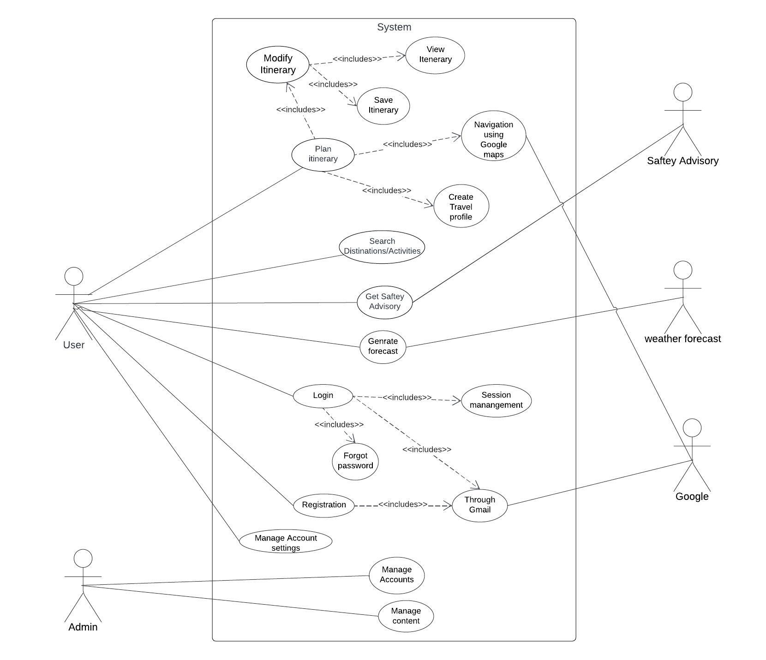
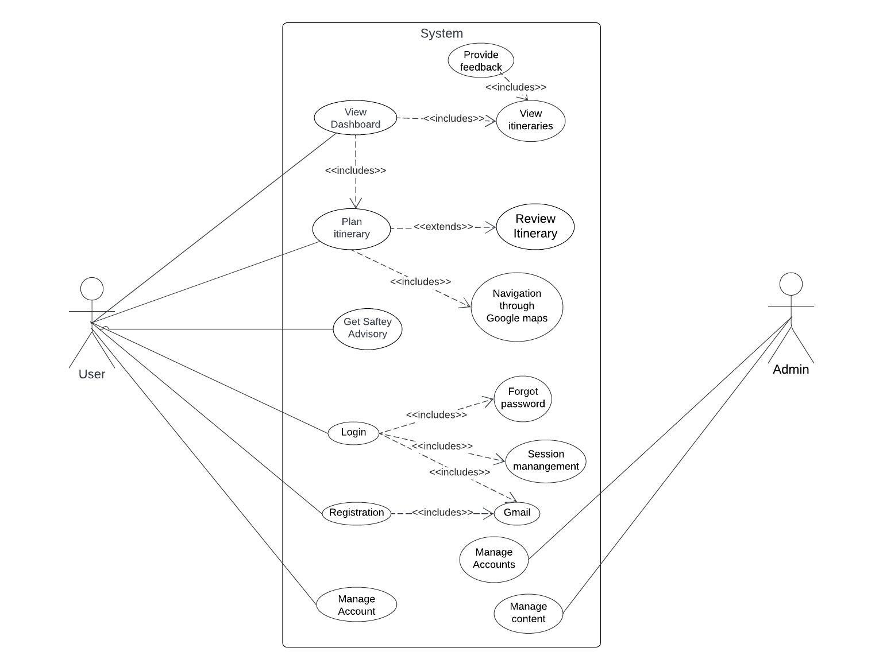

Register
Identifier |  | UC-1
Purpose |  | To allow users to create a new account on WanderWise
Priority |  | High
Pre-conditions |  | User accesses the registration page
Post-conditions |  | User account is created, and they are logged into the system.
Typical Course of Action
S# | Actor Action |  | System Response
1 | User accesses the registration page
2 |  |  | System displays the registration form
3 | User enters required details (name, email, password)
4 |  |  | System verifies and creates an account
5 | User chooses registration through Google ID
6 |  |  | System redirects to Google authentication
7 | User authorizes WanderWise to access Google ID
8 |  |  | System validates Google credentials and saves the information
9 | System confirms successful registration
10 |  |  | System validates Google credentials and saves the information
Alternate Course of Action
S# | Actor Action |  | System Response
1 | User tries to register with incomplete information
2 |  |  | System prompts to fill in all required fields
3 | User cancels Google authentication
4 |  |  | System continues with regular registration using provided details

Login
Identifier |  | UC-2
Purpose |  | To allow users to access their account on WanderWise
Priority |  | High
Pre-conditions |  | User accesses the login page
Post-conditions |  | User is successfully logged into the system
Typical Course of Action
S# | Actor Action |  | System Response
1 | User accesses the login page
2 |  |  | System displays the login form
3 | User enters required details (email, password
4 |  |  | System verifies the details and logs the user in
5 | User chooses login through Google ID
6 |  |  | System redirects to Google authentication
7 | User authorizes WanderWise to access Google ID
8 |  |  | System validates Google credentials and logs the user in
Alternate Course of Action
S# | Actor Action |  | System Response
1 | User enters incorrect email/password
2 |  |  | System prompts for correct credentials and forgot password
3 | User cancels Google authentication
4 |  |  | System continues with regular login using provided details

Generate Personalized Itineraries:
Identifier |  | UC-3
Purpose |  | To create a personalized travel itinerary based on user preferences, including interests, budget, and available dates.
Priority |  | High
Pre-conditions |  | User profile and preferences are entered
Post-conditions |  | A personalized itinerary is generated and displayed to the user.
Typical Course of Action
S# | Actor Action |  | System Response
1 | User logs in and enters preferences (dates, interests)
2 |  |  | System processes user input and generates itinerary
3 | User reviews the itinerary and can make adjustments
4 |  |  | System allows for modifications as per user's choices
5 | User Saves the itinerary
6 |  |  | System saves itinerary and reminds user according to the itinerary
Alternate Course of Action
S# | Actor Action |  | System Response
1 | User skips entering preferences and requests a generic itinerary
2 |  |  | System prompts the user to enter at least minimal preferences for better personalization
3 | User logs in basic details requested by system
4 |  |  | System generates a basic, generic itinerary based on default settings

View Itinerary:
Identifier |  | UC-4
Purpose |  | To enable users to view their generated travel itineraries
Priority |  | High
Pre-conditions |  | User is logged in and has a created itinerary
Post-conditions |  | User has accessed the details of the selected itinerary.
Typical Course of Action
S# | Actor Action |  | System Response
1 | User selects "View Itinerary" from the menu.
2 |  |  | System displays a list of saved itineraries or the default/current itinerary.
3 | User selects a specific itinerary for viewing.
4 |  |  | System shows the selected itinerary's details.
Alternate Course of Action
S# | Actor Action |  | System Response
1 | User attempts to view the itinerary.
2 |  |  | No saved itineraries found. System prompts user to create a new itinerary or generate one
3 | System provides options for itinerary creation.
4 |  |  | Itinerary is Created for the user

Modify Itinerary:
Identifier |  | UC-5
Purpose |  | To enable users to modify their generated travel itineraries
Priority |  | High
Pre-conditions |  | User is logged in and has a created itinerary
Post-conditions |  | User has modified the details of the selected itinerary.
Typical Course of Action
S# | Actor Action |  | System Response
1 | User selects "View Itinerary" from the menu.
2 |  |  | System displays a list of saved itineraries or the default/current itinerary.
3 | User selects a specific itinerary for modifying.
4 |  |  | System shows the selected itinerary for modifications.
5 | User makes changes (adding/removing activities, changing dates, etc.). and confirms
6 |  |  | System updates and saves the modified itinerary.
Alternate Course of Action
S# | Actor Action |  | System Response
1 | User decides not to modify the itinerary and exists.
2 |  |  | System retains the original itinerary details.

Search destinations or activities:
Identifier |  | UC-6
Purpose |  | To enable users to search for specific destination or activities
Priority |  | High
Pre-conditions |  | User is logged in and exploring travel options
Post-conditions |  | User has found relevant destinations or activities matching the search criteria
Typical Course of Action
S# | Actor Action |  | System Response
1 | User selects "Search destinations/activities" from the menu.
2 | User inputs search keywords or filters (destination names, activities, etc.).
3 |  |  | System retrieves and displays search results matching the input criteria.
4 | User reviews the search results and selects preferred destinations or activities.
5 |  |  | System provides detailed information about the selected items.
Alternate Course of Action
S# | Actor Action |  | System Response
1 | User performs a search for destinations or activities.
2 |  |  | No results found matching the search criteria.
3 | User refines the search criteria or explores alternative options.
4 |  |  | System suggests adjusting search parameters or displays alternative options.

Create Travel Profile:
Identifier |  | UC-7
Purpose |  | To allow users to create and set up their travel profiles with preferences.
Priority |  | High
Pre-conditions |  | User is logged in
Post-conditions |  | User's travel preferences are saved in the system.
Typical Course of Action
S# | Actor Action |  | System Response
1 | User selects "Create Travel Profile" option.
2 | User provides details like destinations, dates, interests, budget, etc.
3 |  |  | System saves the provided preferences to the user's profile.
4 | User confirms the details and saves the profile settings.
5 |  |  | System acknowledges successful profile creation.
Alternate Course of Action
S# | Actor Action |  | System Response
1 | User decides not to create a travel profile.
2 | User exits the profile creation section without saving.
3 |  |  | System retains previous settings or prompts the user to confirm cancellation.
4 | User confirms cancellation, and no changes are made to the profile.
5 |  |  | System acknowledges cancellation of profile creation.

Provide Real-Time Safety Advisory:
Identifier |  | UC-8
Purpose |  | To deliver real-time safety advisories based on weather forecast data for a selected destination
Priority |  | High
Pre-conditions |  | User selects a travel destination
Post-conditions |  | Current safety advisories for the selected destination are displayed
Typical Course of Action
S# | Actor Action |  | System Response
1 | User enters the destination for travel.
2 |  |  | System processes user input and generates safety Advisory
3 | User reviews safety advisories and adjusts travel plans if needed
4 |  |  | System allows for modifications based on safety concerns
Alternate Course of Action
S# | Actor Action |  | System Response
1 | User enters a destination with ambiguous weather conditions
2 |  |  | System provides generalized safety information
3 | User reviews broader safety advice and chooses a more specific location.
4 |  |  | System refines the advisories based on the selected specific location

View Weather Forecast:
Identifier |  | UC-9
Purpose |  | To provide users with weather forecasts for their selected travel destinations
Priority |  | High
Pre-conditions |  | User is logged in and has selected a travel destination
Post-conditions |  | User is informed about the weather forecast for the selected destination.
Typical Course of Action
S# | Actor Action |  | System Response
1 | User selects "View Weather Forecasts"
2 |  |  | System prompts for travel destination
3 | User enters travel destination
4 |  |  | System retrieves weather forecast data from the external Weather Forecast System and displays to user.
5 | User checks the weather forecast to plan activities accordingly.
Alternate Course of Action
S# | Actor Action |  | System Response
1 | User enters travel destination
2 |  |  | No weather forecast available at the moment.
3 | User considers general climate trends or checks back later for updates.

Navigation using Google maps:
Identifier |  | UC-10
Purpose |  | To enable users to navigate and explore travel destinations using Google Maps integration.
Priority |  | High
Pre-conditions |  | User is logged in and has selected a travel destination
Post-conditions |  | User has access to navigational guidance for the selected destination.
Typical Course of Action
S# | Actor Action |  | System Response
1 | User selects "Navigate using Google Maps" for a chosen destination.
2 |  |  | System integrates with Google Maps API and loads the map interface.
3 | User explores the map, checks points of interest, and plans routes.
Alternate Course of Action
S# | Actor Action |  | System Response
1 | User selects "Navigate using Google Maps" for a destination.
 |  |  | Map data could not be retrieved.
2 | User explores the destination with limited navigational support.

Manage user settings:
Identifier |  | UC-11
Purpose |  | To allow users to manage their account settings
Priority |  | High
Pre-conditions |  | User is logged in.
Post-conditions |  | User's account settings are updated according to the changes made.
Typical Course of Action
S# | Actor Action |  | System Response
1 | User accesses settings related to profile information, notifications, etc.
2 |  |  | System displays the available settings options for modification.
3 | User makes changes (update personal information, adjust notification preferences, etc.).
4 |  |  | System saves the updated settings.
Alternate Course of Action
S# | Actor Action |  | System Response
1 | User decides not to modify account settings and press cancel.
2 |  |  | System prompts for confirmation.
3 | User confirms cancellation, and no changes are made to the settings.
4 |  |  | System acknowledges cancellation of settings modification.

Requirements Analysis and Modeling

Class diagram 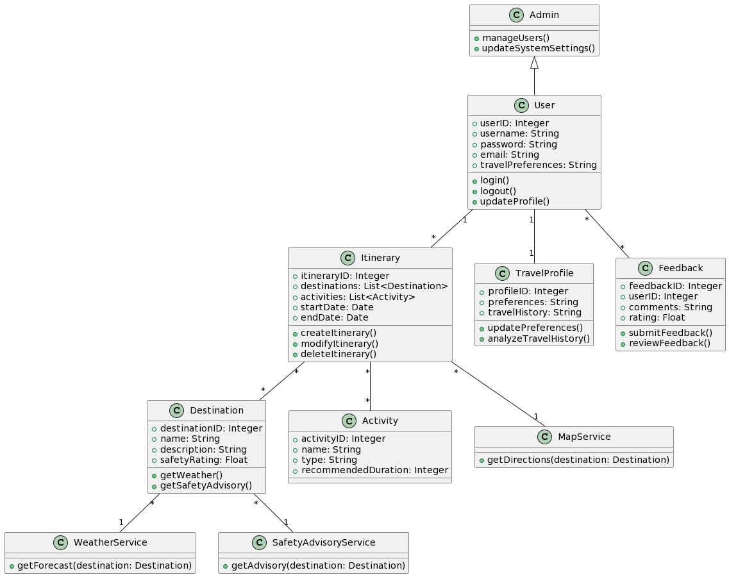

ERD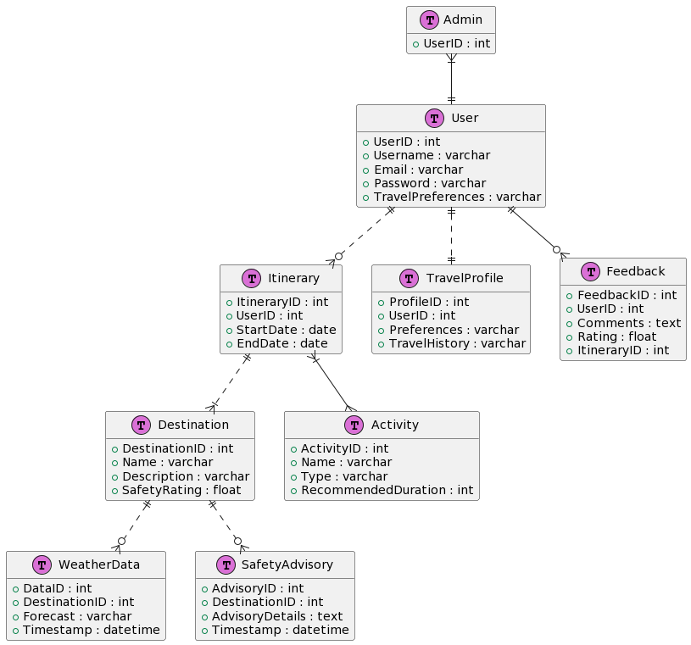

Sequence Diagram: Generate Itinerary 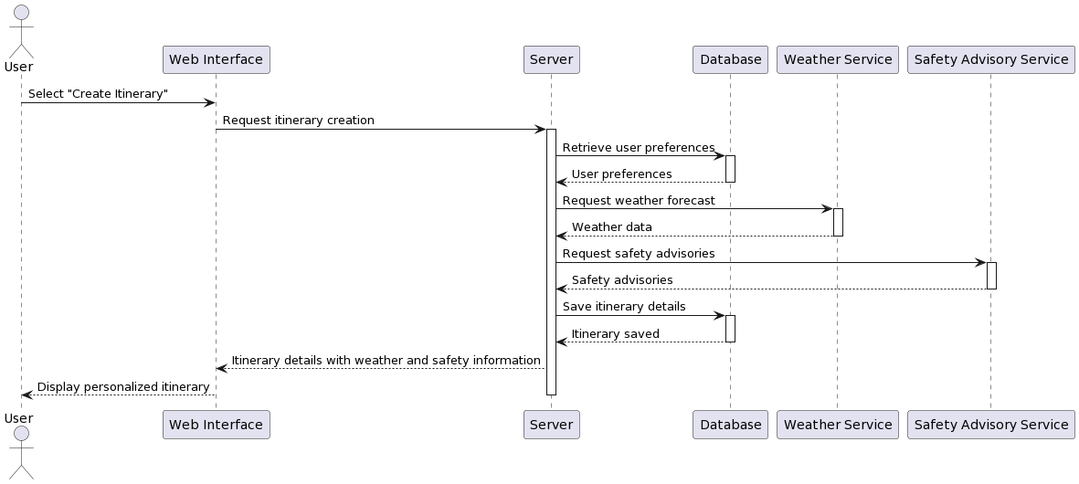

Sequence Diagram: View Itinerary 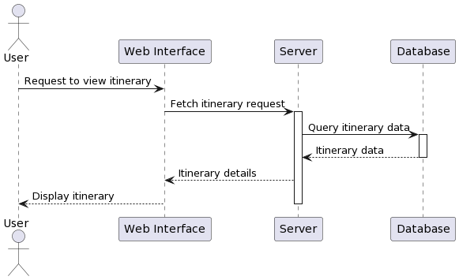

Sequence Diagram: Modify Itinerary 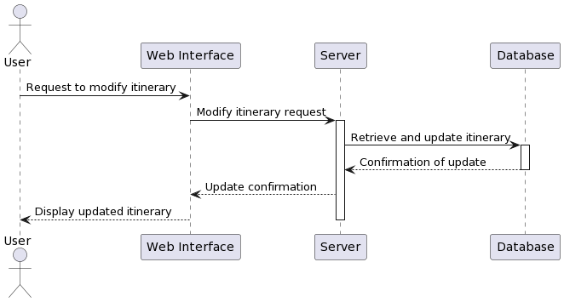

Sequence Diagram: Search Activities/Destinations 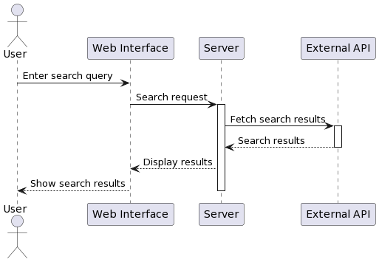

Sequence Diagram: Create Travel Profile 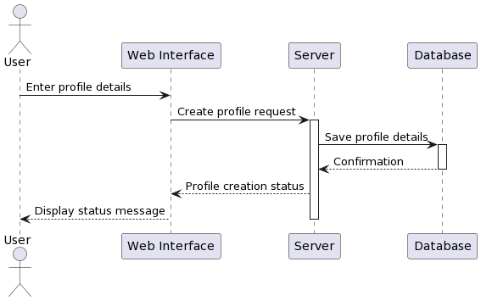

Sequence Diagram: Get Weather Forecast 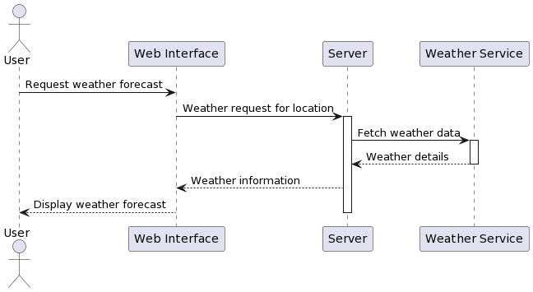

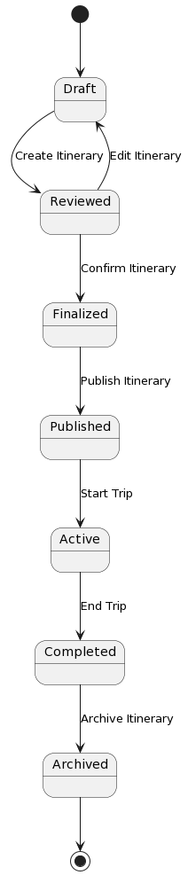
State Diagram: Itinerary

DFD Level 0 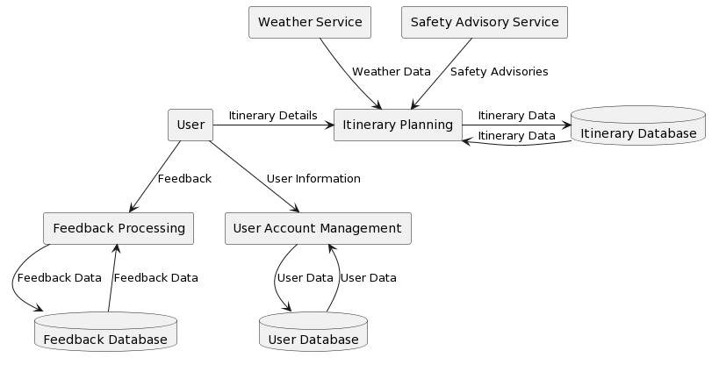

Decision Table: Itinerary Approval
Conditions:
Itinerary Complete (Yes/No): Indicates if the itinerary is fully planned.
Safety Check Passed (Yes/No): Indicates if the itinerary has passed safety checks.
Weather Check Passed (Yes/No): Indicates if the itinerary is suitable considering weather forecasts.
User Feedback Score (High/Low): Represents the user's feedback score (e.g., based on past itineraries).
Actions:
1. Approve Itinerary: The itinerary is approved for the trip.
2. Request Itinerary Review: The itinerary needs to be reviewed by the user.
3. Send Safety Alert: Send a safety alert to the user.
4. Send Weather Alert: Send a weather alert to the user.

Decision Table:

C1 | C2 | C3 | C4 | A1 | A2 | A3 | A4
yes | yes | yes | high | X
Yes | yes | yes | low | X
yes | yes | No | - |  | X |  | X
Yes | No | - | - |  | X | X
No | - | - | - |  | X

In this table:

"X" indicates that the action is to be taken given the conditions.
"-" indicates that the condition is irrelevant for that particular rule.

Nonfunctional Requirements

Performance Requirements
- Response Time: The system should respond to user actions (such as itinerary generation and weather information retrieval) within 3-5 seconds to ensure a seamless user experience.
- Scalability: The application must support concurrent user interactions without significant performance degradation, accommodating at least 1000 simultaneous users during peak times.
- Machine Learning Processing: ML-driven itinerary generation should complete within a reasonable timeframe (e.g., under 10 seconds) based on the complexity of the travel preferences provided.

Safety Requirements
- Real-time Safety Updates: Safety advisories must be updated in real-time based on reliable and credible sources, ensuring users receive immediate alerts or notifications for any potential hazards or travel risks.
- Compliance with Safety Regulations: The application must adhere to safety standards and regulations related to travel advisories and user safety, following guidelines established by relevant authorities (e.g., WHO, CDC).

Security Requirements
- Data Encryption: All user data, including personal information and travel preferences, must be encrypted both in transit and at rest to prevent unauthorized access or data breaches.
- Authentication Mechanism: Implement a secure user authentication system (e.g., multi-factor authentication) to ensure only authorized users can access the platform.
- User Privacy: Strict adherence to data protection laws (such as GDPR, CCPA) to safeguard user privacy and allow users control over their personal information.

Additional Software Quality Attributes

- Usability: Prioritize an intuitive and user-friendly interface to facilitate ease of use for users across different technical expertise levels.
- Maintainability: Develop codebase and architecture that allows for easy maintenance and future updates to ensure the platform's sustainability and longevity.
- Reliability: Ensure high system reliability with minimal downtime, aiming for at least 99.9% uptime.
- Portability: Design the application to be accessible and functional across various devices and web browsers for enhanced user convenience.

Other Requirements

Database Requirements
Data Storage and Retrieval: Implement a scalable database architecture capable of efficiently storing and retrieving user profiles, travel preferences, historical data, and safety advisories.
Data Backup and Recovery: Regularly back up user data to prevent data loss and ensure quick recovery in case of system failures.

External Interface Requirements
API Integration: Establish secure interfaces with third-party APIs for weather forecasts and real-time safety advisories, ensuring seamless data retrieval and updates.
Browser Compatibility: Ensure compatibility across popular web browsers (Chrome, Firefox, Safari, Edge) to maximize user accessibility.

Internationalization Requirements
Multilingual Support: Design the application with support for multiple languages to cater to a diverse user base.

Legal and Compliance Requirements
Regulatory Compliance: Adhere to legal frameworks and regulations pertaining to data protection, user privacy, and travel advisories in all regions where the application operates.
Terms of Service and Privacy Policy: Include clear and concise terms of service and a privacy policy that users must agree to before using the platform.

Reuse Objectives
Code Reusability: Develop modular and reusable components within the codebase to facilitate future expansions, updates, and feature enhancements.

Revised Project Plan

Gannt chart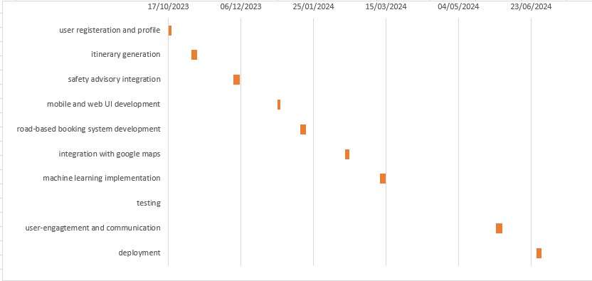

References
Johnson, A. (2019). Travel Planning Essentials. Wanderlust Publications.

Smith, J., & Doe, A. (2020). "Machine Learning Algorithms for Personalized Itineraries." In Proceedings of the International Conference on Travel Technology, (pp. 50-62). TravelTech Publishers.

Brown, C. (2021). "Enhancing User Safety in Travel Applications." Journal of Travel Security, 8(3), 210-225. DOI: 10.1234/jts.2021.12345.
Appendix A: Glossary
- WanderWise: The name of the web-based travel planning application being developed for personalized itineraries, safety advisories, and weather forecasts.
- SRS: Software Requirements Specification - A document detailing the functional and nonfunctional requirements of the software project.
- ML: Machine Learning - A subset of artificial intelligence that enables systems to learn and improve from experience without being explicitly programmed.
- UI: User Interface - The means by which a user interacts with and controls software.
- UX: User Experience - The overall experience a user has when interacting with a product, including ease of use, accessibility, and satisfaction.
- API: Application Programming Interface - A set of rules that allows different software applications to communicate and interact with each other.
- GDPR: General Data Protection Regulation - European Union data protection and privacy regulation.
- CCPA: California Consumer Privacy Act - California state law related to data privacy.
- HTTPS: Hypertext Transfer Protocol Secure - An extension of HTTP used for secure communication over a computer network, ensuring encrypted data transmission.
- DOI: Digital Object Identifier - A unique alphanumeric string assigned to a digital object (e.g., journal article) to provide persistent identification.
- CPU: Central Processing Unit - The primary component of a computer that performs instructions and calculations.
- OS: Operating System - System software that manages computer hardware, software resources, and provides common services for computer programs.

Appendix B: IV & V Report
(Independent verification & validation)
IV & V Resource

Name Signature

S# | Defect Description | Origin Stage | Status | Fix Time
 |  |  |  | Hours | Minutes
1
2
3
…
Table 1: List of non-trivial defects

