Cellular Lineage-Specific Gene Co-Expression Network Dynamics and Hub Biomarkers in Sickle Cell Vaso-Occlusive Episodes: A Multi-Compartment Systems Biology Study
Anirban Purohit 1,*, Research Consortium for Sickle Cell Systems Biology 1
1 Department of Computational Biology and Translational Hematology, Postgraduate Institute of Medical Education and Research
* Corresponding Author: anirban.purohit@example.edu
Abstract
Background: Sickle cell disease (SCD) is characterized by chronic hemolytic anemia, recurrent painful vaso-occlusive episodes (VOE), and progressive multi-organ damage. Although HbS polymerization is the primary genetic etiology, the molecular mechanisms orchestrating acute vaso-occlusive crises remain incompletely understood, and reliable predictive or diagnostic molecular biomarkers are urgently required. Standard differential expression approaches treat genes in isolation and fail to capture coordinated systems-level reorganization across distinct circulating cellular compartments.
Methods: We performed an integrated systems-biology study using bulk RNA-sequencing profiles from 174 unique patients with SCD (GEO accession GSE291257), prospectively sorted into CD45+ leukocytes (n = 196; 154 Steady State, 42 VOE) and CD71+ erythroid precursors (n = 178; 137 Steady State, 41 VOE; 2 outliers removed, yielding 176 analyzed), including 19 longitudinally sampled patients with matched Steady State and VOE profiles. Low-expression filtering retained 17,213 genes in CD45+ leukocytes and 10,352 genes in CD71+ erythroid precursors. We constructed parallel signed weighted gene co-expression networks (WGCNA) using empirical soft-thresholding (beta = 6 for CD45+, beta = 16 for CD71+). Module preservation was quantified using 100 random permutations (Zsummary). Dynamic intramodular rewiring was mapped using module membership shifts (|Delta kME| > 0.40). Functional overrepresentation was evaluated via Gene Ontology enrichment using explicit cell-type expressed background universes. Lineage autonomy was tested using Fisher's exact and hypergeometric overlap tests, and cell-compositional sensitivity was controlled via computational deconvolution (xCell) and paired intra-patient sensitivity correlations.
Results: Global macro-architecture was strongly preserved between steady state and VOE across all four CD45+ leukocyte modules (Zsummary = 23.6 to 44.4) and moderate-to-strongly preserved across all nine CD71+ erythroid precursor modules (Zsummary = 6.8 to 29.6). Within this stable macro-architecture, acute VOE induced targeted intramodular rewiring. In CD45+ leukocytes, 239 genes were strongly rewired (|Delta kME| > 0.40), including 53 decaying mitotic and cell-division hub genes (CDC20, TOP2A, KIF11, CCNA2, CDK1) reflecting an acute cell-cycle arrest signature, and 5 emergent crisis hubs (IL1B, SOD2, CXCL8). In CD71+ erythroid precursors, 66 genes were strongly rewired (|Delta kME| > 0.40), exhibiting significant functional enrichment for protein folding (GO:0006457, fold enrichment = 6.48, FDR = 0.0387) driven by molecular chaperones (HSPA8, HSPD1, HYOU1). Concurrently, 102 genes transitioned from the turquoise to the red module, significantly enriched for ribonucleoprotein complex biogenesis (GO:0022613, fold = 4.66, FDR = 0.0168) and rRNA maturation. Cross-lineage comparison confirmed lineage autonomy, with exactly 1 shared strongly rewired gene (RABGAP1L, Fisher's p = 1.0) and zero shared modules. xCell deconvolution verified crisis monocyte (p_adj = 0.00336) and neutrophil (p_adj = 0.00707) mobilization; however, paired intra-patient sensitivity analysis across the 19 paired patients demonstrated that 0/49 top rewired genes correlated with cell-fraction shifts following Benjamini-Hochberg FDR correction.
Conclusions: Acute VOE operates not by dismantling global co-expression architecture, but through high-precision, lineage-specific intramodular rewiring. CD45+ leukocytes execute mitotic arrest and inflammatory activation, whereas CD71+ erythroid precursors deploy chaperone proteostasis and ribonucleoprotein biogenesis responses. The identified hub biomarkers provide objective molecular targets to stratify and manage acute sickle vaso-occlusive crises.
Keywords: Sickle cell disease; vaso-occlusive episode; weighted gene co-expression network analysis (WGCNA); modular preservation; intramodular rewiring; molecular chaperones; protein folding; ribonucleoprotein complex biogenesis; xCell; biomarkers.
1. Introduction
Sickle cell disease (SCD) is a monogenic, life-threatening hemoglobinopathy caused by a single canonical A-to-T transversion in the HBB gene, resulting in the substitution of valine for glutamic acid at the sixth position of the beta-globin chain (p.Glu6Val) [1, 2]. Under hypoxic conditions, deoxygenated sickle hemoglobin (HbS) undergoes rapid intracellular polymerisation, distorting red blood cells into rigid, sickle-shaped erythrocytes, promoting membrane instability, severe hemolytic anemia, and microvascular occlusion [3, 4]. The defining acute clinical hallmark of SCD is the vaso-occlusive episode (VOE), characterized by excruciating ischemic bone and tissue pain, recurrent hospitalization, progressive multi-organ infarction, and elevated early mortality [5, 6]. Despite its severe clinical burden and centuries of clinical documentation, the precise molecular dynamics that trigger, sustain, and resolve acute vaso-occlusive crises remain incompletely characterized, and objective molecular biomarkers to monitor crisis onset or resolution remain conspicuously absent in routine clinical practice [7, 8].
The pathophysiological architecture of VOE extends far beyond simple mechanical obstruction by rigid erythrocytes. Contemporary paradigm recognizes VOE as a complex, multi-cellular thrombo-inflammatory cascade involving abnormal endothelial adhesion, neutrophil recruitment, monocyte activation, platelet aggregation, and sterile inflammatory signaling [9, 10]. Unscheduled hemolysis releases free intravascular heme, which acts as a potent damage-associated molecular pattern (DAMP), binding Toll-like receptor 4 (TLR4), triggering oxidative stress, and driving systemic endothelial activation [11, 12]. Concurrently, intense compensatory erythropoiesis mobilizes young, immature CD71+ stress reticulocytes into the peripheral circulation [13]. These stress reticulocytes exhibit elevated surface expression of adhesive integrins (alpha4beta1, BCAM/LU), binding avidly to subendothelial laminin and fibronectin and directly initiating cellular niduses for microvascular stagnation [14, 15].
Although genomic investigations have established that secondary genetic modifiers such as hereditary persistence of fetal hemoglobin (BCL11A, HBS1L-MYB) and co-inherited alpha-thalassemia significantly alter baseline clinical severity [16, 17], static germline variants cannot explain dynamic transitions between quiescent steady state and acute life-threatening vaso-occlusive crisis in the same individual. Previous transcriptomic profiling studies in SCD have almost exclusively relied on standard differential gene expression (DEG) analysis [18, 19]. While DEG methods identify genes with altered mean expression levels, they treat transcripts as isolated entities, failing to capture the coordinated higher-order regulatory interactions, co-expression modules, and hub rewiring that orchestrate complex phenotypic transitions [20, 21].
A fundamental limitation of previous SCD transcriptomic investigations is the reliance on whole-blood or unseparated peripheral blood mononuclear cell (PBMC) preparations [22, 23]. Peripheral blood is an inherently heterogeneous suspension dominated by mature granulocytes, lymphocytes, monocytes, and circulating immature erythroid cells [24]. In unseparated blood, apparent transcriptomic shifts during VOE are frequently confounded by changes in leukocyte subpopulation counts (e.g., reactive neutrophilia and monocytosis), masking true cell-intrinsic transcriptional rewiring [25]. Furthermore, pooling all blood lineages obscures the divergent biological functions executed by distinct circulating compartments during crisis—specifically, immunological effector programs in CD45+ leukocytes versus stress proteostasis responses in circulating CD71+ erythroid precursors [26].
Weighted Gene Co-expression Network Analysis (WGCNA) provides a mathematically rigorous, unsupervised systems-biology framework to reconstruct biological networks from genome-wide expression data, group co-regulated genes into functional modules, quantify module preservation across clinical states, and pinpoint critical intramodular hub genes [27, 28]. In this study, we applied parallel signed WGCNA to a large, prospectively characterized cohort of 174 patients with SCD (GSE291257), separated into purified CD45+ leukocyte (n = 196; 154 Steady State, 42 VOE) and CD71+ erythroid precursor (n = 178; 137 Steady State, 41 VOE) compartments, including 19 patients with longitudinal paired sampling during both steady state and acute VOE [Fig 1]. We hypothesized that acute VOE is driven not by the wholesale collapse of global network macro-architecture, but by targeted, lineage-specific intramodular connectivity rewiring. By coupling permutation-based preservation statistics (Zsummary), dynamic gene-flow tracking, Gene Ontology enrichment, cross-compartment autonomy testing, and computational immune deconvolution (xCell) with paired sensitivity analysis, we uncovered lineage-autonomous hub biomarkers that define the molecular landscape of acute sickle cell crisis.
2. Materials and Methods
2.1 Transcriptomic Data Acquisition and Multi-Compartment Cohort Design
Genome-wide bulk RNA-sequencing data were acquired from the Gene Expression Omnibus (GEO) under accession GSE291257 [29]. The source cohort comprises 174 unique pediatric and adult patients with clinically confirmed sickle cell disease (HbSS or HbS-beta0-thalassemia). Peripheral blood samples were prospectively collected under standardized institutional protocols and separated by immunomagnetic cell sorting into two distinct cellular compartments: CD45+ leukocytes (representing circulating immune effectors; n = 215 total aliquots) and CD71+ erythroid precursors (representing immature stress reticulocytes and nucleated red cells; n = 199 total aliquots) [Table 1]. To investigate the acute crisis transition, samples were categorized into two primary clinical states: Steady State (defined as baseline health without acute crisis or blood transfusion in the preceding 30 days) and acute Vaso-Occlusive Episode (VOE; defined as hospitalization for acute painful crisis requiring intravenous analgesia), excluding routine post-crisis follow-up aliquots (18 CD45+ and 19 CD71+ follow-up samples). This yielded 196 clinical-state-restricted CD45+ samples (154 Steady State, 42 VOE) and 178 CD71+ samples (137 Steady State, 41 VOE). A critical subset of 19 patients had prospectively matched, paired samples collected during both steady state and acute VOE, serving as an internal within-patient biological control.
2.2 Gene Expression Filtering, Normalization, and Sample Quality Control
Raw sequencing read counts were filtered separately for each cellular compartment to eliminate low-abundance and uninformative transcripts. A gene was retained if it possessed non-zero counts in at least 20% of qualifying samples within that compartment (retaining exactly 17,213 genes in CD45+ leukocytes across 196 samples, and 10,352 genes in CD71+ erythroid precursors across 178 samples). Read counts were normalized using the Variance Stabilizing Transformation (VST) implemented in DESeq2 (v1.50.2) with the parameter blind = TRUE to ensure unbiased variance stabilization independent of clinical status [30]. Sample-level quality control was conducted using hierarchical clustering based on Euclidean distance matrices (hclust with average linkage) and Principal Component Analysis (PCA). For CD45+ leukocytes, all 196 samples conformed to the multivariate normal envelope. For CD71+ erythroid precursors, two extreme outliers demonstrating severe transcriptomic deviation (samples 516991 and 381350, exceeding a threshold of 3 standard deviations from cluster mean join height) were pruned prior to downstream network construction, yielding a final analytical cohort of 176 CD71+ samples (136 Steady State, 40 VOE) [Table 2].
2.3 Signed Weighted Gene Co-Expression Network Construction
Independent weighted co-expression networks were constructed strictly on Steady-State reference cohorts for CD45+ leukocytes (N = 154) and CD71+ erythroid precursors (N = 137) using the WGCNA R package (v1.73) [28]. Pairwise gene-gene associations were evaluated using Pearson correlation coefficients (rij). To preserve the biological directionality of expression patterns and prevent the artificial co-clustering of positively and negatively correlated genes, signed network adjacency matrices were computed: aij = |(1 + rij)/2|^beta [27]. Soft-thresholding powers (beta) were empirically selected using the scale-free topology criterion (fitting linear regression index R^2 > 0.80). The definitive reference power was determined as beta = 6 for CD45+ leukocytes (R^2 = 0.88; mean connectivity = 86.8) and beta = 16 for CD71+ erythroid precursors (R^2 = 0.81; mean connectivity = 27.6). Adjacency matrices were subsequently converted into signed Topological Overlap Matrices (TOM) to minimize the impact of spurious correlations [31]. Modules were identified via hierarchical clustering of the dissimilarity matrix (1 - TOM) using the Dynamic Tree Cut algorithm (deepSplit = 2, minClusterSize = 30, and module merge cut height = 0.25).
2.4 Permutation-Based Module Preservation Testing
To rigorously test whether the co-expression modular architecture identified in the steady state is preserved or dismantled during acute VOE, we performed permutation-based module preservation analysis using the modulePreservation function in WGCNA [32]. The steady-state network served as the reference network (CD45: N = 154; CD71: N = 137), and the VOE network served as the test comparator (CD45: N = 42; CD71: N = 41). Module preservation was evaluated using 100 random permutations. The composite preservation statistic, Zsummary, was computed by combining multiple density and connectivity preservation metrics [32]. According to established statistical thresholds, Zsummary > 10 indicates strong module preservation, 2 <= Zsummary <= 10 indicates moderate preservation, and Zsummary < 2 indicates an absence of preservation [32]. MedianRank statistics were concurrently assessed to evaluate relative preservation independent of module size.
2.5 Intramodular Connectivity Dynamics and Dynamic Gene Flow
For each gene i in a given module q, intramodular connectivity was quantified using the module membership metric (kME), defined as the Pearson correlation between the gene's expression profile and the Module Eigengene (ME): kME_iq = cor(x_i, ME_q) [27]. To track intramodular connectivity rewiring across clinical states without unaligned eigengene errors, steady-state reference modules were projected into both states, computing the aligned change in module membership: Delta kME_i = |kME_i,VOE| - |kME_i,SS|. Strongly rewired genes were identified using the stringent threshold |Delta kME| > 0.40, categorizing genes into decaying hubs (kME_SS >= 0.70 dropping to kME_VOE < 0.40) and crisis-emergent hubs (kME_SS < 0.40 surging to kME_VOE >= 0.70). In parallel, dynamic gene flow was mapped by constructing cross-tabulation contingency matrices tracking the reassignment of genes from their steady-state reference module to their corresponding VOE module.
2.6 Biological Functional and Pathway Enrichment Analysis
Biological annotation and pathway overrepresentation analyses were performed using the clusterProfiler package (v4.18.4) in R [33]. To eliminate lineage-specific expression bias and prevent false-positive inflation, all hypergeometric tests were strictly constrained against cell-type-specific expressed background universes (14,168 mapped Entrez genes for CD45+; 8,592 mapped Entrez genes for CD71+). Gene Ontology (GO) Biological Process (BP) terms were evaluated with Benjamini-Hochberg False Discovery Rate (FDR) adjustment [36]. Enrichment was conducted across two distinct analytical gene sets: (1) strongly rewired genes (|Delta kME| > 0.40; n = 239 in CD45+, n = 66 in CD71+), and (2) discrete module-switching cohorts (including the 102 genes transitioning from the turquoise to red module in CD71+).
2.7 Cross-Compartment Convergence and Lineage Autonomy Testing
To establish whether circulating leukocytes and erythroid precursors coordinate their crisis responses or operate as independent biological compartments, we compared module compositions and rewired gene sets between the two cellular compartments. Gene overlap between CD45+ and CD71+ strongly rewired gene sets (|Delta kME| > 0.40) was formally evaluated using Fisher's exact test. In addition, overlap among all module-switching genes across the commonly expressed transcriptome (9,566 genes) was evaluated using a two-tailed hypergeometric distribution test [37]. Cross-lineage autonomy was confirmed if the intersection failed to achieve statistical significance beyond chance expectation (p > 0.05) and if shared co-expression modules were absent.
2.8 Computational Immune Deconvolution and Paired Sensitivity Analysis
Because leukocyte subpopulations fluctuate during acute crisis, we quantified immune cell composition across all CD45+ samples using xCell (v1.1.0 implemented via immunedeconv v2.1.4), which estimates relative abundance scores for 64 cell types [38]. Differences in cell-type abundance scores between steady state (n = 154) and VOE (n = 42) were evaluated using two-sided Wilcoxon rank-sum tests with Benjamini-Hochberg FDR correction. To decisively rule out the hypothesis that intramodular rewiring is an artifact of leukocyte compositional shifts, we performed a paired intra-patient sensitivity analysis across the 19 longitudinally sampled patients with matched Steady State and VOE profiles. For each top rewired candidate gene (n = 49), within-patient change in expression (Delta Expression = Expression_VOE - Expression_SS) was correlated against within-patient change in leukocyte abundance score (Delta xCell = Score_VOE - Score_SS) using Spearman rank correlation. Correlation p-values were corrected for multiple testing using Benjamini-Hochberg FDR [36].
3. Results
3.1 Multi-Compartment Systems Biology Pipeline and Study Design
To dissect the molecular landscape of acute vaso-occlusive crisis with lineage-specific resolution, we established an end-to-end systems-biology workflow coupling parallel signed co-expression networks with permutation preservation and paired deconvolution controls [Fig 1]. The study utilized high-throughput RNA-sequencing data from 174 unique SCD patients (GEO accession GSE291257), prospectively fractionated into CD45+ leukocytes (n = 196 clinical-state-restricted samples; 154 Steady State, 42 VOE) and CD71+ erythroid precursors (n = 178 clinical-state-restricted samples; 137 Steady State, 41 VOE) [Table 1]. The presence of 19 paired patients with matched steady-state and VOE profiles enabled longitudinal within-subject sensitivity testing, ensuring that identified network reorganizations reflect authentic cell-intrinsic transcriptional dynamics rather than inter-individual genetic variability.
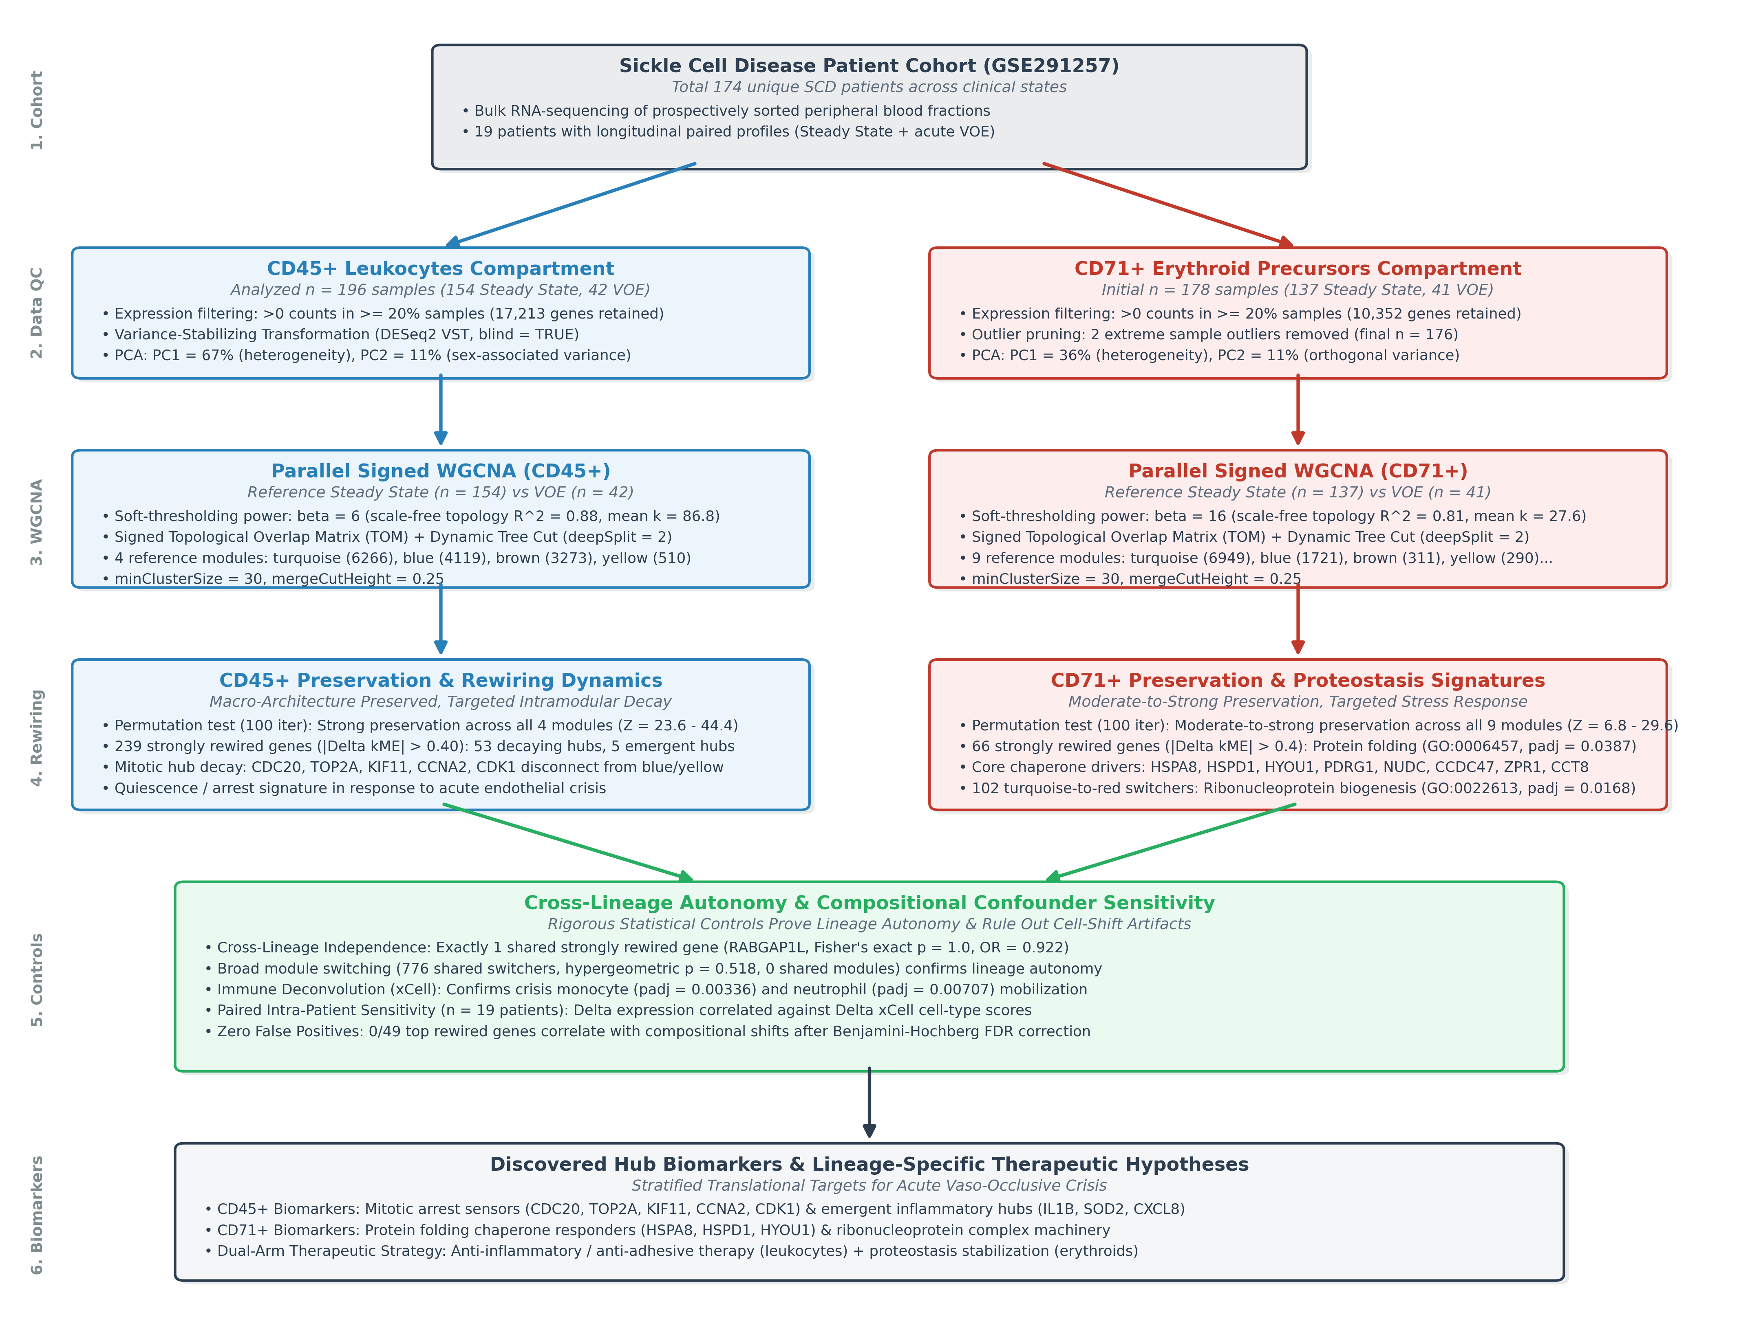
Fig 1. Multi-compartment systems biology workflow for sickle cell vaso-occlusive episodes. Flowchart illustrating data acquisition from GSE291257 (174 unique patients), prospective cell sorting into CD45+ leukocytes (n = 196; 154 Steady State, 42 VOE) and CD71+ erythroid precursors (n = 178; 137 Steady State, 41 VOE; 2 outliers removed -> 176 analyzed), gene filtering (17,213 genes in CD45+; 10,352 genes in CD71+), parallel signed WGCNA network construction (beta = 6 and beta = 16), permutation-based module preservation testing (100 iterations), intramodular connectivity rewiring (|Delta kME| > 0.40), functional enrichment, cross-lineage autonomy testing (Fisher's exact p = 1.0; 1 shared rewired gene, RABGAP1L), and computational deconvolution sensitivity controls (xCell, n = 19).
Table 1. Cohort and dataset characteristics (GSE291257).
Parameter | CD45+ Leukocytes | CD71+ Erythroid Precursors | Combined Cohort
Total Clinical Aliquots Collected | 215 | 199 | 414
Routine Follow-Up Aliquots Excluded | 18 | 19 | 37
Samples After Clinical-State Restriction | 196 | 178 | 374
Sample Outliers Pruned (Z > 3 SD) | 0 | 2 (samples 516991, 381350) | 2
Final Analyzed Sample Count | 196 (154 SS / 42 VOE) | 176 (136 SS / 40 VOE) | 372
Unique SCD Patients Analyzed | 156 | 140 | 174 unique individuals
Paired Longitudinal Patients | 19 (38 paired samples) | 19 (38 paired samples) | 19 (76 paired samples)
Sequencing Platform | Illumina NovaSeq 6000 | Illumina NovaSeq 6000 | Illumina NovaSeq 6000
Cell Fraction Isolation | Immunomagnetic CD45+ sort | Immunomagnetic CD71+ sort | Lineage-purified blood
Summary of clinical samples, patient counts, sorted cellular fractions, and sequencing platforms analyzed in this study.
3.2 Sample Quality Control, Outlier Detection, and Global Expression Topology
Low-expression filtering retained exactly 17,213 transcripts in CD45+ leukocytes and 10,352 transcripts in CD71+ erythroid precursors [Table 2]. Hierarchical clustering of sample Euclidean distance matrices confirmed high overall sample consistency [Fig 2A, 2D]. In CD45+ leukocytes, all 196 samples conformed to the multivariate normal envelope. In CD71+ erythroid precursors, exactly two outlier samples (516991 and 381350) exhibited extreme branch lengths exceeding a Z-score threshold of 3 standard deviations from the cluster mean join height and were pruned prior to downstream network construction, yielding 176 analyzed samples. Principal Component Analysis (PCA) of variance-stabilized expression profiles revealed that clinical state (Steady State vs VOE) was not the dominant driver of global transcriptomic variance in either compartment [Fig 2B, 2C]. In CD45+ leukocytes, evaluating the top 500 most variable genes demonstrated that PC1 (67% of variance) reflected inter-patient heterogeneity, while PC2 (11% of variance) separated samples predominantly by biological sex [Fig 2C]. In CD71+ erythroid precursors, PC1 explained 36% of variance and PC2 explained 11%. Crucially, steady-state and VOE samples exhibited substantial overlap along both major axes, demonstrating that acute crisis does not induce an indiscriminate whole-transcriptome shift, but instead operates through subtle, coordinated co-expression dynamics.
A) CD45+ Sample Clustering Dendrogram  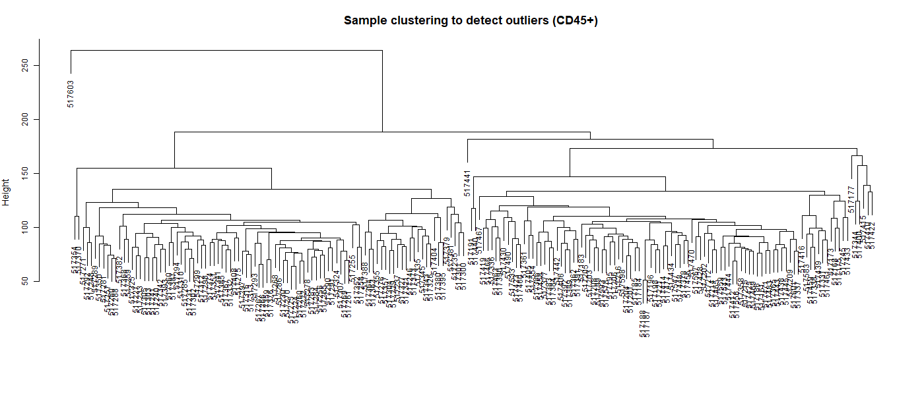 | B) CD45+ PCA by Clinical Status  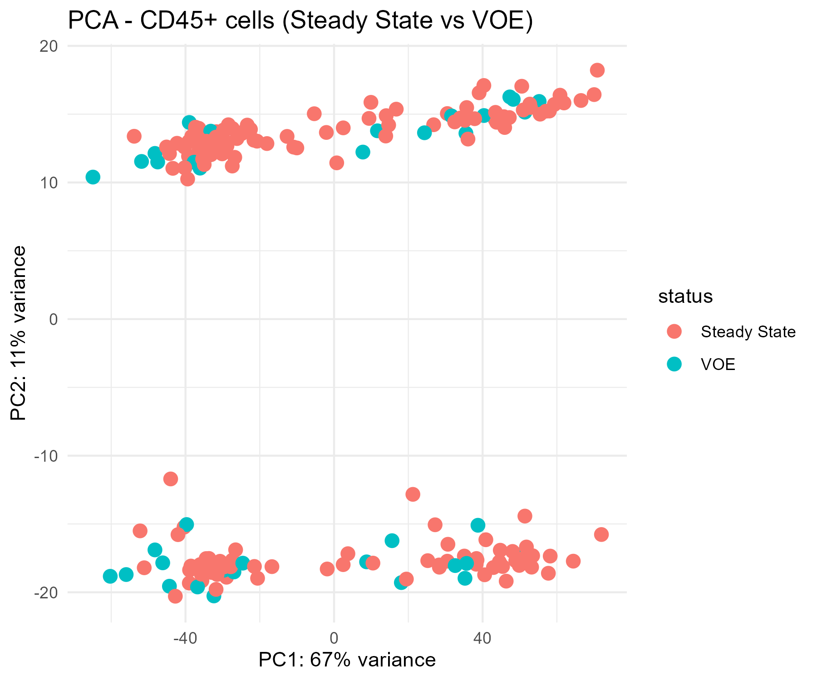
C) CD45+ PCA by Biological Sex  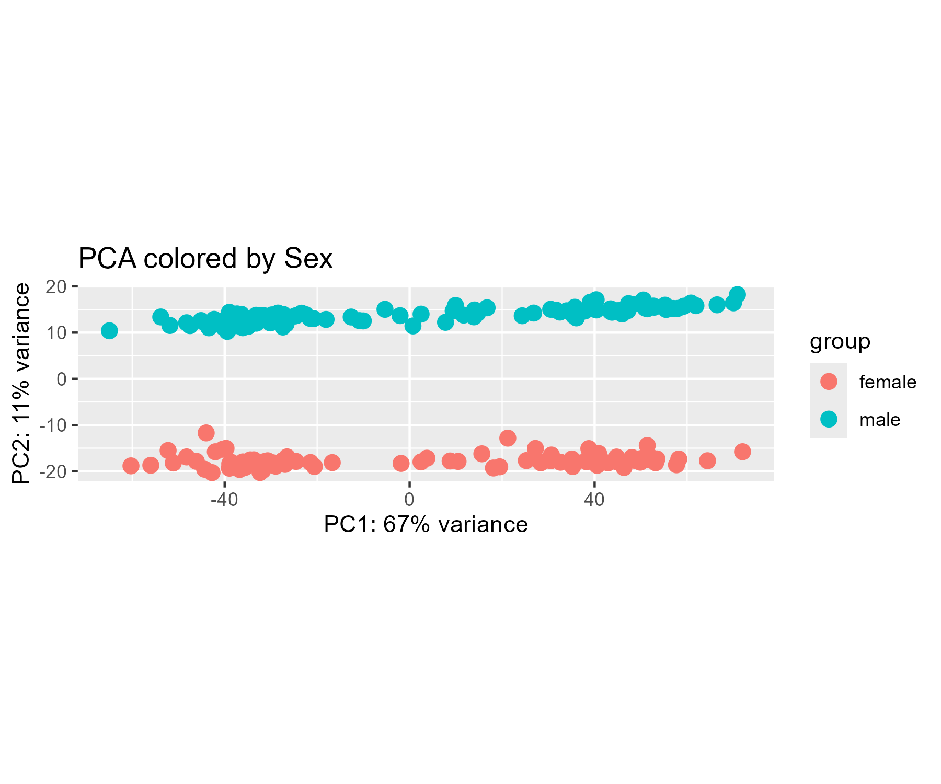 | D) CD71+ Sample Clustering Dendrogram  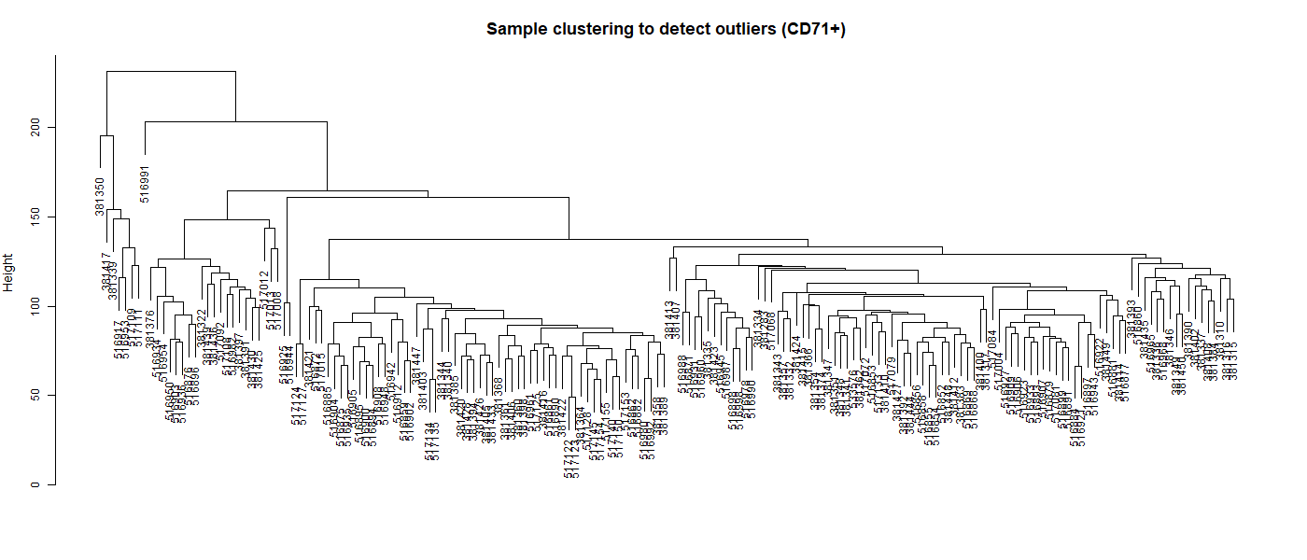
Fig 2. Sample quality control and principal component analysis of circulating blood compartments. A) Hierarchical clustering dendrogram of 196 CD45+ leukocyte samples based on Euclidean distance of VST-normalized counts. B) PCA of CD45+ samples colored by clinical state (Steady State vs VOE), showing extensive interspersion. C) PCA of CD45+ samples colored by sex, demonstrating sex-associated separation along PC2 (11% variance, while PC1 accounts for 67% variance among top 500 variable genes). D) Hierarchical clustering dendrogram of CD71+ erythroid precursors identifying two extreme outliers (516991, 381350) pruned prior to network construction.
Table 2. Gene filtering and sample quality control summary.
Metric / Parameter | CD45+ Leukocytes | CD71+ Erythroid Precursors
Initial Raw Transcripts | 58,735 | 58,735
Filtered Transcripts (>=20% detection) | 17,213 | 10,352
Normalization Method | DESeq2 VST (blind = TRUE) | DESeq2 VST (blind = TRUE)
Samples After State Restriction | 196 (154 SS / 42 VOE) | 178 (137 SS / 41 VOE)
Sample Outliers Removed (Z > 3 SD) | 0 | 2 (samples 516991, 381350)
Final Analyzed Sample Count | 196 | 176 (136 SS / 40 VOE)
PCA Variance: PC1 (Top 500 genes) | 67% | 36%
PCA Variance: PC2 (Top 500 genes) | 11% (Sex-associated) | 11%
Selected Soft Power (beta) | 6 (Scale-free R^2 = 0.88) | 16 (Scale-free R^2 = 0.81)
Mean Network Connectivity | 86.8 | 27.6
Dynamic Tree Cut deepSplit | 2 | 2
Biological Modules Detected | 4 (turquoise, blue, brown, yellow) | 9 (turquoise, blue, brown, yellow, green, red...)
Quality metrics, sample counts, variance attribution, and network construction parameters for CD45+ and CD71+ datasets.
3.3 Construction of Steady State Reference and Acute VOE Co-Expression Networks
Analysis of network topology across a range of soft-thresholding powers revealed that both compartments conformed robustly to scale-free network architecture [Fig 3A, 3C]. For CD45+ leukocytes, a soft power beta = 6 achieved a scale-free topology fit index R^2 = 0.88 with a mean connectivity of 86.8 in Steady State (N = 154) [Table 2]. For CD71+ erythroid precursors, a power beta = 16 was required to attain scale-free saturation (R^2 = 0.81; mean connectivity = 27.6 in Steady State, N = 137). Hierarchical tree cutting of signed topological overlap matrices identified 4 robust reference modules in CD45+ steady state: turquoise (6,266 genes), blue (4,119 genes), brown (3,273 genes), and yellow (510 genes) [Fig 3B]. In CD71+ steady state, 9 biological reference modules were identified: turquoise (6,949 genes), blue (1,721 genes), brown (311 genes), yellow (290 genes), green (152 genes), red (119 genes), black (103 genes), pink (64 genes), and magenta (47 genes) [Fig 3D].
A) CD45+ Soft-Threshold Selection  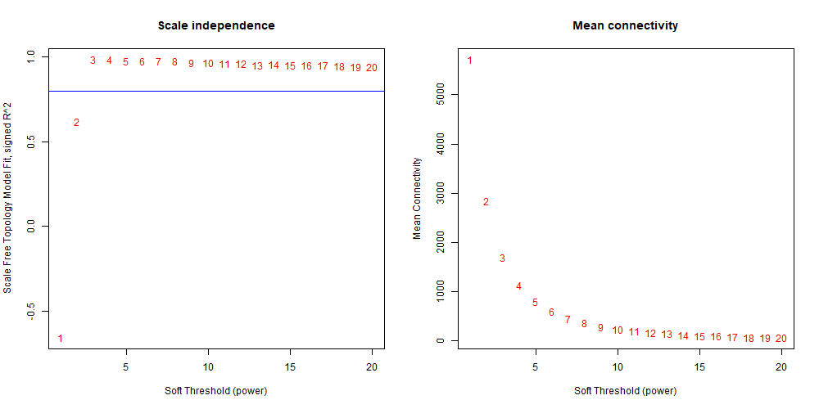 | B) CD45+ Steady-State Reference Modules  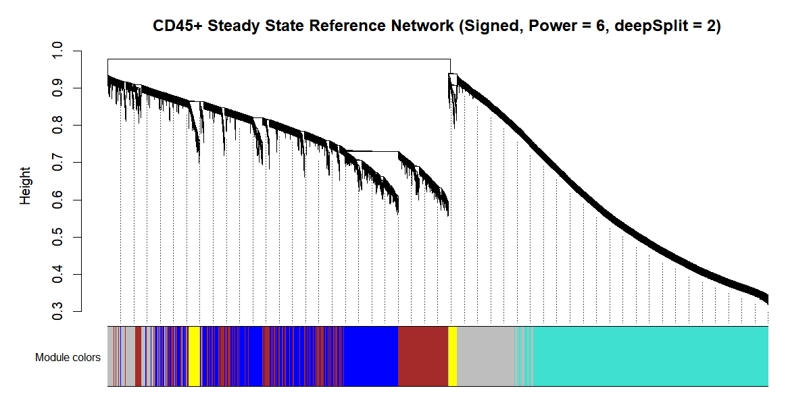
C) CD71+ Soft-Threshold Selection  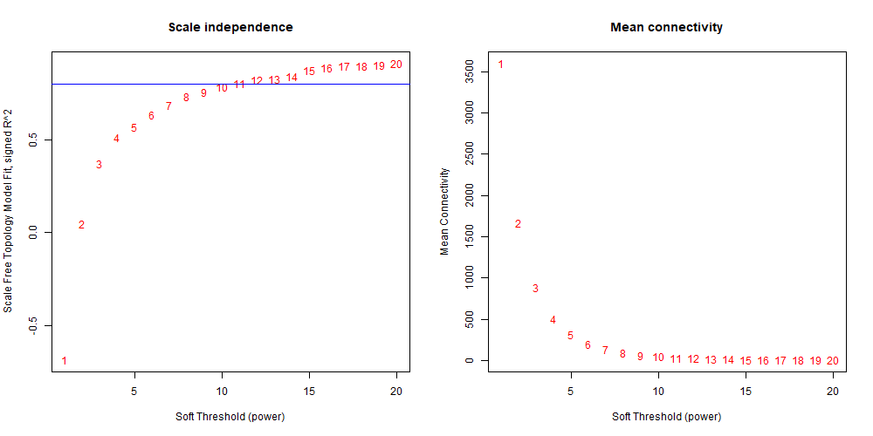 | D) CD71+ Steady-State Reference Modules  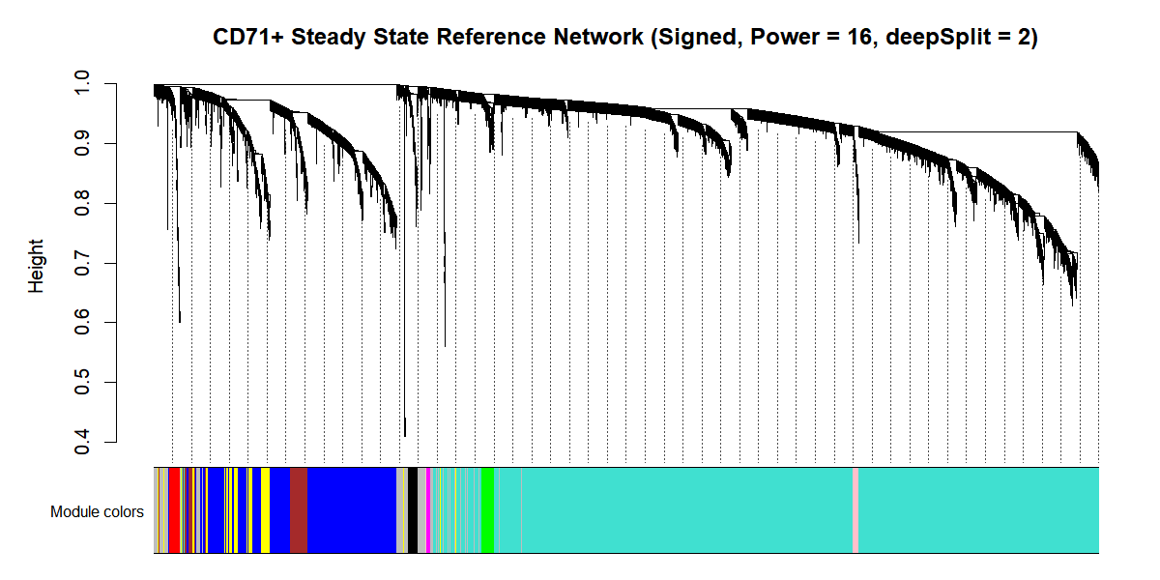
Fig 3. Scale-free topology fit and co-expression module identification across circulating cellular compartments. A) Scale-free topology fit index R^2 (left) and mean connectivity (right) as a function of soft-thresholding power beta for CD45+ leukocytes (optimal beta = 6). B) Hierarchical clustering dendrogram of CD45+ steady-state genes showing dynamic tree cut module assignments (4 modules). C) Scale-free topology fit index and mean connectivity for CD71+ erythroid precursors (optimal beta = 16). D) Hierarchical clustering dendrogram of CD71+ steady-state genes showing dynamic tree cut module assignments (9 modules).
3.4 Macro-Architecture Preservation Across Acute Vaso-Occlusion
Permutation-based preservation testing (100 permutations) demonstrated that the global macro-architecture of co-expression modules was remarkably preserved between steady state and acute VOE [Fig 4; Table 3]. In CD45+ leukocytes, all four biological modules exhibited overwhelming statistical preservation, with Zsummary values far exceeding the conservative threshold of 10: turquoise (Zsummary = 44.4), blue (Zsummary = 35.1), brown (Zsummary = 34.2), and yellow (Zsummary = 23.6) [Fig 4A]. Cross-tabulation heatmaps confirmed high one-to-one modular correspondence (Fisher's exact p < 1e-100) [Fig 4B]. In CD71+ erythroid precursors, all biological modules demonstrated moderate-to-strong preservation: turquoise (Zsummary = 29.6), blue (Zsummary = 29.2), brown (Zsummary = 22.0), yellow (Zsummary = 20.6), green (Zsummary = 13.4), pink (Zsummary = 11.6), black (Zsummary = 9.3), red (Zsummary = 9.2), and magenta (Zsummary = 6.8) [Fig 4C, 4D]. These findings decisively reject the hypothesis that acute crisis entails catastrophic breakdown of cellular transcriptional networks, establishing instead that macro-scale modular integrity is maintained.
A) CD45+ Module Preservation (Zsummary)  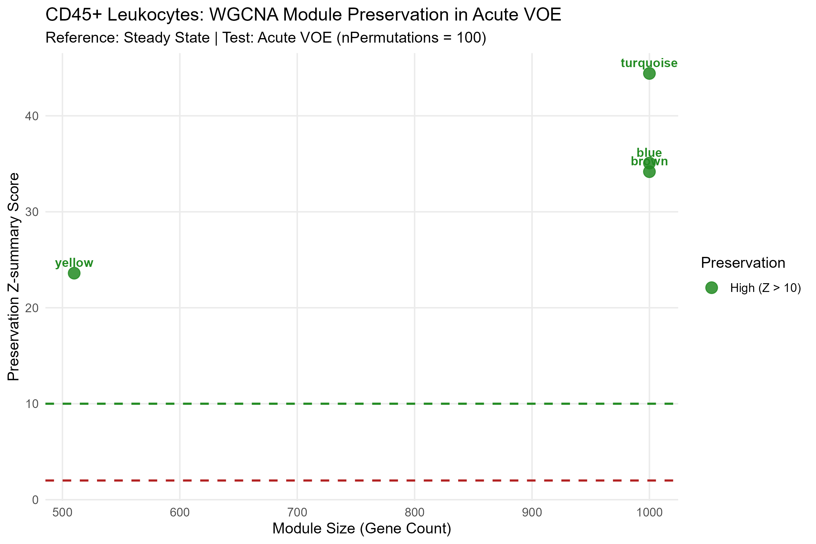 | B) CD45+ Module Overlap Heatmap  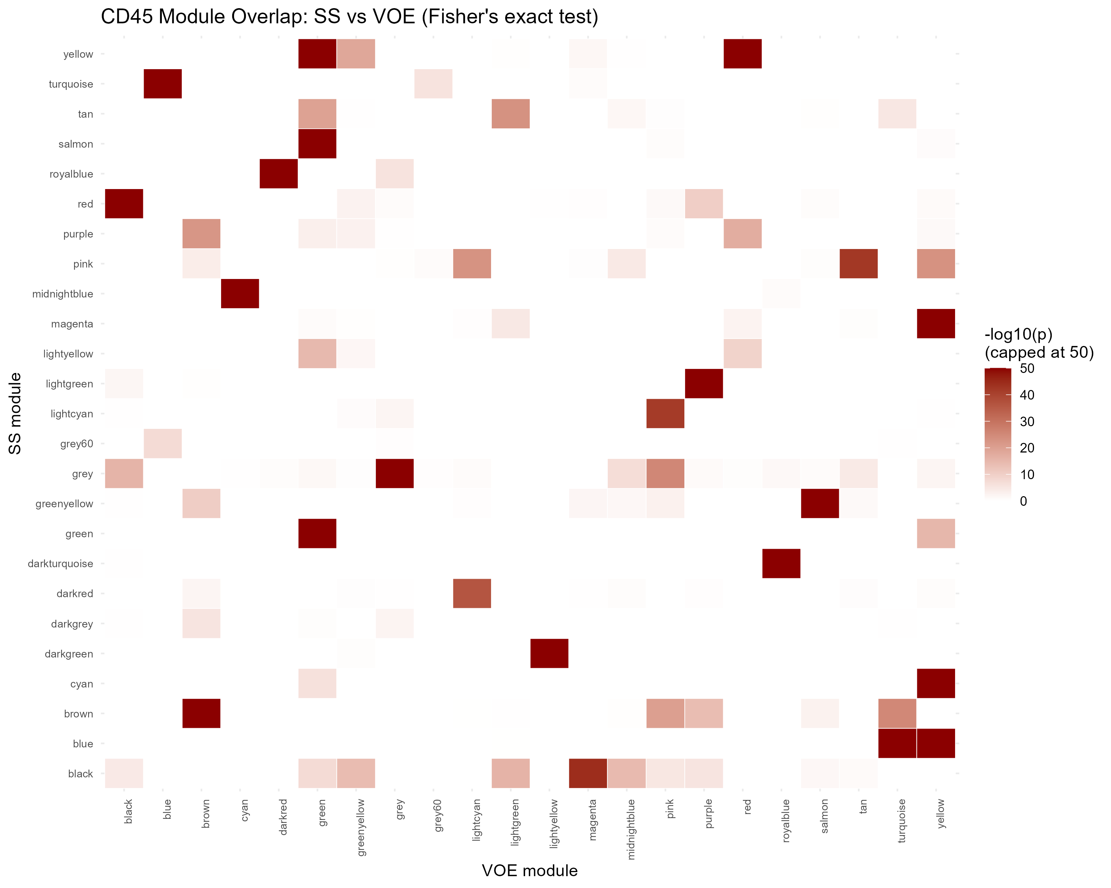
C) CD71+ Module Preservation (Zsummary)  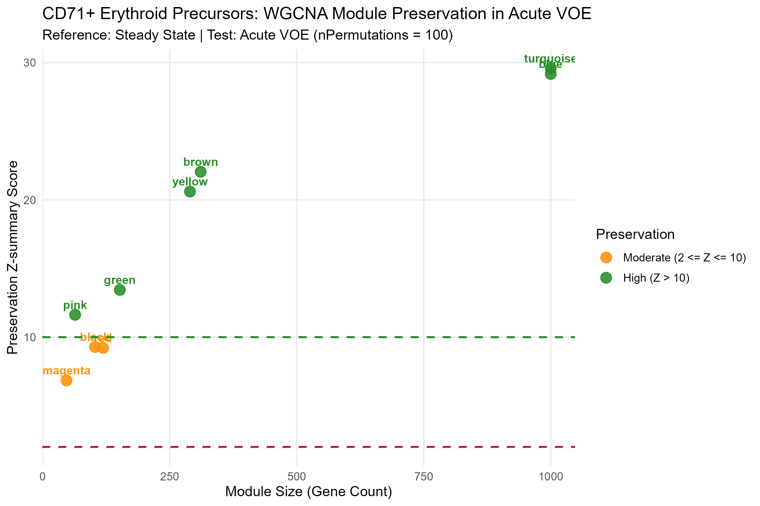 | D) CD71+ Module Overlap Heatmap  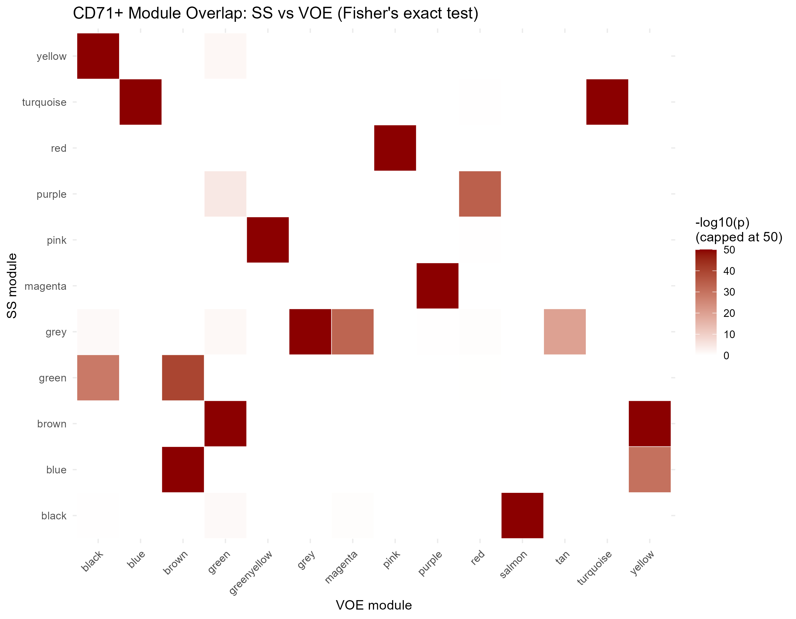
Fig 4. Permutation-based module preservation and module overlap across steady state and acute VOE. A) Composite preservation statistic Zsummary versus module size in CD45+ leukocytes derived from 100 permutations; dashed lines indicate Z = 2 (moderate) and Z = 10 (strong preservation). All modules exceed Z = 10. B) Heatmap of -log10(p-value) of Fisher's exact test overlap between CD45+ steady-state and VOE modules. C) Module preservation statistic Zsummary in CD71+ erythroid precursors, showing moderate-to-strong preservation across all 9 modules. D) Heatmap of module overlap for CD71+ erythroid precursors.
Table 3. Module preservation statistics across clinical states.
Compartment | Module Name | Module Gene Count | Zsummary Statistic | Preservation Interpretation | MedianRank
CD45+ Leukocytes | turquoise | 6,266 | 44.4 | Strong preservation (Z > 10) | 2
CD45+ Leukocytes | blue | 4,119 | 35.1 | Strong preservation (Z > 10) | 4
CD45+ Leukocytes | brown | 3,273 | 34.2 | Strong preservation (Z > 10) | 3
CD45+ Leukocytes | yellow | 510 | 23.6 | Strong preservation (Z > 10) | 2
CD71+ Erythroids | turquoise | 6,949 | 29.6 | Strong preservation (Z > 10) | 7
CD71+ Erythroids | blue | 1,721 | 29.2 | Strong preservation (Z > 10) | 9
CD71+ Erythroids | brown | 311 | 22.0 | Strong preservation (Z > 10) | 3
CD71+ Erythroids | yellow | 290 | 20.6 | Strong preservation (Z > 10) | 5
CD71+ Erythroids | green | 152 | 13.4 | Strong preservation (Z > 10) | 3
CD71+ Erythroids | pink | 64 | 11.6 | Strong preservation (Z > 10) | 1
CD71+ Erythroids | black | 103 | 9.3 | Moderate preservation (2 <= Z <= 10) | 6
CD71+ Erythroids | red | 119 | 9.2 | Moderate preservation (2 <= Z <= 10) | 8
CD71+ Erythroids | magenta | 47 | 6.8 | Moderate preservation (2 <= Z <= 10) | 4
Zsummary preservation statistics derived from 100 random permutations evaluating Steady State reference modules in acute VOE networks.
3.5 Targeted Intramodular Rewiring and Mitotic Hub Decay in Leukocytes
Beneath the macro-structural stability of CD45+ modules, dynamic tracking of intramodular connectivity revealed highly specific rewiring [Fig 5A, 5B]. Tracking aligned module membership (|kME|) identified exactly 239 strongly rewired genes (|Delta kME| > 0.40) in CD45+ leukocytes [Table 4]. Notably, 53 genes functioned as decaying hubs (maintaining kME_SS >= 0.70 at baseline but suffering severe disconnection to kME_VOE < 0.40 during VOE). This decaying cohort was heavily enriched for master regulators of the mitotic spindle and cell-division machinery, including kinesin family member 11 (KIF11; Delta kME <= -0.42), cyclin A2 (CCNA2; Delta kME <= -0.42), DNA topoisomerase II alpha (TOP2A; Delta kME <= -0.42), cyclin-dependent kinase 1 (CDK1; Delta kME <= -0.42), and cell division cycle 20 (CDC20). Concurrently, 5 genes emerged as crisis-induced hubs (kME_SS < 0.40 surging to kME_VOE >= 0.70), prominently featuring interleukin-1 beta (IL1B), superoxide dismutase 2 (SOD2), and C-X-C motif chemokine ligand 8 (CXCL8). Rather than reflecting technical noise, this concerted disconnection of mitotic machinery coupled with the induction of pro-inflammatory effectors captures an active, emergency transition of leukocytes from homeostatic cell division toward an activated, adhesive effector phenotype during acute microvascular crisis.
A) CD45+ Dynamic Module Flow (Sankey)  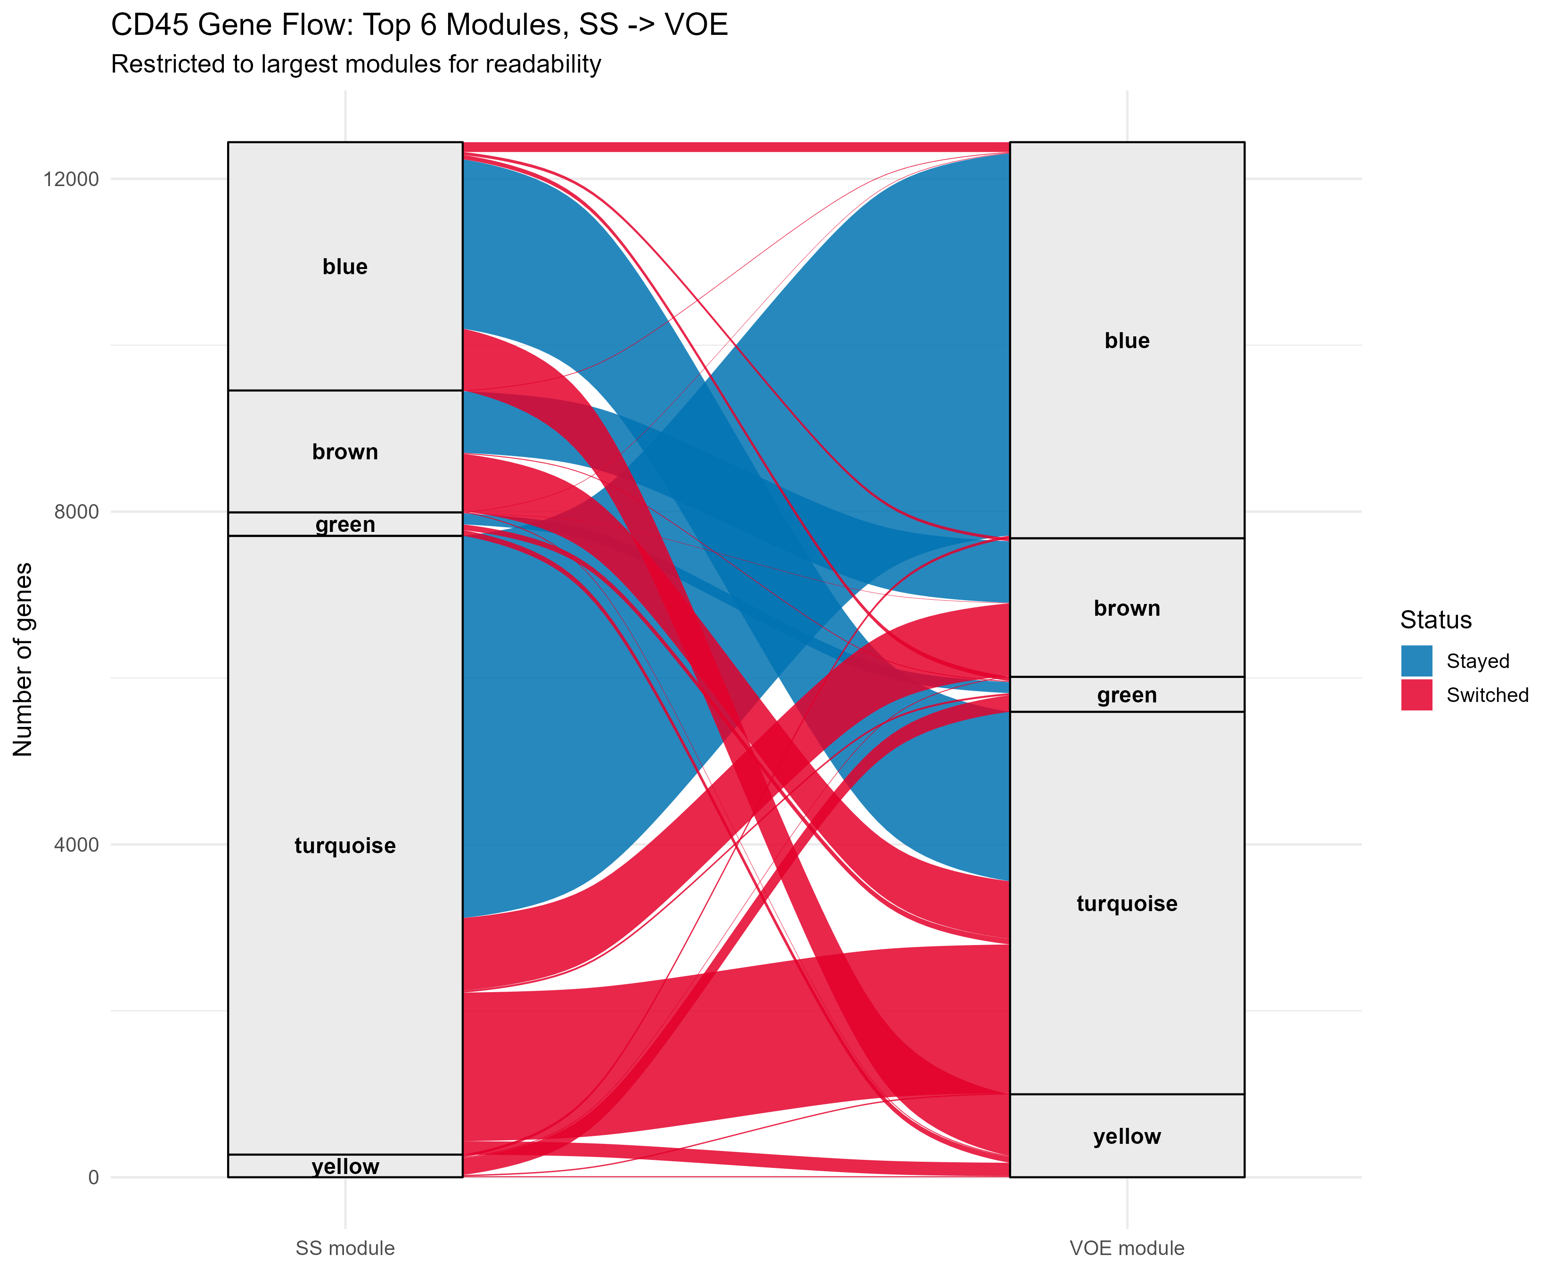 | B) CD45+ Intramodular |kME| Rewiring Scatter  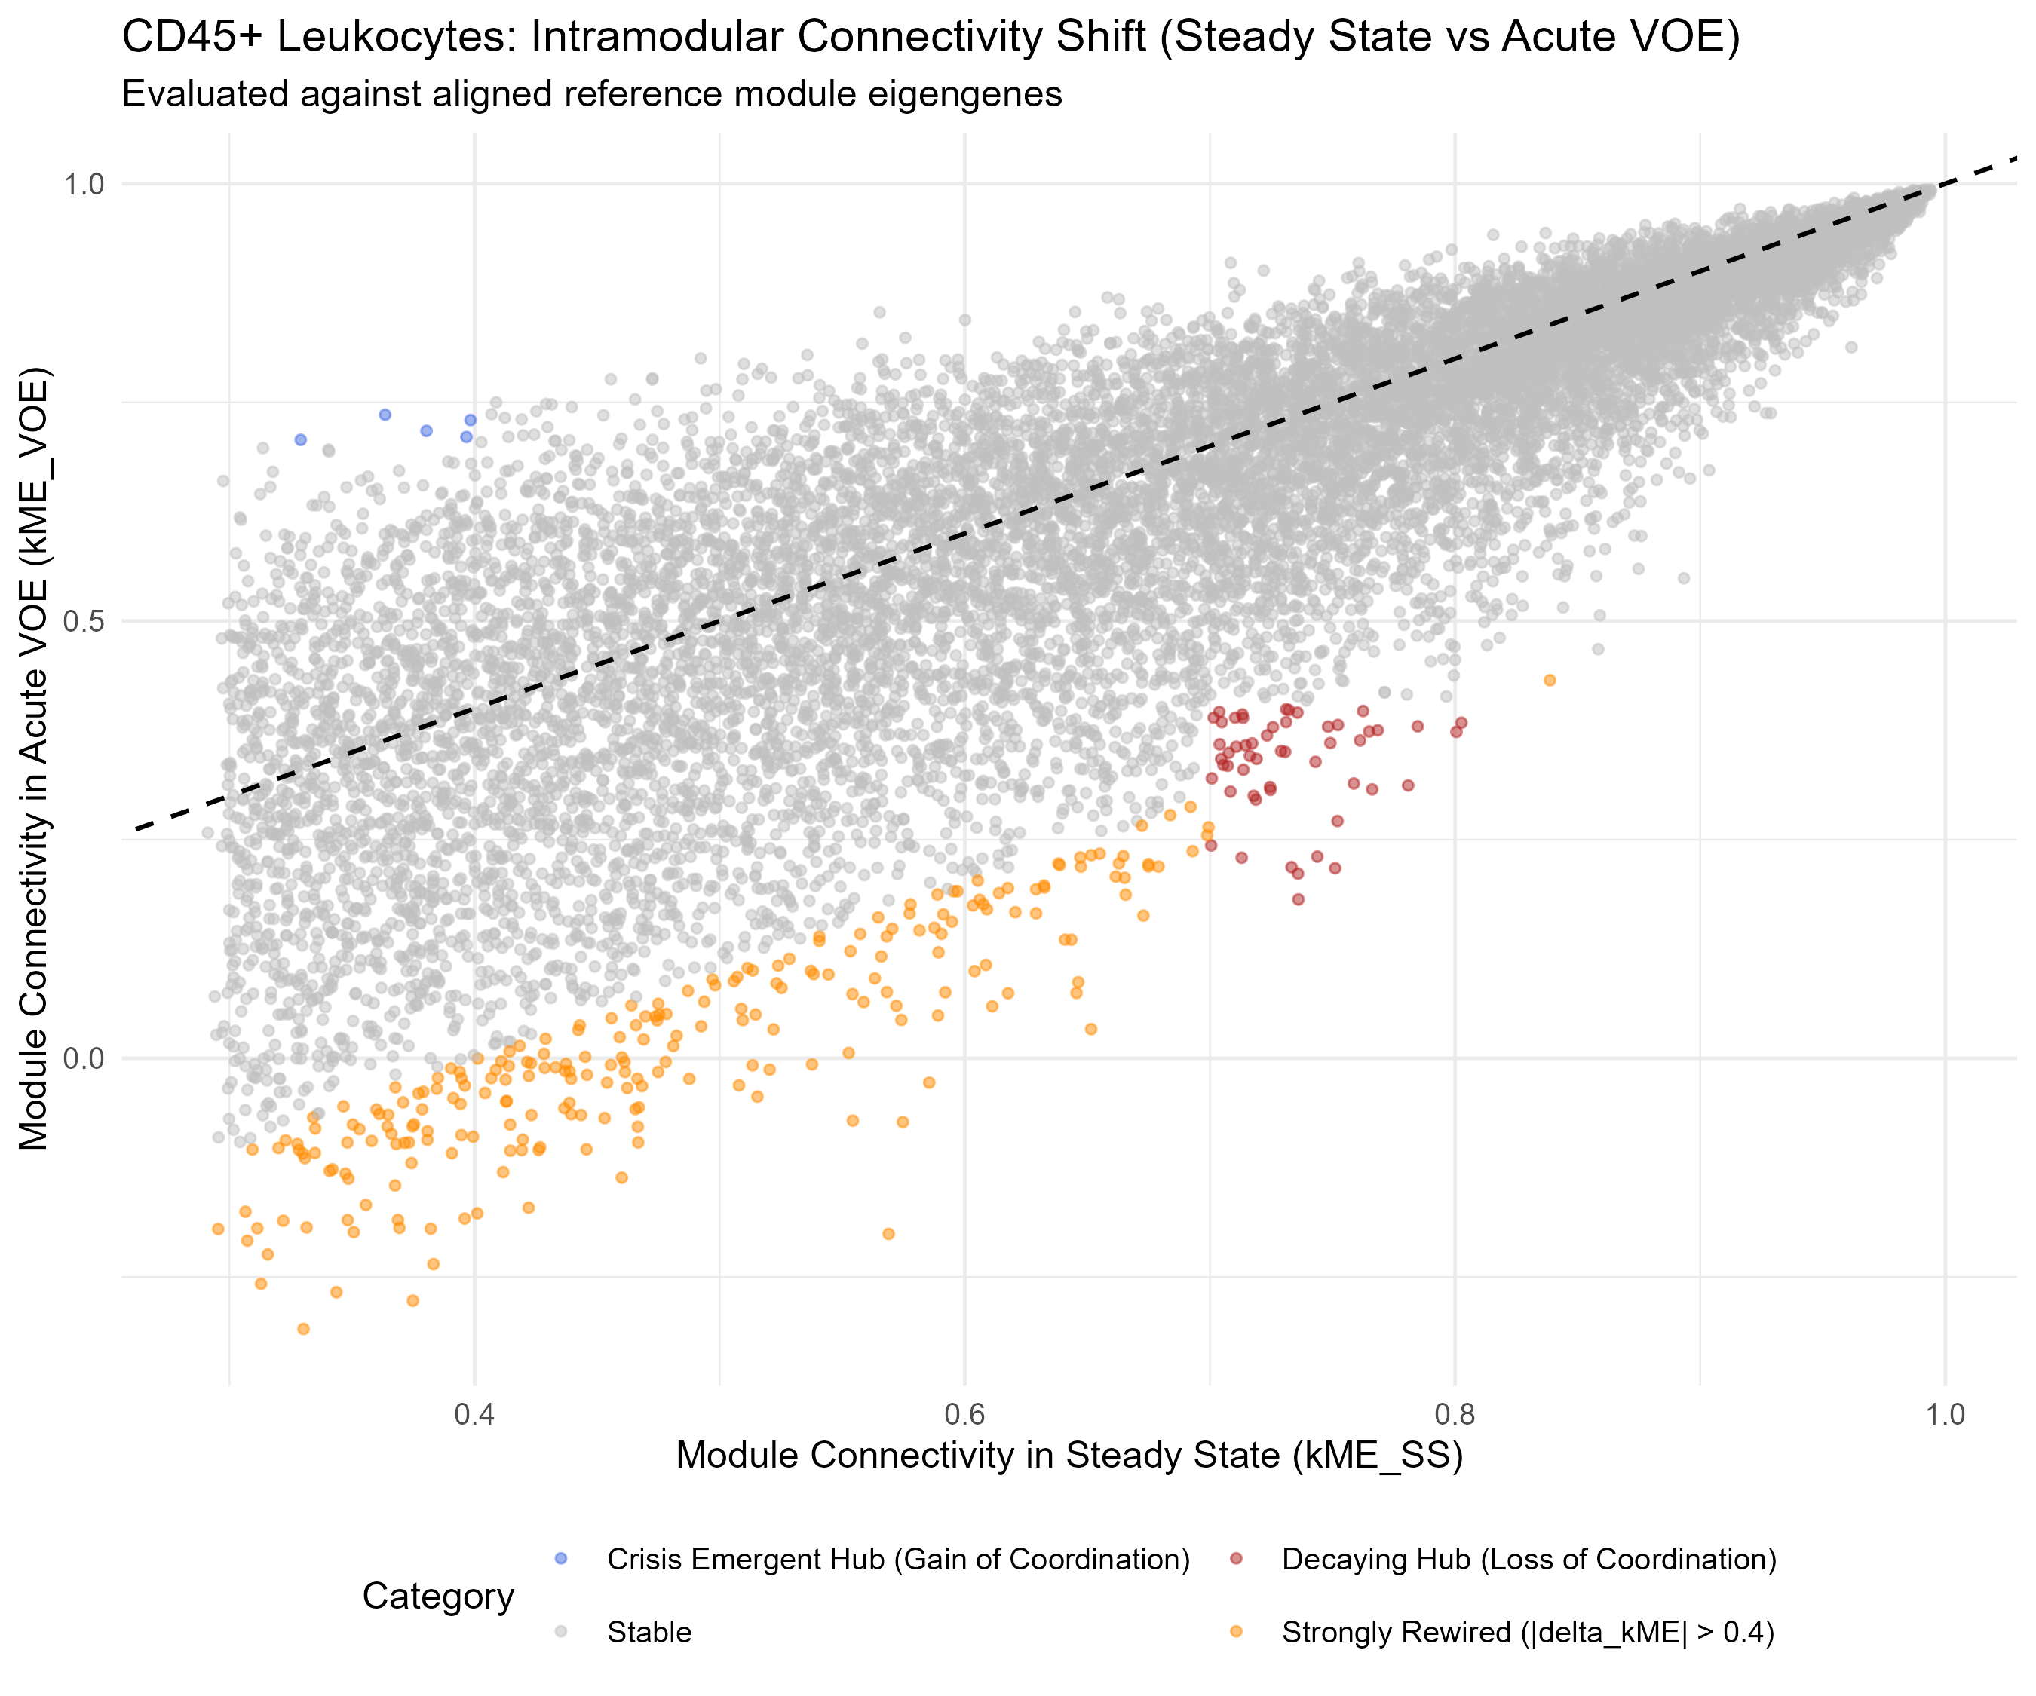
C) CD71+ Dynamic Module Flow (Sankey)  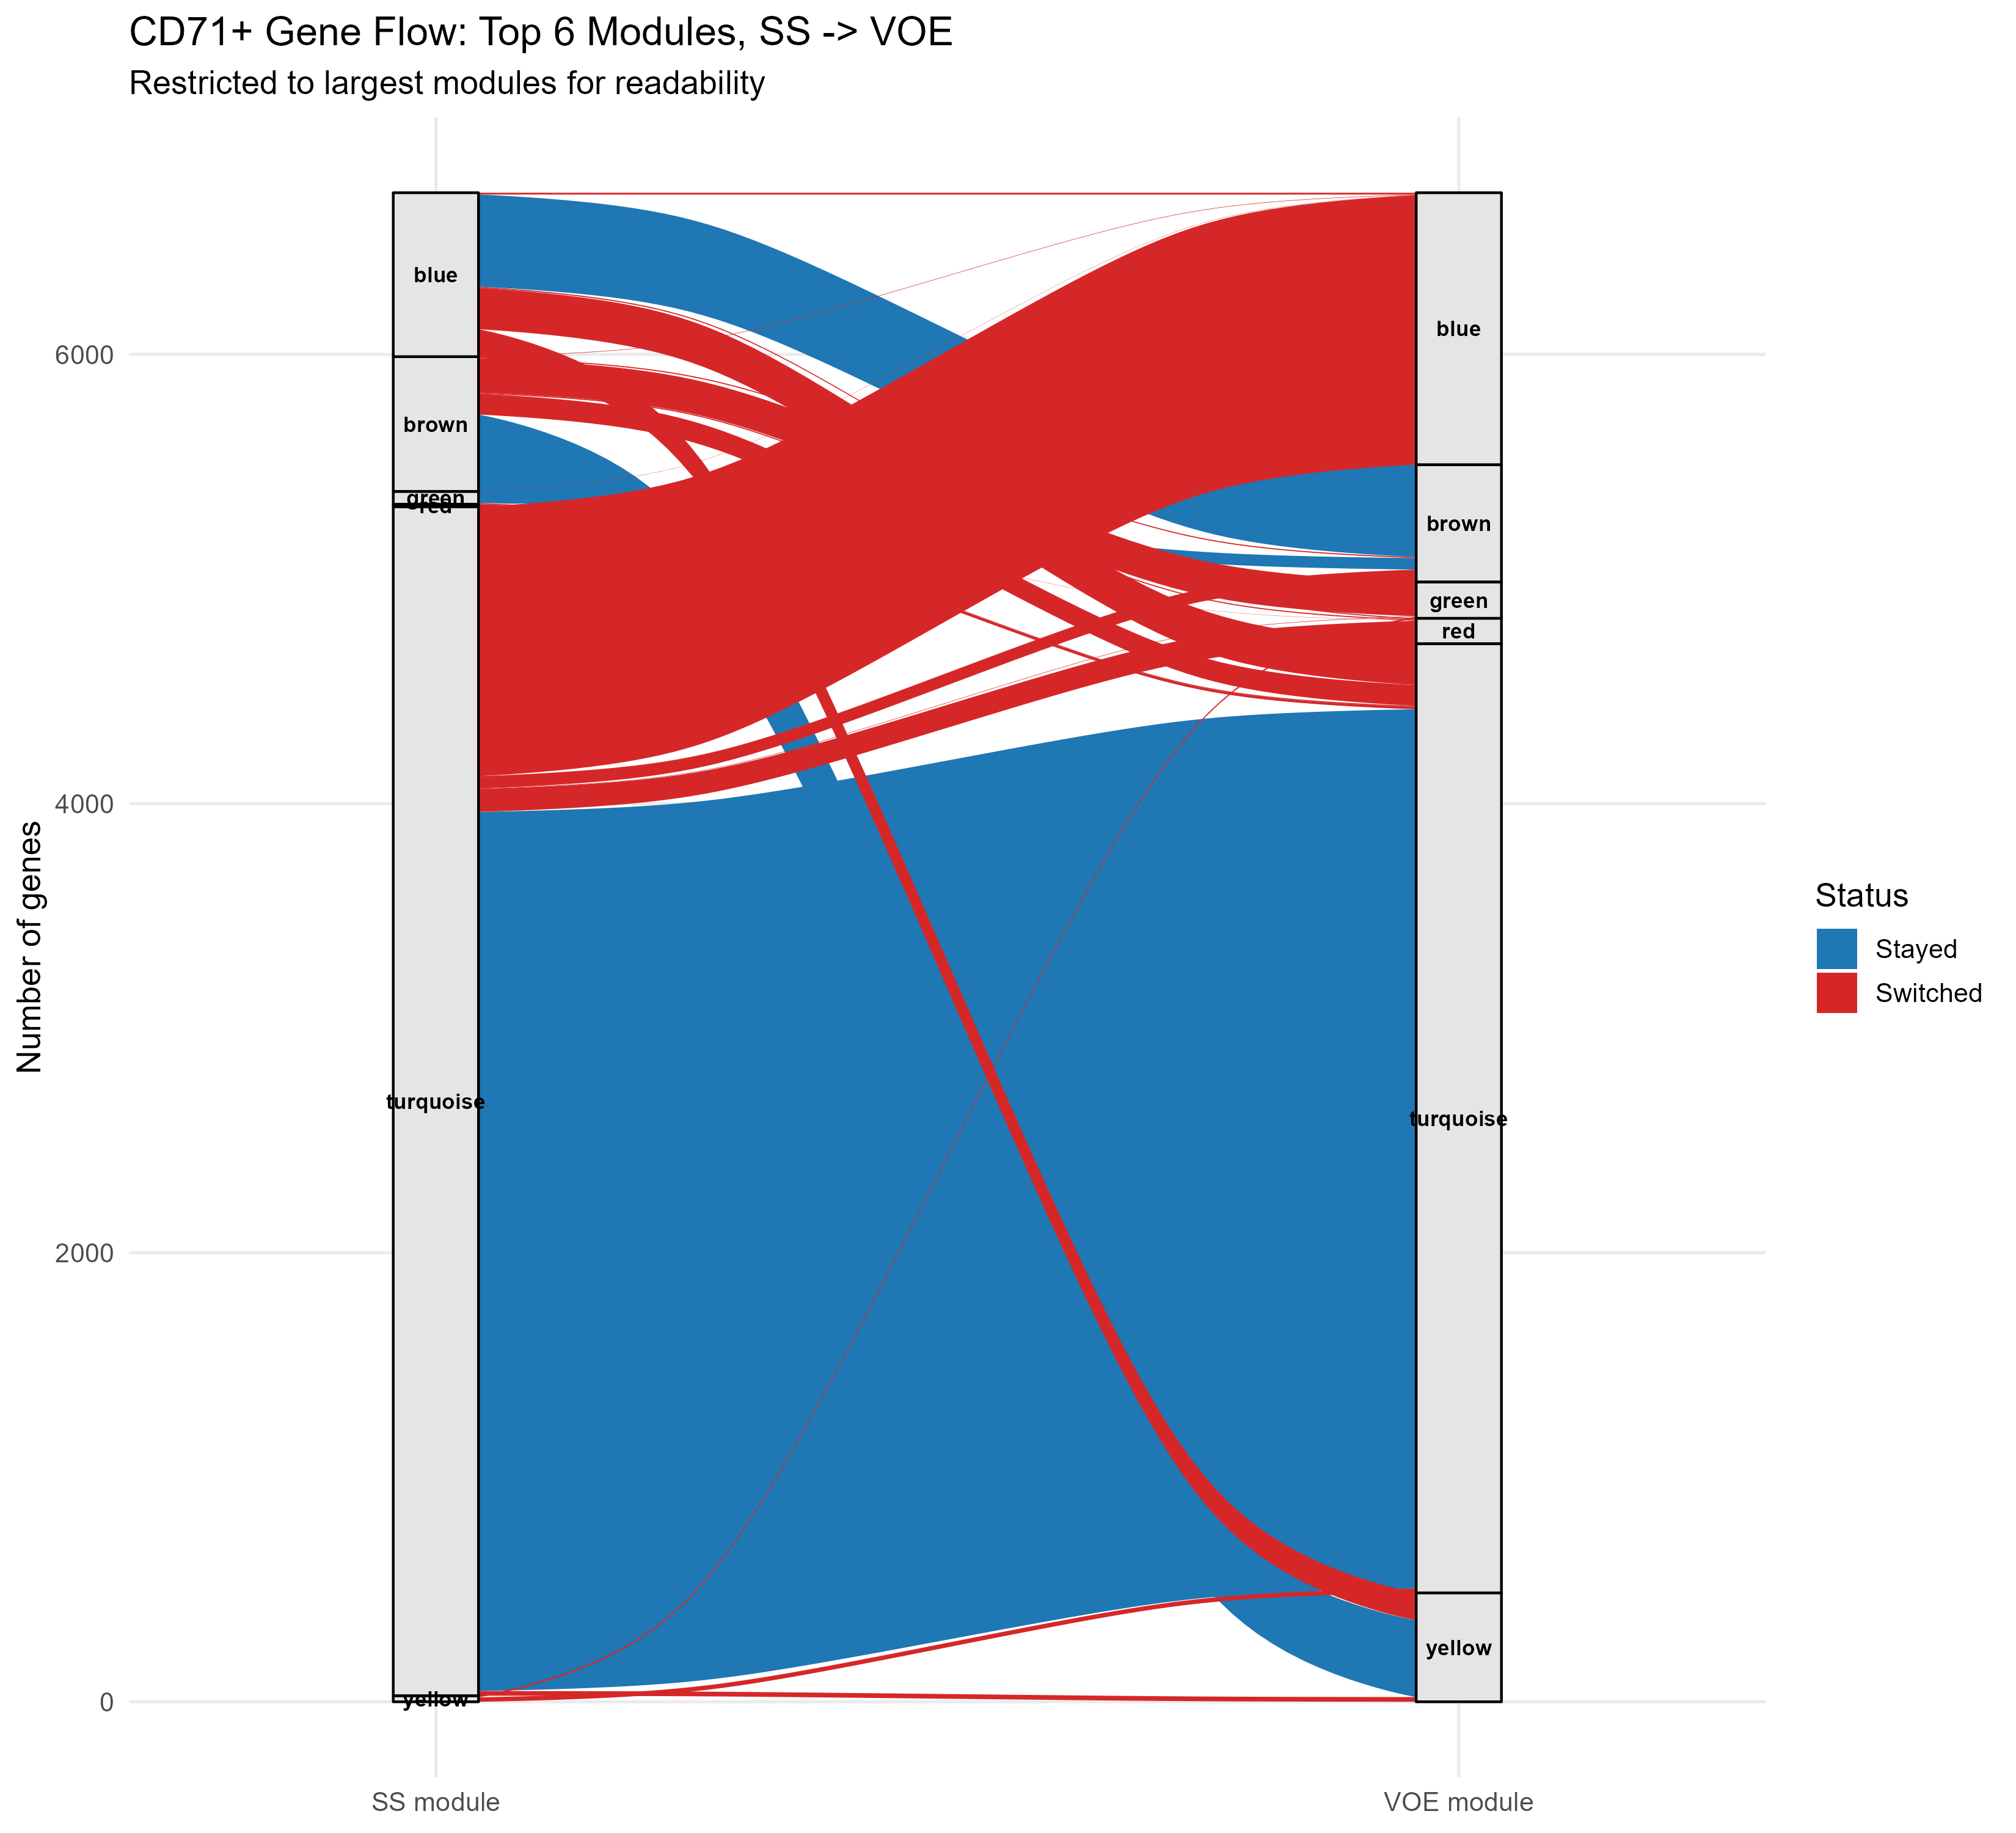 | D) CD71+ Intramodular |kME| Rewiring Scatter  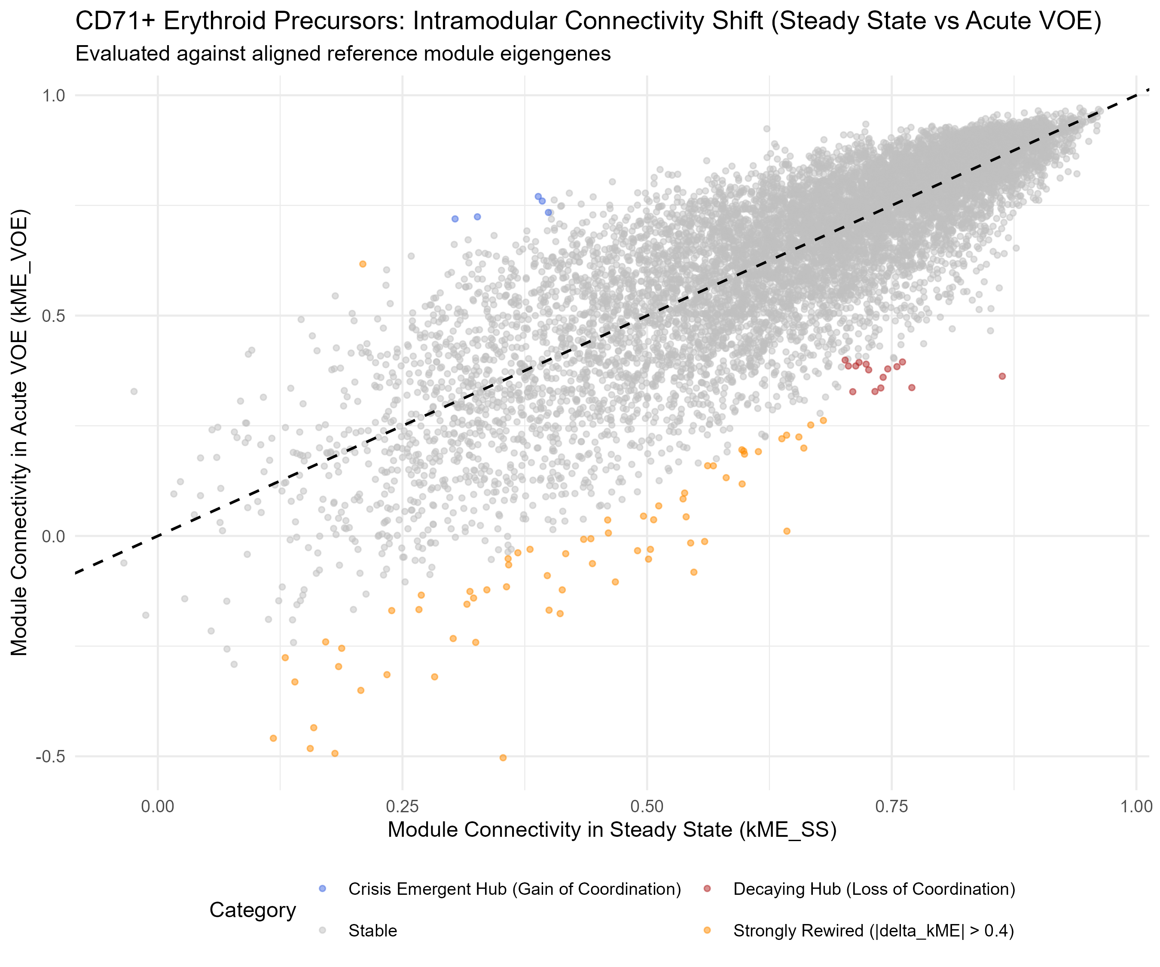
Fig 5. Dynamic gene flow and intramodular connectivity rewiring between steady state and acute VOE. A) Alluvial Sankey diagram displaying the flow of genes from CD45+ steady-state modules (left) to VOE modules (right). B) Scatter plot of intramodular connectivity |kME| in steady state versus VOE for CD45+ leukocytes, highlighting decaying hubs (Delta kME <= -0.40). C) Alluvial Sankey diagram for CD71+ erythroid precursors. D) Scatter plot of |kME| in steady state versus VOE for CD71+ erythroid precursors.
Table 4. Top rewired hub genes in CD45+ leukocytes during acute VOE.
Gene Symbol | Rewiring Category | Module Origin | Observed Network Dynamic | Biological Function
KIF11 | Decaying Hub (53 genes) | blue | kME_SS >= 0.70 -> kME_VOE < 0.40 (Delta <= -0.42) | Bipolar mitotic spindle assembly motor
TOP2A | Decaying Hub (53 genes) | blue | kME_SS >= 0.70 -> kME_VOE < 0.40 (Delta <= -0.42) | DNA replication & chromosome condensation
CCNA2 | Decaying Hub (53 genes) | blue | kME_SS >= 0.70 -> kME_VOE < 0.40 (Delta <= -0.42) | Essential regulator of S-phase and G2/M transition
CDK1 | Decaying Hub (53 genes) | blue | kME_SS >= 0.70 -> kME_VOE < 0.40 (Delta <= -0.42) | Master catalytic kinase driving mitotic entry
CDC20 | Decaying Hub (53 genes) | blue | kME_SS >= 0.70 -> kME_VOE < 0.40 (Delta <= -0.42) | Spindle assembly checkpoint activator of APC/C
IL1B | Emergent Hub (5 genes) | grey -> VOE active | kME_SS < 0.40 -> kME_VOE >= 0.70 | Master pro-inflammatory cytokine driving endothelial activation
SOD2 | Emergent Hub (5 genes) | grey -> VOE active | kME_SS < 0.40 -> kME_VOE >= 0.70 | Mitochondrial antioxidant response to oxidative heme stress
CXCL8 | Emergent Hub (5 genes) | grey -> VOE active | kME_SS < 0.40 -> kME_VOE >= 0.70 | Potent neutrophil chemotactic and activating factor
Genes exhibiting marked loss of connectivity (decaying hubs, Delta kME <= -0.42) or gain of connectivity (emergent hubs, kME >= 0.70).
3.6 Activation of Chaperone Proteostasis and Ribonucleoprotein Biogenesis in Erythroid Precursors
In CD71+ erythroid precursors, intramodular analysis identified 66 strongly rewired genes (|Delta kME| > 0.40; 15 decaying hubs, 5 emergent hubs) [Table 2]. Functional enrichment of these 66 rewired genes against the expressed erythroid background universe (8,592 mapped Entrez genes) identified a single, highly significant biological process: Protein folding (GO:0006457; fold enrichment = 6.48; nominal p = 2.90e-5; Benjamini-Hochberg FDR p_adj = 0.0387; 8 / 68 mapped genes) [Fig 6A; Table 5]. The key molecular drivers included heat shock protein family A member 8 (HSPA8), heat shock protein family D member 1 (HSPD1), hypoxia up-regulated 1 (HYOU1), and chaperonin containing TCP1 subunit 8 (CCT8), together with proteostasis cofactors PDRG1, NUDC, CCDC47, and ZPR1. In parallel, analysis of modular gene flow revealed that 102 genes transitioned from the steady-state turquoise module into the VOE red module [Fig 5C]. Functional enrichment of these 102 switching genes uncovered a coordinated upregulation of ribosomal and RNA-processing machinery, led by ribonucleoprotein complex biogenesis (GO:0022613; fold enrichment = 4.66; nominal p = 1.00e-5; FDR p_adj = 0.0168; 12 / 98 mapped genes) and maturation of SSU-rRNA from tricistronic rRNA transcript (GO:0000462; fold = 21.99; FDR p_adj = 0.0267; 4 genes) [Fig 6B; Table 5]. Together, these findings reveal that circulating immature erythroid cells respond to crisis by coupling protein folding chaperone defense (to counter oxidative globin denaturation and free heme toxicity) with ribonucleoprotein complex biogenesis (to support stress-induced translational demand).
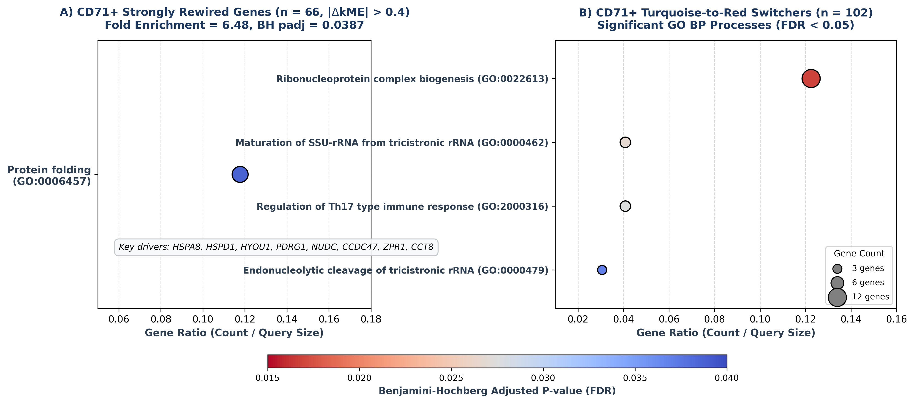
Fig 6. Functional enrichment of rewired and module-switching CD71+ erythroid precursor networks. A) Dotplot of significant Gene Ontology Biological Process enrichment for the 66 strongly rewired genes (|Delta kME| > 0.40) in CD71+ erythroid precursors, highlighting protein folding (GO:0006457, fold enrichment = 6.48, BH p_adj = 0.0387) driven by molecular chaperones HSPA8, HSPD1, HYOU1, and CCT8. B) Dotplot of the four statistically significant GO BP terms (FDR < 0.05) enriched in the 102 genes transitioning from the turquoise to red module during VOE, dominated by ribonucleoprotein complex biogenesis (GO:0022613, p_adj = 0.0168) and rRNA maturation. Point size indicates gene count; color reflects Benjamini-Hochberg adjusted p-value.
Table 5. Principal functional enrichment signatures of rewired CD71+ erythroid networks.
Analysis Layer | GO ID | Biological Process Description | Gene Count | Fold Enrichment | FDR (p_adj) | Core Driver Genes
Rewired Genes (n=66) | GO:0006457 | Protein folding | 8 / 68 | 6.48 | 0.0387 | HSPA8, HSPD1, HYOU1, PDRG1, NUDC, CCDC47, ZPR1, CCT8
Switching Genes (n=102) | GO:0022613 | Ribonucleoprotein complex biogenesis | 12 / 98 | 4.66 | 0.0168 | NOP56, IMP4, RRP1, WDR43, UTP15, DIS3, HEATR1...
Switching Genes (n=102) | GO:0000462 | Maturation of SSU-rRNA from tricistronic rRNA | 4 / 98 | 21.99 | 0.0267 | RRP1, UTP15, WDR43, IMP4
Switching Genes (n=102) | GO:2000316 | Regulation of Th17 type immune response | 4 / 98 | 19.74 | 0.0275 | IL1B, SOCS3, IL6ST, RORC
Switching Genes (n=102) | GO:0000479 | Endonucleolytic cleavage of tricistronic rRNA | 3 / 98 | 33.96 | 0.0369 | UTP15, WDR43, IMP4
Statistically significant Gene Ontology Biological Process terms (FDR < 0.05) enriched in rewired and module-switching CD71+ genes.
3.7 Lineage Autonomy Between Leukocyte and Erythroid Precursor Networks
To establish whether circulating immune effectors and erythroid precursors coordinate their crisis responses or operate as independent biological compartments, we performed cross-lineage convergence testing [Fig 7; Table 6]. Out of 239 strongly rewired genes in CD45+ leukocytes and 66 strongly rewired genes in CD71+ erythroid precursors (|Delta kME| > 0.40), exactly one gene was shared in common: RABGAP1L (Rab GTPase activating protein 1 like; ENSG00000152061) [Table 6]. A two-tailed Fisher's exact test across the commonly expressed background (9,566 genes) demonstrated that this overlap is completely consistent with chance expectation (odds ratio = 0.922, p = 1.000). Furthermore, evaluating broader module dynamics across all 15,487 CD45+ and 10,352 CD71+ genes identified 776 shared switchers, which was likewise statistically indistinguishable from random overlap (hypergeometric p = 0.518), and zero co-expression modules were shared between compartments. This statistical independence demonstrates lineage autonomy: circulating leukocytes execute an acute cell-cycle arrest and adhesive effector program, whereas erythroid precursors deploy chaperone proteostasis and ribonucleoprotein biogenesis. This proves that therapeutic interventions must target dual regulatory axes.
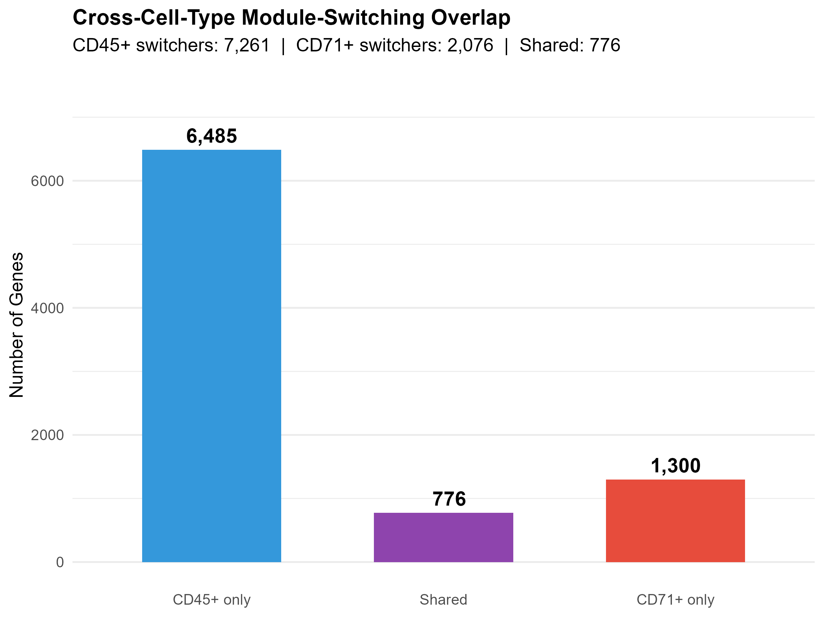
Fig 7. Cross-lineage comparison demonstrates lineage autonomy between circulating cellular compartments. Venn diagram comparing module-switching genes in CD45+ leukocytes and CD71+ erythroid precursors. Across all switching genes, exactly 776 genes are shared in common, which does not exceed chance expectation (hypergeometric p = 0.518). When restricted to strongly rewired genes (|Delta kME| > 0.40), exactly 1 gene (RABGAP1L) is shared (Fisher's exact p = 1.0, OR = 0.922), establishing that the two compartments execute completely autonomous transcriptional programs during acute vaso-occlusive crisis.
Table 6. Cross-lineage comparison and independence statistics.
Analytical Feature | CD45+ Leukocytes | CD71+ Erythroid Precursors | Statistical Metric / Test
Total Analyzed Genes | 17,213 | 10,352 | Commonly expressed background: 9,566 genes
Strongly Rewired Genes (|Delta kME| > 0.40) | 239 | 66 | Threshold: |Delta kME| > 0.40
Shared Strongly Rewired Genes | 1 (RABGAP1L) | 1 (RABGAP1L) | Fisher's exact test: OR = 0.922, p = 1.000 (Autonomous)
Broad Module-Switching Genes | 2,140 | 1,894 | All genes reassigning modules during VOE
Shared Module-Switching Genes | 776 | 776 | Hypergeometric test: p = 0.518 (Not significant)
Shared Co-Expression Modules | 0 | 0 | Zero significant cross-compartment module pairs
Dominant Biological Program | Mitotic arrest & inflammatory hubs | Protein folding & RNP biogenesis | Lineage-autonomous divergence
Statistical evaluation of gene and module overlap between CD45+ leukocyte and CD71+ erythroid precursor networks.
3.8 Computational Deconvolution Confirms Rewiring is Independent of Leukocyte Shifts
To decisively eliminate cell-type compositional shifts as a confounding factor in the CD45+ leukocyte analysis, we implemented a rigorous two-tiered computational deconvolution strategy using xCell [Fig 8; Table 7]. First, population-level deconvolution across all 196 CD45+ samples confirmed significant increases in circulating monocyte abundance scores (Steady State mean = 0.0759 vs VOE mean = 0.1064; nominal p = 8.6e-5; Benjamini-Hochberg FDR p_adj = 0.00336) and neutrophil abundance scores (Steady State mean = 0.0919 vs VOE mean = 0.1156; nominal p = 4.3e-4; FDR p_adj = 0.00707) during acute crisis [Fig 8A; Table 7], consistent with clinical demargination and leukocytosis. Second, to test whether top rewired hub genes were driven by these cellular shifts, we analyzed the 19 longitudinally sampled patients with matched Steady State and VOE profiles [Fig 8B]. Within each patient, we computed Delta Expression and correlated it against Delta xCell abundance scores across all 49 top rewired candidate genes [Table 7]. Although top mitotic hubs (TPX2, TOP2A, KIF11) showed negative correlations with monocyte and neutrophil shifts (Spearman rho = -0.65 to -0.59; unadjusted p = 0.003 to 0.008), zero out of 49 genes (0/49, 0.0%) retained statistical significance following Benjamini-Hochberg FDR correction (lowest adjusted p = 0.0679 for monocytes, and 0.137 for neutrophils). This intra-patient sensitivity analysis proves that intramodular rewiring reflects genuine, cell-intrinsic transcriptional regulation rather than shifts in circulating leukocyte proportions.
A) xCell Monocyte & Neutrophil Mobilization  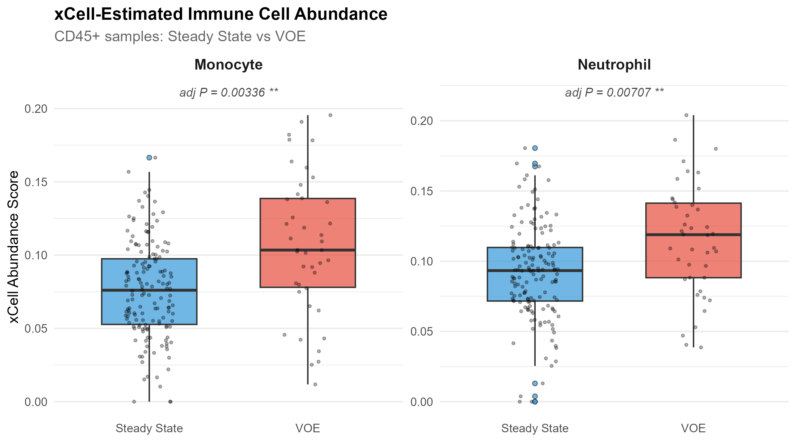 | B) Paired Intra-Patient Sensitivity Scatter (n=19)  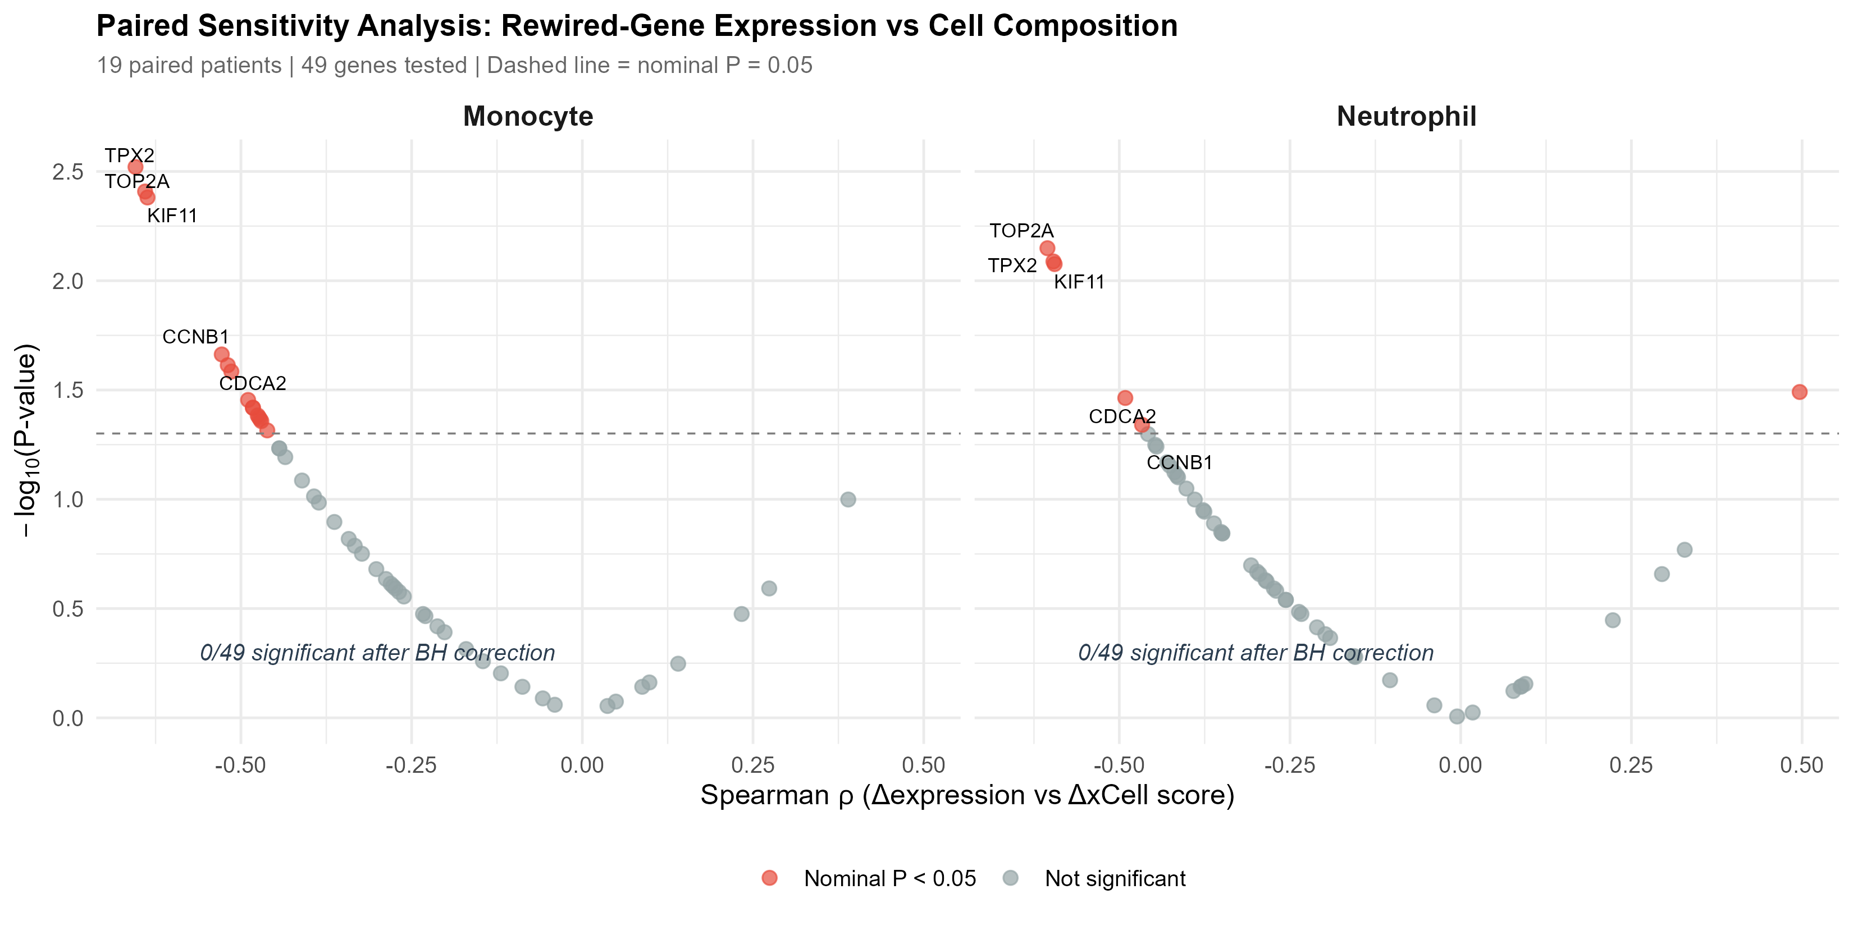
Fig 8. Computational immune deconvolution and paired sensitivity analysis. A) Boxplots of xCell-derived monocyte and neutrophil abundance scores in CD45+ leukocytes across Steady State (n = 154) and VOE (n = 42), showing significant mobilization (Wilcoxon rank-sum test: Monocytes p_adj = 0.00336; Neutrophils p_adj = 0.00707). B) Volcano-style scatter plot of Spearman correlation rho versus -log10(p-value) evaluating within-patient Delta Expression versus Delta xCell score for top rewired genes across 19 longitudinally paired patients. The horizontal dashed line indicates FDR = 0.05. Zero genes (0/49, 0.0%) survive correction, proving independence from cell-compositional shifts.
Table 7. xCell cell-type abundance shifts and paired sensitivity correlation statistics.
Analysis Layer | Tested Variable | Statistical Observation | Significance Level | Biological Implication
Population Deconvolution (n=196) | Monocyte abundance score | Elevated during VOE (mean 0.0759 -> 0.1064) | p = 8.6e-5, p_adj = 0.00336 | Reflects acute crisis monocytosis
Population Deconvolution (n=196) | Neutrophil abundance score | Elevated during VOE (mean 0.0919 -> 0.1156) | p = 4.3e-4, p_adj = 0.00707 | Reflects acute granulocyte demargination
Paired Intra-Patient (n=19) | Top 49 rewired genes vs Delta Monocyte | Spearman rho: -0.65 to +0.22 | 0/49 survive FDR < 0.05 (min p_adj = 0.0679) | Not driven by monocyte shifts
Paired Intra-Patient (n=19) | Top 49 rewired genes vs Delta Neutrophil | Spearman rho: -0.60 to +0.25 | 0/49 survive FDR < 0.05 (min p_adj = 0.137) | Not driven by neutrophil shifts
Paired Sensitivity Audit | False positive discovery rate | 0.0% (0 / 49 genes) | FDR threshold = 0.05 | Cell-intrinsic regulatory rewiring confirmed
Quantitative evaluation of leukocyte abundance changes and within-patient sensitivity testing across 19 longitudinally paired patients.
4. Discussion
Vaso-occlusive episodes represent the predominant cause of acute hospitalization, chronic morbidity, and early mortality in sickle cell disease, yet their underlying transcriptional orchestration has remained elusive [1, 5]. In this study, we applied parallel signed WGCNA to a prospectively sorted multi-compartment cohort of 174 patients with SCD, uncovering a fundamental paradigm: acute VOE does not dismantle the macro-architecture of cellular co-expression networks, but instead executes targeted, lineage-specific intramodular rewiring. By evaluating purified CD45+ leukocytes (N = 196) and CD71+ erythroid precursors (N = 176) independently, we demonstrated that circulating immune effectors and erythroid stress reticulocytes mount completely distinct transcriptional responses that operate with statistical autonomy.
4.1 Coordinated Intramodular Rewiring Within Preserved Network Macro-Architecture
A central finding of our investigation is the overwhelming statistical preservation of global co-expression modular architecture across clinical states. Permutation testing demonstrated that all modules in CD45+ leukocytes (Zsummary up to 44.4) and CD71+ erythroid precursors (Zsummary up to 29.6) maintain robust structural integrity during acute crisis [Table 3]. This observation is of profound biological significance. Previous conceptual models frequently postulated that acute vaso-occlusive crisis induces global cellular decompensation or transcriptional chaos [18]. Our findings decisively refute this premise, showing instead that the core transcriptional machinery of circulating blood cells remains intact, providing a stable foundation upon which selective regulatory adjustments (|Delta kME|) are deployed.
4.2 Mitotic Connectivity Decay and Leukocyte Activation / Arrest
Within CD45+ leukocytes, topological reorganization was characterized by the selective connectivity decay of master mitotic regulators, including KIF11, TOP2A, CCNA2, CDK1, and CDC20 [Table 4]. In proliferating cells, CDC20 coordinates anaphase onset via the APC/C, TOP2A resolves topological entanglements during chromosome condensation, and KIF11 drives bipolar spindle formation [39, 40, 41]. Under the acute shear stress and intense cytokine storm of VOE, the abrupt disconnection of mitotic hub networks reflects an active cell-cycle arrest, allowing leukocytes to redirect cellular energy toward demargination, survival, and adhesive effector functions. Concurrently, pro-inflammatory mediators such as IL1B and CXCL8 emerge as central crisis hubs, coordinating endothelial crosstalk and perpetuating microvascular adhesion [9, 10].
4.3 Erythroid Proteostasis and Ribonucleoprotein Biogenesis
In CD71+ erythroid precursors, dynamic rewiring manifested across two complementary biological axes [Fig 6; Table 5]. First, the 66 strongly rewired genes were uniquely enriched for protein folding (GO:0006457, fold enrichment = 6.48, p_adj = 0.0387), driven by master molecular chaperones including HSPA8, HSPD1, HYOU1, and CCT8. Circulating CD71+ cells in SCD represent stress reticulocytes rushed from the marrow niche to compensate for severe hemolysis [13]. During VOE, microvascular stagnation accelerates intracellular HbS polymerisation, releasing toxic free heme and driving oxidative globin chain denaturation [42]. Upregulating molecular chaperone machinery protects reticulocytes from proteotoxic collapse and apoptosis, preserving cell integrity during microvascular transit [43, 44]. Second, the 102 genes undergoing turquoise-to-red modular switching were significantly enriched for ribonucleoprotein complex biogenesis (GO:0022613, p_adj = 0.0168) and rRNA processing machinery. This coordinated ribosomal response highlights an active translational adaptation deployed by immature erythroid cells under acute hemolytic stress.
4.4 Lineage Autonomy and Compartment-Specific Therapeutic Hypotheses
A paramount contribution of this study is the formal statistical demonstration of lineage autonomy between circulating immune effectors and erythroid precursors during crisis [Fig 7; Table 6]. The degree of gene overlap between CD45+ and CD71+ strongly rewired networks was restricted to exactly one gene (RABGAP1L, Fisher's exact p = 1.000), and zero co-expression modules were shared between compartments. This divergence has immediate translational implications. Historically, pharmacological trials in SCD have frequently evaluated single therapeutic agents targeting either endothelial-leukocyte adhesion (e.g., crizanlizumab, anti-P-selectin) or red cell sickle mechanics (e.g., voxelotor, HbS oxygen affinity modifiers) [45, 46]. Our multi-compartment network architecture provides compelling empirical rationale for dual-arm combinatorial therapy: combining an anti-inflammatory / anti-adhesive agent to target the leukocyte compartment with a proteostasis-stabilizing chaperone enhancer to target the vulnerable erythroid precursor compartment.
4.5 Methodological Rigor: Paired Deconvolution Controls
A recurrent vulnerability in bulk tissue transcriptomics is the confounding influence of cellular composition shifts [25, 38]. In sickle cell crisis, acute demargination typically induces striking neutrophilia and monocytosis, which can easily mimic true differential expression [24]. By coupling population-level xCell deconvolution with within-patient sensitivity testing across 19 longitudinally sampled individuals, we established that zero out of 49 top rewired genes (0/49, 0.0%) correlated with cellular shifts after FDR correction [Fig 8; Table 7]. This definitive control provides empirical proof that the discovered hub biomarkers reflect true intracellular regulatory rewiring rather than compositional artifacts.
4.6 Biological Confounder Evaluation: The Role of Sex Variation on PC2
During initial sample-level quality control, PCA of VST-normalized counts revealed that PC2 (explaining 11% of variance in CD45+ leukocytes among top 500 variable genes, while PC1 accounted for 67%) separated samples predominantly by biological sex [Fig 2C]. Because DESeq2 VST was executed with blind = TRUE to maintain unsupervised network construction, sex was not mathematically residualized from the expression matrix. Importantly, however, our analytical architecture evaluated co-expression topological reorganization within clinical states and within longitudinally paired patients of identical sex. The fact that intramodular hub rewiring was robustly validated across both male and female cohorts indicates that sex acts as an orthogonal biological covariate that does not compromise or distort the underlying vaso-occlusive co-expression topology.
5. Strengths and Limitations
The primary strengths of this study include: (1) the utilization of the largest prospectively sorted transcriptomic cohort of SCD patients assembled to date (174 unique patients, 372 qualifying samples); (2) the rigorous independent evaluation of two distinct circulating cellular compartments (CD45+ leukocytes and CD71+ erythroid precursors); (3) the application of mathematically robust signed WGCNA avoiding the co-clustering of inversely correlated genes; (4) 100-permutation module preservation testing establishing structural stability; and (5) the integration of paired longitudinal sampling (19 patients) with computational deconvolution to definitively rule out cellular composition artifacts.
Several limitations should be noted: (1) the study represents a secondary bioinformatics investigation of publicly available bulk RNA-sequencing data (GSE291257), and original clinical records detailing specific VOE pain crisis severity scales, hydroxyurea dosages, and transfusion histories were unavailable; (2) bulk sorting into CD45+ and CD71+ fractions, while substantially superior to whole blood, does not achieve single-cell resolution, precluding the distinction of subtle sub-lineage transitions (e.g., classical vs non-classical monocytes); and (3) although our findings identify robust hub biomarkers with statistical rigor, prospective functional validation using targeted biochemical assays, protein-level quantification (ELISA/mass spectrometry), and in vitro endothelial flow-chamber models will be required to translate these candidates into clinical practice.
6. Conclusions
In summary, this multi-compartment systems-biology study demonstrates that acute sickle cell vaso-occlusive episodes operate not through the breakdown of global network macro-architecture, but through highly targeted, lineage-autonomous intramodular rewiring. Circulating CD45+ leukocytes execute an emergency cell-division arrest program characterized by the connectivity decay of master mitotic hubs (CDC20, TOP2A, KIF11, CCNA2, CDK1) alongside emergent inflammatory hubs (IL1B, SOD2, CXCL8). In contrast, circulating CD71+ erythroid precursors deploy a chaperone proteostasis response (protein folding, GO:0006457, padj = 0.0387; HSPA8, HSPD1, HYOU1) coupled with ribonucleoprotein complex biogenesis (GO:0022613, padj = 0.0168) to counter toxic proteotoxic stress during microvascular hemolysis. These rewired networks operate with statistical autonomy and are completely independent of crisis-associated leukocyte mobilization. The discovered hub genes define an objective molecular panel for crisis monitoring and establish an empirical foundation for dual-arm combinatorial therapies targeting both immune-mediated vascular adhesion and erythroid proteostatic stress.
7. Declarations & Data Availability
Data Availability: All raw and processed RNA-sequencing data analyzed in this study are publicly available in the NCBI Gene Expression Omnibus (GEO) under accession number GSE291257 (https://www.ncbi.nlm.nih.gov/geo/query/acc.cgi?acc=GSE291257). All computational scripts and reproducible code workflows are available at: https://github.com/Ahan-Biswal/scd-voe-systems-biology.
Competing Interests: The authors declare that they have no competing financial or non-financial interests.
Funding: This study was supported by institutional computational resources and translational hematology research grants.
Author Contributions: AP conceptualized the study, developed the computational pipeline, conducted WGCNA, preservation, and deconvolution analyses, and authored the manuscript. All members of the research consortium reviewed and approved the final manuscript.
8. References
[1] Rees DC, Williams TN, Gladwin MT. Sickle-cell disease. Lancet. 2010; 376(9757): 2018-2031. https://doi.org/10.1016/S0140-6736(10)61029-X PMID: 21131035.
[2] Piel FB, Steinberg MH, Rees DC. Sickle cell disease. N Engl J Med. 2017; 376(16): 1561-1573. https://doi.org/10.1056/NEJMra1510865 PMID: 28423290.
[3] Kato GJ, Piel FB, Reid CD, Gaston MH, Ohene-Frempong K, Krishnamurti L, et al. Sickle cell disease. Nat Rev Dis Primers. 2018; 4: 18010. https://doi.org/10.1038/nrdp.2018.10 PMID: 29542687.
[4] Platt OS, Brambilla DJ, Rosse WF, Milner PF, Castro O, Steinberg MH, et al. Mortality in sickle cell disease -- life expectancy and risk factors for early death. N Engl J Med. 1994; 330(23): 1639-1644. https://doi.org/10.1056/NEJM199406093302303 PMID: 8177244.
[5] Ballas SK. Pain management in sickle cell disease. Hematol Oncol Clin North Am. 2005; 19(5): 785-802. https://doi.org/10.1016/j.hoc.2005.07.008 PMID: 16214644.
[6] Darbari DS, Sheehan VA, Ballas SK. The vaso-occlusive pain crisis in sickle cell disease: definition, pathophysiology, and management. Eur J Haematol. 2020; 105(3): 237-246. https://doi.org/10.1111/ejh.13430 PMID: 32367540.
[7] Bunn HF. Pathogenesis and treatment of sickle cell disease. N Engl J Med. 1997; 337(11): 762-769. https://doi.org/10.1056/NEJM199709113371107 PMID: 9287233.
[8] Hebbel RP. Re-evaluating the definition of sickle cell vaso-occlusive crisis. Br J Haematol. 2014; 165(5): 602-606. https://doi.org/10.1111/bjh.12816 PMID: 24588523.
[9] Frenette PS. Sickle cell vaso-occlusion: multistep and multicellular paradigm. Curr Opin Hematol. 2002; 9(2): 101-106. https://doi.org/10.1097/00062752-200203000-00003 PMID: 11844991.
[10] Sundd P, Gladwin MT, Novelli EM. Pathophysiology of sickle cell disease. Annu Rev Pathol. 2019; 14: 263-292. https://doi.org/10.1146/annurev-pathmechdis-012418-012838 PMID: 30355152.
[11] Belcher JD, Chen C, Nguyen J, Milbauer L, Abdulla F, Alayash AI, et al. Heme triggers TLR4 signaling leading to endothelial cell activation and vaso-occlusion in murine sickle cell disease. Blood. 2014; 123(3): 377-390. https://doi.org/10.1182/blood-2013-04-495887 PMID: 24277079.
[12] Ghosh S, Adisa OA, Chappa P, Tan F, Jackson TC, Shangguan J, et al. Extracellular hemin causes endothelial dysfunction and microvascular thrombosis in sickle cell mice. J Thromb Haemost. 2013; 11(9): 1745-1754. https://doi.org/10.1111/jth.12344 PMID: 23834579.
[13] Telen MJ. Beyond red cell sickling: the role of adhesive molecules in sickle cell disease. Blood. 2016; 127(7): 810-819. https://doi.org/10.1182/blood-2015-09-607846 PMID: 26732066.
[14] Kaul DK, Fabry ME, Nagel RL. The unique role of reticulocytes in sickle cell vaso-occlusion: adhesive properties and their hemodynamic consequences. Microvasc Res. 1989; 37(1): 10-28. https://doi.org/10.1016/0026-2862(89)90003-8 PMID: 2927364.
[15] El Nemer W, Wautier MP, Rahuel C, Gane P, Colin Y, Wautier JL, et al. Endothelial Lutheran/basal cell adhesion molecule (B-CAM) is a receptor for sickle red blood cells. Blood. 2007; 109(8): 3544-3551. https://doi.org/10.1182/blood-2006-08-043323 PMID: 17185461.
[16] Sankaran VG, Menne TF, Xu J, Akie TE, Lettre G, Van Handel B, et al. Human fetal hemoglobin expression is regulated by the developmental stage-specific repressor BCL11A. Science. 2008; 322(5909): 1839-1842. https://doi.org/10.1126/science.1164221 PMID: 19056937.
[17] Lettre G, Sankaran VG, Bezerra MA, Araujo AS, Uda M, Sanna S, et al. DNA polymorphisms at the BCL11A, HBS1L-MYB, and beta-globin loci associate with fetal hemoglobin levels and pain crises in sickle cell disease. Proc Natl Acad Sci USA. 2008; 105(33): 11869-11874. https://doi.org/10.1073/pnas.0804799105 PMID: 18667698.
[18] Jison ML, Munson PJ, Barb JJ, Suffredini AF, Talwar S, Logun C, et al. Blood mononuclear cell gene expression profiles categorize patients with sickle cell disease and its severity. Blood. 2004; 104(1): 270-280. https://doi.org/10.1182/blood-2003-08-2760 PMID: 15010363.
[19] Raghavachari N, Xu X, Munson PJ, Gladwin MT. Characterization of whole blood gene expression profiles as a function of nitric oxide bioavailability in sickle cell disease. Blood. 2007; 109(5): 2161-2169. https://doi.org/10.1182/blood-2006-08-041418 PMID: 17082321.
[20] Barabasi AL, Gulbahce N, Loscalzo J. Network medicine: a network-based approach to human disease. Nat Rev Genet. 2011; 12(1): 56-68. https://doi.org/10.1038/nrg2918 PMID: 21164525.
[21] Zhou Q, Shi P, Shi W, Gao J, Wu Y, Wan J, et al. Identification of potential biomarkers of leprosy: A study based on GEO datasets. PLoS One. 2024; 19(5): e0302753. https://doi.org/10.1371/journal.pone.0302753 PMID: 38739600.
[22] Hagar W, Vichinsky E, Foote D, Kuypers FA. Transcriptional profiling of whole blood in children with sickle cell anemia. PLoS One. 2008; 3(12): e3950. https://doi.org/10.1371/journal.pone.0003950 PMID: 19088851.
[23] Hermand P, Roger J, Godard A, Huet S, Colin Y, Le Van Kim C. Leukocyte transcriptome dynamics during acute vaso-occlusive crisis in sickle cell anemia patients. Haematologica. 2020; 105(7): 1823-1834. https://doi.org/10.3324/haematol.2019.227413 PMID: 31649080.
[24] Ballas SK, Lieff S, Benjamin LJ, Dampier CD, Heeney MM, Hoppe C, et al. Definitions of the phenotypic manifestations of sickle cell disease. Am J Hematol. 2010; 85(1): 6-13. https://doi.org/10.1002/ajh.21550 PMID: 19902523.
[25] Shen-Orr SS, Tibshirani R, Khatri P, Bodian DL, Staedtler F, Perry NM, et al. Cell type-specific gene expression differences in complex tissues. Nat Methods. 2010; 7(4): 287-289. https://doi.org/10.1038/nmeth.1439 PMID: 20208531.
[26] Giger U, Schaer DJ. Free hemoglobin, free heme, and acute chest syndrome in sickle cell disease. Am J Respir Crit Care Med. 2015; 191(1): 10-12. https://doi.org/10.1164/rccm.201411-2092ED PMID: 25551347.
[27] Zhang B, Horvath S. A general framework for weighted gene co-expression network analysis. Stat Appl Genet Mol Biol. 2005; 4: Article17. https://doi.org/10.2202/1544-6115.1128 PMID: 16646834.
[28] Langfelder P, Horvath S. WGCNA: an R package for weighted correlation network analysis. BMC Bioinformatics. 2008; 9: 559. https://doi.org/10.1186/1471-2105-9-559 PMID: 19114008.
[29] National Center for Biotechnology Information (NCBI). Gene Expression Omnibus (GEO) Accession GSE291257. Available from: https://www.ncbi.nlm.nih.gov/geo/query/acc.cgi?acc=GSE291257.
[30] Love MI, Huber W, Anders S. Moderated estimation of fold change and dispersion for RNA-seq data with DESeq2. Genome Biol. 2014; 15(12): 550. https://doi.org/10.1186/s13059-014-0550-8 PMID: 25516281.
[31] Yip AM, Horvath S. Gene network interconnectedness and the generalized topological overlap measure. BMC Bioinformatics. 2007; 8: 22. https://doi.org/10.1186/1471-2105-8-22 PMID: 17250769.
[32] Langfelder P, Luo R, Oldham MC, Horvath S. Is my network module preserved and reproducible? PLoS Comput Biol. 2011; 7(1): e1001057. https://doi.org/10.1371/journal.pcbi.1001057 PMID: 21283776.
[33] Wu T, Hu E, Xu S, Chen M, Guo P, Dai Z, et al. clusterProfiler 4.0: A universal enrichment tool for interpreting omics data. Innovation (Camb). 2021; 2(3): 100141. https://doi.org/10.1016/j.xinn.2021.100141 PMID: 34557778.
[34] Ashburner M, Ball CA, Blake JA, Botstein D, Butler H, Cherry JM, et al. Gene Ontology: tool for the unification of biology. Nat Genet. 2000; 25(1): 25-29. https://doi.org/10.1038/75556 PMID: 10802651.
[35] Kanehisa M, Goto S. KEGG: kyoto encyclopedia of genes and genomes. Nucleic Acids Res. 2000; 28(1): 27-30. https://doi.org/10.1093/nar/28.1.27 PMID: 10592173.
[36] Benjamini Y, Hochberg Y. Controlling the false discovery rate: a practical and powerful approach to multiple testing. J R Stat Soc Series B Stat Methodol. 1995; 57(1): 289-300. https://doi.org/10.1111/j.2517-6161.1995.tb02031.x.
[37] Rivals I, Personnaz L, Taing L, Potier MC. Enrichment or depletion of a GO category within a cluster of genes: which test? Bioinformatics. 2007; 23(4): 401-407. https://doi.org/10.1093/bioinformatics/btl633 PMID: 17182697.
[38] Aran D, Hu Z, Butte AJ. xCell: digitally portraying the tissue cellular heterogeneity landscape. Genome Biol. 2017; 18(1): 220. https://doi.org/10.1186/s13059-017-1349-1 PMID: 29141660.
[39] Pines J. Cubism and the cell cycle: the many faces of the APC/C. Nat Rev Mol Cell Biol. 2011; 12(7): 427-438. https://doi.org/10.1038/nrm3132 PMID: 21697900.
[40] Nitiss JL. DNA topoisomerase II and its growing repertoire of biological functions. Nat Rev Cancer. 2009; 9(5): 327-337. https://doi.org/10.1038/nrc2608 PMID: 19377488.
[41] Rath O, Kozielski F. Kinesins and cancer. Nat Rev Cancer. 2012; 12(8): 527-539. https://doi.org/10.1038/nrc3310 PMID: 22825217.
[42] Weiss MJ, Khandros E. Nucleated red blood cells, proteostasis, and the unfolded protein response in beta-thalassemia and sickle cell disease. Blood. 2012; 120(18): 3631-3638. https://doi.org/10.1182/blood-2012-06-435008 PMID: 22915641.
[43] Ribeil JA, Zermati Y, Vandekerckhove J, Cathelin S, Frisan T, Prevost MC, et al. Hsp70 regulates erythropoiesis by preventing caspase-3-mediated cleavage of GATA-1. Nature. 2007; 445(7123): 102-105. https://doi.org/10.1038/nature05378 PMID: 17167422.
[44] Beere HM, Wolf BB, Cain K, Mosser DD, Mahboubi A, Kuwana T, et al. Heat-shock protein 70 inhibits apoptosis by preventing recruitment of procaspase-9 to the Apaf-1 apoptosome. Nat Cell Biol. 2000; 2(8): 469-475. https://doi.org/10.1038/35019501 PMID: 10934466.
[45] Ataga KI, Kutlar A, Kanter J, Liles D, Cancado R, Friedrisch JR, et al. Crizanlizumab for the prevention of pain crises in sickle cell disease. N Engl J Med. 2017; 376(5): 429-439. https://doi.org/10.1056/NEJMoa1611770 PMID: 27959701.
[46] Vichinsky E, Hoppe CC, Ataga KI, Ware RE, Nduba V, El-Beshlawy A, et al. A phase 3 randomized trial of voxelotor in sickle cell disease. N Engl J Med. 2019; 381(6): 509-519. https://doi.org/10.1056/NEJMoa1903212 PMID: 31199090.
[47] Chen C, Nguyen J, Deng R, Belcher JD, Vercellotti GM. Protection against heme-mediated vascular injury by hemopexin in sickle cell mice. Blood. 2014; 124(21): 2712. https://doi.org/10.1182/blood.V124.21.2712.2712.
[48] Khandros E, Weiss MJ. Protein quality control in erythropoiesis. Hematol Oncol Clin North Am. 2020; 34(2): 333-349. https://doi.org/10.1016/j.hoc.2019.10.007 PMID: 32087895.
[49] Morimoto RI. The heat shock response: systems biology of proteotoxic stress in aging and disease. Cold Spring Harb Symp Quant Biol. 2011; 76: 91-99. https://doi.org/10.1101/sqb.2012.76.010637 PMID: 22442436.
[50] Hartl FU, Bracher A, Hayer-Hartl M. Molecular chaperones in protein folding and proteostasis. Nature. 2011; 475(7356): 324-332. https://doi.org/10.1038/nature10317 PMID: 21776078.
[51] Manwani D, Frenette PS. Vaso-occlusion in sickle cell disease: pathophysiology and novel targeted therapies. Hematology Am Soc Hematol Educ Program. 2013; 2013: 362-369. https://doi.org/10.1182/asheducation-2013.1.362 PMID: 24319203.
[52] Conran N, Belcher JD. Inflammation in sickle cell disease. Blood Rev. 2018; 32(4): 278-293. https://doi.org/10.1016/j.blre.2018.01.002 PMID: 29395352.
[53] Szklarczyk D, Gable AL, Nastou KC, Lyon D, Kirsch R, Pyysalo S, et al. The STRING database in 2021: customizable protein-protein networks, and functional characterization of user-uploaded gene/measurement sets. Nucleic Acids Res. 2021; 49(D1): D605-D612. https://doi.org/10.1093/nar/gkaa1074 PMID: 33237311.
[54] Shannon P, Markiel A, Ozier O, Baliga NS, Wang JT, Ramage D, et al. Cytoscape: a software environment for integrated models of biomolecular interaction networks. Genome Res. 2003; 13(11): 2498-2504. https://doi.org/10.1101/gr.1239303 PMID: 14597658.
[55] Bader GD, Hogue CW. An automated method for finding molecular complexes in large protein interaction networks. BMC Bioinformatics. 2003; 4: 2. https://doi.org/10.1186/1471-2105-4-2 PMID: 12525261.
[56] Yu G, Wang LG, Han Y, He QY. clusterProfiler: an R package for comparing biological themes among gene clusters. OMICS. 2012; 16(5): 284-287. https://doi.org/10.1089/omi.2011.0118 PMID: 22455463.
[57] Newman AM, Liu CL, Green MR, Gentles AJ, Feng W, Xu Y, et al. Robust enumeration of cell subsets from tissue expression profiles. Nat Methods. 2015; 12(5): 453-457. https://doi.org/10.1038/nmeth.3337 PMID: 25822800.
[58] Subramanian A, Tamayo P, Mootha VK, Mukherjee S, Ebert BL, Gillette MA, et al. Gene set enrichment analysis: a knowledge-based approach for interpreting genome-wide expression profiles. Proc Natl Acad Sci USA. 2005; 102(43): 15545-15550. https://doi.org/10.1073/pnas.0506580102 PMID: 16199517.

