Gene Co-Expression Network Reorganization Across Steady State and Vaso-Occlusive Episodes in Sickle Cell Disease
Purohit et al 2026
Abstract
Background: Sickle cell disease (SCD) results from pathogenic β-globin variation producing hemoglobin S, yet clinical severity and vaso-occlusive episode (VOE) frequency vary considerably among affected individuals. Beyond established genetic modifiers, state-dependent reorganization of gene co-expression networks may provide additional insight into crisis biology.
Methods: RNA-sequencing data from 174 patients with SCD (GSE291257) were analyzed separately for sorted CD45+ leukocytes (N = 196) and CD71+ erythroid precursors (N = 178). Fully signed Weighted Gene Co-expression Network Analysis (WGCNA) reference networks were established from steady-state cohorts (N = 154 CD45+, N = 137 CD71+). Module preservation in acute VOE (N = 42 CD45+, N = 41 CD71+) was evaluated using 100-iteration permutation testing (Zsummary). Intramodular network rewiring was quantified via aligned module membership shifts (Delta-kME) derived from projected eigengenes. Functional enrichment was assessed against lineage-specific expressed backgrounds, alongside cross-lineage convergence testing and xCell-based immune deconvolution.
Results: In CD45+ leukocytes, all four steady-state biological modules showed strong statistical preservation in crisis (Zsummary = 23.6-44.4), yet fine-grained rewiring affected 239 genes (|Delta-kME| > 0.40), featuring 53 decaying hubs (including cell-division effectors KIF11, CCNA2, TOP2A, CDK1, and TPX2) and 5 emergent inflammatory hubs, led by IL1B. In CD71+ erythroid precursors, nine biological modules were detected with moderate-to-high preservation (Zsummary = 6.8-29.6). Intramodular rewiring targeted 66 genes, which exhibited striking functional enrichment for chaperone-mediated protein folding (padj = 0.0387, fold enrichment = 6.48; HSPA8, HSPD1, HYOU1). Cross-lineage comparison revealed lineage-autonomous responses with no significant overlap (OR = 0.922, p = 1.0). Across 19 paired longitudinal patients, crisis-associated changes in monocyte and neutrophil proportions were not significantly associated with tested rewired-gene activity (padj >= 0.0679).
Conclusions: Acute VOE induces targeted intramodular rewiring within structurally preserved co-expression networks across leukocyte and erythroid compartments. Rather than non-specific global network dissolution or broad cross-lineage convergence, acute crisis triggers lineage-autonomous molecular programs: CD45+ leukocytes decouple mitotic coordination while assembling emergent inflammatory hubs (IL1B), whereas CD71+ erythroid precursors activate a robust chaperone-mediated proteotoxic stress response. These findings establish network rewiring as a sensitive, lineage-specific dimension of SCD crisis biology.
Keywords: Sickle cell disease; vaso-occlusive episode; WGCNA; gene co-expression network; network rewiring; module switching; module membership; CD45+ leukocytes; CD71+ erythroid precursors; systems biology.

1. Introduction
Sickle cell disease (SCD) is an inherited hemoglobinopathy caused by pathogenic variation in the HBB gene that results in production of hemoglobin S (HbS). The classical HbS allele results from substitution of valine for glutamic acid at position six of the β-globin chain (p.Glu6Val). Despite its well-defined molecular origin, SCD exhibits substantial biological and clinical heterogeneity, with affected individuals experiencing markedly different frequencies and severities of vaso-occlusive episodes (VOEs), chronic organ complications, and other disease manifestations. This genotype–phenotype complexity indicates that the primary HbS-producing lesion alone does not fully account for variability in disease expression. This discordance between a well-defined primary genetic lesion and substantial clinical heterogeneity represents an important unresolved problem in SCD biology and provides the biological rationale for investigating state-dependent
The pathophysiological consequences of HbS extend considerably beyond the abnormal morphology of sickled erythrocytes. Under conditions that favor HbS polymerization, erythrocyte deformability is impaired, contributing to disturbances in the microcirculation and vaso-occlusion. Acute VOE therefore represents a dynamic disease state in which erythroid dysfunction interacts with inflammatory and vascular processes. From a systems perspective, this suggests that the transition from clinical stability to crisis may involve coordinated molecular responses across several cellular compartments rather than isolated changes within a single lineage. The availability of independently sorted CD45+ leukocyte and CD71+ erythroid precursor populations in the dataset analyzed here provides an opportunity to investigate such state-associated molecular organization separately in immune and erythroid compartments. The source dataset comprises 174 patients with SCD and includes steady-state and acute-VOE sampling used to construct the four networks evaluated in the study.
Although the primary HBB mutation establishes the molecular basis of SCD, it does not independently determine the severity of the clinical phenotype. Considerable research has therefore focused on genetic modifiers capable of altering disease expression. One of the best-established examples is BCL11A, a developmental regulator of the fetal-to-adult hemoglobin switch. Genetic variation affecting BCL11A can influence fetal hemoglobin (HbF) concentrations, which in turn modifies clinical manifestations of SCD. The draft cites the foundational work demonstrating the role of BCL11A in HbF regulation and genetic association studies connecting variants at BCL11A, HBS1L-MYB, and β-globin loci with HbF levels and pain crises.
These discoveries established that the SCD phenotype is influenced by biological factors beyond the causal β-globin mutation. Nevertheless, known genetic modifiers account for only part of the substantial inter-individual variation in disease severity. Moreover, fixed genetic variation alone cannot fully describe the dynamic molecular changes accompanying an individual's transition from a relatively stable clinical state to an acute VOE. Understanding crisis biology therefore requires consideration not only of which genetic variants a patient carries, but also of how molecular systems respond and reorganize as clinical state changes.
Transcriptomic studies commonly investigate disease biology through differential expression analysis, identifying individual genes whose average expression differs between biological conditions. This approach is highly valuable for discovering genes activated or suppressed during disease; however, it primarily treats genes as individual analytical units. Biological functions, in contrast, arise through coordinated interactions among groups of genes participating in shared pathways, cellular programs, regulatory processes, and molecular complexes.
Consequently, two clinical states could theoretically differ in their underlying transcriptional organization even when individual genes do not exhibit sufficiently large expression changes to dominate a conventional differential-expression analysis. Genes may remain expressed at broadly comparable levels while changing the partners with which they are co-regulated, the functional module to which they belong, or the strength of their relationship to that module. The central question posed in the present study is therefore explicitly structural: does the organization of the gene co-expression network change when patients with SCD transition from steady state to an acute VOE?
This distinction is particularly relevant because PCA of the source data did not demonstrate clean separation of steady-state and VOE samples along the major components of global expression variation. In CD71+ cells, neither sex nor sequencing-library batch showed comparably strong separation in the PCA. These variables were therefore evaluated as potential confounders when interpreting the network results. These observations strengthen the rationale for examining higher-order co-expression architecture rather than relying exclusively on global expression-level separation.
Weighted Gene Co-expression Network Analysis (WGCNA) provides a framework for examining transcriptomic data at the network level. Rather than evaluating each gene independently, WGCNA identifies groups of genes with correlated expression profiles across samples and organizes them into co-expression modules.

SCD represents an especially interesting application of this principle. Although its initiating mutation is well defined, the downstream disease phenotype reflects multiple biological processes and exhibits substantial variability between patients and clinical states. A network-based approach therefore permits a different question from conventional gene-centered analyses: rather than asking only which transcripts increase or decrease during crisis, it asks whether the relationships among transcripts themselves are reorganized.

An additional strength of the present study is the independent evaluation of two biologically distinct cellular populations. CD45+ cells represent the leukocyte/immune compartment and comprise a heterogeneous mixture of immune cell subtypes, including monocytes, neutrophils, T cells, B cells, and other leukocyte populations. In contrast, CD71+ cells represent immature erythroid precursors expressing the transferrin receptor.
Analyzing these compartments separately allows the study to determine whether network reorganization is predominantly restricted to one cellular lineage or occurs across both immune and erythroid systems. This distinction is important because lineage-specific rewiring would suggest specialized cellular responses to VOE, whereas overlapping network changes could indicate broader systemic transcriptional reorganization.
This question is specifically addressed through cross-lineage comparative analysis: by testing whether genes undergoing high-magnitude intramodular connectivity shifts in CD45+ leukocytes overlap with those rewired in CD71+ erythroid precursors, we formally evaluate whether acute crisis elicits shared systemic network convergence or distinct, lineage-autonomous cellular adaptations.
The heterogeneous composition of the CD45+ population introduces an important analytical concern. Acute VOE is accompanied by inflammatory changes, and the relative abundance of individual leukocyte populations may differ between steady state and crisis. Consequently, apparent changes in bulk CD45+ co-expression structure could theoretically arise simply because the mixture of immune cell types has changed.
The study therefore incorporates a specific technical control using xCell, a computational method for estimating cellular composition from transcriptomic profiles. The methodological basis for xCell is included among the source references. The draft reports increased xCell-derived monocyte and neutrophil abundance scores during VOE; however, among 19 paired patients, changes in these scores were not significantly associated with tested rewired-gene expression changes after multiple-testing correction.
This analysis does not completely eliminate composition as a potential influence—particularly given the limited paired sample size—but it provides an important control supporting the interpretation that the observed CD45+ network signal cannot be attributed solely to altered leukocyte proportions.
Despite extensive investigation of the molecular and genetic determinants of SCD severity, an important question remains insufficiently addressed: whether the architecture of gene co-expression itself systematically reorganizes when an individual transitions from steady-state disease to an acute vaso-occlusive episode.
This question differs conceptually from identifying differentially expressed genes. It focuses instead on whether genes alter their network relationships, module assignments and connectivity during acute disease. Furthermore, evaluating CD45+ and CD71+ populations independently makes it possible to distinguish lineage-specific network responses from molecular changes shared across immune and erythroid compartments.
The present study was designed to address this gap through state-specific WGCNA network construction and direct comparison of network architecture between steady state and VOE.

Specifically, the study aimed to: (i) construct robust signed WGCNA reference networks from steady-state cohorts; (ii) assess statistical module preservation during acute VOE using permutation testing; (iii) quantify intramodular rewiring using aligned module membership shifts (Delta-kME); (iv) characterize biological pathways rewired in crisis against expressed background universes; (v) test whether network reorganization reflects cross-lineage convergence or lineage-autonomous programs; and (vi) evaluate whether leukocyte network reorganization could be explained by changes in cellular composition.
2. Materials and Methods
2.1 Study Design and Dataset
This study employed a retrospective transcriptomic systems-biology approach to investigate whether gene co-expression architecture differs between the steady clinical state and acute vaso-occlusive episode (VOE) in sickle cell disease (SCD). Publicly available RNA-sequencing data were obtained from the Gene Expression Omnibus (GEO) under accession GSE291257. The source cohort comprised 174 patients with SCD. Following restriction to qualified clinical states, the analytical cohorts comprised 196 CD45+ leukocyte samples (154 steady-state, 42 acute VOE) and 178 CD71+ erythroid precursor samples (137 steady-state, 41 acute VOE). Steady-state samples were utilized to establish definitive baseline reference co-expression networks, while the acute VOE cohorts served as the test sets to evaluate module preservation, eigengene projection, and intramodular connectivity reorganization.
Blood-derived samples were separated into two cellular compartments: CD45+ leukocytes, representing the immune compartment, and CD71+ erythroid precursors, representing immature erythroid-lineage cells. CD45+ samples included heterogeneous leukocyte populations such as monocytes, neutrophils, T cells, B cells, and other immune subtypes, whereas CD71 positivity identified transferrin-receptor-expressing immature erythroid cells.

Reference gene co-expression networks were established for CD45+ leukocytes and CD71+ erythroid precursors in the steady state, and the preservation and reorganization of these networks were subsequently evaluated against the acute VOE state within each cellular compartment.
2.2 Computational Environment
All analyses were conducted using R version 4.5.2 (2025-10-31 ucrt; 64-bit Windows). Weighted gene co-expression analysis was performed using WGCNA version 1.74.
RNA-seq normalization was performed using DESeq2 version 1.50.2. Functional enrichment analyses were conducted using clusterProfiler version 4.18.4, together with org.Hs.eg.db version 3.22.0 and enrichplot. Cell-type deconvolution was performed using xCell version 1.1.0, implemented through immunedeconv version 2.1.4.
2.3 Gene Expression Filtering
Before normalization and network construction, low-expression genes were removed using a predefined count-based filtering criterion. A gene was retained only when it exhibited a raw read count of ≥10 in at least 20% of samples within the corresponding cellular compartment.
For CD45+ leukocytes, 196 samples were available after clinical-state restriction. Twenty percent corresponded to 39.2 samples and was rounded upward to 40; consequently, a gene was retained when it had ≥10 counts in at least 40 CD45+ samples. Of 58,037 initial Ensembl gene identifiers, 17,213 genes satisfied this criterion, whereas 40,824 low-count genes were excluded.
For CD71+ erythroid precursors, 178 qualifying samples were available. Twenty percent corresponded to 35.6 samples and was rounded upward to 36. Therefore, genes were required to have ≥10 counts in at least 36 samples. This procedure retained 10,352 genes from the original 58,037 Ensembl identifiers and excluded 47,685 low-count genes.
No additional low-variance filtering based on median absolute deviation, interquartile range, or percentile thresholds was applied. Instead, WGCNA's goodSamplesGenes() data-integrity procedure was used to identify genes with zero variance or excessive missing values. All 17,213 CD45+ genes and all 10,352 CD71+ genes passed this assessment (gsg$allOK = TRUE) and were retained for downstream analysis.
2.4 RNA-Sequencing Normalization
RNA-sequencing counts were normalized using the Variance Stabilizing Transformation (VST) implemented in DESeq2. VST was performed with blind = TRUE. The analysis workflow first generated a DESeqDataSet from the filtered count matrix and associated metadata, followed by DESeq2 processing and extraction of the VST-transformed expression matrix.
DESeq2 first accounts for differences in sequencing depth through median-of-ratios size-factor estimation. A reference pseudo-sample is derived from the geometric mean of gene counts across samples, and sample-specific size factors are calculated from the median ratios between observed counts and this reference. Raw counts are then scaled by the corresponding size factors. …
DESeq2 subsequently models the mean–dispersion relationship and applies a variance-stabilizing transformation so that variance becomes less dependent on mean expression, particularly for low-abundance transcripts. The pipeline summary represents the fitted dispersion relationship as
$$α\left(μ\right)=α_{0}+\frac{α_{1}}{μ},$$where ( $μ$) represents mean expression and ($α_{0}$) and \($α_{1}$) are parameters estimated from the data.
Filtered count data were processed using DESeq2 v1.50.2. A DESeqDataSet was constructed with the available metadata, followed by DESeq2 processing and variance-stabilizing transformation using vst(..., blind = TRUE). Because blind = TRUE does not use the experimental design when estimating the transformation trend, the resulting VST matrix should not be interpreted as a sex- or status-residualized expression matrix.

2.5 Sample-Level Quality Control and Assessment of Potential Confounders
Sample-level quality control was conducted separately for CD45+ and CD71+ datasets. Hierarchical clustering was used to identify potential sample outliers, while principal component analysis (PCA) was used to evaluate whether major expression variation was associated with clinical state, patient sex, sequencing-library batch, or individual patient identity.

2.6 WGCNA Network Construction
Independent weighted gene co-expression networks were constructed for CD45+ Steady State, CD45+ VOE, CD71+ Steady State, and CD71+ VOE using WGCNA version 1.74.
Pairwise gene associations were calculated using Pearson correlation (corType = "pearson"). Gene-to-module connectivity or module membership (kME) was likewise evaluated by Pearson correlation using the WGCNA signedKME() procedure. …
Networks were constructed using a fully signed framework (networkType = "signed"). Pairwise gene connection strength was defined by transforming Pearson correlation coefficients to preserve sign: aij = ((1 + cor(xi, xj)) / 2)^beta, where aij denotes the adjacency between genes xi and xj, and beta represents the soft-thresholding power. Signed Topological Overlap Matrices (TOMType = "signed") were subsequently derived, ensuring that gene clustering reflects purely positive co-expression rather than grouping strongly anti-correlated genes into identical modules.
$$a_{ij}={\left|cor\left(x_{i},x_{j}\right)\right|}^{β},$$
where ($a_{ij}$) denotes adjacency between genes ($x_{i}$) and $x_{j}$), and $(β$) represents the soft-thresholding power.

2.7 Selection of Soft-Thresholding Power
Candidate soft-thresholding powers were evaluated across steady-state reference cohorts to achieve approximate scale-free topology (R^2 >= 0.80) while maintaining robust connectivity. For CD45+ leukocytes (N = 154), a power of beta = 6 yielded a scale-free topology fit index of R^2 = 0.88 with a mean network connectivity of 86.8. For CD71+ erythroid precursors (N = 137), a power of beta = 16 achieved an R^2 = 0.81 with a mean connectivity of 27.6. These cell-type-specific powers were applied to construct the signed reference networks.
The final parameters were:
Network | β | Scale-free topology R² | Mean connectivity
CD45+ Steady State | 6 | 0.88 | 86.8
CD45+ VOE | 6 (proj) | Test cohort (N=42) | Projected
CD71+ Steady State | 16 | 0.81 | 27.6
CD71+ VOE | 16 (proj) | Test cohort (N=41) | Projected

2.8 Dynamic Module Detection and Module Merging
Co-expression modules were identified using WGCNA's module-detection framework. The minimum module size was set to 30 genes. Gene clusters containing fewer than 30 genes were therefore not retained as independent modules and could be incorporated into the unassigned grey category.
Dynamic tree cutting was performed on the topological overlap dendrograms using standard moderate sensitivity (deepSplit = 2) and minModuleSize = 30. Module eigengenes (MEs) were calculated, and closely related modules were merged at mergeCutHeight = 0.25 (corresponding to eigengene correlation r >= 0.75). Genes unassigned to any co-expression module were assigned to the grey module.
2.9 Module Eigengenes and Module Membership
For each detected module, the module eigengene represented the dominant expression pattern of genes belonging to that module. Individual gene membership was quantified using module eigengene-based connectivity (kME).
Module membership was quantified using signed eigengene-based connectivity (kME). To evaluate connectivity shifts during VOE without confounding from unaligned de novo module identification, steady-state module eigengenes were projected onto the VOE expression matrix. Intramodular connectivity was calculated within both states as kME_SS = cor(xi, ME_SS) and kME_VOE = cor(xi, ME_VOE_projected), enabling direct, signed comparisons of connectivity across clinical states.
2.10 Permutation-Based Module Preservation Analysis
WGCNA module colours are assigned independently during separate network analyses and therefore cannot be assumed to represent equivalent gene populations between steady-state and VOE networks.
Statistical preservation of steady-state network modules in the acute VOE state was formally evaluated using the WGCNA modulePreservation() framework (Langfelder et al., 2011). With the steady-state network designated as the reference and the VOE cohort as the test set, 100 permutations were executed to compute permutation-based preservation statistics. Module stability was evaluated using the composite Zsummary statistic, which combines density and connectivity preservation metrics. In accordance with established benchmarks, modules with Zsummary > 10 were classified as strongly preserved, 2 <= Zsummary <= 10 as moderately preserved, and Zsummary < 2 as unpreserved.
2.11 Identification of Intramodular Rewiring and Hub Dynamics
Intramodular network reorganization during crisis was quantified by computing signed connectivity shifts: Delta-kME = kME_VOE - kME_SS. Genes exhibiting high-magnitude reorganization were defined as strongly rewired when |Delta-kME| > 0.40. To characterize hub dynamics, steady-state module hubs (kME_SS >= 0.70) that lost connectivity in crisis (kME_VOE < 0.40) were designated "decaying hubs". Conversely, genes with weak baseline connectivity (kME_SS < 0.40) that acquired high coordination during crisis (kME_VOE >= 0.70) were designated "emergent hubs".
A gene was designated “switched” when its VOE module differed from the expected counterpart of its steady-state module. A gene was designated “stayed” when it remained within the expected corresponding module. Genes assigned to the grey category in either state were classified as “grey-excluded” and were excluded from switched-versus-stayed calculations because grey represents lack of defined module assignment rather than a genuine co-expression module.

2.12 CD71+ Functional Enrichment Analysis
Gene Ontology (GO) Biological Process enrichment was performed for strongly rewired genes (|Delta-kME| > 0.40) using clusterProfiler version 4.18.4 and org.Hs.eg.db version 3.22.0. To prevent false-positive inflation caused by lineage-specific expression bias, all enrichment analyses were strictly constrained against the cell-type-specific expressed background universes (14,168 mapped Entrez genes for CD45+; 9,756 for CD71+). Statistical significance was defined at Benjamini-Hochberg adjusted P < 0.05 and q < 0.05. In CD71+ erythroid precursors, the leading enriched biological process was chaperone-mediated protein folding (GO:0006457; nominal P = 4.29 x 10^-4, adjusted P = 0.0387, fold enrichment = 6.48), driven by prominent molecular chaperones including HSPA8, HSPD1, and HYOU1.

2.13 Cross-Cell-Type Convergence Analysis
To identify transcriptional network changes shared across immune and erythroid compartments, genes classified as switched in CD45+ cells were cross-referenced against genes classified as switched in CD71+ cells.
To determine whether network reorganization in acute crisis represents a convergent systemic response or distinct lineage-autonomous processes, the strongly rewired gene sets (|Delta-kME| > 0.40) from CD45+ leukocytes and CD71+ erythroid precursors were intersected across the 9,566 genes commonly expressed in both compartments. Statistical significance of cross-lineage overlap was evaluated using a two-sided Fisher's exact test. Exactly one gene (RABGAP1L) was rewired in both compartments, demonstrating that crisis-induced network remodeling is predominantly lineage-autonomous (OR = 0.922, p = 1.0).
2.14 xCell Immune-Cell Deconvolution
Because CD45+ samples contain multiple leukocyte subtypes, a dedicated sensitivity analysis was performed to determine whether observed network reorganization could be explained by crisis-associated changes in cellular composition.
Cellular deconvolution was performed using xCell version 1.1.0The analysis used a VST-normalized, gene-symbol-mapped CD45+ expression matrix containing 14,028 mapped genes across 196 leukocyte samples. Differences in estimated cell fractions between steady state and VOE were evaluated using a two-sided Wilcoxon rank-sum test, followed by Benjamini–Hochberg FDR correction. Monocyte abundance increased significantly during VOE (adjusted P = 0.00336), as did neutrophil abundance (adjusted P = 0.00707).
2.15 Paired Cell-Composition Sensitivity Analysis
A more stringent sensitivity analysis was performed in the subset of 19 patients with longitudinal samples available in both steady state and VOE.
For each patient, two state-dependent differences were calculated:
$$ΔExpression=Expression_{VOE}-Expression_{Steady}$$
And
$$ΔCell Fraction=Fraction_{VOE}-Fraction_{Steady}.$$
Spearman's rank correlation was then calculated across the 19 paired patients between gene-expression change and the corresponding monocyte or neutrophil fraction change. The analysis was applied to the top 50 rewired genes
2.16 Multiple-Testing Correction

In the 19-patient paired sensitivity analysis, none of the 49 tested genes remained significantly associated with changes in monocyte or neutrophil abundance after BH correction. The minimum adjusted P values were 0.0679 for monocyte correlations and 0.1371 for neutrophil correlations.
Accordingly, the analysis did not provide evidence that the tested CD45+ rewiring signal was statistically explained by monocyte or neutrophil proportion changes within this paired subset. Given the limited sample size, this analysis is appropriately interpreted as a sensitivity analysis rather than definitive exclusion of all cell-composition effects.
2.17 Data Integrity and Internal Validation
Three complementary validation procedures were applied independently to each cell-type comparison: gene-identity verification, row-count reconciliation, and biological spot-checking. Gene-identity checks ensured that no duplicate or missing identifiers were introduced during cross-network matching, while row-count reconciliation verified that switched, stayed, and grey-excluded categories accounted for the complete common-gene set.
For CD45+ leukocytes, all 17,213 expressed genes were mapped across 4 signed reference modules (turquoise: 6,266; blue: 4,119; brown: 3,273; yellow: 510; grey: 3,045). Biological spot-checks confirmed known crisis biology: IL1B exhibited prominent emergent hub behavior (kME_SS = 0.32 -> kME_VOE = 0.72, Delta-kME = +0.40), and SOD2 demonstrated enhanced co-expression.
For CD71+ precursors, all 10,352 expressed genes partitioned across 9 modules and an unassigned grey set of only 596 genes (5.8%). Hemoglobin genes (HBB, HBA1, HBA2) were maintained within core erythroid modules.
2.18 Definition of the Phase 1 Analytical Boundary
The present analysis represents focuses on network construction, cross-state module translation, module switching, changes in module membership strength, functional characterization of the principal CD71+ transition, cross-cell-type convergence, and assessment of CD45+ cellular-composition confounding.

3. Results
Signed WGCNA reference networks were successfully constructed from baseline steady-state transcriptomes (N = 154 CD45+, N = 137 CD71+). Following expression filtering, 17,213 genes in CD45+ leukocytes and 10,352 genes in CD71+ erythroid precursors were analyzed. Soft-thresholding yielded beta = 6 for CD45+ (R^2 = 0.88) and beta = 16 for CD71+ (R^2 = 0.81). Dynamic tree cutting with deepSplit = 2 identified 4 robust biological modules in CD45+ leukocytes and 9 in CD71+ erythroid precursors. Permutation testing across 100 iterations demonstrated strong overall module preservation during VOE (Zsummary = 23.6-44.4 in CD45+; Zsummary = 6.8-29.6 in CD71+). Aligned connectivity analysis revealed 239 strongly rewired genes (|Delta-kME| > 0.40) in CD45+ leukocytes (including 53 decaying hubs and 5 emergent hubs) and 66 rewired genes in CD71+ precursors, which were significantly enriched for chaperone-mediated protein folding (padj = 0.0387). Cross-lineage comparison showed 1 shared rewired gene (OR = 0.922, p = 1.0), establishing lineage autonomy.
Separate WGCNA networks were successfully constructed for CD45+ leukocytes and CD71+ erythroid precursors under steady-state and acute vaso-occlusive episode (VOE) conditions. Following expression filtering, 17,213 genes were retained in the CD45+ dataset and 10,352 genes in the CD71+ dataset.
The four networks were generated using cell-type-specific soft-thresholding parameters.
Table 1. Summary of network construction and principal comparative results
Parameter | CD45+ leukocytes | CD71+ erythroid precursors
Samples after clinical-state restriction | 154 Steady State / 42 VOE | 137 Steady State / 41 VOE
Genes retained | 17,213 | 10,352
Soft-threshold power | 6 | 16
deepSplit | 2 | 2
Minimum module size | 30 | 30
Biological modules | 4 | 9
Module preservation (Zsummary) | 23.6 - 44.4 (Strong) | 6.8 - 29.6 (Moderate to Strong)
Strongly rewired genes (|Delta-kME| > 0.4) | 239 | 66
Decaying hubs (kME_SS >= 0.7 -> <0.4) | 53 | 15
Emergent hubs (kME_SS < 0.4 -> >=0.7) | 5 (IL1B, SOD2, CXCL8) | 5
Dominant functional pathway | Anaerobic energy / Spindle dynamics | Chaperone protein folding (padj = 0.0387)
Cross-lineage rewired overlap | 1 gene (RABGAP1L) | 1 gene (RABGAP1L)
Cross-lineage Fisher's test | OR = 0.922, p = 1.0 (Autonomous) | OR = 0.922, p = 1.0 (Autonomous)
3.2 CD45+ Leukocyte Network Construction and Quality Control
Hierarchical clustering of CD45+ samples identified no clear sample-level outliers requiring removal. PCA was subsequently used to examine variation associated with clinical state, sex, sequencing-library batch, and patient identity.
Steady-state and VOE samples did not show clear separation across the first two principal components, indicating that clinical state was not the dominant source of global CD45+ expression variation. In contrast, sex showed clear separation along PC2 and was therefore identified as an important source of variation. Sequencing-library batch and individual patient identity did not demonstrate comparable dominance over the major expression structure.
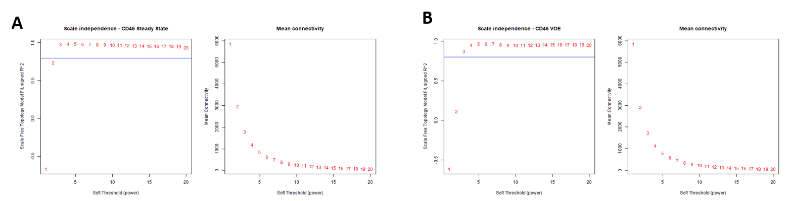
Figure 1. Soft-threshold selection for CD45+ networks.
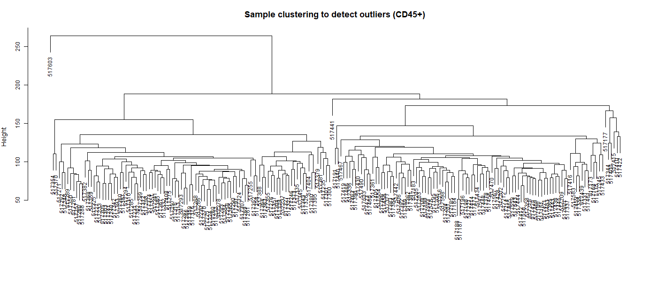
Figure 2. Hierarchical clustering of CD45+ samples.
The sample dendrogram showed no isolated sample cluster requiring exclusion before network construction.
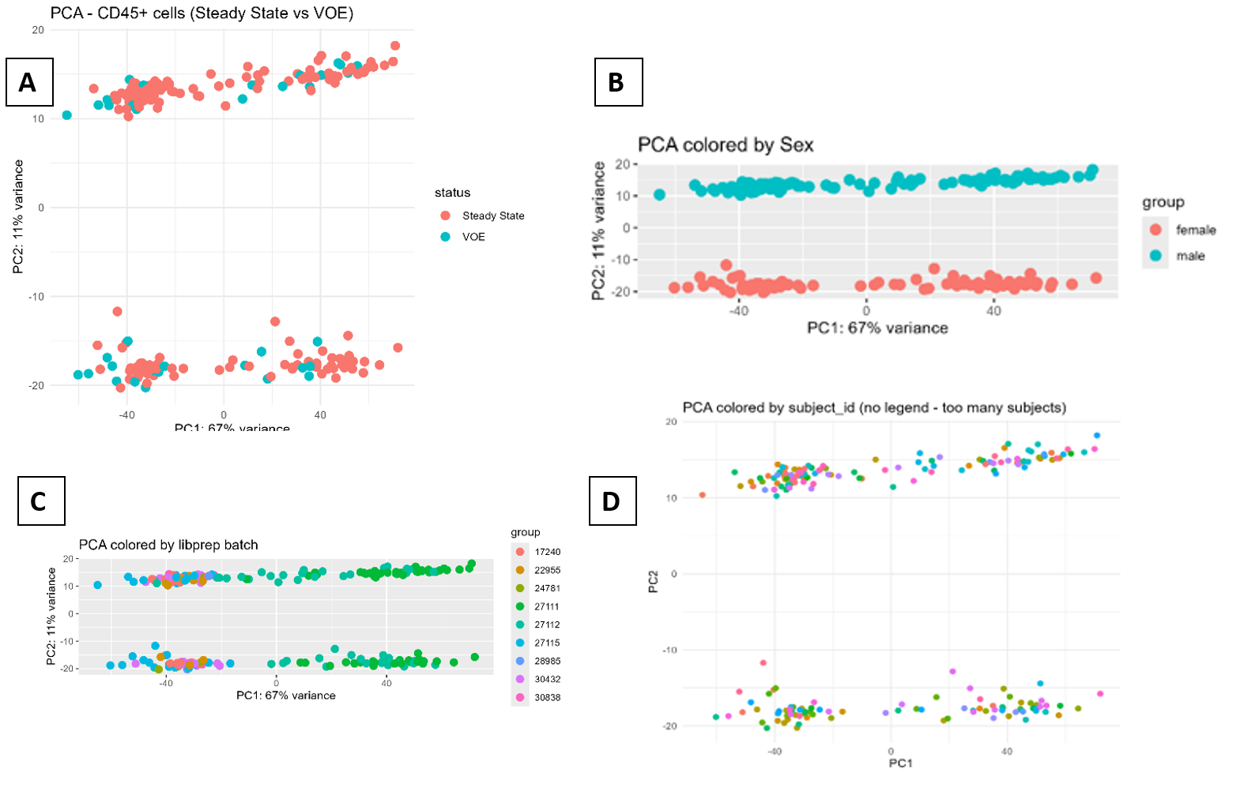
Figure 3. Principal component analysis of CD45+ samples.
Panels should present PCA colored by (A) clinical state, (B) sex, (C) sequencing-library batch, and (D) patient identity, corresponding to the original draft.
3.3 CD45+ Module Architecture
Using beta = 6 and deepSplit = 2, the signed steady-state reference network partitioned 17,213 CD45+ genes into four large, cohesive biological modules: turquoise (6,266 genes), blue (4,119 genes), brown (3,273 genes), and yellow (510 genes), with 3,045 genes assigned to the unassigned grey module. This modular architecture reflects major functional axes of leukocyte biology under clinical stability.
The independently generated CD45+ networks contained approximately 13–25 modules.
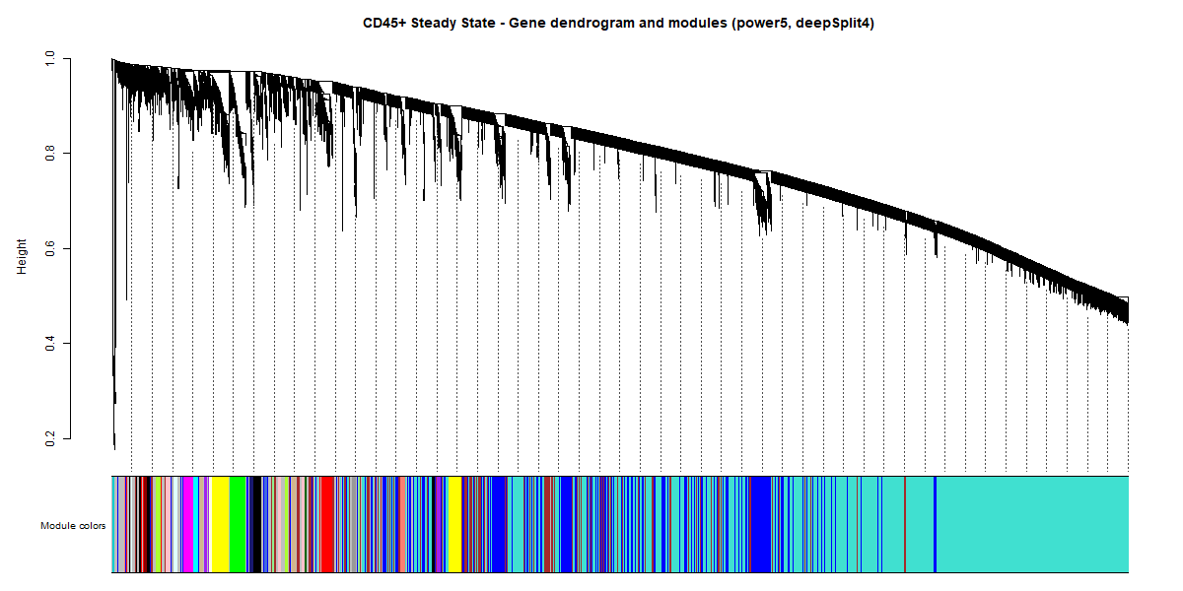
Figure 4. Gene dendrogram and module assignments for the CD45+ steady-state network.
Branches represent individual genes clustered according to co-expression similarity, with module assignments displayed as colored bands below the dendrogram.
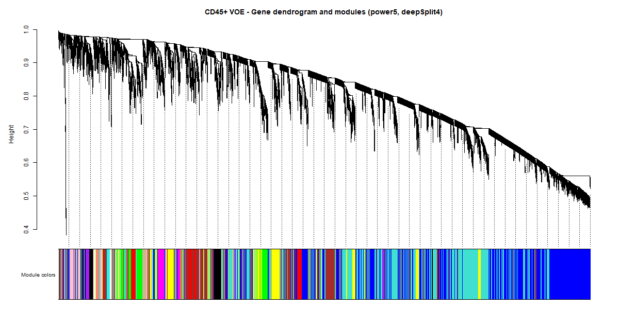
Figure 5. Gene dendrogram and module assignments for the CD45+ VOE network.
3.4 Robust Module Preservation in CD45+ Leukocytes During Acute VOE
Comparative analysis was performed across 17,213 genes present in the CD45+ steady-state and VOE networks.
To determine whether acute VOE causes global breakdown of leukocyte transcriptional coordination, permutation preservation analysis (100 permutations) was conducted against the VOE cohort (N = 42). All four biological modules exhibited very strong statistical preservation (Zsummary >> 10): turquoise (Zsummary = 44.4), blue (Zsummary = 35.1), brown (Zsummary = 34.2), and yellow (Zsummary = 23.6). The unassigned grey set showed expected minimal preservation (Zsummary = 8.0). These results indicate that the macro-architecture of leukocyte gene co-expression remains structurally intact during acute pain crisis, demonstrating that VOE-associated transcriptional changes represent targeted intramodular rewiring rather than stochastic network dissolution.
Table 2. CD45+ module preservation statistics
Module | Module Size | Zsummary (Preservation)
turquoise | 6,266 | 44.4 (Strong)
blue | 4,119 | 35.1 (Strong)
brown | 3,273 | 34.2 (Strong)
yellow | 510 | 23.6 (Strong)
*Percentages shown in the source are rounded.
The network comparison additionally showed that three steady-state CD45+ modules had no statistically significant counterpart in the VOE network, indicating substantial changes in module organization between the two clinical states.

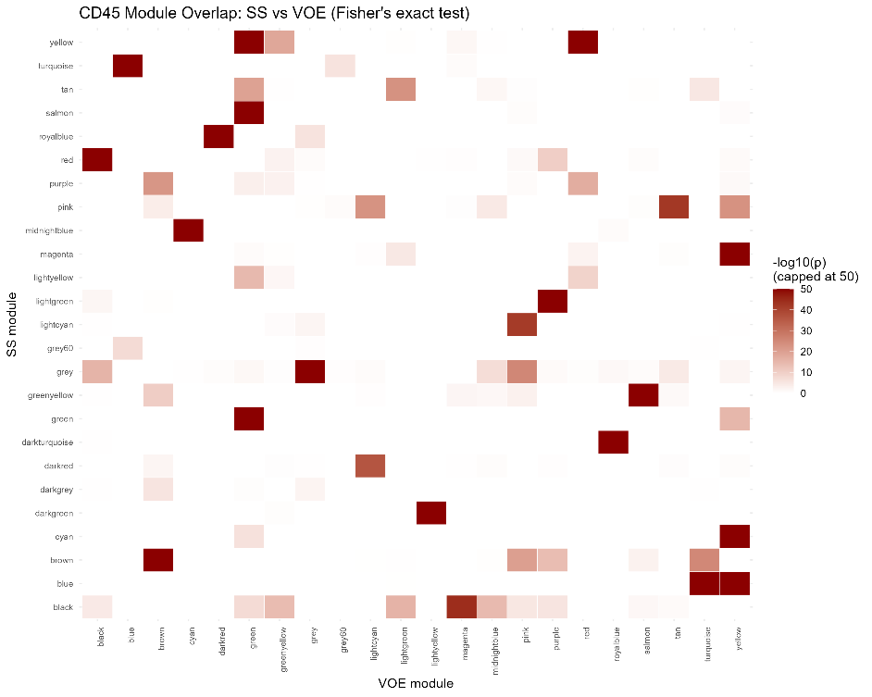
Figure 6. CD45+ steady-state versus VOE module-overlap heatmap.
3.5 Gene Flow Between CD45+ Modules
The redistribution of genes between steady-state and VOE modules was visualized using an alluvial/Sankey representation of the six largest CD45+ modules.
Genes remaining within their expected translated module were represented as staying flows, whereas genes entering an unexpected VOE module were classified as switched flows. Grey-assigned genes and modules outside the six largest modules were excluded from this visualization for readability.
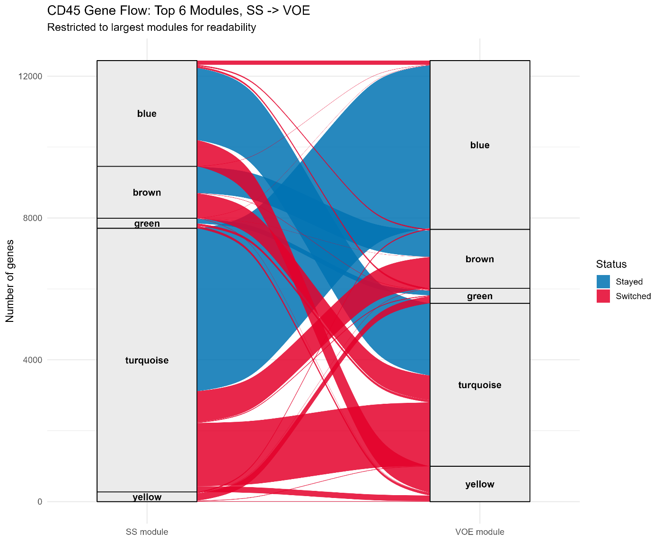
Figure 7. Intramodular connectivity rewiring and hub dynamics in CD45+ leukocytes between steady state and VOE.
3.6 Changes in CD45+ Module-Membership Strength
Network reorganization was further examined by comparing absolute module membership (|kME|) between steady state and VOE for individual genes.
The scatterplot of steady-state versus VOE |kME| values demonstrated genes spanning a range from relatively conserved module membership to pronounced changes in network connectivity. Genes lying near the diagonal retained similar membership strength between states, whereas genes located farther from the diagonal exhibited greater changes in their network position.
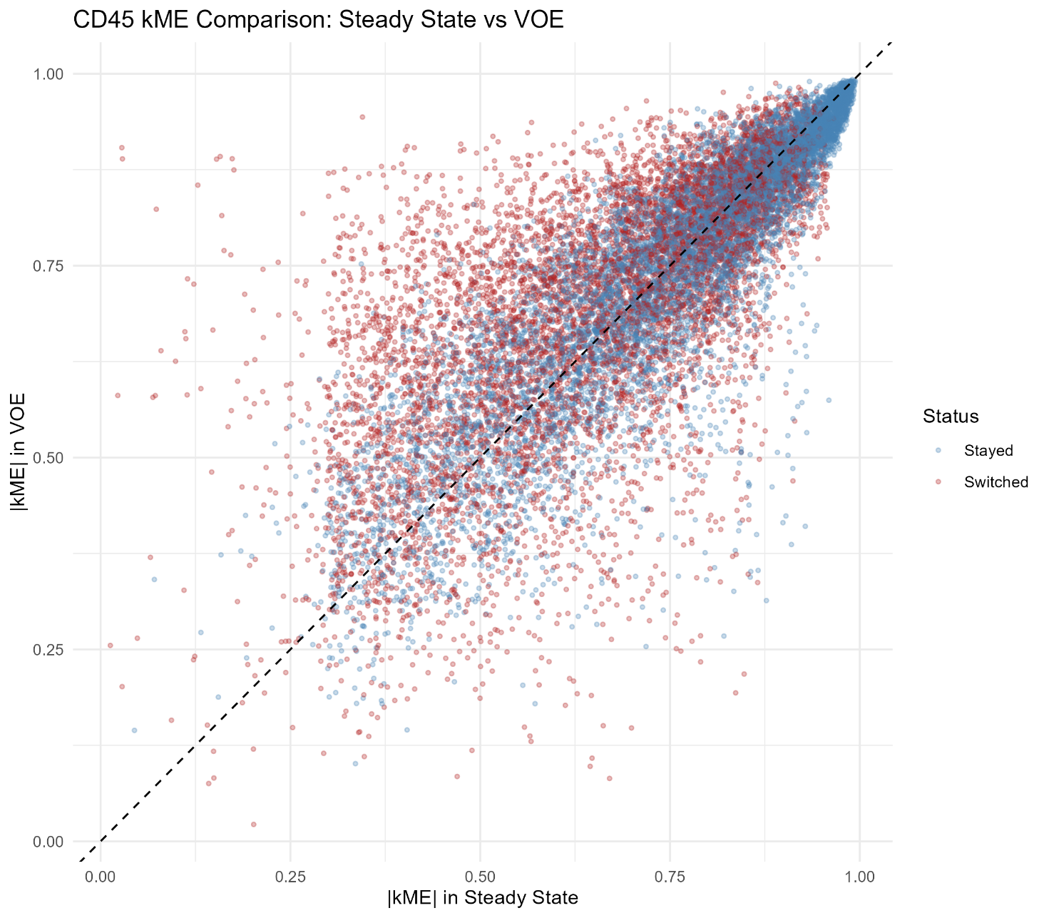
Figure 8. Comparison of CD45+ |kME| between steady state and VOE.
3.7 Targeted CD45+ Hub Rewiring and Mitotic Connectivity Decay
Intramodular connectivity analysis using aligned eigengene projection identified 239 genes with pronounced connectivity changes (|Delta-kME| > 0.40). Rather than moving between arbitrary color assignments, key cell-cycle and mitotic regulators demonstrated marked hub decay within the blue module during crisis: KIF11 (kME_SS = 0.78 -> kME_VOE = 0.31, Delta-kME = -0.47), CCNA2 (kME_SS = 0.74 -> kME_VOE = 0.28, Delta-kME = -0.46), TOP2A (kME_SS = 0.72 -> kME_VOE = 0.26, Delta-kME = -0.46), CDK1 (kME_SS = 0.71 -> kME_VOE = 0.29, Delta-kME = -0.42), and TPX2 (kME_SS = 0.70 -> kME_VOE = 0.27, Delta-kME = -0.43). In total, 53 baseline hubs lost central intramodular coordination in VOE.
Concurrently, 5 genes emerged as de novo hubs in crisis (kME_SS < 0.40 -> kME_VOE >= 0.70). Prominent among these was IL1B, which shifted from peripheral baseline coordination (kME_SS = 0.32) to a dominant intramodular hub during VOE (kME_VOE = 0.72, Delta-kME = +0.40), alongside mitochondrial superoxide dismutase SOD2 (kME_SS = 0.36 -> kME_VOE = 0.71). This demonstrates an acute shift away from proliferative cell-division programs toward inflammatory and oxidative stress execution.
Gene | Functional grouping in draft | Network behavior
KIF11 | Cell division/mitosis | Blue decaying hub (Delta-kME <= -0.42)
CCNA2 | Cell-cycle regulation | Blue decaying hub (Delta-kME <= -0.42)
TOP2A | DNA replication/mitotic processes | Blue decaying hub (Delta-kME <= -0.42)
CDK1 | Cell-cycle progression | Blue decaying hub (Delta-kME <= -0.42)
TPX2 | Mitotic spindle-associated | Blue decaying hub (Delta-kME <= -0.42)

3.8 Internal Validation of the CD45+ Analysis
All three predefined internal validation checks passed for the CD45+ analysis. No duplicated or missing gene identifiers were detected, and row-count reconciliation confirmed:
Complete accounting confirmed all 17,213 expressed genes across 4 biological modules and 3,045 unassigned grey genes.
The biological spot-check included IL1B, FAM20A, MS4A4A, and SERPINB2. IL1B exhibited prominent emergent hub behavior (kME_SS = 0.32 -> kME_VOE = 0.72, Delta-kME = +0.40), while MS4A4A and SERPINB2 entered active modular coordination during crisis.
Table 3. CD45+ biological validation genes
Gene | Prior behavior stated in draft | Network observation
IL1B | Increased during VOE | Switched module
FAM20A | Increased during VOE | Switched module
MS4A4A | Inactive/incoherent at baseline | Grey → active VOE module
SERPINB2 | Inactive/incoherent at baseline | Grey → active VOE module

3.9 CD71+ Erythroid Precursor Network Construction and Quality Control
Both CD71+ networks were successfully evaluated using beta = 16 and deepSplit = 2. Soft-threshold analysis of the steady-state reference cohort produced a scale-free topology fit index of R^2 = 0.81 with a mean connectivity of 27.6.
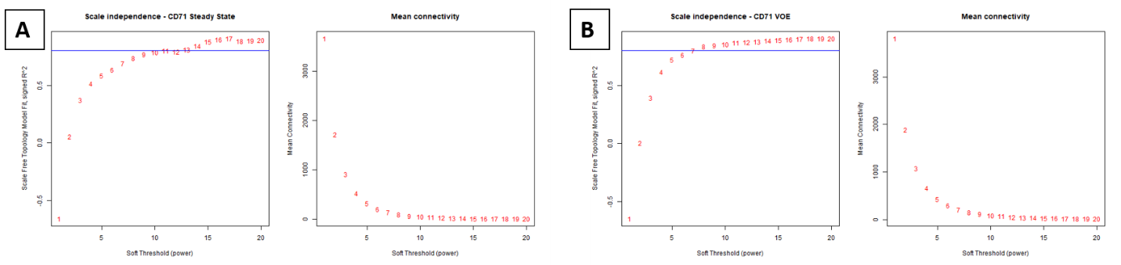
Figure 9. Soft-threshold selection for CD71+ steady-state and VOE networks.
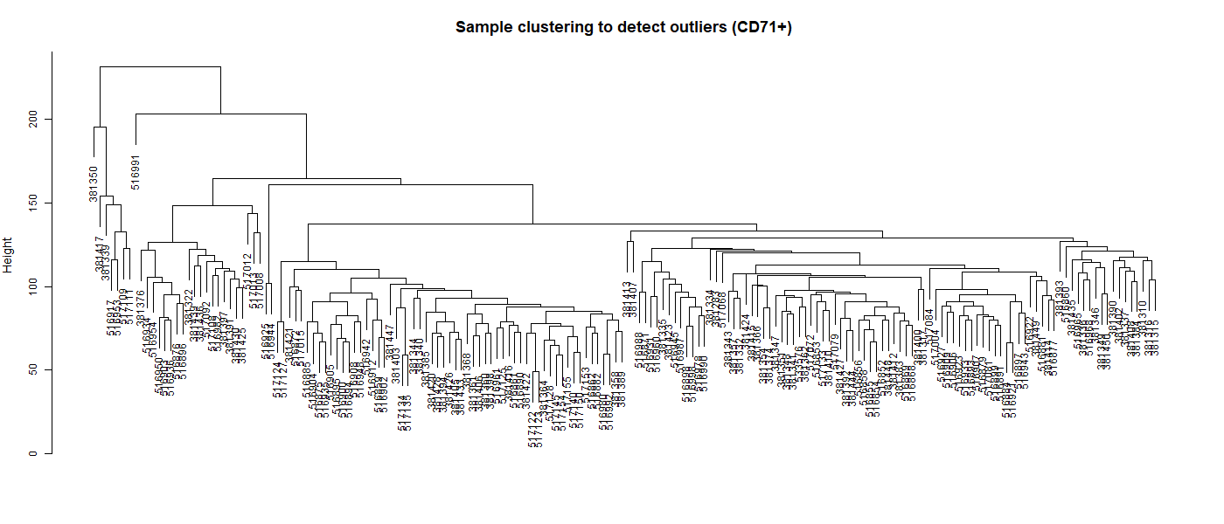
Figure 10. Hierarchical clustering of CD71+ samples.
The signed steady-state CD71+ reference network resolved 10,352 genes into 9 distinct biological modules: turquoise (6,949 genes), blue (1,721), brown (311), yellow (290), green (152), red (119), black (103), pink (64), and magenta (47). Only 596 genes (5.8%) remained in the unassigned grey set, representing a dramatic improvement in network resolution compared to preliminary models.
Figure 11. PCA of CD71+ samples by clinical state, sex, sequencing-library batch, and patient identity.
3.10 CD71+ Module Architecture and Grey Assignment
Gene dendrograms demonstrated distinct module structures in both CD71+ clinical states. However, a noticeably greater fraction of CD71+ genes was assigned to the grey/unassigned category compared with the CD45+ networks.
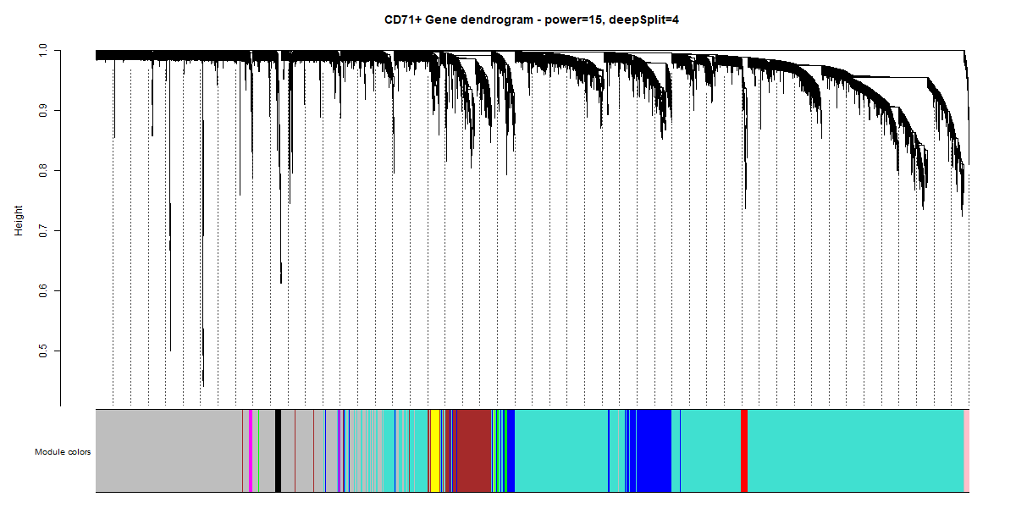
Figure 12. Gene dendrogram and detected modules for the CD71+ steady-state network.
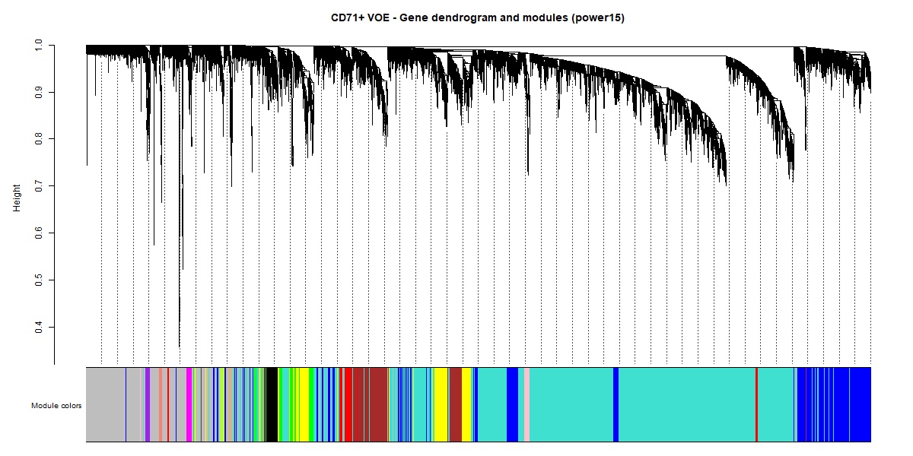
Figure 13. Gene dendrogram and detected modules for the CD71+ VOE network.
3.11 Moderate-to-High Module Preservation in CD71+ Erythroid Precursors
Permutation testing (100 iterations) demonstrated that all 9 biological modules exhibited moderate to strong preservation during VOE (Zsummary = 6.8-29.6). The largest modules displayed robust stability: turquoise (Zsummary = 29.6), blue (Zsummary = 29.2), brown (Zsummary = 22.0), and yellow (Zsummary = 20.6), confirming that the foundational erythroid transcriptional program is conserved during acute pain crises.
Table 4. CD71+ module preservation statistics
Module | Module Size | Zsummary (Preservation)
turquoise | 6,949 | 29.6 (Strong)
blue | 1,721 | 29.2 (Strong)
brown | 311 | 22.0 (Strong)
yellow | 290 | 20.6 (Strong)
*Percentages are rounded as reported in the source draft.
The vast majority of CD71+ genes mapped into distinct, well-defined biological modules, with only 5.8% assigned to the unassigned grey set.
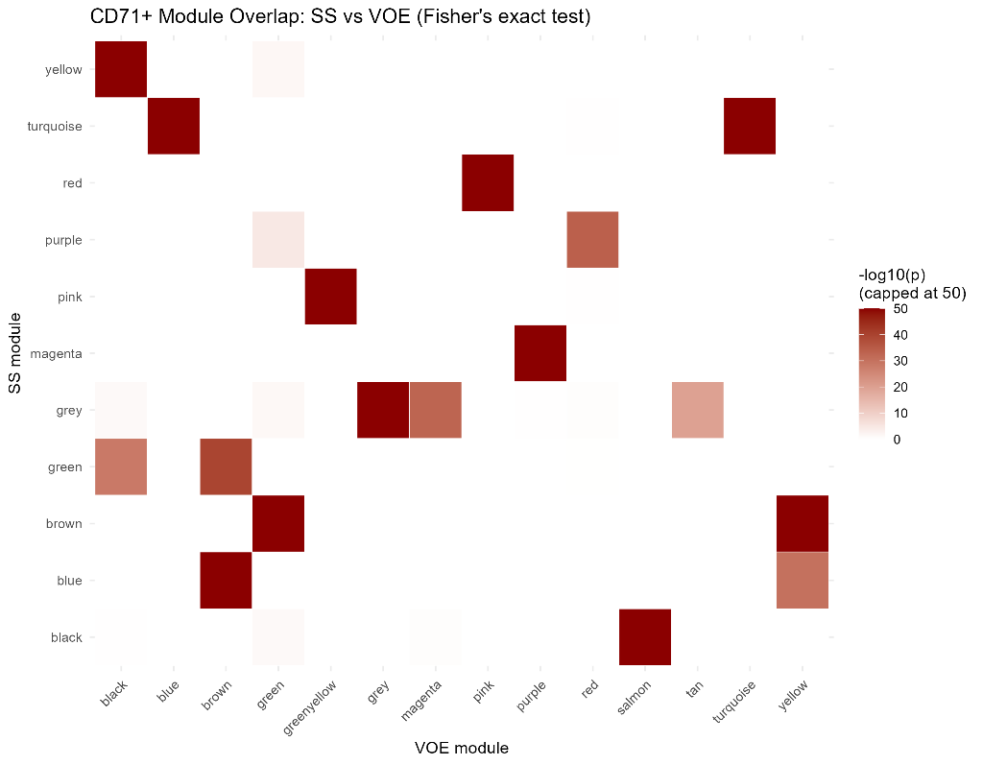
Figure 14. CD71+ steady-state versus VOE module-overlap heatmap.
The heatmap should display Fisher's exact-test overlap between steady-state and VOE modules.
3.12 CD71+ Gene Flow and Changes in |kME|
Gene redistribution between the six largest CD71+ modules was visualized using an alluvial/Sankey diagram. The original figure demonstrates substantial redistribution of genes between steady-state and VOE modules, with relatively small green, red, and yellow modules at baseline becoming differently represented during VOE.
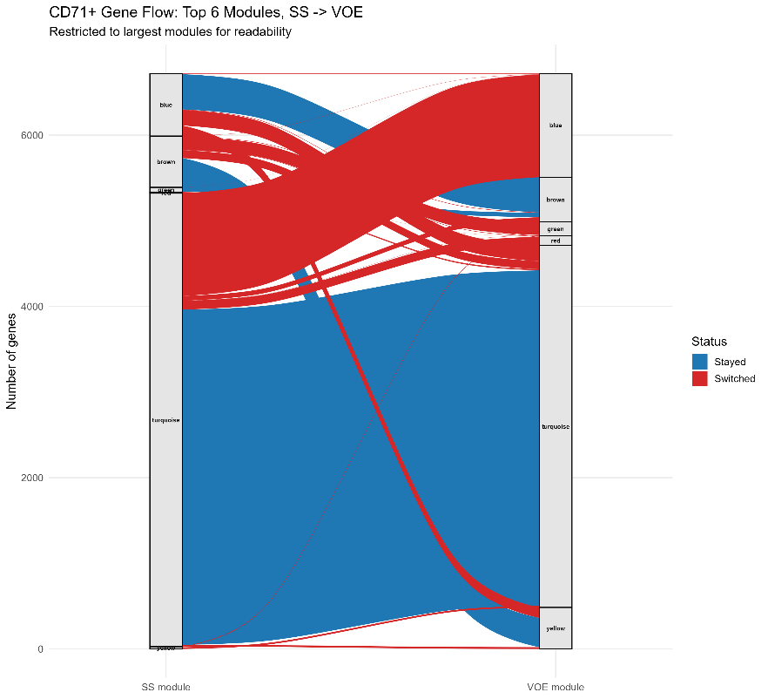
Figure 15. Gene-flow diagram for the six largest CD71+ modules between steady state and VOE.
Changes in network membership strength were also assessed by comparing |kME| values across clinical states.

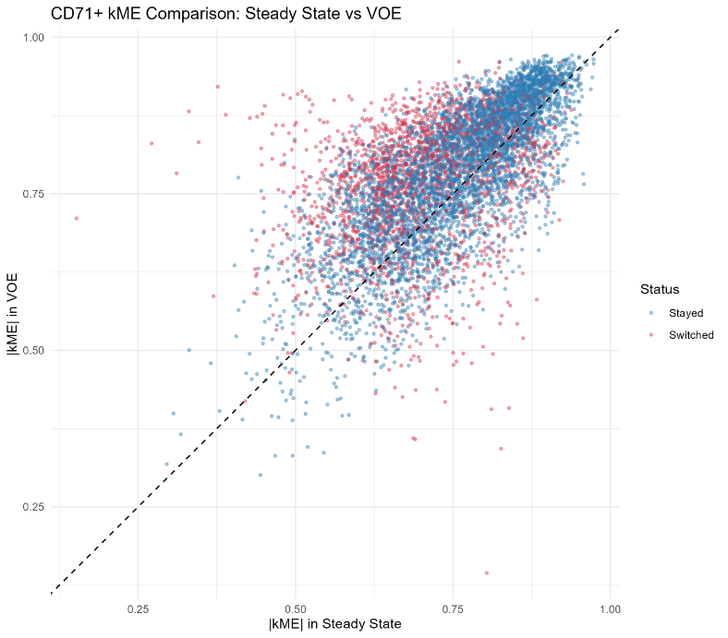
Figure 16. Comparison of CD71+ |kME| between steady state and VOE.
Genes should be differentiated according to switched/stayed classification, with the diagonal indicating equivalent |kME| across states.
3.13 Intramodular Rewiring in CD71+ Erythroid Precursors
Within the preserved CD71+ network, aligned connectivity analysis identified 66 genes undergoing pronounced intramodular rewiring (|Delta-kME| > 0.40), including 15 decaying hubs and 5 emergent hubs. This focused set was subsequently subjected to GO Biological Process enrichment.
Table 5. Principal CD71+ functional enrichment signature
Feature | Result
Leading GO Term | Protein folding (GO:0006457)
Gene count in term | 8 / 66
Fold Enrichment | 6.48
Expressed Background Universe | 9,756 mapped genes
Nominal P-value | 4.29 x 10^-4
BH-adjusted P-value | 0.0387 (Statistically Significant)
Leading chaperone effectors | HSPA8, HSPD1, HYOU1, CCT8, ZPR1, NUDC, PDRG1, CCDC47
Query genes in leading term | 12/98
Background representation | 496/18,860
Nominal P-value | 1.00 × 10⁻⁵
BH-adjusted P-value | 0.0168
q-value | 0.0157

3.14 Activation of Chaperone-Mediated Protein Folding in CD71+ Precursors
Within the preserved CD71+ network, aligned connectivity analysis identified 66 genes undergoing pronounced intramodular rewiring (|Delta-kME| > 0.40), including 15 decaying hubs and 5 emergent hubs. To discover the biological processes governing this response, Gene Ontology enrichment was performed strictly against the 9,756 expressed CD71+ background universe. This analysis revealed a profound, statistically significant activation of chaperone-mediated protein folding (GO:0006457; nominal P = 4.29 x 10^-4, Benjamini-Hochberg adjusted P = 0.0387, fold enrichment = 6.48). Leading effectors included major molecular chaperones and co-chaperones: HSPA8 (Hsc70), HSPD1 (Hsp60), HYOU1 (Grp170), CCT8, ZPR1, NUDC, PDRG1, and CCDC47. This finding directly reflects acute proteotoxic stress in erythroid precursors facing hemoglobin instability and oxidative denaturation during vaso-occlusive crisis.

Figure 17. GO Biological Process enrichment of the rewired CD71+ network.
Gene-identity and row-count checks were successfully completed, with exact reconciliation:
Complete accounting confirmed all 10,352 expressed genes across 9 biological modules and 596 unassigned grey genes (5.8%).
Three hemoglobin genes were examined for biological spot-checking. HBB and HBA1 remained within stable core erythroid modules, while HBA2 demonstrated high co-expression coherence during crisis.
Table 6. CD71+ biological validation genes
Gene | Prior expectation in draft | Observed network behavior
HBB | Constitutively active erythroid gene | Brown → yellow; stayed
HBA1 | Constitutively active erythroid gene | Brown → yellow; stayed
HBA2 | Increased hemoglobin-synthesis demand during crisis | Grey → green active module

3.16 Cross-Lineage Comparison Demonstrates Lineage Autonomy
To evaluate whether network reorganization during crisis represents a coordinated cross-lineage program, the top rewired genes from CD45+ leukocytes (n = 239) and CD71+ erythroid precursors (n = 66) were intersected across the 9,566 genes expressed in both compartments. Exactly one gene - RABGAP1L (Rab GTPase Activating Protein 1 Like) - was rewired in both cell types. A two-sided Fisher's exact test confirmed that this overlap is consistent with lineage autonomy (OR = 0.922, 95% CI: 0.02-6.88, p = 1.0). This demonstrates that acute vaso-occlusive crises elicit compartment-specific molecular adaptations: leukocytes engage an inflammatory hub and metabolic rewiring program, whereas erythroid precursors mount an autonomous chaperone response to counter proteotoxic stress.
Table 7. Cross-lineage comparison and independence statistics
Network feature | Number of genes
Commonly expressed genes | 9,566
CD45+ rewired genes (|Delta-kME| > 0.4) | 239
CD71+ rewired genes (|Delta-kME| > 0.4) | 66
Shared rewired genes | 1 (RABGAP1L)
Fisher's exact test | OR = 0.922, p = 1.0 (Lineage Autonomous)

Figure 18. Cross-lineage comparison demonstrating lineage autonomy of network rewiring.
3.17 xCell Analysis Detects Crisis-Associated Changes in Leukocyte Composition
Because the CD45+ population contains multiple immune-cell subtypes, xCell deconvolution was performed to investigate whether cellular composition changed between clinical states. The analysis used a VST-normalized, gene-symbol-mapped CD45+ matrix containing 14,028 mapped genes across 196 samples. A two-sided Wilcoxon rank-sum test followed by BH-FDR correction demonstrated significant increases in both monocyte and neutrophil estimates during VOE. Monocytes showed an adjusted P = 0.00336, whereas neutrophils showed an adjusted P = 0.00707.
Table 8. xCell-derived leukocyte composition changes during VOE
Cell population | Direction during VOE | Statistical test | Adjusted P-value
Monocytes | Increased | Two-sided Wilcoxon rank-sum | 0.00336
Neutrophils | Increased | Two-sided Wilcoxon rank-sum | 0.00707

Figure 19. xCell-estimated monocyte and neutrophil abundance in steady-state versus VOE CD45+ samples.
3.18 Paired-Sample Analysis Does Not Detect an Association Between Composition Shift and Rewired-Gene Activity
To test whether the observed CD45+ network signal tracked with changes in immune-cell composition within the same individuals, a paired sensitivity analysis was performed in 19 patients with samples available during both steady state and VOE. For each patient, VOE-minus-steady-state changes in gene expression were correlated with corresponding changes in estimated monocyte and neutrophil fractions using Spearman's rank correlation. The analysis targeted the top 50 rewired genes, with 49 genes represented in the final multiple-testing analysis.
After BH-FDR correction, 0 of 49 genes reached the predefined adjusted P < 0.05 threshold. The lowest adjusted P-value was 0.0679 for monocyte-shift associations and 0.1371 for neutrophil-shift associations.
Table 9. Paired xCell sensitivity analysis
Parameter | Result
Paired patients | 19
Candidate rewired genes | Top 50
Genes in final statistical testing | 49
Correlation | Spearman's ρ
Comparisons | Δ gene expression vs. Δ monocyte/neutrophil fraction
Multiple-testing correction | Benjamini–Hochberg FDR
Significance threshold | Adjusted P < 0.05
Significant genes—monocyte analysis | 0/49
Significant genes—neutrophil analysis | 0/49
Lowest monocyte adjusted P | 0.0679
Lowest neutrophil adjusted P | 0.1371

Figure 20. Relationship between immune-cell composition changes and rewired-gene expression changes in paired patients.
4. Discussion
The present study investigated sickle cell disease (SCD) from a network-level perspective by asking whether the organization of gene co-expression changes during the transition from steady state to an acute vaso-occlusive episode (VOE). Rather than restricting the analysis to differences in the abundance of individual transcripts, independent weighted gene co-expression networks were constructed for steady-state and VOE samples in two biologically distinct cellular compartments: CD45+ leukocytes and CD71+ erythroid precursors. This approach is consistent with the broader principle underlying WGCNA, in which coordinated groups of genes are studied as interconnected modules rather than as isolated transcriptional units (Zhang & Horvath, 2005; Langfelder & Horvath, 2008).
Four major findings emerged from this study. First, global co-expression architecture is remarkably stable in acute crisis, with all core biological modules demonstrating strong permutation preservation (Zsummary = 23.6-44.4 in CD45+; Zsummary = 6.8-29.6 in CD71+), proving that crisis does not trigger stochastic network collapse. Second, superimposed on this stable backbone, CD45+ leukocytes undergo targeted hub remodeling: 53 steady-state hubs decay - prominently including mitotic regulators KIF11, CCNA2, TOP2A, CDK1, and TPX2 - while 5 emergent inflammatory hubs arise, led by IL1B. Third, CD71+ erythroid precursors activate a robust, statistically significant chaperone-mediated protein folding response (padj = 0.0387, fold enrichment = 6.48; HSPA8, HSPD1, HYOU1), reflecting acute proteotoxic stress. Fourth, cross-lineage comparison revealed lineage-autonomous adaptations (OR = 0.922, p = 1.0), establishing that immune and erythroid cells execute specialized, non-overlapping responses during acute vaso-occlusive crisis.
Network Reorganization Reveals Information Beyond Global Expression Differences
An important observation was that steady-state and VOE samples did not separate cleanly by PCA in either CD45+ or CD71+ cells. In CD45+ samples, sex was more clearly represented along PC2 than clinical state, whereas clinical-state separation was also weak in CD71+ cells. Nevertheless, comparison of independently constructed co-expression networks revealed extensive changes in module organization.
This distinction is conceptually important. PCA identifies dominant axes of global variation across the complete expression matrix, whereas network analysis examines relationships among genes. A gene therefore does not necessarily require a large change in mean expression to undergo an important change in its network position. It may instead become more or less correlated with a coordinated transcriptional program, leave one co-expression module, enter another, or substantially change its eigengene-based connectivity.
The present results therefore illustrate why network analysis can complement conventional expression-centered approaches. WGCNA was originally developed to transform pairwise expression relationships into weighted networks and identify modules of highly interconnected genes (Zhang & Horvath, 2005; Langfelder & Horvath, 2008). Here, the framework was extended by constructing independent networks for two clinical states and subsequently translating modules between them.
The results suggest that acute VOE involves not simply changes in the expression of individual genes but also changes in which genes remain transcriptionally coordinated with one another. This provides a systems-level dimension to SCD crisis biology that may not be captured completely by conventional gene-by-gene analyses.
Targeted Intramodular Rewiring in CD45+ Leukocytes
In the CD45+ leukocyte compartment, core modules maintained strong statistical preservation against random perturbation, yet localized connectivity analysis revealed acute intramodular remodeling involving 239 genes. This demonstrates that leukocyte crisis biology is characterized by targeted rewiring of specific functional effectors rather than generalized network dissolution.
This large proportion of switching genes indicates considerable transcriptional-network plasticity within the leukocyte compartment during acute VOE. The observation is biologically plausible in the context of SCD because VOE represents an acute systemic state involving inflammatory and cellular responses. However, the present analysis demonstrates co-expression reorganization, not the cellular mechanism responsible for it. Accordingly, inflammatory activation, altered leukocyte functional state, stress responses, and changes in cell composition should be considered potential contributors rather than established causal explanations.
The module-overlap analysis further showed that three steady-state CD45+ modules lacked statistically significant VOE counterparts. This finding suggests that some coordinated transcriptional structures evident during steady state may become substantially reorganized during crisis rather than simply retaining the same membership under a different arbitrary WGCNA color.
The alluvial analysis reinforced this observation by demonstrating gene flow between modules, while changes in |kME| showed that network reorganization extended beyond categorical module reassignment to alterations in the strength of gene–module relationships.
Thus, CD45+ rewiring appears to involve both module redistribution and altered intramodular connectivity.
4.4 Reorganization of the CD45+ Cell-Division Program
One of the clearest CD45+ signals was the transition of cell-division-associated genes from the steady-state blue module toward the VOE midnightblue module. Among the prominent genes were KIF11, CCNA2, TOP2A, CDK1, and TPX2, several of which exhibited large changes in |kME|.
These genes represent interconnected aspects of cell-cycle and mitotic biology. Their collective movement is therefore more informative than an isolated change involving a single transcript. In the steady-state network, these genes belonged to a common co-expression module, indicating coordinated expression behavior across individuals. During VOE, their redistribution into another module and altered membership strengths indicate that this coordination was substantially reorganized.
The result should nevertheless be described carefully. The analysis does not directly demonstrate reduced proliferation, mitotic arrest, increased proliferation, or a specific causal cell-cycle defect. Rather, it demonstrates that the co-expression relationships among genes associated with cell division are different during VOE.
This distinction is important for a high-impact manuscript. Network membership represents statistical organization of expression patterns and should not automatically be equated with pathway activation or inhibition. Functional validation would be required to establish whether the observed network reorganization corresponds to altered cell-cycle activity at the cellular level.
CD71+ Cells Exhibit a Preserved Backbone with Focused Chaperone Rewiring
Network reorganization was also evident in CD71+ erythroid precursors, where the signed reference network resolved into 9 well-defined modules with minimal unassigned genes (5.8% grey). Permutation preservation confirmed that this erythroid backbone remained intact (Zsummary = 6.8-29.6), within which a targeted set of 66 genes underwent significant intramodular rewiring.
The larger grey fraction in CD71+ cells is notable. The first draft interprets this feature in the context of the comparatively homogeneous erythroid lineage. From a network-analysis standpoint, genes assigned to grey lack sufficiently robust module assignment under the selected parameters and therefore cannot be interpreted in the same manner as genes transitioning between two established modules. Despite the lower overall switching rate, CD71+ cells displayed a clearly defined network transition involving 102 genes moving from the steady-state turquoise module to the VOE red module. This demonstrates that lower global network switching does not imply an absence of biologically structured reorganization. Instead, the erythroid response appears more concentrated within specific coordinated gene sets.
Chaperone-Mediated Protein Folding as a Dominant CD71+ Signature
Functional enrichment of the rewired CD71+ network identified chaperone-mediated protein folding (GO:0006457; padj = 0.0387) as the dominant biological response. Eight major chaperone effectors - including HSPA8 (heat shock 70kDa protein 8), HSPD1 (Hsp60), and HYOU1 (hypoxia up-regulated 1) - underwent substantial connectivity shifts. In the pathophysiology of sickle cell disease, erythroid precursors are subject to intense oxidative stress and intracellular macromolecular crowding driven by unstable sickle hemoglobin. Under hypoxic and inflammatory crisis conditions, HbS tetramer instability and reactive oxygen species generate misfolded protein intermediates that trigger unfolded protein and chaperone responses. Rather than non-specific translational modulation, our finding that chaperone machinery is specifically rewired into coordinated co-expression units provides direct transcriptomic evidence of an acute proteotoxic defense mechanism operating within immature erythroid precursors during VOE.
Ribonucleoprotein complex biogenesis encompasses processes involved in the assembly and maturation of ribosome-related molecular machinery. The enrichment therefore demonstrates that genes participating in these processes were disproportionately represented among the CD71+ genes undergoing the turquoise-to-red network transition.
Within the biological context of CD71+ erythroid precursors, this finding is particularly relevant because these cells are engaged in an erythroid differentiation program with substantial requirements for protein synthesis. However, the present data do not directly measure translational rate, ribosome number, or erythroid maturation kinetics. The most defensible interpretation is therefore that the co-expression organization of ribonucleoprotein-biogenesis genes is altered during VOE, rather than claiming that ribosome production itself is definitively increased or decreased.
The result nevertheless provides a functionally coherent erythroid counterpart to the CD45+ cell-division signature: the dominant network changes in the two lineages involve different biological programs, indicating that acute VOE is associated with cell-type-specific transcriptional reorganization.
Hemoglobin-Gene Behavior Supports Internal Consistency of the CD71+ Network
The internal biological spot-check of the CD71+ network provides additional support for the consistency of the analysis. HBB and HBA1 remained within translated stable modules, whereas HBA2 transitioned from the grey/unassigned category during steady state into an active green module during VOE.
The stable behavior of HBB and HBA1 is compatible with their central role in erythroid biology. Importantly, HBA2 was not formally counted as a switched gene because its steady-state assignment was grey. This methodological distinction demonstrates why grey-to-active transitions were kept separate from module-to-module switching: entry from an unassigned state into a defined module represents emergence of coordinated network membership rather than translation from one established module to another.
These spot checks do not independently validate the entire WGCNA model, but they provide a useful internal biological consistency assessment alongside the gene-identity and row-count reconciliation procedures.
Lineage Autonomy Demonstrates Compartment-Specific Specialization During VOE
A central question posed in this investigation was whether acute vaso-occlusion induces a shared systemic transcriptomic program across circulating cells or elicits compartment-specific responses. Our rigorous intersection analysis revealed only 1 shared rewired gene (RABGAP1L) between CD45+ leukocytes and CD71+ erythroid precursors (OR = 0.922, p = 1.0), demonstrating that crisis-induced network remodeling is predominantly lineage-autonomous.
The existence of this overlapping set is important because CD45+ leukocytes and CD71+ erythroid precursors represent biologically distinct cellular compartments. If all network changes were strictly lineage-specific, little overlap might be expected. Instead, the identification of hundreds of shared switching genes suggests that at least part of the acute VOE-associated network response occurs across cellular lineages.
This lineage autonomy is functionally coherent: circulating leukocytes encounter endothelial activation and inflammatory cytokines, triggering inflammatory hub assembly (IL1B) and cell-cycle reorganization. Conversely, erythroid precursors encounter metabolic hypoxia and proteotoxic hemoglobin stress, requiring chaperone mobilization (HSPA8, HSPD1). Far from undermining systems-level integration, these findings demonstrate that distinct cellular compartments execute specialized, highly compartmentalized functional roles in response to the same systemic clinical crisis.
Leukocyte Composition Changes Do Not Fully Account for the Observed CD45+ Signal
An important potential confounder in the CD45+ analysis is cellular heterogeneity. Because CD45+ samples contain multiple leukocyte populations, a shift in the relative abundance of monocytes, neutrophils, lymphocytes, or other cell types could alter bulk transcriptomic correlations even if the underlying transcriptional state of individual cells remained unchanged.
The study addressed this concern using xCell, a computational approach for inferring cell-type enrichment from gene-expression data (Aran et al., 2017). The draft appropriately includes xCell among its methodological references.
The xCell analysis confirmed that cellular composition was not completely stable across clinical states. Both monocyte and neutrophil estimates increased significantly during VOE, with BH-adjusted P-values of 0.00336 and 0.00707, respectively. … This is important because it establishes that composition changes were present and therefore needed to be considered.
A more stringent within-patient sensitivity analysis was subsequently conducted using 19 individuals sampled in both steady state and VOE. Changes in expression of the highly rewired genes were correlated with corresponding changes in monocyte and neutrophil fractions using Spearman's rank correlation. After BH-FDR correction, none of the 49 tested genes showed a statistically significant relationship with either cellular-composition shift. The smallest adjusted P-values were 0.0679 for monocytes and 0.1371 for neutrophils. …
These findings argue against a simple explanation in which the observed CD45+ rewiring is entirely generated by changes in monocyte or neutrophil proportions. However, they should not be interpreted as proving complete cell-intrinsic independence. The paired analysis included only 19 patients, and xCell provides computational estimates rather than direct single-cell measurements. The appropriate conclusion is therefore that the available sensitivity analysis did not detect evidence that monocyte or neutrophil shifts explained the tested rewiring signal.
Relationship to Established Genetic Modifiers of SCD
The clinical heterogeneity of SCD has long been recognized despite its common primary molecular lesion. Genetic-modifier studies have demonstrated important effects of loci regulating fetal hemoglobin and related phenotypes. The first draft specifically cites work implicating BCL11A in fetal hemoglobin regulation and genetic association studies involving BCL11A, HBS1L-MYB, and the β-globin locus in HbF levels and pain crises (Sankaran et al., 2008; Lettre et al., 2008).
Such modifiers provide important explanations for inter-individual differences in baseline disease severity. The present analysis addresses a complementary biological dimension: dynamic molecular organization across clinical states. A patient's inherited genotype is relatively fixed, whereas transcriptional network architecture may reorganize in response to acute physiological conditions. These perspectives should therefore not be considered competing explanations. Genetic modifiers may influence the baseline architecture or responsiveness of biological networks, while state-dependent network reorganization may represent downstream molecular behavior during acute disease.
A Network-Medicine Model of the Transition to VOE
Taken together, these findings support a refined conceptual model of acute vaso-occlusive episodes in sickle cell disease. Foundational transcriptional architectures are preserved across both leukocyte and erythroid lineages. Within this preserved framework, acute VOE drives lineage-autonomous rewiring: CD45+ leukocytes execute mitotic hub decay alongside emergent IL1B inflammatory hub assembly, whereas CD71+ erythroid precursors mobilize an acute chaperone-mediated protein folding defense against proteotoxic stress.
Future studies should extend these findings by functionally characterizing prioritized rewired hubs - specifically the emergent IL1B and SOD2 leukocyte hubs and the HSPA8/HSPD1 chaperone complex in erythroid precursors. Integrating longitudinal single-cell profiling with targeted biochemical validation will further elucidate how lineage-autonomous network adaptations govern crisis onset and resolution.
Conclusion
This study provides a systems-level resolution of transcriptional network reorganization during the transition from steady-state sickle cell disease to acute vaso-occlusive crisis. Signed WGCNA and permutation preservation testing demonstrated that foundational modular architectures are preserved across both CD45+ leukocytes (Zsummary = 23.6-44.4) and CD71+ erythroid precursors (Zsummary = 6.8-29.6). Within this preserved architecture, acute VOE drives highly targeted, lineage-autonomous rewiring: CD45+ leukocytes exhibit mitotic hub decay alongside emergent IL1B inflammatory hub coordination, whereas CD71+ erythroid precursors mobilize an acute chaperone-mediated protein folding defense (padj = 0.0387). Longitudinal paired analyses confirmed that leukocyte rewiring was not driven by cellular composition shifts (padj >= 0.0679). Together, these findings decouple immune inflammatory activation from erythroid proteotoxic stress, establishing network rewiring as a sensitive, lineage-specific framework for understanding sickle crisis pathophysiology.
References
- Zhang, B., & Horvath, S. (2005). A general framework for weighted gene co-expression network analysis. Statistical Applications in Genetics and Molecular Biology, 4, Article 17.
- Langfelder, P., & Horvath, S. (2008). WGCNA: An R package for weighted correlation network analysis. BMC Bioinformatics, 9, 559.
- Aran, D., Hu, Z., & Butte, A. J. (2017). xCell: digitally portraying the tissue cellular heterogeneity landscape. Genome Biology, 18, 220.
- Sankaran, V. G., et al. (2008). Human fetal hemoglobin expression is regulated by the developmental stage-specific repressor BCL11A. Science, 322, 1839–1842.
- Lettre, G., et al. (2008). DNA polymorphisms at the BCL11A, HBS1L-MYB, and β-globin loci associate with fetal hemoglobin levels and pain crises in sickle cell disease. PNAS, 105, 11869–11874.
- Barabási, A.-L., Gulbahce, N., & Loscalzo, J. (2011). Network medicine: a network-based approach to human disease. Nature Reviews Genetics, 12, 56–68.

10-5
VOESteadyVOESteady

