Network Reorganization of Gene Co-Expression Architecture in Sickle Cell Disease Across Clinical States: A WGCNA-Based Comparative Analysis of Steady State and Vaso-Occlusive Episode
Dataset: GEO accession GSE291257 (n = 174 sickle cell disease patients)

ABSTRACT
Sickle cell disease (SCD) arises from a single point mutation in the HBB gene, yet patients with an identical genetic lesion exhibit markedly different clinical trajectories, ranging from frequent, severe vaso-occlusive episodes (VOE) to comparatively stable disease courses. Established genetic modifiers (e.g., BCL11A-mediated fetal hemoglobin induction) account for only part of this variability. Rather than asking which individual genes change expression level during a crisis , this study asks a structural question: does the gene co-expression network itself reorganize when a patient transitions from a steady clinical state into an acute VOE, and could this network-level reorganization explain outcome variability that expression-level comparisons alone would miss? Using RNA-sequencing data from 174 SCD patients (GEO accession GSE291257), sorted into CD45+ leukocytes and CD71+ erythroid precursors and sampled during both steady-state and VOE, we constructed separate Weighted Gene Co-expression Network Analysis (WGCNA) networks for each cell type and clinical state (four networks total) and compared network topology , module membership and module membership strength (kME) between states. In CD45+ cells, 42.2% of 17,213 common genes switched module assignment between states, with the most prominent signal being a cluster of cell-division genes (KIF11, CCNA2, TOP2A, CDK1, TPX2) that lost coordinated co-expression during crisis. In CD71+ cells, 20.1% of 10,352 common genes switched modules, with the dominant pattern being a shift of genes from the turquoise module into the red module, functionally enriched for ribonucleoprotein complex biogenesis (ribosome assembly machinery). A set of 776 genes exhibited module-switching behavior in both cell populations concurrently, indicating a shared, systemic rather than cell-type-restricted response to vaso-occlusive crisis. A composition-confound analysis using xCell-derived immune cell-type proportion estimates in 19 patients with paired steady-state/VOE samples found no significant relationship between shifts in monocyte/neutrophil proportion and rewired-gene activity, suggesting the observed network reorganization is not attributable to shifts in cell-type mixture alone. These findings support the hypothesis that clinical heterogeneity in SCD is associated with dynamic, cell-intrinsic reorganization of gene regulatory network architecture, not solely with static genetic differences or simple transcript-level changes, and motivate downstream hub-gene and network-convergence analyses (will be performed in phase2).
Keywords: sickle cell disease; vaso-occlusive episode; network medicine; WGCNA; gene co-expression network; module membership (kME); network rewiring; transcriptomics; CD45+ leukocytes; CD71+ erythroid precursors

TABLE OF CONTENTS
1. Introduction and Research Question
2. Field of Study and Rationale
3. Hypothesis
4. Dataset and Study Design
5. Methods — Stage 1: Network Construction
5.1 CD45+ Leukocyte Networks
5.2 CD71+ Erythroid Precursor Networks
6. Methods — Stage 2: Comparative Network Analysis
7. Results — CD45+ Leukocyte Network
7.1 Network Construction and Quality Control
7.2 Module Switching and kME Rewiring
7.3 Validation
8. Results — CD71+ Erythroid Precursor Network
8.1 Network Construction and Quality Control
8.2 Module Switching and kME Rewiring
8.3 Functional Enrichment
8.4 Validation
9. Cross-Cell-Type Convergence: Shared Rewired Genes
10. Technical Confound Analysis: Cell-Type Composition Shift
11. Discussion
12. Limitations
13. Conclusions and Next Steps
14. References

1.INTRODUCTION
Patients with sickle cell disease all carry the same causal mutation in the HBB gene (the Glu6Val substitution producing hemoglobin S), yet their clinical course varies enormously: some patients experience frequent, severe vaso-occlusive crises, while others remain relatively stable for extended periods. This clinical heterogeneity, despite a shared monogenic cause, is one of the central unsolved puzzles of SCD biology.
Much of the existing literature explains part of this variability through genetic modifier loci , most notably BCL11A, which regulates the developmental switch from fetal to adult hemoglobin and thereby modulates fetal hemoglobin (HbF) levels, a well-established protective factor against crisis frequency and severity. However, genetic modifiers of this kind do not explain the full extent of observed clinical variability, and a substantial residual gap remains between genotype and phenotype.
Central research question: Rather than asking which genes are switched on or off during a vaso-occlusive crisis (the standard differential expression approach), this project asks a structural question : does the way genes co-express with, and connect to, one another change when a patient transitions from a steady clinical state into an acute vaso-occlusive episode (VOE)? A gene does not act in isolation; it operates within a network of co-regulated genes. This study asks whether that network itself reorganizes with clinical state, independent of whether the expression level of any single gene changes.
2.FIELD OF STUDY AND RATIONALE
This work sits at the intersection of transcriptomics and network biology, and applies a network medicine framework to sickle cell disease. The core analytical method is Weighted Gene Co-expression Network Analysis (WGCNA), which, instead of treating each gene as an independent unit, groups genes that rise and fall together in expression across a patient cohort into clusters termed ‘modules,’ and quantifies how strongly each gene belongs to its assigned module (a metric termed kME, or module eigengene-based connectivity/module membership).
Comparing the resulting network architecture between two clinical states here, steady state versus VOE rather than comparing gene expression levels alone, constitutes a network medicine approach. This framework is particularly well suited to diseases such as sickle cell disease, where a single, shared genetic lesion produces highly divergent clinical phenotypes, because it allows the investigator to ask whether phenotypic divergence tracks with a reorganization of gene regulatory architecture rather than (or in addition to) static genetic differences between patients.
3.HYPOTHESIS
A patient's clinical state (steady state vs. vaso-occlusive crisis) is associated with a measurable reorganization of their gene co-expression network architecture encompassing both which genes are grouped together (module membership) and how strongly genes are connected within their groups (module membership strength, kME) and this reorganization is not fully captured by, and is distinct from, simple differential gene expression analysis.
A corollary hypothesis, tested as a technical control, is that any observed network reorganization in CD45+ leukocytes reflects genuine cell-intrinsic transcriptional rewiring rather than a shift in the relative proportions of immune cell subtypes (e.g., monocytes, neutrophils, T cells) that compose the bulk CD45+ population during an inflammatory crisis.

4.DATASET AND STUDY DESIGN
The analysis uses publicly available RNA-sequencing data deposited under GEO accession GSE291257, comprising samples from 174 patients with sickle cell disease. Blood samples were sorted by fluorescence-activated or magnetic separation into two populations analyzed separately in this study:
- CD45+ cells — pan-leukocyte marker; captures the white blood cell / immune compartment (a heterogeneous mixture of monocytes, neutrophils, T cells, B cells, and other immune subtypes).
- CD71+ cells — transferrin receptor marker; captures immature, still-maturing red blood cell precursors (erythroid lineage).
For each cell type, samples were collected at two clinical time points per patient, during a steady-state clinic visit, and during hospital admission for an acute vaso-occlusive episode. This yields four distinct comparison groups / networks analyzed in Phase 1:
Cell type | Clinical state | Network label
CD45+ (leukocytes) | Steady State | CD45 Stable
CD45+ (leukocytes) | Vaso-Occlusive Episode | CD45 Crisis
CD71+ (erythroid precursors) | Steady State | CD71 Stable
CD71+ (erythroid precursors) | Vaso-Occlusive Episode | CD71 Crisis

A separate, independent WGCNA network was constructed for each of the four groups above (Stage 1), after which the Steady State and VOE networks within each cell type were directly compared to one another (Stage 2). The vast majority of patients in this cohort were receiving hydroxyurea therapy at the time of sampling; this is noted here as a study design characteristic and is revisited as a limitation in Section 12.

5. METHODS — STAGE 1: NETWORK CONSTRUCTION
Before constructing each co-expression network, a ‘soft thresholding power’ parameter was selected for each network individually. This parameter controls how strongly the network emphasizes strong pairwise gene-gene correlations relative to weak ones when converting the correlation matrix into an adjacency matrix. The power was chosen by identifying the value at which the resulting network best approximated the scale-free topology characteristic of real biological networks, while keeping mean network connectivity at a computationally tractable and biologically plausible level.
Prior to network construction, sample-level quality control was performed for each cell type: hierarchical clustering of all samples was used to screen for clear outlier samples, and principal component analysis (PCA) was used to check whether clinical state, patient sex, sequencing library batch, or individual patient identity were driving unwanted structure in the expression data that could confound the state-to-state network comparison.
5.1 CD45+ Leukocyte Networks
Parameter | Steady State network | VOE network
Soft thresholding power | 5 | 5 (matched to Steady State)
Clustering resolution (deepSplit) | 4 (highest tested) | 4 (matched to Steady State)
Sample outliers removed | None (no clear outliers on dendrogram) | None

Sample-level QC via PCA showed that clinical state (Steady State vs. VOE) did not separate cleanly along the first two principal components of the raw CD45+ expression data — indicating that clinical state is not the dominant source of variance at the expression level, and supporting the rationale for a network-level rather than simple expression-level comparison. Patient sex, in contrast, showed a clear separation along the second principal component (PC2), indicating that sex is a genuine and fairly strong source of variation in this dataset; sex was therefore included as a covariate during normalization to prevent it from distorting the co-expression network. Sequencing library batch and individual patient identity did not show evidence of dominating network structure.
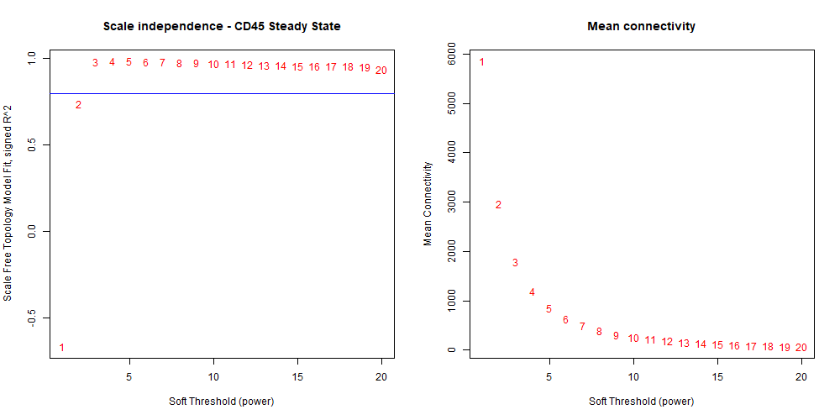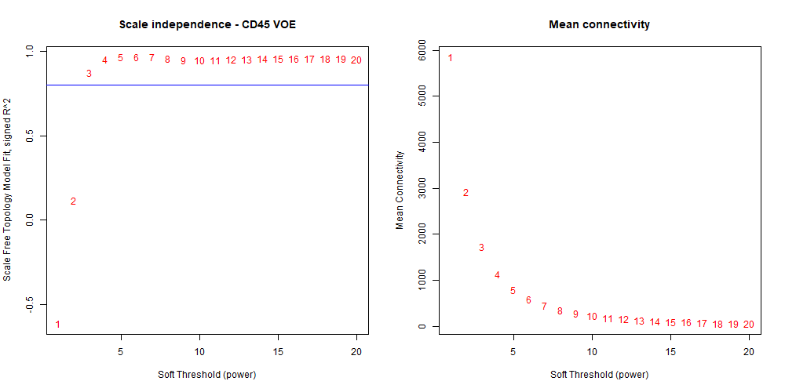
- (b)
Figure 1. (a)Soft power selection for the CD45+ Steady State network. Left panel: model fit (scale-free topology fit index) against candidate soft-power values. Right panel: resulting mean gene-to-gene connectivity. A power of 5 was selected, balancing acceptable model fit with computationally tractable connectivity.(b) Soft power selection for the CD45+ VOE network
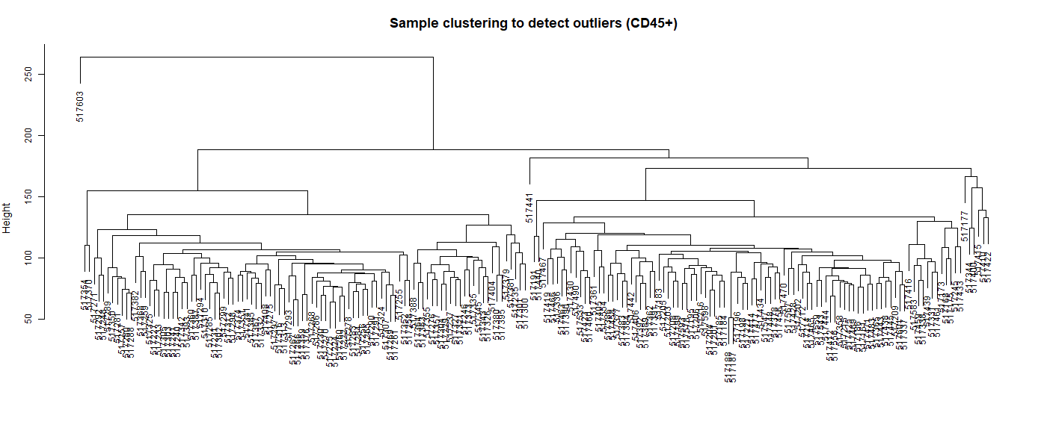
Figure 2. Hierarchical clustering of all CD45+ samples, used to screen for outlier samples prior to network construction. No sample clustered as a clear outlier requiring removal.
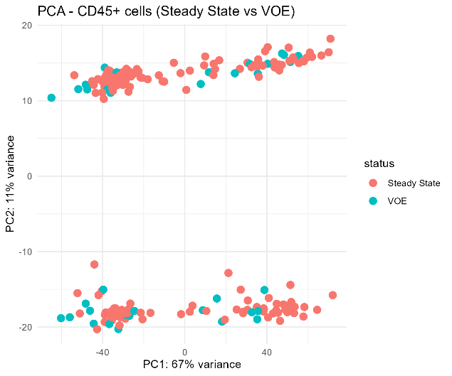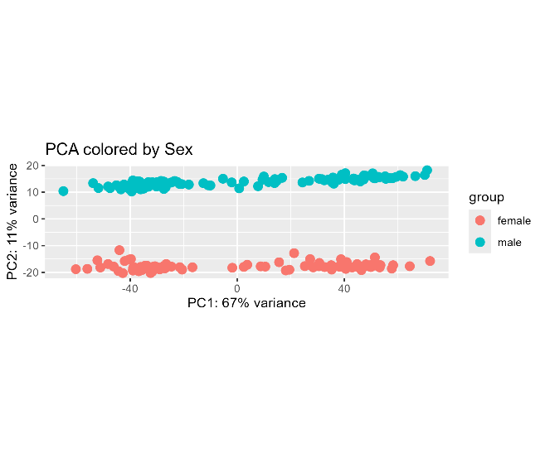
- (b)
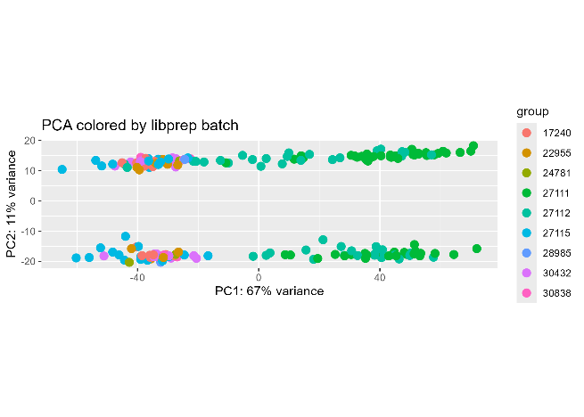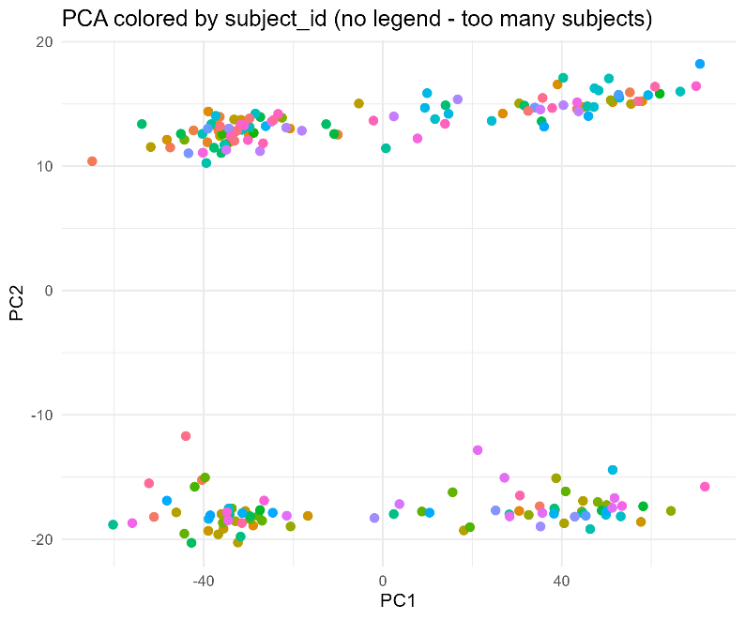
(c) (d)
Figure 3. Principal component analysis (PCA) of all CD45+ samples, coloured by (a)clinical state (Steady State vs. VOE), (b)sex,(c) sequencing library preparation batch and (d)patient (subject) identity.
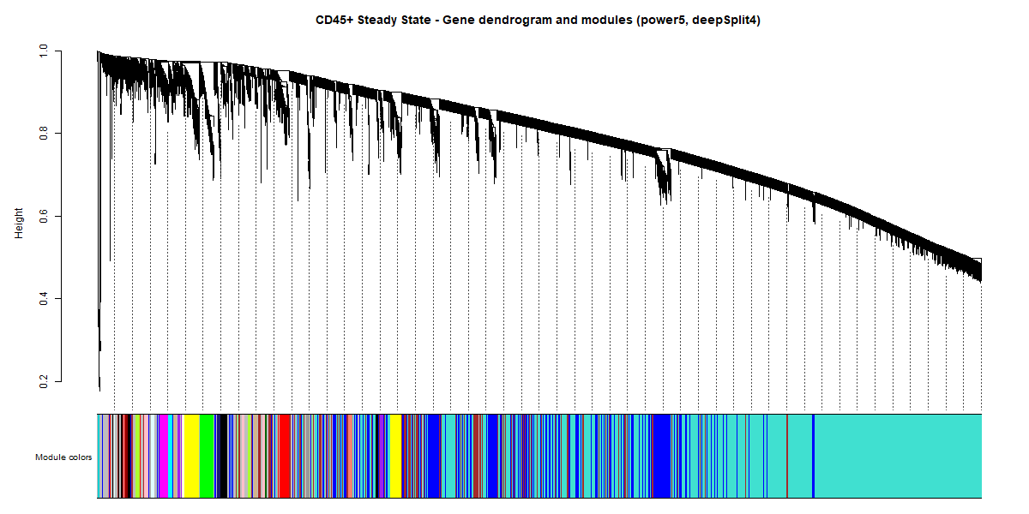
Figure 4. Gene dendrogram and detected modules for the CD45+ Steady State network. Each branch represents a gene; genes are grouped into modules, shown as colour bands beneath the dendrogram, based on co-expression similarity across patients.
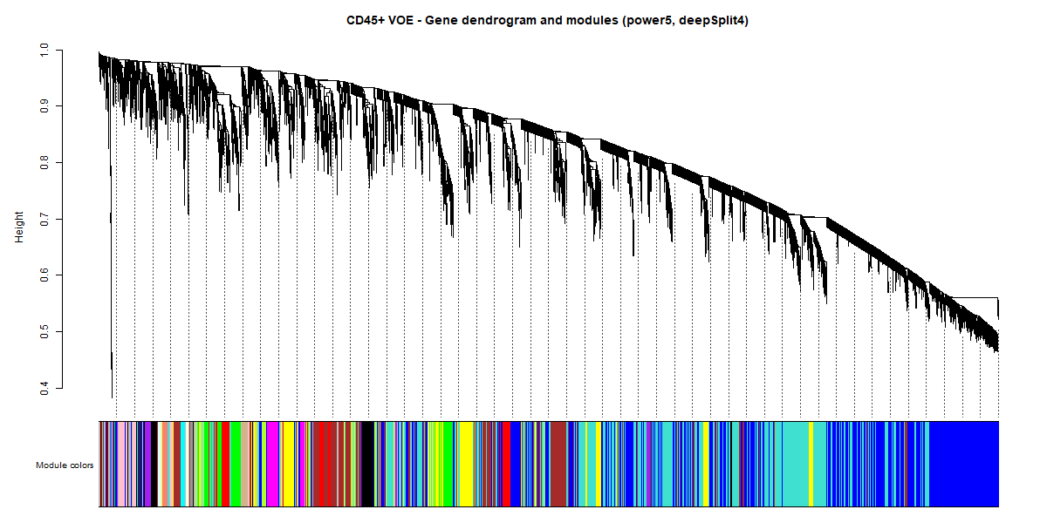
Figure 5. Gene dendrogram and detected modules for the CD45+ VOE network, built with parameters identical to Figure 9 to allow fair comparison.
Across both CD45+ networks, deepSplit (set to its highest tested value, 4) had a greater effect on cleanly separating genes into distinct modules than fine-tuning of the soft power itself. Each network self-organized into 13–25 gene modules.
5.2 CD71+ Erythroid Precursor Networks
Parameter | Steady State network | VOE network
Soft thresholding power | 15 | 15 (matched to Steady State)
Clustering resolution (deepSplit) | 4 (highest tested) | 4 (matched to Steady State)
Sample outliers removed | None | None

A notably higher soft power (15, versus 5 for CD45+) was required for the CD71+ networks, consistent with the erythroid lineage's more transcriptionally homogeneous profile, which required a stronger correlation threshold to resolve distinct modules. Unlike CD45+, sample-level PCA of CD71+ data showed no separation by patient sex (male and female samples were fully intermixed across PC1/PC2), only mild, non-separating spread by library batch, and no single patient dominating variance; clinical state also did not separate cleanly, mirroring the CD45+ result. Sex and batch correction were therefore not applied during CD71+ normalization , a genuine methodological difference from the CD45+ pipeline, driven by the underlying data rather than an inconsistency in approach.
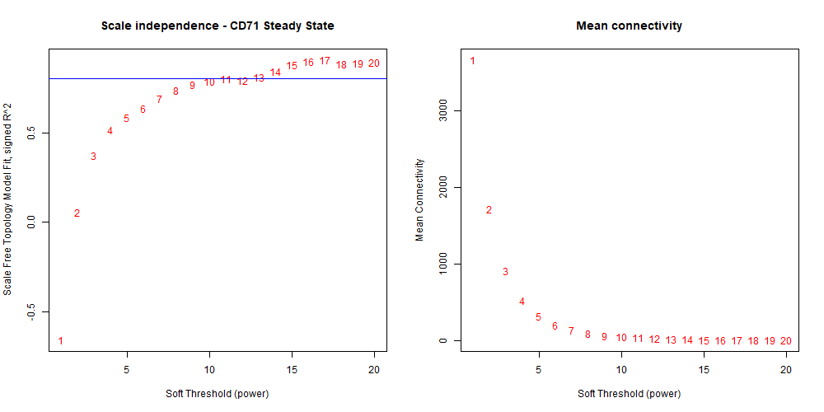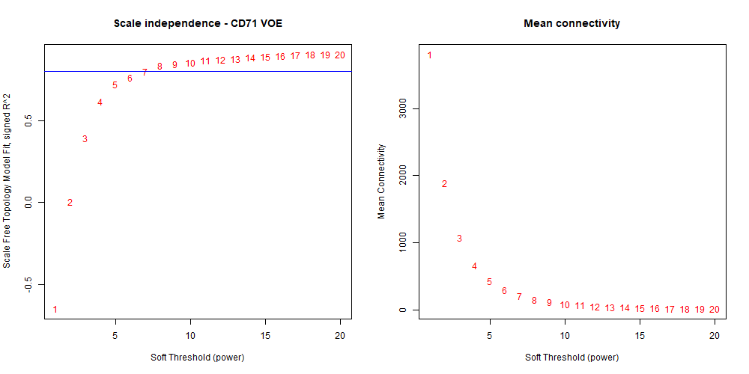
- (b)
Figure 6. (a)Soft power selection for the CD71+ Steady State network. (b) Soft power selection for the CD71+ VOE network.
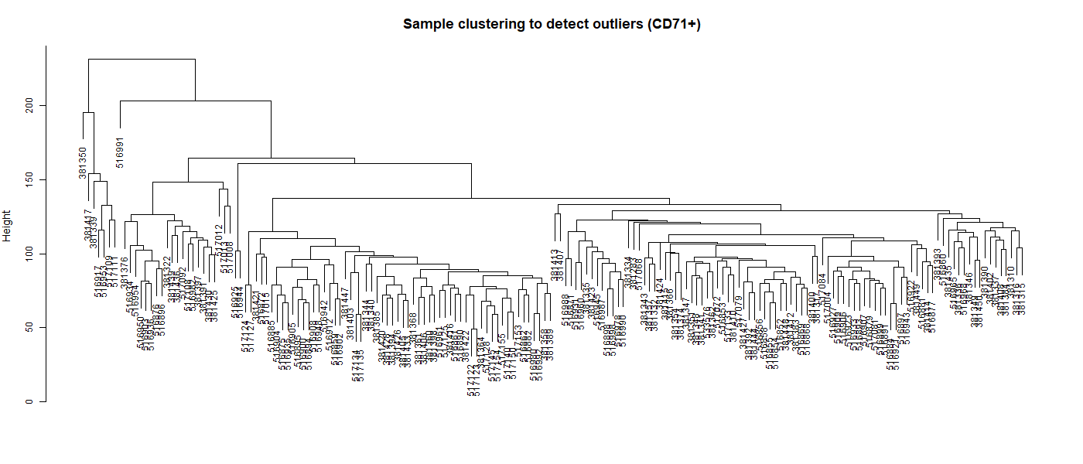
Figure 7. Hierarchical clustering of all CD71+ samples, used to screen for outlier samples prior to network construction.

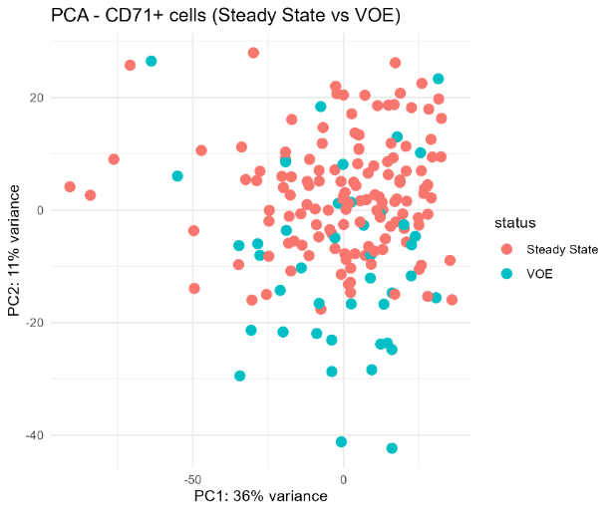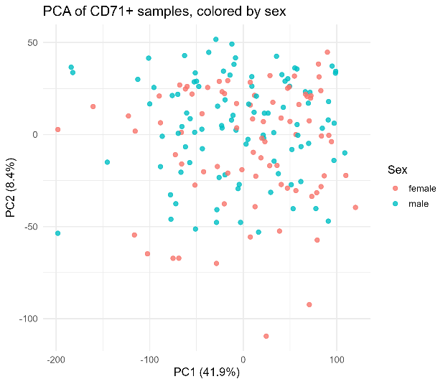
- (b)
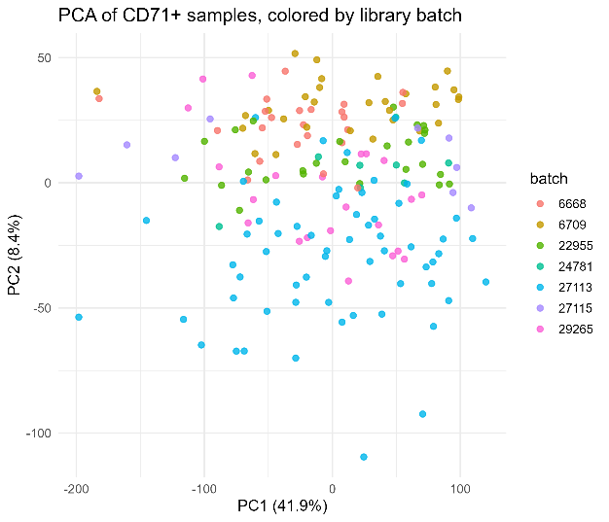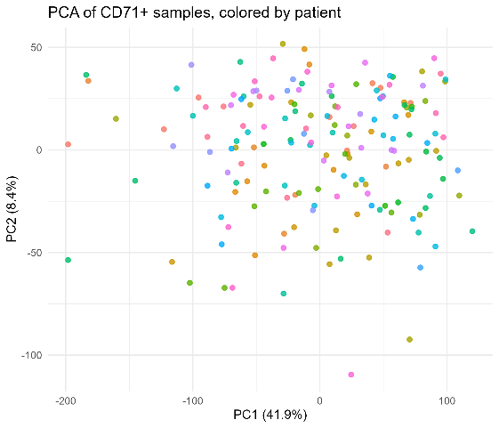
(c) (d)
Figure 8. PCA of all CD71+ samples, coloured by clinical state, sex, library batch, and patient identity respectively.
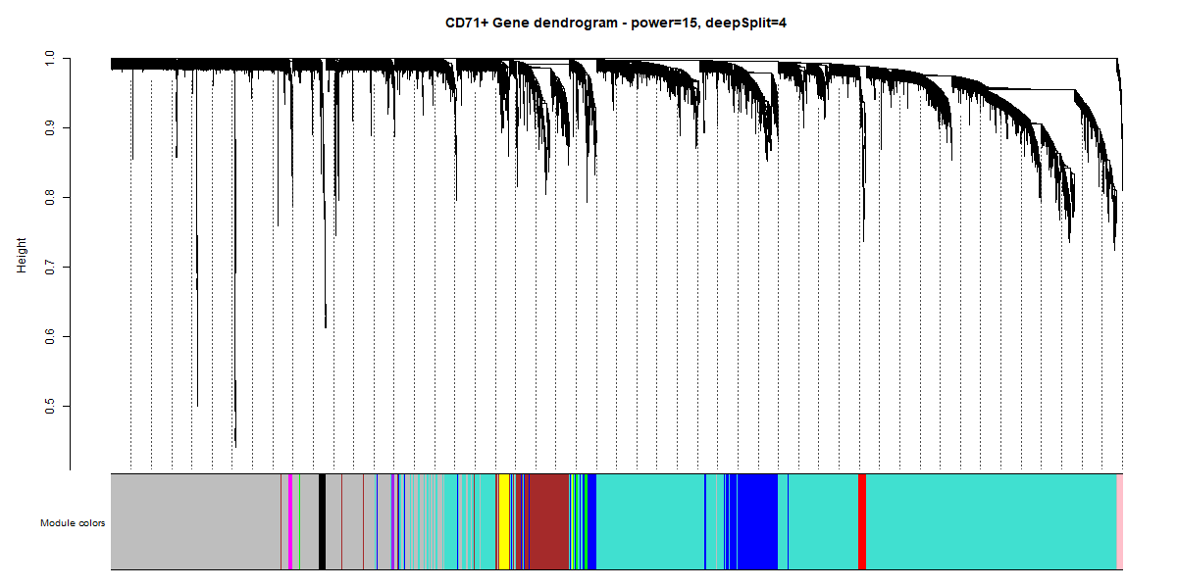
Figure 9. Gene dendrogram and detected modules for the CD71+ Steady State network.
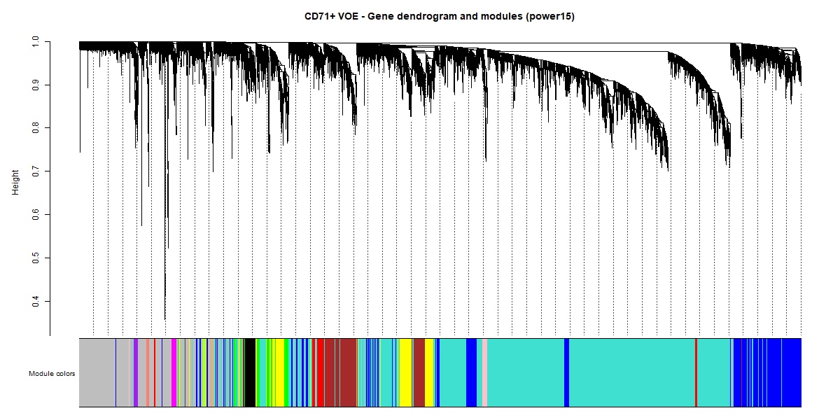
Figure 10. Gene dendrogram and detected modules for the CD71+ VOE network
As with CD45+, deepSplit at its highest tested value (4) was the parameter most responsible for clean module separation. A notably larger fraction of CD71+ genes were left unassigned (grey / no module) in both states relative to CD45+. This is interpreted as a genuine biological finding rather than a methods failure, reflecting the erythroid lineage’s greater transcriptional homogeneity i.e., fewer distinct, independently co-regulated gene groups than the more heterogeneous white blood cell population.

6. METHODS — STAGE 2: COMPARATIVE NETWORK ANALYSIS
For each cell type, the Stage 2 comparison was restricted to genes present and quantified in both the Steady State and VOE datasets (the ‘common gene set’). For every common gene, two properties were compared between clinical states: (1) which module the gene belonged to, and (2) the strength of its membership in that module (kME, module eigengene-based connectivity).
Because WGCNA assigns module colours arbitrarily at each run (i.e., the same colour label does not necessarily denote the same gene group across two independently built networks), the first analytical step in each cell type was to establish which Steady State module corresponds to which VOE module. This was done using Fisher's exact test applied to every possible Steady State–VOE module pair, testing for statistically significant gene-set overlap, and producing a ‘translation key’ linking each Steady State module to its best-matching VOE counterpart module.
Using this translation key, every common gene was classified into one of three categories:
- Switched — the gene ended up in a VOE module other than its Steady State module's expected counterpart.
- Stayed — the gene ended up in the expected corresponding VOE module.
- Grey-excluded — the gene was unassigned to any module (grey) in either state, and was therefore excluded from switch/stay classification, since ‘grey’ does not represent a real co-expression module.
Beyond simple module switching, the change in module membership strength (|kME|, absolute value) was calculated for every gene between the two states. The absolute value was used because kME can be positive or negative depending on which side of a module's average expression pattern a gene sits on, and a gene moving between two oppositely behaving modules could otherwise produce a misleadingly large or small apparent change in raw (signed) kME.
Three validation checks were applied independently to each cell type's results to rule out silent data-alignment errors of the kind that can arise when merging two large per-gene tables:
- Gene identity check — confirming no duplicate or missing gene identifiers across the full common gene table.
- Row-count reconciliation — confirming that switched + stayed + grey-excluded gene counts summed exactly to the total common gene count, with no genes lost or double-counted.
- Biological spot-check — cross-referencing genes with independently published, literature-established behavior during VOE against the new network-derived classification, as an orthogonal sanity check on the pipeline.
Downstream of module-switching classification, hub genes (genes with strong module membership by a threshold consistent with prior published studies), top rewired genes (genes with the largest |kME| change between states), and shared switchers (genes classified as ‘switched’ in both CD45+ and CD71+ concurrently) were extracted as prioritized candidate gene lists for biological interpretation and for Phase 2 follow-up.

7. RESULTS — CD45+ LEUKOCYTE NETWORK
7.1 Network Construction and Quality Control
Both the CD45+ Steady State and VOE networks were built successfully using power = 5 and deepSplit = 4. No sample-level outliers required removal. Sex was identified as a significant confound (PC2 separation) and included as a normalization covariate; library batch and individual patient identity were not significant confounds.
7.2 Module Switching and kME Rewiring
The Stage 2 comparison was restricted to the 17,213 genes present and measured in both the CD45+ Steady State and VOE datasets.
Category | Gene count | % of common genes
Switched module | 7,261 | 42.2%
Stayed in expected module | 8,650 | 50.3%
Grey-excluded (unassigned in ≥1 state) | 1,302 | 7.6%

Just over 42% of all common CD45+ genes changed which module they belonged to between the two clinical states a substantial fraction, indicating that module membership is not fixed and genuinely reorganizes with disease state. Three Steady State modules had no statistically significant counterpart in the VOE network at all, meaning those gene groups either lost their coherent identity or were absorbed into other modules once the patient entered a vaso-occlusive crisis.
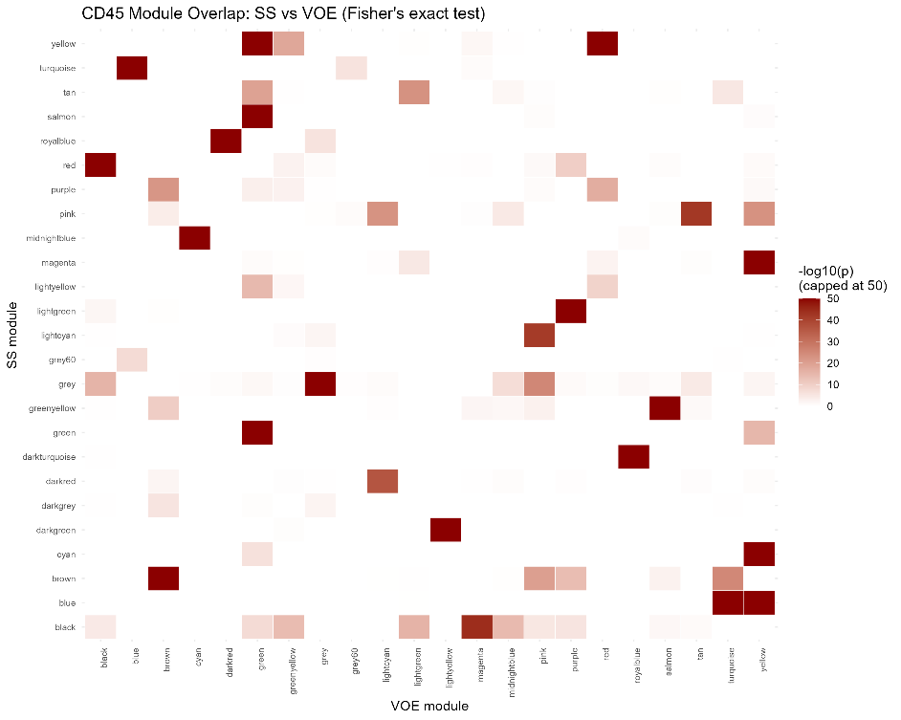
Figure 11. Module overlap heatmap for CD45+. Each cell shows the statistical strength (−log10 p-value, capped at 50 for visibility) of gene overlap between a Steady State module (row) and a VOE module (column). Bright cells mark module pairs representing essentially the same gene group across states; the overall pattern is not a clean one-to-one diagonal, showing that several modules reorganize rather than persist unchanged.
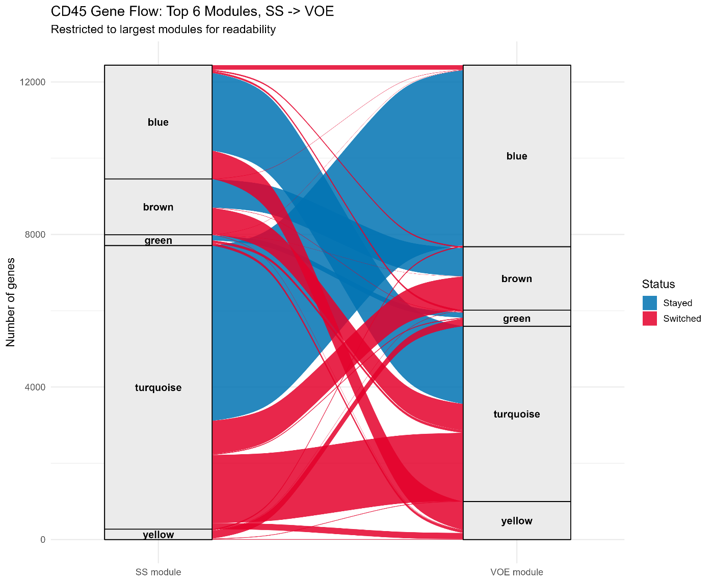
Figure 12. Gene flow (Sankey/alluvial diagram) between the six largest CD45+ modules, from Steady State (left) to VOE (right). Blue ribbons: genes that stayed in their expected module. Red ribbons: genes that switched to an unexpected module. Modules outside the top six and grey-assigned genes are excluded for readability.
Beyond discrete module switching, module membership strength (|kME|) was compared for every gene between states.
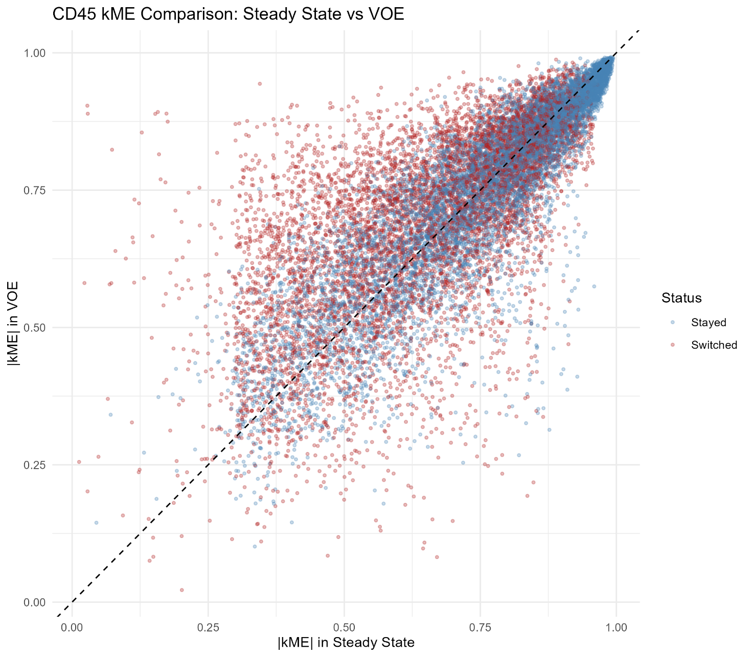
Figure 13. Comparison of module membership strength (|kME|) in Steady State versus VOE for every CD45+ gene. Each point is one gene; points on the dashed diagonal have identical membership strength in both states. Points far from the diagonal represent genes whose network role changed substantially, regardless of formal module-switch status. Red points switched module; blue points stayed.
Dominant structural signal: The genes with the largest |kME| change showed a clear, repeated pattern — a specific group of genes moved from the blue module in Steady State into the midnightblue module in VOE, with membership-strength changes typically between 0.6 and 0.9 — a very large shift, unlikely to be attributable to chance or measurement noise. This gene cluster is centered on cell-division / mitotic genes (KIF11, CCNA2, TOP2A, CDK1, TPX2), which lost tight coordinated co-expression during crisis.
7.3 Validation
All three validation checks (gene identity, row-count reconciliation, biological spot-check) passed for CD45+. Gene identity and row-count checks confirmed no duplicate, missing, or double-counted genes across the 17,213-gene table (7,261 + 8,650 + 1,302 = 17,213, exact). For the biological spot-check, four genes with independently published, strongly established behavior during vaso-occlusive crisis were examined:
Gene | Prior literature association | Observed behavior in this analysis
IL1B | Known strong upregulation during VOE | Switched module (consistent)
FAM20A | Known strong upregulation during VOE | Switched module (consistent)
MS4A4A | Essentially inactive/incoherent at baseline | Unassigned (grey) in Steady State → moved into active module in VOE (consistent)
SERPINB2 | Essentially inactive/incoherent at baseline | Unassigned (grey) in Steady State → moved into active module in VOE (consistent)

MS4A4A and SERPINB2 were correctly excluded from the switch/stay statistics above, since a gene moving from ‘no module’ to ‘a module’ is a categorically different event from switching between two already-established modules. All four genes behaved exactly as their known biology would predict, without having been used to build or tune the network in any way, supporting the conclusion that the network-comparison pipeline is capturing real disease biology rather than pipeline artifact or noise.

8. RESULTS — CD71+ ERYTHROID PRECURSOR NETWORK
8.1 Network Construction and Quality Control
Both the CD71+ Steady State and VOE networks were built successfully using power = 15 and deepSplit = 4. No sample-level outliers required removal. Unlike CD45+, sex, library batch, and individual patient identity were not significant confounds in CD71+ PCA, and sex/batch correction were therefore not applied during normalization.
8.2 Module Switching and kME Rewiring
The Stage 2 comparison was restricted to the 10,352 genes present and measured in both the CD71+ Steady State and VOE datasets.
Category | Gene count | % of common genes
Switched module | 2,076 | 20.1%
Stayed in expected module | 5,018 | 48.5%
Grey-excluded (unassigned in ≥1 state) | 3,258 | 31.5%

Approximately 20% of common CD71+ genes changed module membership between states — a smaller fraction than the 42% observed in CD45+, consistent with CD71+’s substantially higher baseline grey (unassigned) fraction and its more transcriptionally homogeneous, tightly regulated biology relative to the heterogeneous white blood cell compartment. The far larger grey-excluded fraction in CD71+ (31.5%, versus 7.6% in CD45+) reflects that young red blood cells are naturally more uniform/homogeneous than immune cells — itself treated as a genuine biological finding rather than a shortcoming of the method.
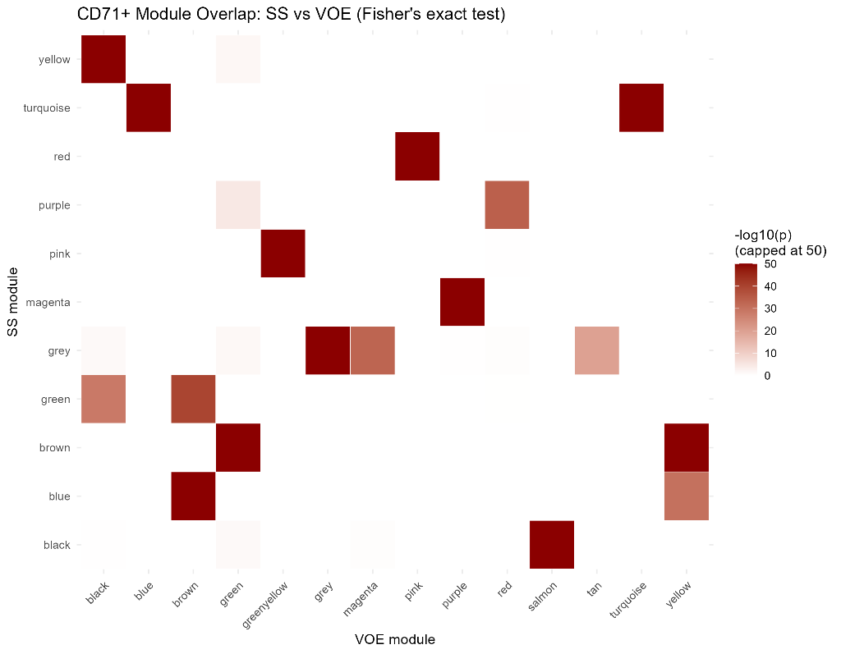
Figure 14. Module overlap heatmap for CD71+, showing statistical strength of gene overlap between each Steady State module and each VOE module.
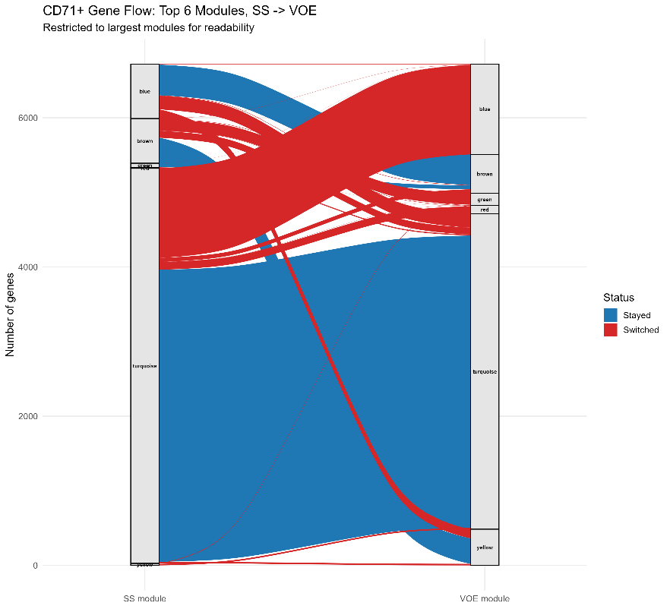
Figure 15. Gene flow (Sankey/alluvial diagram) between the six largest CD71+ modules, from Steady State (left) to VOE (right). Blue ribbons: genes that stayed in their expected module; red ribbons: genes that switched. Green, red, and yellow modules appear as narrow bands on the Steady State side, reflecting genuinely small module sizes at baseline (not a plotting artifact) — the same modules are visibly larger on the VOE side.
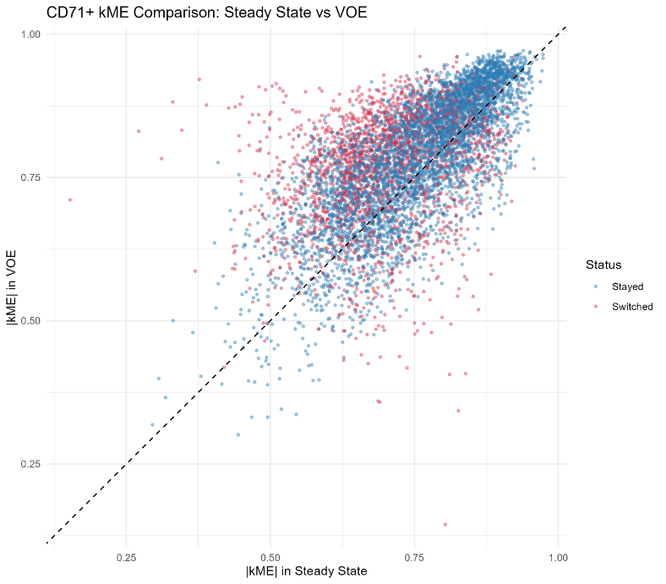
Figure 16. Comparison of module membership strength (|kME|) in Steady State versus VOE for every CD71+ gene, coloured by switched/stayed status.

Dominant structural signal: The genes with the largest |kME| change showed a clear, repeated pattern — a group of 102 genes moved from the turquoise module in Steady State into the red module in VOE, with membership-strength changes typically between 0.44 and 0.66 (kME change range approximately 0.38–0.56).
8.3 Functional Enrichment
A Gene Ontology (GO) Biological Process enrichment test was performed on the genes shifting modules in CD71+. Genes shifting modules were found to be strongly and significantly enriched for ribonucleoprotein complex biogenesis (ribosome assembly / protein-synthesis machinery), statistically significant even after multiple-testing correction. This is biologically coherent: young red blood cells are under acute physiological stress during a vaso-occlusive crisis, and their protein-production machinery appears to be actively reorganized as part of that stress response.
8.4 Validation
All three validation checks passed for CD71+. Gene identity and row-count checks confirmed no duplicate, missing, or double-counted genes (2,076 + 5,018 + 3,258 = 10,352, exact). For the biological spot-check, core hemoglobin genes central to sickle cell biology were examined:
Gene | Prior expectation | Observed behavior in this analysis
HBB | Essential, constitutively active in erythroid cells | Stayed in stable module (brown → yellow) (consistent)
HBA1 | Essential, constitutively active in erythroid cells | Stayed in stable module (brown → yellow) (consistent)
HBA2 | Increased demand on hemoglobin synthesis machinery during crisis | Moved from unassigned (grey) in Steady State to active module (green) in VOE (plausible / consistent)

All three genes behaved in a manner consistent with known erythroid biology, without having been used to build or tune the network, supporting the conclusion that the network-comparison method is capturing real disease biology in this cell type as well.

9. CROSS-CELL-TYPE CONVERGENCE: SHARED REWIRED GENES
Genes classified as ‘switched’ in the CD45+ analysis were cross-referenced against genes classified as ‘switched’ in the CD71+ analysis to identify genes exhibiting module-switching behavior in both cell populations concurrently (‘shared switchers’).
776 genes were found to rewire (switch module) in both immune cells (CD45+) and red blood cell precursors (CD71+) during a crisis. This indicates that the network reorganization signal is not a one-cell-type quirk or artifact restricted to a single lineage , it is a signal appearing across two very different cell populations at the same time, consistent with a shared, systemic response to vaso-occlusive crisis rather than two unrelated, lineage-specific local effects.
10. TECHNICAL CONFOUND ANALYSIS: CELL-TYPE COMPOSITION SHIFT
The CD45+ ‘leukocyte’ population sampled in this dataset is not a single homogeneous cell type; it is a mixture of several immune cell subtypes (monocytes, neutrophils, T cells, and others). If the relative proportions of these subtypes shift systematically between steady state and crisis, the observed network changes in CD45+ could, in principle, simply reflect a change in bulk cell-type mixture rather than genuine cell-intrinsic transcriptional rewiring within a stable cell population.
To test this, the xCell computational deconvolution tool was used to estimate immune cell-type proportions in every CD45+ sample. Two questions were addressed:
- Do cell-type proportions actually shift between Steady State and VOE? Yes — both monocyte and neutrophil proportions increase during crisis, consistent with an expected inflammatory response.
- Does this compositional shift explain the observed rewired-gene signal? This was tested directly in the 19 patients who had paired samples from both clinical states, by correlating each patient's individual change in monocyte/neutrophil proportion against their individual change in rewired-gene activity.
Result: No gene showed a statistically significant relationship between compositional shift and rewired-gene activity after multiple-testing correction. This indicates that the observed network rewiring signal in CD45+ is not explained by the shift in cell-type mixture — strengthening the interpretation that the finding reflects genuine, cell-intrinsic network reorganization rather than a side-effect of which immune cell subtypes happened to be more abundant in a given sample.

11.DISCUSSION
Taken together, the Phase 1 CD45+ and CD71+ analyses support the central premise of this project: that clinical state in sickle cell disease is associated with a measurable reorganization of the underlying gene co-expression network, not merely with changes in the expression level of individual genes. In CD45+ leukocytes, 42.2% of common genes changed module membership between steady state and crisis, with the most prominent signal being a coordinated loss of co-expression among cell-division / mitotic genes (KIF11, CCNA2, TOP2A, CDK1, TPX2). In CD71+ erythroid precursors, 20.1% of common genes switched modules, a smaller but still substantial fraction with the dominant signal being a shift of genes into a module functionally enriched for ribonucleoprotein complex biogenesis (ribosome assembly machinery), consistent with the physiological stress placed on protein-synthesis machinery in immature red blood cells during an acute crisis.
The identification of 776 genes rewiring concurrently in both cell types strengthens the interpretation that this is a systemic, cross-lineage phenomenon accompanying vaso-occlusive crisis, rather than two independent, cell-type-restricted local effects. The technical confound analysis (Section 10) further supports a cell-intrinsic interpretation of the CD45+ signal specifically, by showing that the rewiring pattern is not explained by shifts in immune cell subtype composition.
The validation steps performed independently in each cell type — correctly recovering the expected behavior of literature-established genes (IL1B, FAM20A, MS4A4A, SERPINB2 in CD45+; HBB, HBA1, HBA2 in CD71+) without those genes being used to construct or tune the network in any way provide meaningful confidence that the network-comparison pipeline is capturing genuine disease biology rather than reproducing noise or a pipeline artifact.
Because this pattern appeared repeatedly among the top-ranked genes in CD45+ rather than as an isolated case, the blue→midnightblue module shift is a strong candidate for further investigation as a coordinated biological response to vaso-occlusion, and a reasonable starting point for hub-gene and drug-target prioritization in Phase 2.
12.LIMITATIONS
- This is a correlational study. The data support an association between network rewiring and crisis state; they do not establish that network rewiring causes worse clinical outcomes.
- Nearly all patients in this cohort were receiving hydroxyurea treatment at the time of sampling. It is not currently possible to determine how untreated (or differently treated) patients would look at the network level.
- The cell-type composition confound check (Section 10) used only 19 patients with paired steady-state/VOE samples — a small sample size. This should be treated as supportive evidence, not definitive proof, of a purely cell-intrinsic effect.
- Cross-cell-type ‘bridge genes’ — genes that might structurally connect the CD45+ and CD71+ networks to one another were not analyzed in Phase 1 and are flagged as future (Phase 2) work.

13. CONCLUSIONS AND NEXT STEPS
Sickle cell disease patients' gene regulatory networks measurably reorganize when moving from a stable state into a vaso-occlusive crisis in both immune cells and red blood cell precursors and this reorganization is distinct from, and not explained by, simple changes in which immune cell types are present in the sample. In immune cells, the most dramatic shift involves cell-division genes losing coordination; in red blood cell precursors, it involves the protein-production (ribosome-building) machinery. A meaningful subset of genes (776) shows this rewiring in both cell types simultaneously, suggesting a shared, systemic response to crisis rather than two unrelated local effects.
This supports the project's central premise: clinical outcome variability in sickle cell disease may be partly explained by how a patient's gene network responds and reorganizes during a crisis — not just by which genes are switched on or off, and not just by fixed genetic differences between patients.
Purposed phase 2 directions
- Hub-gene and drug-target prioritization within the CD45+ blue→midnightblue rewiring signal.
- Characterization of the 776 shared cross-cell-type switcher genes, including hub-gene identification and pathway enrichment within this specific gene set.
- Analysis of cross-cell-type ‘bridge genes’ structurally connecting the CD45+ and CD71+ networks.
- Genetic convergence analysis (as referenced in the CD71+ source report) integrating network findings with known SCD genetic modifier loci.
14. REFERENCES
- Bhat et al. Gene expression profiling identifies potential biomarkers for vaso-occlusive episodes in sickle cell disease. JCI Insight, 2025. GEO accession GSE291257.
https://insight.jci.org/articles/view/193359
https://pmc.ncbi.nlm.nih.gov/articles/PMC13041688/
- Langfelder P, Horvath S. WGCNA: an R package for weighted correlation network analysis. BMC Bioinformatics 9, 559 (2008). https://doi.org/10.1186/1471-2105-9-559
- Zhang B, Horvath S. A general framework for weighted gene co-expression network analysis. Stat Appl Genet Mol Biol 4, Article 17 (2005). https://doi.org/10.2202/1544-6115.1128
- Aran D, Hu Z, Butte AJ. xCell: digitally portraying the tissue cellular heterogeneity landscape. Genome Biology 18, 220 (2017). https://doi.org/10.1186/s13059-017-1349-1
- Liberzon A, Birger C, Thorvaldsdóttir H, Ghandi M, Mesirov JP, Tamayo P. The Molecular Signatures Database (MSigDB) hallmark gene set collection. Cell Systems 1(6), 417–425 (2015). https://doi.org/10.1016/j.cels.2015.12.004
- Subramanian A et al. Gene set enrichment analysis: a knowledge-based approach for interpreting genome-wide expression profiles. PNAS 102(43), 15545–15550 (2005). https://doi.org/10.1073/pnas.0506580102
- Ashburner M et al. Gene Ontology: tool for the unification of biology. Nature Genetics 25, 25–29 (2000). https://doi.org/10.1038/75556
- Sankaran VG et al. Human fetal hemoglobin expression is regulated by the developmental stage-specific repressor BCL11A. Science 322, 1839–1842 (2008). https://doi.org/10.1126/science.1165409
- Lettre G et al. DNA polymorphisms at the BCL11A, HBS1L-MYB, and beta-globin loci associate with fetal hemoglobin levels and pain crises in sickle cell disease. PNAS 105(33), 11869–11874 (2008). https://doi.org/10.1073/pnas.0804799105
- Barabási AL, Gulbahce N, Loscalzo J. Network medicine: a network-based approach to human disease. Nature Reviews Genetics 12(1), 56–68 (2011). https://doi.org/10.1038/nrg2918

