Game Design Document

Fill up the following document

1. Write the title of your project.

Beware of Covid-19!!!

1. What is the goal of the game?

To spread awareness among people about the deadly virus through a game.

1. Write a brief story of your game.

There will be 2 levels.

First of all there will be a lot of viruses.The player has to kill them to reach the next level. In the next level the player has to help a girl(name:Anna) reach her house either by killing the viruses or by dodging them.

If the player successfully passes both the levels then atlast we will teach them how to maintain hygiene and stay safe from covid and give them a prize like treasue or something.

1. Which are the playing characters of this game?

* Playing characters are the ones who respond to the user based on the input from the user.
* Cars, monkeys, dinos, wizards, etc., are the playing characters in the game.

|  |  |  |
| --- | --- | --- |
| Number | Character Name | What can this character do? |
| 1 | Sanitizer | It can kill viruses. |
| 2 | Anna(the girl) | She can kill viruses and dodge them. |
| 3 |  |  |
| 4 |  |  |
| 5 |  |  |
| 6 |  |  |
| 7 |  |  |
| 8 |  |  |

1. Which are the Non-Playing Characters of this game?

* Non-Playing characters are the ones that don't have an action or behavior when the user interacts with the game.
* Hurdles, stones, bananas, coins, etc., are non-playing characters in the game.

|  |  |  |
| --- | --- | --- |
| Number | Character Name | What can this character do? |
| 1 | Virus1 | If there are excess number of virus in level 1 the player will automatically lose. |
| 2 | Virus2 | It can kill the player’s avatar(Anna) |
| 3 |  |  |
| 4 |  |  |
| 5 |  |  |
| 6 |  |  |
| 7 |  |  |
| 8 |  |  |

Draw your imagination of this game. What does this game look like?

* Draw the game either on your computer or on paper.
* Add images of the game scenes to show each of the playing and non-playing characters at least once.

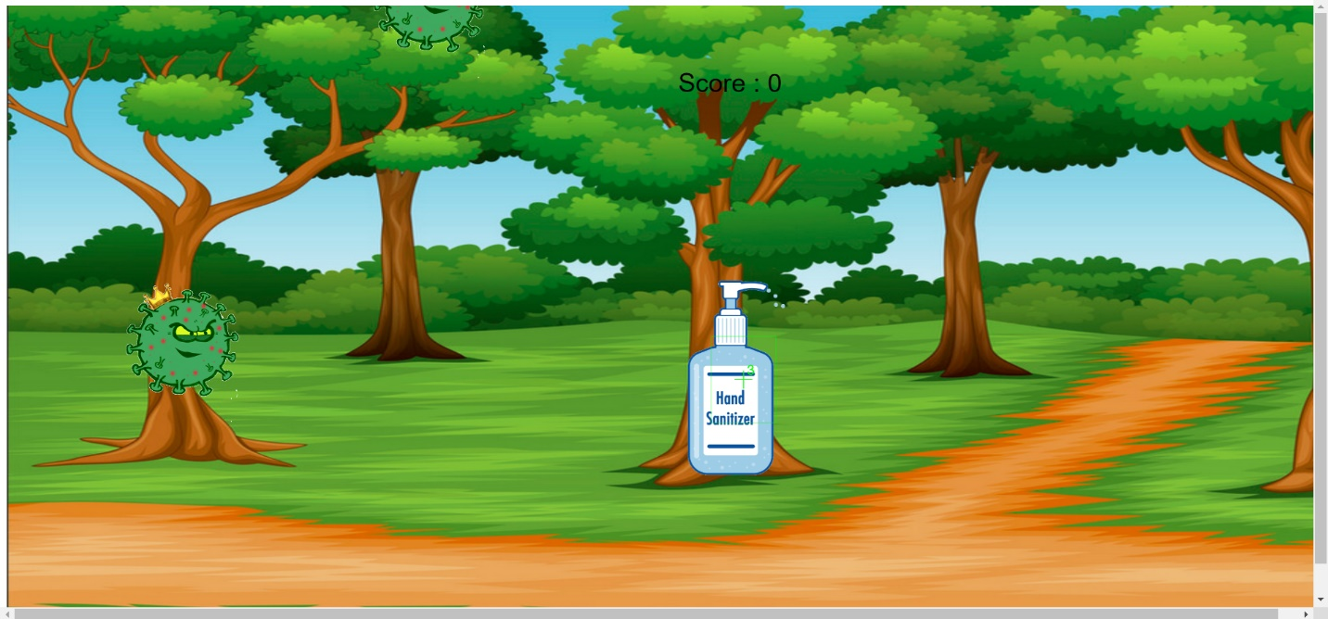

How do you plan to make your game engaging?

We can make the game engaging by adding different types of sound effects,increasing game adaptivity,showing scores etc. It may not look boring.