**Screenshot 1A:** Terminal showing project directory contents (engine.c, monitor.c, Makefile, etc.)
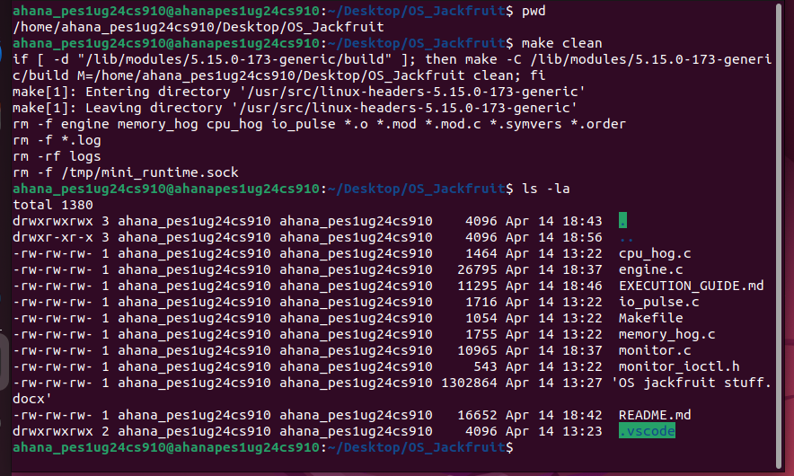

**Screenshot 1B:** Terminal showing successful build output ending with "All targets built successfully" or similar
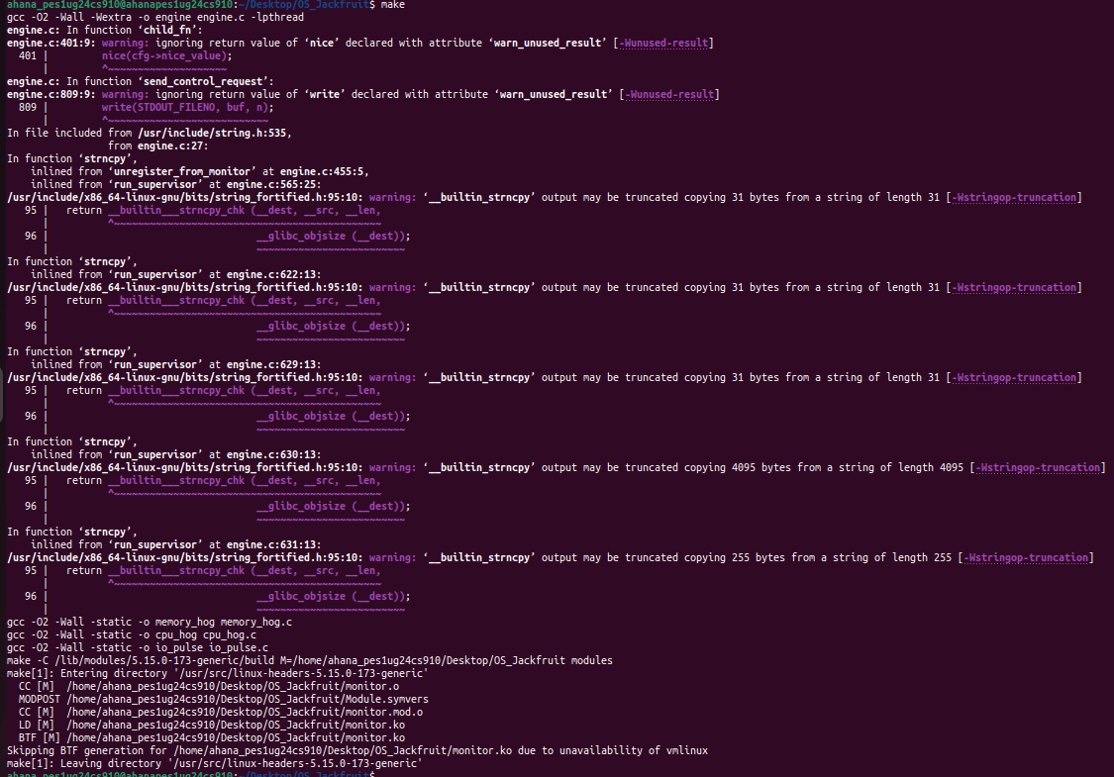
**Screenshot 1C:** Terminal showing all binaries exist with correct types (ELF executable, kernel module)
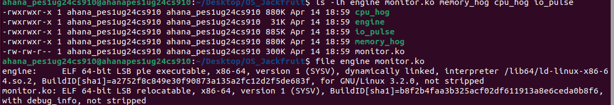

**Screenshot 1D:** Terminal showing:
- `monitor` in lsmod output
- `/dev/container_monitor` device exists
- Kernel message "monitor: module loaded" or similar in dmesg
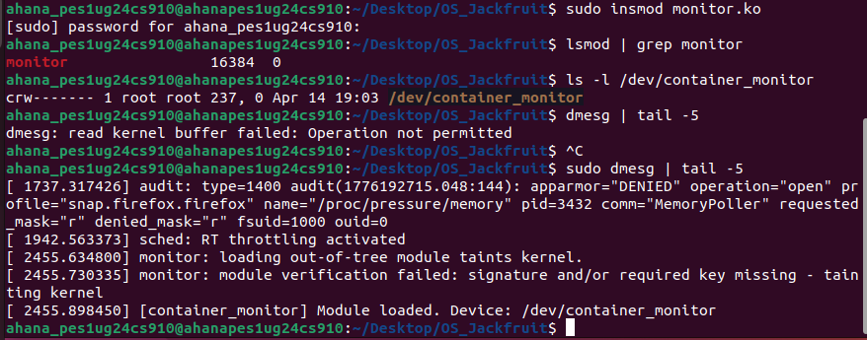

**Screenshot 2A:** Terminal showing rootfs-base directory with Alpine files (bin, etc, usr, etc.)
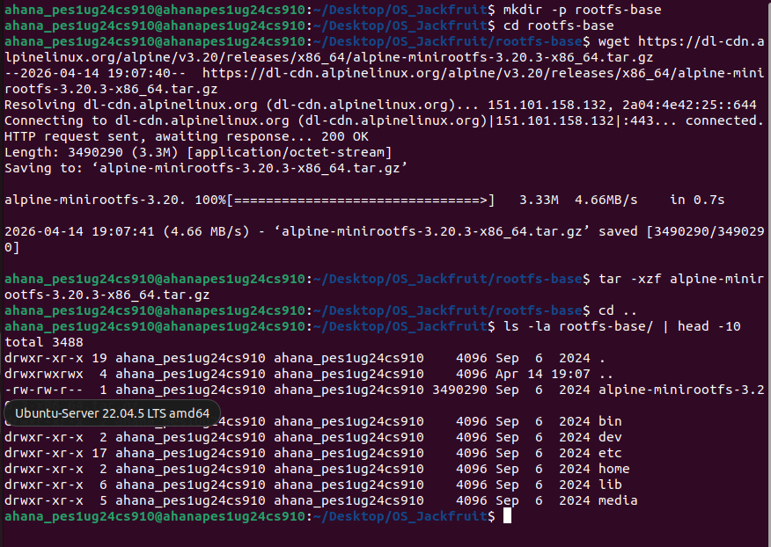

**Screenshot 2B:** Terminal showing three directories: rootfs-base, rootfs-alpha, rootfs-beta
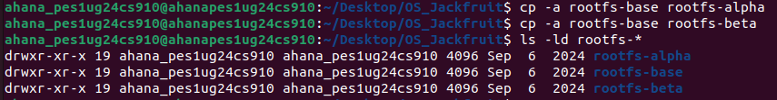

**Screenshot 2C:** Terminal confirming workload binaries are in each container's rootfs
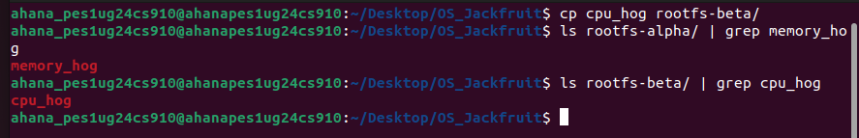

**Screenshot 3A:** Terminal 1 showing supervisor startup message

**Screenshot 3B:** Terminal 2 showing `/tmp/mini_runtime.sock` exists after the supervisor is running
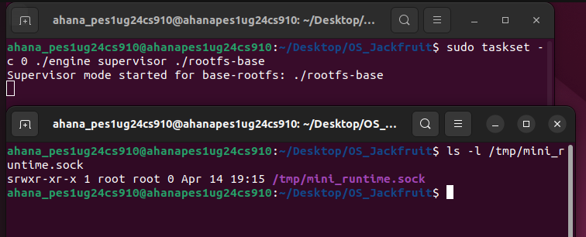

**Screenshot 4A:** Terminal 2 showing "start" command and "OK: started..." response
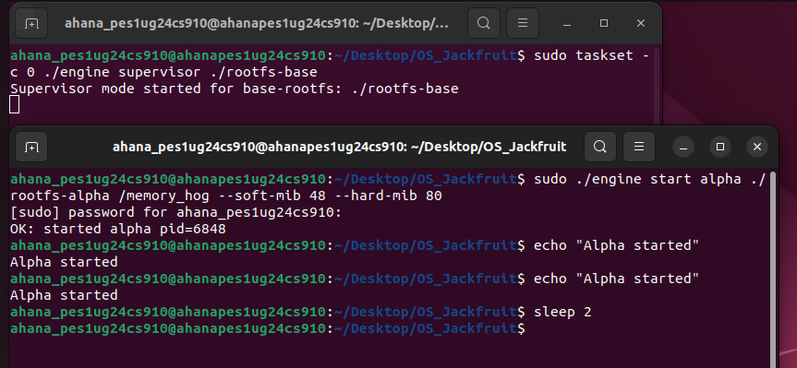

**Screenshot 4B:** Terminal 2 showing "start" command and "OK: started..." response
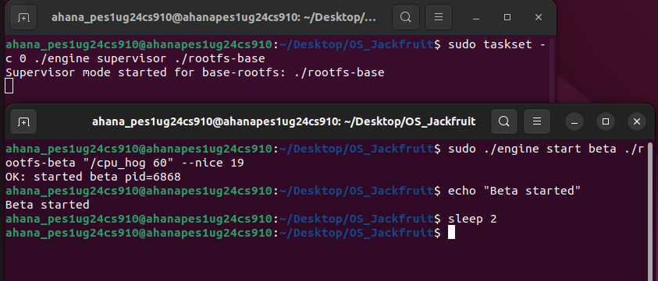

**Screenshot 4C (IMPORTANT - Screenshot #2 for submission):** Terminal output of ps showing:
- Container IDs (alpha, beta)
- PIDs
- States (RUNNING)
- Memory limits (soft/hard MiB)
- Log file paths
(This demonstrates metadata tracking)
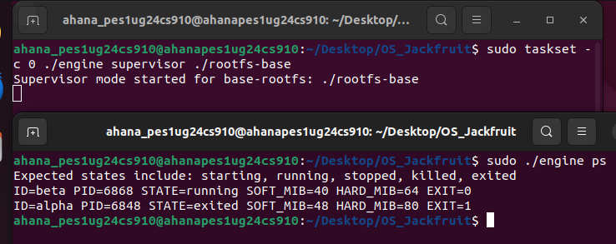

**Screenshot 4D (IMPORTANT - Screenshot #3 for submission):** This is the bounded-buffer logging screenshot. Capture terminal output where `./engine ps` shows alpha in `STATE=running` and logs show `allocation=...` lines.
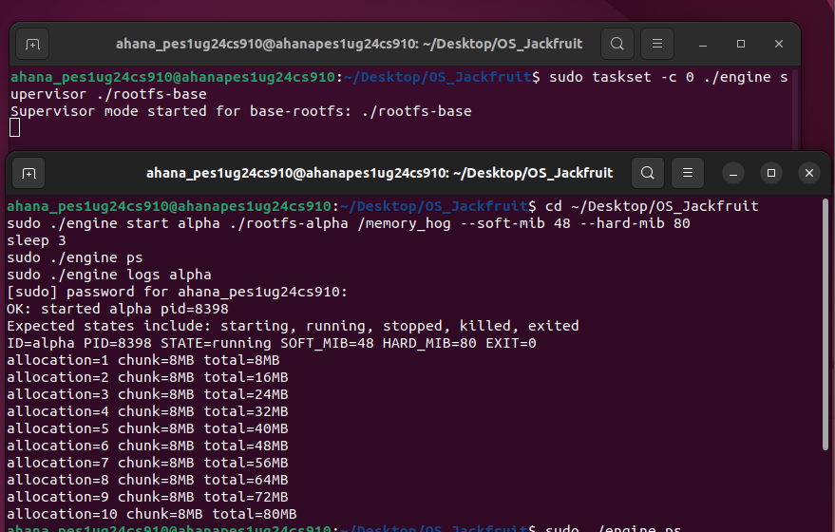

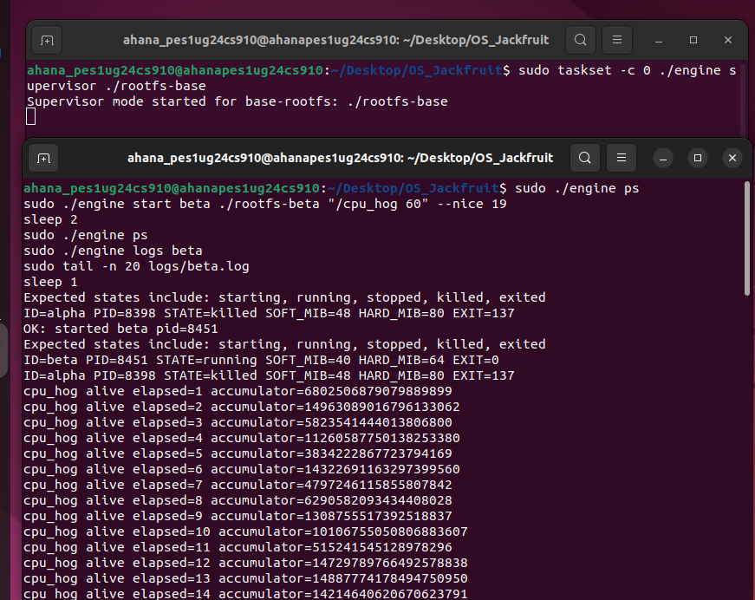

**Screenshot 4E:** Terminal 3 showing dmesg output
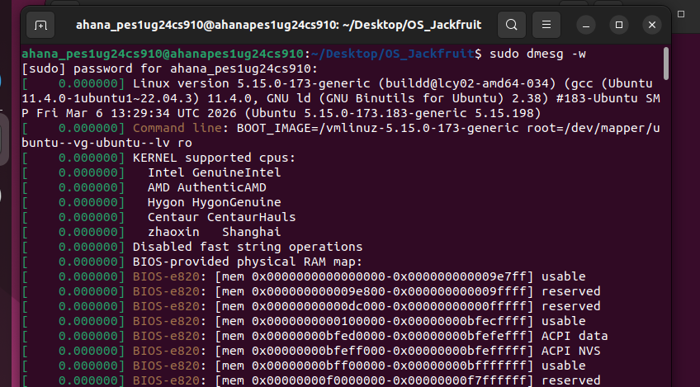
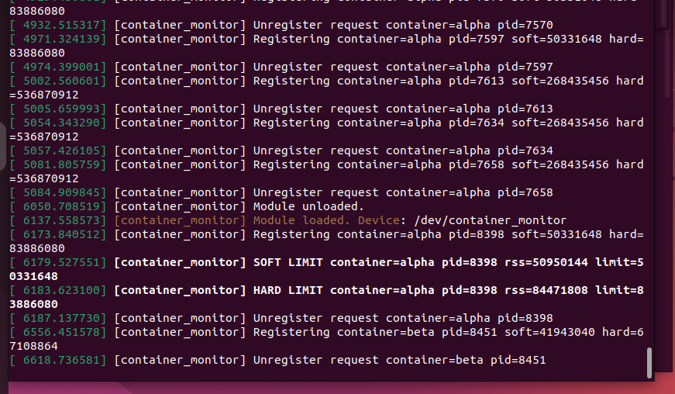

**Screenshot 5A (IMPORTANT - Screenshot #5 for submission):** dmesg output showing:
`[container_monitor] Soft limit warning: PID XXX exceeded YYY KiB soft limit`
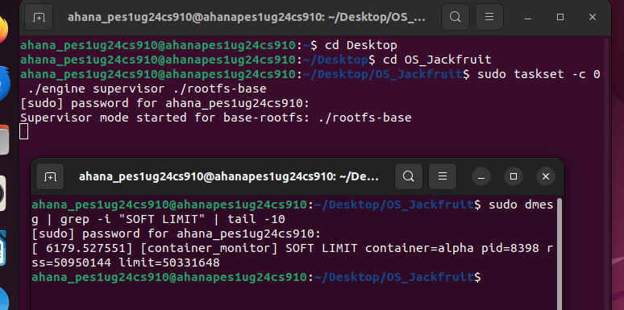
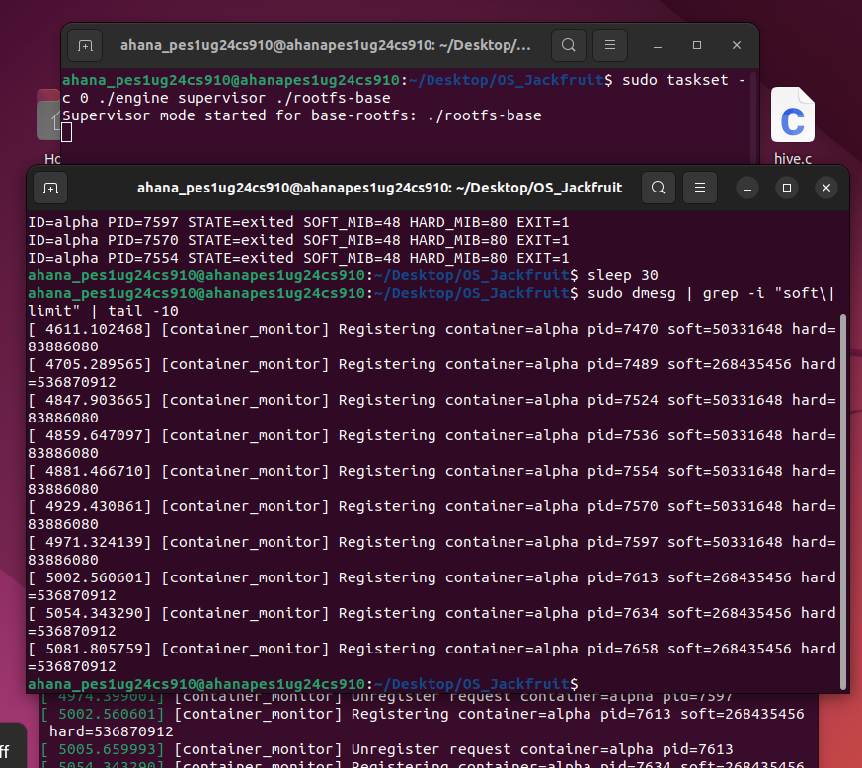

**Screenshot 5B (IMPORTANT - Screenshot #6 for submission):** dmesg output showing:
`[container_monitor] HARD LIMIT container=... pid=... rss=... limit=...
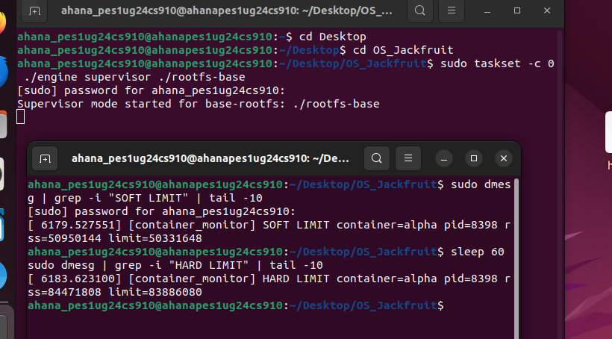

**Screenshot 5C:** Terminal showing alpha state changed to KILLED_HARD_LIMIT
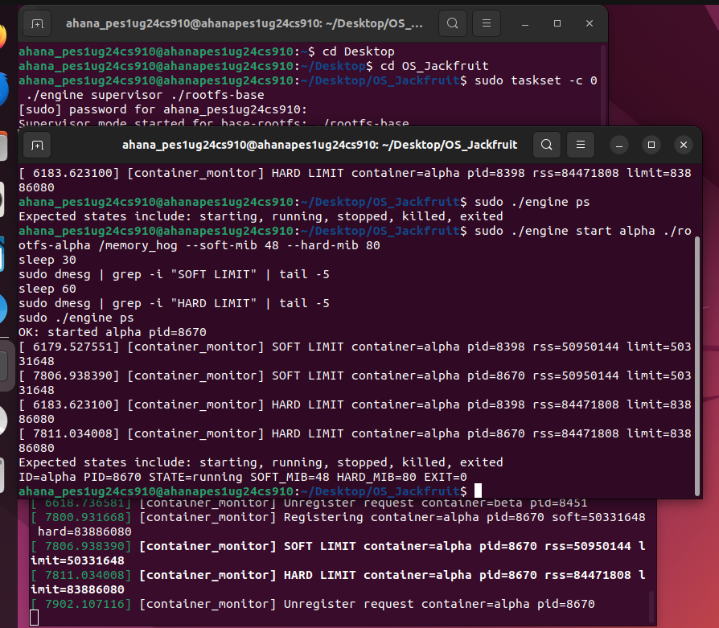
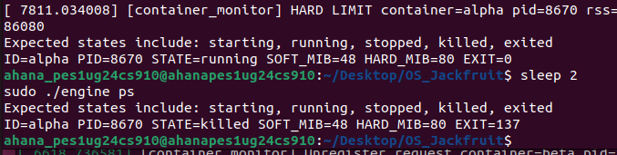

**Screenshot 6A (IMPORTANT - Screenshot #7 for submission):** top output showing:
- alpha (cpu_hog) with ~98-99% CPU
- beta (cpu_hog) with ~0-1% CPU
(Demonstrates CFS scheduling with nice values)

**Screenshot 6B:** ps output showing both containers in RUNNING state but with different CPU allocation

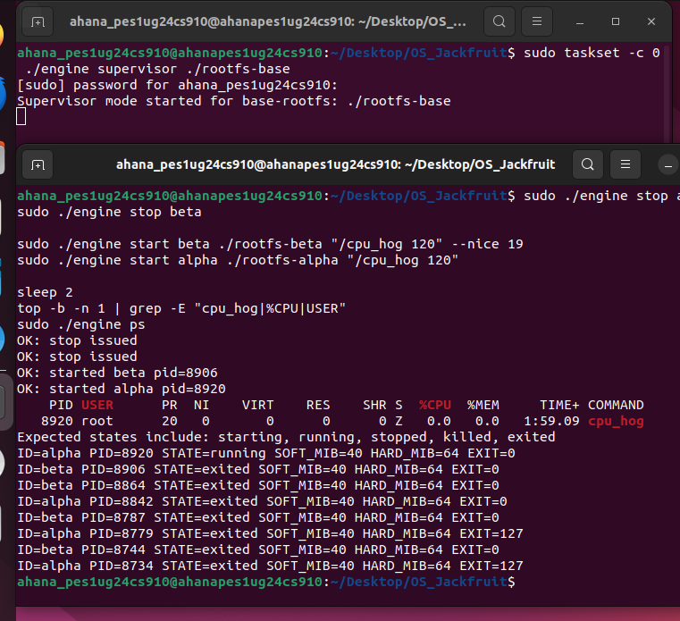

**Screenshot 7A:** Terminal output showing stop command accepted

**Screenshot 7C (IMPORTANT - Screenshot #8 for submission):** Terminal 1 showing:
- Supervisor shutdown messages
- "All children reaped" or similar
- Clean exit
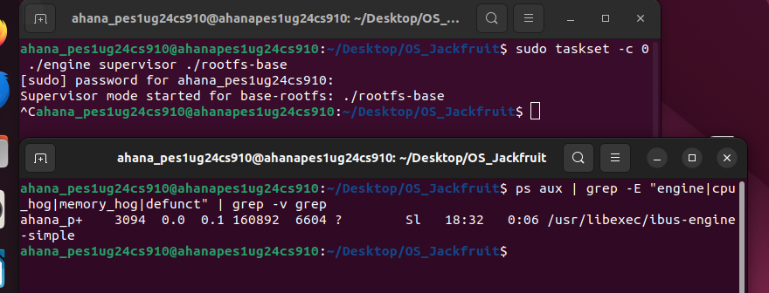

**Screenshot 7D:** Terminal showing no zombie processes (only grep in the output)
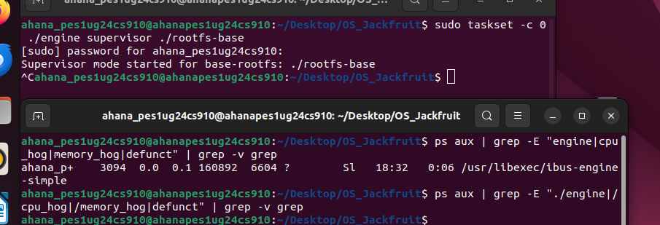

**Screenshot 7E:** Terminal confirming monitor module removed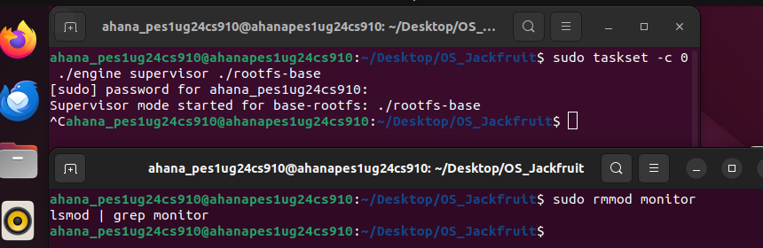

**Screenshot 7F:** Terminal showing per-container log files with captured output
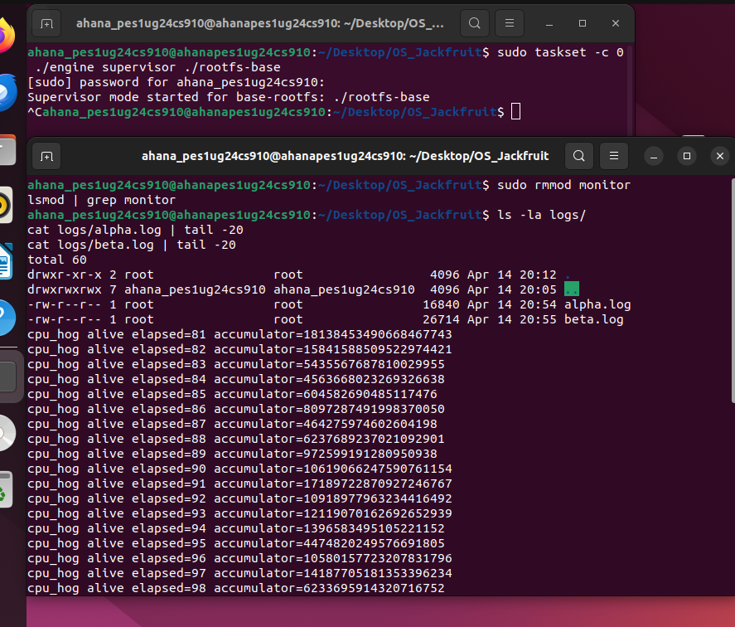
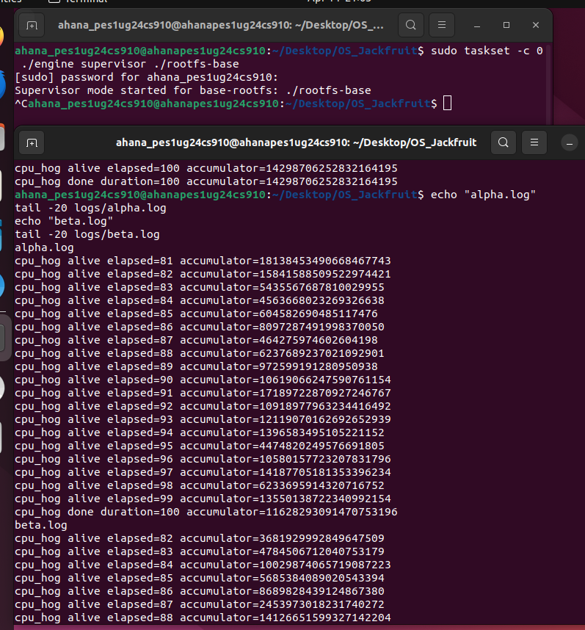

**Screenshot 7G:** Terminal showing final dmesg entries including module unload message